RISC-V VeeR EL2 Based SoC for Image / Data Processing

System Specification Document
Document Version: 1.0 Status: Draft for Implementation (Kiro Agent Input) Core IP: CHIPS Alliance VeeR EL2 (RV32IMC, in-order, single-issue/dual-issue capable, low-power)

Table of Contents
- Introduction
- Block Diagram 2.1 Top-Level (System) Block Diagram 2.2 Internal Block Diagrams and Interconnections
- Signal List 3.1 Global Clock & Reset Signals 3.2 VeeR EL2 Core Complex Boundary Signals 3.3 System Interconnect Cross-Block Signals 3.4 Image Processing Unit (IPU) Signals 3.5 DMA Controller Signals 3.6 Peripheral Subsystem Signals 3.7 Debug Subsystem Signals
- Control Path
- Data Path

1. Introduction
This document specifies a System-on-Chip (SoC) built around the RISC-V VeeR EL2 core (32-bit, in-order, low-power RV32IMC, CHIPS Alliance) for real-time image and data processing (edge detection, spatial filtering, color-space conversion, streaming sensor data conditioning).
The SoC splits work into a control plane and a data plane. The VeeR EL2 core is the control-plane processor: it boots, configures the Image Processing Unit (IPU) and DMA controller, services interrupts, and runs application firmware, but never touches the bulk data stream directly. The data plane — the IPU accelerator plus a DMA controller — moves and transforms image/data frames between System SRAM and the processing pipeline autonomously once started, synchronizing back to the CPU only via completion/error interrupts. A shared AXI4 interconnect ties the CPU, DMA, IPU, memories, and standard peripherals (UART, SPI, GPIO, Timer, PIC) together, with a JTAG/DMI debug subsystem for external debug and programming.
Design goals: clean control/data-path separation to keep the CPU free for control tasks; modular IP blocks on a common interconnect so accelerators can be added/swapped; low-power operation via clock gating and DMA-driven (non-polling) data movement; and full debuggability through CPU- and JTAG-visible status registers on every block.

2. Block Diagram

2.1 Top-Level (System) Block Diagram
The top-level diagram shows the SoC as a single large block subdivided into its major functional units, connected through the System Interconnect.

Big-block description:
Block | Role
VeeR EL2 Core Complex | Control-plane processor: fetch/decode/execute firmware, configure all peripherals and accelerators, service interrupts
System Interconnect (AXI4 crossbar) | Shared fabric connecting all AXI4 masters (CPU IFU/LSU, DMA) to all AXI4 slaves (SRAM, Boot ROM, IPU config port, peripheral bridge)
System SRAM | Shared memory for frame/data buffers, DMA source/destination
Boot ROM | First-stage bootloader / reset code
DMA Controller | Moves data between SRAM and IPU stream ports without CPU intervention
IPU (Image/Data Processing Unit) | Hardware accelerator: performs the actual image/data transformation
Peripheral Subsystem | UART, SPI, GPIO, Timer, PIC — control/communication/timing
Debug Subsystem | JTAG TAP + DMI bridge into the VeeR EL2 debug module
Clock & Reset Unit | Generates and distributes clk / rst_l / dbg_rst_l to all blocks
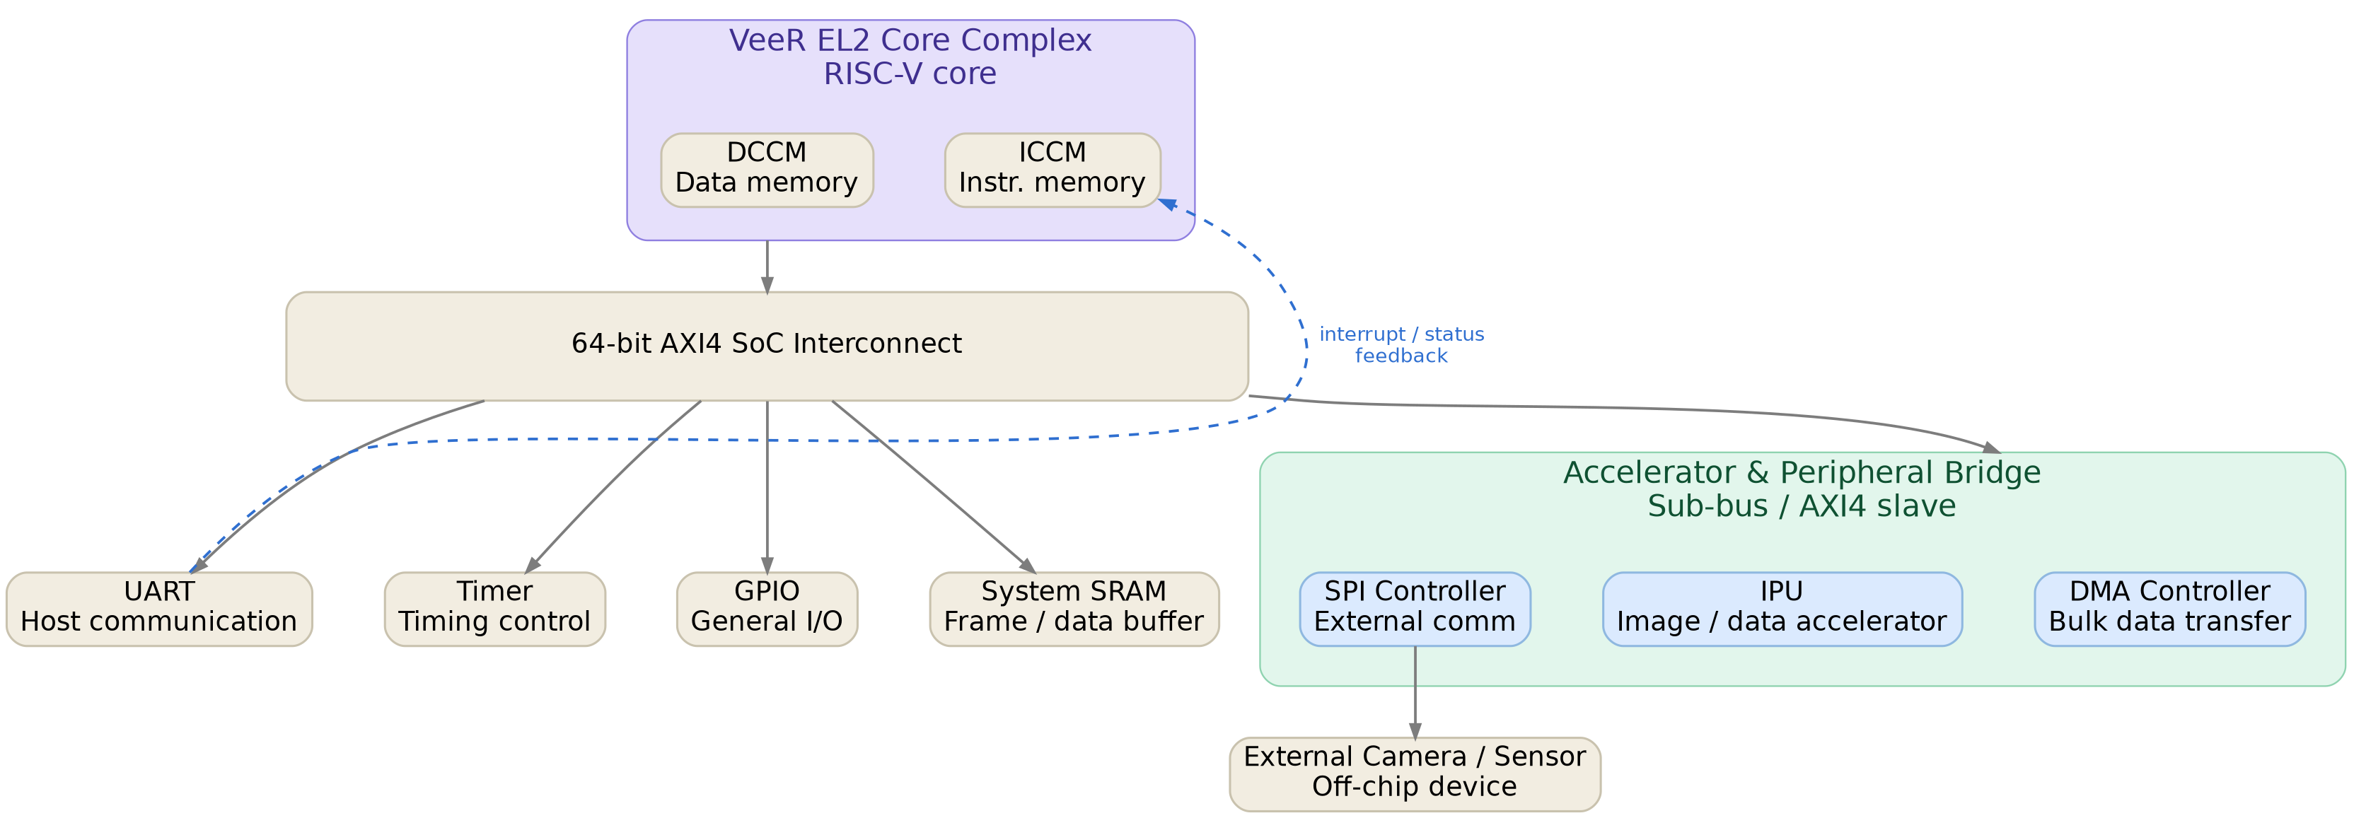

2.2 Internal Block Diagrams and Interconnections
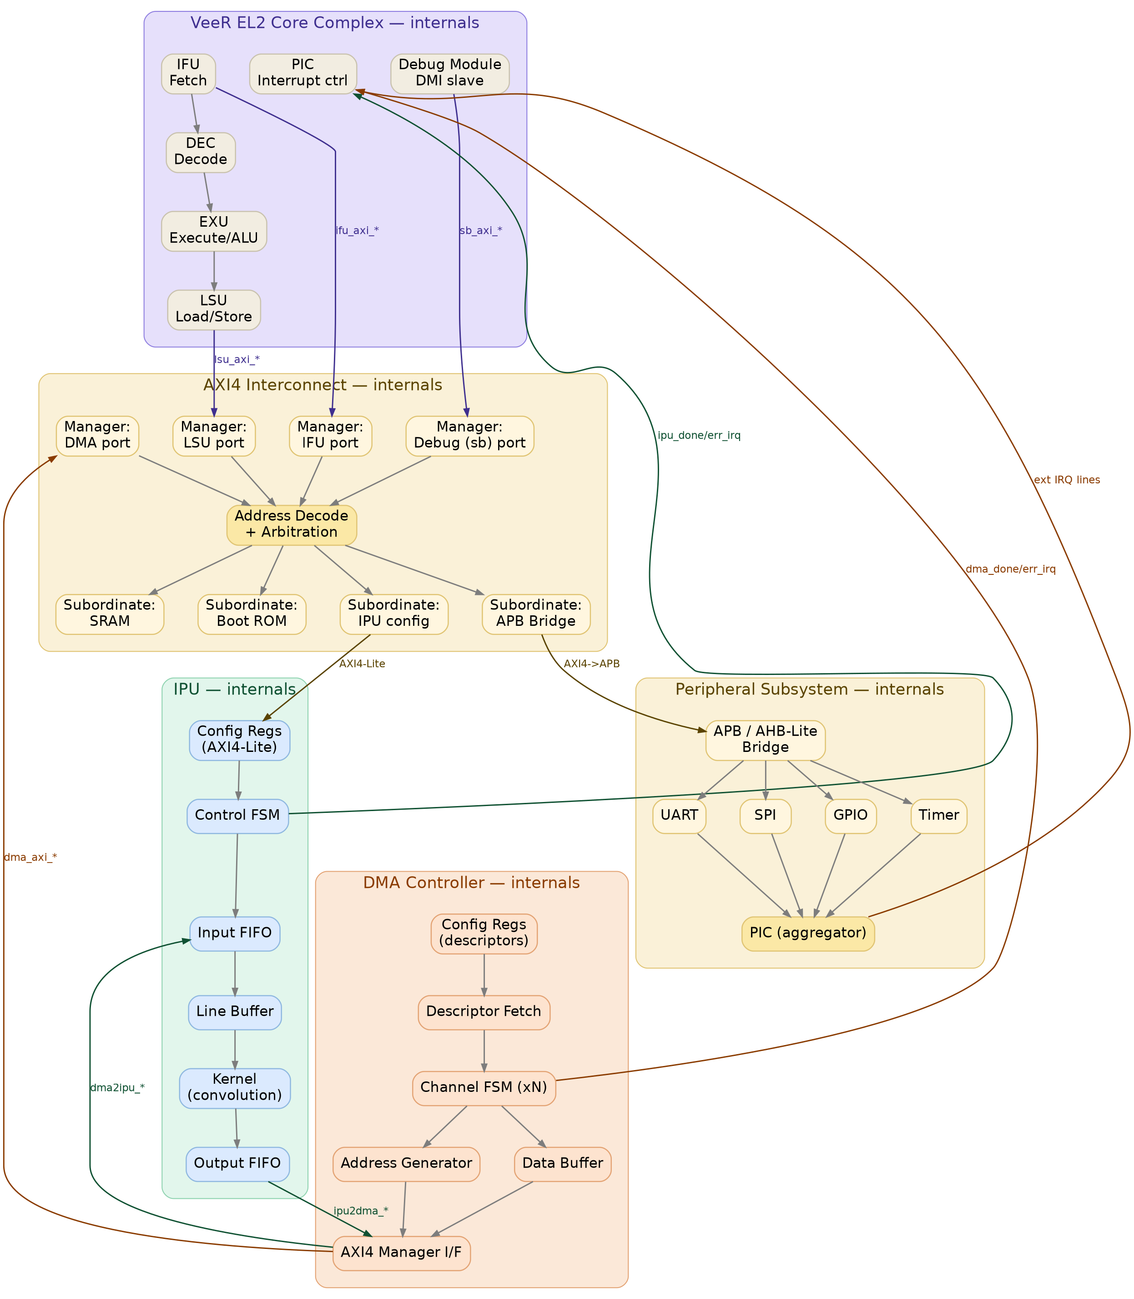
The diagram above zooms into each top-level block from Section 2.1 and shows its internal sub-blocks plus the cross-block signal groups that connect them (color-coded per source block: purple = Core Complex, yellow = Interconnect, green = IPU, orange = DMA Controller, yellow/tan = Peripheral Subsystem).

Connections, by block:
- VeeR EL2 Core Complex: IFU fetches instructions (from ICCM or, on a miss, via ifu_axi_* to the interconnect). DEC decodes and issues micro-ops to EXU, which hands off memory operations to LSU (DCCM or lsu_axi_* to the interconnect for MMIO/external accesses). The Debug Module talks to an external JTAG TAP via DMI and independently reaches memory/registers through its own sb_axi_* port. The PIC aggregates external interrupt lines and presents them to the core.
- AXI4 Interconnect: Four manager ports (CPU IFU, CPU LSU, CPU Debug/sb, DMA) present AXI4 address/data channels to a shared address-decode + arbitration block, which grants access to one of four subordinate ports (SRAM, Boot ROM, IPU config, APB Bridge) based on a fixed memory map.
- IPU: The CPU configures the IPU only through its AXI4-Lite Config Regs (mode, frame size, kernel coefficients, start/stop). The Control FSM sequences the Input FIFO → Line Buffer → Kernel → Output FIFO pipeline and raises ipu_done_irq / ipu_err_irq to the PIC.
- DMA Controller: The CPU programs descriptors (src/dst address, length, burst, mode) through Config Regs. Descriptor Fetch loads a channel's Channel FSM, which drives the Address Generator and Data Buffer through the AXI4 Manager I/F — reading/writing SRAM on one side and pushing/pulling the IPU's Input/Output FIFOs (dma2ipu_* / ipu2dma_*) on the other. Completion/error raise dma_done_irq / dma_err_irq.
- Peripheral Subsystem: The APB/AHB-Lite Bridge converts AXI4 transactions from the interconnect's S3 port into APB transfers for UART, SPI, GPIO and Timer; each peripheral's interrupt feeds the PIC aggregator, which drives the Core Complex's PIC input.

3. Signal List
Signals are grouped by scope:
- Boundary signals: cross the SoC top-level pin boundary (external world) — shown in the pinout diagram below, inputs on the left and outputs on the right.
- Cross-block signals: connect two or more internal blocks (e.g., CPU ↔ interconnect, DMA ↔ IPU) — tabulated in 3.2–3.6.
- Internal signals: local to a single block, listed for completeness at the sub-block level — tabulated in 3.2–3.6.

3.0 SoC Top-Level Boundary Pinout
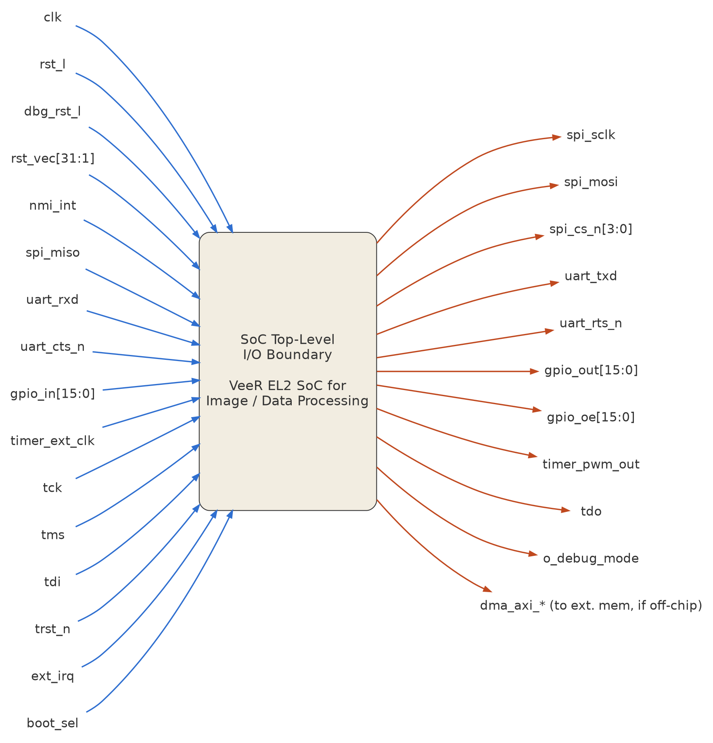
Direction | Signals
Inputs | clk, rst_l, dbg_rst_l, rst_vec[31:1], nmi_int, spi_miso, uart_rxd, uart_cts_n, gpio_in[15:0], timer_ext_clk, tck, tms, tdi, trst_n, ext_irq, boot_sel
Outputs | spi_sclk, spi_mosi, spi_cs_n[3:0], uart_txd, uart_rts_n, gpio_out[15:0], gpio_oe[15:0], timer_pwm_out, tdo, o_debug_mode, dma_axi_* (only if DMA target memory is off-chip)

The remaining sub-sections (3.1–3.6) detail the internal register-level and cross-block signals that sit behind this boundary — between the CPU, interconnect, DMA, IPU and peripherals — which are not part of the external pinout.

3.1 Global Clock & Reset Signals (Boundary + Cross-Block)
Signal | Direction (SoC boundary) | Width | Description
clk | Input | 1 | Primary system clock, distributed to all blocks
rst_l | Input | 1 | Active-low asynchronous system reset (core, interconnect, DMA, IPU, peripherals)
dbg_rst_l | Input | 1 | Active-low reset for the debug module (independent of rst_l so debug survives core reset)
rst_vec[31:1] | Input | 31 | Core reset (boot) vector, wired to Boot ROM base address
nmi_int | Input | 1 | Non-maskable interrupt pin into VeeR EL2
nmi_vec[31:1] | Input | 31 | NMI handler vector
scan_mode | Input | 1 | DFT scan-test enable (tied low in functional mode)
clk_ipu_gated | Internal (cross-block) | 1 | Gated clock to IPU, enabled by Clock & Reset Unit when IPU is active (power optimization)
clk_dma_gated | Internal (cross-block) | 1 | Gated clock to DMA controller

3.2 VeeR EL2 Core Complex Boundary Signals
Grouped by interface, following the standard VeeR EL2 top-level (veer_wrapper) integration contract.
IFU AXI4 Manager (Instruction Fetch) — cross-block, CPU ↔ Interconnect
Signal | Direction | Description
ifu_axi_awvalid/awready/awaddr/awid/awlen/awsize/awburst | N/A (write not used on IFU) | Not driven (IFU is read-only)
ifu_axi_arvalid | Output (CPU) | Instruction fetch address valid
ifu_axi_arready | Input (CPU) | Interconnect ready to accept fetch address
ifu_axi_araddr[31:0] | Output (CPU) | Instruction fetch address
ifu_axi_arid[3:0] | Output (CPU) | Fetch transaction ID
ifu_axi_arlen[7:0] / arsize[2:0] / arburst[1:0] | Output (CPU) | Burst parameters for fetch
ifu_axi_rvalid | Input (CPU) | Fetch data valid
ifu_axi_rready | Output (CPU) | CPU ready to accept fetch data
ifu_axi_rdata[63:0] | Input (CPU) | Fetched instruction data
ifu_axi_rresp[1:0] | Input (CPU) | Fetch response (OKAY/error)
ifu_axi_rid[3:0] / rlast | Input (CPU) | Response ID / burst last

LSU AXI4 Manager (Load/Store) — cross-block, CPU ↔ Interconnect
Signal | Direction | Description
lsu_axi_awvalid/awready/awaddr[31:0]/awid/awlen/awsize/awburst | Output/Input (CPU) | Store address channel
lsu_axi_wvalid/wready/wdata[63:0]/wstrb[7:0]/wlast | Output/Input (CPU) | Store data channel
lsu_axi_bvalid/bready/bresp[1:0]/bid | Input/Output (CPU) | Store write response
lsu_axi_arvalid/arready/araddr[31:0]/arid/arlen/arsize/arburst | Output/Input (CPU) | Load address channel
lsu_axi_rvalid/rready/rdata[63:0]/rresp[1:0]/rid/rlast | Input/Output (CPU) | Load data channel

System Bus (Debug Module) AXI4 Manager — cross-block, Debug ↔ Interconnect
Signal | Direction | Description
sb_axi_awvalid/awready/awaddr/awid/awlen/awsize/awburst | Output/Input | Debug-initiated write address
sb_axi_wvalid/wready/wdata/wstrb | Output/Input | Debug-initiated write data
sb_axi_bvalid/bready/bresp | Input/Output | Debug write response
sb_axi_arvalid/arready/araddr/arid/arlen/arsize/arburst | Output/Input | Debug-initiated read address
sb_axi_rvalid/rready/rdata/rresp/rlast | Input/Output | Debug read data

Interrupts — cross-block, PIC ↔ CPU
Signal | Direction | Description
timer_int | Input (CPU) | Machine timer interrupt
soft_int | Input (CPU) | Machine software interrupt
extintsrc_req[pt.PIC_TOTAL_INT-1:0] | Input (CPU) | Vector of external interrupt requests from PIC (DMA, IPU, UART, SPI, GPIO, Timer)

Debug / JTAG — boundary, external ↔ Debug Module
Signal | Direction (SoC boundary) | Description
trst_n | Input | JTAG TAP reset
tck | Input | JTAG clock
tms | Input | JTAG mode select
tdi | Input | JTAG data in
tdo | Output | JTAG data out
tdoEnable | Output | JTAG output buffer enable
dmi_reg_en/wr_en/addr/wdata/rdata | Internal (cross-block) | DMI register interface between JTAG TAP and Debug Module

Miscellaneous Core Boundary
Signal | Direction | Description
core_id[31:0] | Input | Static hart/core identifier
mpc_debug_halt_req / mpc_debug_halt_ack | Input/Output | External halt request/ack (multi-core debug hooks, tied off if single-core)
mpc_debug_run_req / mpc_debug_run_ack | Input/Output | External run request/ack
dec_tlu_perf_l2_cnt | Output | Performance-monitor export (optional, for profiling)
o_debug_mode | Output | Indicates core is halted in debug mode

3.3 System Interconnect Cross-Block Signals
Signal Group | From → To | Description
m0_axi_* (AW/W/B/AR/R channels) | CPU IFU → Crossbar | Instruction fetch manager port
m1_axi_* | CPU LSU → Crossbar | Load/store manager port
m2_axi_* | Debug (sb) → Crossbar | Debug system-bus manager port
m3_axi_* | DMA → Crossbar | DMA manager port
s0_axi_* | Crossbar → SRAM | Subordinate port to shared SRAM
s1_axi_* | Crossbar → Boot ROM | Subordinate port to Boot ROM
s2_axi_* (Lite subset) | Crossbar → IPU config | AXI4-Lite subordinate port to IPU registers
s3_axi_* | Crossbar → APB/AHB Bridge | Subordinate port to peripheral bridge
arb_grant[3:0] | Internal to Crossbar | One-hot grant vector from arbiter to manager ports
addr_decode_hit[3:0] | Internal to Crossbar | One-hot subordinate select from address decoder
xbar_err_irq | Crossbar → PIC | Raised on decode error / unmapped address access

3.4 Image Processing Unit (IPU) Signals
Boundary (Config, AXI4-Lite slave) — cross-block, Interconnect ↔ IPU
Signal | Direction | Description
ipu_awvalid/awready/awaddr[11:0] | Input/Output | Config write address
ipu_wvalid/wready/wdata[31:0]/wstrb[3:0] | Input/Output | Config write data
ipu_bvalid/bready/bresp[1:0] | Output/Input | Config write response
ipu_arvalid/arready/araddr[11:0] | Input/Output | Config read address
ipu_rvalid/rready/rdata[31:0]/rresp[1:0] | Output/Input | Config read data

Internal Registers (accessed via config slave)
Register | Width | Description
IPU_CTRL | 32 | bit0: start, bit1: stop, bit2: soft-reset, bits[5:4]: mode select
IPU_STATUS | 32 | bit0: busy, bit1: done, bit2: error, bit3: fifo_overflow, bit4: fifo_underflow
IPU_FRAME_WIDTH | 32 | Frame width in pixels/words
IPU_FRAME_HEIGHT | 32 | Frame height in lines
IPU_KERNEL_COEFF[0..N] | 32 x N | Convolution kernel coefficients
IPU_IRQ_MASK | 32 | Per-event interrupt enable mask
IPU_IRQ_STATUS | 32 | Sticky interrupt status (write-1-to-clear)

Cross-block Streaming Interface — DMA ↔ IPU
Signal | Direction | Description
dma2ipu_valid | DMA → IPU | Input stream word valid
dma2ipu_ready | IPU → DMA | Input FIFO ready (backpressure)
dma2ipu_data[31:0] | DMA → IPU | Streamed input data word (pixel/data sample)
dma2ipu_sof | DMA → IPU | Start-of-frame marker
dma2ipu_eof | DMA → IPU | End-of-frame marker
ipu2dma_valid | IPU → DMA | Output stream word valid
ipu2dma_ready | DMA → IPU | Output DMA channel ready (backpressure)
ipu2dma_data[31:0] | IPU → DMA | Processed output data word
ipu2dma_sof / ipu2dma_eof | IPU → DMA | Frame boundary markers on output stream

Internal (Sub-block) Signals
Signal | Between | Description
infifo_push/pop/full/empty/count[7:0] | CTRLFSM ↔ Input FIFO | Input FIFO control/status
linebuf_wr_en/rd_en/window_valid | CTRLFSM ↔ Line Buffer | Windowing control for N x N neighborhood
kernel_start/kernel_done/kernel_result[31:0] | CTRLFSM ↔ Kernel | Processing-element handshake
outfifo_push/pop/full/empty/count[7:0] | CTRLFSM ↔ Output FIFO | Output FIFO control/status
ipu_done_irq | IRQGEN → PIC | Frame processing complete
ipu_err_irq | IRQGEN → PIC | FIFO overflow/underflow or config error

3.5 DMA Controller Signals
Boundary (Config, AXI4-Lite slave) — cross-block, Interconnect ↔ DMA
Signal | Direction | Description
dma_awvalid/awready/awaddr[11:0] | Input/Output | Descriptor register write address
dma_wvalid/wready/wdata[31:0] | Input/Output | Descriptor register write data
dma_arvalid/arready/araddr[11:0] | Input/Output | Descriptor register read address
dma_rvalid/rready/rdata[31:0] | Output/Input | Descriptor / status register read data

Internal Registers
Register (per channel, x N channels) | Width | Description
DMA_CHx_SRC_ADDR | 32 | Source address (SRAM or peripheral)
DMA_CHx_DST_ADDR | 32 | Destination address / stream target select
DMA_CHx_LENGTH | 32 | Transfer length in bytes/words
DMA_CHx_CTRL | 32 | bit0: enable, bit1: stream-mode, bits[3:2]: burst size
DMA_CHx_STATUS | 32 | bit0: busy, bit1: done, bit2: error

Cross-block AXI4 Manager — DMA ↔ Interconnect
Signal | Direction | Description
dma_axi_awvalid/awready/awaddr[31:0]/awlen/awsize/awburst | Output/Input | DMA write address channel
dma_axi_wvalid/wready/wdata[31:0]/wstrb/wlast | Output/Input | DMA write data channel
dma_axi_bvalid/bready/bresp | Input/Output | DMA write response
dma_axi_arvalid/arready/araddr[31:0]/arlen/arsize/arburst | Output/Input | DMA read address channel
dma_axi_rvalid/rready/rdata[31:0]/rresp/rlast | Input/Output | DMA read data channel

Cross-block Interrupts — DMA ↔ PIC
Signal | Description
dma_done_irq[N-1:0] | Per-channel transfer-complete interrupt
dma_err_irq[N-1:0] | Per-channel error interrupt (bus error, misaligned address)

Internal (Sub-block) Signals
Signal | Between | Description
desc_fetch_req/ack/data[95:0] | DESC ↔ CHFSM | Descriptor fetch handshake
addr_gen_next_addr[31:0]/addr_gen_valid | ADDRGEN ↔ AXIM | Next burst address generation
dbuf_wr_en/rd_en/full/empty | BUF ↔ CHFSM/AXIM | Store-and-forward buffer control

3.6 Peripheral Subsystem Signals
Boundary — external world ↔ peripherals
Signal | Direction (SoC boundary) | Description
uart_txd | Output | UART transmit
uart_rxd | Input | UART receive
spi_sclk | Output | SPI clock (master mode, e.g. to camera/sensor module)
spi_mosi / spi_miso | Output / Input | SPI data lines
spi_cs_n[3:0] | Output | SPI chip-selects
gpio_in[15:0] / gpio_out[15:0] / gpio_oe[15:0] | Input / Output / Output | General-purpose I/O
timer_ext_clk (optional) | Input | Alternate timer clock source

Cross-block — Peripherals ↔ Bridge ↔ Interconnect
Signal | Description
apb_paddr[15:0]/psel[4:0]/penable/pwrite/pwdata[31:0]/prdata[31:0]/pready/pslverr | Standard APB signals between bridge and each peripheral

Cross-block — Peripherals ↔ PIC
Signal | Description
uart_irq | UART TX/RX threshold or error interrupt
spi_irq | SPI transfer-complete / error interrupt
gpio_irq[15:0] | Per-pin GPIO interrupt
timer_irq | Timer compare-match / overflow interrupt

3.7 Debug Subsystem Signals
Already listed under 3.2 (JTAG/DMI boundary signals) and 3.3 (m2_axi_* cross-block system-bus signals). No additional signals beyond those two groups.

4. Control Path
The control path carries configuration, command, status and interrupt information — low bandwidth, latency-tolerant, always CPU-initiated or CPU-terminated (except for hardware-generated interrupt requests)

Control path description, step by step:
- Initialization (boot): On rst_l deassertion, the VeeR EL2 core fetches its first instructions from Boot ROM at rst_vec. Firmware initializes stack, CSRs, and the PIC (interrupt priorities/enables).
- Peripheral/Accelerator configuration: Firmware issues LSU store instructions targeting the memory-mapped registers of the DMA controller and the IPU (via the AXI4-Lite config slave ports, reached through the interconnect's address-decoded subordinate ports s2/part of s3). These are single-word, non-burst AXI4 transactions.
- Descriptor setup: DMA channel registers (DMA_CHx_SRC_ADDR, DMA_CHx_DST_ADDR, DMA_CHx_LENGTH, DMA_CHx_CTRL) are programmed for both the "SRAM → IPU input" channel and the "IPU output → SRAM" channel.
- IPU configuration: IPU_FRAME_WIDTH, IPU_FRAME_HEIGHT, kernel coefficient registers and IPU_CTRL mode bits are written.
- Start command: Firmware writes the start bit in IPU_CTRL and the enable bit in DMA_CHx_CTRL. These writes are the last control-path actions before the data path takes over autonomously.
- Autonomous operation: The DMA Control FSM and IPU Control FSM now exchange handshake/backpressure signals directly (dma2ipu_*, ipu2dma_*) without further CPU control-path traffic (this is the data path, Section 5).
- Completion / interrupt: On frame completion, ipu_done_irq and dma_done_irq assert into the PIC. The PIC prioritizes/masks and asserts extintsrc_req[] into the VeeR EL2 core, which vectors to the corresponding interrupt handler.
- Status read-back and clear: The interrupt handler (firmware) issues LSU loads to IPU_STATUS / DMA_CHx_STATUS, and writes to IPU_IRQ_STATUS / DMA per-channel IRQ status (write-1-to-clear) to de-assert the interrupt line.
- Error handling: If ipu_err_irq or dma_err_irq assert (FIFO overflow/underflow, bus error, misaligned descriptor), the same interrupt path is used; firmware reads status registers to diagnose and may issue a soft-reset (IPU_CTRL.soft_reset) before reconfiguring.
- Debug control path (parallel): Independently of the above, an external JTAG debugger can halt the core (dmi_* → Debug Module → core pipeline control), single-step, and read/write memory or MMIO registers through the sb_axi_* system-bus manager port — a secondary, debug-only control path that does not go through the CPU's own LSU.

5. Data Path
The data path carries the actual bulk image/data payload — high bandwidth, streaming, and (in steady state) entirely hardware-driven (DMA + IPU), bypassing the CPU pipeline.
Data path description, step by step:
- Ingress: Raw data enters System SRAM either (a) via the SPI/sensor peripheral under DMA or CPU-programmed transfer (control-path-initiated, but the byte movement itself is a data-path burst), or (b) pre-loaded by an external host before the SoC starts processing.
- DMA read burst (SRAM → IPU): DMA Channel A issues AXI4 read bursts (dma_axi_ar*/r*) against the System SRAM subordinate port through the interconnect, using the burst size/stride programmed in DMA_CHx_* registers. Data is buffered in the DMA's internal store-and-forward buffer.
- Streaming handoff (DMA → IPU): The DMA drains its internal buffer into the IPU's Input FIFO over the dedicated point-to-point streaming interface (dma2ipu_valid/ready/data/sof/eof), independent of the AXI4 fabric — this avoids burning interconnect bandwidth on a bus protocol for a fixed producer-consumer pair and gives natural backpressure via ready.
- Windowing: The IPU's Line Buffer accumulates enough lines to form the neighborhood window required by the Kernel (e.g., a 3x3 window for a convolution filter), asserting window_valid once a full window is available for each output pixel/sample.
- Processing: The Kernel (convolution engine / pixel ALU / color-space converter, depending on IPU_CTRL mode) computes one output sample per valid window and pushes the result into the Output FIFO.
- Streaming handoff (IPU → DMA): DMA Channel B drains the IPU's Output FIFO over ipu2dma_valid/ready/data/sof/eof, buffering results internally.
- DMA write burst (IPU → SRAM): DMA Channel B issues AXI4 write bursts (dma_axi_aw*/w*/b*) to place processed data into the output region of System SRAM.
- Egress / consumption: Once dma_done_irq/ipu_done_irq signal completion (control path), the CPU (if needed) reads the processed buffer via its own LSU AXI4 read path (lsu_axi_ar*/r*) for further action — e.g., forwarding over UART/SPI to a host, additional software post-processing, or simply signaling readiness to an external consumer.
- Back-to-back frames: For continuous streaming (e.g., video), the DMA descriptors can be configured in ping-pong/double-buffer mode so that while DMA Channel B writes out frame N's results, DMA Channel A and the IPU are already ingesting frame N+1, keeping the data path continuously active with only periodic control-path interrupts for buffer-swap bookkeeping.
Data path characteristics summary:
Segment | Interface Type | Typical Width | Flow Control
SRAM ↔ DMA | AXI4 (full, burst) | 32/64-bit | AXI4 valid/ready per channel
DMA ↔ IPU | Point-to-point streaming | 32-bit | valid/ready handshake with sof/eof framing
Internal IPU pipeline | Internal FIFOs / line buffers | 32-bit | FIFO full/empty flags
SRAM ↔ CPU LSU (result read) | AXI4 (full or burst) | 32/64-bit | AXI4 valid/ready



