Week 7
Q2) Thread-Safe In-Memory Cache with Expiration Bug

Models/CacheRecord.cs
namespace CacheSystem.Models
{
public class CacheRecord
{
public object Data { get; }
public DateTime ExpirationTime { get; }
public CacheRecord(object data, TimeSpan ttl)
{
Data = data;
ExpirationTime = DateTime.UtcNow.Add(ttl);
}
public bool HasExpired()
{
return DateTime.UtcNow > ExpirationTime;
}
}
}
Interfaces/ICacheProvider.cs
using CacheSystem.Models;
namespace CacheSystem.Interfaces
{
public interface ICacheProvider
{
void Add(string key, object value, TimeSpan ttl);
object? Retrieve(string key);
}
}
Services/MemoryCacheProvider.cs
using System.Collections.Concurrent;
using CacheSystem.Interfaces;
using CacheSystem.Models;
namespace CacheSystem.Services
{
public class MemoryCacheProvider : ICacheProvider
{
private readonly ConcurrentDictionary<string, CacheRecord> _storage;
private static readonly Lazy<MemoryCacheProvider> _lazyInstance =
new Lazy<MemoryCacheProvider>(() => new MemoryCacheProvider());
public static MemoryCacheProvider Current => _lazyInstance.Value;
private MemoryCacheProvider()
{
_storage = new ConcurrentDictionary<string, CacheRecord>();
StartBackgroundCleanup();
}
public void Add(string key, object value, TimeSpan ttl)
{
var record = new CacheRecord(value, ttl);
_storage[key] = record;
}
public object? Retrieve(string key)
{
if (!_storage.TryGetValue(key, out var record))
return null;
if (record.HasExpired())
{
_storage.TryRemove(key, out _);
return null;
}
return record.Data;
}
private void StartBackgroundCleanup()
{
Task.Run(async () =>
{
while (true)
{
try
{
foreach (var entry in _storage)
{
if (entry.Value.HasExpired())
{
_storage.TryRemove(entry.Key, out _);
}
}
}
catch
{
// ignore errors
}
await Task.Delay(5000);
}
});
}
}
}
Controllers/CacheApiController.cs
using Microsoft.AspNetCore.Mvc;
using CacheSystem.Interfaces;
namespace CacheSystem.Controllers
{
[ApiController]
[Route("api/cache")]
public class CacheApiController : ControllerBase
{
private readonly ICacheProvider _provider;
public CacheApiController(ICacheProvider provider)
{
_provider = provider;
}
[HttpPost("set")]
public IActionResult Add(string key, string value, int seconds)
{
_provider.Add(key, value, TimeSpan.FromSeconds(seconds));
return Ok("Stored successfully");
}
[HttpGet("get")]
public IActionResult Retrieve(string key)
{
var result = _provider.Retrieve(key);
if (result == null)
return NotFound("Key missing or expired");
return Ok(result);
}
}
}
Program.cs
using CacheSystem.Interfaces;
using CacheSystem.Services;
var builder = WebApplication.CreateBuilder(args);
builder.Services.AddControllers();
builder.Services.AddSingleton<ICacheProvider>(_ => MemoryCacheProvider.Current);
builder.Services.AddEndpointsApiExplorer();
builder.Services.AddSwaggerGen();
var app = builder.Build();
app.UseSwagger();
app.UseSwaggerUI();
app.MapGet("/", ctx =>
{
ctx.Response.Redirect("/swagger");
return Task.CompletedTask;
});
app.UseHttpsRedirection();
app.MapControllers();
app.Run();

Q1) Extensible Notification System with Failure Handling
Controllers/MessageController.cs
using Microsoft.AspNetCore.Mvc;
[ApiController]
[Route("api/messages")]
public class MessageController : ControllerBase
{
private readonly IMessageService _messageService;
public MessageController(IMessageService messageService)
{
_messageService = messageService;
}
[HttpPost("bulk")]
public async Task<IActionResult> ProcessBulk(BatchRequest request)
{
await _messageService.HandleBulkAsync(request.Items);
return Ok("Completed");
}
}

DTOs/BatchRequest.cs
public class BatchRequest
{
public List<MessageRequest> Items { get; set; } = new();
}

Interfaces/IMessageService.cs
public interface IMessageService
{
Task HandleBulkAsync(List<MessageRequest> items);
}

Interfaces/IMessageHandler.cs
public interface IMessageHandler
{
string Channel { get; }
Task ExecuteAsync(MessageRequest request);
}

Logging/AppLogger.cs
public class AppLogger
{
public void Write(string msg)
{
Console.WriteLine($"[ERROR]: {msg}");
}
}

Models/MessageRequest.cs
public class MessageRequest
{
public string Channel { get; set; } = string.Empty;
public string Content { get; set; } = string.Empty;
public string Receiver { get; set; } = string.Empty;
}

Services/MessageService.cs
public class MessageService : IMessageService
{
private readonly IEnumerable<IMessageHandler> _handlers;
private readonly AppLogger _logger;
public MessageService(IEnumerable<IMessageHandler> handlers, AppLogger logger)
{
_handlers = handlers;
_logger = logger;
}
public async Task HandleBulkAsync(List<MessageRequest> items)
{
var jobs = items.Select(item => HandleSingle(item));
await Task.WhenAll(jobs);
}
private async Task HandleSingle(MessageRequest item)
{
var handler = _handlers.FirstOrDefault(h => h.Channel == item.Channel);
if (handler == null)
{
_logger.Write($"Unsupported channel: {item.Channel}");
return;
}
try
{
await handler.ExecuteAsync(item);
}
catch
{
try
{
await handler.ExecuteAsync(item);
}
catch (Exception ex)
{
_logger.Write($"Failed for {item.Channel}: {ex.Message}");
}
}
}
}

Strategies/EmailHandler.cs
public class EmailHandler : IMessageHandler
{
public string Channel => "Email";
public async Task ExecuteAsync(MessageRequest request)
{
await Task.Delay(500);
if (new Random().Next(0, 3) == 0)
throw new Exception("Email service error");
Console.WriteLine($"Email delivered to {request.Receiver}");
}
}

📁 Strategies/SmsHandler.cs
public class SmsHandler : IMessageHandler
{
public string Channel => "SMS";
public async Task ExecuteAsync(MessageRequest request)
{
await Task.Delay(300);
if (new Random().Next(0, 3) == 0)
throw new Exception("SMS gateway timeout");
Console.WriteLine($"SMS delivered to {request.Receiver}");
}
}

Strategies/PushHandler.cs
public class PushHandler : IMessageHandler
{
public string Channel => "Push";
public async Task ExecuteAsync(MessageRequest request)
{
await Task.Delay(200);
Console.WriteLine($"Push notification sent to {request.Receiver}");
}
}

Program.cs
var builder = WebApplication.CreateBuilder(args);
builder.Services.AddControllers();
builder.Services.AddEndpointsApiExplorer();
builder.Services.AddSwaggerGen();
builder.Services.AddScoped<IMessageService, MessageService>();
builder.Services.AddScoped<IMessageHandler, EmailHandler>();
builder.Services.AddScoped<IMessageHandler, SmsHandler>();
builder.Services.AddScoped<IMessageHandler, PushHandler>();
builder.Services.AddSingleton<AppLogger>();
var app = builder.Build();
app.UseSwagger();
app.UseSwaggerUI();
app.MapGet("/", ctx =>
{
ctx.Response.Redirect("/swagger");
return Task.CompletedTask;
});
app.UseHttpsRedirection();
app.MapControllers();
app.Run();
Q4)API Rate Limiting System (Scalable Design)
Models/ClientTracker.cs
namespace RateLimiterSystem.Models
{
public class ClientTracker
{
public Queue<DateTime> RequestTimes { get; } = new();
}
}
Services/RequestLimiter.cs
using System.Collections.Concurrent;
using RateLimiterSystem.Models;
namespace RateLimiterSystem.Services
{
public class RequestLimiter
{
private readonly ConcurrentDictionary<string, ClientTracker> _clients
= new();
private readonly int _maxRequests = 5;
private readonly TimeSpan _timeWindow = TimeSpan.FromSeconds(10);
public bool AllowRequest(string clientId)
{
var now = DateTime.UtcNow;
var client = _clients.GetOrAdd(clientId, _ => new ClientTracker());
lock (client)
{
while (client.RequestTimes.Count > 0 &&
now - client.RequestTimes.Peek() > _timeWindow)
{
client.RequestTimes.Dequeue();
}
if (client.RequestTimes.Count >= _maxRequests)
return false;
client.RequestTimes.Enqueue(now);
return true;
}
}
}
}
Middleware/RequestLimitingMiddleware.cs
using RateLimiterSystem.Services;
namespace RateLimiterSystem.Middleware
{
public class RequestLimitingMiddleware
{
private readonly RequestDelegate _next;
public RequestLimitingMiddleware(RequestDelegate next)
{
_next = next;
}
public async Task InvokeAsync(HttpContext context, RequestLimiter limiter)
{
var clientId = context.Connection.RemoteIpAddress?.ToString() ?? "unknown";
if (!limiter.AllowRequest(clientId))
{
context.Response.StatusCode = 429;
context.Response.ContentType = "text/plain";
await context.Response.WriteAsync("Rate limit exceeded");
return;
}
await _next(context);
}
}
}
Controllers/SampleController.cs
using Microsoft.AspNetCore.Mvc;
namespace RateLimiterSystem.Controllers
{
[ApiController]
[Route("api/sample")]
public class SampleController : ControllerBase
{
[HttpGet]
public IActionResult Get()
{
return Ok("Success");
}
}
}
Program.cs
using RateLimiterSystem.Middleware;
using RateLimiterSystem.Services;
var builder = WebApplication.CreateBuilder(args);
builder.Services.AddControllers();
builder.Services.AddSingleton<RequestLimiter>();
builder.Services.AddEndpointsApiExplorer();
builder.Services.AddSwaggerGen();
var app = builder.Build();
app.UseSwagger();
app.UseSwaggerUI();
app.UseMiddleware<RequestLimitingMiddleware>();

Q3) JWT Authentication System with Random Failures

Models/UserLogin.cs
namespace AuthSystem.Models
{
public class UserLogin
{
public string Username { get; set; } = string.Empty;
public string Password { get; set; } = string.Empty;
}
}
Models/AuthTokens.cs
namespace AuthSystem.Models
{
public class AuthTokens
{
public string AccessToken { get; set; } = string.Empty;
public string RefreshToken { get; set; } = string.Empty;
}
}
Models/StoredRefreshToken.cs
namespace AuthSystem.Models
{
public class StoredRefreshToken
{
public string Token { get; set; } = string.Empty;
public DateTime ExpiryTime { get; set; }
public string UserId { get; set; } = string.Empty;
}
}
Interfaces/IAuthManager.cs
using AuthSystem.Models;
namespace AuthSystem.Interfaces
{
public interface IAuthManager
{
AuthTokens SignIn(UserLogin request);
AuthTokens Renew(string refreshToken);
}
}
Services/AuthManager.cs
using System.IdentityModel.Tokens.Jwt;
using System.Security.Claims;
using System.Text;
using AuthSystem.Interfaces;
using AuthSystem.Models;
using Microsoft.IdentityModel.Tokens;
namespace AuthSystem.Services
{
public class AuthManager : IAuthManager
{
private readonly IConfiguration _config;
private static readonly Dictionary<string, StoredRefreshToken> _tokenStore = new();
public AuthManager(IConfiguration config)
{
_config = config;
}
public AuthTokens SignIn(UserLogin request)
{
if (request.Username != "admin" || request.Password != "123")
throw new Exception("Invalid credentials");
var userId = "1";
var role = "Admin";
var accessToken = CreateJwt(userId, role);
var refreshToken = CreateRefreshToken(userId);
_tokenStore[refreshToken.Token] = refreshToken;
return new AuthTokens
{
AccessToken = accessToken,
RefreshToken = refreshToken.Token
};
}
public AuthTokens Renew(string refreshToken)
{
if (!_tokenStore.TryGetValue(refreshToken, out var stored))
throw new Exception("Invalid refresh token");
if (stored.ExpiryTime < DateTime.UtcNow)
throw new Exception("Refresh token expired");
var newAccess = CreateJwt(stored.UserId, "Admin");
return new AuthTokens
{
AccessToken = newAccess,
RefreshToken = refreshToken
};
}
private string CreateJwt(string userId, string role)
{
var key = new SymmetricSecurityKey(
Encoding.UTF8.GetBytes(_config["Jwt:Key"]!)
);
var credentials = new SigningCredentials(key, SecurityAlgorithms.HmacSha256);
var claims = new[]
{
new Claim("UserId", userId),
new Claim(ClaimTypes.Role, role)
};
var token = new JwtSecurityToken(
issuer: _config["Jwt:Issuer"],
audience: _config["Jwt:Audience"],
claims: claims,
expires: DateTime.UtcNow.AddMinutes(15),
signingCredentials: credentials
);
return new JwtSecurityTokenHandler().WriteToken(token);
}
private StoredRefreshToken CreateRefreshToken(string userId)
{
return new StoredRefreshToken
{
Token = Guid.NewGuid().ToString(),
ExpiryTime = DateTime.UtcNow.AddDays(1),
UserId = userId
};
}
}
}
Controllers/AuthApiController.cs
using AuthSystem.Interfaces;
using AuthSystem.Models;
using Microsoft.AspNetCore.Authorization;
using Microsoft.AspNetCore.Mvc;
namespace AuthSystem.Controllers
{
[ApiController]
[Route("api/auth")]
public class AuthApiController : ControllerBase
{
private readonly IAuthManager _manager;
public AuthApiController(IAuthManager manager)
{
_manager = manager;
}
[HttpPost("login")]
public IActionResult Login(UserLogin request)
{
try
{
var result = _manager.SignIn(request);
return Ok(result);
}
catch (Exception ex)
{
return Unauthorized(ex.Message);
}
}
[HttpPost("refresh")]
public IActionResult Refresh(string refreshToken)
{
try
{
var result = _manager.Renew(refreshToken);
return Ok(result);
}
catch (Exception ex)
{
return Unauthorized(ex.Message);
}
}
[Authorize]
[HttpGet("secure")]
public IActionResult SecureEndpoint()
{
return Ok("Access granted!");
}
}
}
Program.cs
using System.Text;
using AuthSystem.Interfaces;
using AuthSystem.Services;
using Microsoft.AspNetCore.Authentication.JwtBearer;
using Microsoft.IdentityModel.Tokens;
var builder = WebApplication.CreateBuilder(args);
builder.Services.AddControllers();
builder.Services.AddScoped<IAuthManager, AuthManager>();
builder.Services.AddEndpointsApiExplorer();
builder.Services.AddSwaggerGen();
builder.Services.AddAuthentication(JwtBearerDefaults.AuthenticationScheme)
.AddJwtBearer(options =>
{
options.RequireHttpsMetadata = false;
options.SaveToken = true;
options.TokenValidationParameters = new TokenValidationParameters
{
ValidateIssuer = true,
ValidateAudience = true,
ValidateLifetime = true,
ValidateIssuerSigningKey = true,
ValidIssuer = builder.Configuration["Jwt:Issuer"],
ValidAudience = builder.Configuration["Jwt:Audience"],
IssuerSigningKey = new SymmetricSecurityKey(
Encoding.UTF8.GetBytes(builder.Configuration["Jwt:Key"]!)
),
ClockSkew = TimeSpan.Zero
};
});
builder.Services.AddAuthorization();
var app = builder.Build();
app.UseSwagger();
app.UseSwaggerUI();
app.UseAuthentication();
app.UseAuthorization();
app.MapGet("/", ctx =>
{
ctx.Response.Redirect("/swagger");
return Task.CompletedTask;
});
app.MapControllers();
app.Run();

Q5) Deadlock Creation and Resolution

Services/DeadlockSimulator.cs
namespace DeadlockSystem.Services
{
public class DeadlockSimulator
{
private readonly object _resource1 = new();
private readonly object _resource2 = new();
public void TriggerDeadlock()
{
var thread1 = new Thread(() =>
{
lock (_resource1)
{
Console.WriteLine("Thread A locked Resource1");
Thread.Sleep(1000);
lock (_resource2)
{
Console.WriteLine("Thread A locked Resource2");
}
}
});
var thread2 = new Thread(() =>
{
lock (_resource2)
{
Console.WriteLine("Thread B locked Resource2");
Thread.Sleep(1000);
lock (_resource1)
{
Console.WriteLine("Thread B locked Resource1");
}
}
});
thread1.Start();
thread2.Start();
}
}
}
Services/DeadlockResolvedService.cs
namespace DeadlockSystem.Services
{
public class DeadlockResolvedService
{
private readonly object _resource1 = new();
private readonly object _resource2 = new();
public void ResolveUsingOrdering()
{
var t1 = new Thread(() => Acquire());
var t2 = new Thread(() => Acquire());
t1.Start();
t2.Start();
}
private void Acquire()
{
lock (_resource1)
{
Console.WriteLine($"{Thread.CurrentThread.ManagedThreadId} locked Resource1");
lock (_resource2)
{
Console.WriteLine($"{Thread.CurrentThread.ManagedThreadId} locked Resource2");
}
}
}
}
}
Services/DeadlockMonitorService.cs
namespace DeadlockSystem.Services
{
public class DeadlockMonitorService
{
private readonly object _resource1 = new();
private readonly object _resource2 = new();
public void ExecuteWithDetection()
{
var t1 = new Thread(() => Work(_resource1, _resource2));
var t2 = new Thread(() => Work(_resource2, _resource1));
t1.Start();
t2.Start();
}
private void Work(object first, object second)
{
bool lock1 = false;
bool lock2 = false;
try
{
Monitor.TryEnter(first, TimeSpan.FromSeconds(2), ref lock1);
if (!lock1)
{
Console.WriteLine("Deadlock detected at first resource");
return;
}
Console.WriteLine("First lock acquired");
Thread.Sleep(500);
Monitor.TryEnter(second, TimeSpan.FromSeconds(2), ref lock2);
if (!lock2)
{
Console.WriteLine("Deadlock detected at second resource");
return;
}
Console.WriteLine("Second lock acquired");
}
finally
{
if (lock2) Monitor.Exit(second);
if (lock1) Monitor.Exit(first);
}
}
}
}
Controllers/DeadlockApiController.cs
using DeadlockSystem.Services;
using Microsoft.AspNetCore.Mvc;
namespace DeadlockSystem.Controllers
{
[ApiController]
[Route("api/deadlock")]
public class DeadlockApiController : ControllerBase
{
private readonly DeadlockSimulator _simulator;
private readonly DeadlockResolvedService _resolver;
private readonly DeadlockMonitorService _monitor;
public DeadlockApiController(
DeadlockSimulator simulator,
DeadlockResolvedService resolver,
DeadlockMonitorService monitor)
{
_simulator = simulator;
_resolver = resolver;
_monitor = monitor;
}
[HttpGet("trigger")]
public IActionResult Trigger()
{
_simulator.TriggerDeadlock();
return Ok("Deadlock started");
}
[HttpGet("resolve")]
public IActionResult Resolve()
{
_resolver.ResolveUsingOrdering();
return Ok("Deadlock resolved");
}
[HttpGet("detect")]
public IActionResult Detect()
{
_monitor.ExecuteWithDetection();
return Ok("Detection running");
}
}
}
Program.cs
using DeadlockSystem.Services;
var builder = WebApplication.CreateBuilder(args);
builder.Services.AddControllers();
builder.Services.AddSingleton<DeadlockSimulator>();
builder.Services.AddSingleton<DeadlockResolvedService>();
builder.Services.AddSingleton<DeadlockMonitorService>();
builder.Services.AddEndpointsApiExplorer();
builder.Services.AddSwaggerGen();
var app = builder.Build();
app.UseSwagger();
app.UseSwaggerUI();
app.MapGet("/", ctx =>
{
ctx.Response.Redirect("/swagger");
return Task.CompletedTask;
});
app.MapControllers();
app.Run();

Q6) Custom HashMap with Performance Degradation

Models/Node.cs
namespace CustomHashMap.Models
{
public class Node<TKey, TValue>
{
public TKey Key { get; set; }
public TValue Value { get; set; }
public Node<TKey, TValue>? Next { get; set; }
public Node(TKey key, TValue value)
{
Key = key;
Value = value;
}
}
}
Services/CustomMap.cs
using CustomHashMap.Models;
namespace CustomHashMap.Services
{
public class CustomMap<TKey, TValue>
{
private Node<TKey, TValue>?[] _table;
private int _capacity;
private int _count;
private const double Threshold = 0.75;
private readonly object _lock = new();
public CustomMap(int capacity = 16)
{
_capacity = capacity;
_table = new Node<TKey, TValue>[capacity];
}
private int GetIndex(TKey key, int size)
{
int hash = key!.GetHashCode();
hash ^= (hash >> 16);
hash &= 0x7fffffff;
return hash % size;
}
public void Insert(TKey key, TValue value)
{
lock (_lock)
{
AddNode(key, value, _table);
if ((double)_count / _capacity > Threshold)
{
Resize();
}
}
}
private void AddNode(TKey key, TValue value, Node<TKey, TValue>?[] table)
{
int index = GetIndex(key, table.Length);
var current = table[index];
while (current != null)
{
if (current.Key!.Equals(key))
{
current.Value = value;
return;
}
current = current.Next;
}
var node = new Node<TKey, TValue>(key, value)
{
Next = table[index]
};
table[index] = node;
_count++;
}
public TValue? Retrieve(TKey key)
{
int index = GetIndex(key, _capacity);
var current = _table[index];
while (current != null)
{
if (current.Key!.Equals(key))
return current.Value;
current = current.Next;
}
return default;
}
public bool Delete(TKey key)
{
lock (_lock)
{
int index = GetIndex(key, _capacity);
var current = _table[index];
Node<TKey, TValue>? prev = null;
while (current != null)
{
if (current.Key!.Equals(key))
{
if (prev == null)
_table[index] = current.Next;
else
prev.Next = current.Next;
_count--;
return true;
}
prev = current;
current = current.Next;
}
return false;
}
}
private void Resize()
{
int newSize = _capacity * 2;
var newTable = new Node<TKey, TValue>[newSize];
foreach (var bucket in _table)
{
var current = bucket;
while (current != null)
{
var next = current.Next;
int newIndex = GetIndex(current.Key, newSize);
current.Next = newTable[newIndex];
newTable[newIndex] = current;
current = next;
}
}
_table = newTable;
_capacity = newSize;
}
}
}
Controllers/MapController.cs
using CustomHashMap.Services;
using Microsoft.AspNetCore.Mvc;
namespace CustomHashMap.Controllers
{
[ApiController]
[Route("api/map")]
public class MapController : ControllerBase
{
private static readonly CustomMap<string, string> _map = new();
[HttpPost("add")]
public IActionResult Add(string key, string value)
{
_map.Insert(key, value);
return Ok("Inserted");
}
[HttpGet("get")]
public IActionResult Get(string key)
{
var result = _map.Retrieve(key);
if (result == null)
return NotFound("Not found");
return Ok(result);
}
[HttpDelete("remove")]
public IActionResult Remove(string key)
{
var removed = _map.Delete(key);
if (!removed)
return NotFound("Not found");
return Ok("Deleted");
}
}
}
Program.cs
var builder = WebApplication.CreateBuilder(args);

// Register MVC controllers
builder.Services.AddControllers();

// Enable Swagger services
builder.Services.AddEndpointsApiExplorer();
builder.Services.AddSwaggerGen();

var app = builder.Build();

// Enable Swagger middleware
app.UseSwagger();
app.UseSwaggerUI();

// Redirect root URL to Swagger UI
app.MapGet("/", context =>
{
context.Response.Redirect("/swagger");
return Task.CompletedTask;
});

// Map controller routes
app.MapControllers();

// Run application
app.Run();

Q7)High-Load Order Processing System

Models/OrderEntity.cs
namespace OrderSystem.Models;
public class OrderEntity
{
public string Id { get; set; } = Guid.NewGuid().ToString();
public string UserId { get; set; } = "";
public string Product { get; set; } = "";
public DateTime CreatedOn { get; set; } = DateTime.UtcNow;
}
Models/CreateOrderRequest.cs
namespace OrderSystem.Models;
public class CreateOrderRequest
{
public string Product { get; set; } = "";
}
Models/AuthToken.cs
namespace OrderSystem.Models;
public class AuthToken
{
public string AccessToken { get; set; } = "";
}
Models/CacheEntry.cs
namespace OrderSystem.Models;
public class CacheEntry
{
public object Data { get; set; }
public DateTime ExpireAt { get; set; }
public CacheEntry(object data, TimeSpan ttl)
{
Data = data;
ExpireAt = DateTime.UtcNow.Add(ttl);
}
public bool IsExpired() => DateTime.UtcNow > ExpireAt;
}
Interfaces/IOrderStore.cs
using OrderSystem.Models;
namespace OrderSystem.Interfaces;
public interface IOrderStore
{
void Save(OrderEntity order);
OrderEntity? Fetch(string id);
}
Interfaces/IOrderManager.cs
using OrderSystem.Models;
namespace OrderSystem.Interfaces;
public interface IOrderManager
{
OrderEntity Create(string userId, CreateOrderRequest request);
OrderEntity? Get(string id);
}
Interfaces/INotificationHandler.cs
namespace OrderSystem.Interfaces;
public interface INotificationHandler
{
string Channel { get; }
Task SendAsync(string message);
}
Interfaces/IAuthManager.cs
using OrderSystem.Models;
namespace OrderSystem.Interfaces;
public interface IAuthManager
{
AuthToken Generate(string user);
}
Services/OrderStore.cs
using System.Collections.Concurrent;
using OrderSystem.Interfaces;
using OrderSystem.Models;
namespace OrderSystem.Services;
public class OrderStore : IOrderStore
{
private readonly ConcurrentDictionary<string, OrderEntity> _data = new();
public void Save(OrderEntity order)
{
_data[order.Id] = order;
}
public OrderEntity? Fetch(string id)
{
_data.TryGetValue(id, out var order);
return order;
}
}
Services/MemoryCacheService.cs
using System.Collections.Concurrent;
using OrderSystem.Models;
namespace OrderSystem.Services;
public class MemoryCacheService
{
private readonly ConcurrentDictionary<string, CacheEntry> _cache = new();
public MemoryCacheService()
{
StartCleaner();
}
public void Set(string key, object value, TimeSpan ttl)
{
_cache[key] = new CacheEntry(value, ttl);
}
public object? Get(string key)
{
if (_cache.TryGetValue(key, out var entry))
{
if (entry.IsExpired())
{
_cache.TryRemove(key, out _);
return null;
}
return entry.Data;
}
return null;
}
private void StartCleaner()
{
Task.Run(async () =>
{
while (true)
{
foreach (var key in _cache.Keys)
{
if (_cache.TryGetValue(key, out var entry) && entry.IsExpired())
_cache.TryRemove(key, out _);
}
await Task.Delay(5000);
}
});
}
}
Services/AuthManager.cs
using System.IdentityModel.Tokens.Jwt;
using System.Security.Claims;
using System.Text;
using Microsoft.IdentityModel.Tokens;
using OrderSystem.Interfaces;
using OrderSystem.Models;
namespace OrderSystem.Services;
public class AuthManager : IAuthManager
{
private readonly IConfiguration _config;
public AuthManager(IConfiguration config)
{
_config = config;
}
public AuthToken Generate(string user)
{
var key = new SymmetricSecurityKey(
Encoding.UTF8.GetBytes(_config["Jwt:Key"]!)
);
var token = new JwtSecurityToken(
claims: new[] { new Claim("UserId", user) },
expires: DateTime.UtcNow.AddMinutes(15),
signingCredentials: new SigningCredentials(key, SecurityAlgorithms.HmacSha256)
);
return new AuthToken
{
AccessToken = new JwtSecurityTokenHandler().WriteToken(token)
};
}
}
Services/OrderManager.cs
using OrderSystem.Interfaces;
using OrderSystem.Models;
namespace OrderSystem.Services;
public class OrderManager : IOrderManager
{
private readonly IOrderStore _store;
private readonly MemoryCacheService _cache;
private readonly IEnumerable<INotificationHandler> _handlers;
public OrderManager(IOrderStore store, MemoryCacheService cache, IEnumerable<INotificationHandler> handlers)
{
_store = store;
_cache = cache;
_handlers = handlers;
}
public OrderEntity Create(string userId, CreateOrderRequest request)
{
var order = new OrderEntity
{
UserId = userId,
Product = request.Product
};
_store.Save(order);
_cache.Set(order.Id, order, TimeSpan.FromMinutes(5));
Task.Run(async () =>
{
foreach (var handler in _handlers)
{
int attempts = 2;
while (attempts-- > 0)
{
try
{
await handler.SendAsync($"Order {order.Id} placed");
break;
}
catch
{
await Task.Delay(200);
}
}
}
});
return order;
}
public OrderEntity? Get(string id)
{
var cached = _cache.Get(id) as OrderEntity;
if (cached != null) return cached;
var order = _store.Fetch(id);
if (order != null)
_cache.Set(id, order, TimeSpan.FromMinutes(5));
return order;
}
}
Strategies/EmailHandler.cs
using OrderSystem.Interfaces;
namespace OrderSystem.Strategies;
public class EmailHandler : INotificationHandler
{
public string Channel => "Email";
public async Task SendAsync(string message)
{
await Task.Delay(200);
Console.WriteLine("EMAIL: " + message);
}
}
Strategies/SmsHandler.cs
using OrderSystem.Interfaces;
namespace OrderSystem.Strategies;
public class SmsHandler : INotificationHandler
{
public string Channel => "SMS";
public async Task SendAsync(string message)
{
await Task.Delay(200);
Console.WriteLine("SMS: " + message);
}
}
Middleware/ErrorMiddleware.cs
namespace OrderSystem.Middleware;
public class ErrorMiddleware
{
private readonly RequestDelegate _next;
public ErrorMiddleware(RequestDelegate next)
{
_next = next;
}
public async Task Invoke(HttpContext context)
{
try
{
await _next(context);
}
catch (Exception ex)
{
context.Response.StatusCode = 500;
await context.Response.WriteAsync($"Error: {ex.Message}");
}
}
}
Middleware/RequestLimitMiddleware.cs
using System.Collections.Concurrent;
namespace OrderSystem.Middleware;
public class RequestLimitMiddleware
{
private readonly RequestDelegate _next;
private static readonly ConcurrentDictionary<string, List<DateTime>> _logs = new();
public RequestLimitMiddleware(RequestDelegate next)
{
_next = next;
}
public async Task Invoke(HttpContext context)
{
var key = context.Connection.RemoteIpAddress?.ToString() ?? "unknown";
var now = DateTime.UtcNow;
var list = _logs.GetOrAdd(key, _ => new List<DateTime>());
lock (list)
{
list.RemoveAll(x => (now - x).TotalSeconds > 10);
if (list.Count >= 5)
{
context.Response.StatusCode = 429;
return;
}
list.Add(now);
}
await _next(context);
}
}
Middleware/IdempotencyMiddleware.cs
using System.Collections.Concurrent;
namespace OrderSystem.Middleware;
public class IdempotencyMiddleware
{
private readonly RequestDelegate _next;
private static readonly ConcurrentDictionary<string, string> _store = new();
public IdempotencyMiddleware(RequestDelegate next)
{
_next = next;
}
public async Task Invoke(HttpContext context)
{
if (context.Request.Headers.TryGetValue("Idempotency-Key", out var key))
{
if (_store.TryGetValue(key!, out var response))
{
await context.Response.WriteAsync(response);
return;
}
}
await _next(context);
}
}
Controllers/AuthController.cs
using Microsoft.AspNetCore.Mvc;
using OrderSystem.Interfaces;
namespace OrderSystem.Controllers;
[ApiController]
[Route("api/auth")]
public class AuthController : ControllerBase
{
private readonly IAuthManager _auth;
public AuthController(IAuthManager auth)
{
_auth = auth;
}
[HttpPost("login")]
public IActionResult Login(string user)
{
return Ok(_auth.Generate(user));
}
}
Controllers/OrdersController.cs
using Microsoft.AspNetCore.Authorization;
using Microsoft.AspNetCore.Mvc;
using OrderSystem.Interfaces;
using OrderSystem.Models;
namespace OrderSystem.Controllers;
[ApiController]
[Route("api/orders")]
public class OrdersController : ControllerBase
{
private readonly IOrderManager _manager;
public OrdersController(IOrderManager manager)
{
_manager = manager;
}
[Authorize]
[HttpPost]
public IActionResult Create(CreateOrderRequest request)
{
var userId = User.FindFirst("UserId")?.Value ?? "user";
return Ok(_manager.Create(userId, request));
}
[Authorize]
[HttpGet("{id}")]
public IActionResult Get(string id)
{
var order = _manager.Get(id);
if (order == null) return NotFound();
return Ok(order);
}
}
Program.cs
using System.Text;
using Microsoft.AspNetCore.Authentication.JwtBearer;
using Microsoft.IdentityModel.Tokens;
using OrderSystem.Interfaces;
using OrderSystem.Middleware;
using OrderSystem.Services;
using OrderSystem.Strategies;
var builder = WebApplication.CreateBuilder(args);
builder.Services.AddControllers();
builder.Services.AddSingleton<IOrderStore, OrderStore>();
builder.Services.AddSingleton<IOrderManager, OrderManager>();
builder.Services.AddSingleton<MemoryCacheService>();
builder.Services.AddScoped<IAuthManager, AuthManager>();
builder.Services.AddScoped<INotificationHandler, EmailHandler>();
builder.Services.AddScoped<INotificationHandler, SmsHandler>();
builder.Services.AddAuthentication(JwtBearerDefaults.AuthenticationScheme)
.AddJwtBearer(options =>
{
options.TokenValidationParameters = new TokenValidationParameters
{
ValidateIssuerSigningKey = true,
IssuerSigningKey = new SymmetricSecurityKey(
Encoding.UTF8.GetBytes(builder.Configuration["Jwt:Key"]!)
),
ValidateLifetime = true,
ClockSkew = TimeSpan.Zero
};
});
builder.Services.AddAuthorization();
builder.Services.AddSwaggerGen();
var app = builder.Build();
app.UseSwagger();
app.UseSwaggerUI();
app.UseMiddleware<ErrorMiddleware>();
app.UseMiddleware<IdempotencyMiddleware>();
app.UseMiddleware<RequestLimitMiddleware>();
app.UseAuthentication();
app.UseAuthorization();
app.MapGet("/", ctx =>
{
ctx.Response.Redirect("/swagger");
return Task.CompletedTask;
});
app.MapControllers();
app.Run();

Projects
Q1: Extensible Notification System with Failure Handling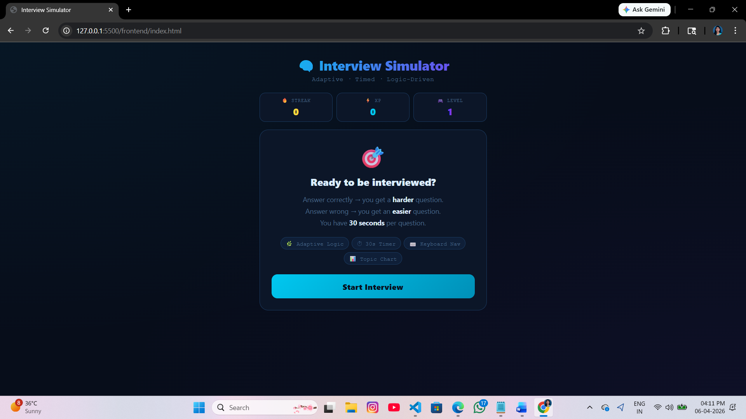
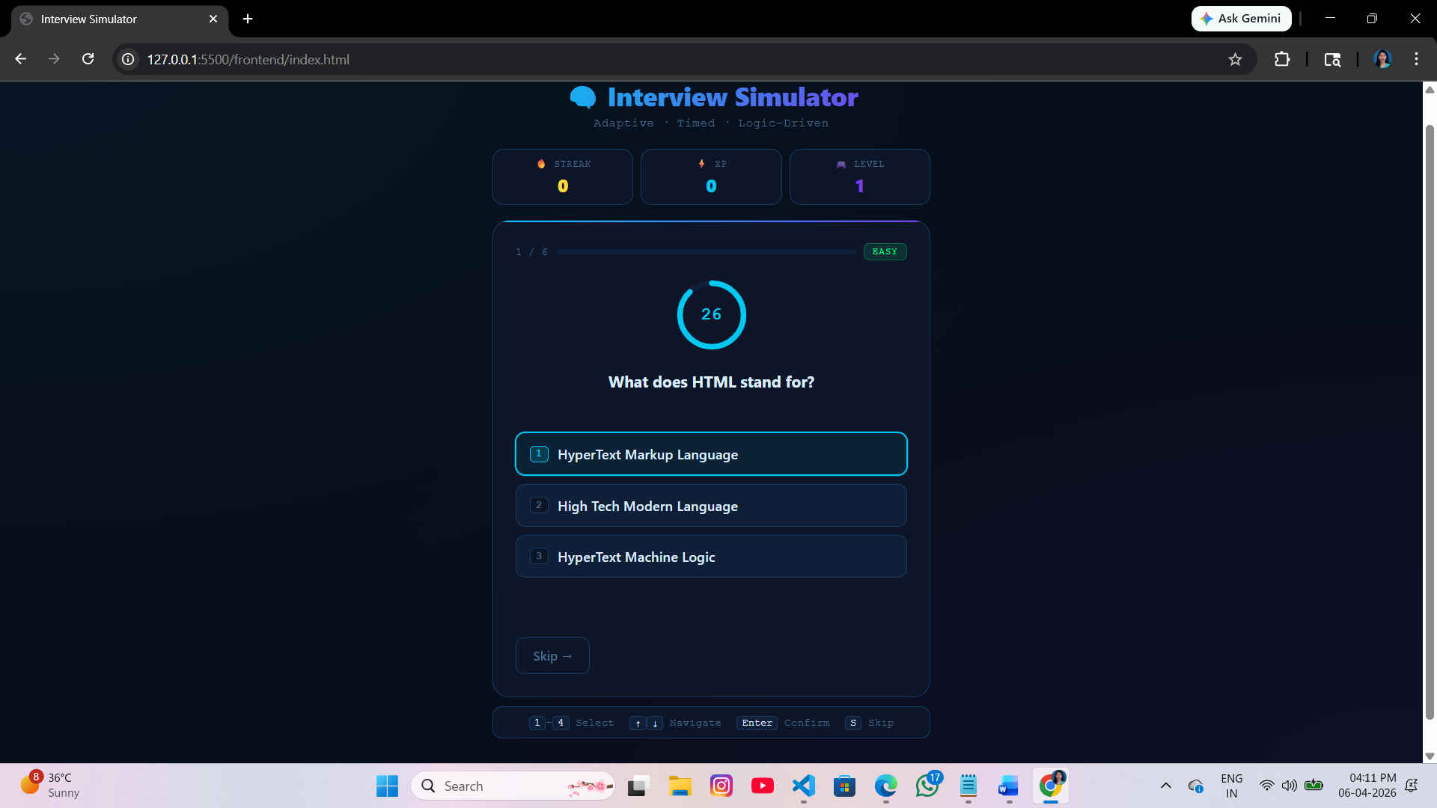

2) Full-Stack Healthcare Appointment System (ASP.NET Core + SQL)(Backend)
This project is a Healthcare Appointment System developed using ASP.NET Core Web API.
It allows managing doctors, patients, appointments, and medical records.
The system also includes a dashboard that shows statistics using LINQ queries.
Swagger UI is used to test all API endpoints.
TECHNOLOGIES USED
• ASP.NET Core Web API
• Entity Framework Core
• SQLite Database
• Swagger UI
• LINQ
PROJECT STRUCTURE
• Controllers – Handle API requests
• Models – Represent database tables
• DTOs – Data transfer objects
• Services – Business logic
• Data – DbContext
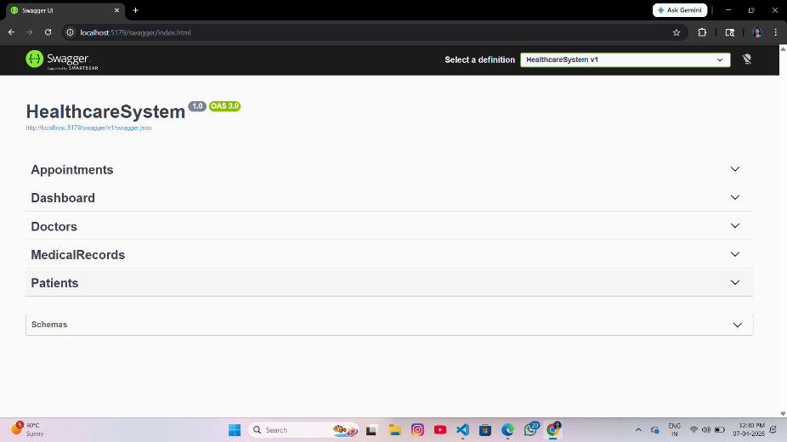
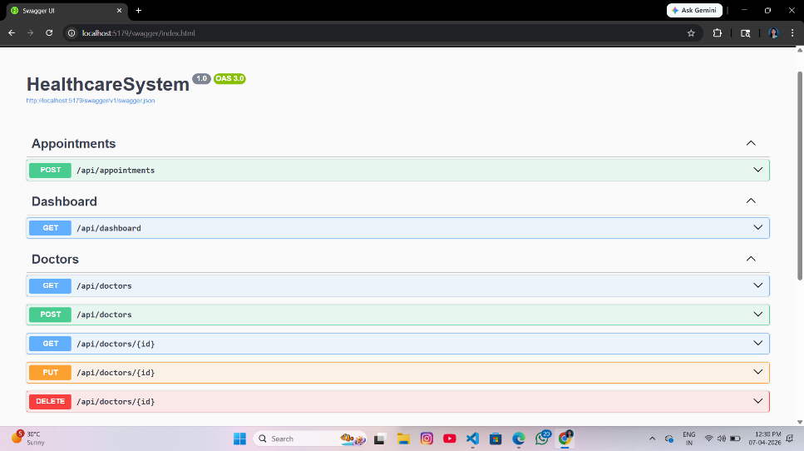

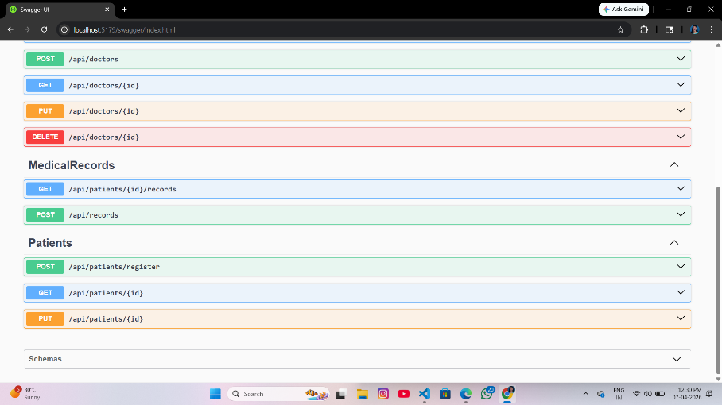
Doctors
POST /api/doctors → Add doctor
GET /api/doctors → Get all doctors

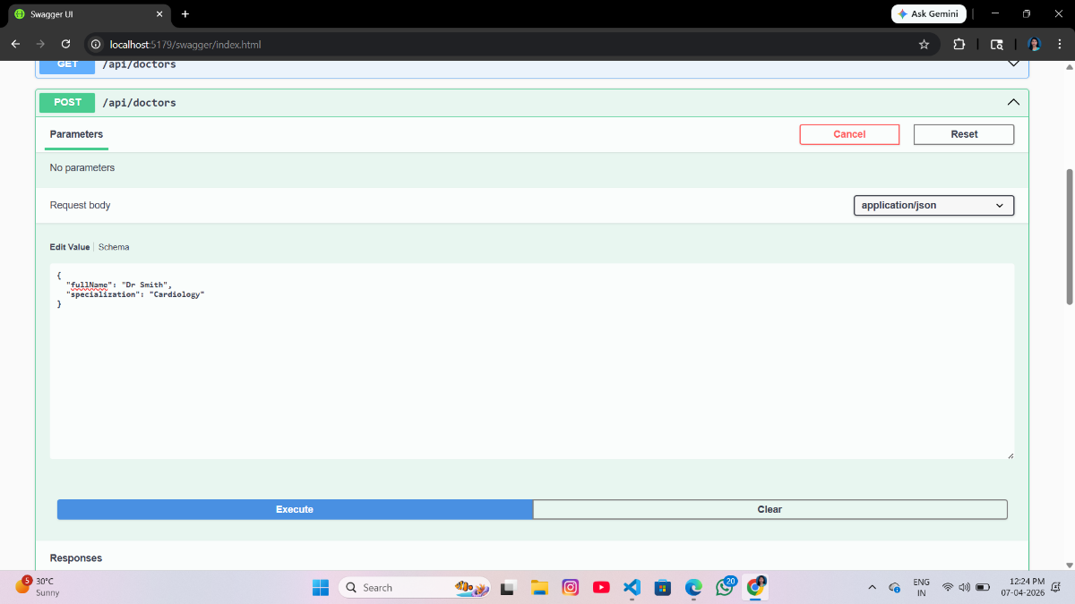

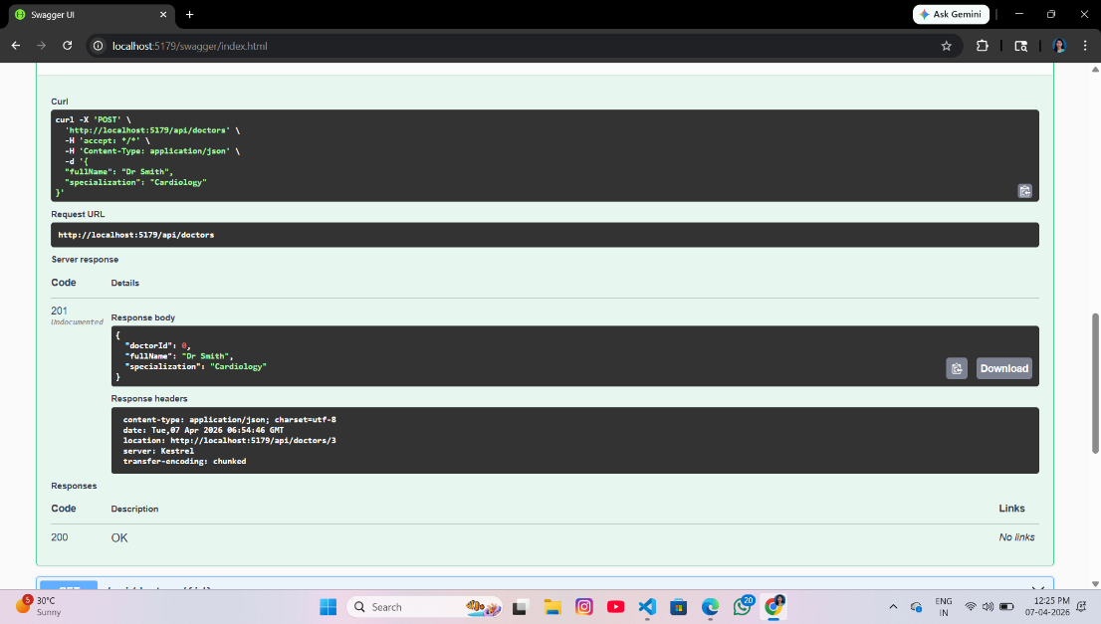
Patients
POST /api/patients/register → Register patient
GET /api/patients/{id} → Get patient

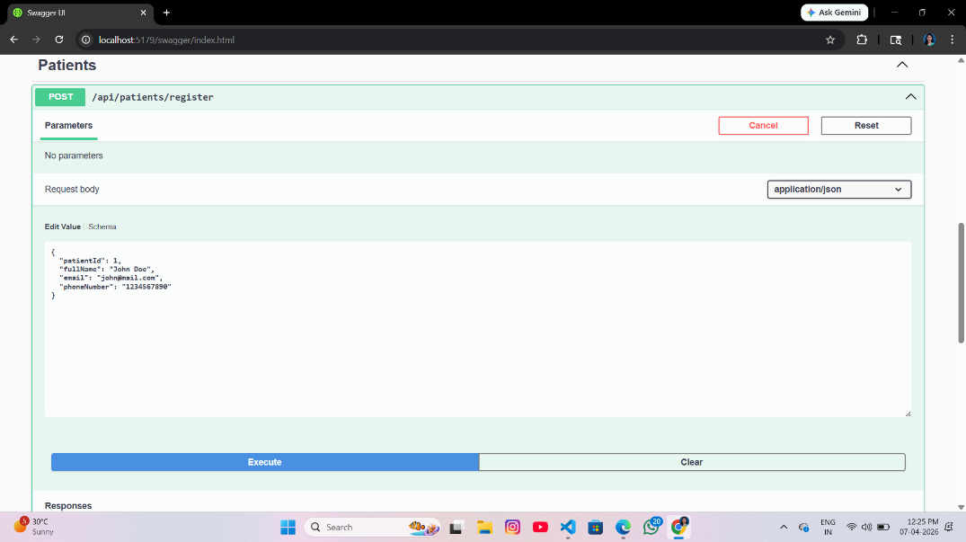

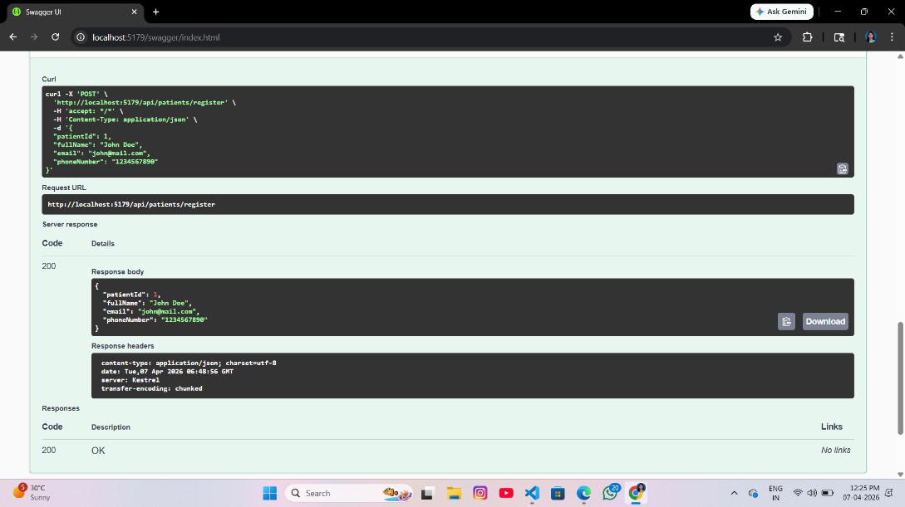

Appointments
POST /api/appointments → Book appointment

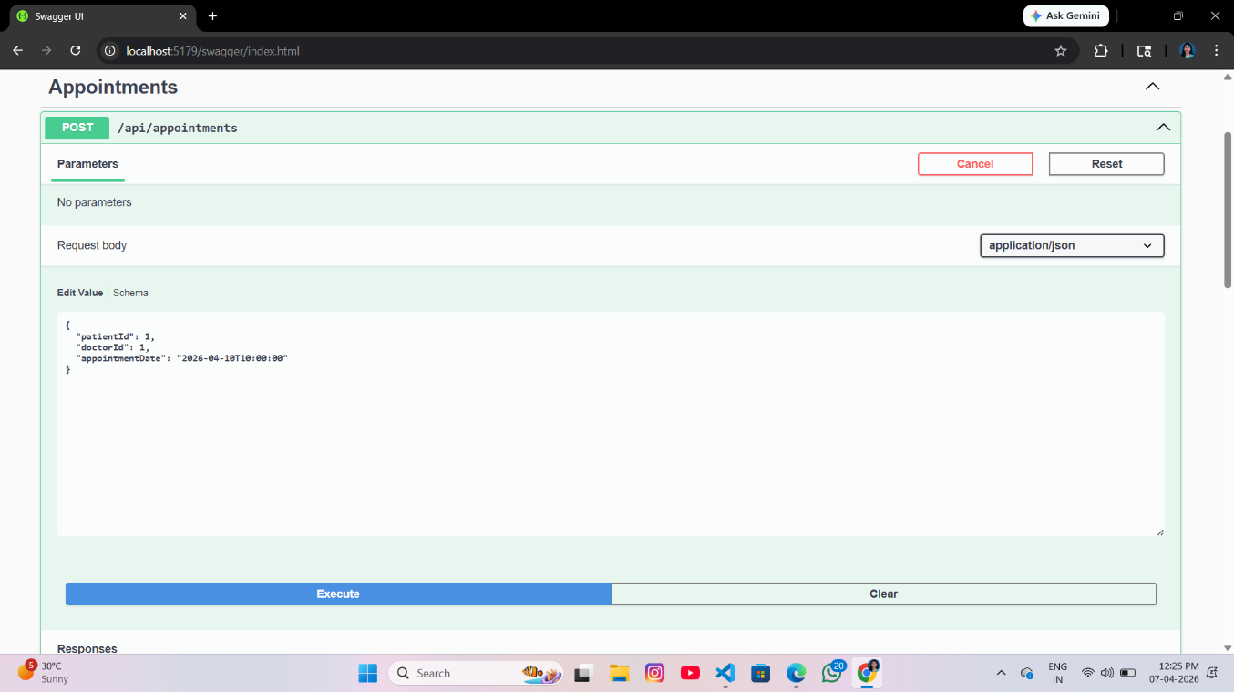

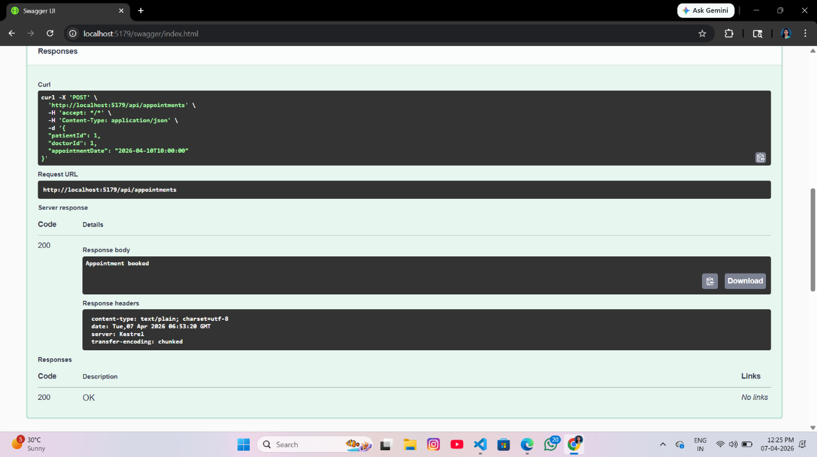

Medical Records
POST /api/records → Add record
GET /api/patients/{id}/records → View records

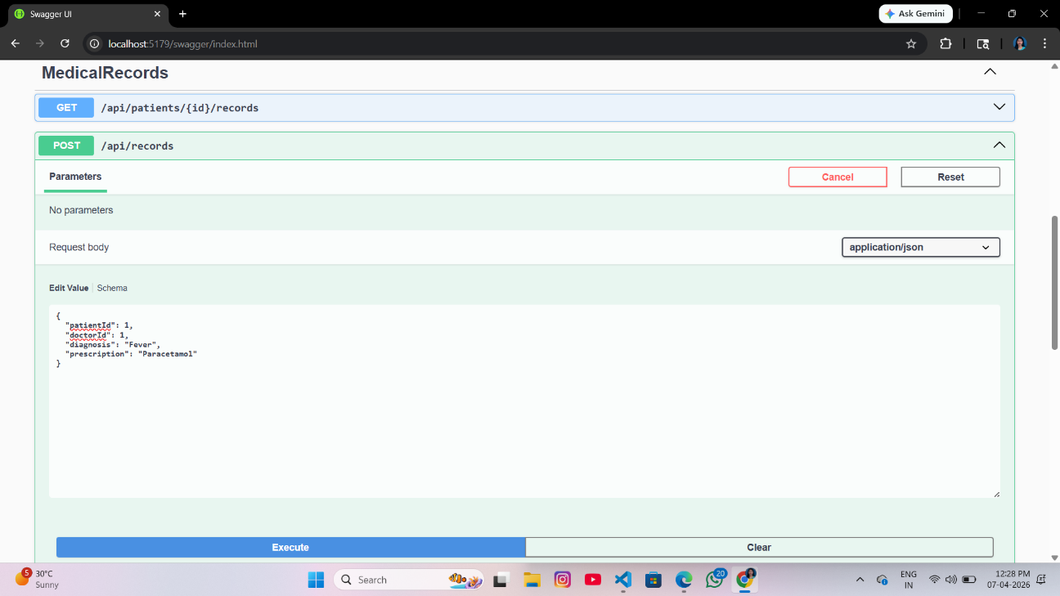

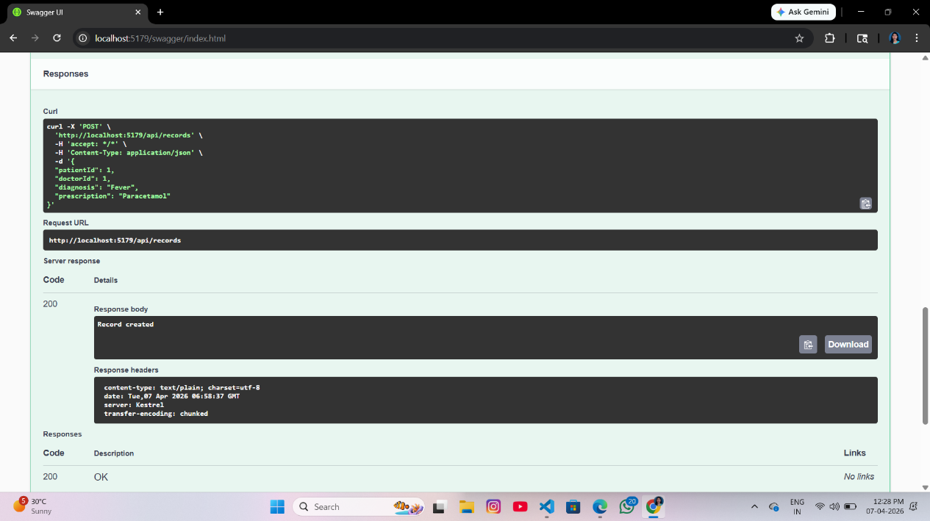
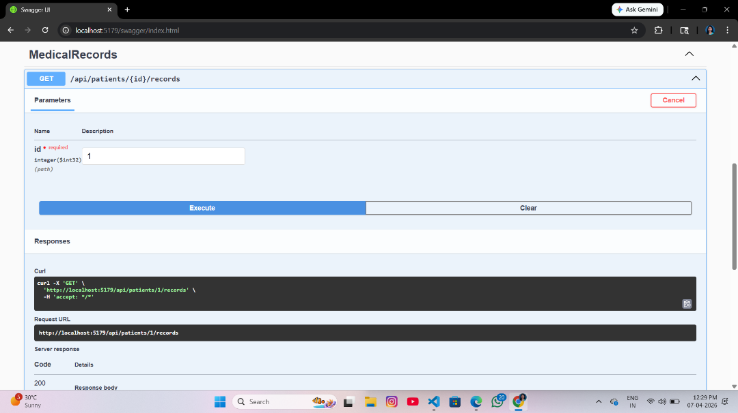

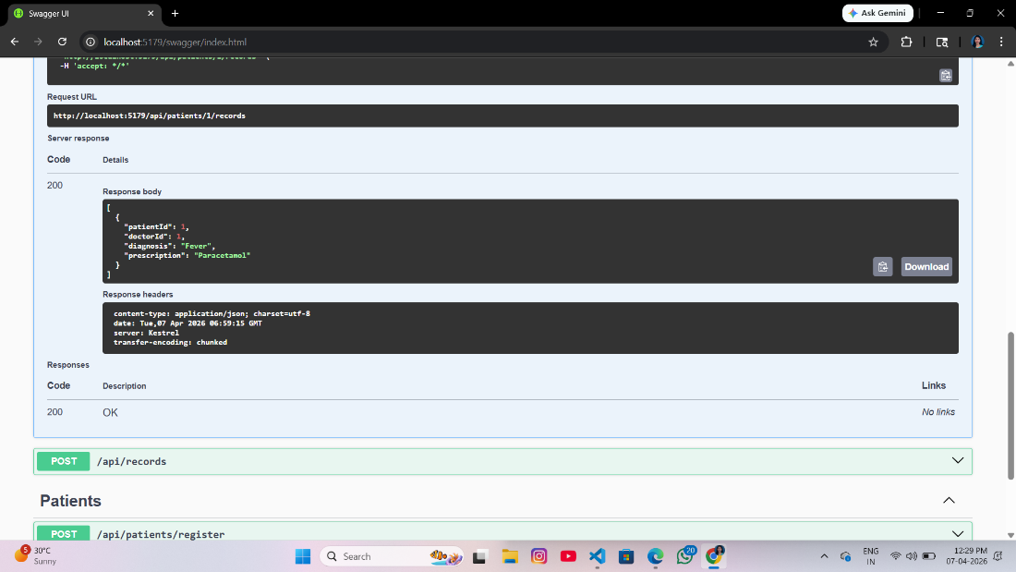
Dashboard
GET /api/dashboard → View statistics

