**SL4J_Hands_On**

**Exercise 1: Logging Error Messages and Warning Levels**

**Task:** Write a Java application that demonstrates logging error messages and warning levels using SLF4J.

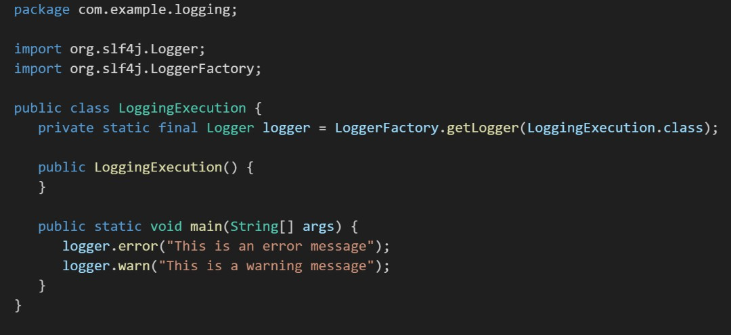

Output:

