DEPLOYING THE GIVEN REACT APPLICATION TO PRODUCTION READY STATE

- Project initialization and setting up the repository
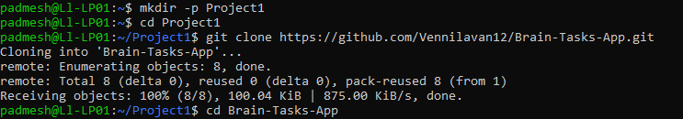
- Repository Re-initialization and version control setup
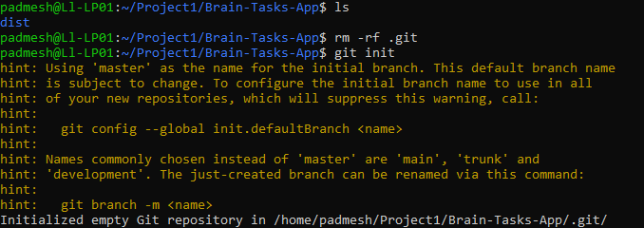
- Initial commit and push to GitHub repository
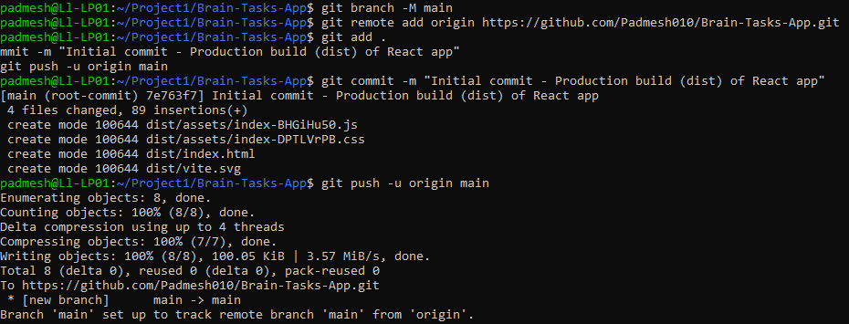
- Docker file creation and Docker image build
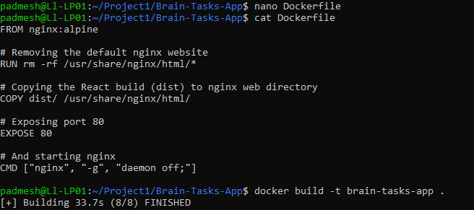
- Running Docker container and pushing Docker file to GitHub
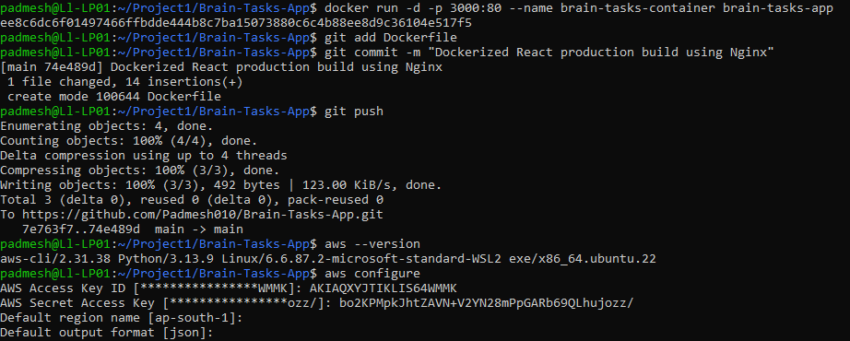
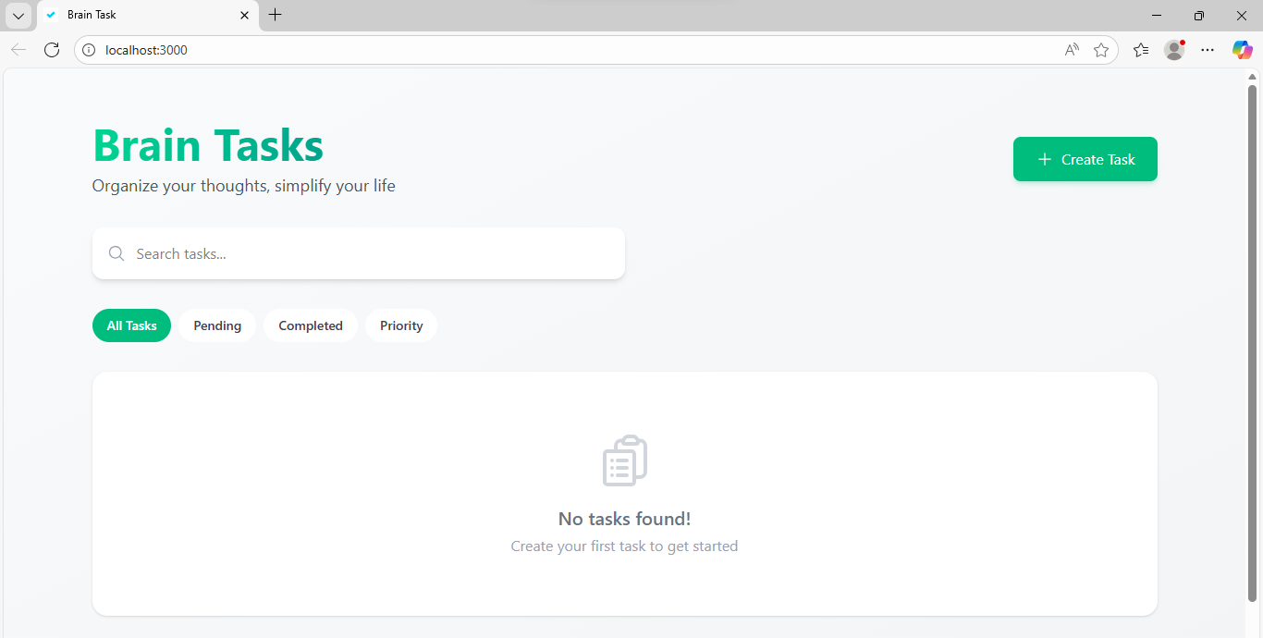
- Creating an ECR repository and authenticating docker
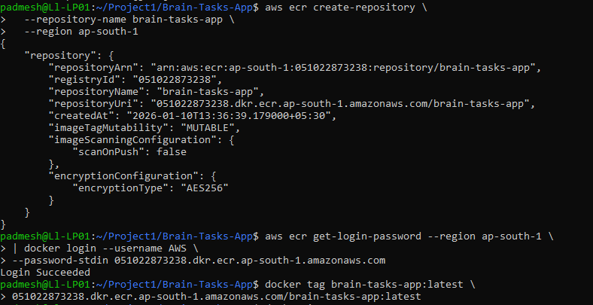
- Pushing Docker image to Amazon ECR.
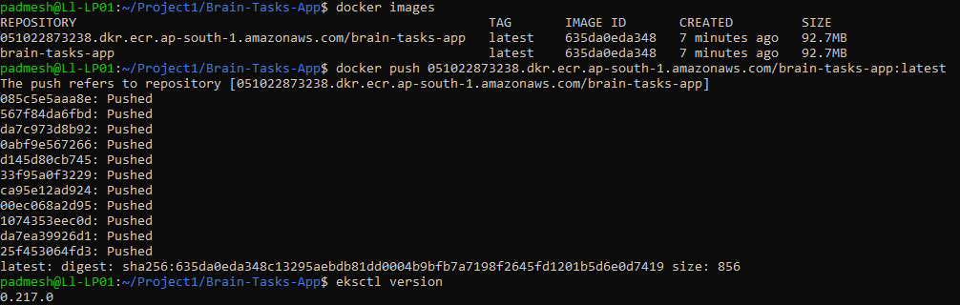
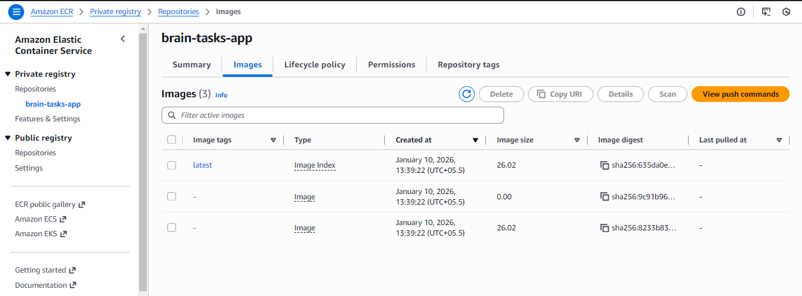
- Creating Amazon EWS cluster using eksctl
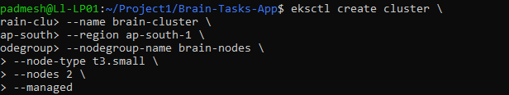
- EKS node verification and Kubernetes deployment configuration
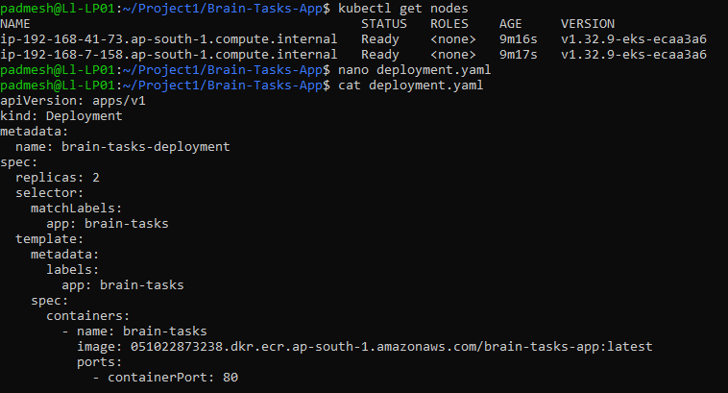
- Application deployment on Kubernetes and validation
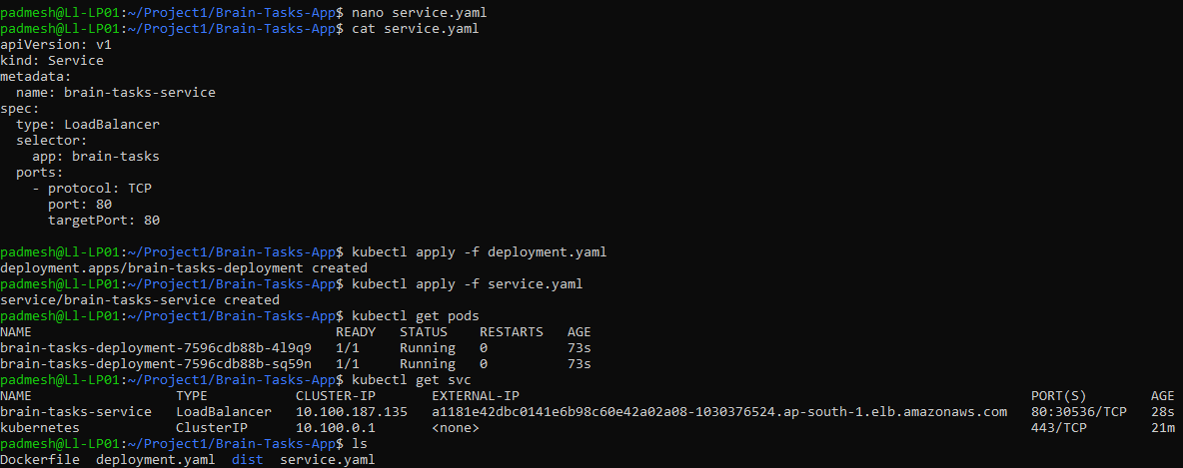
- End-to-End CI/CD Pipeline for Dockerized React Application using AWS ECR, EKS & CodeBuild.
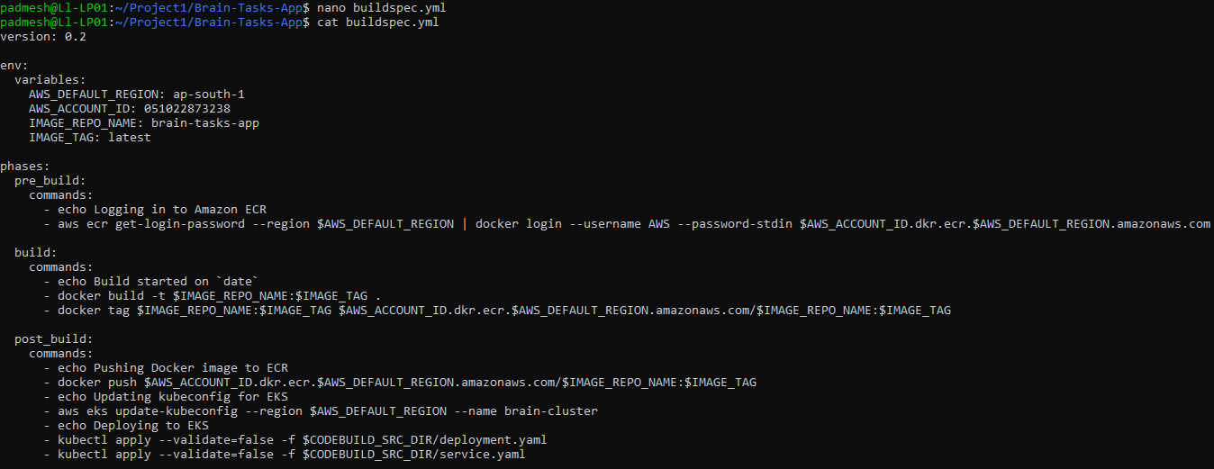
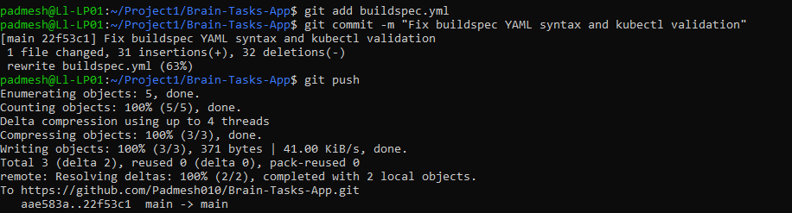
- CodeBuild IAM role verification (EKS access enabled)
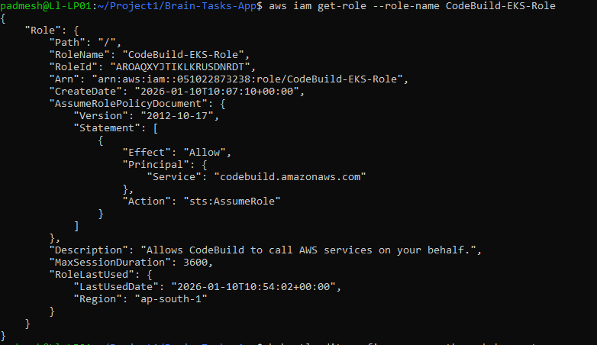
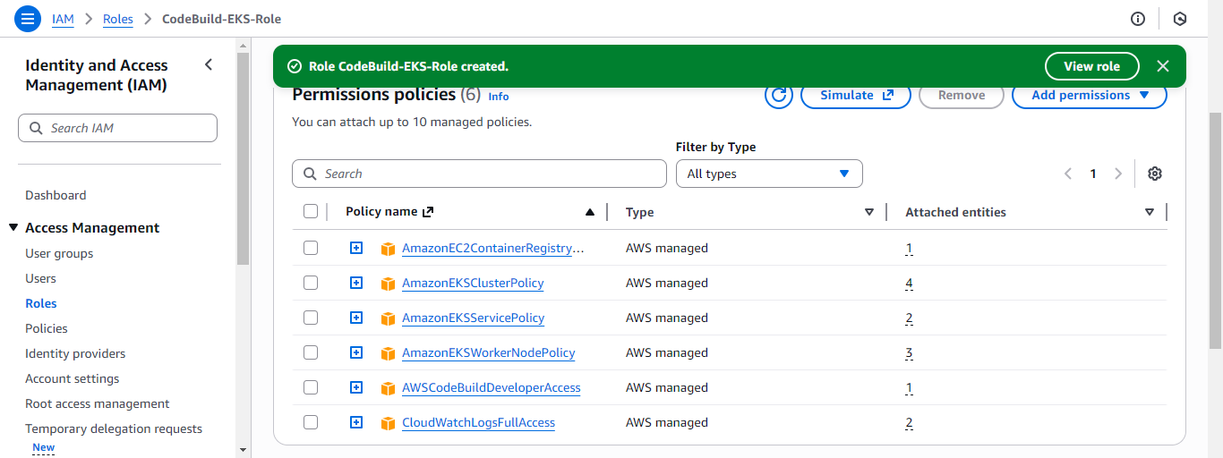
- EKS cluster access configuration.
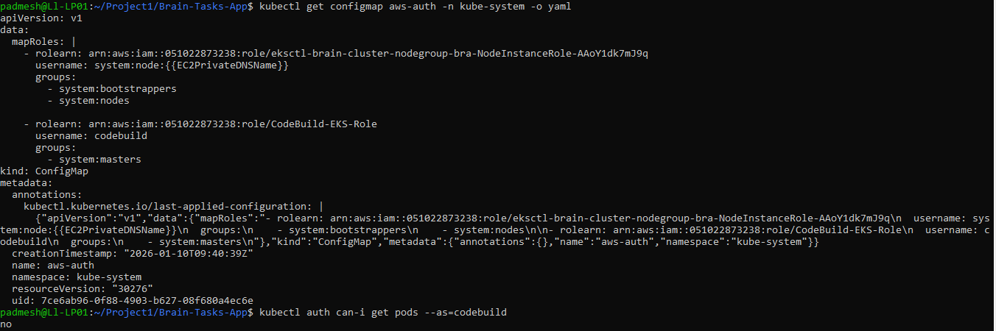
- Kubernetes application deployment verification
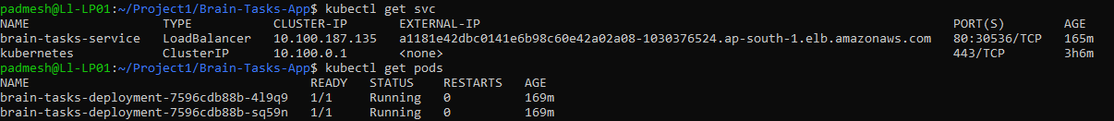
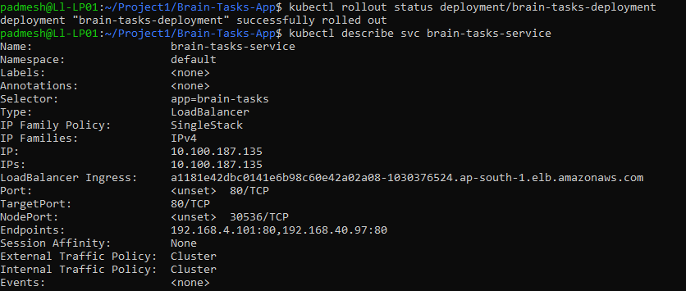
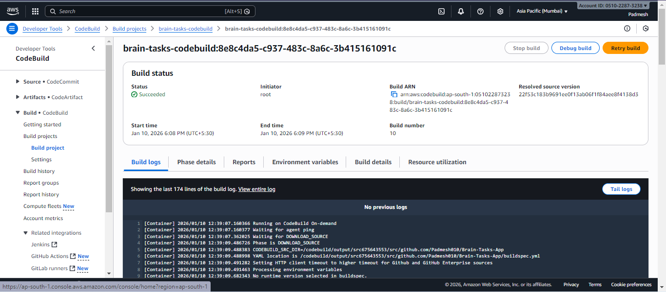
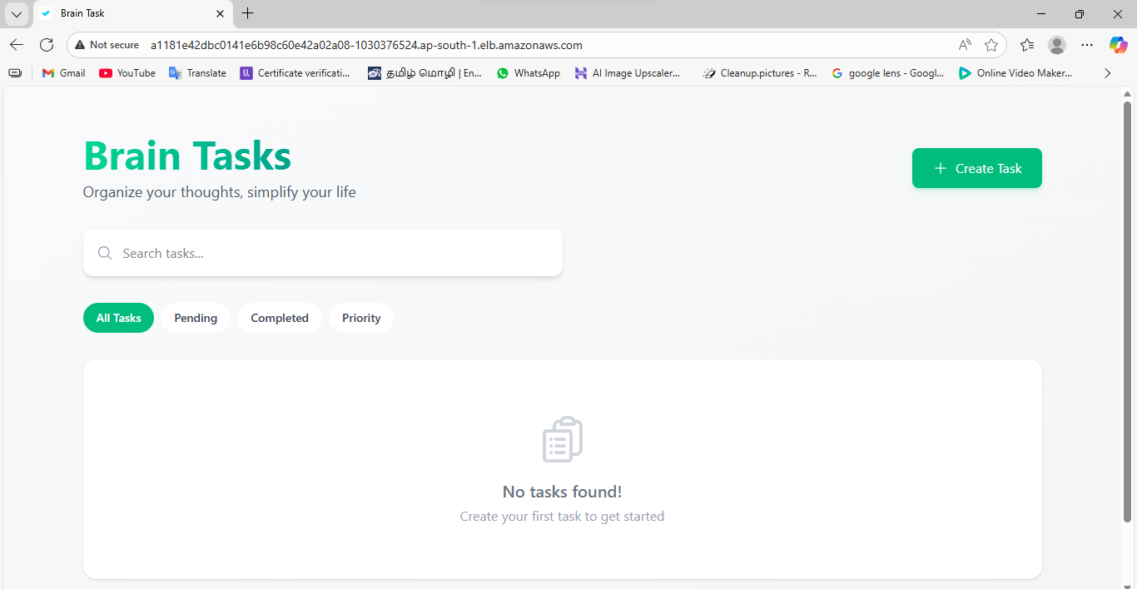
- CI/CD pipeline automation using AWS CodePipeline.
