APPLICATION DEPLOYMENT

- Git setup and GitHub SSH authentication
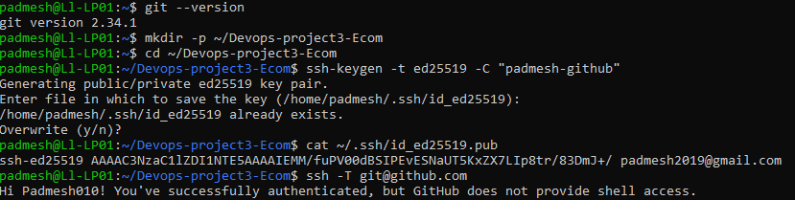

- Cloning project repository and setting up dev branch
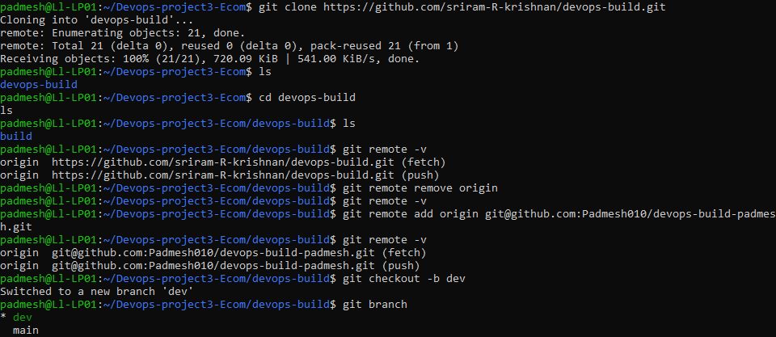

- Docker file, docker compose, dockerignore and .gitignore configuration
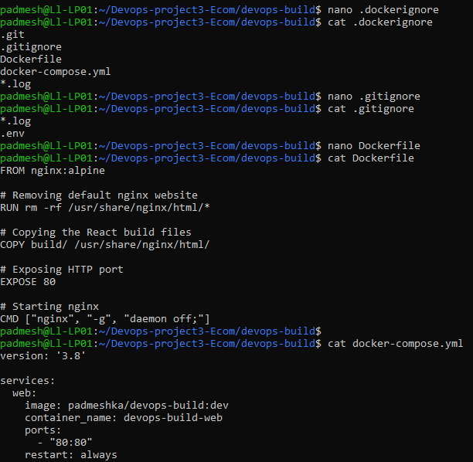

- Build.sh and deploy.sh for Docker image build and deployment
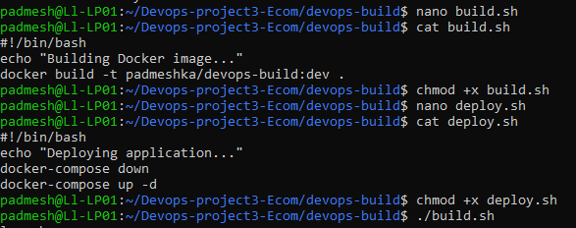

- Application deployment using deploy.sh
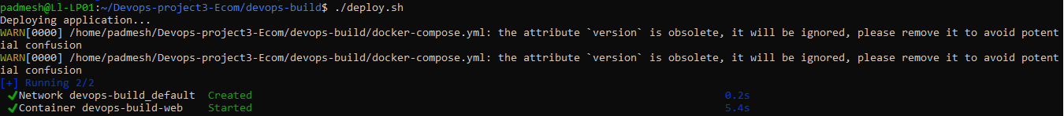

- Docker running status (application live on port 80)
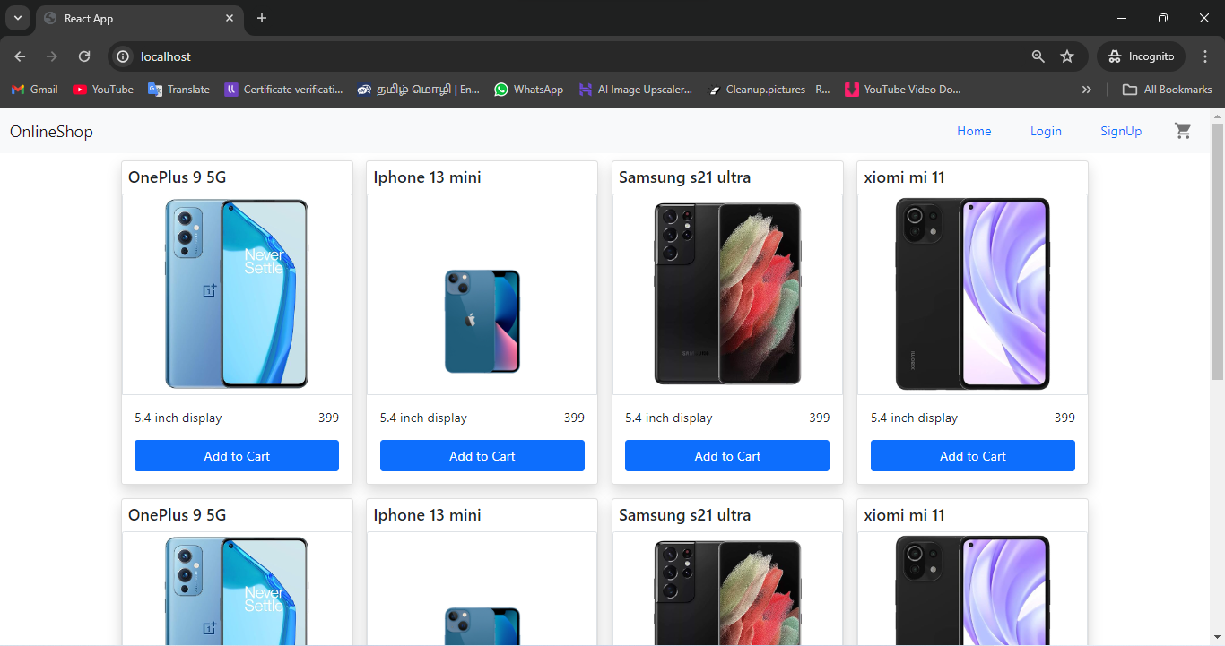

- Docker hub repositories Dev(Public) and Prod(Private)
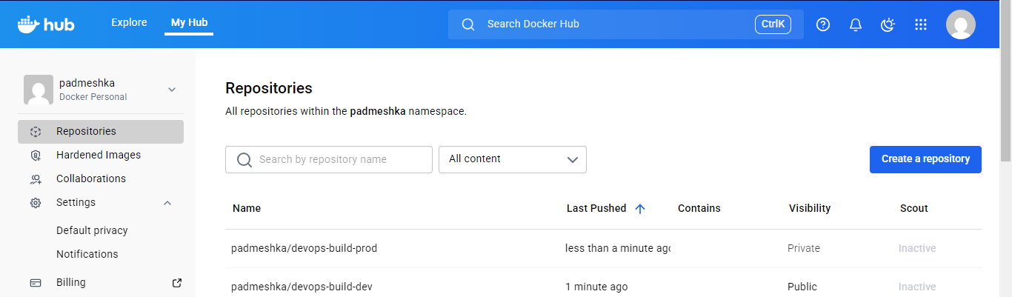

- Docker login status
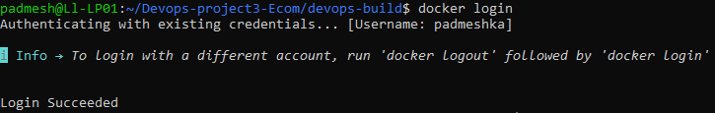

- Bash scripting for Docker build and Docker compose configuration
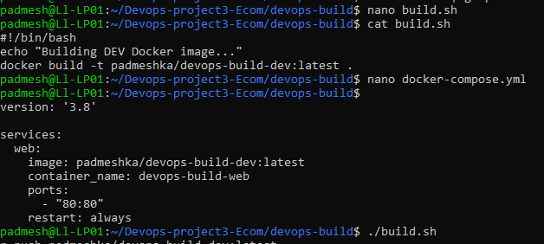

- Pushing DEV Docker image to Docker hub (Public)
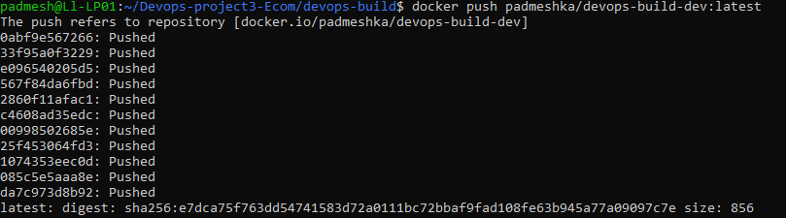

- Pushing application code to GitHub Dev branch
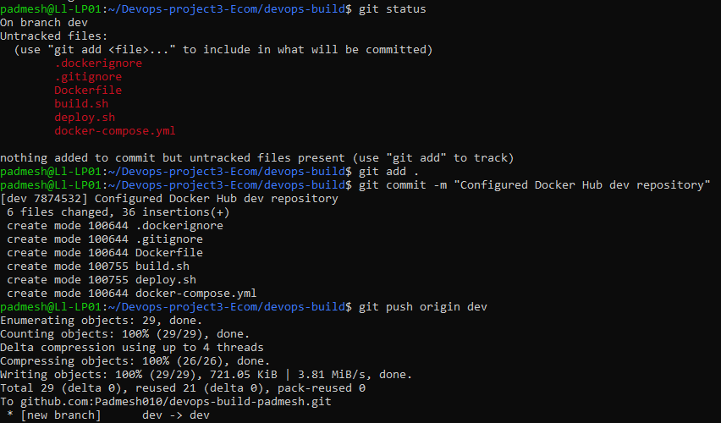

- AWS EC2 Instance details for Jenkins, Application and Monitoring setup
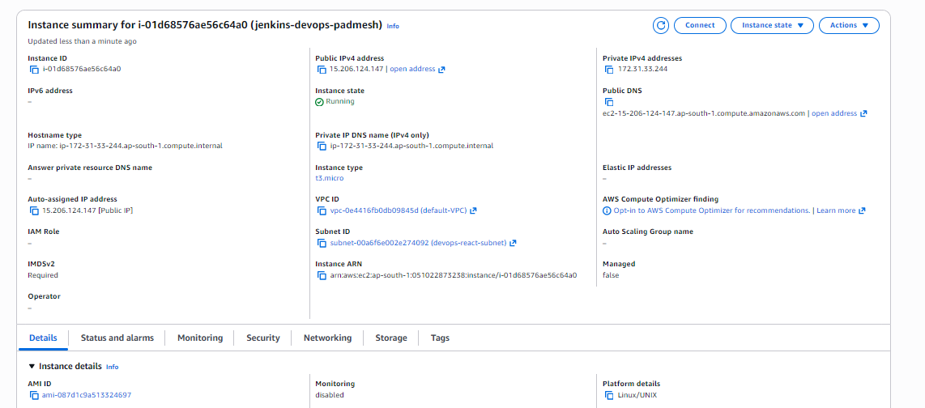

- Secure SSH access from local to AWS EC2 Instance
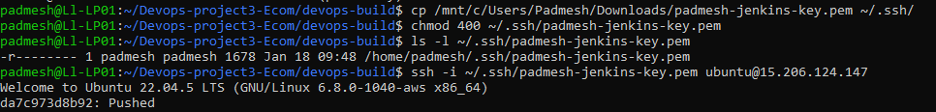

- Docker installation on AWS EC2 Instance
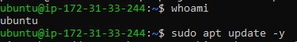

- Docker service verification on EC2
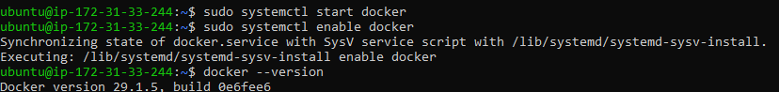

- Granting Docker permissions to Jenkins user
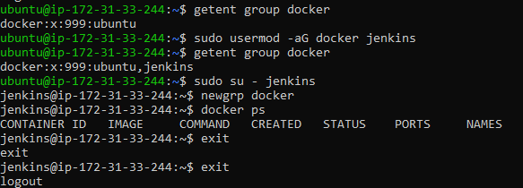

- Jenkins home page
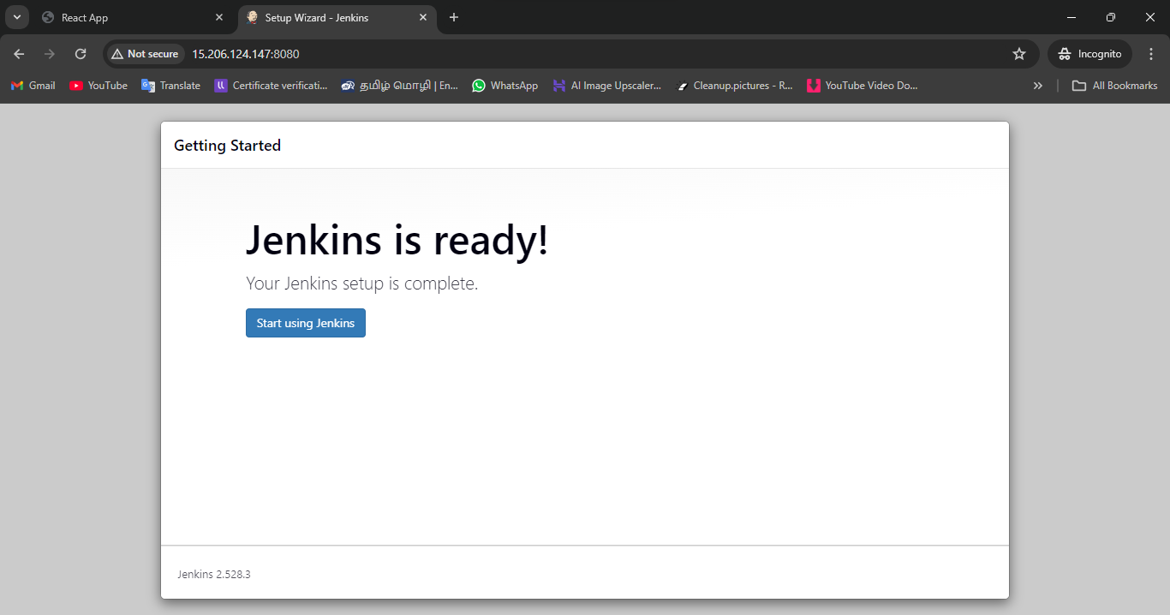

- Jenkins Global credentials configuration (GitHub and Docker Hub)
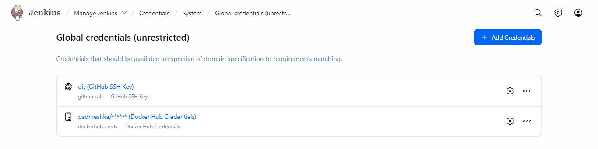
- Git branch management and Production Pipeline trigger (Dev to Master)
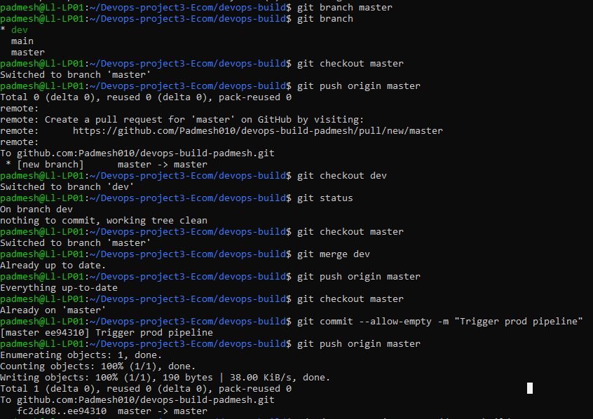

- Jenkins creation and DEV branch CI pipeline configuration (Initial test)
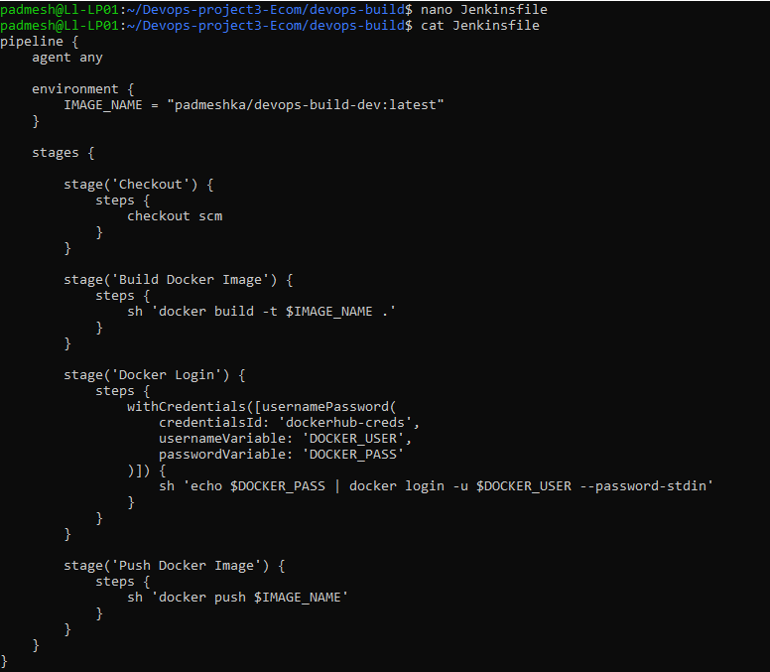
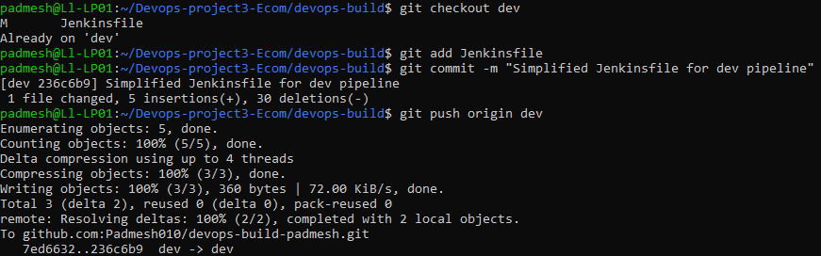

- Jenkins DEV pipeline successful build status (Initial test)
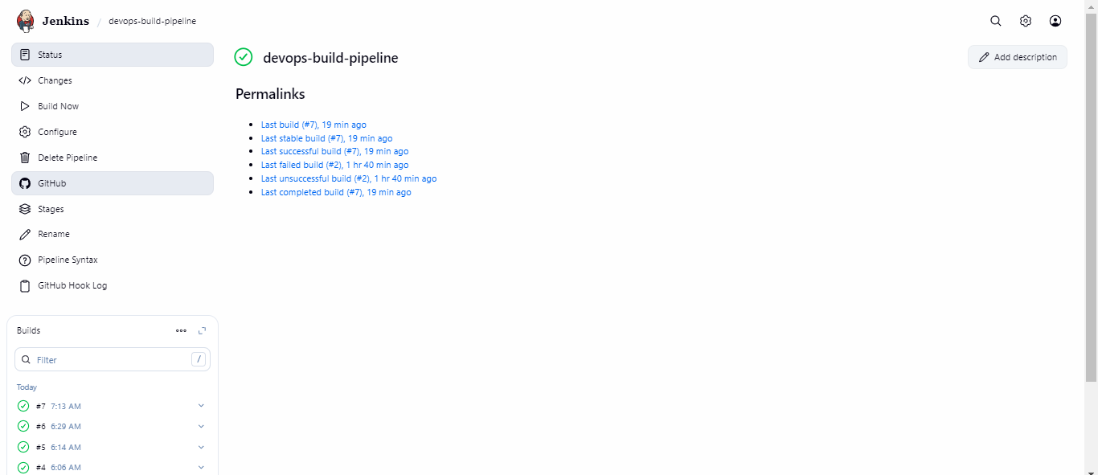

- Docker image pulled and application container running on EC2 port 80
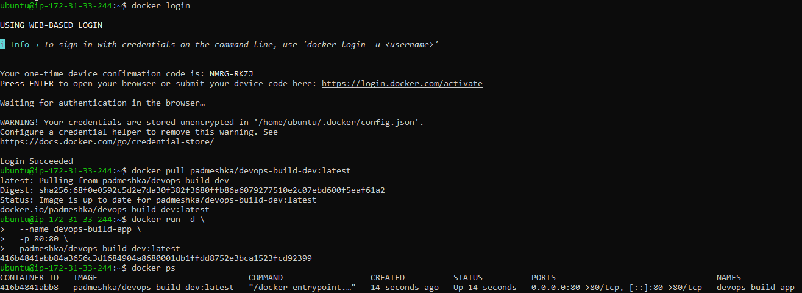

- Application running on AWS EC2 port 80

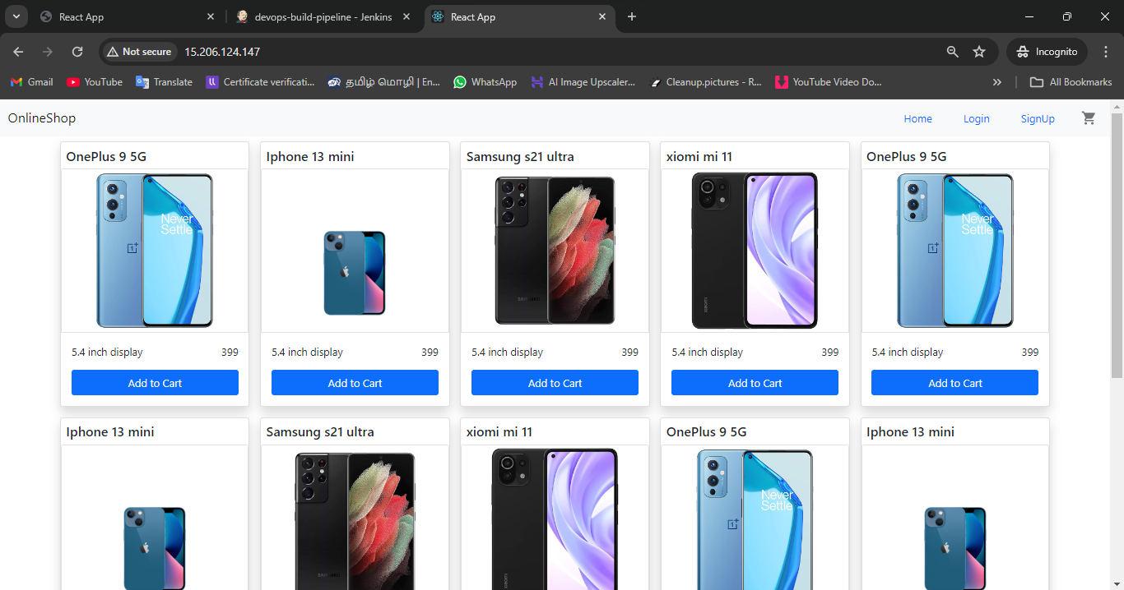

- Automated application deployment on EC2 using custom deploy.sh script
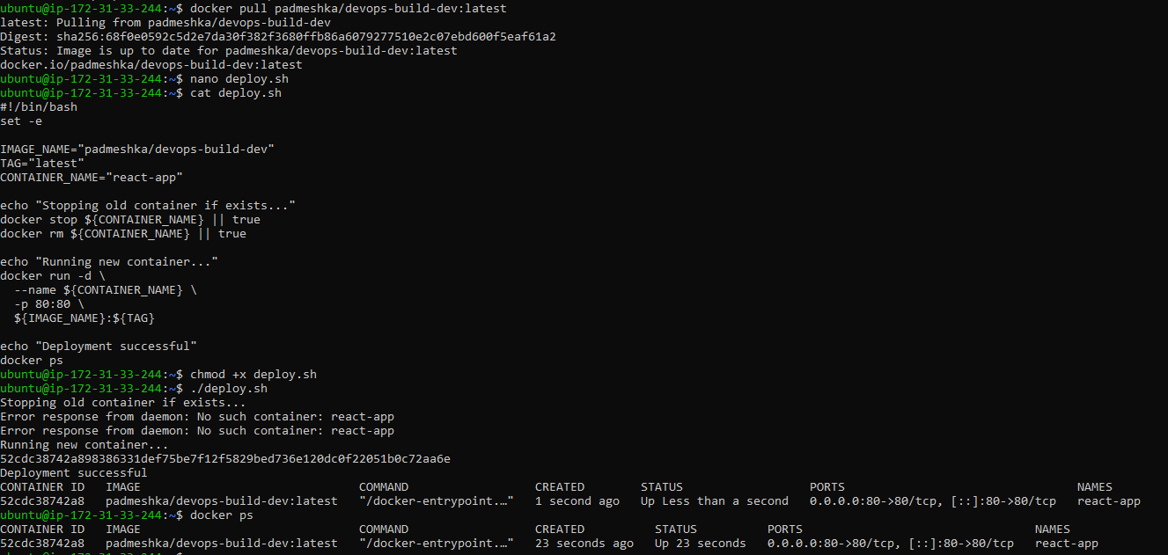

- Application live on AWS EC2 through public IP
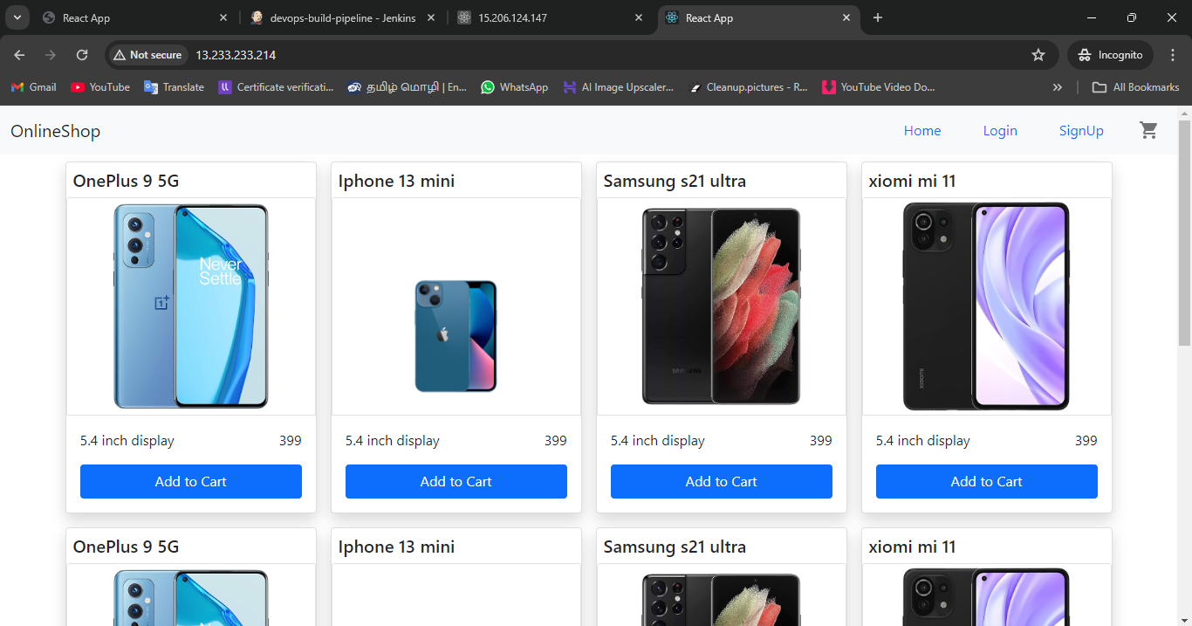

- Application deployment on EC2 using Docker compose
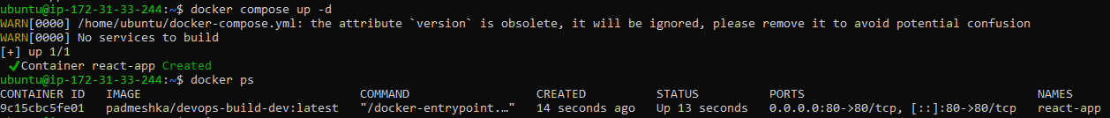

- Branch based Jenkins pipeline for DEV and PROD Docker images (Final)
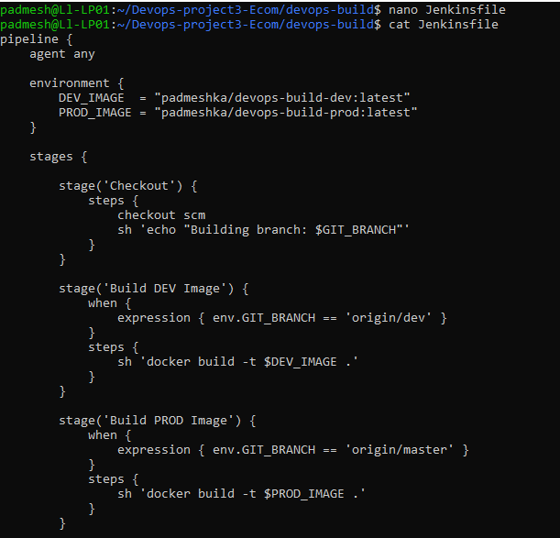
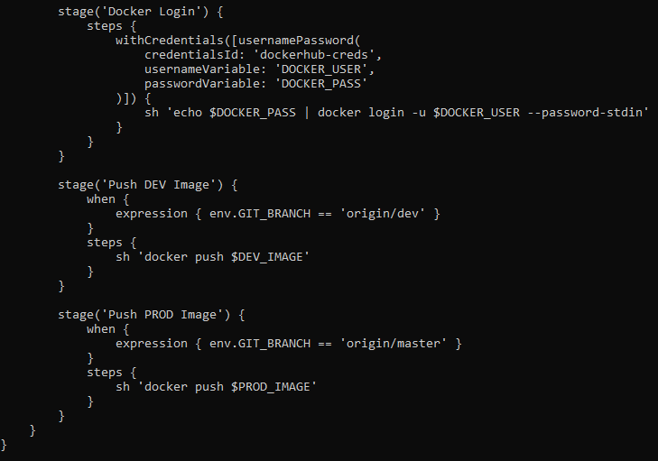
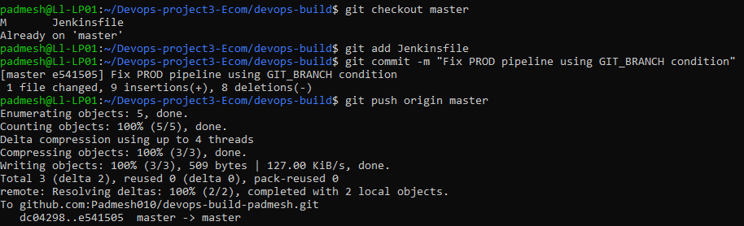

- CI/CD pipeline execution and Docker image management (Dev and Prod)
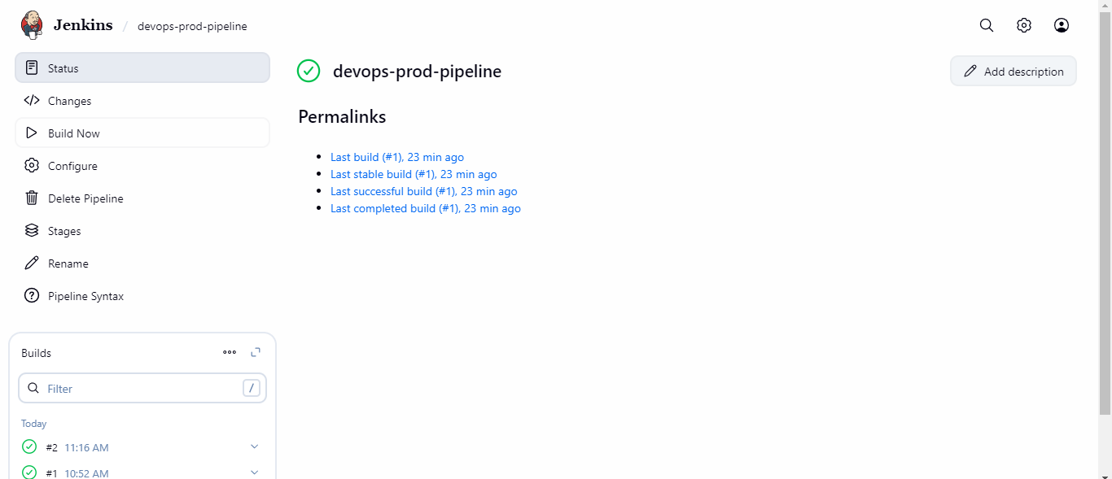
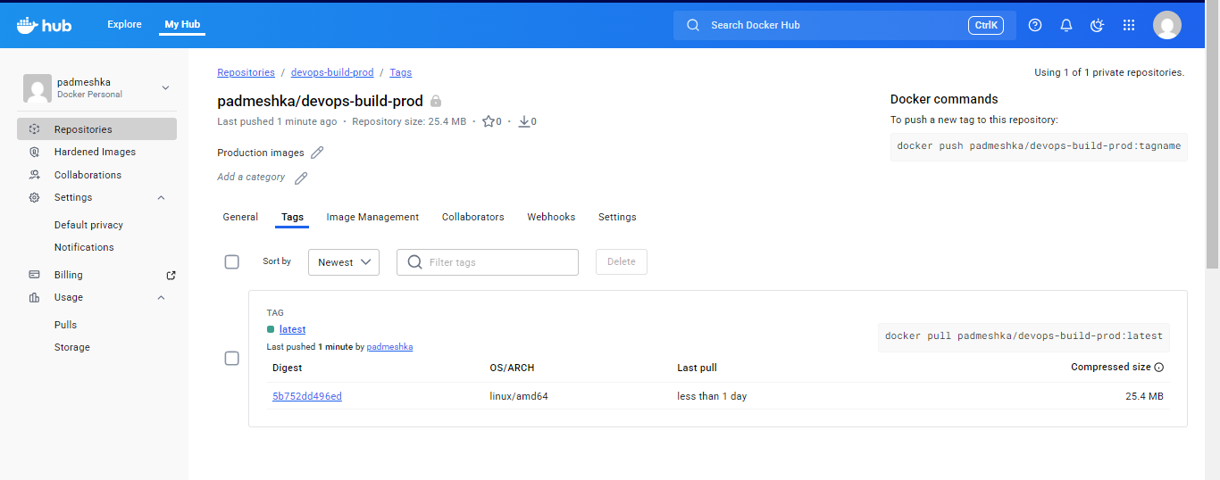
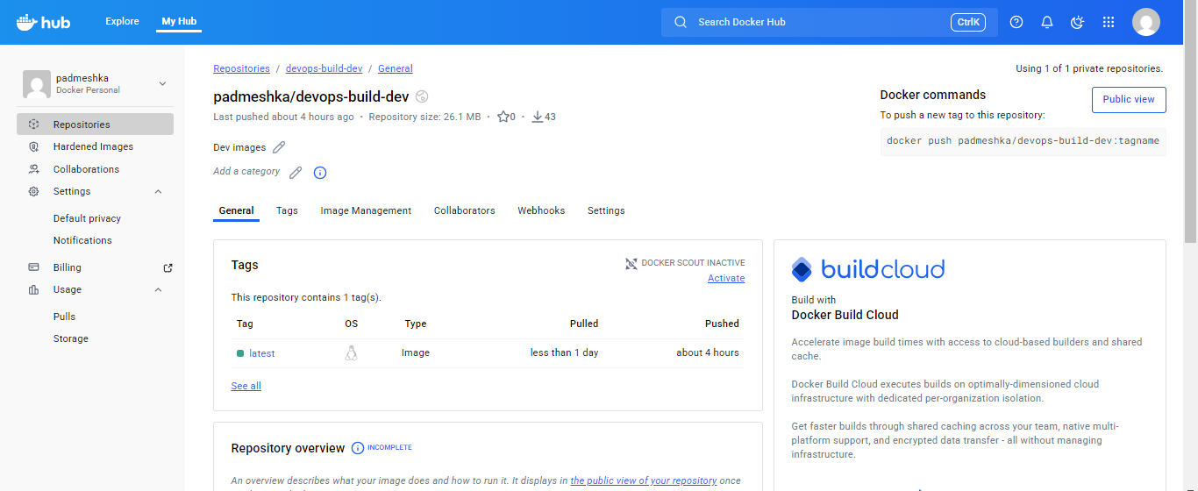

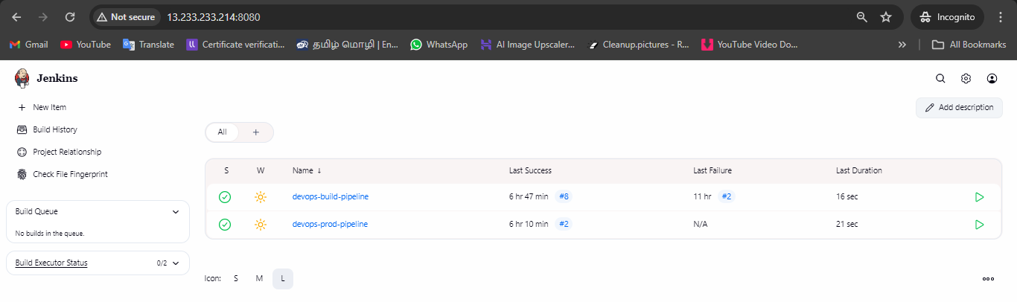

- Production application deployment using Docker(Prod image)
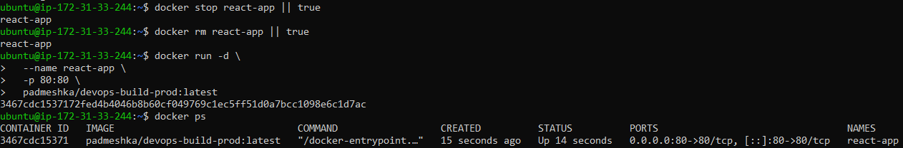

- Automated production deployment using custom shell script (deploy.sh)
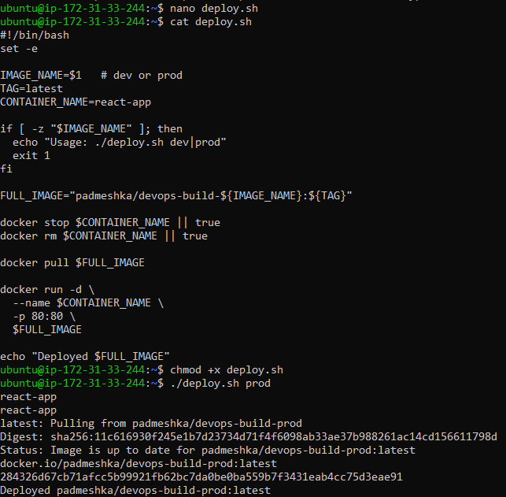

- Node exporter installation and metrics verification
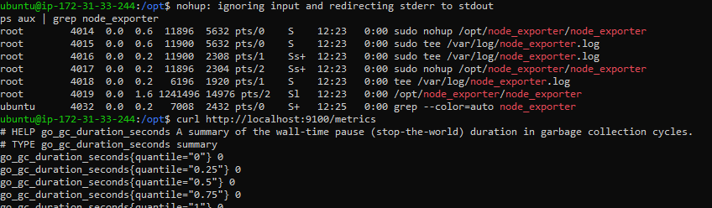

- Prometheus server startup and health verification
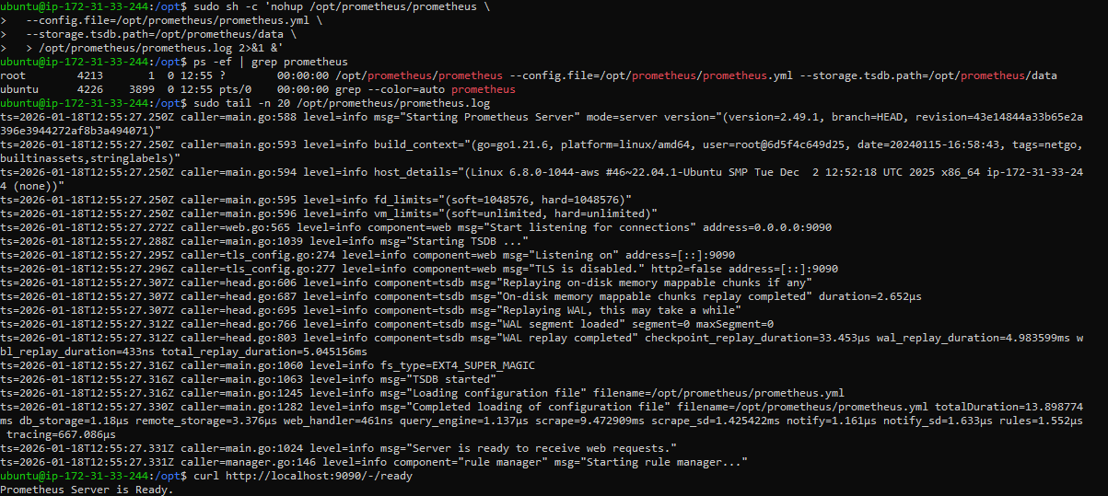

- Prometheus targets status

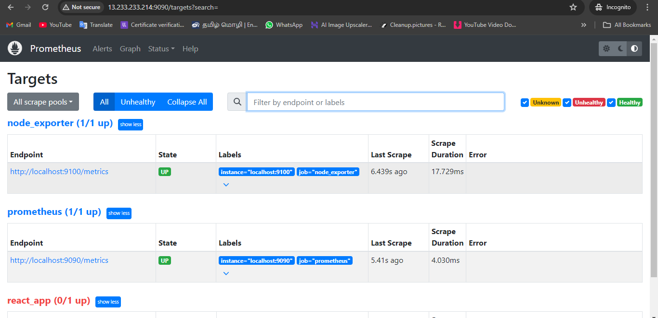

- Grafana service installation and runtime verification
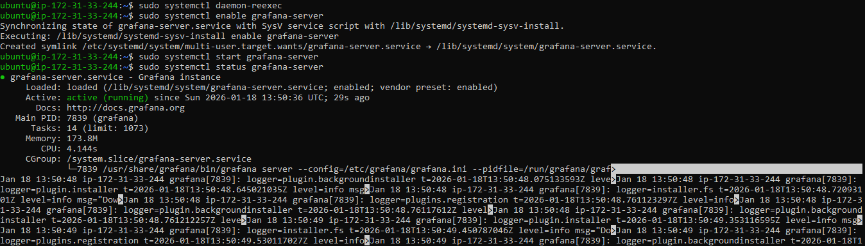

- Grafana Prometheus data source configuration and validation

