Application Deployment
(Deploy the given React application to a production ready state)
- Project Initialization and SSH Key Generation
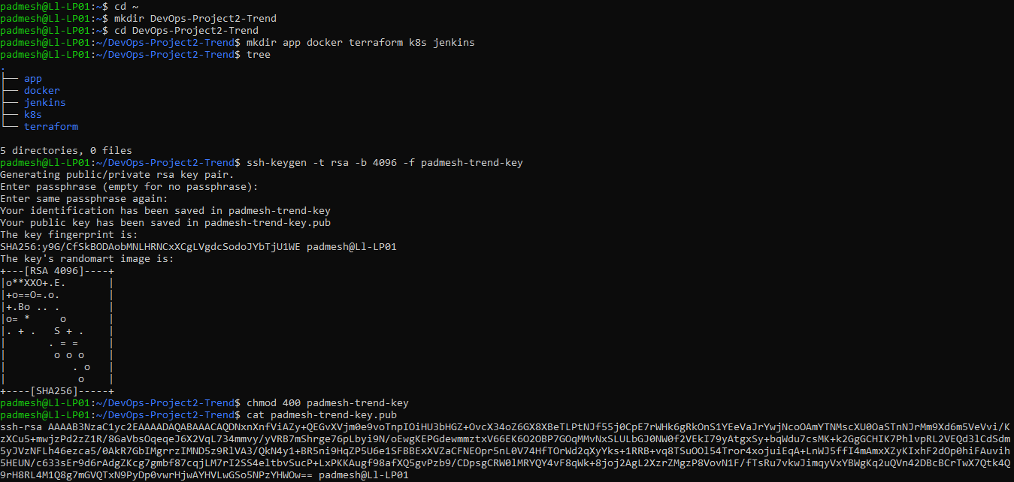
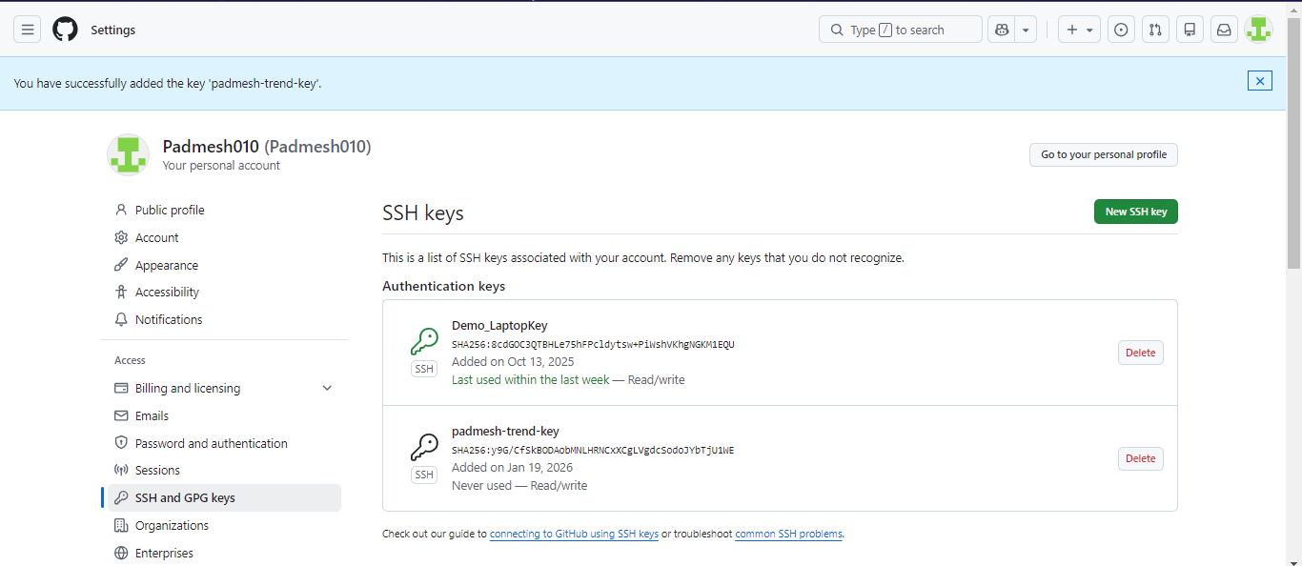

- AWS EC2 Key Pair Deletion and Re-Import Configuration
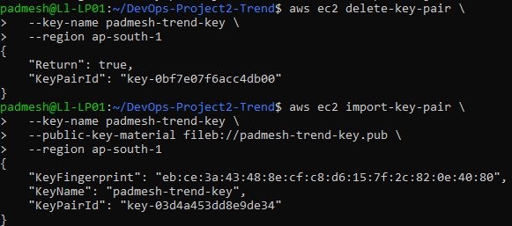

- Cloning the Trend Application Repository and Verifying Build Artifacts
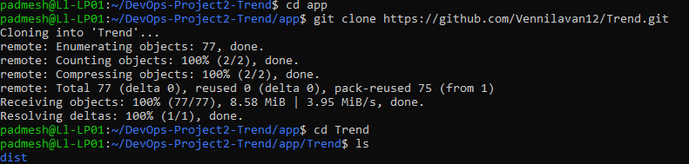

- Creating Dockerfile and Building the Trend Application Docker Image
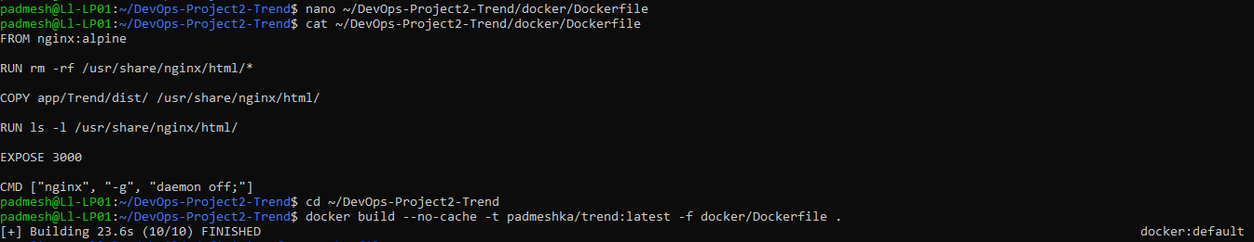

- Running and Testing the Trend Application Container Locally
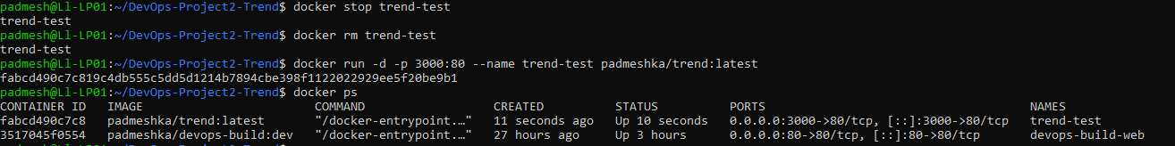
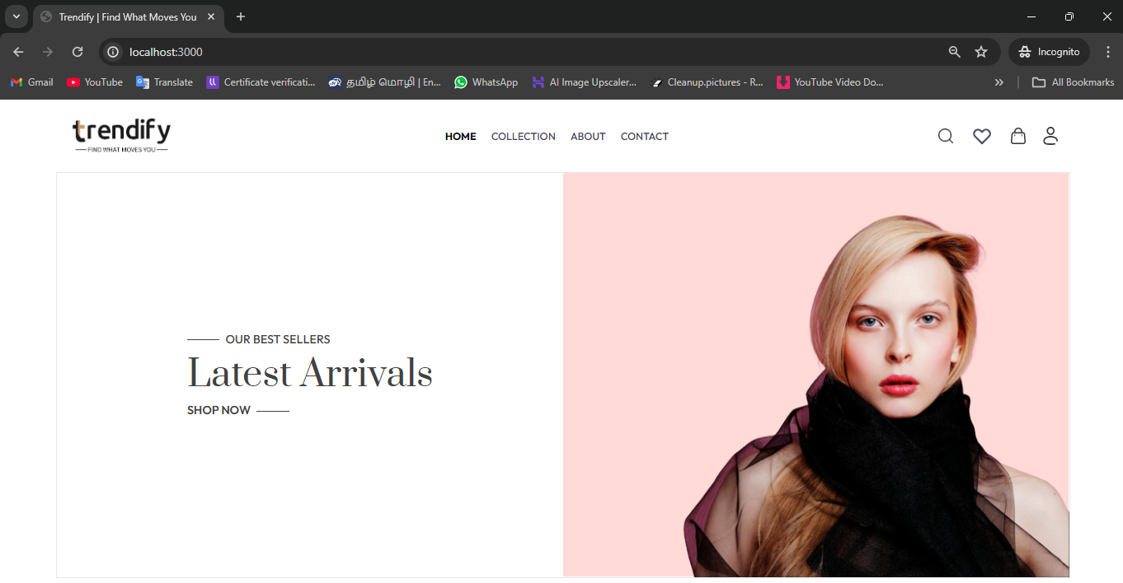

- Pushing the Trend Docker Image to DockerHub
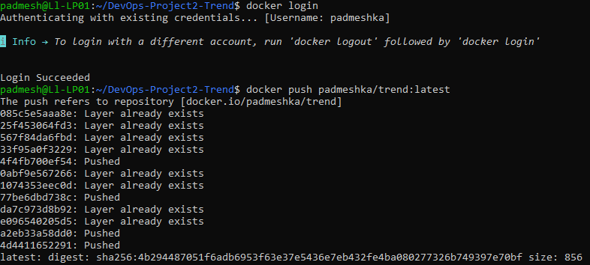

- Creating .gitignore and .dockerignore and Initializing Git Repository and Linking to GitHub Remote
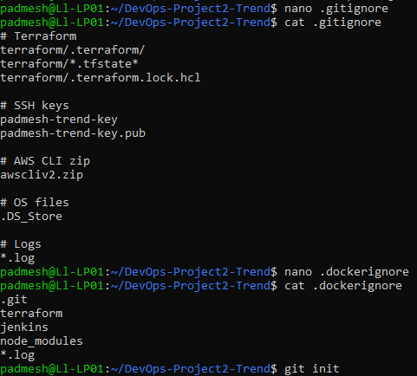

- Pushing Docker Image to DockerHub and Verifying Git Remote Configuration
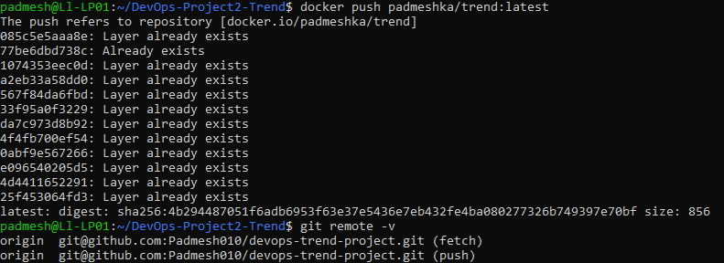

- Verifying Git Repository Status, Commit History, and Application Directory Structure
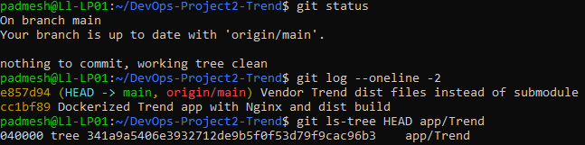

- Setting Up AWS Infrastructure Using Terraform
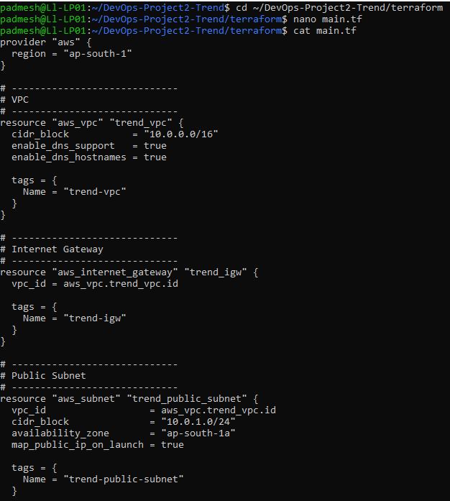
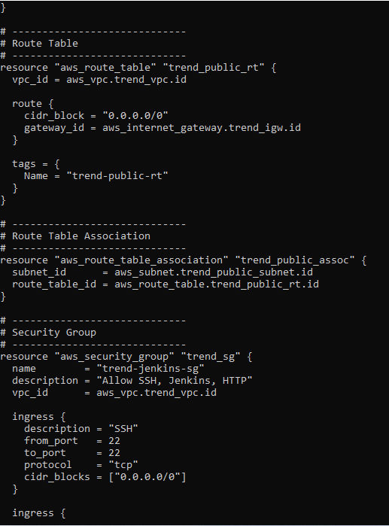
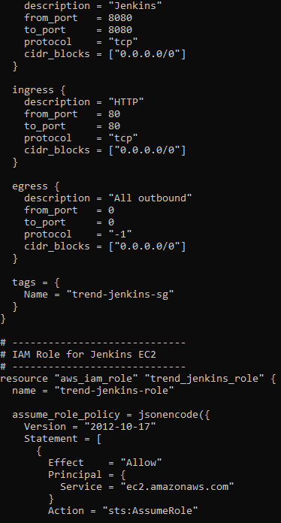
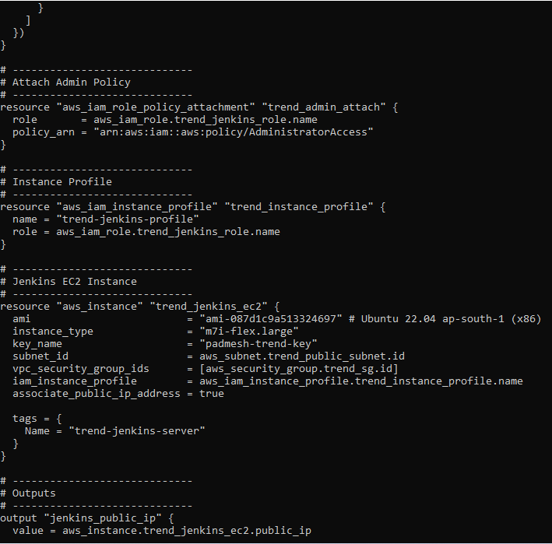

- Terraform Initialize and Terraform Apply Successful

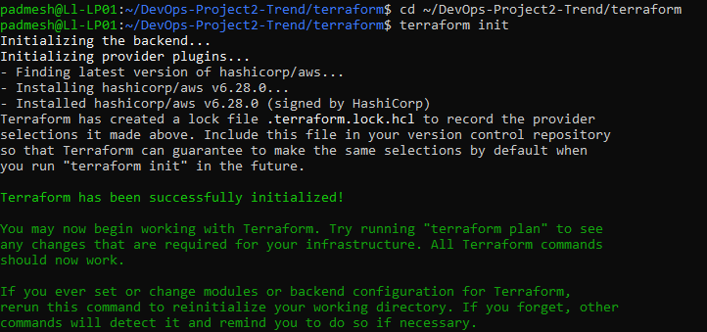
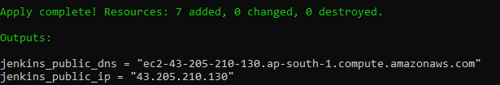

- SSH Login to EC2 Instance
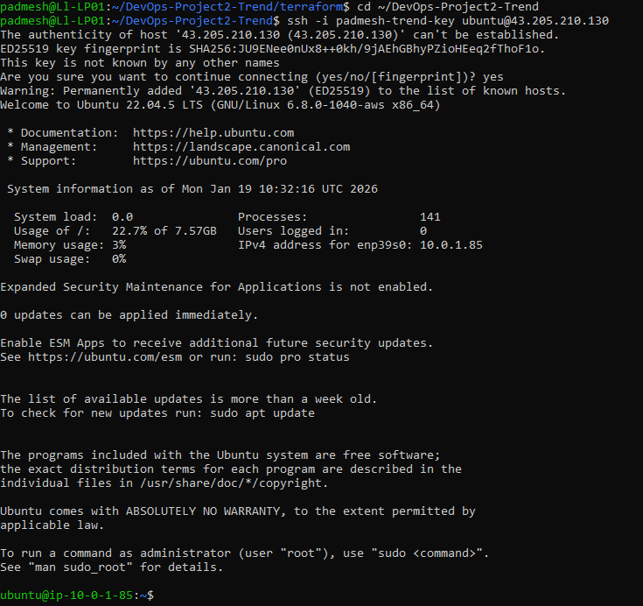
- Installed and Configured Docker, Git, and Java on EC2
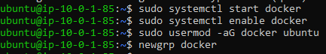

- Jenkins Installed and Web Interface Successfully Launched
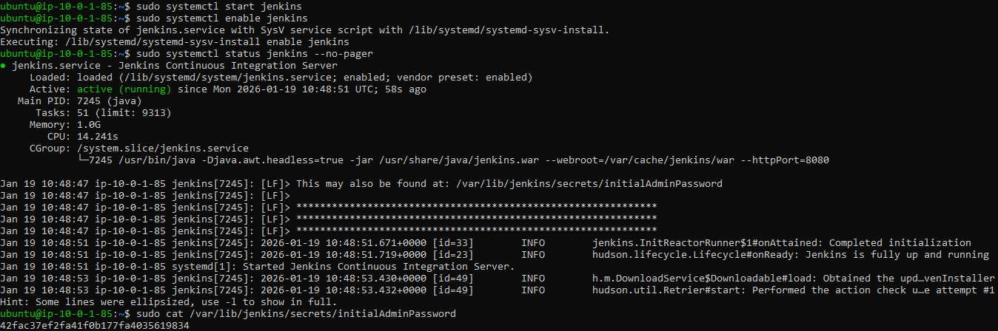
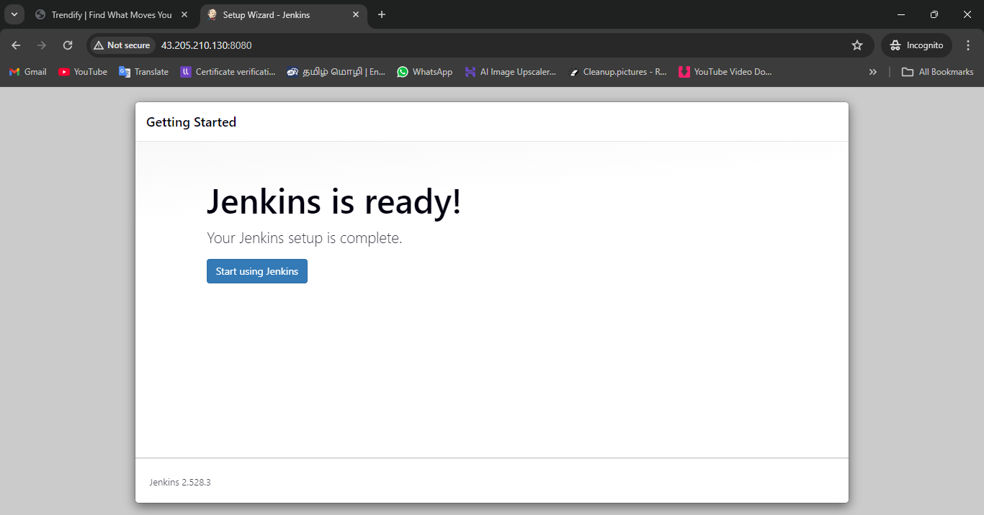
- Installing AWS CLI, kubectl, and eksctl & Configuring AWS Credentials
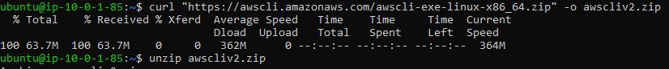
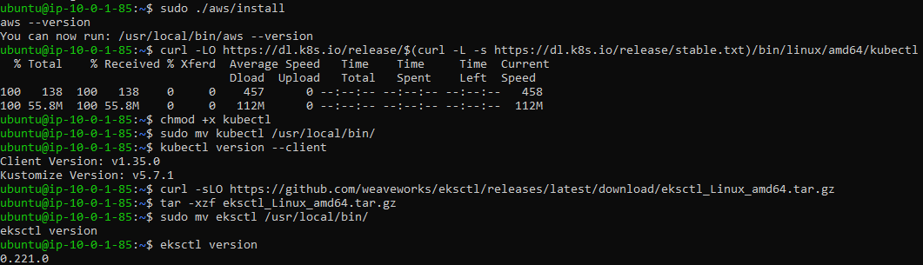
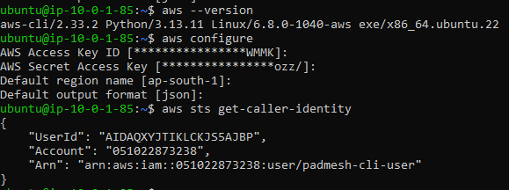

- Creating the EKS Cluster with eksctl
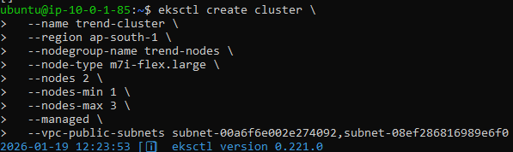

- EKS Cluster Validation – Nodes and System Pods Running Successfully
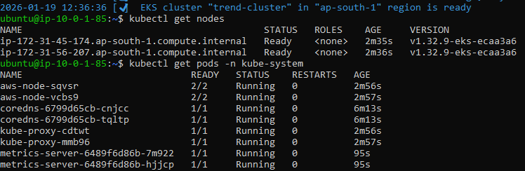

- AWS Identity Verification and Kubernetes Namespace Creation
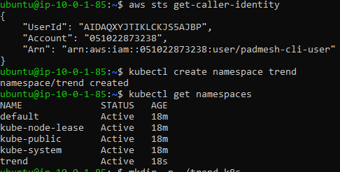

- Kubernetes Deployment and Service Configuration for Trend Application

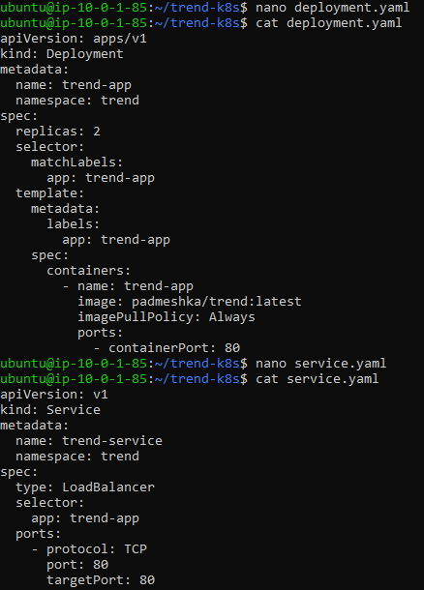
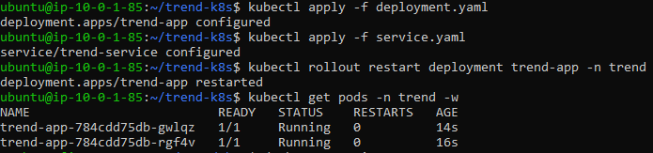
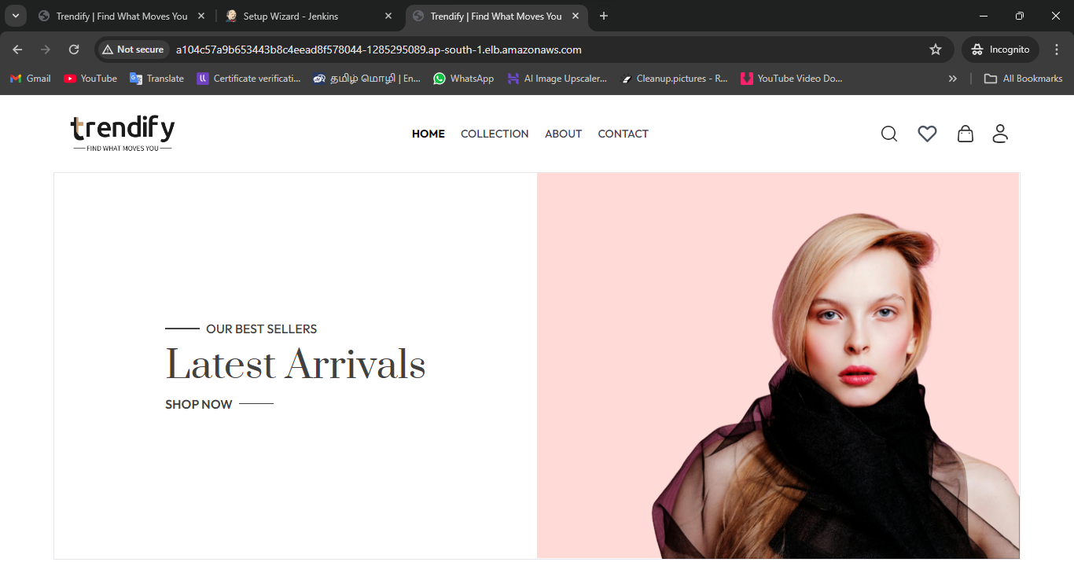

- Configuring AWS and Kubernetes Access for Jenkins User
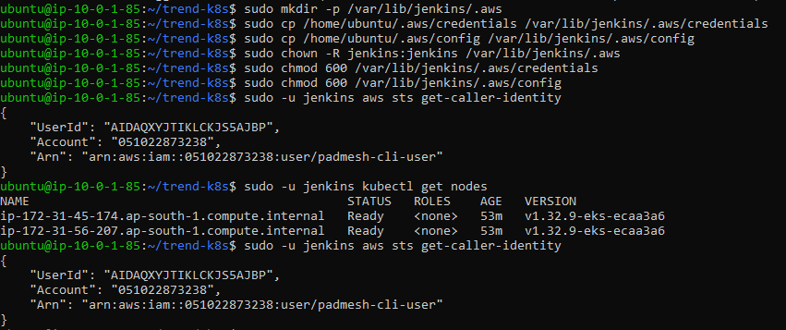

- Adding DockerHub and GitHub Credentials in Jenkins
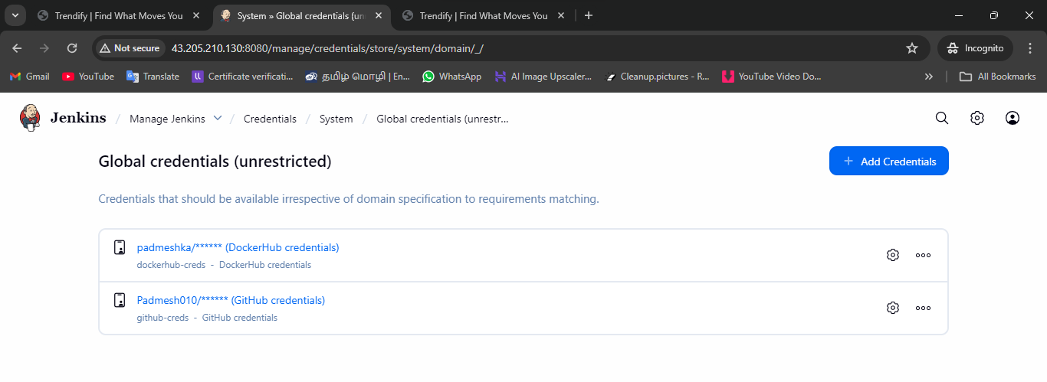
- Creating and Committing the Jenkins Declarative Pipeline (Jenkinsfile)
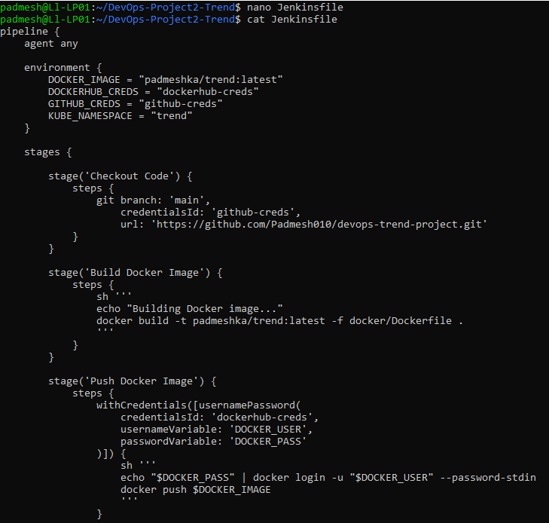
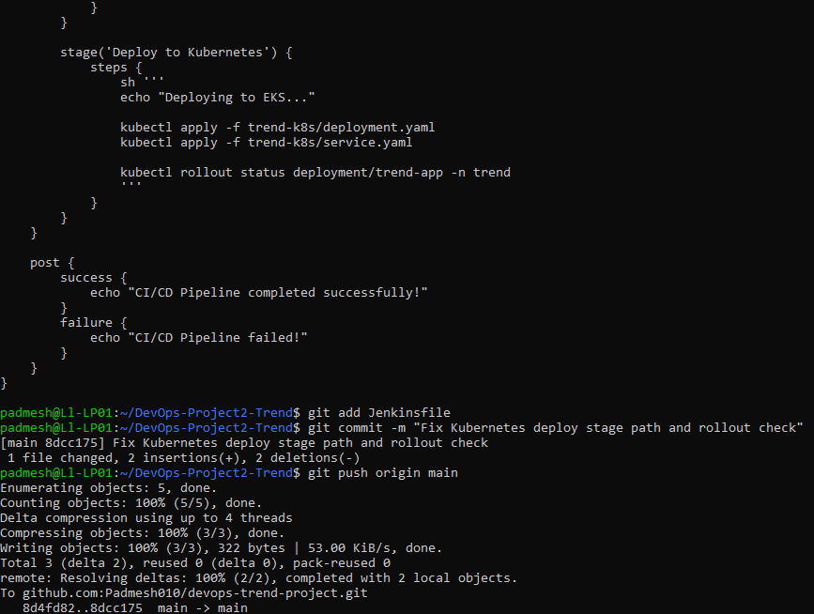

- Successful Execution of the Jenkins CI/CD Pipeline
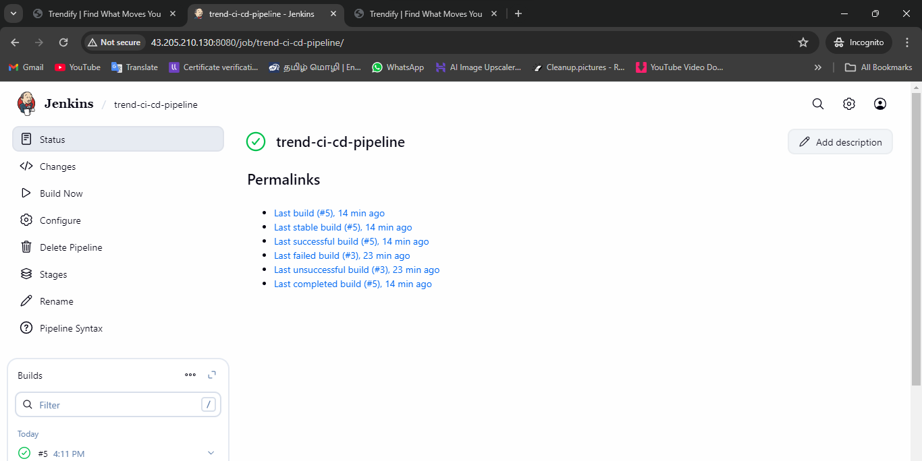
- Installing Helm and Deploying the Kube-Prometheus Monitoring Stack on EKS
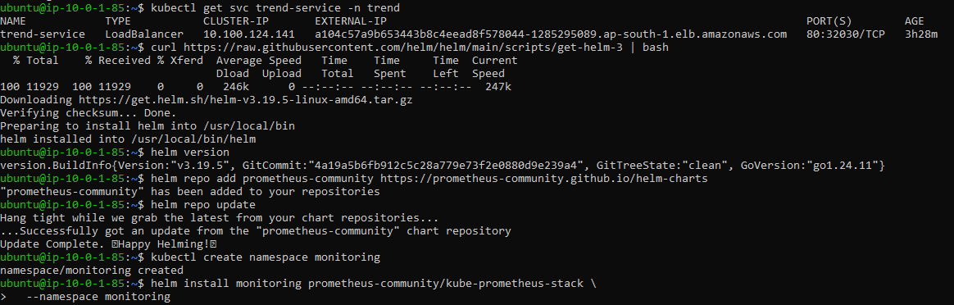

- Exposing Grafana via LoadBalancer and Retrieving Admin Credentials
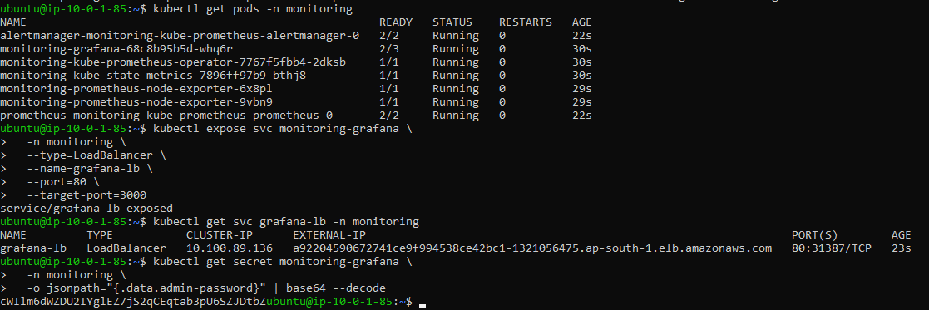

- Grafana Web UI – Initial Login and Home Dashboard
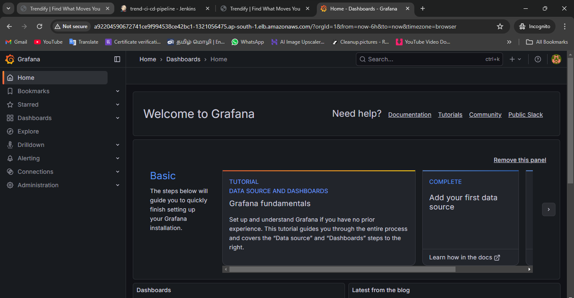
- Kubernetes Cluster Monitoring Dashboard (Prometheus – Grafana)
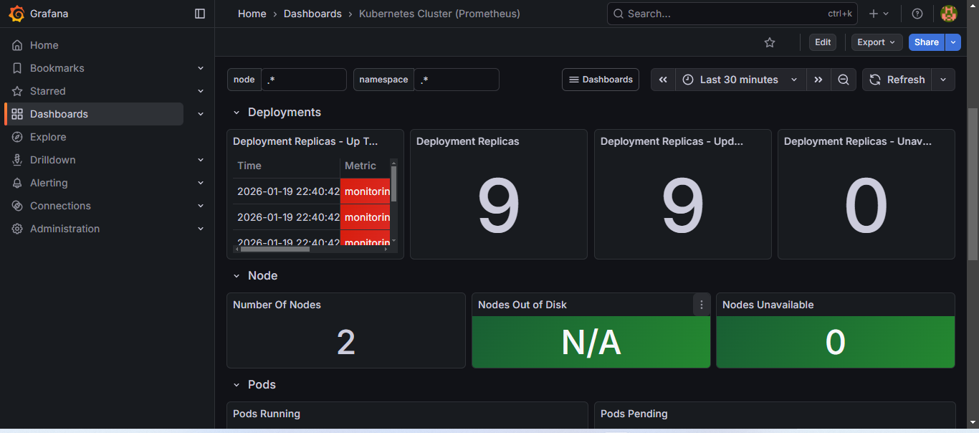

- Node Exporter Full Dashboard – Node CPU, Memory, and Disk Metrics
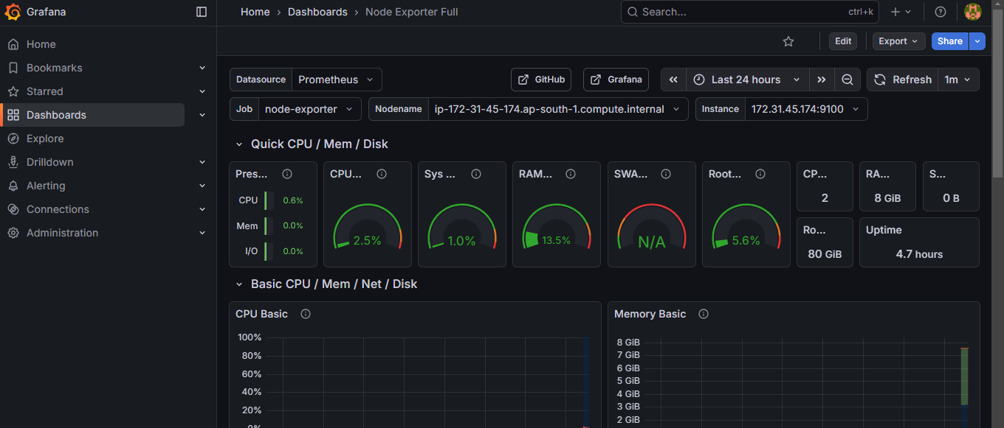

- Kubernetes Monitoring Stack Status and Resource Utilization (Prometheus & Grafana)
