- Jenkins Installation and Initial Setup on AWS EC2
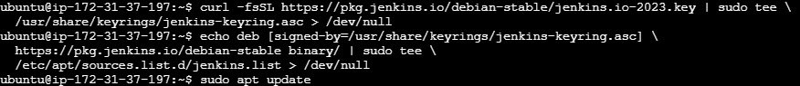
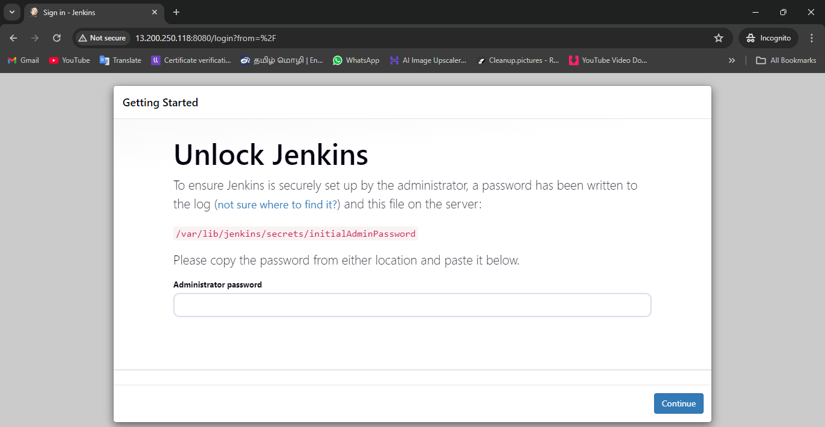
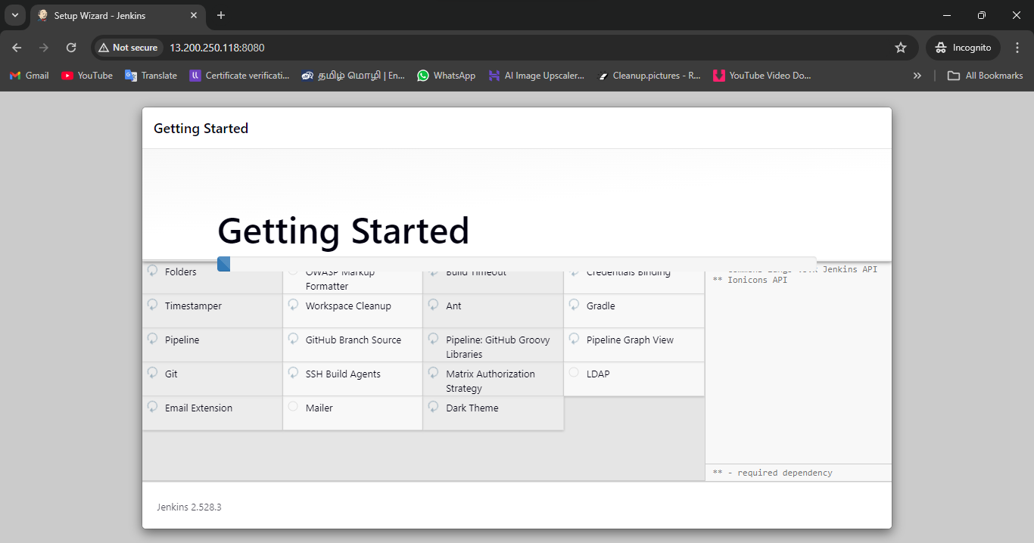
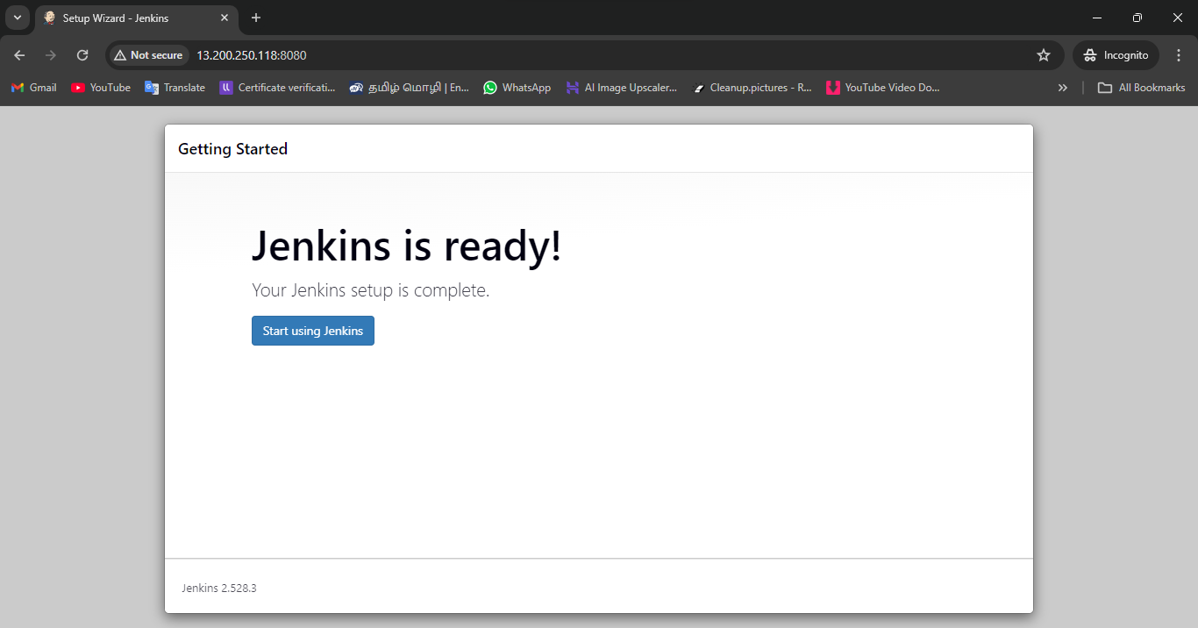

- Cloning GitHub Repository and Creating Jenkins Script File
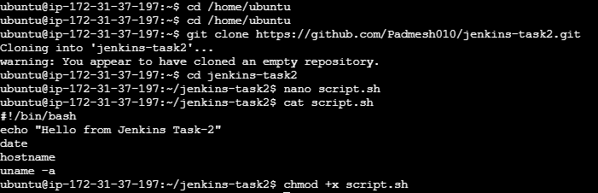

- Committing and Pushing Jenkins Script to GitHub Repository
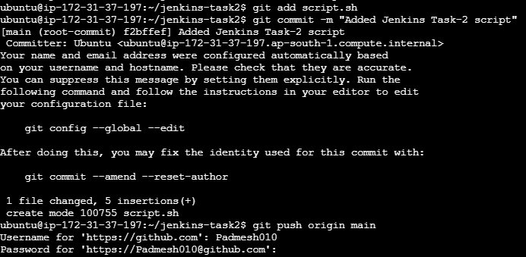

- Creating and Configuring Jenkins Freestyle Job with GitHub Integration
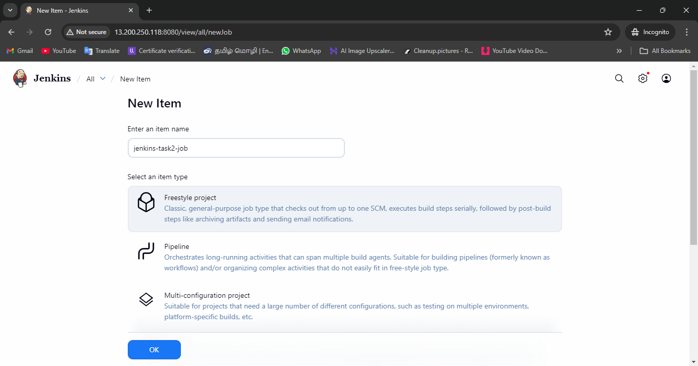
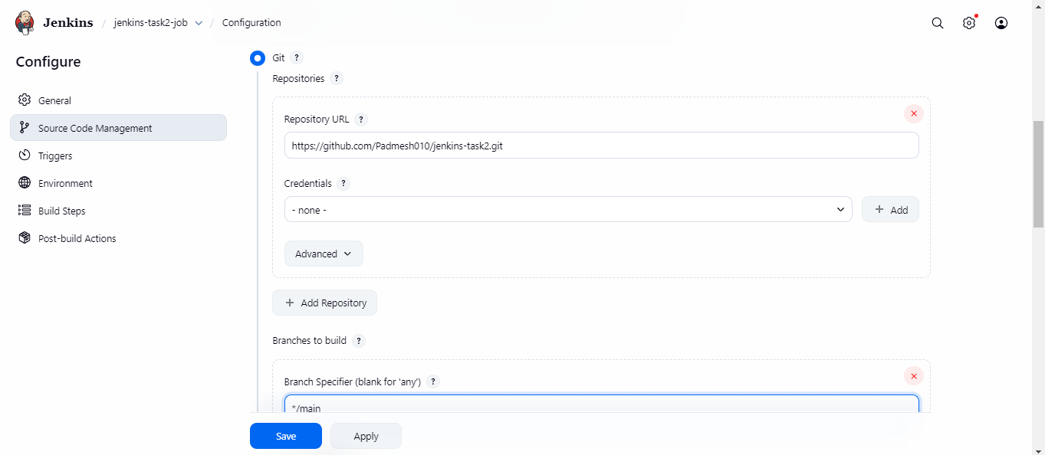
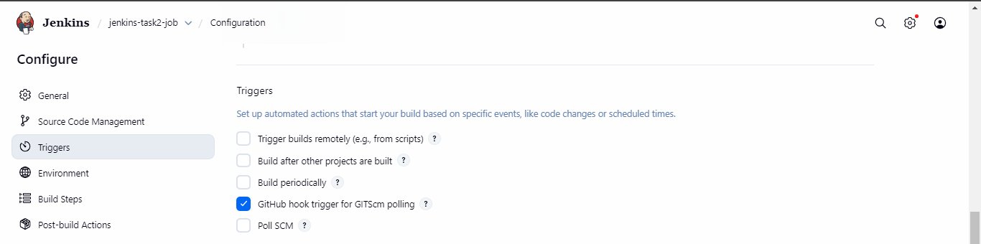
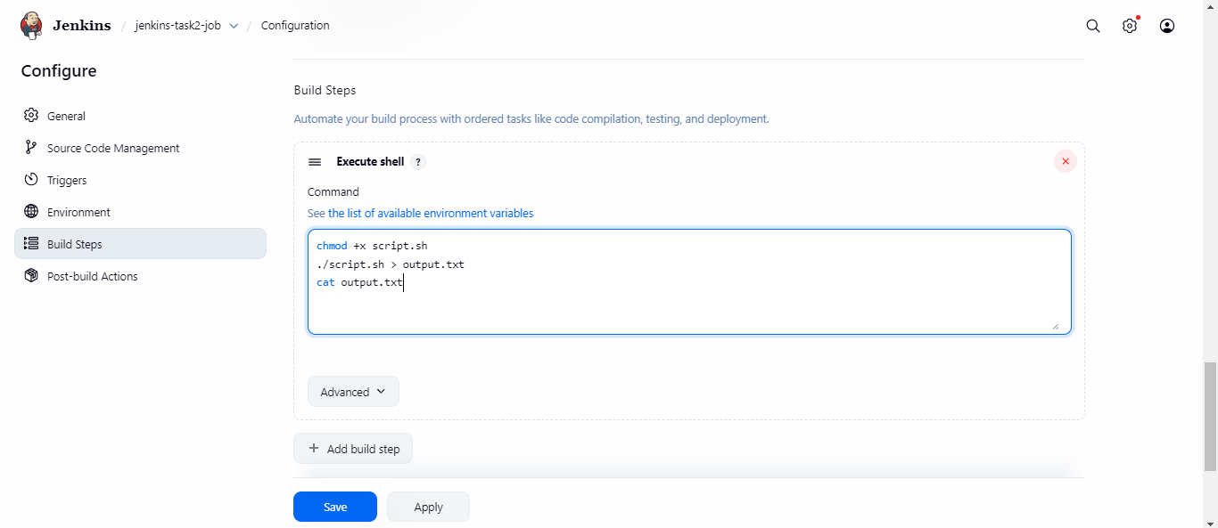

- Installing Required Jenkins Plugins for GitHub and Email Integration
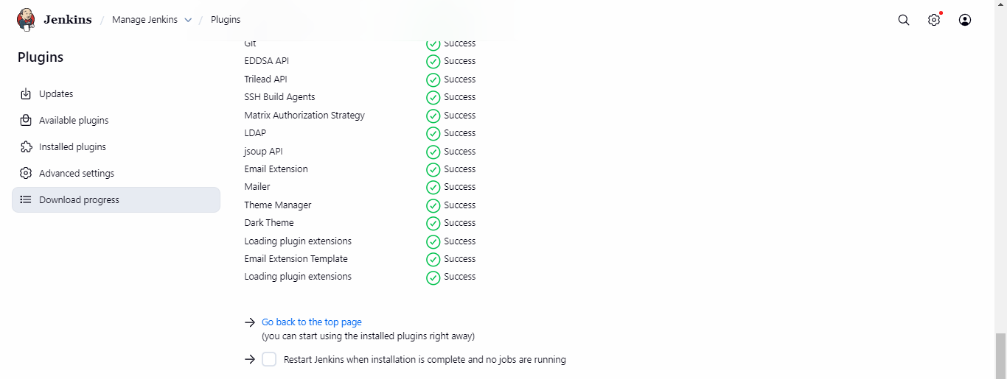

- Configuring Email Notifications in Jenkins and Verifying Job Status
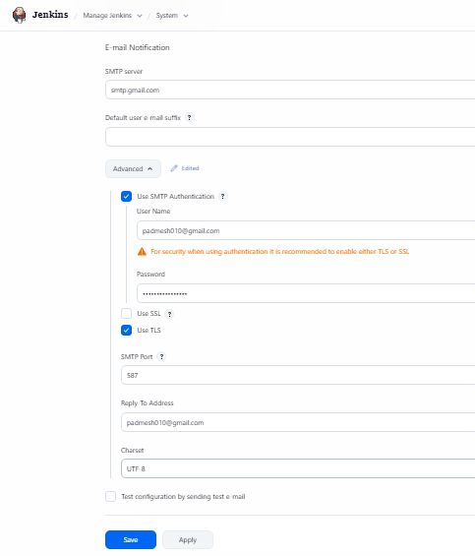
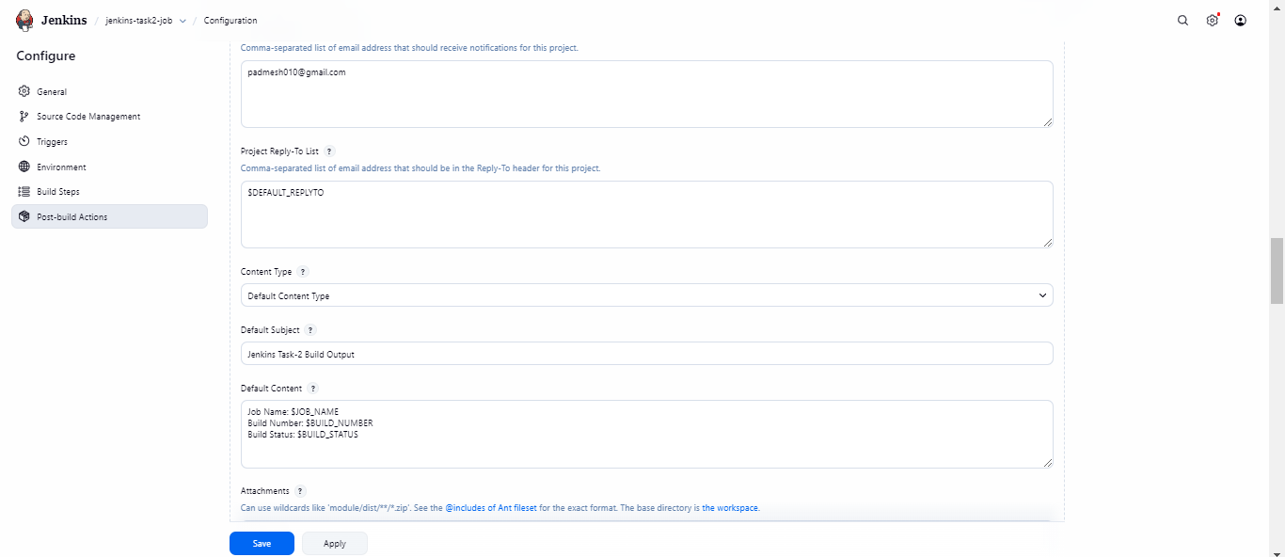
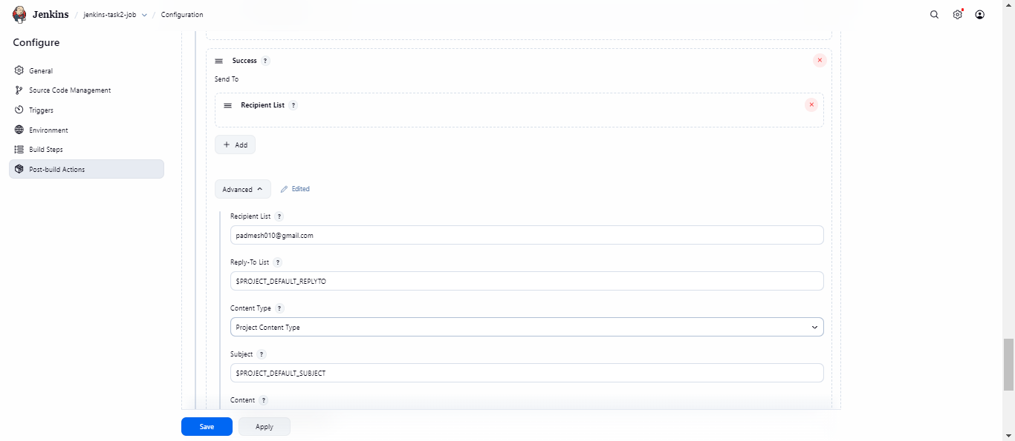
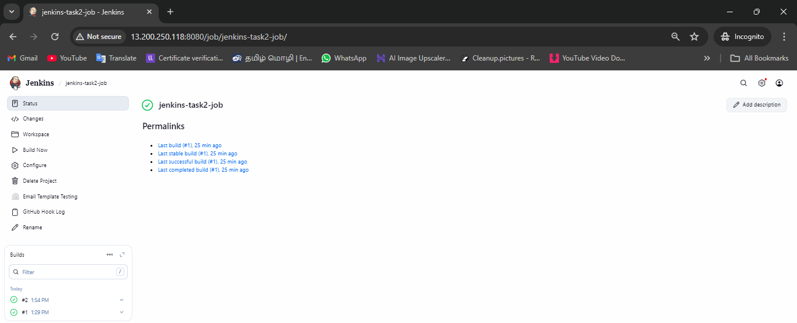

- Configuring GitHub Webhook for Jenkins Auto-Trigger
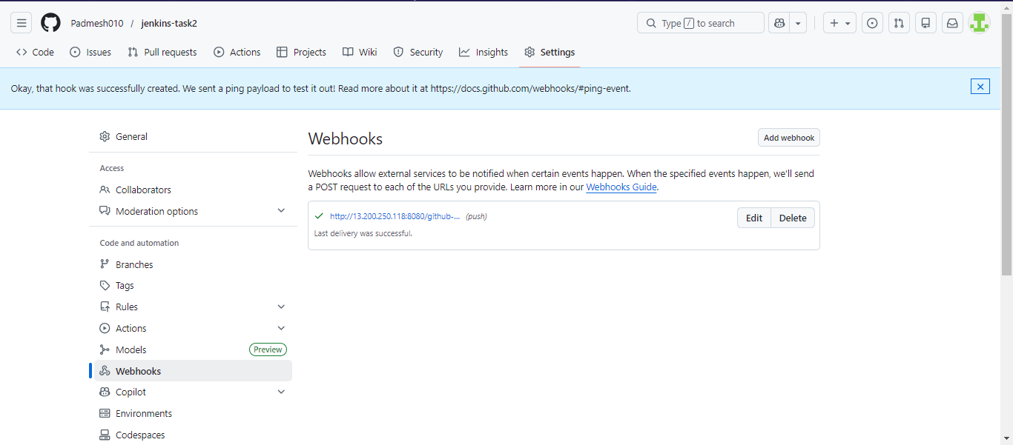

- Modifying Script and Pushing Commit to Trigger Jenkins Automatically
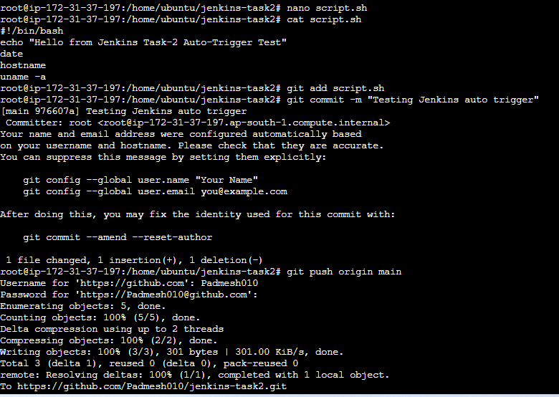
- Jenkins Job Automatically Triggered by GitHub Push Event
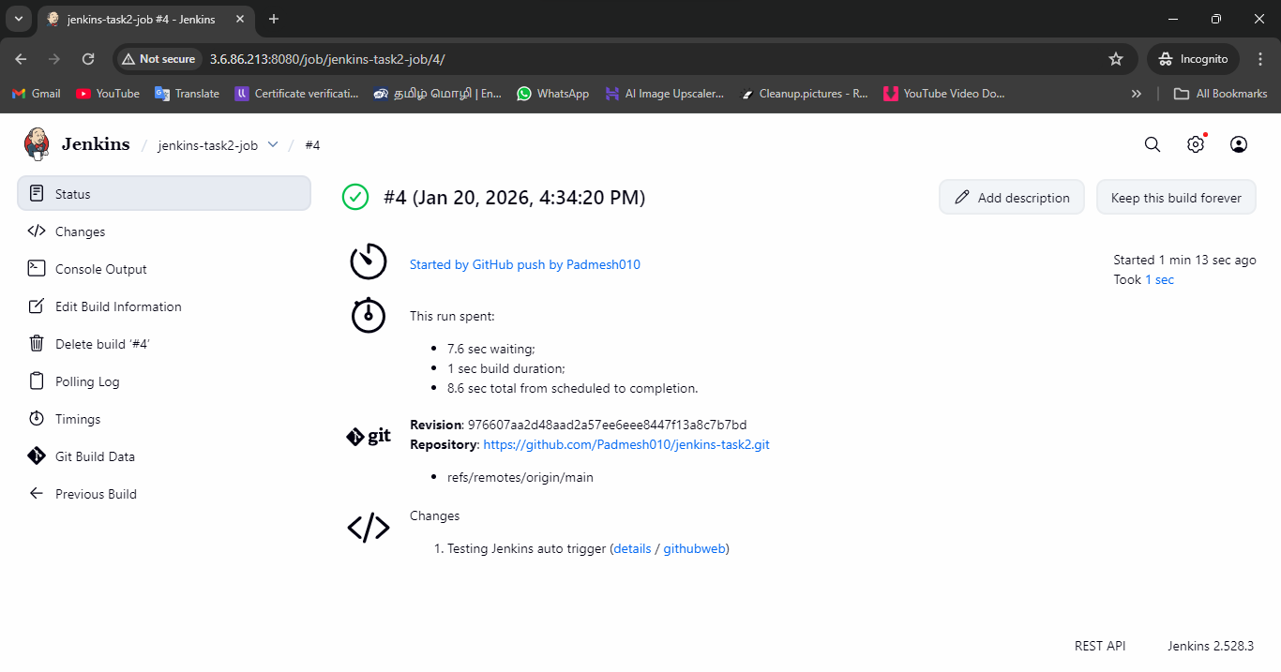

GitHub repo: https://github.com/Padmesh010/jenkins-task2

