- Prometheus Installation and Initial Setup
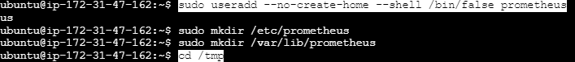
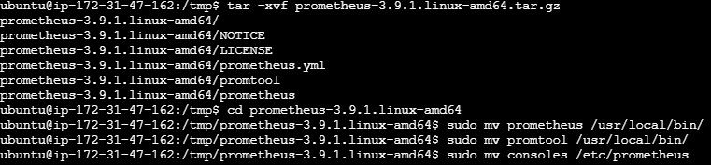
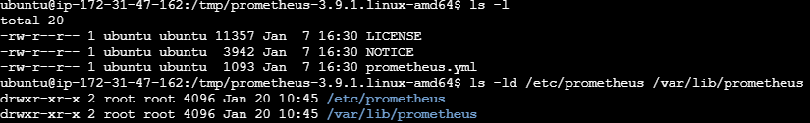

- Prometheus Configuration File Setup
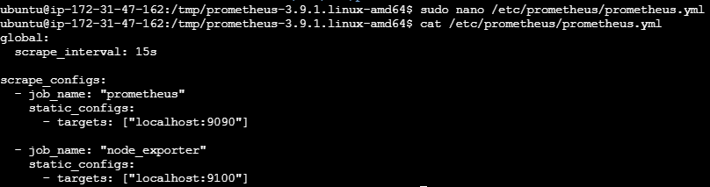

- Prometheus Service Configuration and Permission Setup
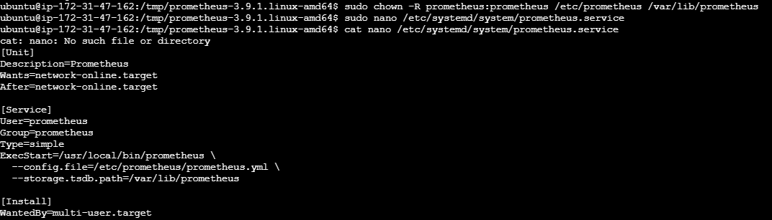

- Prometheus Service Startup and Status Verification
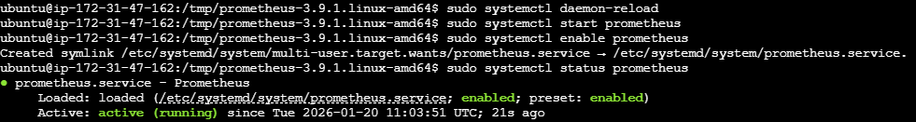
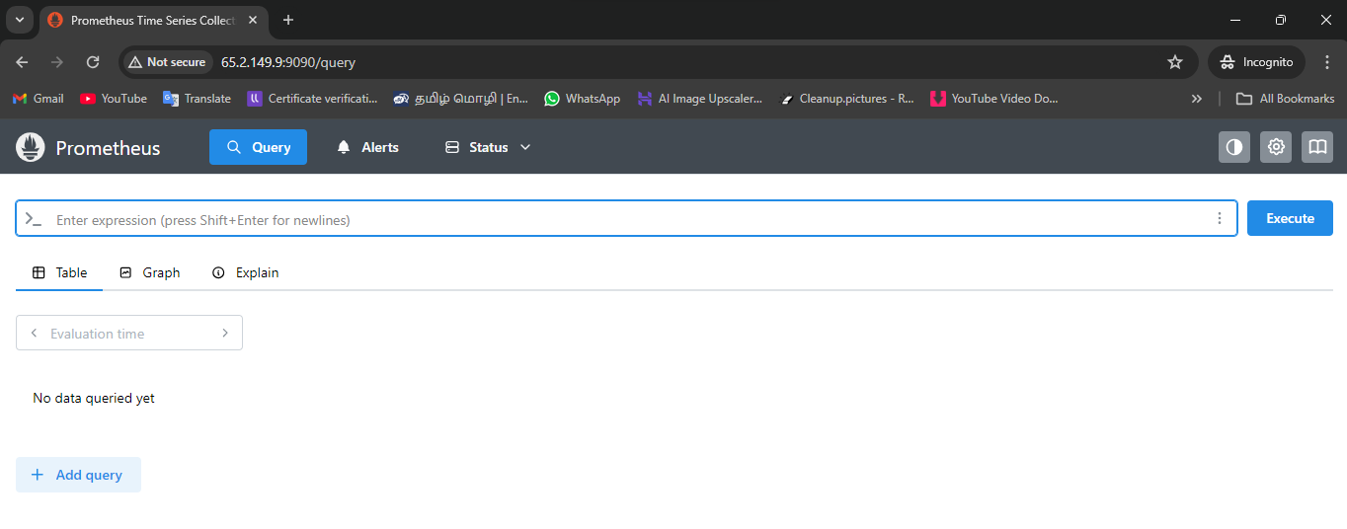

- Prometheus Data Directory and TSDB Initialization
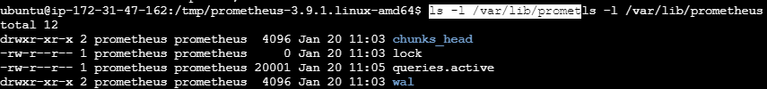
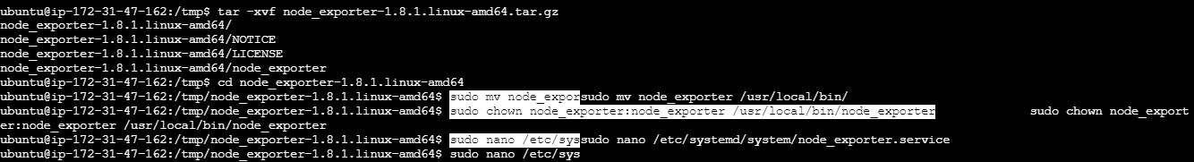
- Node Exporter Service Configuration and Node Exporter Metrics Endpoint and Prometheus Target Verification
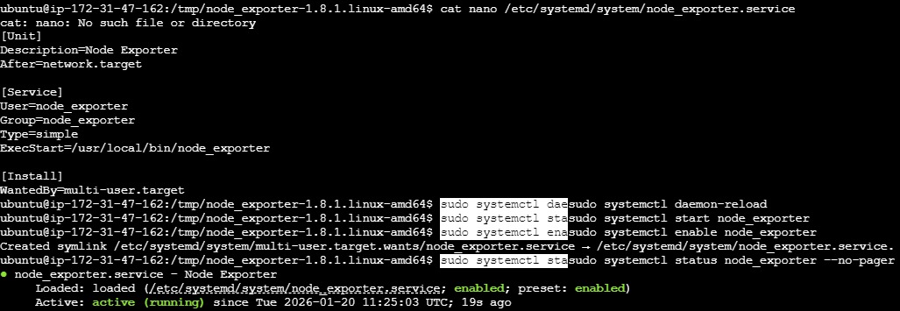
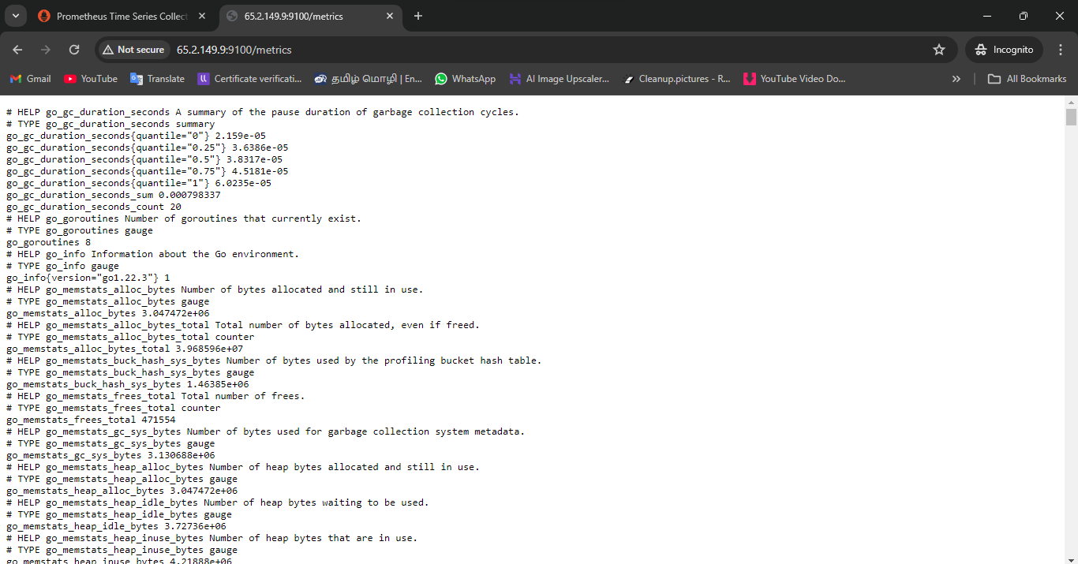
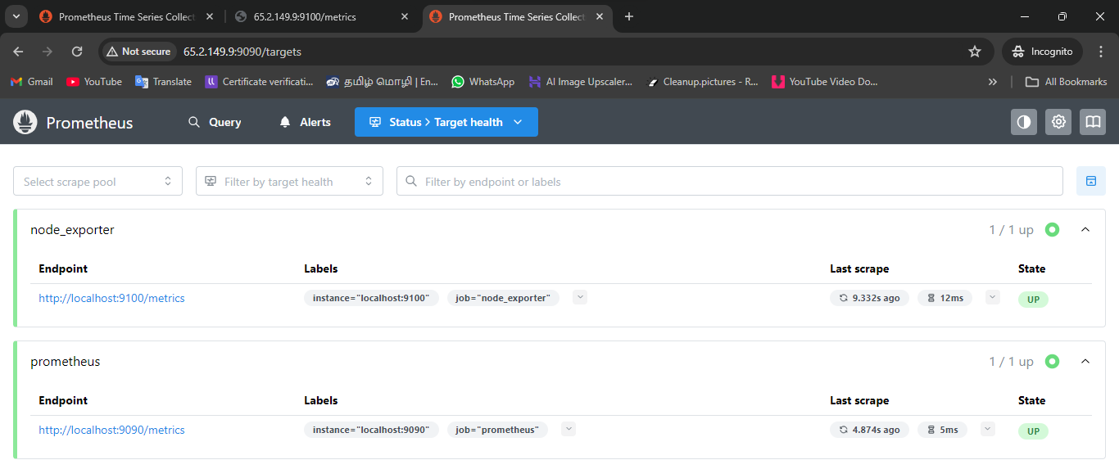
- Grafana Installation, Service Startup, and Web UI Access
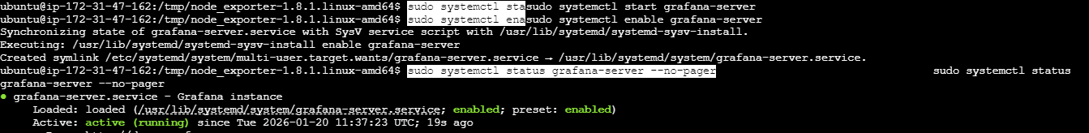
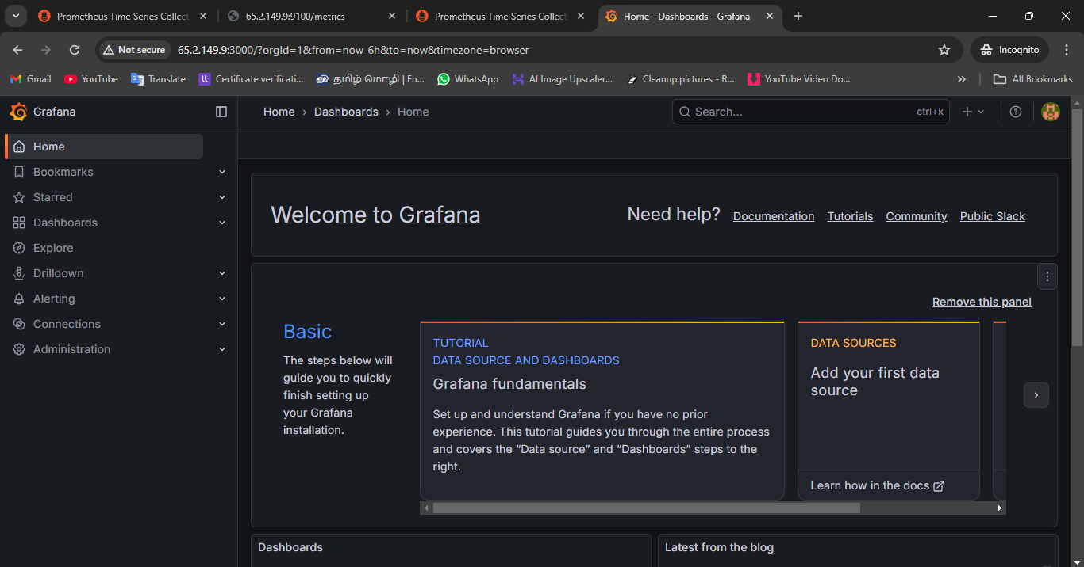

- Grafana Data Source Configuration and Dashboard Visualization
