**INTRODUCTION**

**Periods?** ***Shhh*** ..... Don’t say it loudly . What if any male member of family hear this ? It’s definitely not sounding weird .Coz it’s normalized in a desi household.This stigma make us understand that menstrual cycle is something to be hidden or to be ashamed of. When actually it isn’t.

Mensturation or Periods is still a taboo in today’s society. The menstruation taboo extends to many parts of a woman’s physiology and sexuality, but it primarily involves the stigma around discussing and caring for menstrual needs. This taboo often leads to the exclusion of women from social, domestic, and educational activities. The taboo also makes people feel like the topic of periods is uncomfortable, embarrassing, and even dangerous to discuss in some societies. This often leads women to use code words or slang to refer to periods.

* “According to reports of 2020, **88%** of women in India still rely on cloths, rags, hay, ash, and even leaves to manage their periods.”

**AIM**

So, Our initiative aims to improve the lives of women and girls by letting them know every fact related to sexual and reproductive issue . The step is to **generate awareness about the serious hygiene and emotional hurdles faced by women** in India during mensturation. This project is a step to normalize periods.

Periods isn’t a thing to be shamed of , Sanitary pads aren’t a thing to be covered in newspaper or black polythene as if we’re smuggling something. Periods give power to create a new life . So, How it can be unclean?

**NEED**

Even if your cycle is regular, charting your menstrual cycle is a good way to identify other gynecological health issues you may not be aware of. If you're someone who deals with a reproductive issue like endometriosis, fibroids, or polycystic ovary syndrome (PCOS), understanding your cycle as much as possible has major benefits. And of course, if you’re trying to get pregnant or trying to avoid pregnancy at all costs, knowing information like when you ovulate can help you on your journey. For example, if you’re feeling anxious or depressed or have persistent bloating, you might have a condition like [premenstrual dysphoric disorder](https://www.cosmopolitan.com/health-fitness/a27724313/pmdd-symptoms/)

Tracking what happens in your body each month also helps your doctor diagnose the reason you are not getting pregnant when you want to, since it can reveal if you are not ovulating, if you are having a short second part (luteal phase) of your cycle, or even if you have polycystic ovary syndrome or another hormone imbalance.

Not only can the app help women who are avoiding or attempting pregnancy, but it also helps those who are undergoing fertility treatments such as intrauterine insemination and in vitro fertilization.

Tracking problems with your period is important because bad periods are not something you need to suffer through. If the next time you see your doctor you point out painful cramps or long bleeding days you have tracked, they may be able to suggest lifestyle changes or medicines to make things better for you. For example, a change in your cycle might suggest that you have fibroids, a vaginal infection, pelvic inflammatory disease, or endometriosis. In rare cases, it can be a flag for endometrial cancer.

**Final Outlook**

* Register with Social Profile
* View Fertility window
* Check cycle & get estimated date of the next menstruation
* Get suggestions about upcoming PMS
* Show number of days left before the next period
* Push Notification to make daily log entries
* Push Notifications for onset of the next phase of the cycle
* Reminders to enter moods and take medications
* Create Detailed health profile with details like: Weight, Height, Ailments, Allergies, Period date
* Show days favorable for conception in fertility calendar
* Get notification for upcoming periods, ovulation and fertility
* Option to log symptoms to get improved predictions if the user have irregular periods
* Countdown to the birth of the baby
* Track weeks of pregnancy
* Graphical view of insights like baby’s growth
* View graphs of cycle, ovulation, fertility, and symptoms history
* Log cycle and period duration, weight changes, and activity during the cycle
* Get Medical and scientific information regarding periods and pregnancy
* Receive daily health tips based on your data
* Integrate app with Fitbit or other devices
* Detect moods, physical and emotional patterns
* Generate health report for doctor consultation
* Consult with women’s health expert via video or live chat

**SOME INSIGHTS**

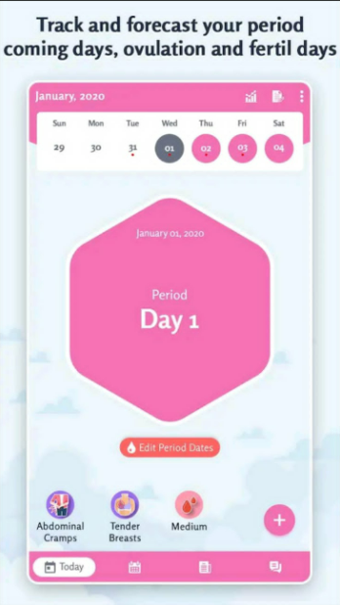 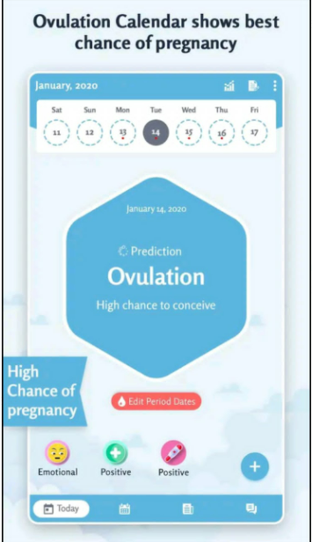 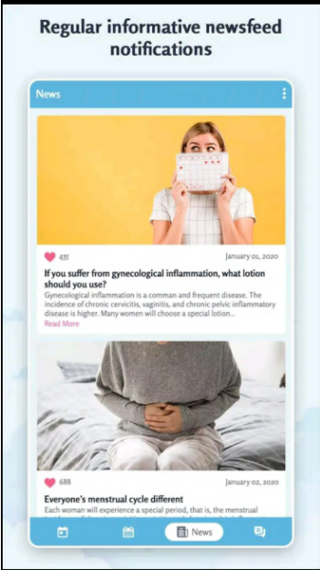 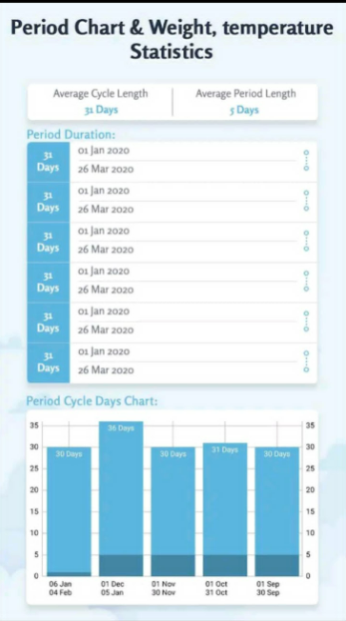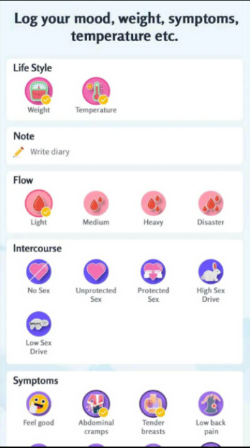 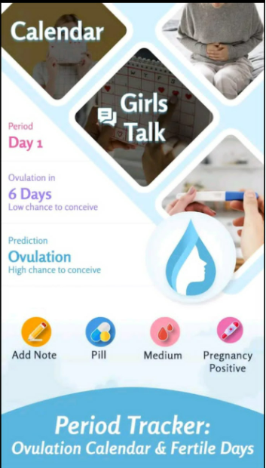 <https://support.apple.com/en-us/HT210407>