|  |
| --- |
|  |
| BIRD DETECTION AND CLASSIFICATION USING YOLO V3 |
| A FASTER APPROACH TO DETECTION AND CLASSIFICATION |

|  |
| --- |
| Padmini Ramesh , Ramdas Krishnakumar, Shashank Nigam  11-3-2019 |

CONTENTS

|  |  |
| --- | --- |
| TITLE | PAGE NO |
| 1. Abstract | 3 |
| 1. Architecture | 3 |
| 2.1 Network architecture of YOLO | 5 |
| 2.1.1 Training | 6 |
| 2.1.2 Loss Function | 7 |
| 2.1.3 Non maximal suppression | 9 |
| 2.1.4 Advantages | 9 |
| 2.1.5 Disadvantages | 9 |
| 2.2 YOLO v2 | 9 |
| 2.2.1 Dimensional clusters | 11 |
| 2.2.2 Direct location Prediction | 11 |
| 2.2.3 Fine grained features | 12 |
| 2.2.4 Multi scale training | 12 |
| 2.2.5 Training and classification | 12 |
| 2.2.6 Hierarchical classification | 13 |
| 2.3 YOLO v3 | 14 |
| 2.3.1 Bounding box Prediction | 14 |
| 2.3.2 Classification | 14 |
| 2.3.3 Feature extractor | 14 |
| 2.3.4 Pyramid feature network and prediction across scales | 15 |
| 2.3.5 Performance | 34 |
| 1. Structure of the code | 35 |
| 3.1 Functions Created | 37 |
| 1. Steps to improve Accuracy | 44 |
| 1. Findings | 44 |
| 1. Conclusion | 45 |
| References | 46 |
|  |  |
|  |  |
|  |  |
|  |  |

**1.ABSTRACT:**

In this project we present YOLO v3, a new approach to object detection. YOLO can be expanded as You Only Look Once. The prior work on object detection was carried out as a two-step process. They first generate a potential bounding box in an image and then use a classifier on those boxes. After classification, post-processing is used to refine the bounding boxes, eliminate duplicate detections and rescore the boxes based on the other objects in the scene. These methods are complex and are time-consuming. Also, they are hard to train and optimize because each individual component must be trained separately. YOLO eliminates these problems by carrying out the whole detection process in a single pipeline. As its name suggests, uses a single neural network to predict bounding boxes and class probabilities directly from full images in one evaluation [1]. This project describes the procedure of bird detection and classification using YOLO v3 , inferences from training and its OpenCV implementation.

**2.ARCHITECTURE:**

Many applications such as self-driving cars, responsive robotic systems, etc., require fast and accurate algorithms for object detection by eliminating the use of specialized sensors and assistive devices to report the real -time scenes. Pre-existing detection algorithms make use of classifiers to carry out detection. Methods like Deformable parts models (DPM) make use of a sliding window approach where in a sliding window is employed to traverse the entire image for extracting static features, classify regions and predict bounding boxes for high scoring regions. These disparate parts are hard to optimize and must be trained individually which makes a slow practice [1]. Figure 1 shows the example of an image where the sliding window approach is carried out.

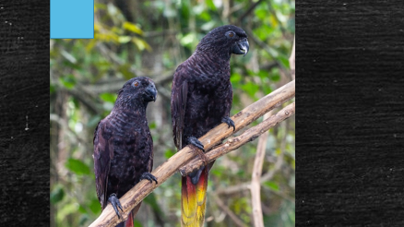

Figure 1: Example of sliding window approach

R-CNN (Regional CNN) uses a region-based approach replacing the sliding window procedure as discussed above. Selective region – based search produces bounding boxes, a convolutional network extracts features, an SVM classifier to bring out the probability scores of the boxes, a linear model adjusts the bounding boxes and non- maximal suppression to eliminate the bounding boxes [1]. The disadvantage of R-CNN is that it develops patches over regions of an image where an object is not present and gives rise to false detection. Figure 2 shows an example of R-CNN method.

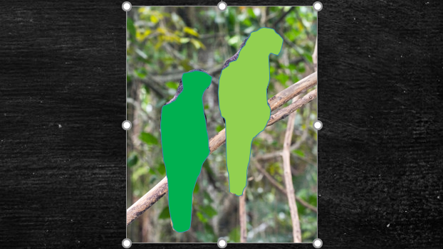

Figure 2: R-CNN method.

The above-mentioned methods suffer from the demerit of being slow. Hence the need for a faster training approach arose and emergence of YOLO occurred. It gives a global reasoning about the image while making predictions. It employs a single convolutional network to predict multiple bounding boxes and class probabilities for those boxes. It reframes object detection as a regression problem straight from image pixels to bounding box co-ordinates and class probabilities. As the whole network is a single network, it can be optimised from end to end.[1]

The working of YOLO can be put down as follows: It divides an input image into “S x S” grid cells and each cell can predict only one object. Each cell also concludes a fixed number of bounding boxes. The following elements can be deduced from a YOLO model:

* Each grid cell predicts ‘B’ bounding boxes.
* Each bounding box ‘B’ has ‘C’ confidence score.
* Each bounding box consists of five predictions: x, y, w, h, confidence score.

Where “x, y” are the co-ordinates of the centre of the bounding box.

“w, h” are the width and the height of the predicted box over the entire image.

Confidence score defines the likeliness of a box containing an object accuracy of the model in predicting the box that contains the object. It is formulated as follows: Pr(Object)* IOUPRED TRUTH

Where Pr(object)= Probability that an object is present in the box

IOUPREDTRUTH is the intersection over union of the predicted object and the ground truth.

Each cell has about N conditional class probabilities where N denotes the total number of classes. The conditional class probability is the probability that the detected object belongs to a class. Therefore, each cell contains one probability per category. The prediction of YOLO can be represented as (S, S, Bx5+C). [2]

The backbone of YOLO is a compilation of convolutional network to predict the tensor of (S, S, B*5+C). It makes use of convolutional network to reduce the spatial dimension to S x S with 1024 output channels at each location. It performs a linear regression using two fully connected layers to make the boundary box predictions. To make a final prediction, we keep those boxes with higher confidence scores as our final predictions. The class confidence score for each prediction box can be constituted as:

Class confidence score = Box Confidence Score x Conditional Class Probability

Conditional class probability can be formulated as: Pr(classi/object)

Where, Pr(classi/object) gives the probability the object belongs to classi given an object is present.

Class confidence score can be equated as: Pr(classi) * IOU

Where, Pr(classi) gives the probability the object belongs to classi

IOU is the intersection over union between the predicted and the ground truth.[2]

**2.1 NETWORK ARCHITECTURE OF YOLO:**

It consists of 24 convolutional layers followed by two fully connected layers. Few convolutional layers use 1x1 reduction layers to reduce the depth of feature maps. For the last convolutional layer, it gives out a tensor of shape (S, S,1024). It is then flattened. With two fully connected layers as a linear regressor, it outputs (S, S, B*5+C). Figure 3 represents the block diagram of the above-mentioned network.[2]

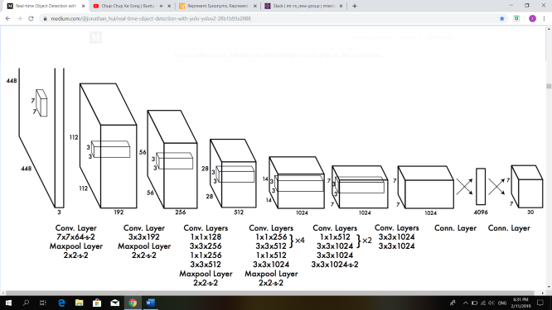

Figure 3: Architecture of YOLO [2]

The model summary can be visualized as follows:

Model: “model”

_________________________________________________________________

Layer (type) Output Shape Param #

=================================================================

input_1 (InputLayer) [(None, 448, 448, 3)] 0

_________________________________________________________________

conv2d (Conv2D) (None, 224, 224, 64) 9472

_________________________________________________________________

max_pooling2d (MaxPooling2D) (None, 112, 112, 64) 0

_________________________________________________________________

conv2d_1 (Conv2D) (None, 112, 112, 192) 110784

_________________________________________________________________

max_pooling2d_1 (MaxPooling2 (None, 56, 56, 192) 0

_________________________________________________________________

conv2d_2 (Conv2D) (None, 56, 56, 128) 24704

_________________________________________________________________

conv2d_3 (Conv2D) (None, 56, 56, 256) 295168

_________________________________________________________________

conv2d_4 (Conv2D) (None, 56, 56, 256) 65792

_________________________________________________________________

conv2d_5 (Conv2D) (None, 56, 56, 512) 1180160

_________________________________________________________________

max_pooling2d_2 (MaxPooling2 (None, 28, 28, 512) 0

_________________________________________________________________

conv2d_6 (Conv2D) (None, 28, 28, 256) 131328

_________________________________________________________________

conv2d_7 (Conv2D) (None, 28, 28, 512) 1180160

_________________________________________________________________

conv2d_8 (Conv2D) (None, 28, 28, 256) 131328

_________________________________________________________________

conv2d_9 (Conv2D) (None, 28, 28, 512) 1180160

_________________________________________________________________

conv2d_10 (Conv2D) (None, 28, 28, 256) 131328

_________________________________________________________________

conv2d_11 (Conv2D) (None, 28, 28, 512) 1180160

_________________________________________________________________

conv2d_12 (Conv2D) (None, 28, 28, 256) 131328

_________________________________________________________________

conv2d_13 (Conv2D) (None, 28, 28, 512) 1180160

_________________________________________________________________

conv2d_14 (Conv2D) (None, 28, 28, 1024) 4719616

_________________________________________________________________

max_pooling2d_3 (MaxPooling2 (None, 14, 14, 1024) 0

_________________________________________________________________

conv2d_15 (Conv2D) (None, 14, 14, 512) 524800

_________________________________________________________________

conv2d_16 (Conv2D) (None, 14, 14, 1024) 4719616

_________________________________________________________________

conv2d_17 (Conv2D) (None, 14, 14, 512) 524800

_________________________________________________________________

conv2d_18 (Conv2D) (None, 14, 14, 1024) 4719616

_________________________________________________________________

conv2d_19 (Conv2D) (None, 14, 14, 1024) 9438208

_________________________________________________________________

max_pooling2d_4 (MaxPooling2 (None, 7, 7, 1024) 0

_________________________________________________________________

conv2d_20 (Conv2D) (None, 7, 7, 1024) 9438208

_________________________________________________________________

conv2d_21 (Conv2D) (None, 7, 7, 1024) 9438208

_________________________________________________________________

flatten (Flatten) (None, 50176) 0

_________________________________________________________________

dense (Dense) (None, 4096) 205524992

_________________________________________________________________

dense_1 (Dense) (None, 1470) 6022590

=================================================================

Total params: 262,002,686

Trainable params: 262,002,686

Non-trainable params: 0

Total trainable parameters are 262,002,686

**2.1.1 TRAINING:**

The convolutional layers are pre-trained on the ImageNet 1000 -class competition data set. The first 20 convolutional layers are being used for this purpose followed by an average -pooling layer and a fully connected layer. The network was trained for a week to achieve top -5 accuracy of 88%. The model is then converted to perform detection. Furthermore, four convolutional layers and two fully connected layers with randomly initialized weights are added. The input resolution of the network is increased from 224 x 224 to 448 x 448 to produce fine-grained visual information to perform detection. The heights and weights of the bounding box are normalized to fall between 0 and 1. The final layer predicts both class probabilities and bounding box coordinates. The x and y co-ordinates are parameterized to be offsets of a grid cell location, so they are bounded between 0 and 1. The final layer makes use of linear activation and all other layers makes use of leaky rectified linear activation which can be depicted as:

We optimize for the sum of squared error for the model. It weights localization error equally with classification error which may not be ideal. To remedy this one can, increase the loss from the bounding box coordinate predictions and decrease the loss confidence for the boxes that do not contain the object. Two parameters noobj=0.5 are used to accomplish this. Sum- squared error is also equally weights error in large boxes and small boxes. In order to penalize less the boxes with large height and width we make use of square root of the bounding box width and height instead of width directly. YOLO predicts multiple bounding boxes per grid cell. During training, only one bounding box predictor to be responsible for each object is required. Each predictor gets better at predicting certain sizes, aspect ratio, or classes of object, improving overall recall. [1]

**2.1.2 LOSS FUNCTION:**

The loss function comprises of the following:

Classification loss:

If an object is detected, the classification loss at each cell is the squared error of the conditional class probabilities for each class as shown in figure 4:

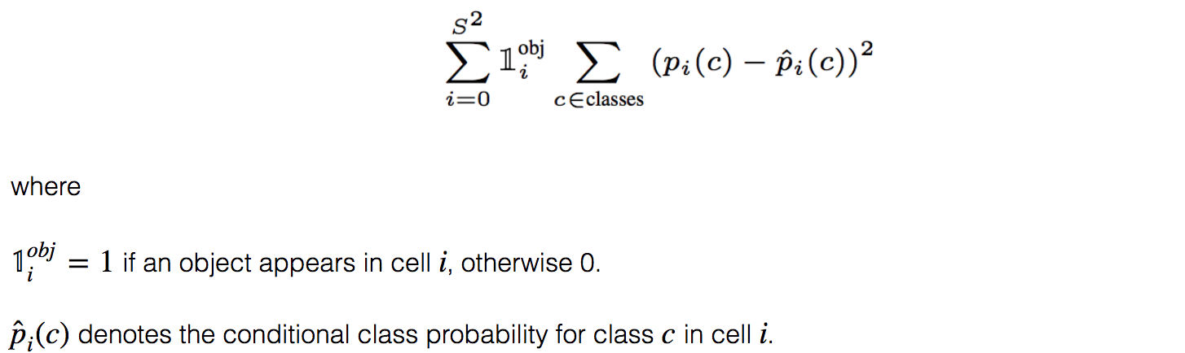

Figure 4: Classification loss [2]

Localization loss:

The localization loss measures the errors in the predicted boundary box locations and sizes. It is depicted in figure 5.

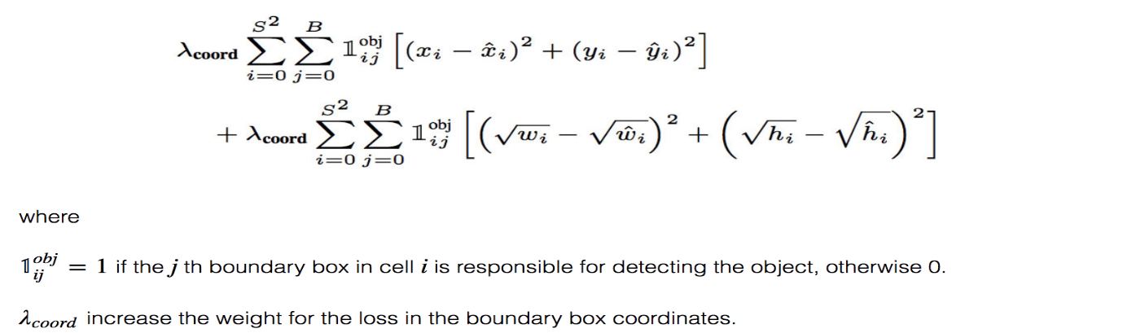

Figure 5: Localization loss [2]

Confidence loss:

If an object is detected in the box, the confidence loss (measuring the presence of an object in the box) is as shown in figure 6:

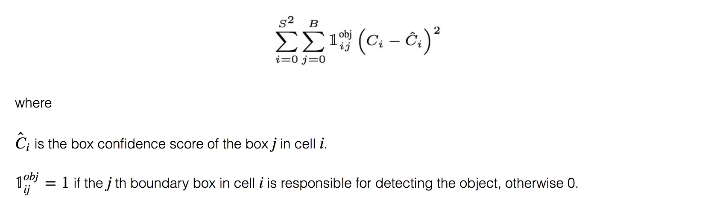

Figure 6: Confidence loss [2]

If an object is not detected in the box, then the loss equals to:

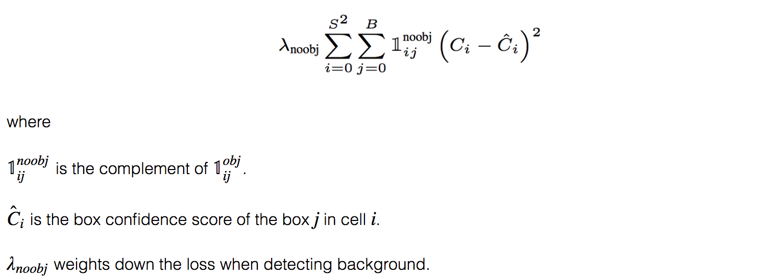

Figure 7: No -object detection loss [2]

The final loss adds up confidence loss, classification loss and the localization loss together.

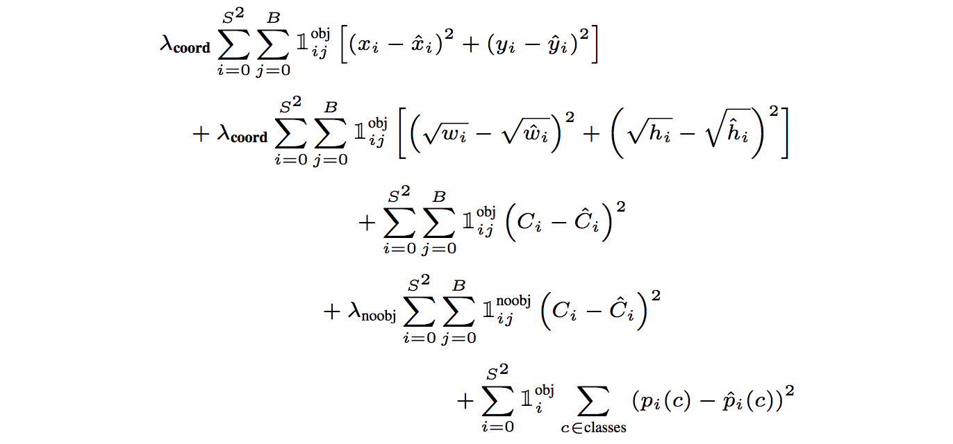

Figure 8 : Total Loss [2]

**2.1.3 NON -MAXIMAL SUPPRESSION:**

There are situations where YOLO can duplicate detections for the same object. In order to eradicate this, YOLO employs non-maximal suppression to remove duplicate detections with lower confidence. It adds to about 2-3% in mAP. It is implemented by sorting the predictions by their confidence scores. From the top scores, ignore any current prediction if any previous prediction has the same class and IoU >0.5 with the current prediction. Repeat this step until all predictions are checked.[2]

**2.1.4 ADVANTAGES:**

The prediction of object locations and their classes are made from one single network. Hence, they can be trained end to end to improve accuracy. This makes the algorithm work faster and it turns out to be good for real-time processing. It outperforms other methods when generalizing from natural images to other domains like artwork.[1]

**2.1.5 DISADVANTAGES:**

It accesses the whole image in predicting boundaries. Hence it demonstrates fewer false positives in the background areas. It has high localization errors, that is, measurement of how to good to locate all objects is high. YOLO imposes strong spatial constraints on bounding box predictions since each grid cell only predicts 2 boxes and can have one class. This spatial constraint limits the number of nearby objects that our model can predict. The network suffers in localization for the objects that appear in groups such as flock of birds. YOLO learns from the data, so it is hard to predict the newer aspect ratio or configurations. Down Sampling layers from input image causes network to learn limited features.[1]

**2.2 YOLO V2:**

This is the second version of YOLO which was designed with the objective to improve the accuracy and make it faster. This is achieved by adding batch normalization in convolutional layers. It removes the need for adding dropouts and improves the mAP by 2 %. YOLO v2 starts with 224 x 224 pictures for the classifier training but then retune the classifier again with 448 x 448 with fewer epochs. This makes the detector training easier and increases the mAP by 4 %. Here, instead of predicting arbitrary bounding boxes, the offset to each boxes are predicted. If the offset values are constrained, the diversity of the predictions can be maintained, and each prediction can be made to focus on a specific shape. Hence the training is stable.[4]

Here, the fully connected layers present in YOLO are replaced with three 3x3 convolutional layers each outputting 1024 output channels. Then a 1 x 1 convolutional layer is used to convert S x S x 1024 output into S x S x 5 x [ location, classes, objectness]. Here each prediction includes 4 parameters for the boundary box : 1 box confidence score and C class probabilities.[2]

The model can be visualized as follows in figure 9:

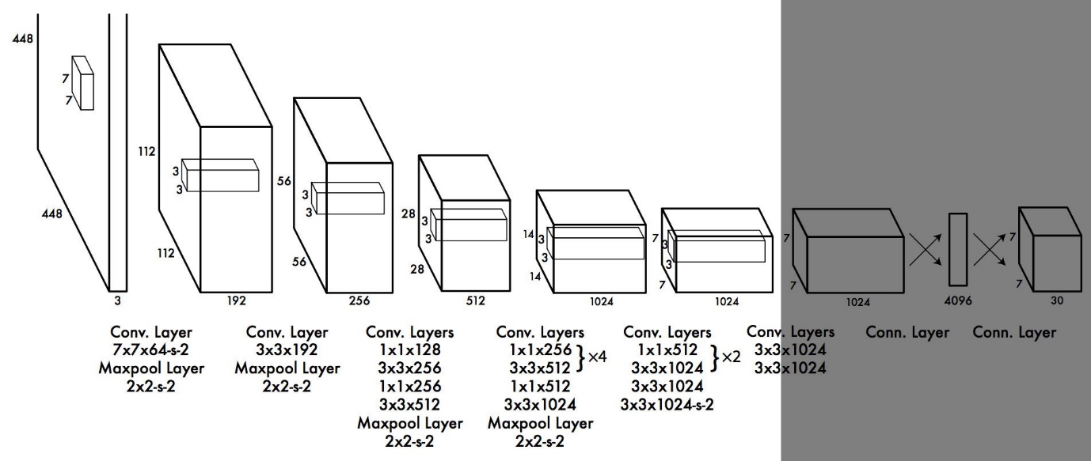

Figure 9: Model architecture of YOLO

The model summary is listed below:

Model: "model_11"

_________________________________________________________________

Layer (type) Output Shape Param #

=================================================================

input_17 (InputLayer) [(None, 224, 224, 3)] 0

_________________________________________________________________

batch_normalization_91 (Batc (None, 224, 224, 3) 12

_________________________________________________________________

conv2d_112 (Conv2D) (None, 224, 224, 32) 896

_________________________________________________________________

max_pooling2d_32 (MaxPooling (None, 112, 112, 32) 0

_________________________________________________________________

batch_normalization_92 (Batc (None, 112, 112, 32) 128

_________________________________________________________________

conv2d_113 (Conv2D) (None, 112, 112, 64) 18496

_________________________________________________________________

max_pooling2d_33 (MaxPooling (None, 56, 56, 64) 0

_________________________________________________________________

batch_normalization_93 (Batc (None, 56, 56, 64) 256

_________________________________________________________________

conv2d_114 (Conv2D) (None, 56, 56, 128) 73856

_________________________________________________________________

batch_normalization_94 (Batc (None, 56, 56, 128) 512

_________________________________________________________________

conv2d_115 (Conv2D) (None, 56, 56, 64) 73792

_________________________________________________________________

batch_normalization_95 (Batc (None, 56, 56, 64) 256

_________________________________________________________________

conv2d_116 (Conv2D) (None, 56, 56, 128) 73856

_________________________________________________________________

max_pooling2d_34 (MaxPooling (None, 28, 28, 128) 0

_________________________________________________________________

batch_normalization_96 (Batc (None, 28, 28, 128) 512

_________________________________________________________________

conv2d_117 (Conv2D) (None, 28, 28, 256) 295168

_________________________________________________________________

batch_normalization_97 (Batc (None, 28, 28, 256) 1024

_________________________________________________________________

conv2d_118 (Conv2D) (None, 28, 28, 128) 295040

_________________________________________________________________

batch_normalization_98 (Batc (None, 28, 28, 128) 512

_________________________________________________________________

conv2d_119 (Conv2D) (None, 28, 28, 256) 295168

_________________________________________________________________

max_pooling2d_35 (MaxPooling (None, 14, 14, 256) 0

_________________________________________________________________

batch_normalization_99 (Batc (None, 14, 14, 256) 1024

_________________________________________________________________

conv2d_120 (Conv2D) (None, 14, 14, 512) 1180160

_________________________________________________________________

batch_normalization_100 (Bat (None, 14, 14, 512) 2048

_________________________________________________________________

conv2d_121 (Conv2D) (None, 14, 14, 256) 1179904

_________________________________________________________________

batch_normalization_101 (Bat (None, 14, 14, 256) 1024

_________________________________________________________________

conv2d_122 (Conv2D) (None, 14, 14, 512) 1180160

_________________________________________________________________

batch_normalization_102 (Bat (None, 14, 14, 512) 2048

_________________________________________________________________

conv2d_123 (Conv2D) (None, 14, 14, 256) 1179904

_________________________________________________________________

batch_normalization_103 (Bat (None, 14, 14, 256) 1024

_________________________________________________________________

conv2d_124 (Conv2D) (None, 14, 14, 512) 1180160

_________________________________________________________________

max_pooling2d_36 (MaxPooling (None, 7, 7, 512) 0

_________________________________________________________________

batch_normalization_104 (Bat (None, 7, 7, 512) 2048

_________________________________________________________________

conv2d_125 (Conv2D) (None, 7, 7, 1024) 4719616

_________________________________________________________________

batch_normalization_105 (Bat (None, 7, 7, 1024) 4096

_________________________________________________________________

conv2d_126 (Conv2D) (None, 7, 7, 512) 4719104

_________________________________________________________________

batch_normalization_106 (Bat (None, 7, 7, 512) 2048

_________________________________________________________________

conv2d_127 (Conv2D) (None, 7, 7, 1024) 4719616

_________________________________________________________________

batch_normalization_107 (Bat (None, 7, 7, 1024) 4096

_________________________________________________________________

conv2d_128 (Conv2D) (None, 7, 7, 512) 4719104

_________________________________________________________________

batch_normalization_108 (Bat (None, 7, 7, 512) 2048

_________________________________________________________________

conv2d_129 (Conv2D) (None, 7, 7, 1024) 4719616

_________________________________________________________________

batch_normalization_109 (Bat (None, 7, 7, 1024) 4096

_________________________________________________________________

conv2d_130 (Conv2D) (None, 7, 7, 1000) 1025000

_________________________________________________________________

global_average_pooling2d_1 ( (None, 1000) 0

=================================================================

Total params: 31,677,428

Trainable params: 31,663,022

**2.2.1 DIMENSIONAL CLUSTERS:**

Other networks make use of the prior boxes that are handpicked. This makes the network easier to train. Instead of choosing priors by hand YOLO v2 makes use of K means clustering on the training set of bounding boxes to automatically find good priors. Standard K means with Euclidean distance generates more error for larger boxes than for smaller boxes. The main idea of using priors is for good IOU scores which are independent of the size of the boxes. New vector used is: d (box, centroid) = 1 – IOU (box, centroid).When running K means for different values of k and plotting the average IOU with the closes centroid k=5 is used as a good tradeoff between the model complexity and high recall. The cluster centroids are significantly different than the handpicked anchor boxes. There are fewer short wide boxes and more tall and thin boxes. [4]

**2.2.2 DIRECT LOCATION PREDICTION:**

Predictions are made based on the offsets to the anchors. YOLO predicts five parameters (tx,ty, tw, th and t0) and applies the sigma function to constraint its possible offset range.This has been exhibited in figure 10.

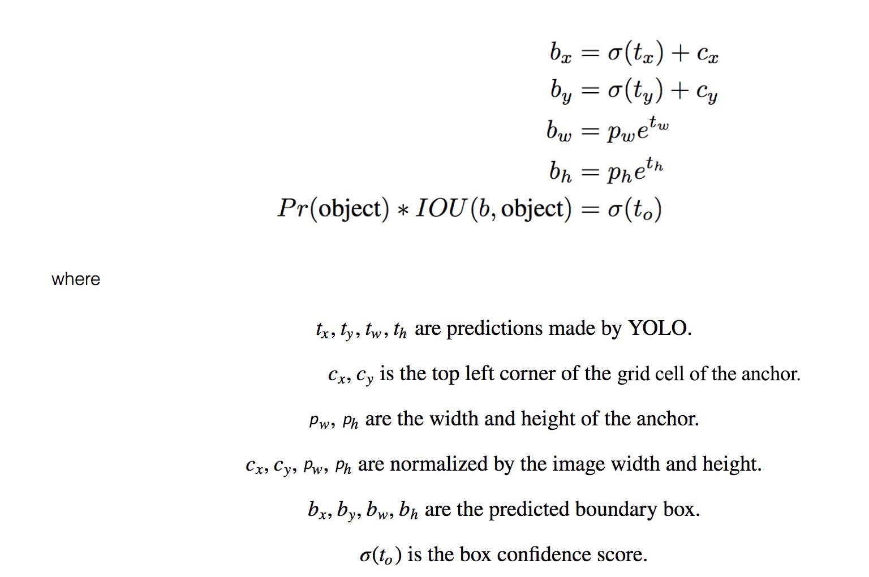

Figure 10: Direct location prediction in YOLO v2 [2]

**2.2.3 FINE – GRAINED FEATURES:**

Convolutional layers reduce the spatial dimension gradually. Other object detectors like Mobile SSD detects objects from features extracted in each layer. Here YOLO adopts a method called passthrough where a 13x13x2048 layer is obtained by reshaping 26x26x512. It is then concatenated with the original 13x13x1024 output layer and then convolution is performed on the 13x13x3072.[4]

**2.2.4 MULTI-SCALE TRAINING:**

The original YOLO uses an input resolution of 448x448. With the addition of anchor boxes the resolution changes to 416x416. Since YOLO makes use of only convolution and pooling layers it can be resized on the fly. YOLOv2 needs to be robust to running on images of different sizes so it can train this into model. Instead of fixing the input size the network can be changed for very few iterations. Every 10 batches of the network randomly choose a new image dimension size. As the model down samples by 32 one can pull from multiples of 32 : {320,352,….608}.

Network is resized to that dimension and continues to train. This forces the network to learn to predict well across a variety of input dimensions. Same network can predict detections at different resolutions.[4]

**2.2.5 TRAINING AND CLASSIFICATION:**

The initial training is performed on ImageNet 1000 class classification dataset with 160 epochs: using stochastic gradient descent with a learning rate of 0.1, polynomial rate decay with a power of 4, weight decay of 0.0005 and momentum of 0.9. After initial training of images of size 224x224, the image is further fined tuned at a larger size. The modification of network for detection is done by removing the last convolution later and instead adding the three 3x3 convolution layer with 1024 filters each is followed by 1x1 convolution layer with the number of outputs required for the detection. During training both detection and classification processes are mixed. When the network sees an image for detection it can back propagate based on the full YOLOv2 loss function. When it sees a classification image it can back propagate loss from the classification specific parts of the architecture.[2]

**2.2.6 HIERARCHICAL CLASSIFICATION:**

YOLO combines labels from different data sets to form a tree like structure called word tree. It involves parent – child relationship where the main category becomes the parent and its sub-categories are merged as its children as shown in figure 11.The merged labels are not mutually exclusive. A softmax function is applied to compute the probability from the scores of a child and its siblings.

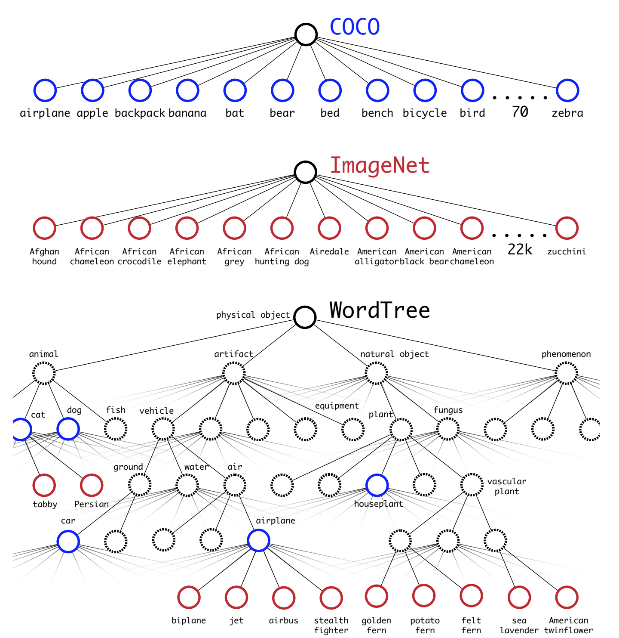

Figure 11: Word tree

**2.3 YOLO V3:**

This is an updated version of YOLO v2 and the network layers are slightly bigger than the previous ones.

**2.3.1 BOUNDING BOX PREDICTION:**

It predicts the objectness score for each bounding box using logistic regression. Bounding box are predicted using dimensional clusters as anchor boxes. The network predicts 4 coordinates (opposed to 5 in case of YOLOv2) tx, ty, tw, th.[3] If the cell offsets from the top left corner of the image by (cx, cy) and bounding box prior has width and height of pw, ph then the prediction corresponds to (figure 12):



Figure 12: Bounding box prediction

During training, sum of squared error loss is used for the prediction. If the ground truth label for some coordinate prediction is ^t*, its gradient is the ground truth minus prediction: t^* -t* This ground truth values can be easily computed by inverting the equations above. This should be 1 if the bounding box prior overlaps a ground truth more than any other bounding box prior.

If the bounding box prior is not the best but it overlaps the ground truth by more than some threshold, then the prediction is ignored. If a bounding box prior is not assigned to a ground truth object it does not incur any loss for coordinate or class prediction, only on objectness. [3]

**2.3.2 CLASSIFICATION:**

YOLO v3 uses multi-label classification. It replaces the softmax activation function with independent logistic classifiers to calculate the likeliness of an input belonging to a label. It uses binary cross entropy loss for each label which reduces the computational complexity.[2]

**2.3.3 FEATURE EXTRACTOR:**

Here a new 53 layer “Darknet 53” is put into action. It mainly comprises of 3 x 3 and 1 x 1 with skip connections like residual networks in ResNets. It has less billion floating point operations (BFLOP) than ResNet 152 , but achieves the same classification accuracy 2 x faster.[2]. Figure 13 shows the structure of Darknet 53.

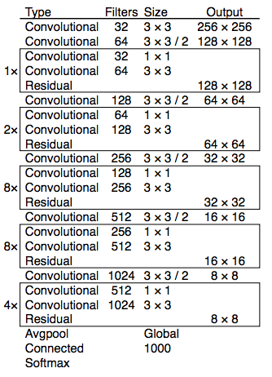

Figure 13: Darknet 53 [2]

**2.3.4 PYRAMID FEATURE NETWORK AND PREDICTION ACROSS SCALES:**

YOLO v3 makes three predictions per location. Each prediction consists of a boundary box, an objectness and C class scores, that is, N x N x [3 x [4 + 1+ C]] predictions. The predictions are made at three different layers. One at the last feature map layer. Second, it goes two layers back, up samples it by 2. It then takes a feature map with higher resolution and merges it with the up sampled feature map using element -wise addition. It applies convolutional filters on the merged map to make the second set of predictions. Repeat the previous step so that the resulted feature map has good level of semantic information and good resolution spatial information on object locations. To determine the priors, it applies k-means clustering by pre-selecting nine clusters. For COCO dataset, the width and height of the anchors are (10 x 13), (16 x 30), (33 x 23), (30 x 61), (62 x 45), (59 x 119) , (116 x 90) , (156 x 198 ), ( 373 x 326). These nine priors are grouped into three different groups according to their scales. Each group is assigned to a specific feature map for detecting objects.[3] The whole model starting from base feature extractor can be visualized as follows:

Model: "model_4"

__________________________________________________________________________________________________

Layer (type) Output Shape Param # Connected to

==================================================================================================

input_1 (InputLayer) [(None, None, None, 0

__________________________________________________________________________________________________

conv2d (Conv2D) (None, None, None, 3 864 input_1[0][0]

__________________________________________________________________________________________________

batch_normalization (BatchNorma (None, None, None, 3 128 conv2d[0][0]

__________________________________________________________________________________________________

leaky_re_lu (LeakyReLU) (None, None, None, 3 0 batch_normalization[0][0]

__________________________________________________________________________________________________

zero_padding2d (ZeroPadding2D) (None, None, None, 3 0 leaky_re_lu[0][0]

__________________________________________________________________________________________________

conv2d_1 (Conv2D) (None, None, None, 6 18432 zero_padding2d[0][0]

__________________________________________________________________________________________________

batch_normalization_1 (BatchNor (None, None, None, 6 256 conv2d_1[0][0]

__________________________________________________________________________________________________

leaky_re_lu_1 (LeakyReLU) (None, None, None, 6 0 batch_normalization_1[0][0]

__________________________________________________________________________________________________

conv2d_2 (Conv2D) (None, None, None, 3 2048 leaky_re_lu_1[0][0]

__________________________________________________________________________________________________

batch_normalization_2 (BatchNor (None, None, None, 3 128 conv2d_2[0][0]

__________________________________________________________________________________________________

leaky_re_lu_2 (LeakyReLU) (None, None, None, 3 0 batch_normalization_2[0][0]

__________________________________________________________________________________________________

conv2d_3 (Conv2D) (None, None, None, 6 18432 leaky_re_lu_2[0][0]

__________________________________________________________________________________________________

batch_normalization_3 (BatchNor (None, None, None, 6 256 conv2d_3[0][0]

__________________________________________________________________________________________________

leaky_re_lu_3 (LeakyReLU) (None, None, None, 6 0 batch_normalization_3[0][0]

__________________________________________________________________________________________________

add (Add) (None, None, None, 6 0 leaky_re_lu_1[0][0]

leaky_re_lu_3[0][0]

__________________________________________________________________________________________________

zero_padding2d_1 (ZeroPadding2D (None, None, None, 6 0 add[0][0]

__________________________________________________________________________________________________

conv2d_4 (Conv2D) (None, None, None, 1 73728 zero_padding2d_1[0][0]

__________________________________________________________________________________________________

batch_normalization_4 (BatchNor (None, None, None, 1 512 conv2d_4[0][0]

__________________________________________________________________________________________________

leaky_re_lu_4 (LeakyReLU) (None, None, None, 1 0 batch_normalization_4[0][0]

__________________________________________________________________________________________________

conv2d_5 (Conv2D) (None, None, None, 6 8192 leaky_re_lu_4[0][0]

__________________________________________________________________________________________________

batch_normalization_5 (BatchNor (None, None, None, 6 256 conv2d_5[0][0]

__________________________________________________________________________________________________

leaky_re_lu_5 (LeakyReLU) (None, None, None, 6 0 batch_normalization_5[0][0]

__________________________________________________________________________________________________

conv2d_6 (Conv2D) (None, None, None, 1 73728 leaky_re_lu_5[0][0]

__________________________________________________________________________________________________

batch_normalization_6 (BatchNor (None, None, None, 1 512 conv2d_6[0][0]

__________________________________________________________________________________________________

leaky_re_lu_6 (LeakyReLU) (None, None, None, 1 0 batch_normalization_6[0][0]

__________________________________________________________________________________________________

add_1 (Add) (None, None, None, 1 0 leaky_re_lu_4[0][0]

leaky_re_lu_6[0][0]

__________________________________________________________________________________________________

conv2d_7 (Conv2D) (None, None, None, 6 8192 add_1[0][0]

__________________________________________________________________________________________________

batch_normalization_7 (BatchNor (None, None, None, 6 256 conv2d_7[0][0]

__________________________________________________________________________________________________

leaky_re_lu_7 (LeakyReLU) (None, None, None, 6 0 batch_normalization_7[0][0]

__________________________________________________________________________________________________

conv2d_8 (Conv2D) (None, None, None, 1 73728 leaky_re_lu_7[0][0]

__________________________________________________________________________________________________

batch_normalization_8 (BatchNor (None, None, None, 1 512 conv2d_8[0][0]

__________________________________________________________________________________________________

leaky_re_lu_8 (LeakyReLU) (None, None, None, 1 0 batch_normalization_8[0][0]

__________________________________________________________________________________________________

add_2 (Add) (None, None, None, 1 0 add_1[0][0]

leaky_re_lu_8[0][0]

__________________________________________________________________________________________________

zero_padding2d_2 (ZeroPadding2D (None, None, None, 1 0 add_2[0][0]

__________________________________________________________________________________________________

conv2d_9 (Conv2D) (None, None, None, 2 294912 zero_padding2d_2[0][0]

__________________________________________________________________________________________________

batch_normalization_9 (BatchNor (None, None, None, 2 1024 conv2d_9[0][0]

__________________________________________________________________________________________________

leaky_re_lu_9 (LeakyReLU) (None, None, None, 2 0 batch_normalization_9[0][0]

__________________________________________________________________________________________________

conv2d_10 (Conv2D) (None, None, None, 1 32768 leaky_re_lu_9[0][0]

__________________________________________________________________________________________________

batch_normalization_10 (BatchNo (None, None, None, 1 512 conv2d_10[0][0]

__________________________________________________________________________________________________

leaky_re_lu_10 (LeakyReLU) (None, None, None, 1 0 batch_normalization_10[0][0]

__________________________________________________________________________________________________

conv2d_11 (Conv2D) (None, None, None, 2 294912 leaky_re_lu_10[0][0]

__________________________________________________________________________________________________

batch_normalization_11 (BatchNo (None, None, None, 2 1024 conv2d_11[0][0]

__________________________________________________________________________________________________

leaky_re_lu_11 (LeakyReLU) (None, None, None, 2 0 batch_normalization_11[0][0]

__________________________________________________________________________________________________

add_3 (Add) (None, None, None, 2 0 leaky_re_lu_9[0][0]

leaky_re_lu_11[0][0]

__________________________________________________________________________________________________

conv2d_12 (Conv2D) (None, None, None, 1 32768 add_3[0][0]

__________________________________________________________________________________________________

batch_normalization_12 (BatchNo (None, None, None, 1 512 conv2d_12[0][0]

__________________________________________________________________________________________________

leaky_re_lu_12 (LeakyReLU) (None, None, None, 1 0 batch_normalization_12[0][0]

__________________________________________________________________________________________________

conv2d_13 (Conv2D) (None, None, None, 2 294912 leaky_re_lu_12[0][0]

__________________________________________________________________________________________________

batch_normalization_13 (BatchNo (None, None, None, 2 1024 conv2d_13[0][0]

__________________________________________________________________________________________________

leaky_re_lu_13 (LeakyReLU) (None, None, None, 2 0 batch_normalization_13[0][0]

__________________________________________________________________________________________________

add_4 (Add) (None, None, None, 2 0 add_3[0][0]

leaky_re_lu_13[0][0]

__________________________________________________________________________________________________

conv2d_14 (Conv2D) (None, None, None, 1 32768 add_4[0][0]

__________________________________________________________________________________________________

batch_normalization_14 (BatchNo (None, None, None, 1 512 conv2d_14[0][0]

__________________________________________________________________________________________________

leaky_re_lu_14 (LeakyReLU) (None, None, None, 1 0 batch_normalization_14[0][0]

__________________________________________________________________________________________________

conv2d_15 (Conv2D) (None, None, None, 2 294912 leaky_re_lu_14[0][0]

__________________________________________________________________________________________________

batch_normalization_15 (BatchNo (None, None, None, 2 1024 conv2d_15[0][0]

__________________________________________________________________________________________________

leaky_re_lu_15 (LeakyReLU) (None, None, None, 2 0 batch_normalization_15[0][0]

__________________________________________________________________________________________________

add_5 (Add) (None, None, None, 2 0 add_4[0][0]

leaky_re_lu_15[0][0]

__________________________________________________________________________________________________

conv2d_16 (Conv2D) (None, None, None, 1 32768 add_5[0][0]

__________________________________________________________________________________________________

batch_normalization_16 (BatchNo (None, None, None, 1 512 conv2d_16[0][0]

__________________________________________________________________________________________________

leaky_re_lu_16 (LeakyReLU) (None, None, None, 1 0 batch_normalization_16[0][0]

__________________________________________________________________________________________________

conv2d_17 (Conv2D) (None, None, None, 2 294912 leaky_re_lu_16[0][0]

__________________________________________________________________________________________________

batch_normalization_17 (BatchNo (None, None, None, 2 1024 conv2d_17[0][0]

__________________________________________________________________________________________________

leaky_re_lu_17 (LeakyReLU) (None, None, None, 2 0 batch_normalization_17[0][0]

__________________________________________________________________________________________________

add_6 (Add) (None, None, None, 2 0 add_5[0][0]

leaky_re_lu_17[0][0]

__________________________________________________________________________________________________

conv2d_18 (Conv2D) (None, None, None, 1 32768 add_6[0][0]

__________________________________________________________________________________________________

batch_normalization_18 (BatchNo (None, None, None, 1 512 conv2d_18[0][0]

__________________________________________________________________________________________________

leaky_re_lu_18 (LeakyReLU) (None, None, None, 1 0 batch_normalization_18[0][0]

__________________________________________________________________________________________________

conv2d_19 (Conv2D) (None, None, None, 2 294912 leaky_re_lu_18[0][0]

__________________________________________________________________________________________________

batch_normalization_19 (BatchNo (None, None, None, 2 1024 conv2d_19[0][0]

__________________________________________________________________________________________________

leaky_re_lu_19 (LeakyReLU) (None, None, None, 2 0 batch_normalization_19[0][0]

__________________________________________________________________________________________________

add_7 (Add) (None, None, None, 2 0 add_6[0][0]

leaky_re_lu_19[0][0]

__________________________________________________________________________________________________

conv2d_20 (Conv2D) (None, None, None, 1 32768 add_7[0][0]

__________________________________________________________________________________________________

batch_normalization_20 (BatchNo (None, None, None, 1 512 conv2d_20[0][0]

__________________________________________________________________________________________________

leaky_re_lu_20 (LeakyReLU) (None, None, None, 1 0 batch_normalization_20[0][0]

__________________________________________________________________________________________________

conv2d_21 (Conv2D) (None, None, None, 2 294912 leaky_re_lu_20[0][0]

__________________________________________________________________________________________________

batch_normalization_21 (BatchNo (None, None, None, 2 1024 conv2d_21[0][0]

__________________________________________________________________________________________________

leaky_re_lu_21 (LeakyReLU) (None, None, None, 2 0 batch_normalization_21[0][0]

__________________________________________________________________________________________________

add_8 (Add) (None, None, None, 2 0 add_7[0][0]

leaky_re_lu_21[0][0]

__________________________________________________________________________________________________

conv2d_22 (Conv2D) (None, None, None, 1 32768 add_8[0][0]

__________________________________________________________________________________________________

batch_normalization_22 (BatchNo (None, None, None, 1 512 conv2d_22[0][0]

__________________________________________________________________________________________________

leaky_re_lu_22 (LeakyReLU) (None, None, None, 1 0 batch_normalization_22[0][0]

__________________________________________________________________________________________________

conv2d_23 (Conv2D) (None, None, None, 2 294912 leaky_re_lu_22[0][0]

__________________________________________________________________________________________________

batch_normalization_23 (BatchNo (None, None, None, 2 1024 conv2d_23[0][0]

__________________________________________________________________________________________________

leaky_re_lu_23 (LeakyReLU) (None, None, None, 2 0 batch_normalization_23[0][0]

__________________________________________________________________________________________________

add_9 (Add) (None, None, None, 2 0 add_8[0][0]

leaky_re_lu_23[0][0]

__________________________________________________________________________________________________

conv2d_24 (Conv2D) (None, None, None, 1 32768 add_9[0][0]

__________________________________________________________________________________________________

batch_normalization_24 (BatchNo (None, None, None, 1 512 conv2d_24[0][0]

__________________________________________________________________________________________________

leaky_re_lu_24 (LeakyReLU) (None, None, None, 1 0 batch_normalization_24[0][0]

__________________________________________________________________________________________________

conv2d_25 (Conv2D) (None, None, None, 2 294912 leaky_re_lu_24[0][0]

__________________________________________________________________________________________________

batch_normalization_25 (BatchNo (None, None, None, 2 1024 conv2d_25[0][0]

__________________________________________________________________________________________________

leaky_re_lu_25 (LeakyReLU) (None, None, None, 2 0 batch_normalization_25[0][0]

__________________________________________________________________________________________________

add_10 (Add) (None, None, None, 2 0 add_9[0][0]

leaky_re_lu_25[0][0]

__________________________________________________________________________________________________

zero_padding2d_3 (ZeroPadding2D (None, None, None, 2 0 add_10[0][0]

__________________________________________________________________________________________________

conv2d_26 (Conv2D) (None, None, None, 5 1179648 zero_padding2d_3[0][0]

__________________________________________________________________________________________________

batch_normalization_26 (BatchNo (None, None, None, 5 2048 conv2d_26[0][0]

__________________________________________________________________________________________________

leaky_re_lu_26 (LeakyReLU) (None, None, None, 5 0 batch_normalization_26[0][0]

__________________________________________________________________________________________________

conv2d_27 (Conv2D) (None, None, None, 2 131072 leaky_re_lu_26[0][0]

__________________________________________________________________________________________________

batch_normalization_27 (BatchNo (None, None, None, 2 1024 conv2d_27[0][0]

__________________________________________________________________________________________________

leaky_re_lu_27 (LeakyReLU) (None, None, None, 2 0 batch_normalization_27[0][0]

__________________________________________________________________________________________________

conv2d_28 (Conv2D) (None, None, None, 5 1179648 leaky_re_lu_27[0][0]

__________________________________________________________________________________________________

batch_normalization_28 (BatchNo (None, None, None, 5 2048 conv2d_28[0][0]

__________________________________________________________________________________________________

leaky_re_lu_28 (LeakyReLU) (None, None, None, 5 0 batch_normalization_28[0][0]

__________________________________________________________________________________________________

add_11 (Add) (None, None, None, 5 0 leaky_re_lu_26[0][0]

leaky_re_lu_28[0][0]

__________________________________________________________________________________________________

conv2d_29 (Conv2D) (None, None, None, 2 131072 add_11[0][0]

__________________________________________________________________________________________________

batch_normalization_29 (BatchNo (None, None, None, 2 1024 conv2d_29[0][0]

__________________________________________________________________________________________________

leaky_re_lu_29 (LeakyReLU) (None, None, None, 2 0 batch_normalization_29[0][0]

__________________________________________________________________________________________________

conv2d_30 (Conv2D) (None, None, None, 5 1179648 leaky_re_lu_29[0][0]

__________________________________________________________________________________________________

batch_normalization_30 (BatchNo (None, None, None, 5 2048 conv2d_30[0][0]

__________________________________________________________________________________________________

leaky_re_lu_30 (LeakyReLU) (None, None, None, 5 0 batch_normalization_30[0][0]

__________________________________________________________________________________________________

add_12 (Add) (None, None, None, 5 0 add_11[0][0]

leaky_re_lu_30[0][0]

__________________________________________________________________________________________________

conv2d_31 (Conv2D) (None, None, None, 2 131072 add_12[0][0]

__________________________________________________________________________________________________

batch_normalization_31 (BatchNo (None, None, None, 2 1024 conv2d_31[0][0]

__________________________________________________________________________________________________

leaky_re_lu_31 (LeakyReLU) (None, None, None, 2 0 batch_normalization_31[0][0]

__________________________________________________________________________________________________

conv2d_32 (Conv2D) (None, None, None, 5 1179648 leaky_re_lu_31[0][0]

__________________________________________________________________________________________________

batch_normalization_32 (BatchNo (None, None, None, 5 2048 conv2d_32[0][0]

__________________________________________________________________________________________________

leaky_re_lu_32 (LeakyReLU) (None, None, None, 5 0 batch_normalization_32[0][0]

__________________________________________________________________________________________________

add_13 (Add) (None, None, None, 5 0 add_12[0][0]

leaky_re_lu_32[0][0]

__________________________________________________________________________________________________

conv2d_33 (Conv2D) (None, None, None, 2 131072 add_13[0][0]

__________________________________________________________________________________________________

batch_normalization_33 (BatchNo (None, None, None, 2 1024 conv2d_33[0][0]

__________________________________________________________________________________________________

leaky_re_lu_33 (LeakyReLU) (None, None, None, 2 0 batch_normalization_33[0][0]

__________________________________________________________________________________________________

conv2d_34 (Conv2D) (None, None, None, 5 1179648 leaky_re_lu_33[0][0]

__________________________________________________________________________________________________

batch_normalization_34 (BatchNo (None, None, None, 5 2048 conv2d_34[0][0]

__________________________________________________________________________________________________

leaky_re_lu_34 (LeakyReLU) (None, None, None, 5 0 batch_normalization_34[0][0]

__________________________________________________________________________________________________

add_14 (Add) (None, None, None, 5 0 add_13[0][0]

leaky_re_lu_34[0][0]

__________________________________________________________________________________________________

conv2d_35 (Conv2D) (None, None, None, 2 131072 add_14[0][0]

__________________________________________________________________________________________________

batch_normalization_35 (BatchNo (None, None, None, 2 1024 conv2d_35[0][0]

__________________________________________________________________________________________________

leaky_re_lu_35 (LeakyReLU) (None, None, None, 2 0 batch_normalization_35[0][0]

__________________________________________________________________________________________________

conv2d_36 (Conv2D) (None, None, None, 5 1179648 leaky_re_lu_35[0][0]

__________________________________________________________________________________________________

batch_normalization_36 (BatchNo (None, None, None, 5 2048 conv2d_36[0][0]

__________________________________________________________________________________________________

leaky_re_lu_36 (LeakyReLU) (None, None, None, 5 0 batch_normalization_36[0][0]

__________________________________________________________________________________________________

add_15 (Add) (None, None, None, 5 0 add_14[0][0]

leaky_re_lu_36[0][0]

__________________________________________________________________________________________________

conv2d_37 (Conv2D) (None, None, None, 2 131072 add_15[0][0]

__________________________________________________________________________________________________

batch_normalization_37 (BatchNo (None, None, None, 2 1024 conv2d_37[0][0]

__________________________________________________________________________________________________

leaky_re_lu_37 (LeakyReLU) (None, None, None, 2 0 batch_normalization_37[0][0]

__________________________________________________________________________________________________

conv2d_38 (Conv2D) (None, None, None, 5 1179648 leaky_re_lu_37[0][0]

__________________________________________________________________________________________________

batch_normalization_38 (BatchNo (None, None, None, 5 2048 conv2d_38[0][0]

__________________________________________________________________________________________________

leaky_re_lu_38 (LeakyReLU) (None, None, None, 5 0 batch_normalization_38[0][0]

__________________________________________________________________________________________________

add_16 (Add) (None, None, None, 5 0 add_15[0][0]

leaky_re_lu_38[0][0]

__________________________________________________________________________________________________

conv2d_39 (Conv2D) (None, None, None, 2 131072 add_16[0][0]

__________________________________________________________________________________________________

batch_normalization_39 (BatchNo (None, None, None, 2 1024 conv2d_39[0][0]

__________________________________________________________________________________________________

leaky_re_lu_39 (LeakyReLU) (None, None, None, 2 0 batch_normalization_39[0][0]

__________________________________________________________________________________________________

conv2d_40 (Conv2D) (None, None, None, 5 1179648 leaky_re_lu_39[0][0]

__________________________________________________________________________________________________

batch_normalization_40 (BatchNo (None, None, None, 5 2048 conv2d_40[0][0]

__________________________________________________________________________________________________

leaky_re_lu_40 (LeakyReLU) (None, None, None, 5 0 batch_normalization_40[0][0]

__________________________________________________________________________________________________

add_17 (Add) (None, None, None, 5 0 add_16[0][0]

leaky_re_lu_40[0][0]

__________________________________________________________________________________________________

conv2d_41 (Conv2D) (None, None, None, 2 131072 add_17[0][0]

__________________________________________________________________________________________________

batch_normalization_41 (BatchNo (None, None, None, 2 1024 conv2d_41[0][0]

__________________________________________________________________________________________________

leaky_re_lu_41 (LeakyReLU) (None, None, None, 2 0 batch_normalization_41[0][0]

__________________________________________________________________________________________________

conv2d_42 (Conv2D) (None, None, None, 5 1179648 leaky_re_lu_41[0][0]

__________________________________________________________________________________________________

batch_normalization_42 (BatchNo (None, None, None, 5 2048 conv2d_42[0][0]

__________________________________________________________________________________________________

leaky_re_lu_42 (LeakyReLU) (None, None, None, 5 0 batch_normalization_42[0][0]

__________________________________________________________________________________________________

add_18 (Add) (None, None, None, 5 0 add_17[0][0]

leaky_re_lu_42[0][0]

__________________________________________________________________________________________________

zero_padding2d_4 (ZeroPadding2D (None, None, None, 5 0 add_18[0][0]

__________________________________________________________________________________________________

conv2d_43 (Conv2D) (None, None, None, 1 4718592 zero_padding2d_4[0][0]

__________________________________________________________________________________________________

batch_normalization_43 (BatchNo (None, None, None, 1 4096 conv2d_43[0][0]

__________________________________________________________________________________________________

leaky_re_lu_43 (LeakyReLU) (None, None, None, 1 0 batch_normalization_43[0][0]

__________________________________________________________________________________________________

conv2d_44 (Conv2D) (None, None, None, 5 524288 leaky_re_lu_43[0][0]

__________________________________________________________________________________________________

batch_normalization_44 (BatchNo (None, None, None, 5 2048 conv2d_44[0][0]

__________________________________________________________________________________________________

leaky_re_lu_44 (LeakyReLU) (None, None, None, 5 0 batch_normalization_44[0][0]

__________________________________________________________________________________________________

conv2d_45 (Conv2D) (None, None, None, 1 4718592 leaky_re_lu_44[0][0]

__________________________________________________________________________________________________

batch_normalization_45 (BatchNo (None, None, None, 1 4096 conv2d_45[0][0]

__________________________________________________________________________________________________

leaky_re_lu_45 (LeakyReLU) (None, None, None, 1 0 batch_normalization_45[0][0]

__________________________________________________________________________________________________

add_19 (Add) (None, None, None, 1 0 leaky_re_lu_43[0][0]

leaky_re_lu_45[0][0]

__________________________________________________________________________________________________

conv2d_46 (Conv2D) (None, None, None, 5 524288 add_19[0][0]

__________________________________________________________________________________________________

batch_normalization_46 (BatchNo (None, None, None, 5 2048 conv2d_46[0][0]

__________________________________________________________________________________________________

leaky_re_lu_46 (LeakyReLU) (None, None, None, 5 0 batch_normalization_46[0][0]

__________________________________________________________________________________________________

conv2d_47 (Conv2D) (None, None, None, 1 4718592 leaky_re_lu_46[0][0]

__________________________________________________________________________________________________

batch_normalization_47 (BatchNo (None, None, None, 1 4096 conv2d_47[0][0]

__________________________________________________________________________________________________

leaky_re_lu_47 (LeakyReLU) (None, None, None, 1 0 batch_normalization_47[0][0]

__________________________________________________________________________________________________

add_20 (Add) (None, None, None, 1 0 add_19[0][0]

leaky_re_lu_47[0][0]

__________________________________________________________________________________________________

conv2d_48 (Conv2D) (None, None, None, 5 524288 add_20[0][0]

__________________________________________________________________________________________________

batch_normalization_48 (BatchNo (None, None, None, 5 2048 conv2d_48[0][0]

__________________________________________________________________________________________________

leaky_re_lu_48 (LeakyReLU) (None, None, None, 5 0 batch_normalization_48[0][0]

__________________________________________________________________________________________________

conv2d_49 (Conv2D) (None, None, None, 1 4718592 leaky_re_lu_48[0][0]

__________________________________________________________________________________________________

batch_normalization_49 (BatchNo (None, None, None, 1 4096 conv2d_49[0][0]

__________________________________________________________________________________________________

leaky_re_lu_49 (LeakyReLU) (None, None, None, 1 0 batch_normalization_49[0][0]

__________________________________________________________________________________________________

add_21 (Add) (None, None, None, 1 0 add_20[0][0]

leaky_re_lu_49[0][0]

__________________________________________________________________________________________________

conv2d_50 (Conv2D) (None, None, None, 5 524288 add_21[0][0]

__________________________________________________________________________________________________

batch_normalization_50 (BatchNo (None, None, None, 5 2048 conv2d_50[0][0]

__________________________________________________________________________________________________

leaky_re_lu_50 (LeakyReLU) (None, None, None, 5 0 batch_normalization_50[0][0]

__________________________________________________________________________________________________

conv2d_51 (Conv2D) (None, None, None, 1 4718592 leaky_re_lu_50[0][0]

__________________________________________________________________________________________________

batch_normalization_51 (BatchNo (None, None, None, 1 4096 conv2d_51[0][0]

__________________________________________________________________________________________________

leaky_re_lu_51 (LeakyReLU) (None, None, None, 1 0 batch_normalization_51[0][0]

__________________________________________________________________________________________________

add_22 (Add) (None, None, None, 1 0 add_21[0][0]

leaky_re_lu_51[0][0]

__________________________________________________________________________________________________

conv2d_52 (Conv2D) (None, None, None, 5 524288 add_22[0][0]

__________________________________________________________________________________________________

batch_normalization_52 (BatchNo (None, None, None, 5 2048 conv2d_52[0][0]

__________________________________________________________________________________________________

leaky_re_lu_52 (LeakyReLU) (None, None, None, 5 0 batch_normalization_52[0][0]

__________________________________________________________________________________________________

conv2d_53 (Conv2D) (None, None, None, 1 4718592 leaky_re_lu_52[0][0]

__________________________________________________________________________________________________

batch_normalization_53 (BatchNo (None, None, None, 1 4096 conv2d_53[0][0]

__________________________________________________________________________________________________

leaky_re_lu_53 (LeakyReLU) (None, None, None, 1 0 batch_normalization_53[0][0]

__________________________________________________________________________________________________

conv2d_54 (Conv2D) (None, None, None, 5 524288 leaky_re_lu_53[0][0]

__________________________________________________________________________________________________

batch_normalization_54 (BatchNo (None, None, None, 5 2048 conv2d_54[0][0]

__________________________________________________________________________________________________

leaky_re_lu_54 (LeakyReLU) (None, None, None, 5 0 batch_normalization_54[0][0]

__________________________________________________________________________________________________

conv2d_55 (Conv2D) (None, None, None, 1 4718592 leaky_re_lu_54[0][0]

__________________________________________________________________________________________________

batch_normalization_55 (BatchNo (None, None, None, 1 4096 conv2d_55[0][0]

__________________________________________________________________________________________________

leaky_re_lu_55 (LeakyReLU) (None, None, None, 1 0 batch_normalization_55[0][0]

__________________________________________________________________________________________________

conv2d_56 (Conv2D) (None, None, None, 5 524288 leaky_re_lu_55[0][0]

__________________________________________________________________________________________________

batch_normalization_56 (BatchNo (None, None, None, 5 2048 conv2d_56[0][0]

__________________________________________________________________________________________________

leaky_re_lu_56 (LeakyReLU) (None, None, None, 5 0 batch_normalization_56[0][0]

__________________________________________________________________________________________________

conv2d_59 (Conv2D) (None, None, None, 2 131072 leaky_re_lu_56[0][0]

__________________________________________________________________________________________________

batch_normalization_58 (BatchNo (None, None, None, 2 1024 conv2d_59[0][0]

__________________________________________________________________________________________________

leaky_re_lu_58 (LeakyReLU) (None, None, None, 2 0 batch_normalization_58[0][0]

__________________________________________________________________________________________________

up_sampling2d (UpSampling2D) (None, None, None, 2 0 leaky_re_lu_58[0][0]

__________________________________________________________________________________________________

concatenate (Concatenate) (None, None, None, 7 0 up_sampling2d[0][0]

add_18[0][0]

__________________________________________________________________________________________________

conv2d_60 (Conv2D) (None, None, None, 2 196608 concatenate[0][0]

__________________________________________________________________________________________________

batch_normalization_59 (BatchNo (None, None, None, 2 1024 conv2d_60[0][0]

__________________________________________________________________________________________________

leaky_re_lu_59 (LeakyReLU) (None, None, None, 2 0 batch_normalization_59[0][0]

__________________________________________________________________________________________________

conv2d_61 (Conv2D) (None, None, None, 5 1179648 leaky_re_lu_59[0][0]

__________________________________________________________________________________________________

batch_normalization_60 (BatchNo (None, None, None, 5 2048 conv2d_61[0][0]

__________________________________________________________________________________________________

leaky_re_lu_60 (LeakyReLU) (None, None, None, 5 0 batch_normalization_60[0][0]

__________________________________________________________________________________________________

conv2d_62 (Conv2D) (None, None, None, 2 131072 leaky_re_lu_60[0][0]

__________________________________________________________________________________________________

batch_normalization_61 (BatchNo (None, None, None, 2 1024 conv2d_62[0][0]

__________________________________________________________________________________________________

leaky_re_lu_61 (LeakyReLU) (None, None, None, 2 0 batch_normalization_61[0][0]

__________________________________________________________________________________________________

conv2d_63 (Conv2D) (None, None, None, 5 1179648 leaky_re_lu_61[0][0]

__________________________________________________________________________________________________

batch_normalization_62 (BatchNo (None, None, None, 5 2048 conv2d_63[0][0]

__________________________________________________________________________________________________

leaky_re_lu_62 (LeakyReLU) (None, None, None, 5 0 batch_normalization_62[0][0]

__________________________________________________________________________________________________

conv2d_64 (Conv2D) (None, None, None, 2 131072 leaky_re_lu_62[0][0]

__________________________________________________________________________________________________

batch_normalization_63 (BatchNo (None, None, None, 2 1024 conv2d_64[0][0]

__________________________________________________________________________________________________

leaky_re_lu_63 (LeakyReLU) (None, None, None, 2 0 batch_normalization_63[0][0]

__________________________________________________________________________________________________

conv2d_67 (Conv2D) (None, None, None, 1 32768 leaky_re_lu_63[0][0]

__________________________________________________________________________________________________

batch_normalization_65 (BatchNo (None, None, None, 1 512 conv2d_67[0][0]

__________________________________________________________________________________________________

leaky_re_lu_65 (LeakyReLU) (None, None, None, 1 0 batch_normalization_65[0][0]

__________________________________________________________________________________________________

up_sampling2d_1 (UpSampling2D) (None, None, None, 1 0 leaky_re_lu_65[0][0]

__________________________________________________________________________________________________

concatenate_1 (Concatenate) (None, None, None, 3 0 up_sampling2d_1[0][0]

add_10[0][0]

__________________________________________________________________________________________________

conv2d_68 (Conv2D) (None, None, None, 1 49152 concatenate_1[0][0]

__________________________________________________________________________________________________

batch_normalization_66 (BatchNo (None, None, None, 1 512 conv2d_68[0][0]

__________________________________________________________________________________________________

leaky_re_lu_66 (LeakyReLU) (None, None, None, 1 0 batch_normalization_66[0][0]

__________________________________________________________________________________________________

conv2d_69 (Conv2D) (None, None, None, 2 294912 leaky_re_lu_66[0][0]

__________________________________________________________________________________________________

batch_normalization_67 (BatchNo (None, None, None, 2 1024 conv2d_69[0][0]

__________________________________________________________________________________________________

leaky_re_lu_67 (LeakyReLU) (None, None, None, 2 0 batch_normalization_67[0][0]

__________________________________________________________________________________________________

conv2d_70 (Conv2D) (None, None, None, 1 32768 leaky_re_lu_67[0][0]

__________________________________________________________________________________________________

batch_normalization_68 (BatchNo (None, None, None, 1 512 conv2d_70[0][0]

__________________________________________________________________________________________________

leaky_re_lu_68 (LeakyReLU) (None, None, None, 1 0 batch_normalization_68[0][0]

__________________________________________________________________________________________________

conv2d_71 (Conv2D) (None, None, None, 2 294912 leaky_re_lu_68[0][0]

__________________________________________________________________________________________________

batch_normalization_69 (BatchNo (None, None, None, 2 1024 conv2d_71[0][0]

__________________________________________________________________________________________________

leaky_re_lu_69 (LeakyReLU) (None, None, None, 2 0 batch_normalization_69[0][0]

__________________________________________________________________________________________________

conv2d_72 (Conv2D) (None, None, None, 1 32768 leaky_re_lu_69[0][0]

__________________________________________________________________________________________________

batch_normalization_70 (BatchNo (None, None, None, 1 512 conv2d_72[0][0]

__________________________________________________________________________________________________

leaky_re_lu_70 (LeakyReLU) (None, None, None, 1 0 batch_normalization_70[0][0]

__________________________________________________________________________________________________

conv2d_57 (Conv2D) (None, None, None, 1 4718592 leaky_re_lu_56[0][0]

__________________________________________________________________________________________________

conv2d_65 (Conv2D) (None, None, None, 5 1179648 leaky_re_lu_63[0][0]

__________________________________________________________________________________________________

conv2d_73 (Conv2D) (None, None, None, 2 294912 leaky_re_lu_70[0][0]

__________________________________________________________________________________________________

batch_normalization_57 (BatchNo (None, None, None, 1 4096 conv2d_57[0][0]

__________________________________________________________________________________________________

batch_normalization_64 (BatchNo (None, None, None, 5 2048 conv2d_65[0][0]

__________________________________________________________________________________________________

batch_normalization_71 (BatchNo (None, None, None, 2 1024 conv2d_73[0][0]

__________________________________________________________________________________________________

leaky_re_lu_57 (LeakyReLU) (None, None, None, 1 0 batch_normalization_57[0][0]

__________________________________________________________________________________________________

leaky_re_lu_64 (LeakyReLU) (None, None, None, 5 0 batch_normalization_64[0][0]

__________________________________________________________________________________________________

leaky_re_lu_71 (LeakyReLU) (None, None, None, 2 0 batch_normalization_71[0][0]

__________________________________________________________________________________________________

conv2d_58 (Conv2D) (None, None, None, 1 166050 leaky_re_lu_57[0][0]

__________________________________________________________________________________________________

conv2d_66 (Conv2D) (None, None, None, 1 83106 leaky_re_lu_64[0][0]

__________________________________________________________________________________________________

conv2d_74 (Conv2D) (None, None, None, 1 41634 leaky_re_lu_71[0][0]

__________________________________________________________________________________________________

input_2 (InputLayer) [(None, 13, 13, 3, 5 0

__________________________________________________________________________________________________

input_3 (InputLayer) [(None, 26, 26, 3, 5 0

__________________________________________________________________________________________________

input_4 (InputLayer) [(None, 52, 52, 3, 5 0

__________________________________________________________________________________________________

yolo_loss (Lambda) () 0 conv2d_58[0][0]

conv2d_66[0][0]

conv2d_74[0][0]

input_2[0][0]

input_3[0][0]

input_4[0][0]

==================================================================================================

Total params: 61,834,822

Trainable params: 61,782,214

Non-trainable params: 52,608

__________________________________________________________________________________________________

**2.3.5 PERFORMANCE:**

Its performance is analyzed on the COCO dataset. Its AP metric is on par with SSD but three times faster. But its AP is still behind Retina Net. The AP @ IOU = 0.75 drops significantly comparing with RetinaNet which suggests YOLO v3 has higher localization error. It also shows significant improvement in detecting small objects.[3]

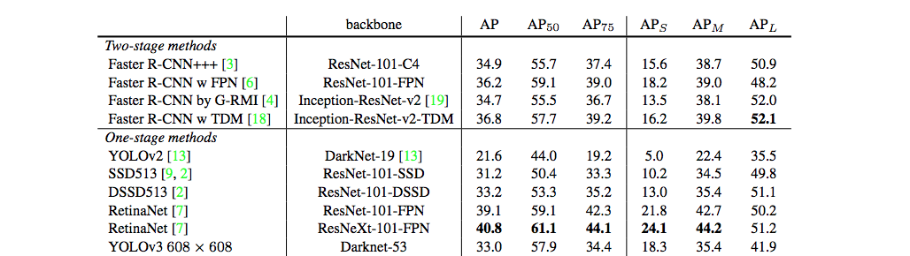

Figure 14: Performance of YOLO v3 [3]

From the above figure 14, we can infer that YOLO v3 has done alright .RetinaNet has 3.8 x longer to process an image. YOLO v3 is better than SSD variants and comparable to state of the art models on the AP50 metric.[3]

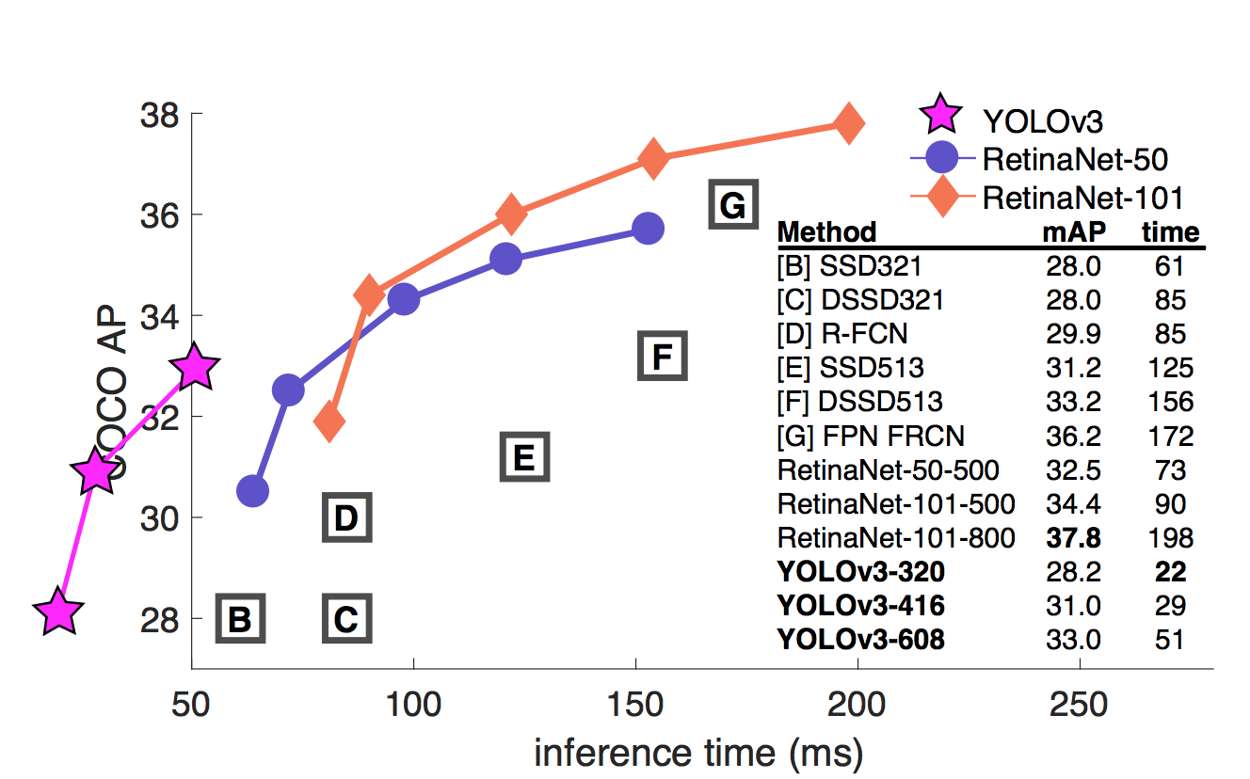

Figure 15 : Inference time vs COCO AP

From the above figure 15, we can deduce that speed and the accuracy of YOLO v3 is larger compared to the other networks at mAP=0.5 IOU metric.[3]

**3. STRUCTURE OF THE CODE:**

YOLO V3 is based on the Darknet 53 Model. The following are the main utility functions written around the Model to establish YOLO Algorithm:

Model Workflow:

# 

Figure 16 : Model Workflow

**3.1 FUNCTIONS CREATED:**

Function : yolo_body

**Definition:** yolo_body(inputs,num_anchors,num_classes)

**Explanation:**

num_anchors : (int) Number of anchor boxes used

num_classes : (int) Number of target classes

Because of the pyramidal feature mapping of the yolo, the layers are added at different levels of the base model. The pyramid network extracts the features at 3 different scales. At the output of the base model we get the data of grid size 13x13. Since the data has been down sampled 5 times assuming the data size as 416 itself.

The data obtained from the convolutional layers is obtained as darknet 53, route1 and route2. The yolo_body function forms the yolo body. The first layer gives the feature maps at layer 13x13 second at 26x26 and 3rd at 52x52 respectively.

Function: yolo_head

**Definition:** yolo_head(feats,anchors,num_classes,input_shape,calc_loss=False)

**Explanation:**

Converting the final layer obtained to bounding box parameters

Parameters are defined as follows:

feats: (tensor) Final convolution layer features

anchors : (array) Anchor-box width and height

num_classes : (int) Number of target classes

Returns:

box_xy : (tensor) x,y prediction adjusted by spatial location in convlayer (each of the feature map level)

box_wh: (tensor) w,h predictions adjusted by anchors and conv spatial resolution (each of the feature map level)

box_conf: (tensor) Probability estimate to indicate whether the box contains an object or not (confidence score )

box_class_pred : (tensor) Probability distribution of the box for each of the labels (class prediction)

The value obtained from the last layer are separated at each grid point. 13x13 26x26 and 52x52 respectively. Each point is responsible for predicting a value of the box

x and y values are predicted as:

bx= sigmoid(pred_x)+cx/width

by= sigmoid(pred_y)+cy/height

Width and height are calculated as below:

Bw = pw*e(tw)

Bh= ph*e(th)

pw and ph are the values of the anchor tensors. The values of bw and bh are further normalized with respect to height and width values. Box confidence is calculated and normalized between 0 to 1. Class probabilities of different classes are calculated and normalized between 0 and 1While training of the yolo grid size (feature map size) the last layer resized and further centre coordinates x,y and w and h are calculated.

Function: residual_darknet53

The function custom model for the yolo networks. The block represents the residual blocks for the same. We are using Batch Normalization after using convolution layers as per the algorithm.

Function: box_iou

**Definition:** box_iou(b1,b2)

**Parameters:**

b1: tensor of shape (i1,...,iN,4),xywh

b2: tensor, shape = (j,4), xywh

**Returns:**

iou tensor,shape = (i1,...,iN,j)

**Explanation:**

The function is used to define the box IOU (intersection over union). Given 2 boxes this gives the maximum area covered by the 2 boxes.

IOU being defined as:

IOU = (Intersection-Area)/(Union Area: box1-Area + box2-Area - Intersection area)

Function: yolo_loss

**Definition:** yolo_loss(args,anchors,num_classes,ignore_thres=.5,print_loss=True)

**Parameters:**

args: y_predicted : x_center, y_center,width, height, class

This contains 2 arguments:

1. true boxes

2. predicted boxes

y_true: actual values it onsidts of following blocks: Number of batches of data, grid shape on the prediction, anchors and 4 + 1 + number pf classes

yolo_outputs: tensor representing a single loss mean localiztion loss across minibatch

Final convolution layer features

true_boxes: (tensor)

--Ground truth boxes, tensor with shape[batch,num_true_boxes,5]

--containing box x_center,y_center, width, height and class

detector_mask :(array)

anchors: (tensor) Anchor boxes for model

num_classes: (int) Number of object classes

Parameters here are as follows:

yolo_outputs: list of tensor representing the output of yolo_body

y_true: list of array, the output of preprocess_true_boxes

anchors:array, shape=(N,2) wh

num_classes:integer

ignore_thres: float, the iou threshold whether to ignore the object confidence loss

**Returns:**

loss: tensor,shape=(1,)

**Explanation:**

The YOLO loss is defined as

1/N(samples) (xy_loss+wh_loss+confidence_loss+class_loss) : total loss

**Anchor Mask:**

**Pseudo -code :**

[yolo]

mask = 6,7,8

[yolo]

mask = 3,4,5

[yolo]

mask = 0,1,2

Every layer has to know about all of the anchors but it is only predicting a subset of them. The first yolo predicts 6,7,8 because it is the largest ones and it’s on the coarse scale.The second layer predicts more smaller one's and so forth.

The [yolo] layers simply apply logistic activation to some of the neurons, mainly the ones predicting (x,y) offset, objectiveness and class probabilities.

Anchors are initial sizes some of which will be resized to the object size some using the outputs from the neural network.

There are 4 important variables:

anchors: predetermined set of boxes with particular height and width ratios

mask: list of ids of the bounding boxes that the layer is responsible for predicting

num: total number of anchors

filter = (num_classes+5)*k where k is the number of mask in one yolo layer

YOLOv3 predicts offsets from a predetermined set of boxes with height-width ratios. Anchors are initialized (width, height) sizes, some of which will be resized to the object size

Default configuration of YOLOv3:

[yolo]

anchors = 10,13 16,30 33,23 30,61 62,45 59,119 116,90 156,198 373,326

mask = 0,1,2

[[6,7,8],[3,4,5],[0,1,2]]

mask 0,1,2

The last layer of the yolo config file is responsible for predicting the bounding boxes related to

0 (10,13) 3 (30,61) 6 (116,90)

1 (16,30) 4 (62,45) 7 (156,198)

2 (33,23) 5 (59,119) 8 (373,326)

Thus the first yolo layer is responsible for predicting the 6,7,8 coarse one second 3,4,5 (fine-tuned using up sampling) and the third 0,1,2 (more fine-tuned).

The first and second output of the yolo layers are scaled to 32 as the original image is down sampled by that amount by 5 down sampling layers.

For each of the layers get the resulting yolo outputs:

grid_shape : Getting the feature maps of the outputs : 13x13 26x26 52x52

The first value of the yolo_output returns the batch size

The final layers obtained are passed to the yolo head. This function returns the grid used at each feature map. The value of box xy width and height and output tensor in the required format.

The width and centre points are concatenated with each other this is used for calculation of loss function

Extracting the true values:

The raw xy is obtained scaled to the grid size and then subtracted by the grid off set. This is to have a value between 0 and 1 that can be used for the prediction of the centre coordinates.

Raw wh is obtained and is scaled to be compared with predicted values of width and height as

tx = log (bx*scale)/achor_width

ty = log (by*scale)/anchor_height

In case the object score is 0 then the value is 0 instead of -inf. No loss is calculated when there are no object present.

Since the box is rescaled y_true[l][...,2:3] and y_true[l][...,3:4] box scale loss is calculated:

2 - width* height

Ideally the max area covered by the box is 1 since the values are normalized. This can further be used as a penalizing factor.

The ignore mask is generated according to the IoU threshold and the prediction. and the value of the box are calculated as IoU. The value of the anchor box whose IoU is smaller than the maximum threshold is suppressed. For each of the batches this gives the value of the objectiveness score as either true or false

The shape of the Ignore mask is of ?,?,?,3,1. (? represents don’t care)

0 index is batch size

1 and 2 indices are feature map

3 index is anchors

4 index is prediction

Function: preprocess_box_anchors

**Definition:** preprocess_box_anchors(true_boxes,input_shape,anchors,num_classes)

**Parameters:**

true boxes : array of shape (batch_Size,size of labels per image,labels)

input_shape : shape of the array multiples of 32

anchors : anchors used shape = N,2 w h format

num_classes: integer

**Returns:**

y_true : list of array shaped liked yolo output for loss comparison. It is composed of the size m:batch_size, (h,w) :feature map size, objectiveness and the bounding_box + objectivness_class prediction. I.e. it can be summarized as a tensor of b:batches ,width ,height ,number of anchor per layer, 4 box + 1 confidence + class.

(a)------------------------------------ (anchor_mins)

|(i)------------------------------(b) | (negative) box min intersect mean

| | | |

--------------------------------------- (centre point)

| | | | (positive)

| ----------------------------(b i)| box_max intersect max

------------------------------------(anchor_maxs)

Function : loop_body

**Definition:** loop_body(b,ignore_mask)

**Decription:**

This returns a value of true box which is masked by boolean threshold. If the objectiveness of the mask is 0 then object is not present. The loss is simply not calculated

At each batch the IOU is calculated and returned. The best of the predicting anchor is stored as best_iou; the values of the best IOU remains as (batch, index of anchor matching the most).

In case the threshold covered is very low then it is pushed to the ignore_mask tensor.

For all the values the input argument and the batch size the values are calculated.

As stated above, the mask whose IOU is less then the threshold is pushed to the ignore_mask tensor.The mask are further stacked. This is used in the calculation of the confidence loss.

Loss is calculated as:

xy_loss: objective mask*box_loss_Scale*binary_cross_entropy(true and predicted values )

wh_loss: 1/2(raw_wh-raw_wh)^2*box_loss*objective_mask

confidence_loss : objective_mask*binary_crossentropy(confidence_true,predicted) + (1- objective_mask)*binary_crossentropy(object_mask,raw_predictions[...,4:5])

class_loss: true class v/s binary_cross entropy

The box loss, width and height are further normalized. The confidence_loss is summed and normalized. The class_loss is normalized per batch

Finaly all the losses are aggregated

Total loss = xy_loss+ confidence_loss + class_loss

Function : draw_bounding

Definition: draw_bounding ( img_file, anchors, score_threshold=0.2)

Parameters:

img_file: The input image that is being tested

anchors: The anchors box array

score_threshold: The threshold function for non-max suppression

Description: This function is used to generate the bounding boxes from the predicted classes and co-ordinates

Function : eval

Definition: eval(img,anchors,num_classes,max_boxes=20,score_threshold=0.2,iou_threshold=0.5)

Parameters:

img: The input image that is being tested

anchors: The anchors box array

num_classes: number of predicted classes

max_boxes: maximum number of boxes to be predicted.

score_threshold: The threshold function for non-max suppression

iou_threshold: it is the threshold ratio of intersection over union score for overlapping predicted boxes

Return:

boxes_ : bounding boxes from the testing image

scores_ : confidence scores per bounding box

classes_ : Predicted classes per bounding box

Description: This function is used to run prediction on an image using the model and to generate bounding boxes, scores and classes

Function: non_max_suppression

definition: non_max_suppression(boxes,thresh)

Parameters:

boxes : array of predicted boxes

thresh : The IOU threshold for non_max_suppression

Return:

pick: Selected bounding boxes for localization

Description:

The function prunes away boxes that have high intersection over union (IOU) overlap with previous selected boxes.Bounding boxes are supplied as [y1,x1,y2,x2] where (y1,x1) and (y2,x2) are coordinates are the coordinates of any diagonal pair of box corners and the coordinates can be provided as normalized(i.e lying in the interval [0,1]) or absolute.

**4.STEPS TO IMPROVE ACCURACY:**

* The average precision for medium and large objects can be improved as medium is five percent and large is 10 percent.
* MAP score between 0.5 to 0.95 IOU can be increased.[5]
* Reduce loss by increasing training time by training it for higher number of epochs
* Including background images (images with no objects) in the dataset to train the model on what not to identify.
* Expanding the data set by increasing the number of classes and the number of images per class.

**5.FINDINGS:**

Based on the training and prediction process, the following limitations were figured out. It is constrained to the 43 classes of images employed. The bounding boxes predicted did not coincide with the ground truth. For augmented images, the prediction is correct, but the confidence score is low. The width and height of the bounding box generated by the model is not as accurate as desired as depicted in figure 17. When scaling width and height using standard scaling formula, the center point was scaled properly, whereas the width and height was scaled beyond the image dimension. To overcome this, custom scaling formula has been used.

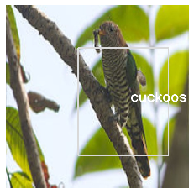 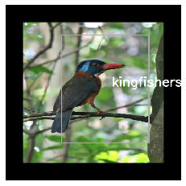 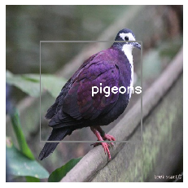

Figure 17: Scaling issue in width and height of the bounding boxes.

**6.CONCLUSION:**

YOLO v3 is fast compared to models such as faster RCNN and this makes it stand as one amongst the powerful object detection model. It can be made use in domains like media, retail, manufacturing, robotics where the models need to be very fast.[5]. From the above project, it can also be resulted that instead of using pre-defined anchor boxes, they can be determined from the input images of dataset as mentioned in [3].

References:

1.http://pjreddie.com/yolo

2. <https://medium.com/@jonathan_hui/real-time-object-detection-with-yolo-yolov2-28b1b93e2088>

3. YOLO v3 : An incremental improvement, by Joseph Redmon , Ali Farhadi ,University of Washington

4. <http://pjreddie.com/yolo9000/>

5. <https://medium.com/@anand_sonawane/yolo3-a-huge-improvement-2bc4e6fc44c5>