/*Q1. List all customers and the products they ordered with the order date. (Inner join)

Tables used: customers, orders, order_details, products

Output should have below columns:

companyname AS customer,

orderid,

productname,

quantity,

orderdate */

select c.company_name as customer, od.order_id, p.product_name, o.order_date

from customers c

join orders o

on c.customer_id = o.customer_id

join order_details od

on o.order_id =od.order_id

join products p

on od.product_id = p.product_id

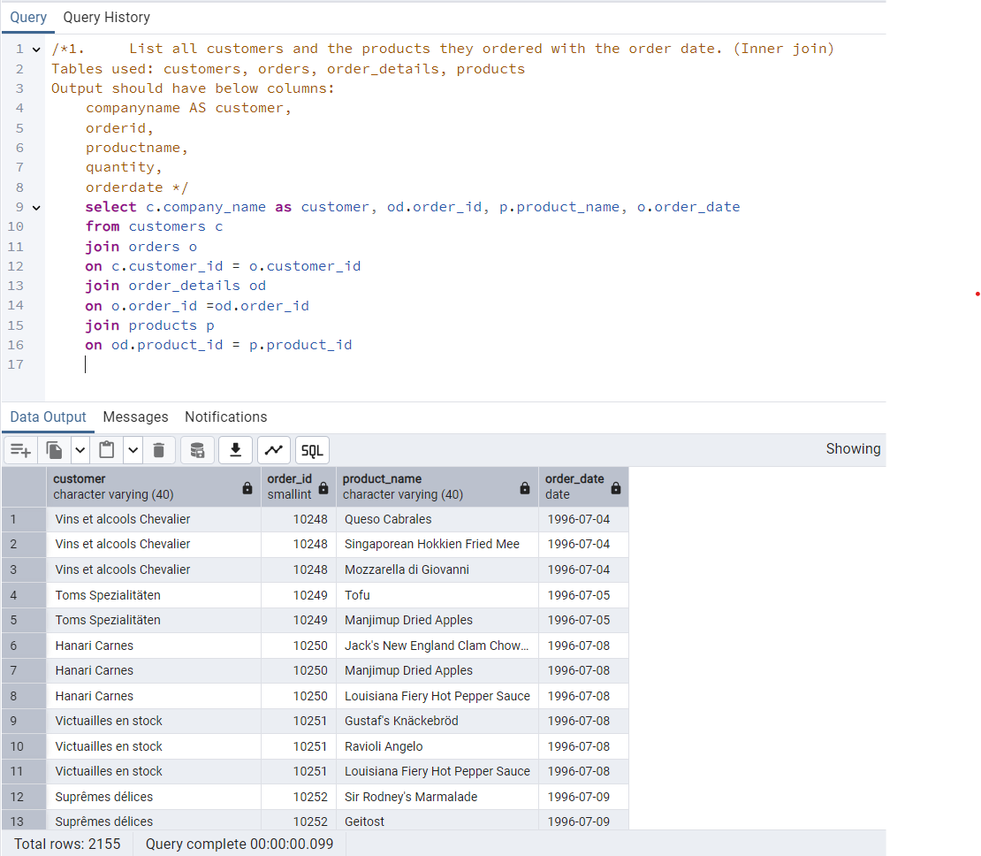

/*2. Show each order with customer, employee, shipper, and product info — even if some parts are missing. (Left Join)

Tables used: orders, customers, employees, shippers, order_details, products */

select c.company_name as customer, o.order_id,e.first_name||' '||e.last_name as employee,s.company_name as shipper, p.product_name

from orders o

join customers c

on o.customer_id= c.customer_id

join employees e

on o.employee_id = e.employee_id

join order_details od

on od.order_id = o.order_id

join products p

on p.product_id =od.product_id

join shippers s

on s.shipper_id = o.ship_via

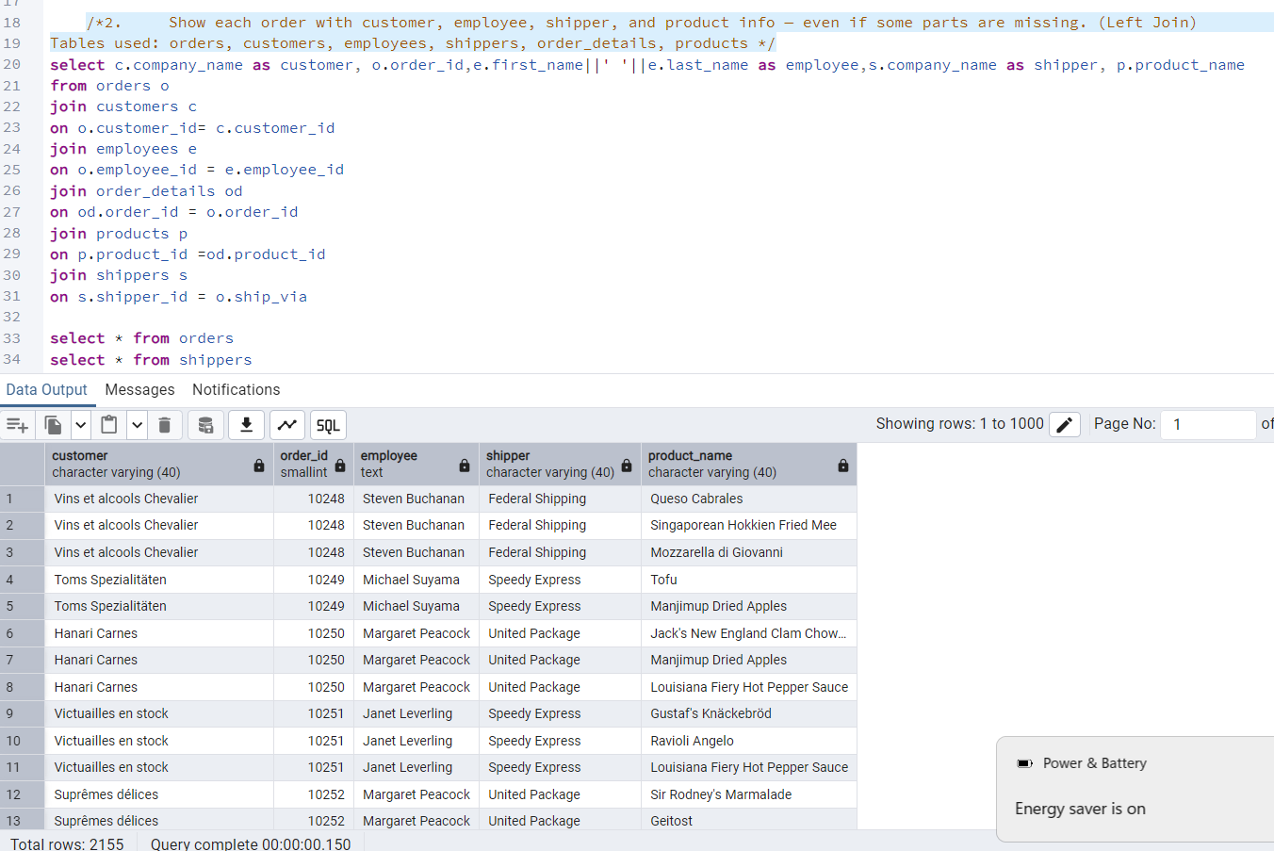

/*3. Show all order details and products (include all products even if they were never ordered). (Right Join)

Tables used: order_details, products

Output should have below columns:

orderid,

productid,

quantity,

productname */

select od.order_id,od.Product_id, od.quantity,p.product_name

from order_details od

right join products p

on od.product_id =p.product_id

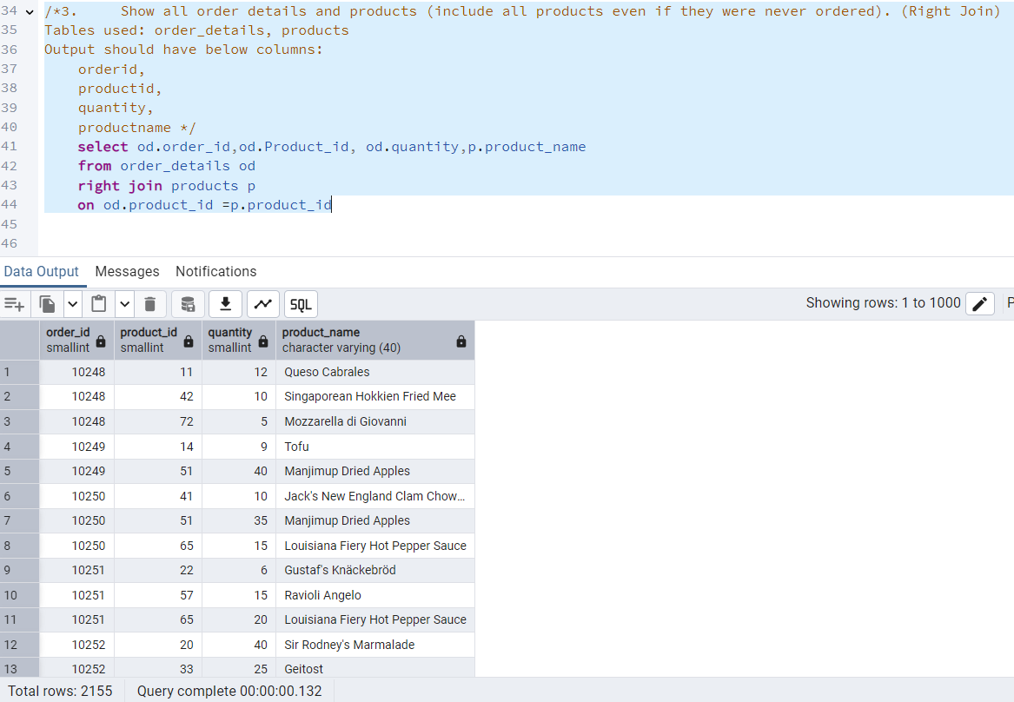

/*4. List all product categories and their products — including categories that have no products,

and products that are not assigned to any category.(Outer Join)

Tables used: categories, products */

select * from products p

full outer join categories c

on p.category_id =c.category_id

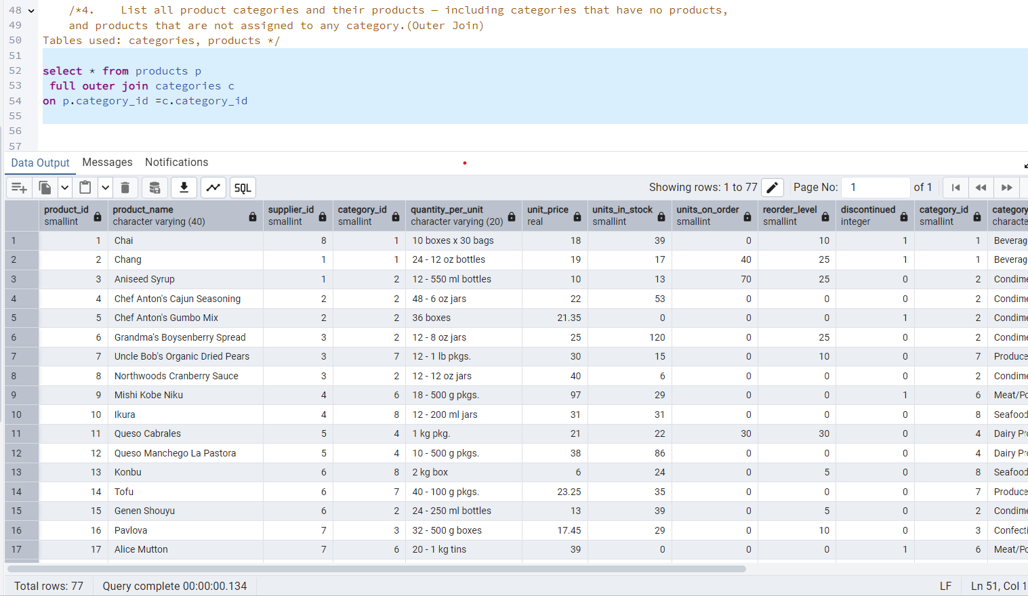

/* 5. Show all possible product and category combinations (Cross join).*/

select * from products p

cross join categories c

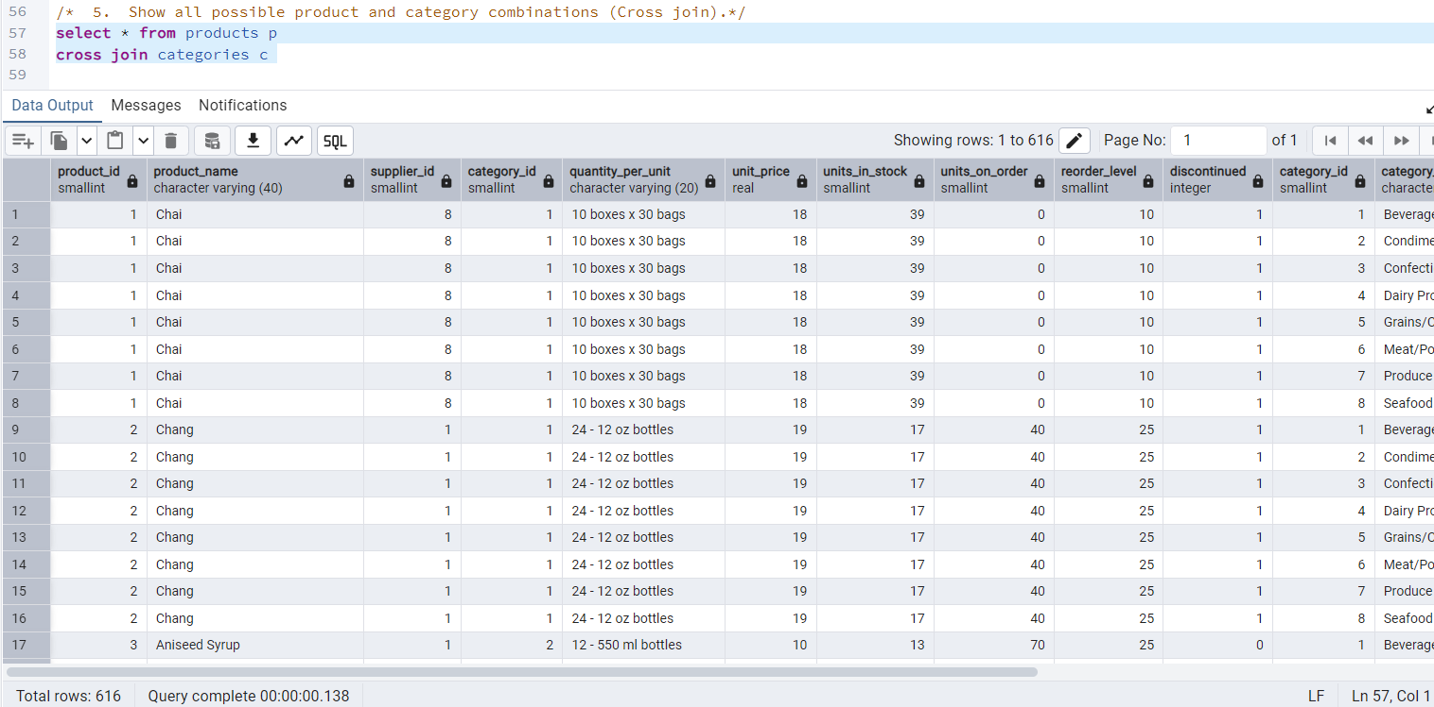

/* 6. Show all employees and their manager(Self join(left join))*/

select e.employee_id, e.first_name ||' '|| e.last_name as full_name, m.first_name ||' '|| m.last_name as Manager_name

from employees e left join employees m

on e.reports_to =m.employee_id

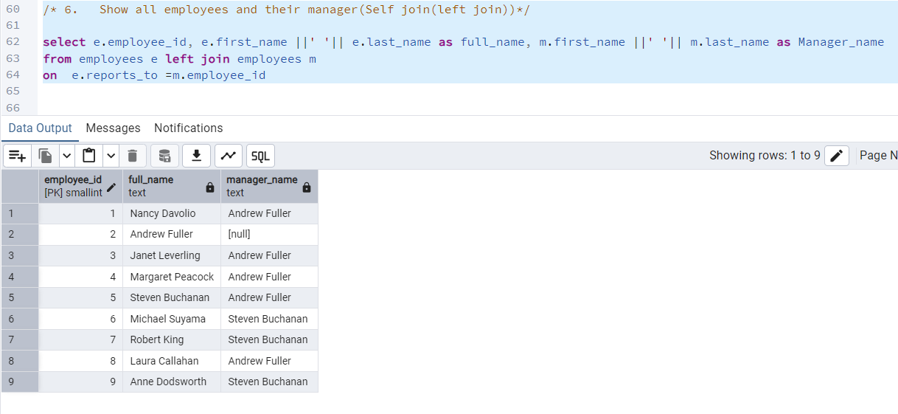

/*7. List all customers who have not selected a shipping method.

Tables used: customers, orders

(Left Join, WHERE o.shipvia IS NULL)*/

select c.company_name as customers, o.ship_via

from customers c

left join orders o on c.customer_id = o.customer_id

where ship_via is null

