` /* 1. GROUP BY with WHERE - Orders by Year and Quarter

Display, order year, quarter, order count, avg freight cost only for those orders where freight cost > 100 */

select extract(year from order_date) as order_year,

extract(quarter from order_date) as quarter,

count(*) as order_count,

avg(freight) as freight_cost

from orders

where freight>100

group by extract(year from order_date),extract(quarter from order_date)

order by order_year,quarter

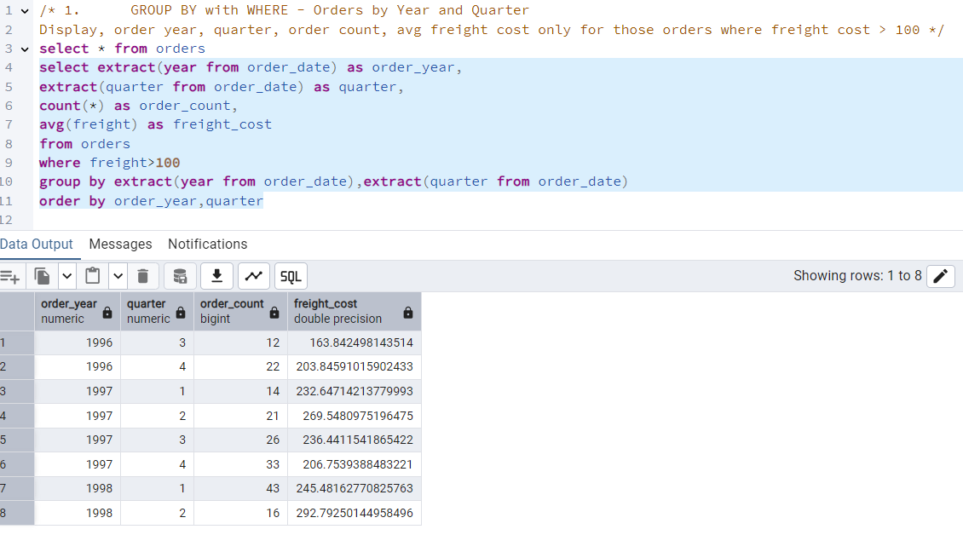

/*2. GROUP BY with HAVING - High Volume Ship Regions

Display, ship region, no of orders in each region, min and max freight cost

Filter regions where no of orders >= 5*/

select ship_region, count(*), max (freight), min(freight)

from orders

group by ship_region

having count(*)>=5 and ship_region is not null

order by count(*) desc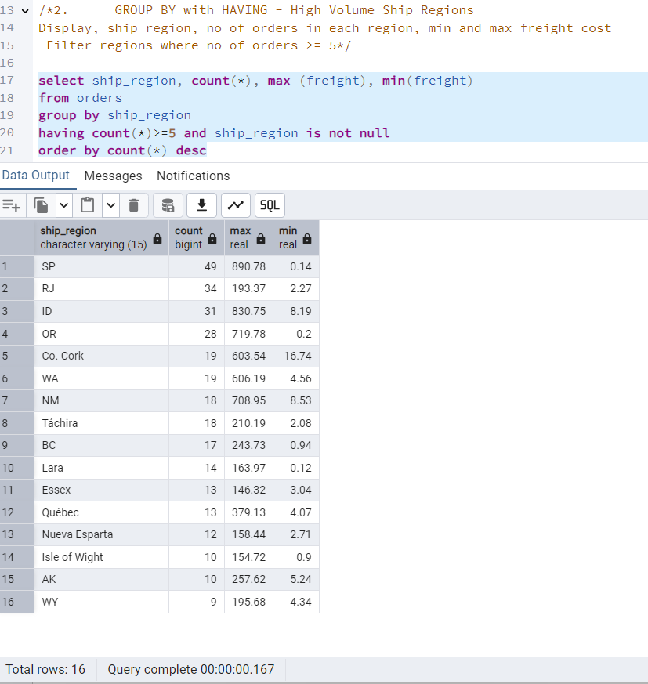

/*3. Get all title designations across employees and customers ( Try UNION & UNION ALL)*/

select title as employee_Designation

from employees

union

select contact_title as customer_Designation

from customers

select title as employee_Designation

from employees

union all

select contact_title as customer_Designation

from customers

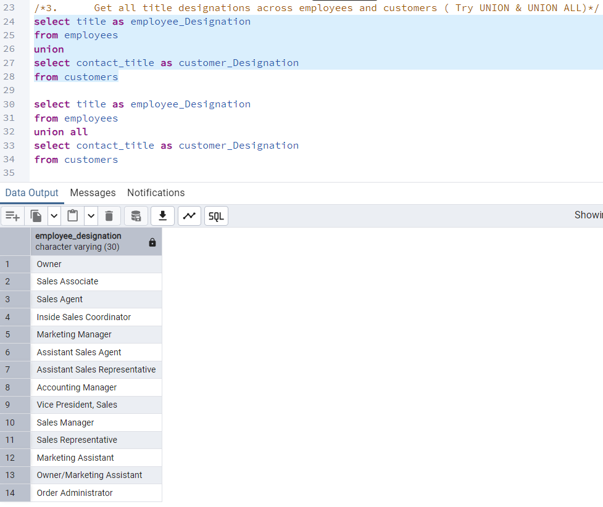

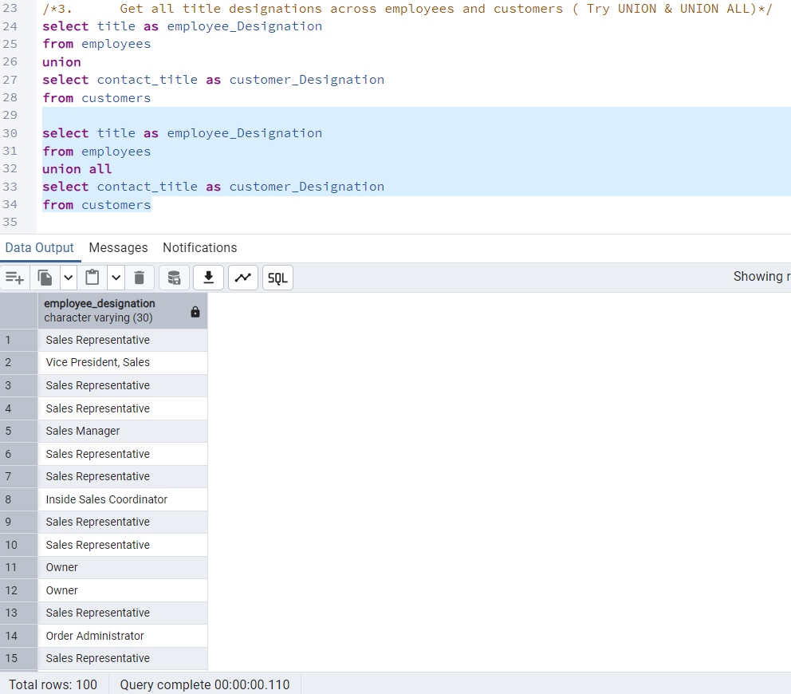

/*4. Find categories that have both discontinued and in-stock products

(Display category_id, instock means units_in_stock > 0, Intersect)*/

select category_id

from products

where units_in_stock >0

intersect

select category_id

from products

where discontinued =1

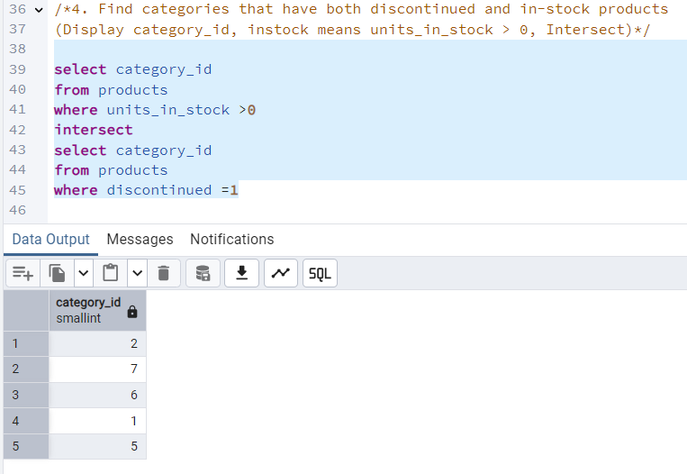

/*5. Find orders that have no discounted items (Display the order_id, EXCEPT)*/

select order_id from order_details

except

select order_id from order_details where discount !=0

