1 ./* GROUP BY with WHERE - Orders by Year and Quarter

Display, order year, quarter, order count,

avg freight cost only for those orders where freight cost > 100*/

Query:

select

extract(year from order_date)as order_year,

extract(quarter from order_date)as quarter,

count(*)as ordercount,

avg(freight)as freightcost

from orders

where freight>100

group by extract(year from order_date),

extract(quarter from order_date)

order by

Order_year,quarter;

Output

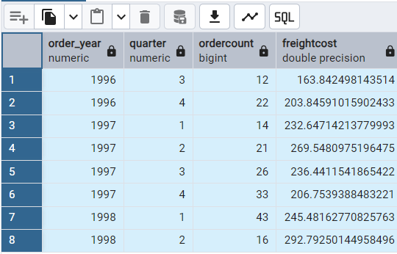

2./*GROUP BY with HAVING - High Volume Ship Regions

Display, ship region, no of orders in each region,

min and max freight cost

Filter regions where no of orders >= 5*/

Query:

select * from shippers;

select * from region;

select

ship_region,

count(*) as number_of_orders,

min(freight)as min_freight,

max(freight)as max_freight,

round(sum(freight)::numeric,2)as total_frieght

from orders

group by

ship_region

having

count(*)>=5 and ship_region is not null

order by

total_frieght desc;

Output:

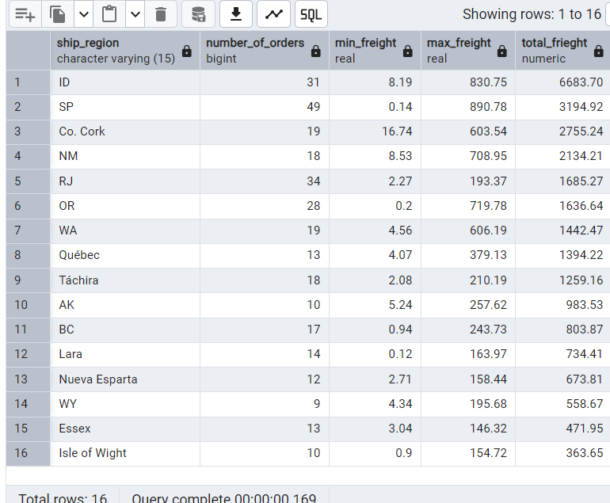

3./*Get all title designations across employees and customers

( Try UNION & UNION ALL)*/

Query:

select * from employees;

select * from customers;

select title as designation

from employees

union

select contact_title as designation

from customers;

select title as designation

from employees

union all

select contact_title as designation

from customers;

Output:

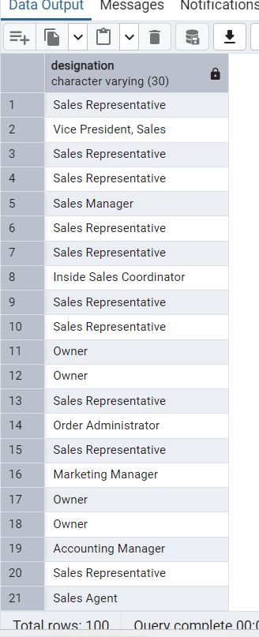

/*4. Find categories that have both discontinued and in-stock products

(Display category_id, instock means units_in_stock > 0, Intersect)*/

Query:

select * from products;

select

category_id

from products

where units_in_stock>0

intersect

select

category_id

from products

where discontinued=1

order by category_id

Output:

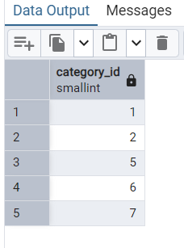

5./* Find orders that have no discounted items (Display the order_id, EXCEPT)*/

Query:

select order_id,discount

from order_details

except

select order_id,discount

from order_details

where discount!=0

Output:

