1. Categorize products by stock status

(Display product_name, a new column stock_status whose values are based on below condition

units_in_stock = 0 is 'Out of Stock'

units_in_stock < 20 is 'Low Stock')

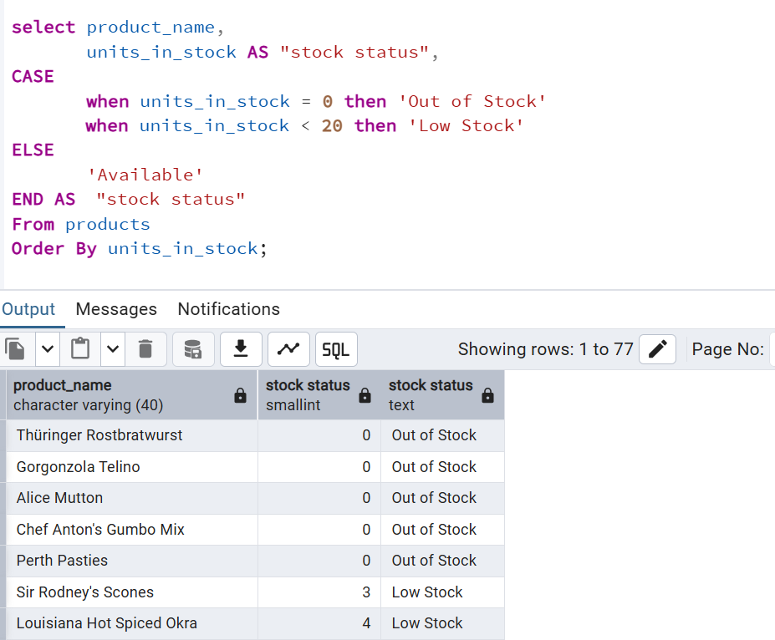

2. Find All Products in Beverages Category

(Subquery, Display product_name,unitprice)

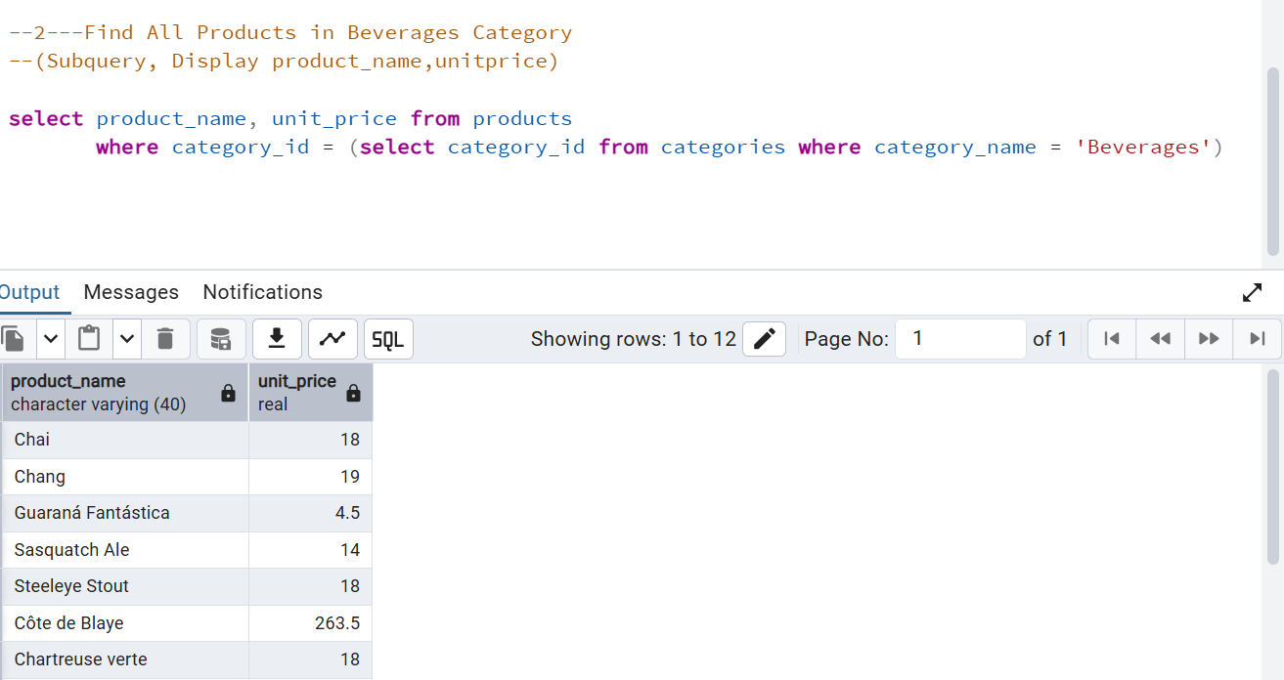

3. Find Orders by Employee with Most Sales

(Display order_id, order_date, freight, employee_id.

Employee with Most Sales=Get the total no.of of orders for each employee then order by DESC and limit 1. Use Subquery)

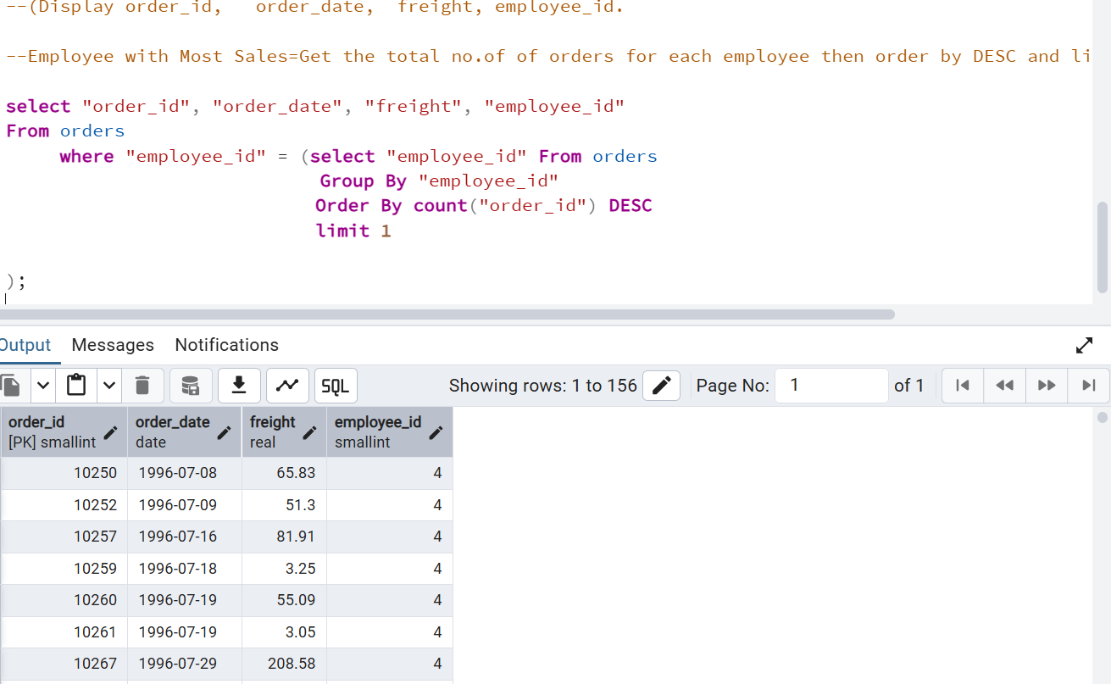

4. Find orders where for country!= ‘USA’ with freight costs higher than any order from USA. (Subquery, Try with ANY, ALL operators)

