1./**\*Categorize products by stock status**

(Display product_name, a new column stock_status

whose values are based on below condition

units_in_stock = 0 is 'Out of Stock'

units_in_stock < 20 is 'Low Stock')*/

Query:

SELECT

product_name,

units_in_stock as stock_status,

CASE

when units_in_stock=0 Then 'Out of Stock'

when units_in_stock<20 Then 'Low Stock'

ELSE

'Available'

end as stock_status

from products

ORDER BY

Units_in_stock;

Output:

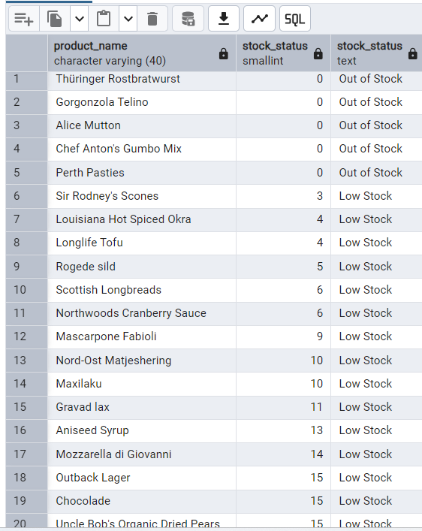

2.  **Find All Products in Beverages Category**

(Subquery, Display product_name,unitprice)

Query:

select

product_name,

unit_price,

category_id

from

products

where category_id=(

select category_id

from categories

where category_name='Beverages'

);

Output:

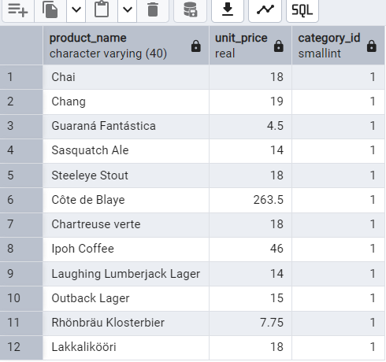

**3.Find Orders by Employee with Most Sales**

(Display order_id, order_date, freight, employee_id.

Employee with Most Sales=Get the total no.of of orders for each employee then order by DESC and limit 1. Use Subquery)

Query:

select

order_id,

order_date,

freight,

employee_id

FROM

orders

WHERE

employee_id=(

select employee_id

from orders

group by employee_id

order by count(order_id)DESC

limit 1

);

Output:

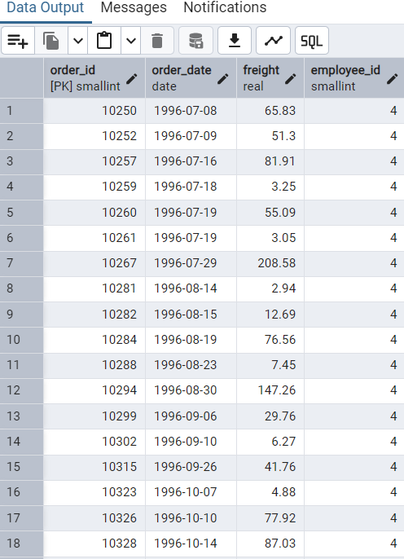

**4. Find orders where for country!= ‘USA’ with freight costs higher than any order from USA.**

(Subquery, Try with ANY, ALL operators)

Query:

select

Order_id,

Ship_country,

freight

from

orders

where ship_country!='USA' and freight> any (

select freight

from orders

where ship_country='USA'

order by freight

)

group by

order_id;

**Output:**

