/*Q1. Rank employees by their total sales

(Total sales = Total no of orders handled, JOIN employees and orders table)*/

select e.employee_id, count(o.order_id),

rank()over(order by count(o.order_id) desc ) as Rank_employee

from employees e

join orders o

on e.employee_id = o.employee_id

group by e.employee_id

order by Rank_employee;

/*Q2.Compare current order's freight with previous and next order for each customer.

(Display order_id, customer_id, order_date, freight,

Use lead(freight) and lag(freight).*/

select order_id, customer_id,order_date,freight,

lag(freight,1,freight) over (partition by customer_id order by order_date) as lag_value,

lead(freight,1,freight) over (partition by customer_id order by order_date) as lead_value,

case when freight > lag(freight) over (partition by customer_id order by order_date) then 'more than previous'

when freight < lag(freight) over (partition by customer_id order by order_date) then 'less than previous'

else 'no change'

end as lag_comparision,

lead(freight) over (partition by customer_id order by order_date) - freight as lead_difference,

case when (lead(freight,1,freight) over (partition by customer_id order by order_date) - freight)>0 then 'more Lead'

when (lead(freight,1,freight) over (partition by customer_id order by order_date) - freight)< 0 then 'less lead'

else 'no change' end as Lead_comparision

from orders

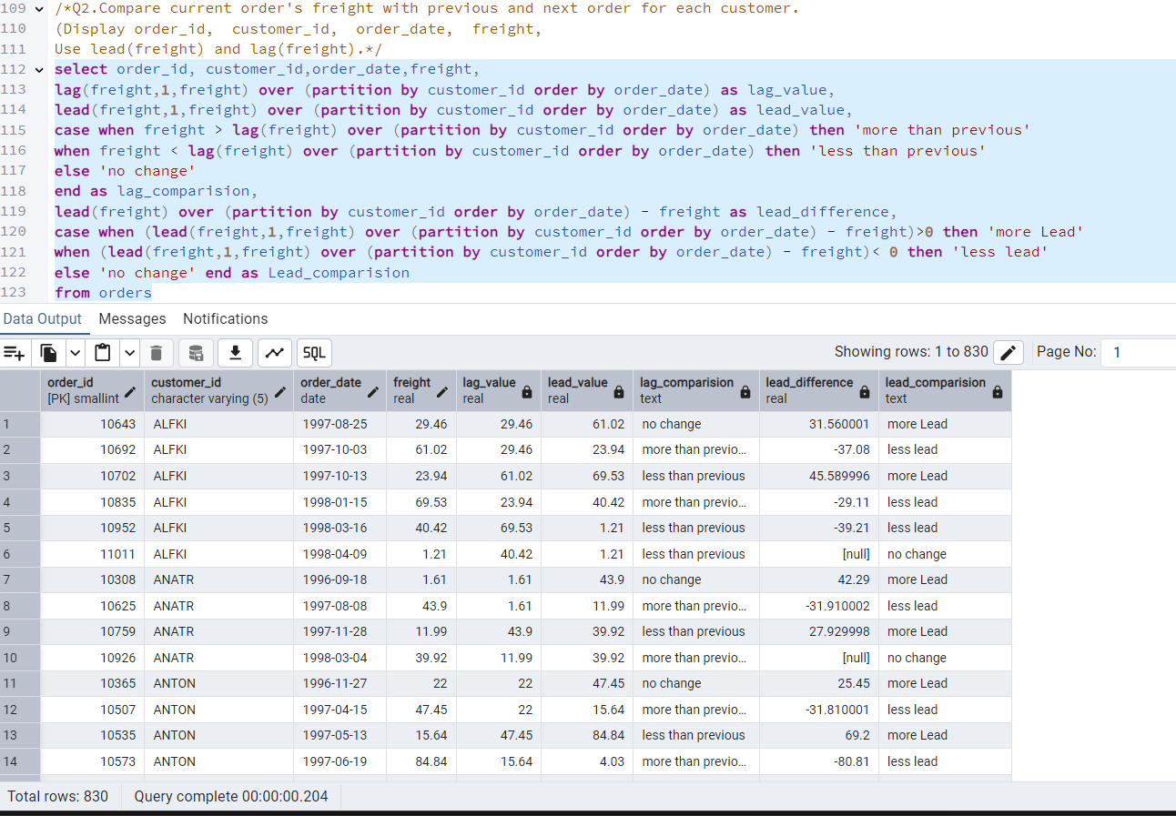

/* Q3. Show products and their price categories, product count in each category, avg price:

(HINT:

· Create a CTE which should have price_category definition:

WHEN unit_price < 20 THEN 'Low Price'

WHEN unit_price < 50 THEN 'Medium Price'

ELSE 'High Price'

· In the main query display: price_category, product_count in each price_category, ROUND(AVG(unit_price)::numeric, 2) as avg_price)*/

WITH categorized_products AS (

SELECT category_id,product_id, product_name, unit_price,

CASE

WHEN unit_price < 20 THEN 'Low Price'

WHEN unit_price < 50 THEN 'Medium Price'

ELSE 'High Price'

END AS price_category

FROM products

)

SELECT category_id, price_category, COUNT(*) AS product_count,

ROUND(AVG(unit_price)::numeric, 2) AS avg_price

FROM categorized_products

GROUP BY category_id ,price_category

ORDER BY category_id;

