**1./* Rank employees by their total sales**

(Total sales = Total no of orders handled, JOIN employees and orders table)*/

select * from orders;

Query:

select

employee_id,

count(*)as total_sales,

rank()OVER

(order by count(*)DESC) as sales_rank

from

orders

group by

Employee_id;

Output:

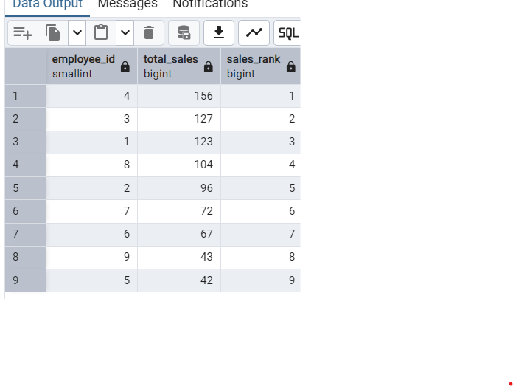

**2./* Compare current order's freight with previous and next order for**

**each customer.**

(Display order_id, customer_id, order_date, freight,

Use lead(freight) and lag(freight).*/

Query:

select

order_id,

customer_id,

order_date,

freight,

lag(freight)over (partition by customer_id order by freight)as previous_order_freight,

freight-lag(freight)over(partition by customer_id order by freight)as next_order_freight

from orders;

select

order_id,

customer_id,

order_date,

freight,

lead(freight)over (partition by customer_id order by freight)as previous_order_freight,

freight-lead(freight)over(partition by customer_id order by freight)as next_order_freight

from orders;

select

order_id,

customer_id,

order_date,

freight,

lead(freight)over (partition by customer_id order by freight)as previous_order_freight,

freight-lead(freight)over(partition by customer_id order by freight)as next_order_freight

from orders;

Output:

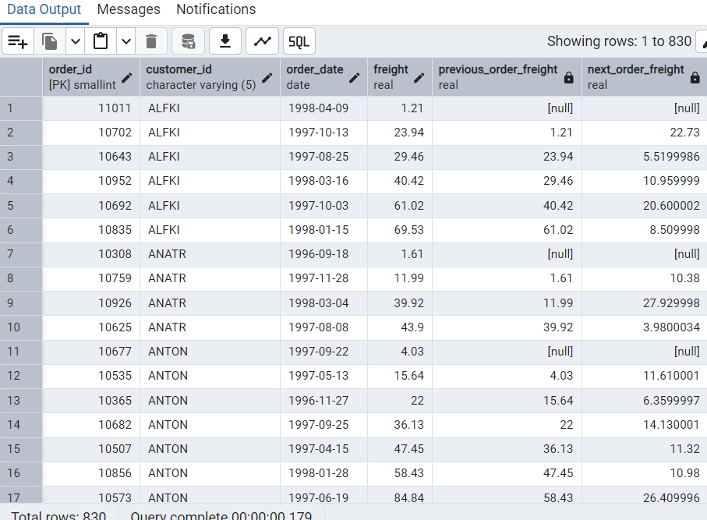

**3./* Show products and their price categories, product count**

**in each category, avg price:**

(HINT:

· Create a CTE which should have price_category definition:

WHEN unit_price < 20 THEN 'Low Price'

WHEN unit_price < 50 THEN 'Medium Price'

ELSE 'High Price'

· In the main query display: price_category, product_count

in each price_category, ROUND(AVG(unit_price)::numeric, 2) as avg_price)*/

QUERY:

with

price_category as(

select

category_id,

unit_price,

case

when unit_price<20 Then'Low Price'

when unit_price<50 Then 'Medium price'

ELSE 'High Price'

end as price_category

From products

)

select price_category,

count(*)as product_count,

ROUND(AVG(unit_price)::numeric, 2) as avg_price

from price_category

group by price_category;

OUTPUT:

