1. Create view vw_updatable_products (use same query whatever I used in the training)

Try updating view with below query and see if the product table also gets updated.

Update query:

UPDATE updatable_products SET unit_price = unit_price * 1.1 WHERE units_in_stock < 10;

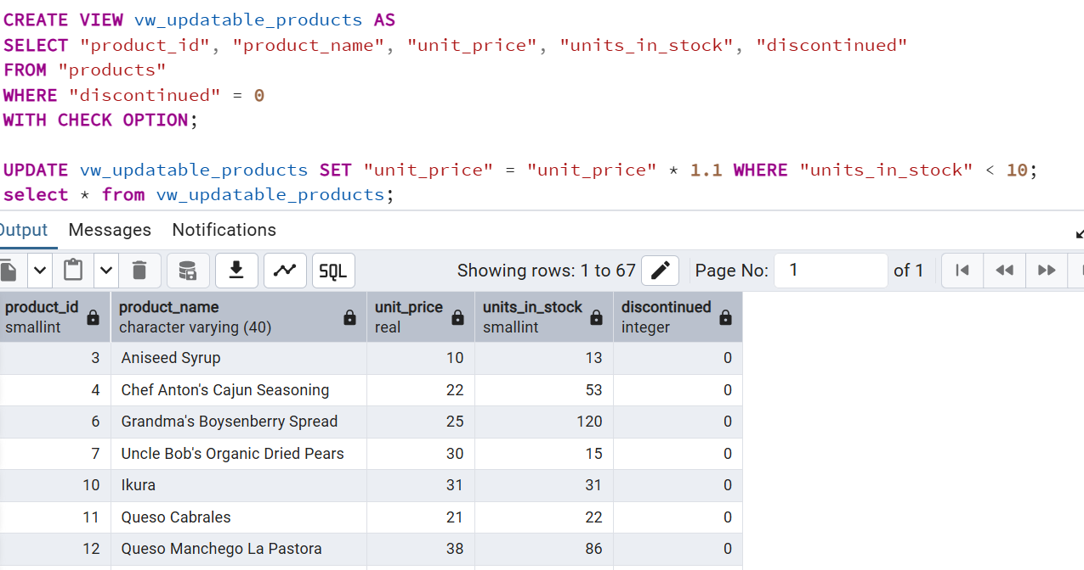

2. Transaction:

Update the product price for products by 10% in category id=1

Try COMMIT and ROLLBACK and observe what happens.

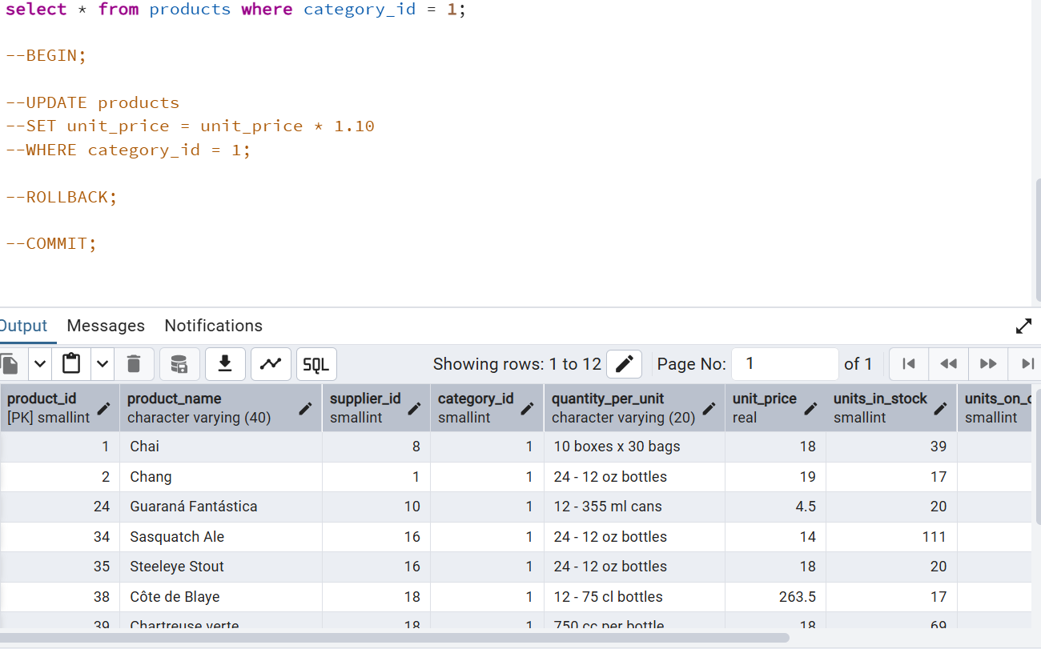

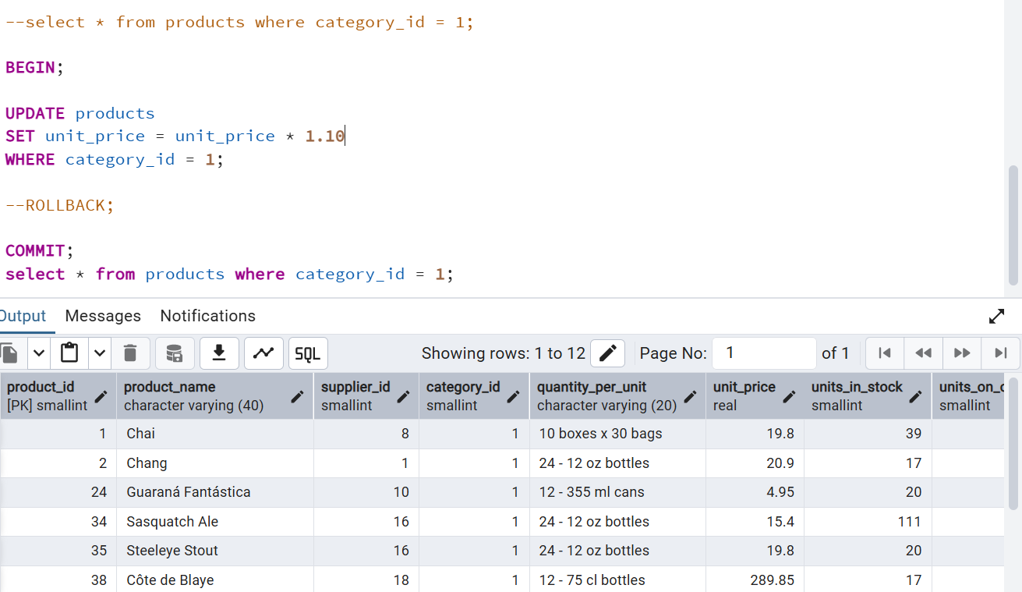

3. Create a regular view which will have below details (Need to do joins):

Employee_id,

Employee_full_name,

Title,

Territory_id,

territory_description,

region_description

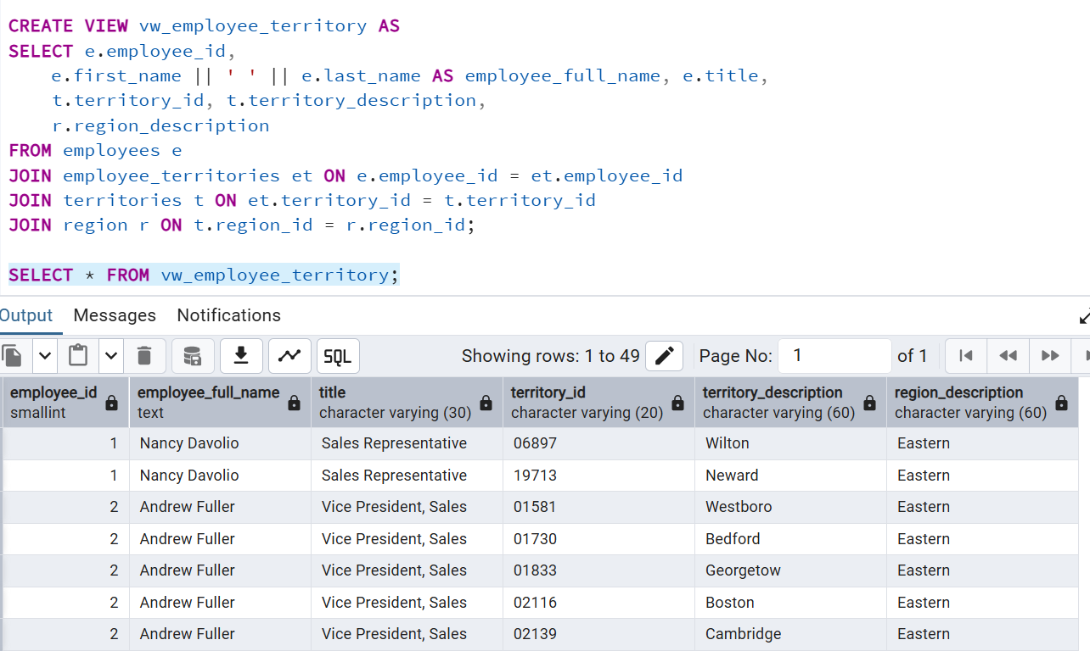

4. Create a recursive CTE based on Employee Hierarchy

