**1./*Create view vw_updatable_products** (use same query whatever

I used in the training)

Try updating view with below query and see if the product

table also gets updated.

Update query:

UPDATE updatable_products SET unit_price = unit_price * 1.1 WHERE

units_in_stock < 10;*/

select * from products;

**QUERY:**

CREATE view vw_updatable_products AS

select

product_id,

product_name,

unit_price,

units_in_stock,

discontinued

from products

where discontinued=0

with CHECK option;

UPDATE vw_updatable_products

set unit_price=unit_price*1.1

where units_in_stock<10;

select * from vw_updatable_products;

**OUTPUT:**

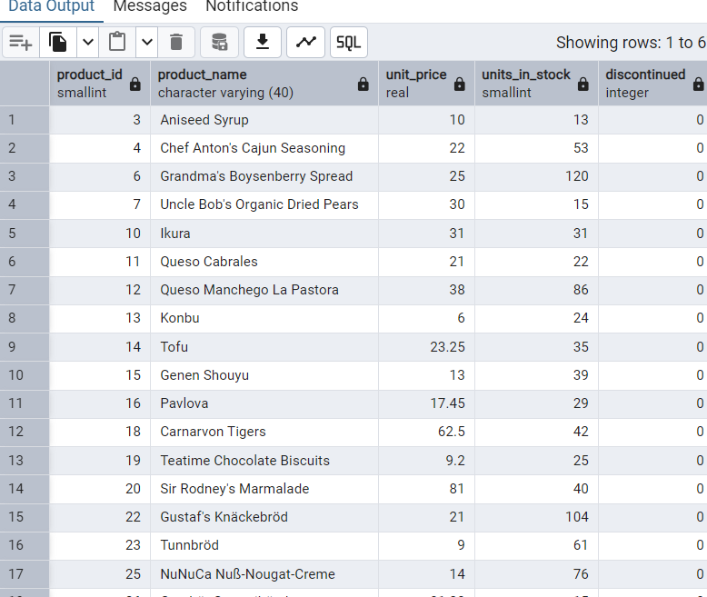

**2. /* Transaction:**

Update the product price for products by 10% in category id=1

Try COMMIT and ROLLBACK and observe what happens.*/

**QUERY:**

select * from products;

BEGIN;

update products

set unit_price=unit_price*1.10

where category_id=1;

commit;

rollback;

**OUTPUT:**

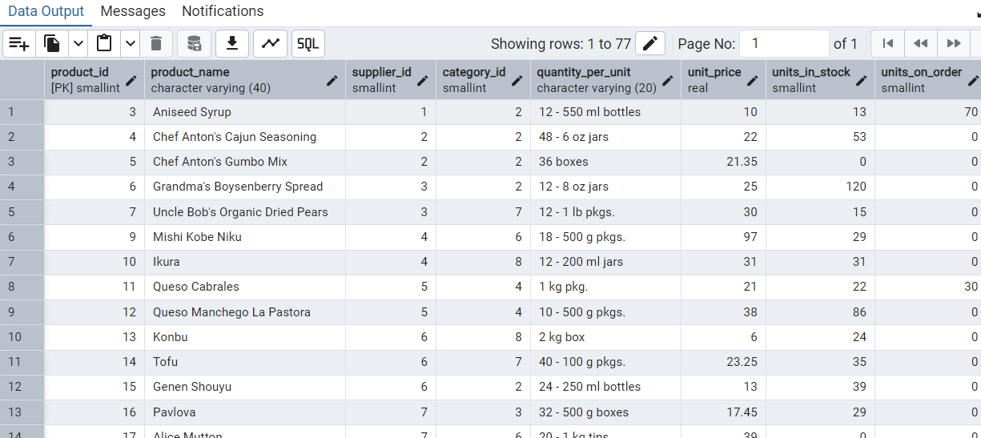

**3./* Create a regular view which will have below details**

**(Need to do joins):**

**Employee_id,**

**Employee_full_name,**

**Title,**

**Territory_id,**

**territory_description,**

**region_description*/**

**QUERY:**

**select * from employees;**

**select * from employee_territories;**

**select * from region;**

**create VIEW vw_employee_territory AS**

**select**

**e.employee_id,**

**e.first_name||''||e.last_name as fullname,**

**e.title,**

**t.territory_id,**

**t.territory_description,**

**r.region_description**

**from employees e**

**JOIN employee_territories et ON et.employee_id=e.employee_id**

**join territories t ON t.territory_id = et.territory_id**

**JOIN region r ON r.region_id = t.region_id;**

**select * from vw_employee_territory;**

**OUTPUT:**

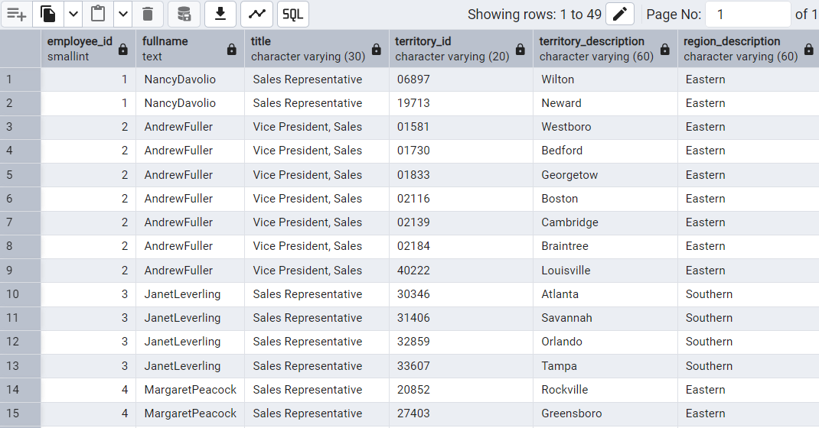

**4./*Create a recursive CTE based on Employee Hierarchy*/**

**QUERY:**

**with recursive cte_employee_hierarchy AS(**

**select**

**employee_id,**

**first_name,**

**last_name,**

**reports_to,0 as level**

**from employees e**

**where reports_to is null**

**union all**

**select**

**e.employee_id,**

**e.first_name,**

**e.last_name,**

**e.reports_to,eh.level+1**

**from employees e**

**join cte_employee_hierarchy eh ON eh.employee_id=e.reports_to)**

**select**

**level,**

**employee_id,**

**first_name||''||last_name as fullname**

**from cte_employee_hierarchy**

**order by level,employee_id;**

**OUTPUT:**

