1. Create AFTER UPDATE trigger to track product price changes

a. Create product_price_audit table with below columns:

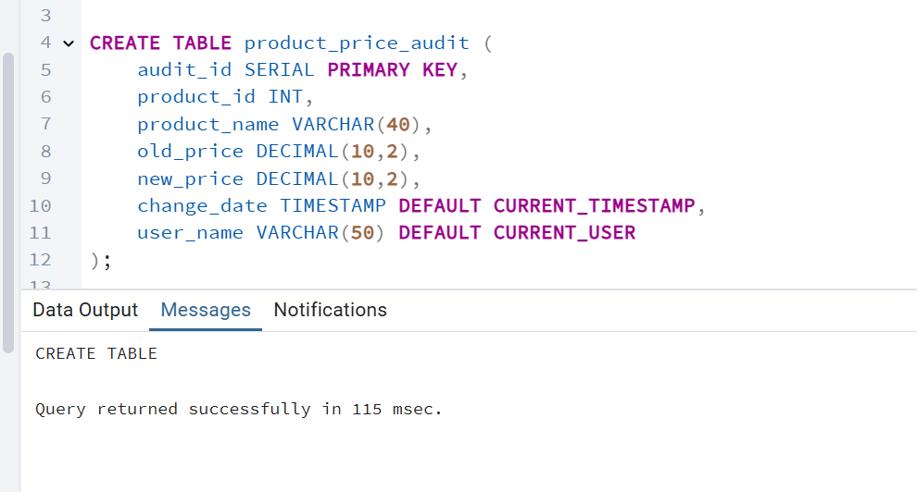

b. Create a trigger function with the below logic:

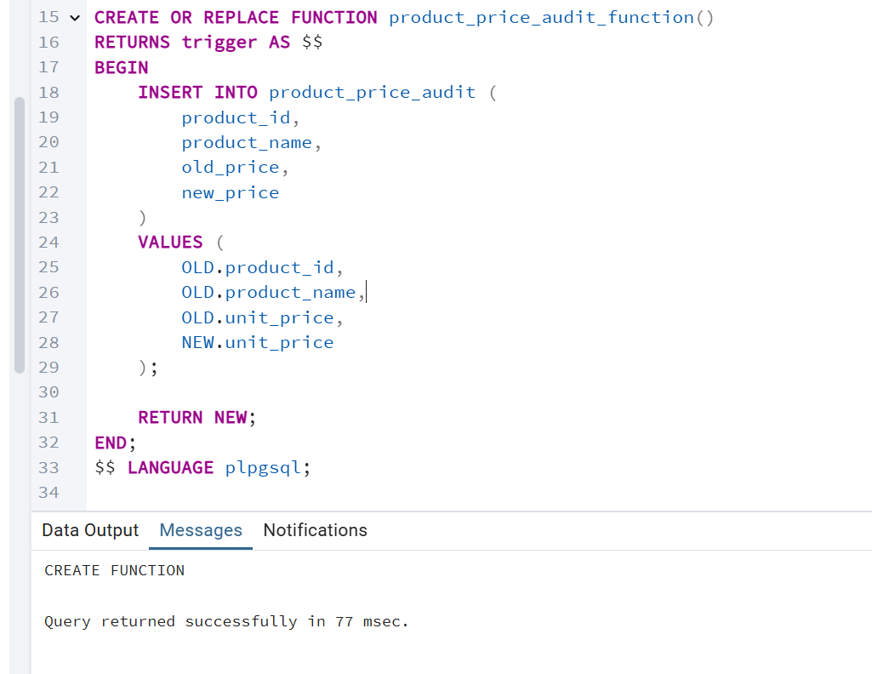

c. Create a row level trigger for below event:

AFTER UPDATE OF unit_price ON products

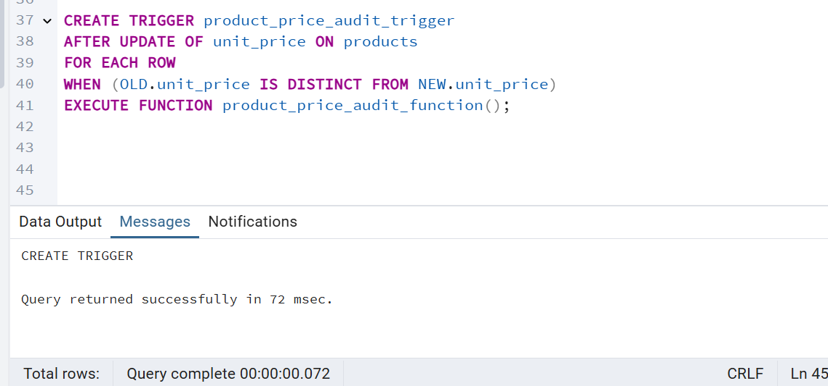

D. Test the trigger by updating the product price by 10% to any one product_id.

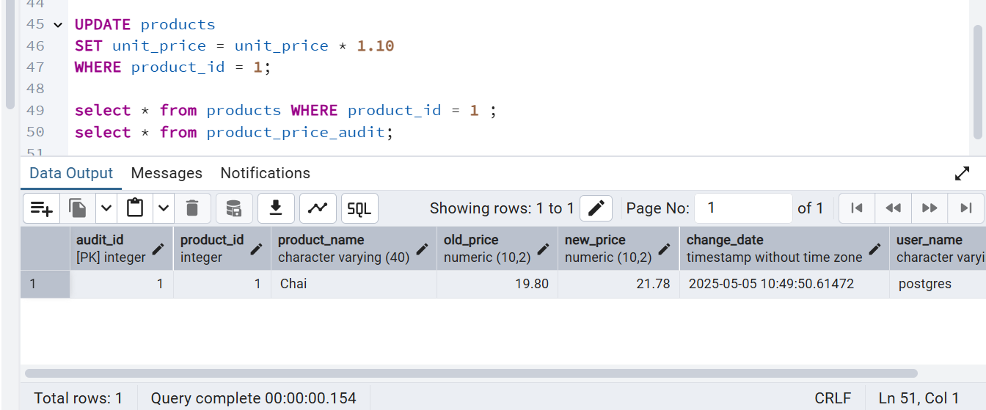

2. Create stored procedure using IN and INOUT parameters to assign tasks to employees

a. Create table employee_tasks CREATE TABLE IF NOT EXISTS employee_tasks ( task_id SERIAL PRIMARY KEY, employee_id INT, task_name VARCHAR(50), assigned_date DATE DEFAULT CURRENT_DATE);

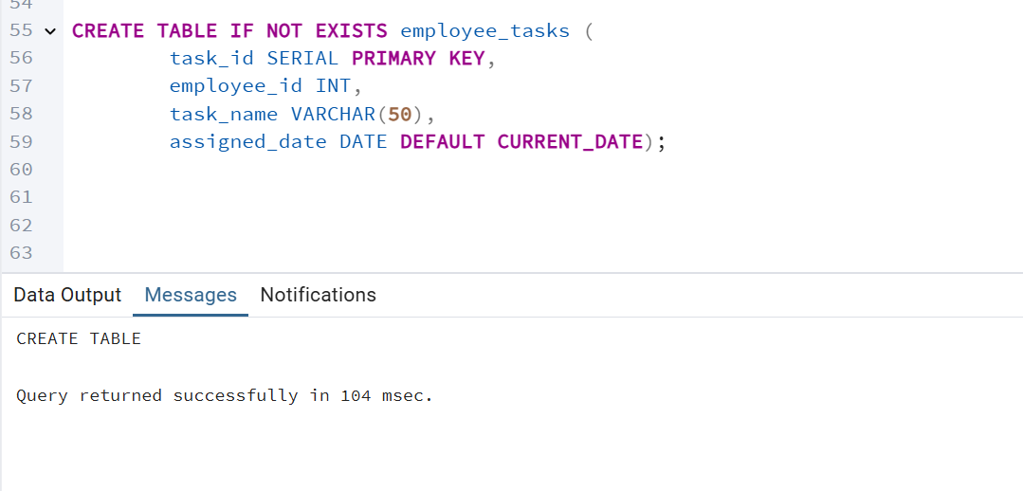

b. Create a Stored Procedure

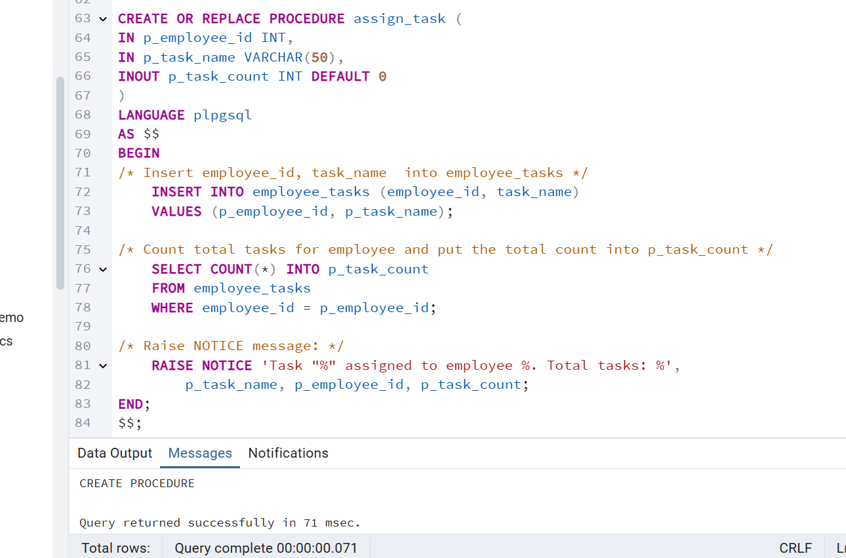

C. Call the Stored Procedure

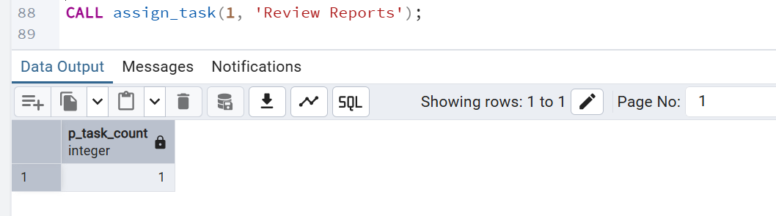

D. You should see the entry in employee_tasks table.

