1. What are the two main types of testing?

Ans: The 2 main types of testing are

* + 1. Manual Testing : Testing done without help of any tools
    2. Automation Testing :Where the testing is carried out with the help of tools or stand-alone scripts

1. What is BVA(Boundary value analysis) ?

Ans: The Validation technique used to validate the text boxes that accepts numbers.

E.g., If field is taking 1-100 values. According to BVA , we should text +1 or -1 from the boundaries.

In this case , 0,2 and 99,100 are the values to be tested.

1. What is Severity and Priority of a bug?

Ans:

|  |  |
| --- | --- |
| Priority | Severity |
| * Defines the order in which developer should resolve the defect. | * Defined the degree of impact that a defect has on the operations of the product. |
| * 3 types :   Low  Medium  High | * 5 types :   Critical  Major  Moderate  Minor  Cosmetic |
| * Associated with scheduling the defect | * Associated with functionality and standards |
| * How soon the defect should be fixed | * Seriousness of the defect on product functionality |
| * Manager/Client | * QA Engineer |
| * Subjective , can changes based on the project situation | * Objective Less likely to change. |
| * HIGH priority and LOW severity , immediate fix   E.g., Wrong logo error for any shipment website  Not effecting any functionality but do not want any further shipment with the wrong Logo | * HIGH severity and LOW priority , can take time to fix   E.g., Flight operating website , DEFECT in reservation functionality can be high severity but low priority ,as it can be scheduled in next release. |
| * Based on customer requirement | * Technical aspect of the product |
| * During UAT based on PRIORITY defects are fixed | * During SIT ,Developers fix the defects based on Severity first and then priority. |

**Defect Triage:**

* Reviewing all the defects including rejected defects by the team
* Initial assessment of the defects is based on its content and respective priority and severity settings
* Prioritizing the defect based on the inputs
* Assign the defect to correct release by product manager
* Re-directs the defect to the correct owner/team for further action

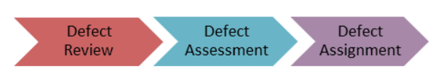

Guidelines to follow before selecting a severity :

* Understand the concept of priority and severity well
* Always assign the severity level based on the issue type as this will affect its priority
* Understand how a particular scenario or[Test Case](https://www.guru99.com/test-case.html)would affect the end-user
* Need to consider how much time it would take to fix the defect based on its complexity and time to verify the defect

1. What is Requirement traceability matrix(RTM) ? Why is it important?

Ans:

**What ??**

* 1. Document that maps and traces all the requirement with test cases.
  2. Delivered at the time of conclusion of the SDLC
  3. Purpose is to validate all the requirements with the test cases , so that no functionality is unchecked.

**Why ??**

1. To make sure the requirement is tested with all possible scenarios
2. No requirement is left out form testing

**Parameters to me included in RTM are :**

* 1. Requirement ID
  2. Requirement Type and Description
  3. Test cases with the status

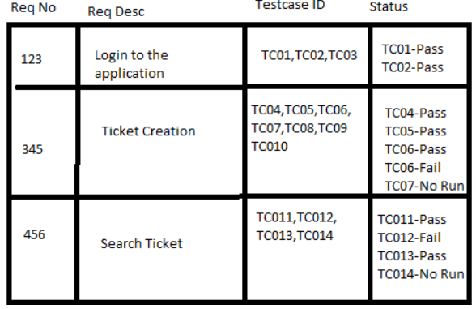

**Typical RTM**

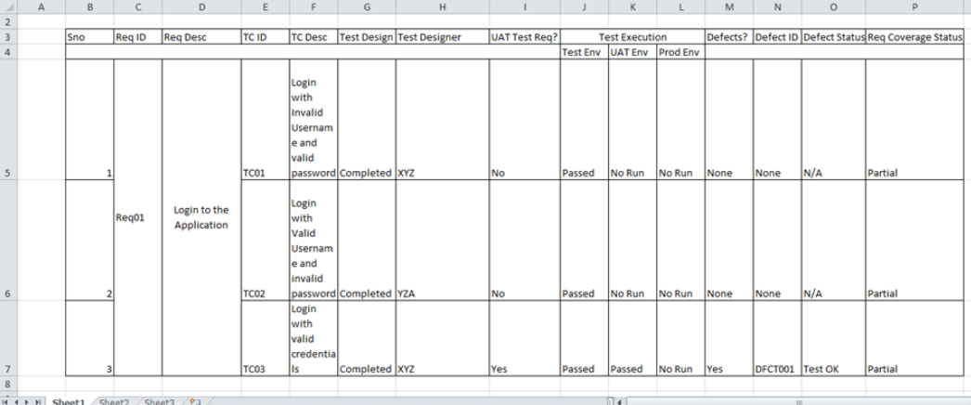

1. What are the different levels of testing?

Ans:

* 1. Unit testing
  2. Integration testing
  3. System Testing
  4. Acceptance testing

1. What is a test plan?

Ans:

1. is a detailed document that describes the test strategy, objectives, schedule, estimation, deliverable, and resources required to perform testing for a software product.
2. Estimates the effort required
3. Like a blueprint , prepared by the manager.
4. Helps the outside team like developers , business managers,customers to understand the details
5. Guides the tester like a rule book.

**How to Write Test Plan:**

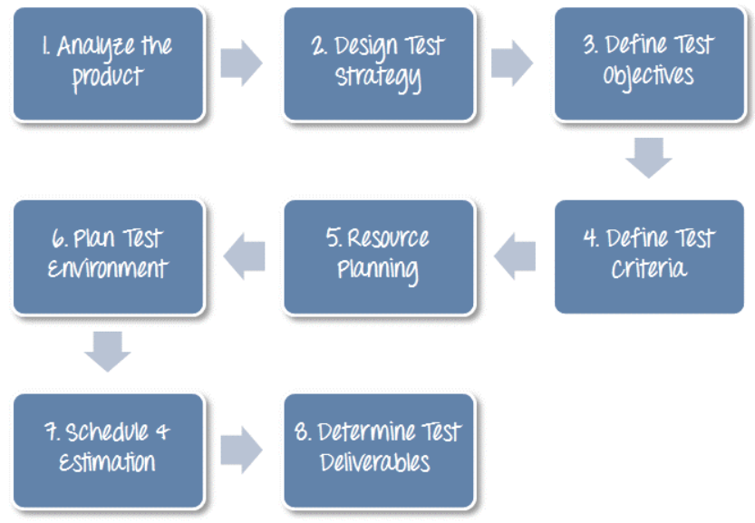

1. Analyse the product :

* Who will use the website?
* What is it used for?
* How will it work?
* What are software/ hardware the product uses?

1. Develop Test Strategy

* Critical Step
* Test Manager
* Test objectives and means to achieve them
* Testing effort and cost

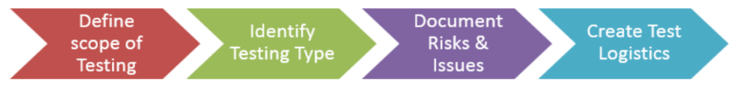

1. Test Objective

* Overall goal and achievement of the test execution
* To make the software bug free
* List all the software features to be tested (Top-Down approach e.g, components and sub components)
* Define a target

1. Define Test Criteria

* Entry and Exit Criteria
* Suspension Criteria (Testing suspended if more than acceptable % of test failures appear)

1. Resource Planning

* Human resource
* System resource

1. Plan Test Environment
2. Schedule & Estimation
3. Test Deliverable

Test deliverable are provided **before**testing phase.

* + Test plans document.
  + Test cases documents
  + Test Design specifications.

Test deliverable are provided **during**the testing

* + Test Scripts
  + Simulators.
  + Test Data
  + Test Traceability Matrix
  + Error logs and execution logs.

Test deliverable s are provided **after**the testing cycles is over.

* + Test Results/reports
  + Defect Report
  + Installation/ Test procedures guidelines
  + Release notes

1. What is the difference between regression and retesting?

Ans:

|  |  |
| --- | --- |
| Regression | Re-testing |
| * Carried out to find out if the recent fixes have made any changes in the existing functionality | * Carried out to test if the defects found during the execution are fixed. |
| * Regression testing can be executed in parallel with Re-testing | * Re-testing holds the highest priority so it should be executed prior to regression. |
| * Can be automated , Manual testing is exhaustive and time consuming | * Cannot be automated |
| * Generic Testing | * Planned testing |
| * Done for Passed test-cases | * Done for Failed test-cases |
| * Checks for unexpected side effects | * Original issue is resolved |
| * Test-cases are derived from Functional specifications ,user tutorials and manuals and defect reports | * Can not be obtained before start of the testing |

1. Different stages of defect life cycle ?

Ans:

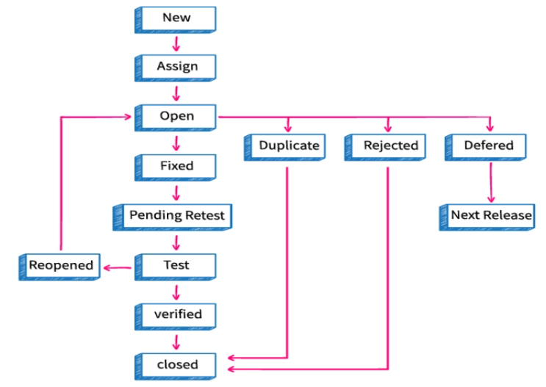

1. Latent Defects - Defects that may not cause failures in the system or impact the customer. The defect which silently present in the product.

Masked Defect - Defect that is hidden behind another defect and can only be found once the other defect is found.

1. What are the different parts of a defect report?

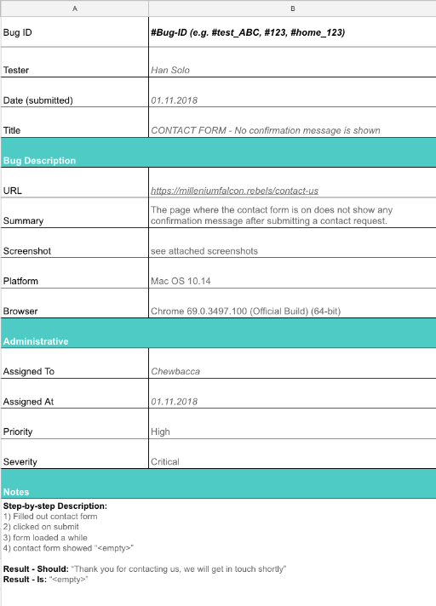

1. Explain different types of testing.

* Functional Testing
* Non-Functional testing

|  |  |
| --- | --- |
| * Unit Testing | * Test an individual unit or group of interrelated units * Developer |
| * Integration Testing | * Testing Group of Components * Bottom-up integration :Testing begins with unit testing, followed by modules or builds. * Top-down integration :The highest-level modules are tested first and lower-level modules are tested thereafter |
| * System testing | * Whole integrated System is tested * Verify if the functional and technical specifications are met * Test, verify, and validate both the business requirements and Application   architecture. |
| * Regression Testing | * To verify that a fixed bug hasn't resulted in another functionality or business rule   violation   * Testing the new changes to verify that the changes made did not affect any other area of the application. |
| * Acceptance Testing | * To test whether the system is developed according to the requirements   communicated by the stakeholders.   * Done by Customers |
| * Alpha Testing | * Done within the team * Unit testing, integration testing and system testing when combined together |
| * Beta Testing | * Pre-Release Testing * Small intended audience |
| * Re-Testing | * Testing the failed Tc's after the bugs corresponding to those Tc's have been fixed * Part of bug life cycle * Regression needs to be performed |

|  |  |
| --- | --- |
| * Sanity Testing | * Subset of regression testing * Test bug fixes and Critical functionalities * No Documentation needed |
| * Smoke Testing | * Crucial Test cases are executed (build verification test) * Can be documented and automated too. |
| * Negative Testing(Error path) | * Providing  invalid or unexpected data |
| * Performance Testing | * Application is evaluated under simulated expected or higher than expected workload. * Jmeter tool (helps to create virtual users) |
| * Load Testing | * Performance testing in which the performance of the application is evaluated under the expected load * Parameters tested are reponse time , load on server |
| * Stress testing | * Performance testing ,evaluated under a load much higher than the expected or the anticipated load |
| * Usability Testing | * Testing to see how easily used or operated |
| * Security Testing | * Testing system’s readiness to fight back against any external or internal attacks |

1. Explain STLC(Software Testing Life Cycle)

Ans:

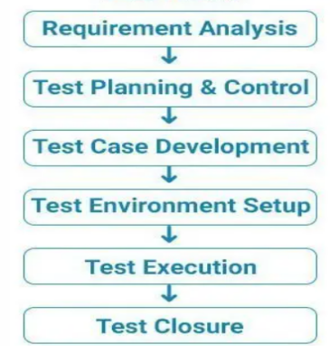

1. Different Testing methods

Ans:

Black-Box Testing :Tester has n access to the internal functionality

White-Box Testing : Tester has the complete access to the source code

Grey-Box Testing :Tester will have partial access to the source code like DB connections , API calls .

1. When Manual testing is chosen over automation testing?

Ans:

* Re-testing
* Tc’s need to be run only few times
* Adhoc and Exploratory
* Checking the user friendliness of the application
* While handling complex scenarios
* Tc’s whee random decision making is involved

1. Difference between Exploratory testing and Adhoc Testing

Ans:

|  |  |
| --- | --- |
| Adhoc | Exploratory |
| * Functionality needs to be understood | * No prior knowledge of the application is required |
| * No target or goal to complete | * Goals and targets can be set |
| * No Documentation | * Well documented |
| * Generic Testing | * Planned testing |
| * Very little practical use | * Good practical use in the market to test |
| * Bugs can’t be handled properly | * Critical bugs can be handled efficiently |

1. What does a test-case template consists of?

Ans:

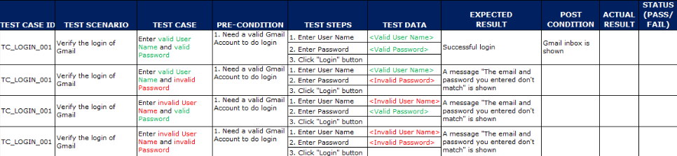

1. What are the few test deliverable?

Ans:

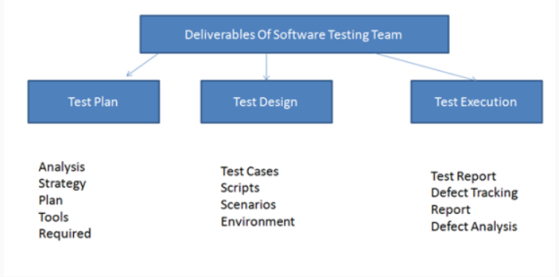

1. Bug Leakage: A bug is missed by the testing team during test phase and it has escaped to production where it is discovered by the actual user and called leaked bug. The phenomenon is called Bug leakage.
2. Show Stopper defect : The bug that will not allow the testing to be continued. App crash , Login failure..
3. Hot fix : Sometimes build deployed would have critical defect and build have to be rolled back.An emergency fix is released as a new patch.
4. Difference between Smoke testing and Sanity testing

Ans:

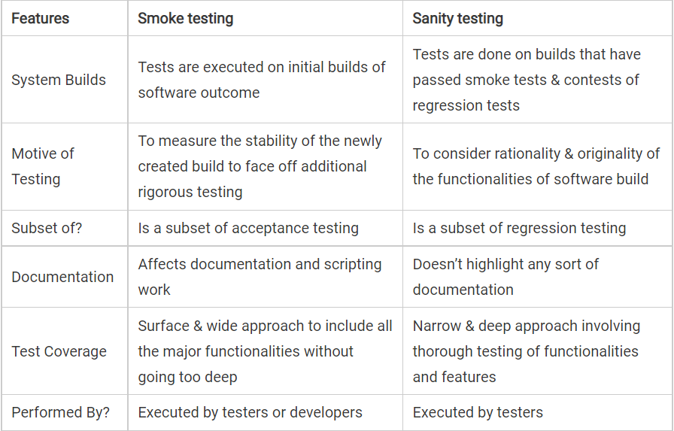

1. Different testing techniques .Explain

Ans:

|  |  |  |
| --- | --- | --- |
| Technique | Guidelines | Examples |
| * Boundary Value Analysis (BVA) | * Based on testing at the boundaries between partition * It includes maximum, minimum, inside or outside boundaries, typical values and error values. * Black-Box testing * If the values are restricted between X and Y , then Tc’s should be designed above or below X and Y values * Above and below min and max values | * Input condition is valid between 1 to 10 * Boundary values 0,1,2 and 9,10,11 |
| * Equivalence Class Partitioning | * Goals and targets can be set |  |
| * No Documentation | * Well documented |  |
| * Generic Testing | * Planned testing |  |
| * Very little practical use | * Good practical use in the market to test |  |
| * Bugs can’t be handled properly | * Critical bugs can be handled efficiently |  |