2.

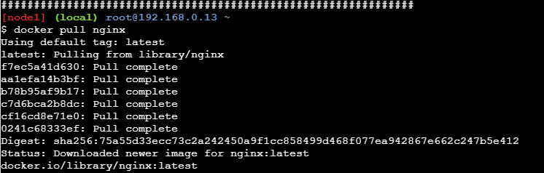

3.

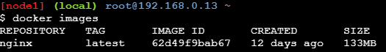

4.
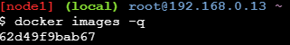

5.Containers---------

- containers--------------
Initially,

But after running container

- containers-------------

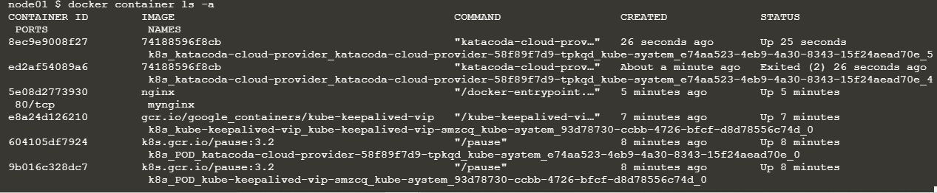

- Containers----------

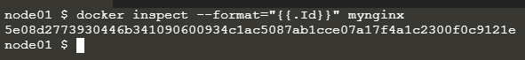

9.

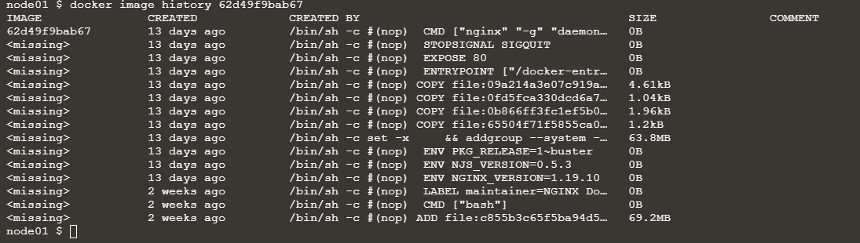

10.

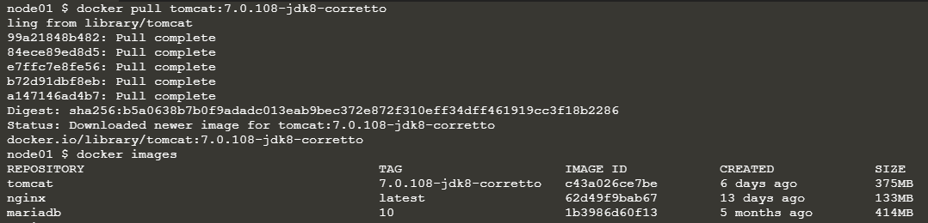

11.

12.

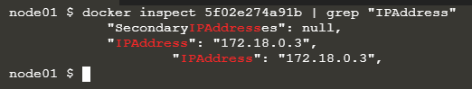

13.

14.
localhost:8080 is not accessible(this site can't be reached)

15.

16.

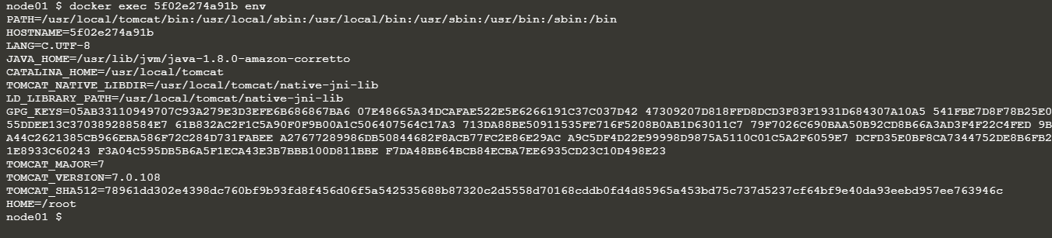

17.
Same as 13

18.

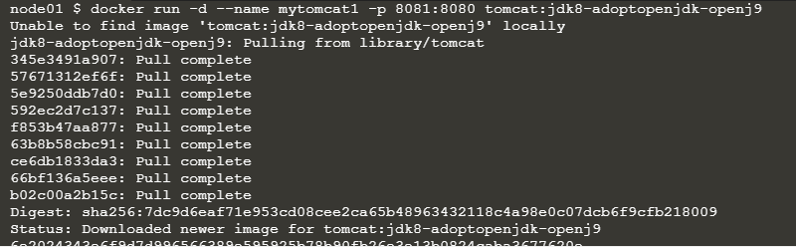

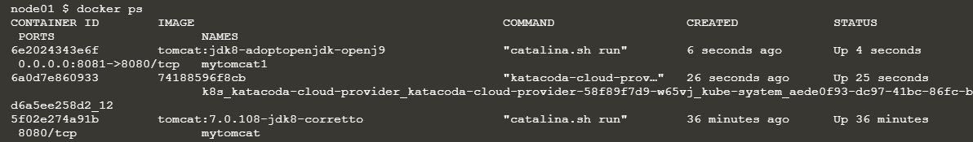

- Both 20 and 21

20.
docker run -d --name myubuntu1 -p 9090:8080 ubuntu:xenial-20210416

21.

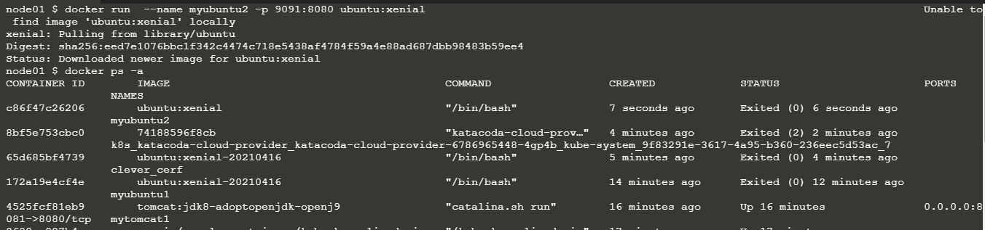

22.

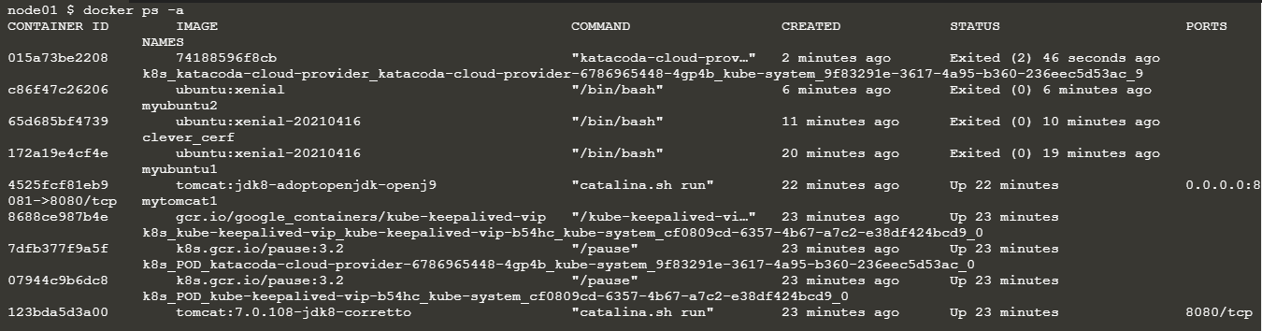

23.
Yes, tomcat is running u can see it from 22.

- Still there..

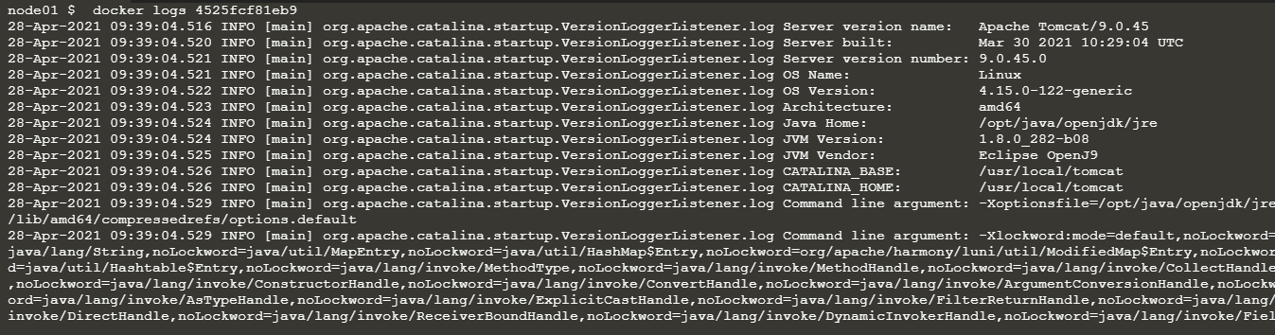

Also tried to access localhost:8081
but the ouput is ==the site can't be reached.

25.Ubuntu is running

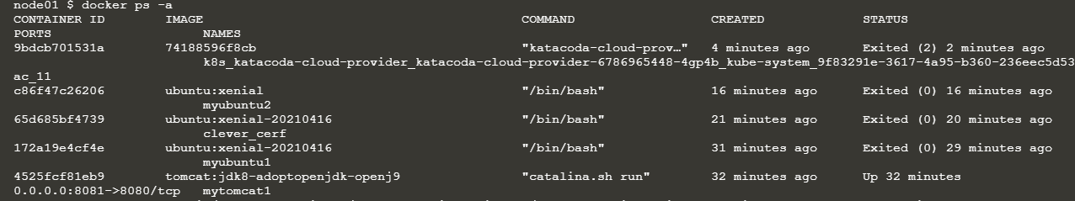

39.1

39.2

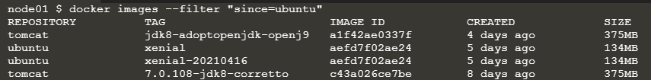

39.3

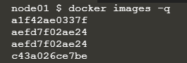

40.1

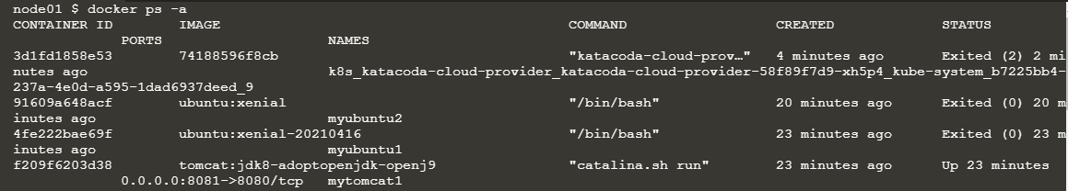

40.2

40.3

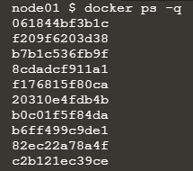

40.4

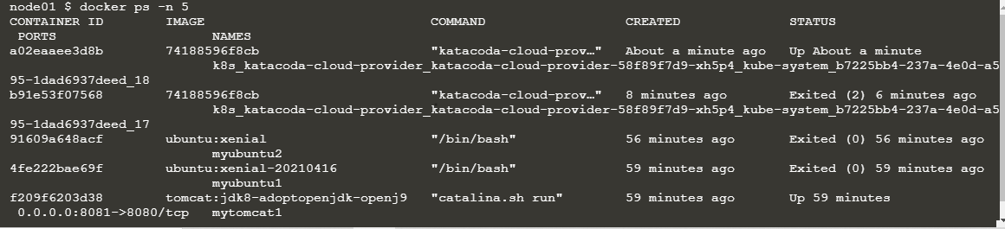

40.5

40.6

