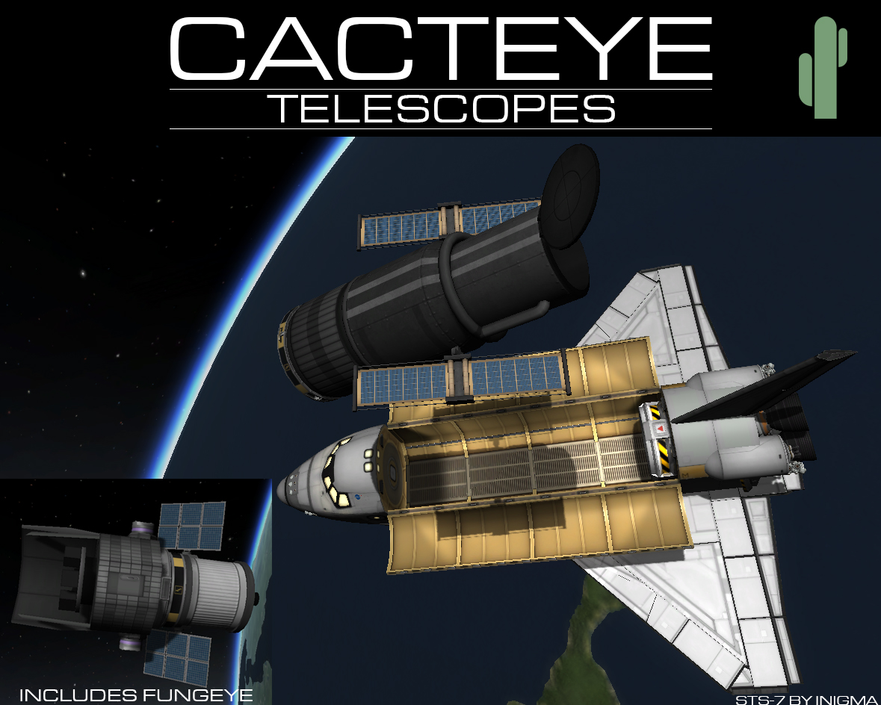  
  
CactEye is a plugin and set of parts that allow for modular orbital telescopes. CactEye telescopes feature a fully-functional science system, and are upgradeable/serviceable (primarily through [Kerbal Inventory System](http://forum.kerbalspaceprogram.com/threads/113111-1-0-4-Kerbal-Inventory-System-%28KIS%29-1-2-2)). Orbital telescopes also now become fundamental to discovering asteroids.  
  
CactEye Telescopes works best with [Distant Object Enhancement](http://forum.kerbalspaceprogram.com/threads/98943) by MOARdv.  
  
CactEye Telescopes Continued is available as a BETA release. As of right now, the Wide Field cameras and the Asteroid cameras are available and should be fully functional. The Occultation experiments are not yet available, but will be in a future release.  
  
Download  
Github: [Current Release](https://github.com/Angel-125/CactEye-2/releases)  
Source Code  
Github: [Current Source Code](https://github.com/Angel-125/CactEye-2)  
License  
<http://creativecommons.org/licenses/by/4.0/>  
"CactEye Telescopes Continued" is a derivative work of "CactEye 2" by Raven, which is a derivative work of "CactEye Orbital Telescope" by Rubber-Ducky. It is licensed under CC BY 4.0.   
Icons made by Freepik from <http://www.flaticon.com> is licensed by <http://creativecommons.org/licenses/by/3.0/> CC BY 3.0  
  
Screenshots  
[imgur]A63gG[/imgur]  
  
Future Enhancements  
Integration with Research Bodies  
Integration with Asteroid Day  
Integration with Outer Planets Mod  
Ground-based telescope  
More cameras