Valle de Oro Water Treatment Ponds

## Abstract

We are creating three treatment ponds that resemble a wetland to clean storm runoff that is possible from up to the 100-year storm before it enters the Rio Grande or water table. This will filter out harmful substances before they enter the water we drink while also restoring the Valle to a state similar to what it may have been like before domestication. The goal of the first pond is to remove the large debris and large sediments. This one may start out with a manmade structure to remove the large debris (i.e. plastic bags or shopping carts). The second pond is geared towards removing oils and moderate sediment. The final pond is geared towards removing the dissolved solids and finer pollutants.

We looked into natural methods of cleaning water and compared maintenance demands and efficiency and decided that plants would be the best option for cleaning the water. In order to find the best way to filter water, we researched plants indigenous to New Mexico, and which of them have the highest levels of pollutant absorptivity, anaerobic tolerance, and drought resistance. We concluded that Saltgrass, Coyote Willow, Southern Cattail, and Drummond's Willow are the best options for cleaning the water. The first pond will be mostly filled with Coyote Willow, Southern Cattail, and Drummonds Willow and may contain a man made structures to easily remove the large debris, such as plastic bags, that will flow into the pond. The second pond will be filled with Southern Cattail, Coyote Willow, and a large amount of Saltgrass. This pond, along with the final pond, will be fairly shallow and slow-flowing.

**Introduction**

In September of 2004 the Valle de Oro national wildlife refuge opened to the public. This 488 acre refuge was a dairy farm for years before the Fish and Wildlife bought it and the long and difficult project to restore, rehabilitate, and nurture the land of the only urban wildlife refuge in New Mexico back to its untamed state of meandering rivers and wetlands filled with plant and wildlife.. The now domesticated land of the Valle was not always dry and plowed. It was once a diverse piece of land with wetlands routing clean, pure water into the Rio Grande. Restoring this functionality is what Daniel Aguirre and his team at Wilson and Co were tasked to do. To help them achieve this task, they teamed up with a group of students from nex+Gen Academy, a local high school that had worked with the Valle de Oro in the past. The nex+Gen team was tasked to research plants native to New Mexico and develop plans for a series of treatment ponds designed to clean storm runoff from the area around the Valle. These ponds would also ultimately resemble the wetlands that were once the lifeblood of the Valle.

## **Methodology**

In order to provide the best treatment for water running through our ponds, we chose to use Seep Willows (Binomial Nomenclature), Coyote Willows (Binomial Nomenclature), Drummond's Willows (Salix Drummondiana), Bluestem Willows (Binomial Nomenclature), Screwbean Mesquite (Binomial Nomenclature), Bebb Willows (salix bebbiana), and Saltgrass (Binomial Nomenclature) because they all are indigenous to New Mexico and have desirable qualities for treating water according to our plans. We chose to use the Seep Willow because, along with cottonwoods, these willows are a dwindling species in the Bosque. The willows would be great for trapping water in the soil and preventing erosion. In addition, the seep willow will catch metal shavings and trash and, if implemented correctly, will stop large debris from infiltrating the second and third pond. We chose to use coyote willow because Coyote Willows are effective at filtering out large debris and help slow down water allowing more contaminants to be removed. We also feel that Coyote Willows are an important addition because the willow population of the Middle Rio Grande Valley is decreasing. The Drummond’s Willow is commonly found in wetlands and would serve the same purpose as the other willows we recommended. Using four different types of willows instead of just one raises the ecosystems score on the Shannon and Simpson index. The Bluestem Willows are great because of their height. They would ensure the wetlands were a sanctuary for small birds, while deterring large birds that may cause problems for the planes overhead. We feel like cattails are an essential addition because the number of sandbars, and therefore cattails, on the Rio Grande is decreasing. The Rio Grande had many sandbars covered with cattails even 50 to 60 years ago. By simply creating sandbars and adding cattails to hold the ground in place, our ponds would be significantly more similar to how the Rio used to be. . The ponds that have sandbars will also have slower moving water, which will allow the sediments to settle out, give the chemicals more time to be absorbed from the water by the soil, allowing an adequate sun exposure to help recycle the nitrates and phosphates. The Screwbean Mesquite would potentially be helpful in deterring large birds from landing in the wetland. Finally, we chose Saltgrass because it will trap the oils, allowing them to be broken down naturally.

## **Benefits**

The benefits of this project will advance the goal of the Valle de Oro dramatically both with its establishment and it’s legacy. The plants we detailed are shown to be highly efficient in removing pollutants from water. The majority of these plants clean out metals, trash, and also remove a significant number of other harmful substances that are should not be in water. Bringing plant life to these ponds will provide a good foundation for the ecosystem that will be established there. For public awareness, this project will provide a educational benefit to city of albuquerque by teach students, and adults alike about the logistics of this project.

## **Conclusion**

The Valle de Oro is an important area not only to the local community of Albuquerque, but also to the ecosystem of the Rio Grande. The vision for the Valle is that it will be a haven for birds, small mammals, and sightseers who want to escape city life without having to drive to a remote location. Our part of making this vision a reality was to design ponds to naturally treat stormwater flowing into the Rio Grande. We had to consider multiple characteristics of plants including drought resistance, height, and anaerobic tolerance to select the best plants to put in our ponds. Our plans for these three treatment ponds are not only to clean stormwater, but also to provide a visually appealing landscape that simulates the wetlands present a century or even a millennium ago and serving as an educational device illustrating state of the old Valle and illuminating the dangers of over developing nature.

## 

## **Appendix**

Graph 1

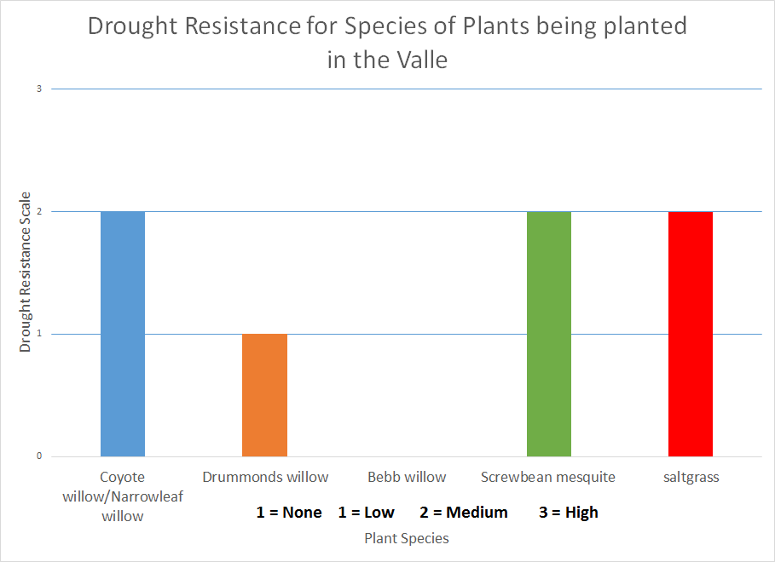

Graph 2

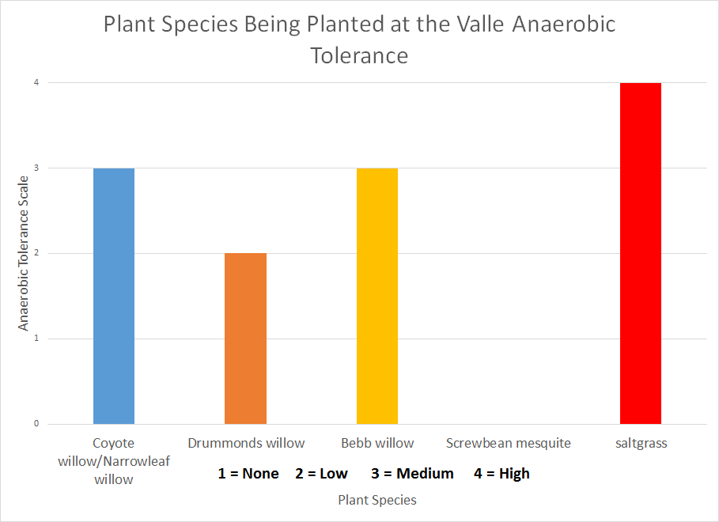

Graph 3

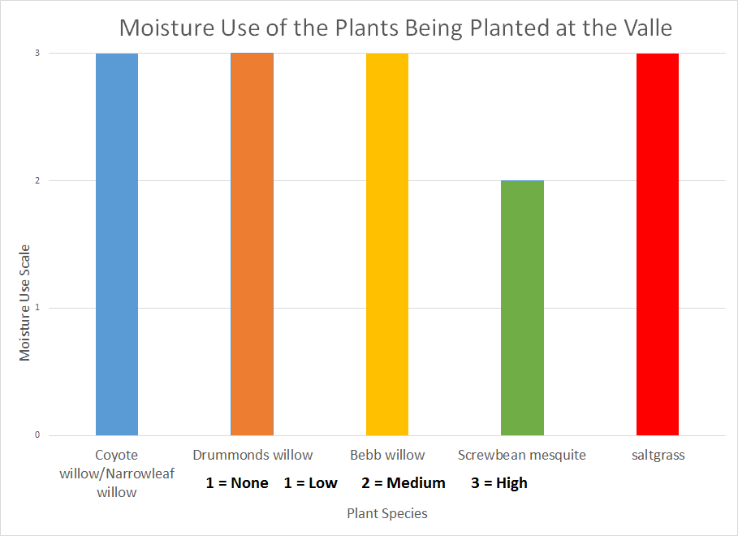

Graph 4

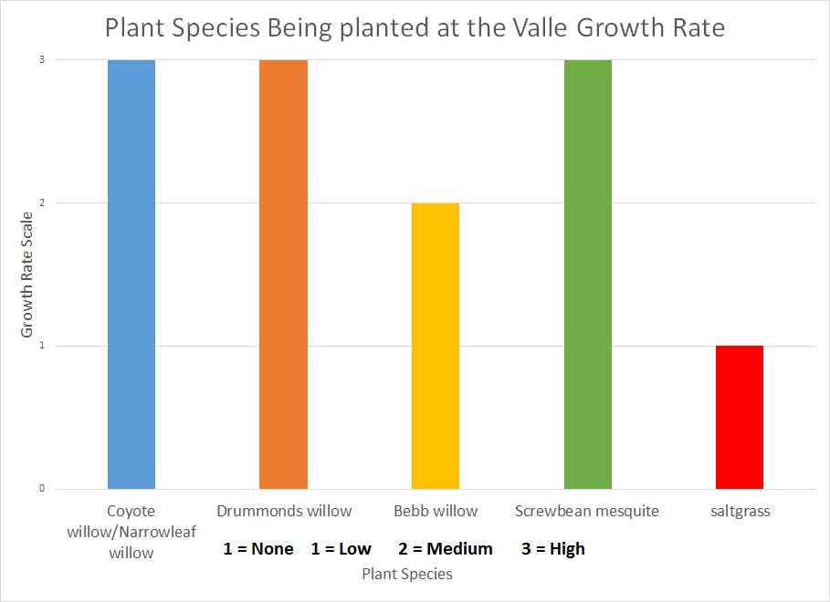

## 

## 

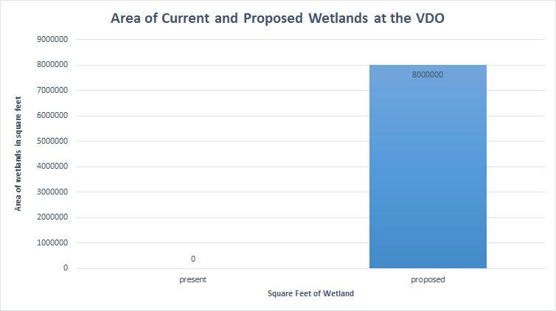

## 

## 

## 

## 

## 

## Works Cited

"Riparian Plants of New Mexico."*NMSU -*. Web. 20 Oct. 2016.

"Conservation Plant Characteristics for ScientificName (CommonName) | USDA PLANTS." *Conservation Plant Characteristics for ScientificName (CommonName) | USDA PLANTS*. Web. 20 Oct. 2016.

"Albuquerque, New Mexico - Average Rainfall - Current ..." N.p., n.d. Web. 21 Oct. 2016.

"River Plankton And Water Quality Of The Lower Rio Grande/rio Bravo, Texas, Usa." *Journal of Phycology* 37 (2008): 16-17. Web.

"Carbofuran." *Carbofuran*. Web. 21 Oct. 2016.

"Carbofuran." *Exotoxnet*. N.p., Sept. 1993. Web. 11 Oct. 2016. <http://pmep.cce.cornell.edu/profiles/extoxnet/carbaryl-dicrotophos/carbofuran-ext.html>.

"Metolachlor." *Metolachlor*. Web. 21 Oct. 2016.

"DCPA." *DCPA*. Web. 21 Oct. 2016.

"Diazinon." *Diazinon*. Web. 21 Oct. 2016.

"Chlorpyrifos." *Chlorpyrifos*. Web. 21 Oct. 2016.

"River Plankton And Water Quality Of The Lower Rio Grande/rio Bravo, Texas, Usa." *Journal of Phycology* 37 (2008): 16-17. Web.

"Secondary Drinking Water Standards: Guidance for Nuisance Chemicals." *EPA*. Environmental Protection Agency. Web. 21 Oct. 2016.

1. Overview
2. Methodology
3. Benefits
4. Works Cited