Aluno: Pedro Augusto Ferreira de Almeida

Dever de casa:

Faça uma calculadora simples em HTML e usando CSS externo.

Use como modelo a imagem abaixo.

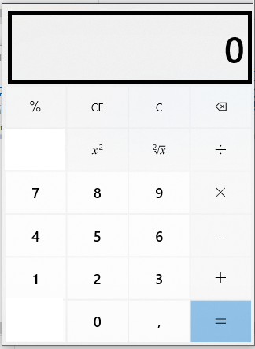

Para Visor coloque uma input do tipo texto

E os números e operadores, botões.

Fala uma lista com todos os requisitos para o funcionamento de uma calculadora.

Faça as funções básicas: +, -, *, / e =

Dicas:

Pense em realizar o cálculo básico

Valor1 **operador** valor2 **sinal de igual** resultado.

n1 + n2 = resultado.

**CSS:**

#div_main{

    margin-left: 20%;

    margin-top: 200px;

    border: 2px solid black;

    width: 350px;

    height: 460px;

    background-color: #ebebeb;

}

body{

    background-color: burlywood;

}

#visor{

    background-color: #ebebeb;

    border: 5px solid black;

    text-align: right;

    margin-top: 50px;

    margin-left: 8px;

    padding-right: 15px;

    height: 50px;

    width: 310px;

    font-size: 30px;

    font-weight: 800;

}

#primeiroValor{

    position: absolute;

    background-color: #ebebeb;

    margin-top: 3%;

    margin-left: 1%;

    border: none;

    height: 11px;

    padding: 0px;

}

.operadores{

    border: none;

    background-color: #ffffff;

    font-size: 120%;

    width: 77.5px;

    height: 50px;

    margin-top: 6px;

    margin-left: 3px;

}

#nada{

    margin-left: 10px;

}

**CÓDIGO:**

<!DOCTYPE html>

<html lang="en">

<head>

    <meta charset="UTF-8">

    <meta name="viewport" content="width=device-width, initial-scale=1.0">

    <title>Calculadora</title>

</head>

<link rel="stylesheet" href="style_cal.css" type="text/css">

<body>

    <script>

        var num1 = 0, num2 = 0, num3 = 0, op = 0, controleOperador = 0,

            controleBotoes = 0, controleResultado = 0, aux = 0, aux2 = 0, aux3 = 0;

        function preencher(valor) {

            if (controleResultado == 0) {

                if (document.getElementById("visor").value == 0) {

                    document.getElementById("visor").value = valor;

                } else {

                    if (controleBotoes == 0) {

                        document.getElementById("visor").value += valor;

                    } else {

                        document.getElementById("visor").value = valor;

                        controleBotoes = 0;

                    }

                }

            } else {

                limpar();

            }

        }

        function operador(operador) {

            controleResultado = 0;

            switch (controleOperador) {

                case 0:

                    op = operador;

                    num1 = parseFloat(document.getElementById("visor").value);

                    controleBotoes = 1;

                    controleOperador = 1;

                    aux = 1;

                    aux3 = 1;

                    document.getElementById("primeiroValor").value = num1 + " " + op;

                    break;

                case 1:

                    num2 = parseFloat(document.getElementById("visor").value);

                    aux = 2;

                    aux2 = 1;

                    aux3 = 0;

                    calcular();

                    op = operador;

                    document.getElementById("primeiroValor").value = num3 + " " + op;

                    break;

                case 2:

                    num1 = parseFloat(document.getElementById("visor").value);

                    num2 = num3;

                    aux = 2;

                    aux3 = 0;

                    calcular();

                    op = operador;

                    document.getElementById("primeiroValor").value = num3 + " " + op;

                    break;

                default:

                    document.getElementById("visor").value = "Erro na função operador";

            }

        }

        function calcular(valor) {

            if (valor == 1 && controleOperador != 0 && aux3 == 1) {

                if (num3 != 0) {

                    num1 = parseFloat(document.getElementById("visor").value);

                    num2 = num3;

                    document.getElementById("primeiroValor").value += " " + num1 + " =";

                    switch (op) {

                        case '+':

                            document.getElementById("visor").value = num1 + num2;

                            num3 = num1 + num2;

                            break;

                        case '-':

                            document.getElementById("visor").value = num2 - num1;

                            num3 = num1 - num2;

                            break;

                        case '*':

                            document.getElementById("visor").value = num1 * num2;

                            num3 = num1 * num2;

                            break;

                        case '/':

                            document.getElementById("visor").value = num2 / num1;

                            num3 = num1 / num2;

                            break;

                        default:

                            break;

                    }

                } else {

                    num2 = parseFloat(document.getElementById("visor").value);

                    document.getElementById("primeiroValor").value += " " + num2 + " =";

                    switch (op) {

                        case '+':

                            document.getElementById("visor").value = num1 + num2;

                            num3 = num1 + num2;

                            break;

                        case '-':

                            document.getElementById("visor").value = num1 - num2;

                            num3 = num1 - num2;

                            break;

                        case '*':

                            document.getElementById("visor").value = num1 * num2;

                            num3 = num1 * num2;

                            break;

                        case '/':

                            document.getElementById("visor").value = num1 / num2;

                            num3 = num1 / num2;

                            break;

                        default:

                            document.getElementById("visor").value = "erro 404";

                    }

                }

                controleResultado = 1;

                controleBotoes = 0;

                controleOperador = 0;

                aux = 0;

                aux3 = 0;

            } else {

                switch (aux) {

                    case 1:

                        num2 = parseFloat(document.getElementById("visor").value);

                        document.getElementById("primeiroValor").value += " " + num2 + " =";

                        switch (op) {

                            case '+':

                                document.getElementById("visor").value = num1 + num2;

                                num3 = num1 + num2;

                                break;

                            case '-':

                                document.getElementById("visor").value = num1 - num2;

                                num3 = num1 - num2;

                                break;

                            case '*':

                                document.getElementById("visor").value = num1 * num2;

                                num3 = num1 * num2;

                                break;

                            case '/':

                                document.getElementById("visor").value = num1 / num2;

                                num3 = num1 / num2;

                                break;

                            default:

                                document.getElementById("visor").value = "erro na função calcular1";

                        }

                        controleResultado = 1;

                        controleBotoes = 0;

                        controleOperador = 0;

                        break;

                    case 2:

                        if (aux2 == 1) {

                            switch (op) {

                                case '+':

                                    document.getElementById("visor").value = num1 + num2;

                                    num3 = num1 + num2;

                                    break;

                                case '-':

                                    document.getElementById("visor").value = num1 - num2;

                                    num3 = num1 - num2;

                                    break;

                                case '*':

                                    document.getElementById("visor").value = num1 * num2;

                                    num3 = num1 * num2;

                                    break;

                                case '/':

                                    document.getElementById("visor").value = num1 / num2;

                                    num3 = num1 / num2;

                                    break;

                                default:

                                    break;

                            }

                            document.getElementById("primeiroValor").value = document.getElementById("visor").value + " " + op;

                            controleBotoes = 1;

                            controleOperador = 2;

                            aux2 = 0;

                        } else {

                            switch (op) {

                                case '+':

                                    document.getElementById("visor").value = num1 + num2;

                                    num3 = num1 + num2;

                                    break;

                                case '-':

                                    document.getElementById("visor").value = num2 - num1;

                                    num3 = num2 - num1;

                                    break;

                                case '*':

                                    document.getElementById("visor").value = num1 * num2;

                                    num3 = num1 * num2;

                                    break;

                                case '/':

                                    document.getElementById("visor").value = num2 / num1;

                                    num3 = num2 / num1;

                                    break;

                                default:

                                    break;

                            }

                            document.getElementById("primeiroValor").value = document.getElementById("visor").value + " " + op;

                            controleBotoes = 1;

                            controleOperador = 2;

                        }

                        break;

                    default:

                        break;

                }aux = 0;

                aux3 = 1;

            }

        }

        function limpar() {

            document.getElementById("visor").value = 0;

            document.getElementById("primeiroValor").value = "";

            controleResultado = 0;

            controleOperador = 0;

            controleBotoes = 0;

            aux = 0;

            aux2 = 0;

aux3 = 0;

            num1 = 0;

            num2 = 0;

            num3 = 0;

            op = 0;

        }

        function zero() {

            if (document.getElementById("visor").value != 0) {

                document.getElementById("visor").value += 0;

            }

        }

    </script>

    <div id="div_main">

        <input type="text" id="primeiroValor" value="">

        <input type="text" id="visor" value="0">

        <input type="button" value="%" id="nada" class="operadores">

        <input type="button" value="CE" class="operadores">

        <input type="button" value="C" class="operadores" onclick="limpar()">

        <input type="button" value="&#8592;" class="operadores">

        <input type="button" value="&#8900;" id="nada" class="operadores">

        <input type="button" value="x&#178;" class="operadores">

        <input type="button" value="&#8730;x" class="operadores">

        <input type="button" value="&#247;" class="operadores" onclick="operador('/')">

        <input type="button" value="7" id="nada" class="operadores" onclick="preencher(7)">

        <input type="button" value="8" class="operadores" onclick="preencher(8)">

        <input type="button" value="9" class="operadores" onclick="preencher(9)">

        <input type="button" value="&#215;" class="operadores" onclick="operador('*')">

        <input type="button" value="4" id="nada" class="operadores" onclick="preencher(4)">

        <input type="button" value="5" class="operadores" onclick="preencher(5)">

        <input type="button" value="6" class="operadores" onclick="preencher(6)">

        <input type="button" value="-" class="operadores" onclick="operador('-')">

        <input type="button" value="1" id="nada" class="operadores" onclick="preencher(1)">

        <input type="button" value="2" class="operadores" onclick="preencher(2)">

        <input type="button" value="3" class="operadores" onclick="preencher(3)">

        <input type="button" value="+" class="operadores" onclick="operador('+')">

        <input type="button" value="&#8900;" id="nada" class="operadores">

        <input type="button" value="0" class="operadores" onclick="zero()">

        <input type="button" value="," class="operadores" onclick="preencher('.')">

        <input type="button" value="=" class="operadores" onclick="calcular(1)">

    </div>

</body>

</html>

**Depois verifique as outras possibilidades de cálculos:**

**10 + = ?**

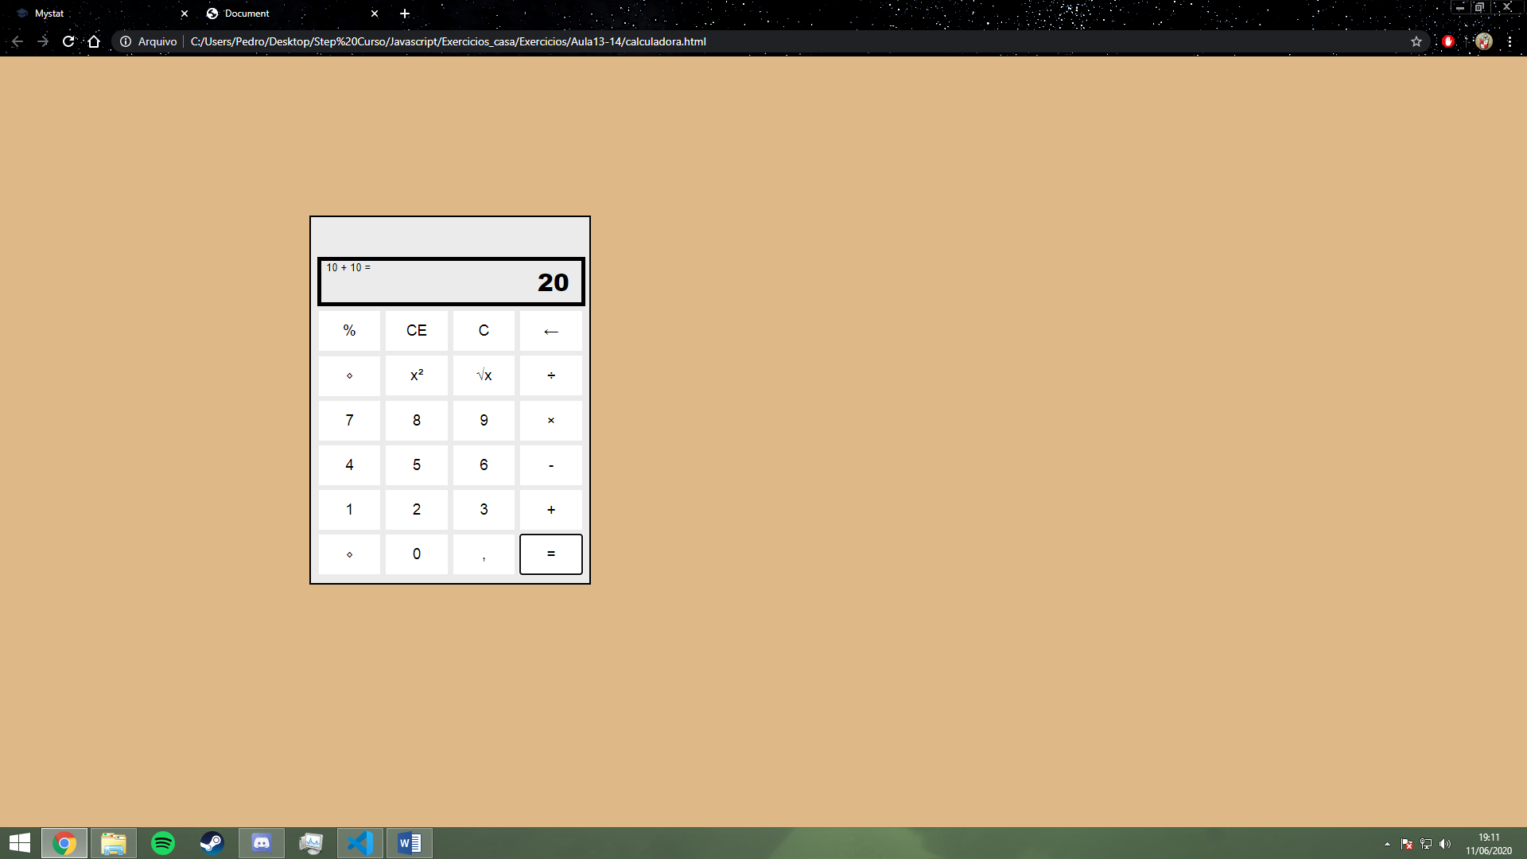

**11 + 5 + 6 =?**

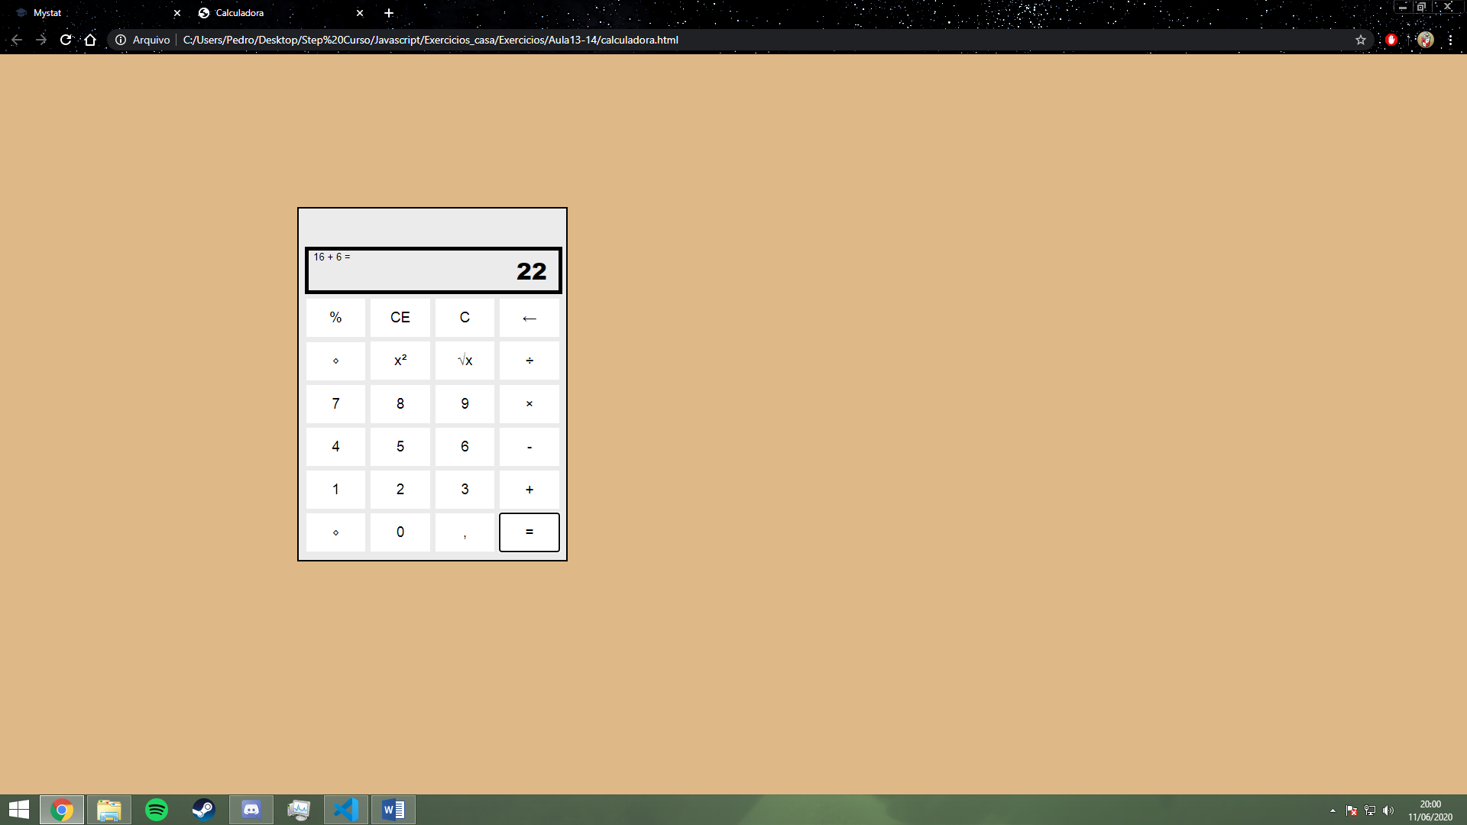

**4 + 5 * 8 =?**

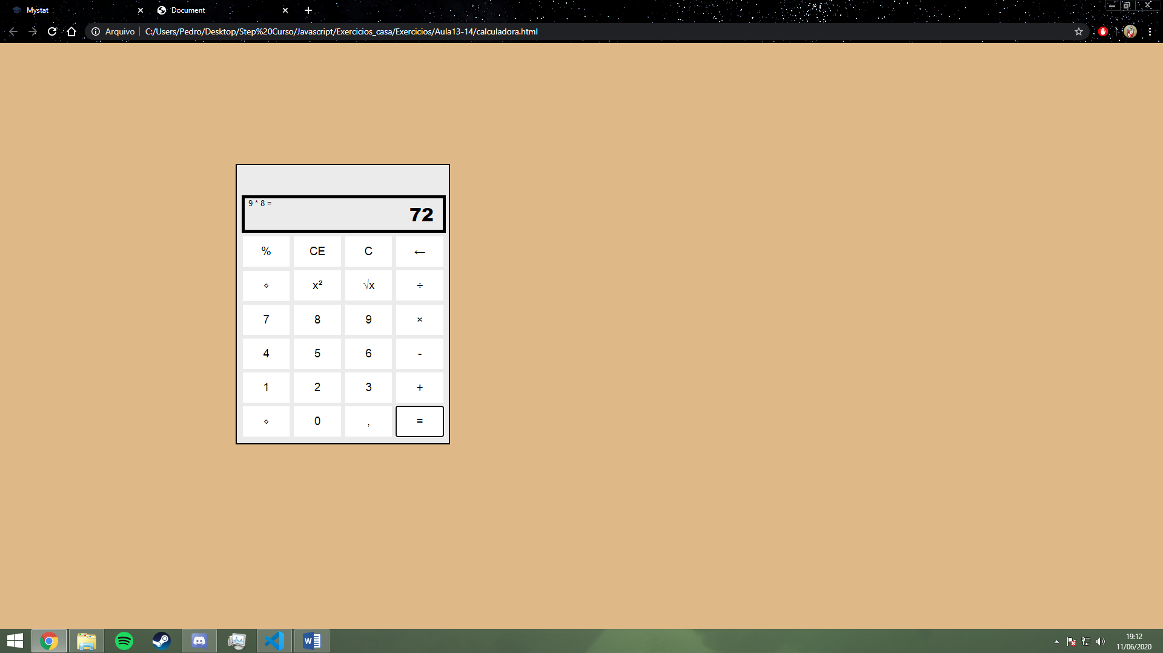

**-10 + 8 =?**  
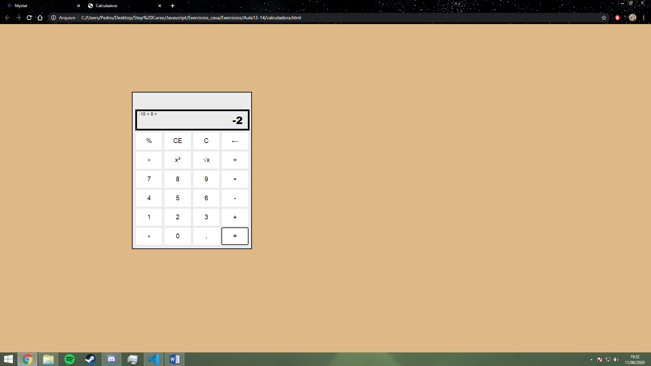

**4 + * 2 =?**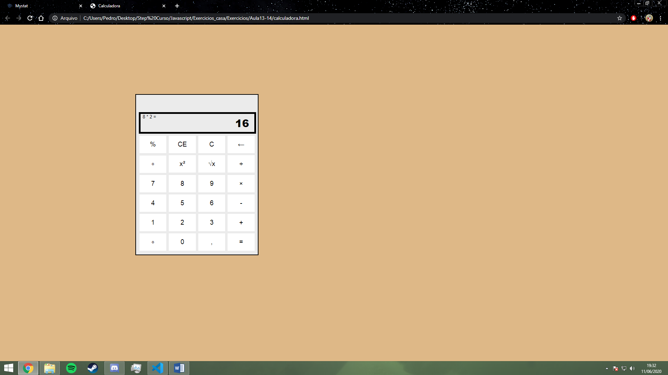

**5=?**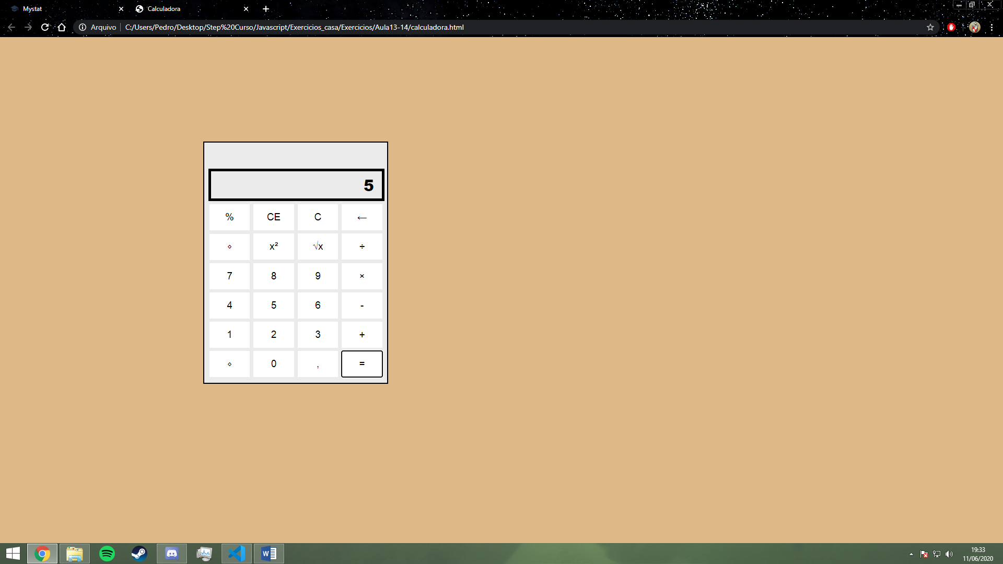

**4 + 8 = +3=?**

