NEXORA
UNIFIED COMPUTE MANAGEMENT PLATFORM
A Project Based Component Project Report
Submitted in partial fulfillment of the requirement for the PBC component of
BACHELOR OF TECHNOLOGY
IN
COMPUTER SCIENCE ENGINEERING
by
[Student Name 1] ([Registration Number 1])
[Student Name 2] ([Registration Number 2])
[Student Name 3] ([Registration Number 3])
[Student Name 4] ([Registration Number 4])

Under the Guidance of
Dr. Nagendra Panini Challa
SCHOOL OF COMPUTER SCIENCE AND ENGINEERING
VIT-AP UNIVERSITY
AMARAVATI - 522237
October 2026

ABSTRACT
Nexora - Unified Compute Management Platform (UCMP) is a distributed-compute orchestration prototype that coordinates a browser dashboard, a FastAPI control plane and independently running provider agents. The project addresses the practical difficulty of discovering heterogeneous compute machines, selecting a compatible provider, dispatching a workload, observing progress and retaining a record of execution state. Rather than operating as a cloud provider, Nexora supplies an orchestration layer: provider-owned machines advertise their capacity and execute work while the control plane owns user identity, scheduling, job state, token accounting and recovery metadata.
The implementation uses a static JavaScript frontend, a Python FastAPI backend with SQLAlchemy persistence, and Python provider agents using requests and psutil. Implemented source paths include user registration and JWT-backed sessions, shared-token provider registration, heartbeat telemetry, capacity and cost/reliability-aware provider selection, polling-based job dispatch, controlled workload execution, artifact handling, checkpoint storage, attempt fencing, recovery after provider heartbeat loss, a token ledger, and optional remote live-stream encoding with MediaMTX and FFmpeg. The frontend consumes REST snapshots and an authenticated WebSocket topic set for real-time updates.
Evidence in this report distinguishes implementation from demonstrated behavior. Python syntax checks completed successfully and twelve frontend utility tests passed. The backend pytest suite was not run because pytest was absent from the supplied virtual environment; Docker Compose, a live provider, PostgreSQL, MediaMTX, OBS/browser capture, cloud deployment and destination streaming were not run during the audit. Consequently, the report presents Nexora as a technically substantial prototype with verified source-level behavior and limited runtime validation, not as a production-ready compute marketplace or independently verified streaming service.
Keywords: distributed computing, orchestration, FastAPI, provider agent, scheduling, checkpoint recovery, telemetry, WebSocket, MediaMTX, FFmpeg.

TABLE OF CONTENTS
Right-click and select Update Field to refresh the table of contents.
The report is organized in the reference format: six chapters followed by supporting materials, references and appendices. Page numbers can be refreshed in Microsoft Word by selecting all fields and updating them.
Abstract
Chapter 1 Introduction
1.1 Background and Motivation
1.2 Problem Statement
1.3 Project Objectives and Scope
Chapter 2 Literature Review and Core Concepts
2.1 Distributed Compute Orchestration
2.2 Control Plane and Provider Agent Architecture
2.3 Scheduling, Checkpointing and Telemetry
2.4 Artifact, Streaming and Token Accounting Concepts
Chapter 3 System Architecture and Methodology
3.1 Proposed System Architecture
3.2 Module Interoperability and Data Flow
3.3 Implementation Environment
Chapter 4 Implementation and Details
4.1 Orchestration and Entry Points
4.2 Authentication and Provider Management
4.3 Workload Scheduling and Recovery
4.4 Frontend and Realtime Communication
4.5 Artifacts, Billing and Streaming
Chapter 5 Results and Analysis
5.1 Qualitative Results
5.2 Quantitative Validation Evidence
5.3 Edge Cases and Limitations
5.4 Security and Reliability Analysis
Chapter 6 Conclusion and Future Work
Supporting Materials
References
Appendix A API and Data Model Summary
Appendix B Deployment, Testing and Selected Listings

CHAPTER 1
INTRODUCTION

CHAPTER 1 INTRODUCTION

1.1 Background and Motivation
Modern computing workloads frequently span machines with different processors, memory capacities, GPU availability, network positions and operating conditions. In small laboratories, academic groups and prototype deployments, these machines are often operated independently. A user must manually decide where work can run, verify whether a machine is available, transfer input data, observe execution, and interpret failures. This fragmented process motivates a unified orchestration layer that makes distributed compute resources visible through one control plane while preserving the provider machine as the location of execution.
Nexora addresses this coordination problem. The codebase implements a static browser console through which authenticated users can inspect providers, submit jobs, observe state, access billing information and configure a control-plane URL. A FastAPI backend maintains durable application state and provides the interface between users and providers. Python provider agents are responsible for inspecting their own hardware, registering capacity, reporting telemetry, polling for work and executing assigned workloads. The design therefore separates governance and state management from physical compute ownership.

1.2 Problem Statement
The problem addressed by Nexora is the absence of a lightweight, source-visible workflow for coordinating heterogeneous provider resources and workloads without relying on an opaque centralized cloud platform. The project must authenticate users, register provider capacity, choose a compatible provider, reserve a controlled amount of token credit, dispatch a job, retain progress and checkpoint state, report results, and handle at least a basic provider-loss scenario. The implementation must also avoid presenting simulations as completed external integrations.

1.3 Project Objectives and Scope
Objective | Source-backed realization | Status
Provide a web control plane | Hash-routed frontend with REST and WebSocket clients | Implemented in source
Discover compute providers | Provider registration with hardware/system metadata | Implemented in source
Select compatible resources | CPU/RAM/GPU/FFmpeg filters and adjusted cost comparison | Implemented in source
Execute controlled workloads | Provider supports matrix, prime, Fibonacci, video and custom Python paths | Implemented in source
Retain recovery evidence | Checkpoint rows, state hashes, attempts and a recovery monitor | Implemented in source
Demonstrate validation | Python parsing and 12 frontend tests recorded | Tested

Table 1.1: Project objectives and implementation status
The scope is a prototype control plane. Nexora is not a public cloud provider, a provider marketplace, a production payment system, a container-orchestration system, or a proven high-availability deployment. The interface contains a resource-pool simulator, while persistent resource-pool policies were not found. Token purchase and card top-up are intentionally simulated. Optional remote streaming depends on separately reachable MediaMTX and destination services and was not verified end to end.

1.4 Significance and Boundaries

1.5 Target Users and Stakeholders
Nexora serves three technical stakeholder groups. End users submit and inspect workloads through the browser dashboard. Provider operators run the Python agent on machines whose compute capacity they choose to contribute; the agent reports local capability rather than granting remote shell access to the control plane. Project evaluators and maintainers use the backend APIs, database records, audit events, configuration and tests to understand how the platform behaves. This separation gives every participant a defined responsibility: users request work, the control plane coordinates it, and providers execute it locally.

1.6 Representative Use Cases
Use case | User action | Control-plane outcome | Provider outcome
Controlled computation | Submit a matrix, prime-search or Fibonacci request | Validate requirements, reserve tokens and schedule a compatible provider | Poll, execute, checkpoint and report result
Video processing | Upload a supported video then create a compression job | Probe artifact, attach metadata and select FFmpeg-capable provider | Download input, transcode and upload output
Provider participation | Start the provider agent on a machine | Store capacity, status and last heartbeat | Measure local resource state and poll work
Recovery demonstration | Allow heartbeat to exceed configured timeout | Create recovery attempt or fail/refund when no replacement exists | Resume checkpoint-capable workload when assigned
Streaming demonstration | Create an OBS or browser-capture session | Allocate stream-capable provider and session credentials | Use FFmpeg to consume media and publish encoded output
Table 1.2: Representative Nexora use cases and responsibilities

1.7 Functional and Non Functional Requirements
Category | Requirement derived from implementation
Functional | Create and validate accounts; authenticate sessions; register providers; submit and cancel jobs; track progress, checkpoints, artifacts and token activity.
Functional | Report current CPU, RAM, disk and optional GPU/FFmpeg capability; select compatible provider based on request constraints.
Functional | Expose dashboard, provider, job, billing, artifact, checkpoint and optional streaming interfaces through REST and realtime topics.
Non functional | Persist application state through SQLAlchemy, reject malformed request bodies through Pydantic constraints, and restrict user-owned job/artifact access.
Non functional | Allow local development, Docker Compose topology and split static frontend/backend deployment configuration.
Constraint | Provider connectivity is polling based; current cloud/media deployments, external payment and distributed high availability are outside verified scope.
Table 1.3: Functional and non functional requirements

1.8 Design Constraints
The design favors a compact prototype that can be read end to end. Consequently, backend routes, database models, scheduler behavior and realtime infrastructure occupy one FastAPI module, and provider behavior occupies one Python module. This choice reduces the number of deployment units for an academic demonstration but increases coupling. A second constraint is network reachability: the provider initiates its own registration, heartbeat and polling calls, making it easier to operate behind common network boundaries. A final constraint is evidence discipline: external services may be configured by the repository, but they are described as configured integrations unless execution evidence exists.
The principal academic value of Nexora is that it exposes the entire path from user intent to provider-side execution. It shows how authentication, capacity metadata, scheduling, persistence, telemetry, real-time delivery, recovery and accounting interact. The main boundary is important: the control plane coordinates provider-owned machines; it does not itself sell, host or guarantee compute capacity. In particular, a configured render or Vercel deployment is not evidence of a verified operational service.

CHAPTER 2
LITERATURE REVIEW AND CORE CONCEPTS

CHAPTER 2 LITERATURE REVIEW AND CORE CONCEPTS

2.1 Distributed Compute Orchestration
Distributed compute orchestration is the coordination of workloads across separately managed resources. A practical orchestration layer requires a clear distinction between the control plane, which makes policy and stores system state, and the data or execution plane, which performs work on a provider machine. Nexora follows this concept: the FastAPI control plane persists users, providers, jobs and accounting data, whereas the provider agent inspects local hardware and runs the assigned workload. The project is intentionally smaller in scope than mature cluster schedulers, but the separation makes responsibilities explicit.

2.2 Control Plane and Provider Agent Architecture
A control plane can expose stable HTTP APIs while agents use periodic heartbeats and polling to function through common firewall and NAT environments. In Nexora, the provider sends a shared-token registration request and periodic heartbeats. It then polls its pending-job endpoint every two seconds. This pull model avoids requiring the control plane to initiate a connection to the provider. The trade-off is dispatch latency and the need for robust job-claim semantics; the current source returns scheduled jobs before the provider asynchronously records RUNNING, which is a documented reliability risk.

2.3 Scheduling, Checkpointing and Recovery
Scheduling requires eligibility checks before selection. Nexora filters providers by online state, requested CPU, requested memory, optional GPU availability and FFmpeg capability for media-oriented workloads. From candidates it selects the lowest cost per hour adjusted by reliability. This is a rule-based strategy, not an optimization engine, learning algorithm, resource-pool planner or fair-share scheduler. Checkpoints store a sequence number, attempt number, progress, state version, deterministic hash and payload. On loss of a heartbeat, the recovery monitor may mark the failed provider offline, identify a compatible replacement and create a fenced recovery attempt.

2.4 Telemetry and Real-Time Communication
Telemetry is a current-state mechanism in this project. The provider reports CPU, RAM and disk utilization through psutil. It optionally uses nvidia-smi for device-wide GPU compute and memory metrics; a Torch allocator fallback can report only process-local GPU memory. The frontend receives state by REST refresh and by a user-scoped WebSocket topic set. Since no historical telemetry entity was found, the live charts represent accumulated frontend snapshots and current provider state rather than a durable observability time series.

2.5 Artifact Processing, Streaming and Token Accounting

2.6 Related Work and Design Position
Research on cloud, edge and fog scheduling treats heterogeneous capacity, response time, cost, utilization and reliability as competing objectives. Recent surveys group scheduling approaches into deterministic, heuristic, metaheuristic and learning-based families [3]-[5]. Nexora intentionally chooses a transparent deterministic rule: it rejects incompatible providers and selects the candidate with the minimum cost adjusted by the stored reliability value. This is appropriate for an inspectable academic prototype because the decision can be traced directly to provider attributes. It is not presented as a replacement for fair-share, backfilling, predictive or reinforcement-learning scheduling.
Checkpoint-restart research explains why saved state can improve fault recovery and resource use: a failed computation can continue from a retained recovery point rather than beginning again [6]. Nexora uses application-level checkpoints rather than transparent process snapshots. Its checkpoint payload is workload-specific, has a canonical hash, and is associated with a sequence and attempt number. That choice keeps the storage model simple but means arbitrary custom Python processes cannot be migrated transparently; the provider deliberately restarts that workload from the beginning on recovery.

2.7 Security Concepts Applied to Nexora
The authentication design combines password hashing, JWTs and server-side session records. The backend uses PBKDF2-HMAC-SHA256 with a generated salt and 600,000 iterations. Python documentation describes PBKDF2-HMAC as a password-based key derivation function and notes that iteration count should reflect contemporary computing power [7]. Nexora additionally validates session state on every protected request, so a missing, revoked or expired session is rejected even when a token is structurally valid. WebSocket credentials are placed in a subprotocol header rather than a URL. These controls protect normal user sessions; they do not eliminate the separate provider-identity limitation described in Chapter 5.

2.8 Comparative Concept Table
Concept | General objective | Nexora realization | Academic interpretation
Heterogeneous scheduling | Map work to differing capacities | CPU/RAM/GPU/FFmpeg eligibility then cost/reliability ordering | Rule-based baseline
Control plane | Coordinate state and policy | FastAPI routes, models, scheduler and realtime hub | Central coordination boundary
Provider agent | Execute work near resources | Python agent with psutil, requests, FFmpeg probe and worker functions | Execution-plane representative
Checkpoint recovery | Reduce loss from failure | State payload, hashes, attempts and replacement assignment | Application-level recovery
Realtime monitoring | Expose current state | REST snapshots plus authenticated WebSocket events | Current-state observability
Accounting | Associate use with balance | Wallet, token ledger, reservation and settlement | Demonstration accounting model
Table 2.1: Core concepts, Nexora adaptation and design position
Artifact handling is necessary when a job requires input or produces output. Nexora validates and probes user video uploads, records metadata and checksums, lets the assigned provider download job input, and lets a provider upload output. The optional streaming path uses a session model: the backend validates an RTMP/RTMPS destination, allocates an FFmpeg-capable provider, hands MediaMTX session credentials to the correct participants, and bills tokens only after streaming state is reported. The project does not itself operate a payment gateway; its wallet and purchase interactions are a token-accounting demonstration.
Concept | Nexora adaptation | Boundary
Control plane | FastAPI API, SQLAlchemy state, scheduler, recovery monitor | Single-process coordination
Provider agent | Hardware probe, polling, execution and heartbeat | Shared provider credential
Checkpoint | Hash-protected state and attempt fencing | Live multi-machine recovery not tested
Realtime delivery | Authenticated WebSocket topics plus REST resync | In-memory event hub
Streaming | MediaMTX/FFmpeg session workflow | External media host required

Table 2.2: Core concepts mapped to Nexora

CHAPTER 3
SYSTEM ARCHITECTURE AND METHODOLOGY

CHAPTER 3 SYSTEM ARCHITECTURE AND METHODOLOGY

3.1 Proposed System Architecture
Figure 3.1 depicts the source-backed system context. The browser dashboard communicates with the control plane over authenticated REST and a WebSocket endpoint. The control plane uses SQLAlchemy against default SQLite or configured PostgreSQL. Provider agents communicate only with the control plane through authenticated HTTP polling, while optional MediaMTX handles media ingest/read and calls the backend for per-session authorization. A destination such as a video platform is outside Nexora and is never treated as an integrated or tested Nexora component.
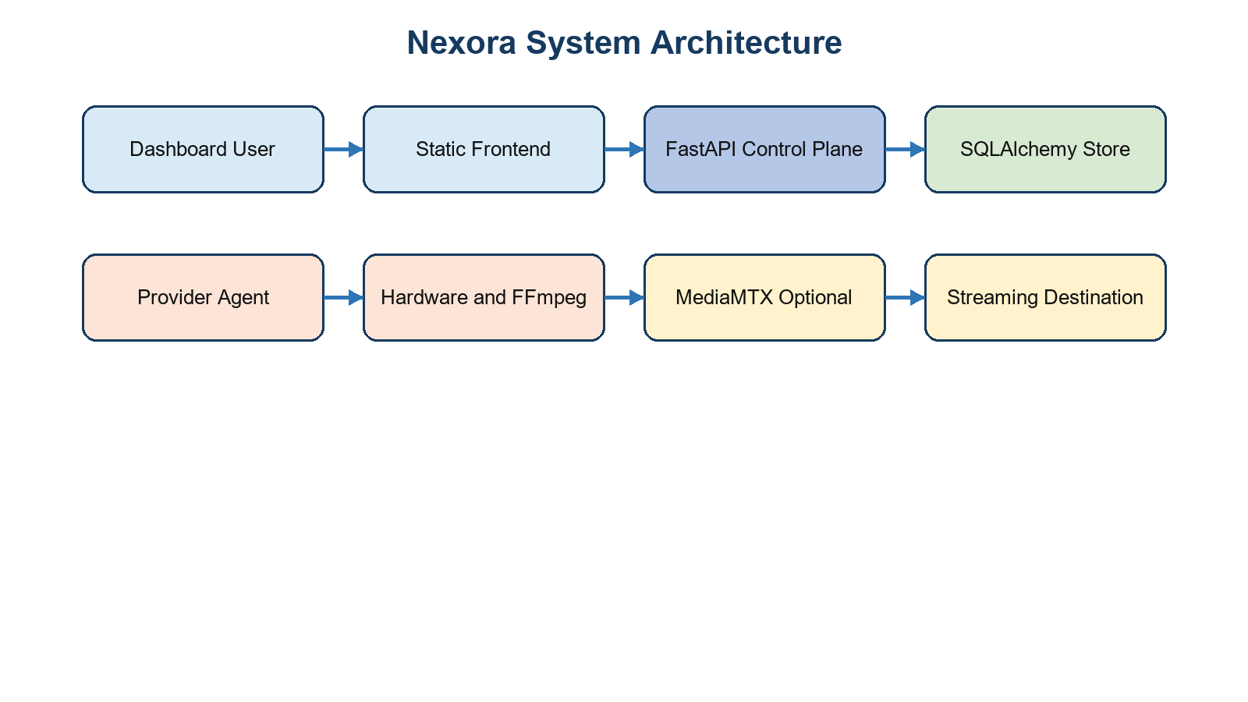
Figure 3.1: Overall Nexora system architecture

3.2 Module Interoperability and Data Flow
Figure 3.2 shows the normal workload path. After login, the frontend submits a job definition. The backend merges the workload into its requirements, verifies any video input artifact, selects a compatible online provider, estimates and reserves tokens, stores a job in SCHEDULED state and publishes events. The provider's listener receives the scheduled job through its polling request, reports RUNNING, emits checkpoint state through the provider endpoints, and finally reports a completed or failed result. Terminal transitions release the provider and settle reserved tokens when the update path is used.
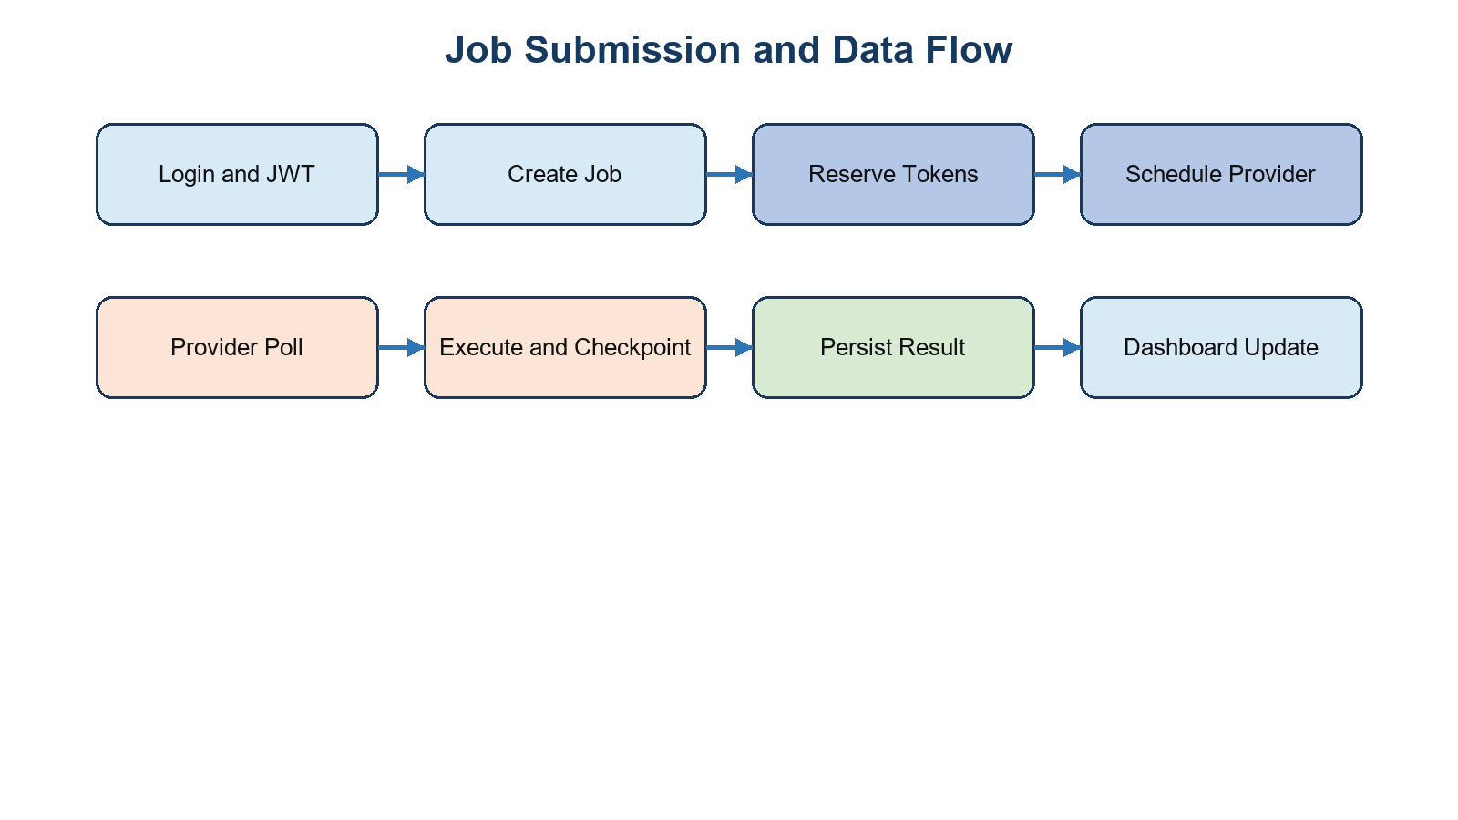
Figure 3.2: Module interoperability and workload data flow

3.3 Implementation Environment

3.3.1 Required system tools
- Python 3 environment for the FastAPI control plane and provider agent.
- A browser capable of ES modules, fetch and WebSocket for the static frontend.
- FFmpeg for artifact probing, video compression and optional live encoding; imageio-ffmpeg is a fallback locator in selected code paths.
- Docker and Docker Compose only for the unverified local backend/PostgreSQL/MediaMTX topology.

3.3.2 Environment variables
Variable | Component | Purpose
DATABASE_URL | Backend | SQLite default or PostgreSQL connection selection
JWT_SECRET | Backend | JWT signature and derived stream-key encryption material
PROVIDER_SHARED_TOKEN | Backend and provider | Current shared HTTP provider credential
CORS_ORIGINS / CORS_ORIGIN_REGEX | Backend | Browser origin policy
MEDIAMTX_INGEST_URL / MEDIAMTX_PROVIDER_READ_URL | Backend | Media addresses returned to clients/providers
UCMP_BACKEND_URL | Provider | Explicit control-plane base URL
NEXORA_FFMPEG_PATH / FFMPEG_PATH | Provider | FFmpeg discovery override

Table 3.1: Selected environment configuration variables

3.3.3 Key software packages
Technology | Verified source role | Use category
FastAPI 0.115.6 and Uvicorn 0.34.0 | HTTP API, WebSocket endpoint, app lifecycle | Backend
SQLAlchemy 2.0.36 and psycopg 3.2.3 | ORM and PostgreSQL connectivity | Persistence
Pydantic 2.10.3 | Request schema validation | Backend
PyJWT 2.10.1 and cryptography | JWT sessions and Fernet encryption | Security
requests 2.32.3 and psutil 6.1.1 | Provider communication and utilization | Provider
MediaMTX 1.21.2 and FFmpeg | Optional ingest/read/transcode workflow | Streaming

Table 3.2: Technology stack and actual roles

3.3.4 Runtime considerations
The backend defaults to a local SQLite file and creates database tables at application lifespan startup. Docker Compose instead configures PostgreSQL and MediaMTX. The provider agent uses a five-second default heartbeat and a two-second listener polling cadence. The recovery monitor evaluates provider heartbeat age every five seconds and uses a default twenty-second timeout. These timings are implementation defaults, not measured performance guarantees.

3.3.5 Logging and artifact locations

3.4 User Authentication and Provider Registration Flow
Figure 3.3 shows the distinct trust paths. A user register/login operation creates or validates credentials and returns a JWT tied to a durable session identifier. Subsequent user requests carry a bearer token. A provider follows another path: it collects capacity metadata and sends it with `X-Provider-Token`; the control plane creates or updates the provider record. These paths meet at the scheduling layer but retain different authorization checks.
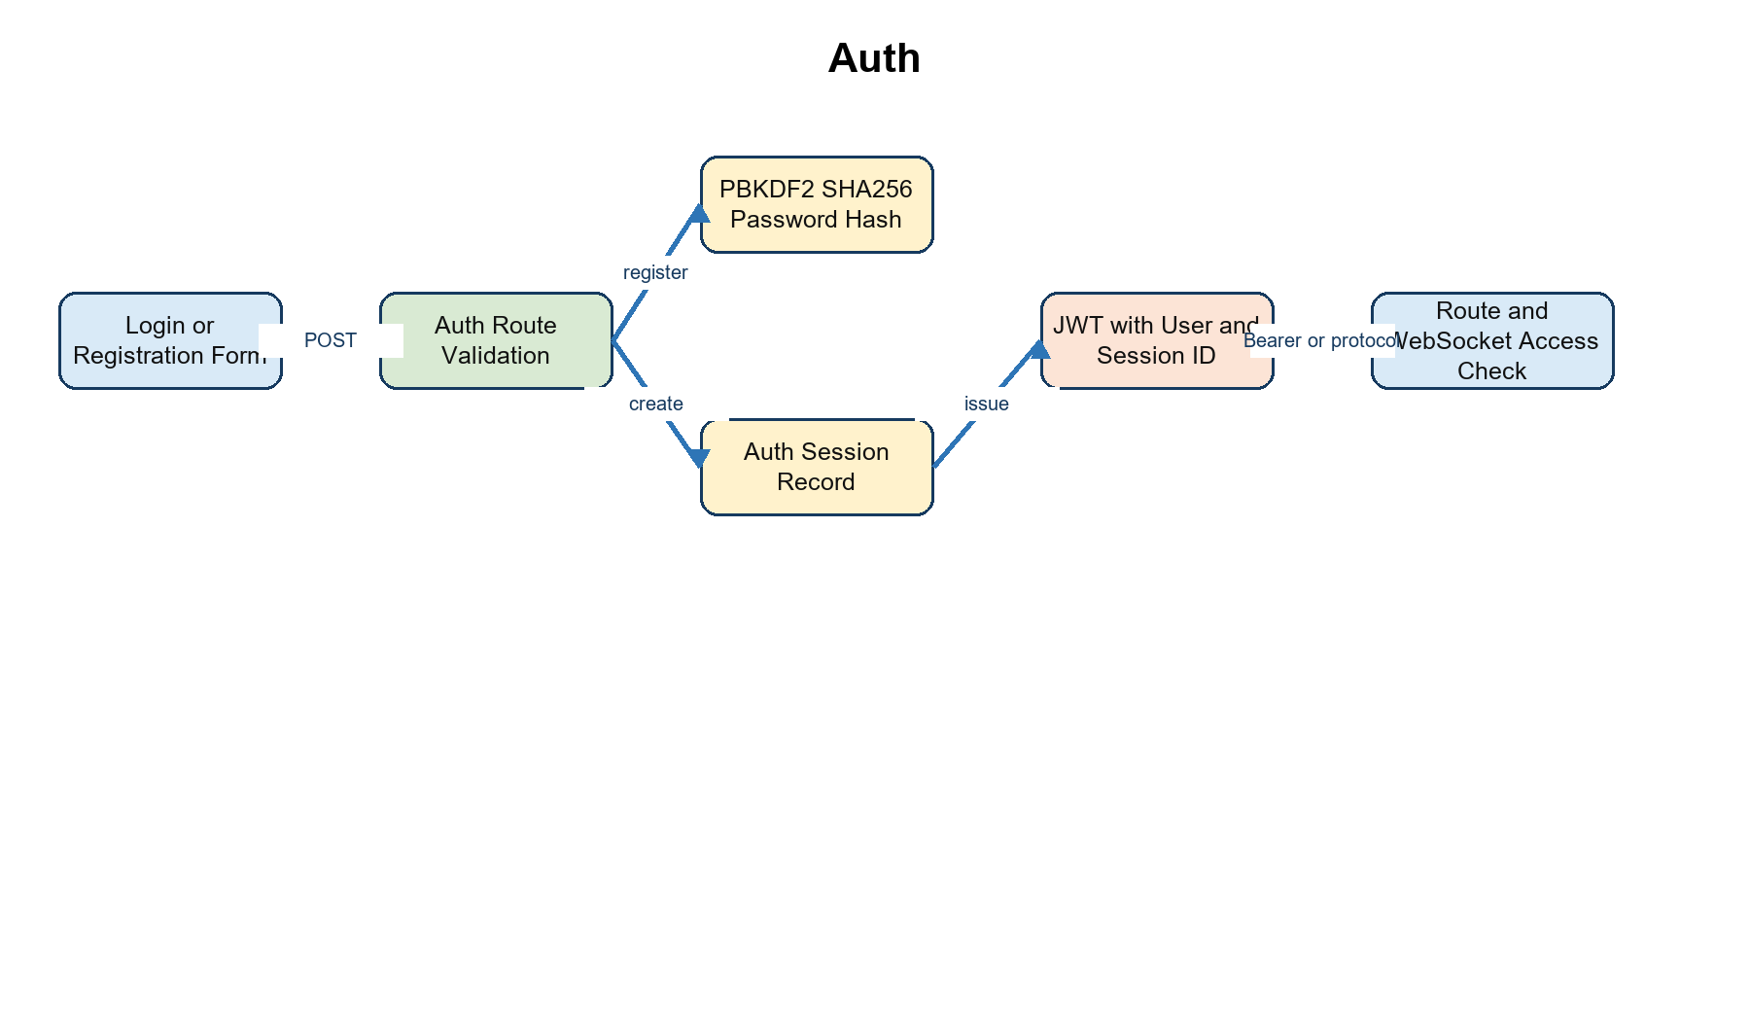
Figure 3.3: User session creation and protected-access flow

3.5 Provider Heartbeat and Telemetry Flow
The provider reads its local operating-system and hardware state before registration. After registration it sends utilization heartbeats at the configured interval. The backend overwrites current utilization and last-heartbeat fields, publishes telemetry events, and the frontend merges events into its client-side state. Figure 3.4 makes explicit that the project presents current telemetry rather than a historical metrics database.
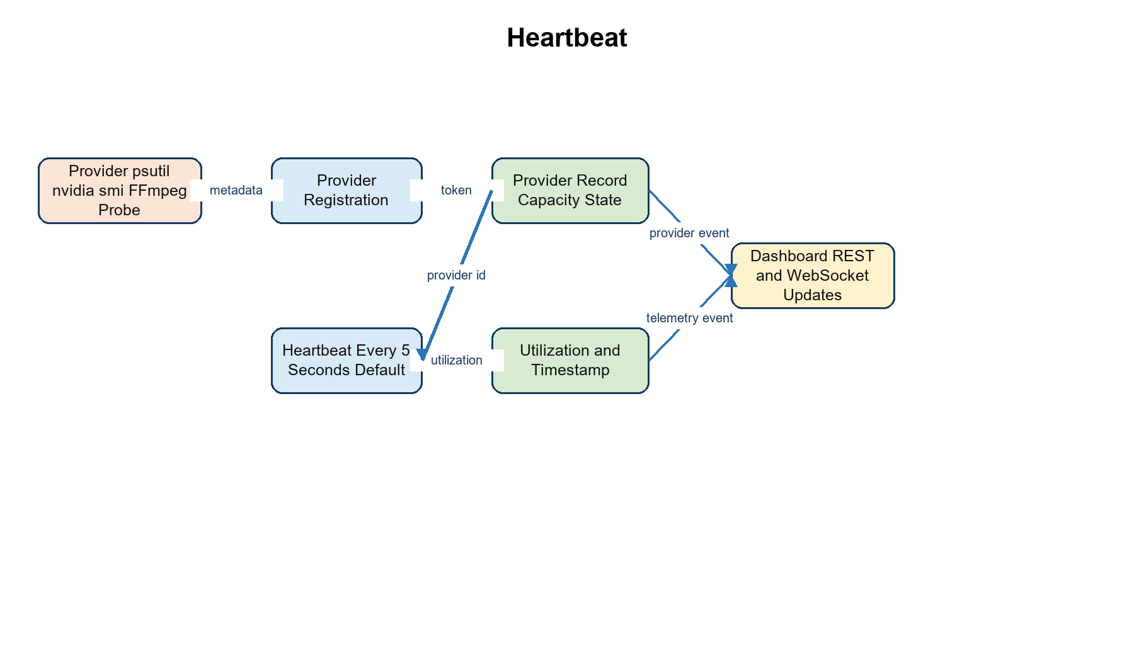
Figure 3.4: Provider discovery, registration, heartbeat and telemetry publication

3.6 Job Submission Scheduling and Dispatch Methodology
The scheduling methodology is request driven. The backend copies the workload into a requirements map, validates workload-specific prerequisites, evaluates each provider, reserves tokens, and stores a scheduled job. The provider then obtains its own pending work through polling rather than the backend directly connecting to it. Figure 3.5 traces each decision and identifies the point where token reservation occurs before provider execution.
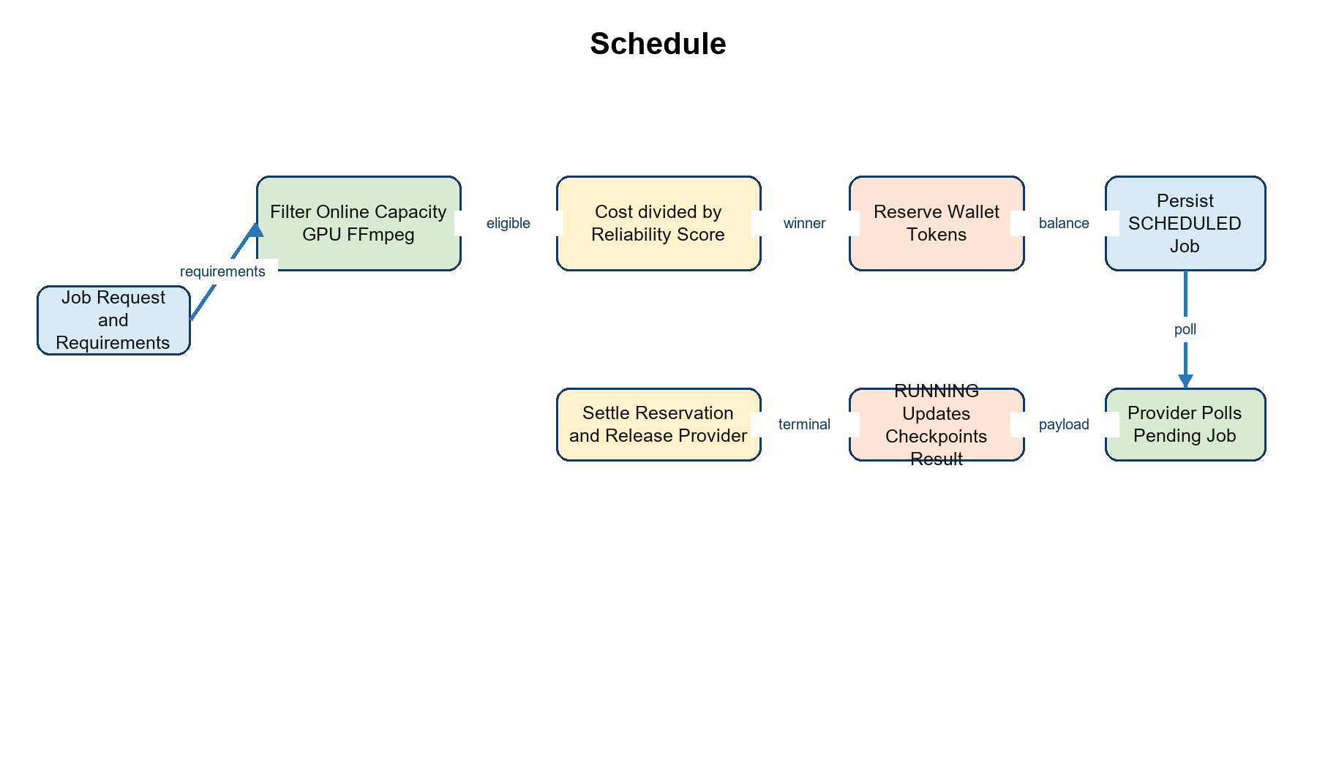
Figure 3.5: Job submission, provider selection, dispatch and settlement flow

3.7 Recovery and State Management Methodology
The recovery monitor is a background thread started through the application lifespan. It periodically evaluates active providers against a heartbeat timeout. For each affected job it reads the latest checkpoint, searches for an alternative compatible provider, increments the attempt, records recovery metadata and relies on fencing to reject late messages from a previous attempt. Figure 3.6 distinguishes a successful recovery branch from the failure/refund branch.
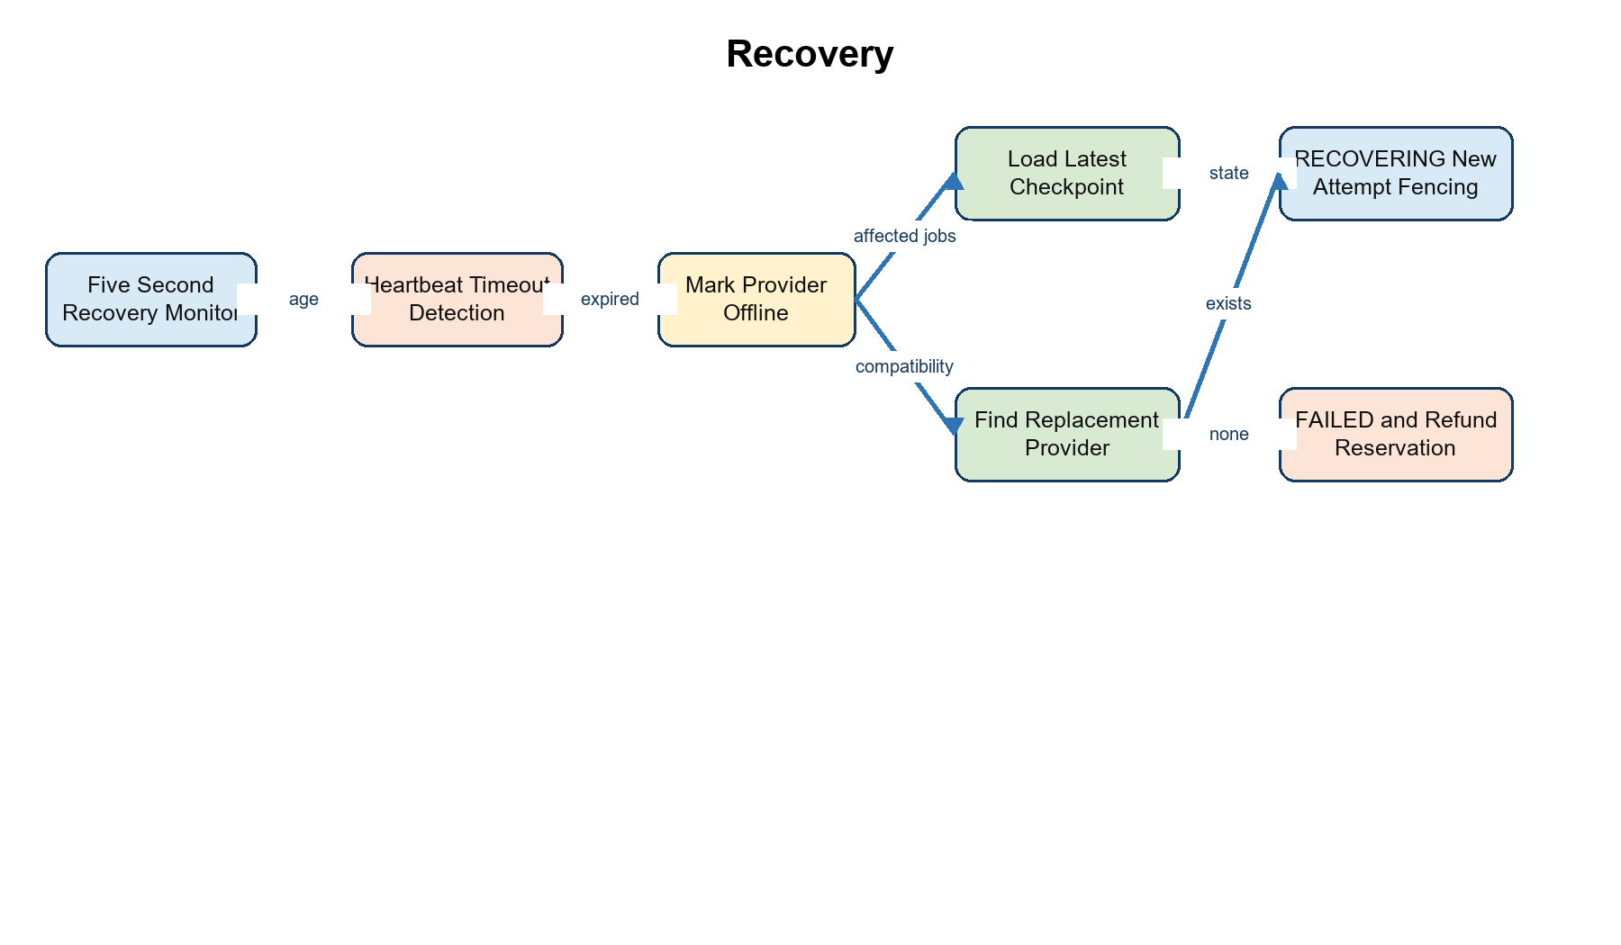
Figure 3.6: Heartbeat-loss detection, checkpoint selection and fenced recovery

3.8 Data Model and Ownership Methodology
The database is ownership-oriented. Users own sessions, wallets, jobs and user artifacts. Jobs optionally reference providers and have checkpoints, billing records and related artifacts. Stream sessions link user, provider, encrypted destination state and accounting data. This model enables user-specific job/artifact retrieval and allows provider activity to be reflected in persistent records. Figure 3.7 summarizes the entity groups; Chapter 4 and Appendix A enumerate fields and relationships.
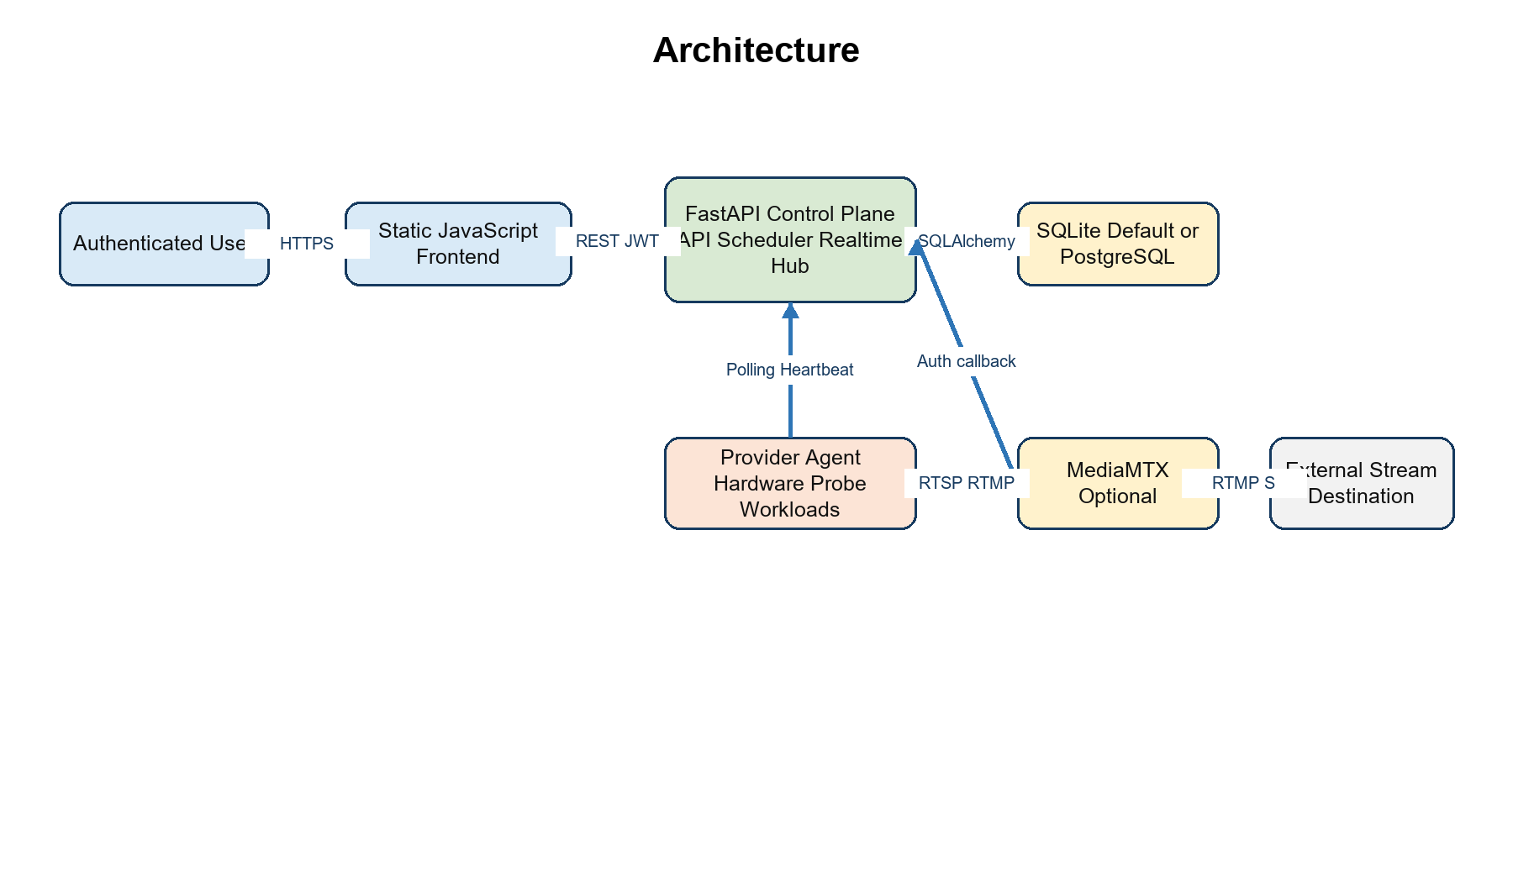
Figure 3.7: Component and data-store relationships across the Nexora architecture
The code records audit events in the database and prints selected provider/recovery status messages to process output. Artifacts are stored under the backend application data directory, specifically a `data/artifacts` tree derived from the backend path. No centralized logging, retention worker, object storage integration or historical telemetry table was found. The local filesystem arrangement is suitable for a prototype but constrains durability and scale.

CHAPTER 4
IMPLEMENTATION AND DETAILS

CHAPTER 4 IMPLEMENTATION AND DETAILS

4.1 Orchestration and Entry Points
The backend entry point is `user-website/backend/app/main.py`, which defines models, request schemas, lifecycle behavior, REST routes and the realtime hub in a single module. The provider entry point is `provider-server/main.py`, which initializes provider identity, hardware information and background heartbeat/listener behavior. The frontend entry point is `user-website/nexora-frontend/index.html`; `js/app.js` initializes routing, state refresh, polling and realtime behavior. The repository contains start scripts for backend, provider and static frontend serving, alongside Docker/Render/Vercel configuration.
# Backend scheduling decision - simplified source-backed excerpt
for p in s.query(Provider).all():
if p.id == exclude_id or p.status not in ("ONLINE", "AVAILABLE"):
continue
if p.cpu_cores < min_cores or p.ram_gb < min_ram:
continue
if requirements.get("gpu_required") and not p.gpu_name:
continue
candidates.append(p)
return min(candidates, key=lambda x: x.cost_per_hour / (max(x.reliability, 1) / 100))
Listing 4.1: Condensed provider eligibility and selection logic based on `compatible_provider`

4.2 Authentication and Session Management
Registration and login accept an email and a minimum eight-character password. Password hashes use PBKDF2-HMAC-SHA256 with a generated salt and 600,000 rounds. A successful session creates an `auth_sessions` record and a JWT containing a user subject, session identifier, email and expiry. The `current_user` dependency verifies the JWT and checks that the associated database session exists, is not revoked and has not expired. Browser WebSocket authentication uses a `nexora.jwt.<token>` WebSocket subprotocol instead of placing the bearer token in the URL.
The implementation does not expose an observed logout/revoke endpoint, password reset flow, administrator role, or role-based authorization layer. User-facing resources generally filter jobs/artifacts by owning user, whereas provider endpoints are protected by one configured shared token. This distinction is material to the security analysis in Chapter 5.

4.3 Provider Registration and Telemetry
The provider maintains a persistent locally generated provider ID unless overridden by environment. At registration, it sends logical CPU core count, RAM size, optional GPU name and memory, configured cost per hour, detailed system information, FFmpeg availability and detected H.264 encoder names. Heartbeats store current provider status and utilization. CPU, RAM and disk values use psutil; `nvidia-smi` may produce device-wide GPU compute/memory utilization. The backend serializes provider state and emits provider/telemetry events to realtime subscribers.
Provider authentication compares the received `X-Provider-Token` against a single configured secret. The provider ID remains supplied in the route/body rather than being cryptographically bound to an enrolled identity. The report labels this design as implemented but unsuitable as a strong production identity model.

4.4 Workload Submission and Scheduling
A user POSTs a `JobCreate` body containing a bounded name, workload string and requirements object. The backend creates a provider-compatible requirements dictionary, validates a referenced artifact for video compression, chooses a provider, estimates tokens, ensures wallet balance, marks the provider BUSY, persists the job and creates a reservation ledger entry plus job billing row. For submitted Python source, it stores a source artifact record. The provider listener polls for jobs assigned to its own ID and creates a thread per returned job. This is a functional prototype mechanism, but the absence of an atomic execution claim creates a possible duplicate-dispatch race.
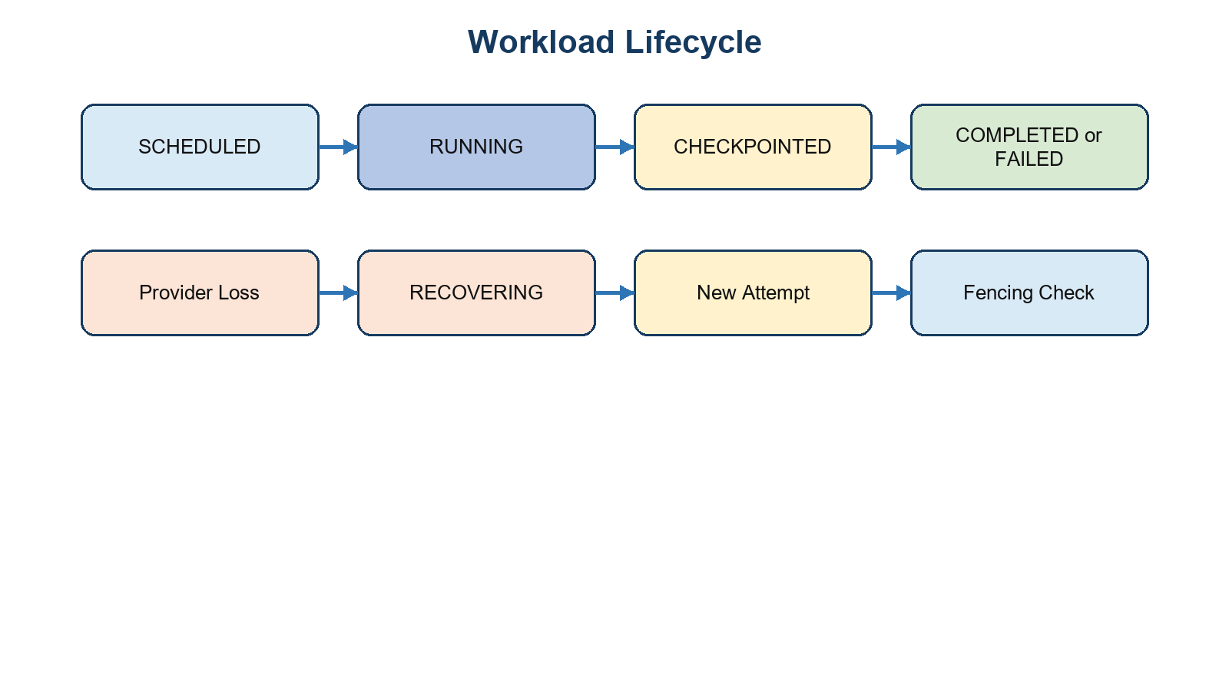
Figure 4.1: Implemented workload lifecycle and recovery state concepts

4.5 Provider Execution and Job Lifecycle
Provider execution supports matrix multiplication, prime search, Fibonacci, video compression and custom Python branches. Controlled computation functions report progress and state to the checkpoint helper. Custom Python writes supplied source into a temporary directory and invokes the isolated Python interpreter mode using `-I`; however, isolated interpreter mode does not form a security sandbox. In a trusted demonstration environment the feature shows flexible dispatch. In an untrusted environment it is a high-risk remote-code-execution path and requires container or VM isolation, resource quotas and network/file restrictions.

4.6 Checkpointing and Failure Recovery
A checkpoint contains job/provider identifiers, attempt and sequence values, progress, state version, canonical state hash and payload. Provider updates carry an attempt value; stale updates are rejected by a fencing check. A background recovery thread identifies providers whose heartbeat exceeds the configured timeout. It marks a lost provider OFFLINE, finds the latest checkpoint for affected jobs, selects a replacement provider where possible, increments the attempt and recovery count, marks the job RECOVERING and embeds resume metadata in requirements. If no replacement exists, it marks the job failed and refunds the outstanding reservation. Figure 4.2 summarizes this control path.
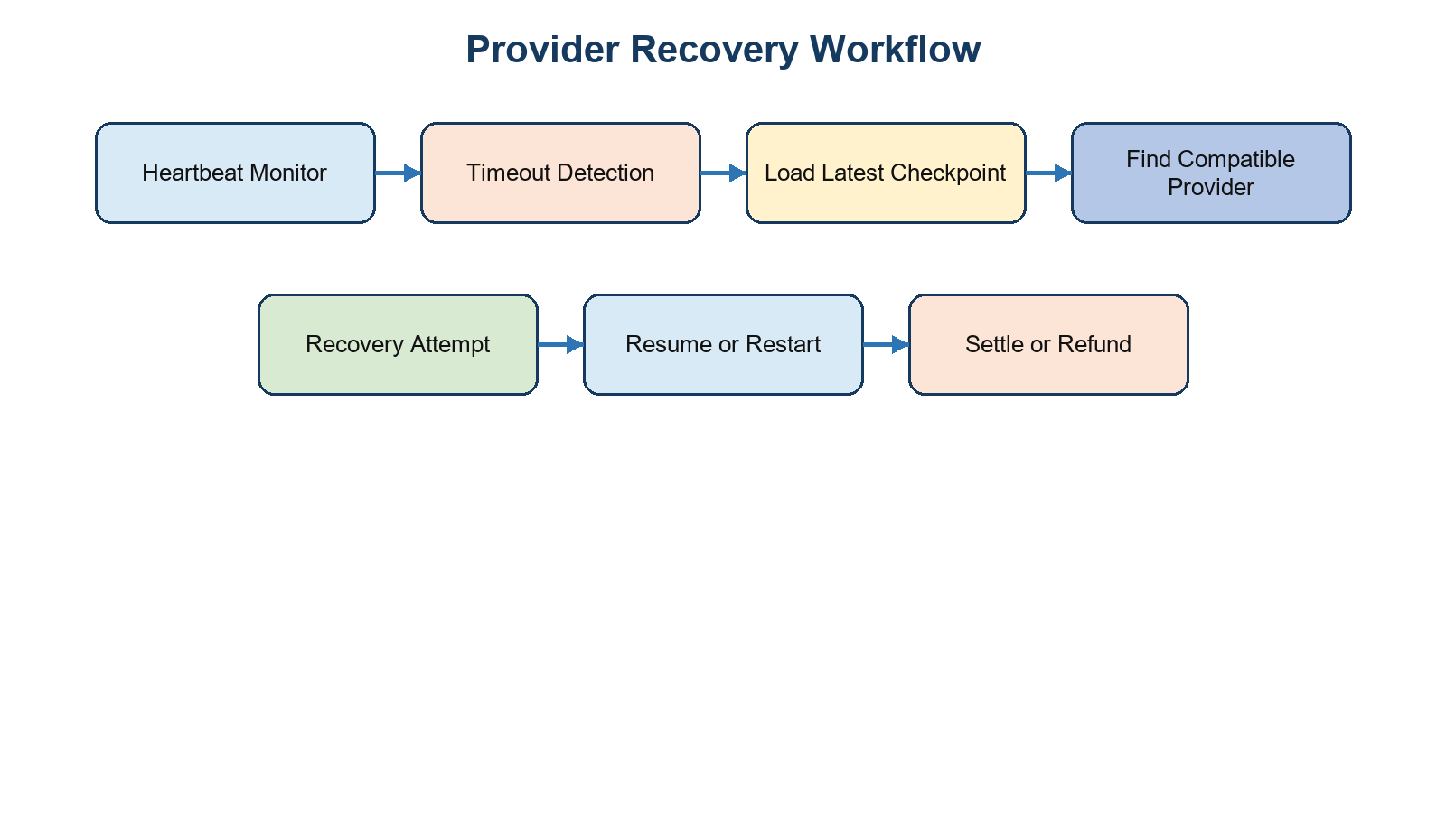
Figure 4.2: Checkpoint recovery and provider-loss handling workflow

4.7 Frontend State Management and Realtime Events
The static frontend uses ES modules rather than React. `router.js` maps landing, overview, jobs, streaming, providers, resource-pool, billing, analytics and settings views. Console routes require local authenticated state. `api.js` stores a selected API base and bearer token, wraps fetch errors and supports artifact upload. `state.js` obtains dashboard, jobs, providers, checkpoints, billing, analytics and active-stream data through a coordinated refresh. `realtime.js` subscribes to allowed topics, sends pings, reconnects with backoff and requests REST resynchronization after connection changes or recovery events.

4.8 Artifact Processing and Video Workloads
The input artifact endpoint accepts selected video extensions and MIME types, streams uploads to a generated artifact directory, enforces a configured maximum size, probes the file through FFmpeg, rejects invalid or oversized-duration videos, calculates a SHA-256 checksum, and persists metadata. An owner can retrieve artifact metadata or download output tied to an owned job. The provider has a dedicated download route for job input and an upload route for output. The provider output upload path does not apply the same observed size/type/duration validation as the user input path, so this is a current technical debt item.

4.9 Token Wallet and Billing
Wallets are created on demand with an initial token adjustment. A token ledger records the balance before and after each server-side mutation. Job estimation uses workload requirements and provider-related information to reserve tokens before dispatch. On terminal provider update, the current code settles a reservation only while the reservation remains positive: it refunds the full reservation and then debits calculated actual usage for successful work. Stream usage is billed only after the provider reports STREAMING and a complete minute has elapsed. Payment-related UI and top-up API flows are simulated; no payment gateway, charge authorization or external transaction confirmation is implemented.

4.10 Remote Live Stream Encoding

4.11 Frontend Page by Page Behavior
Page | Purpose and controls | Data and resulting state
Landing | Explains product concept; opens authentication interaction; exposes a client-side scheduling simulator. | Public view; no authenticated backend page data required.
Overview | Displays active job count, available nodes, token balance, utilization summaries, recent jobs and charts. | Dashboard API snapshot plus provider/telemetry/job events update state.
Jobs | Searches jobs, opens job creation modal, accepts supported video input, opens a drawer and can cancel/stop all. | Jobs and artifact APIs create/inspect/update user-owned jobs.
Providers | Lists provider capacity, status, reliability and current utilization. | Provider list plus realtime provider-status events.
Resource pool | Lets a user vary conditions and inspect candidate filtering. | Client-side simulation based on available provider data; not persistent scheduler configuration.
Billing | Shows balance, package options, ledger activity and demo top-up form. | Billing APIs change application token state; payment itself is simulated.
Analytics and settings | Shows total jobs/success ratio/recovering count; sets API base/theme/polling behavior. | Analytics API and browser-local settings/health check.
Streaming | Creates OBS/browser-capture session, shows credentials/status/metrics and stops session. | Stream session REST, WebSocket updates and browser WHIP helper where selected.
Table 4.1: Frontend pages, user controls and state relationships
The frontend follows a small explicit architecture. `router.js` parses the hash and redirects unauthenticated console routes to the landing page. `state.js` owns the shared dashboard snapshot and prevents overlapping refreshes. `realtime.js` subscribes to server topics, sends periodic pings, reconnects when necessary and asks for a REST resynchronization when an event requires it. `api.js` centralizes bearer-token headers, configured API base selection and error-message extraction. This design makes page components thin: they render state and invoke named API helpers rather than implementing their own transport logic.

4.12 Backend Module Structure and Lifecycle
The FastAPI application is intentionally consolidated into `app/main.py`. Imports and environment loading are followed by database setup, model declarations, request schemas, lifecycle tasks, real-time support, authentication helpers, scheduling/billing functions and route definitions. At lifespan startup the application establishes the realtime event loop, attempts media configuration validation without disabling non-stream features, creates ORM tables, applies selected SQLite compatibility columns, ensures wallets for users and starts the recovery monitor. On shutdown it signals the monitor to stop and closes realtime clients. This lifecycle approach makes state initialization reproducible for a single application process.

4.13 Password Hashing JWT Sessions and Access Checks
The password helper generates a random 16-byte salt and derives a PBKDF2-HMAC-SHA256 digest. The stored representation records the algorithm, iteration count, salt and digest. Login uses a timing-safe comparison. `session_response` generates a durable session identifier with a twelve-hour expiry, stores it in `auth_sessions`, creates a JWT with `sub`, `sid`, email and `exp` claims, and returns a user object with current token balance. `current_user` decodes the token and verifies the referenced session. User-owned access is subsequently enforced by filters such as `job.user_id == u.id` and `artifact.user_id == u.id`.
def current_user(authorization: str = Header(...), s: Session = Depends(db)):
payload = jwt.decode(authorization.removeprefix("Bearer "), JWT_SECRET,
algorithms=["HS256"])
session = s.get(AuthSession, payload["sid"])
if not session or session.revoked or session.expires_at < now:
raise HTTPException(401, "Invalid or expired session")
return s.get(User, int(payload["sub"]))
Listing 4.2: Condensed session-validation behavior derived from `current_user`

4.14 Provider Eligibility and Selection Algorithm
The `compatible_provider` function implements the scheduler decision. It identifies workload-specific minimum CPU and RAM requirements, excludes the failed provider during recovery, considers only ONLINE or AVAILABLE providers, checks requested GPU presence, and requires FFmpeg/encoder capability for video compression or streaming. For remote streaming it additionally excludes providers with active stream sessions. Among survivors it selects the minimum of `cost_per_hour / (max(reliability, 1) / 100)`. A lower cost and a higher reliability value reduce the effective score. The function returns no candidate when every provider fails a rule, causing the job creation route to return a clear conflict response rather than creating an unschedulable job.
Figure 4.3: Detailed eligibility, scoring and dispatch sequence

4.15 Job State Transitions and Execution Updates
State | Entered by | Meaning and next actions
SCHEDULED | Backend job creation | Provider selected and tokens reserved; provider polling may retrieve job.
RUNNING | Provider update | Execution began; started time recorded when absent; progress and checkpoints may follow.
RECOVERING | Recovery monitor | Lost provider is replaced; attempt increases and resume metadata is supplied.
COMPLETED | Provider update | Result recorded; provider returned ONLINE; reservation settled to actual usage.
FAILED | Provider or recovery monitor | Failure result persisted; reservation settlement/refund behavior applies.
CANCELLED | User cancel/stop-all | Application state records cancellation; provider-stop coverage is a future reliability item.
Table 4.2: Job states, authors and resulting control-plane behavior
The update route uses an attempt number as a fencing token. A provider message whose attempt does not match the stored attempt is rejected with HTTP 409. This prevents a late result from the failed provider attempt from overwriting a newer recovery attempt. The provider sends RUNNING before execution, progress/checkpoints during supported workloads and a terminal update with an elapsed duration/result payload. When a terminal update still has reserved tokens, the backend performs idempotent settlement by clearing the reservation, returning it to the wallet and debiting actual successful usage where applicable.

4.16 Checkpoint Storage Integrity and Recovery
Checkpoint requests are accepted only for existing jobs and current attempts. The backend computes a canonical JSON hash for state payloads and rejects a supplied nonmatching hash. It assigns a sequence number when one is not supplied and stores the provider identifier, attempt, progress, state version, hash, payload and timestamp. Latest and historical checkpoint routes make the state available to authenticated providers, while the user checkpoint route joins jobs to limit results to the caller. On recovery, the provider obtains the latest valid checkpoint and passes workload-specific resume state into matrix/prime/Fibonacci functions. Arbitrary custom Python does not claim transparent memory migration; it cleanly starts again.

4.17 Artifact Upload Validation and Video Processing
User video upload begins with extension and MIME allow lists. The server reads the uploaded file in chunks into an artifact-specific directory while enforcing a configured maximum byte count. It resolves FFmpeg through PATH or imageio-ffmpeg and probes duration, dimensions, codec, frame rate and audio presence. The route rejects a missing/invalid video or duration above the configured limit, computes a SHA-256 checksum, stores metadata in `job_artifacts`, records an audit event and returns non-sensitive metadata. The job creation route verifies that a video compression input artifact belongs to the authenticated user before attaching it to the job. The provider later downloads the matching input path, creates an output and uploads the result artifact.
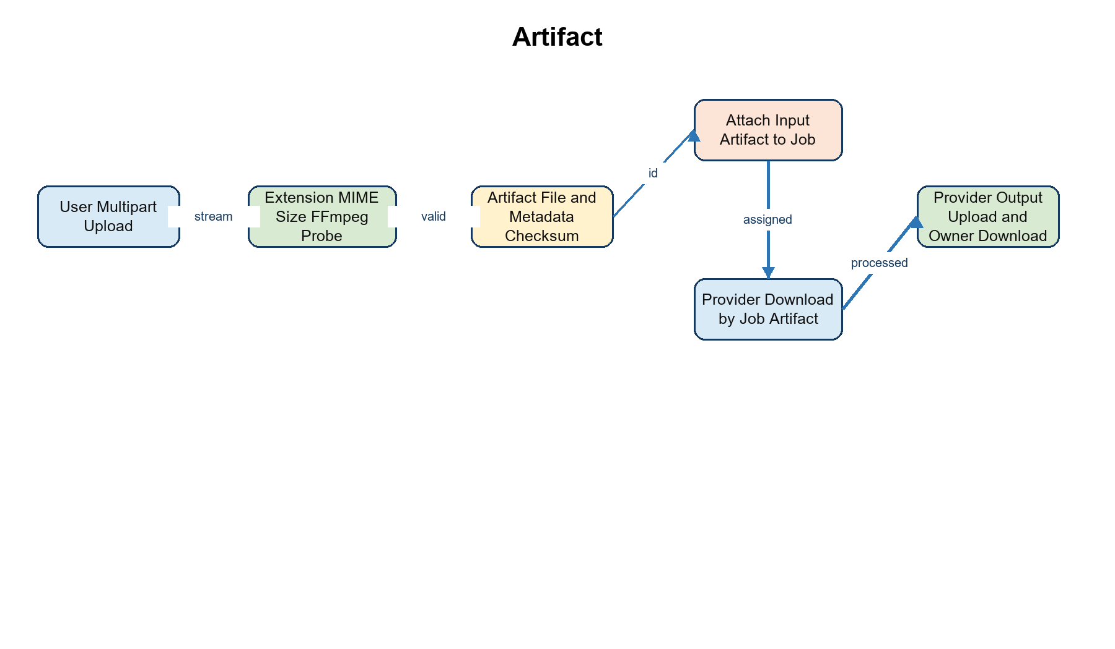
Figure 4.4: Artifact upload, validation, provider transfer and output ownership flow

4.18 Token Wallet Reservation Settlement and Refunds
Token accounting is server owned. `wallet_for` creates a wallet and initial adjustment only where a user has no wallet. `token_ledger` records transaction type, signed amount, balance before/after, reference type, reference ID, description and optional job ID; it rejects a debit that would make the balance negative. `estimate_tokens` derives a reservation from workload requirements. Job creation creates both a negative reservation transaction and a `job_billing` record. Terminal successful completion uses the reported elapsed seconds to calculate a bounded actual token amount, returns the reservation and debits usage. Failure or provider loss can return an outstanding reservation. Package purchase and demo top-up are application token credits rather than card-network charges.
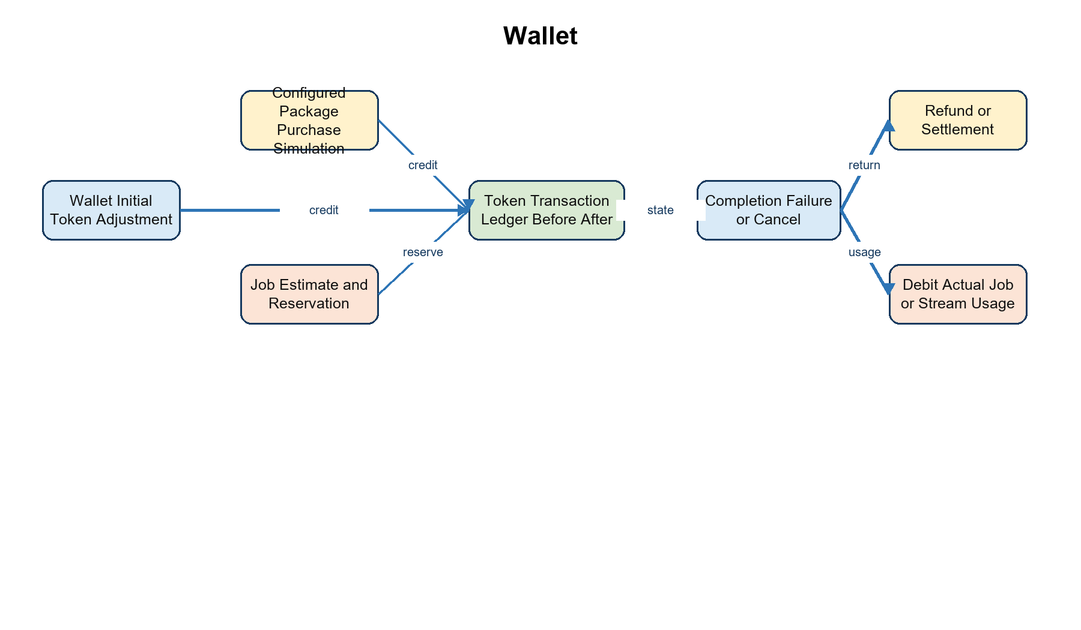
Figure 4.5: Wallet creation, reservation, settlement, refund and simulated purchase flow

4.19 REST API and WebSocket Topic Design
API group | Representative routes | Authentication | Primary effect
Identity | POST /auth/register; POST /auth/login | Public | User/session creation or token return
User workload | GET/POST /jobs; POST /jobs/{id}/cancel; GET /checkpoints | Bearer JWT | Create, inspect and alter owned job state
Provider | POST /providers/register; heartbeat; pending; update; checkpoint | Provider token | Capacity state and execution lifecycle
Artifacts | upload, metadata, user download, provider download/output upload | JWT or provider token | Transfer and ownership-controlled file access
Billing | GET /billing; transactions; purchase; demo-topup | Bearer JWT | Read/change application token ledger
Streaming | stream sessions, claim, heartbeat, stopped, MediaMTX auth | Context-specific | Allocate and supervise stream session
Realtime | WS /ws/realtime | JWT in subprotocol | Topic subscription and event delivery
Table 4.3: Representative REST and realtime interface groups
The realtime endpoint accepts subscriptions to telemetry, providers, jobs, checkpoints, billing, resources and streams. It checks browser origin, authenticates a token carried in the WebSocket protocol list, caps connection/message characteristics, validates topic names and responds to a ping. The server publishes already committed state changes. The frontend still treats REST reads as authoritative and uses a refresh after reconnect or event-driven resync, preventing the realtime channel from becoming a separate persistence source.

4.20 Stream Sessions MediaMTX Authorization and FFmpeg
A stream-session request validates that its source mode is OBS or browser capture, destination platform is YouTube/Twitch/custom RTMP, profile exists, wallet balance meets the minimum, destination uses RTMP or RTMPS and does not resolve to forbidden local/internal addresses. The backend then selects a provider with capacity, FFmpeg availability and a usable H.264 encoder. It stores an allocated `stream_sessions` record containing a generated session ID, publish/read keys, encrypted destination key, profile/encoder configuration, token rate and state metrics. The owner obtains session credentials only through authorized calls; the provider receives the destination credentials only after a single-use claim of its assigned session.
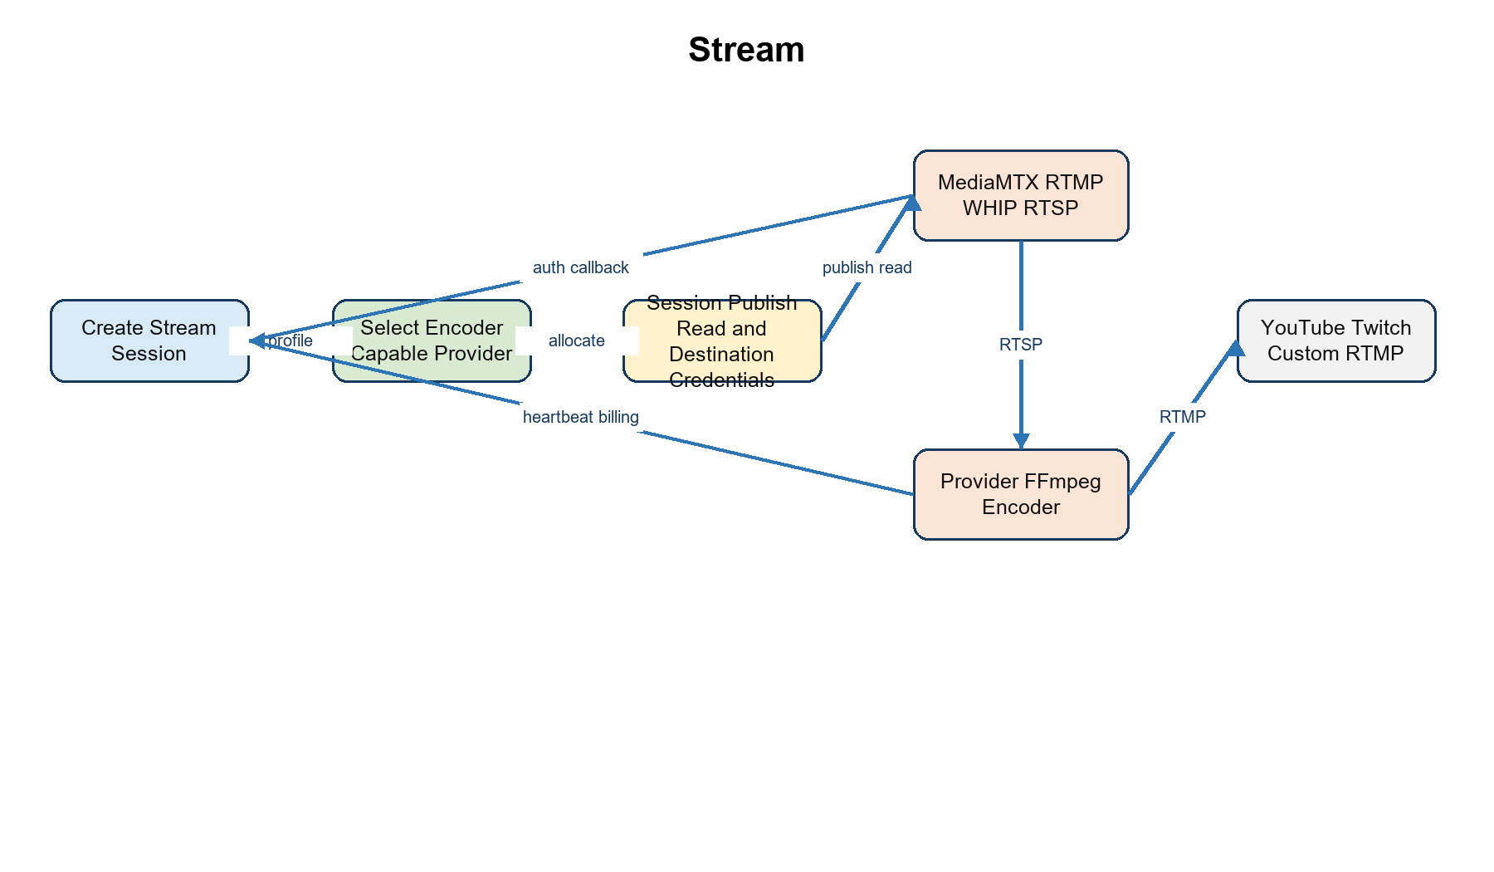
Figure 4.6: Remote streaming session, MediaMTX authorization and provider FFmpeg pathway
The MediaMTX callback authenticates publish/read attempts against the active session path and credential. The provider stream runner creates FFmpeg arguments for the chosen profile, parses progress, reports valid stream state and asks the backend for continue/stop action through heartbeat. The backend accrues stream tokens only while state is STREAMING and at least a full minute has elapsed. On a final stopped message it stores metrics/errors, releases the provider and clears the session credentials. This is a fully specified repository workflow, while a real public broadcast still depends on separately operating MediaMTX, networking and destination credentials.
Streaming sessions add a specialized but optional workflow. The backend validates destination platform, profile, token balance, URL host/scheme and provider FFmpeg capability. It creates session-scoped publish/read credentials and encrypts the destination key with Fernet derived from the configured JWT secret. MediaMTX sends publish/read authorization requests to an internal backend callback. The assigned provider claims exactly one session through the provider API, receives a source URL and destination credentials, starts FFmpeg and sends stream heartbeat metrics. Stream stop may be immediate before claim or asynchronous after a STOPPING command. Figure 4.3 depicts this source-backed topology; it must not be treated as a demonstrated public broadcast.
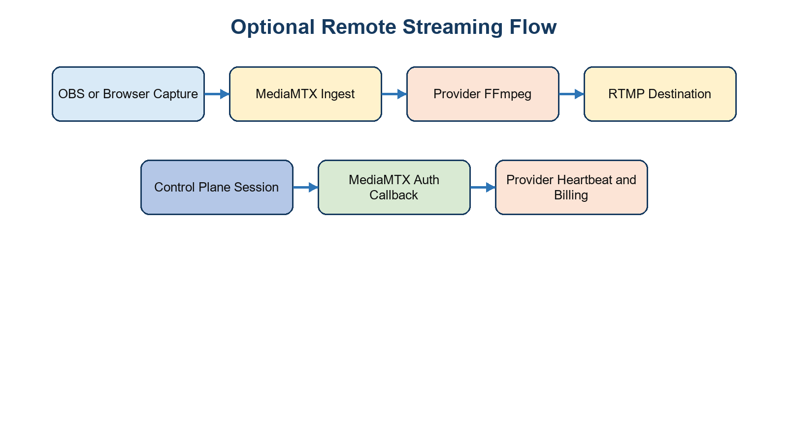
Figure 4.7: Optional MediaMTX and FFmpeg remote streaming architecture

CHAPTER 5
RESULTS AND ANALYSIS

CHAPTER 5 RESULTS AND ANALYSIS

5.1 Qualitative Results and Implementation Artifacts
The strongest result available for this report is implementation evidence, not a performance benchmark. Repository inspection confirms a coherent control-plane/provider path: user routes, provider routes, data models, scheduling logic, background recovery logic, frontend pages, stream configuration and test files are present. The frontend includes views for overview, jobs, providers, resource-pool simulation, billing, analytics, settings and streaming. The backend includes routes for those user workflows and provider-facing polling/update operations. Figure 5.1 presents the data relationships that make the workflow durable at application level.
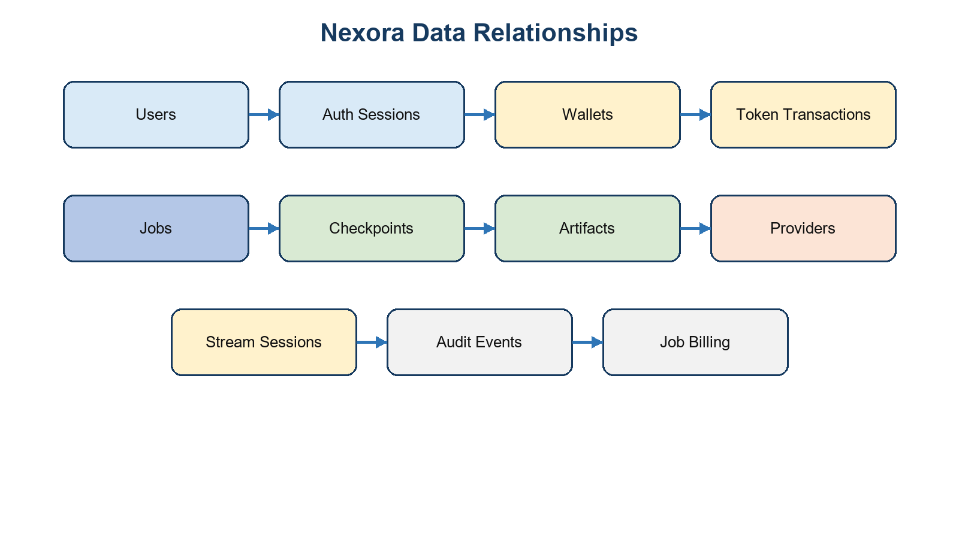
Figure 5.1: Entity relationship view derived from SQLAlchemy model declarations

5.2 Quantitative Validation Evidence
The audit recorded only the checks that were actually executed. Both primary Python modules compiled successfully with `py_compile`. The Node test runner executed twelve frontend utility tests across browser capture and stream stopping with zero failures. These tests covered error reporting, WHIP negotiation/cleanup behavior, capture cleanup, backend stop confirmation and idempotent combined cleanup. They do not demonstrate a native capture session, a media server or a remote destination broadcast.
Validation activity | Result | Interpretation
Python syntax compilation: backend and provider modules | Passed, exit code 0 | Modules parsed; runtime behavior not established
Node utility tests for browser capture and stream stop | Passed: 12 tests, 0 failures | Focused unit behavior; external media mocked/absent
Backend pytest suite | Not run | pytest absent from supplied virtual environment
Provider pytest suite | Not run | pytest absent from supplied virtual environment
Docker Compose, database, MediaMTX, OBS, cloud deployment | Not run | End-to-end behavior unverified

Table 5.1: Validation evidence actually available to this report

5.3 Feature Implementation and Verification Matrix
Capability | Implementation status | Validation status | Evidence boundary
JWT session and user routes | Implemented in source | Unverified runtime | Models and auth routes present
Provider registration and heartbeat | Implemented in source | Unverified live provider | Provider/client routes present
Capacity/cost selection | Implemented in source | Unverified integrated | Rule-based scheduler in backend
Checkpoint and recovery | Implemented in source | Unverified multi-machine | Recovery monitor and tests inspected
Token accounting | Implemented in source | Unverified functional | Ledger/reservation/settlement code
Resource-pool interface | Simulated | N/A | Client-side candidate filtering
Payment purchase | Simulated | N/A | Configured demo packages only
Media streaming | Implemented in source | Unverified end to end | Routes, MediaMTX config, provider runner

Table 5.2: Feature status matrix with explicit verification boundaries

5.4 Edge Cases and Limitations
- Historical telemetry persistence was not found. Dashboard utilization derives from current provider state and frontend snapshots.
- Administrator RBAC was not found; authenticated users can list providers through the observed API.
- Cancellation state is recorded but does not show an observed command path that terminates a running provider workload; stop-all does not show reservation refunds.
- Artifact output upload lacks the same observed content limits applied to user input artifact upload.
- Media deployment requires a separately reachable MediaMTX host with applicable TCP/UDP, TLS and NAT configuration; Render web service configuration alone is insufficient.

5.5 Security and Reliability Analysis
Risk | Evidence | Impact | Recommended mitigation
Custom Python execution | Provider writes/runs submitted source | Untrusted code can affect provider host | Container/VM isolation, quotas, network/file policy
Shared provider token | Single configured provider credential | Provider impersonation if secret leaks | Per-provider enrollment, rotation or mTLS
Dispatch race | Polling returns jobs before asynchronous RUNNING update | Possible duplicate local execution | Atomic lease/claim and single-slot worker control
Single-process coordination | In-memory event hub/recovery plus SQLite default | Replica/durability limits | PostgreSQL baseline, queue/lock/pubsub
Local artifact storage | Backend filesystem artifact paths | Durability and exhaustion risk | Object store, retention and output limits

Table 5.3: Security and reliability findings

5.6 Deployment Topology

5.7 Component Level Results Analysis
Subsystem | What source demonstrates | User or operator value | Evidence type
Frontend console | Nine routes, page modules, authentication guard, API wrapper, shared state and realtime reconnection | One interface for jobs, providers, billing, analytics and streams | Source inspection; frontend utility tests
Control plane | Persistent models, route groups, scheduler, recovery loop and websocket hub | Centralized state and decisions | Source inspection; Python parse check
Provider agent | Hardware probes, heartbeats, polling, workload handlers and FFmpeg runner | Local execution while retaining control-plane coordination | Source inspection
Persistence | Users, sessions, providers, jobs, checkpoints, artifacts, wallet/ledger, audit and streams | Traceable ownership and lifecycle data | ORM declarations/configuration
Media path | Session credentials, callback checks and FFmpeg progress handling | Structured optional streaming demonstration | Source/config/test inventory
Table 5.4: Component-level implementation analysis

5.8 Scheduling Telemetry Billing Artifact and Streaming Analysis
Scheduling is transparent and easy to audit: every selection begins by eliminating incompatible resources, then applies a single score rather than hiding allocation behind a black-box model. This makes it suitable for explaining why a request cannot be scheduled and for demonstrating capacity-aware selection. Telemetry is intentionally current-state focused; it gives the dashboard a practical operational view of provider CPU, RAM, disk and optional GPU values. Billing connects an action to a durable token ledger before and after job execution. Artifact flow establishes provenance through owner association, checksum and metadata. Streaming extends the same provider-selection and accounting principles to a session-oriented media workload.

5.9 Deployment and Operational Considerations
Figure 5.3 describes the supported deployment alternatives. The static dashboard can be served locally or through Vercel. The control plane can run directly, in Docker Compose or through the Render Blueprint. SQLite is appropriate for the default direct demonstration, while Compose/Render configuration makes PostgreSQL available for a more durable service topology. Providers remain separate processes and must target the same backend and credential configuration. The media plane is deliberately separate because MediaMTX needs network listeners that ordinary web hosting does not provide.
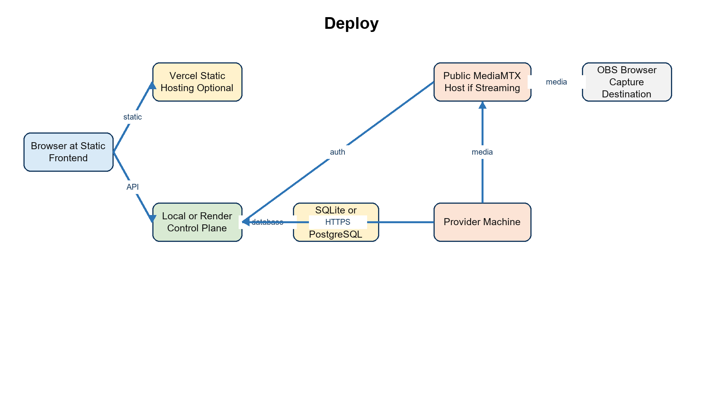
Figure 5.2: Local, hosted and media deployment topology

5.10 Focused Limitations and Engineering Implications
The codebase has a clear prototype boundary. Custom Python execution is flexible but needs true workload isolation before it is exposed to untrusted users. The shared provider token simplifies setup but should be replaced with per-provider enrollment and revocation. Polling dispatch should gain an atomic lease/claim so concurrent agent activity cannot start duplicated work. Application cancellation should send a provider-visible stop command and perform one idempotent settlement. Artifact paths should evolve from backend-local storage to capacity-controlled durable storage. The in-memory realtime/recovery mechanism is appropriate to a single process but would require a distributed coordination design for replicas. These are focused engineering improvements; they do not invalidate the implemented workflows described above.
Figure 5.2 presents the available deployment configurations. Direct local operation uses separate backend, provider and static-server processes. Docker Compose defines backend, PostgreSQL and MediaMTX services but does not start a provider. The Render and Vercel files define a potential hosted backend/database and static frontend topology. An external media host remains required for remote streaming. The audit did not deploy any of these configurations.
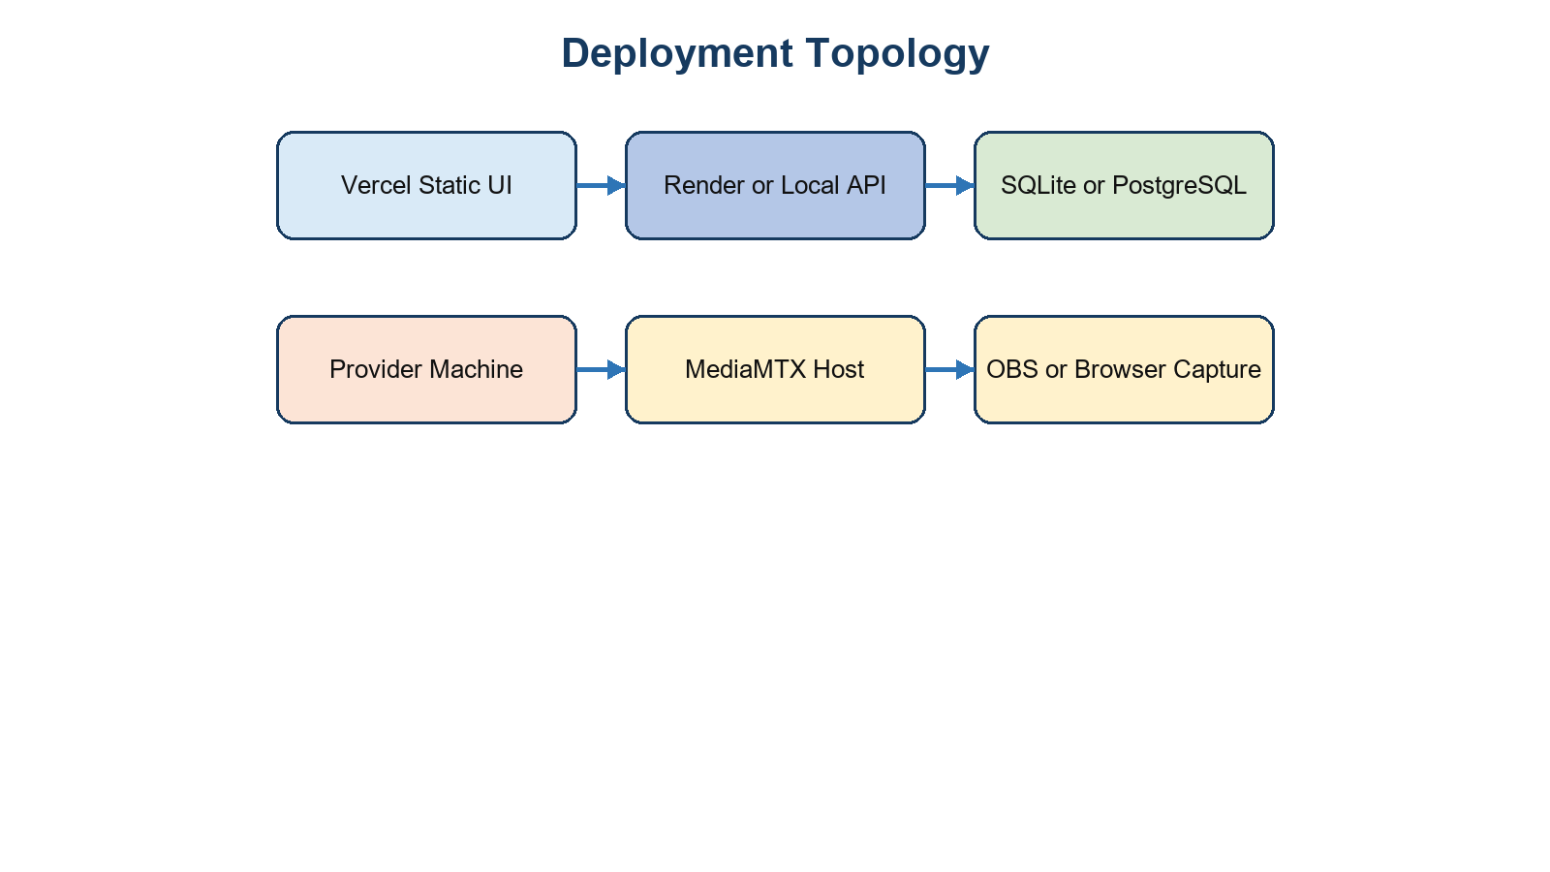
Figure 5.3: Documented but unverified deployment topology

CHAPTER 6
CONCLUSION AND FUTURE WORK

CHAPTER 6 CONCLUSION AND FUTURE WORK

6.1 Conclusion
Nexora demonstrates a complete source-level prototype of a unified compute management workflow. The project connects user-facing job submission to provider discovery, capacity filtering, selection, polling-based dispatch, provider execution, checkpoints, recovery state, artifacts, token ledger operations and dashboard updates. Its design is particularly useful as an academic case study because each concern remains visible in a compact repository: the frontend is static and inspectable, the backend exposes the state model and routes, and the provider agent reveals the boundary between control-plane decisions and local execution.
The implementation should nevertheless be described accurately. Python syntax validation and twelve frontend utility tests are the runtime evidence recorded in this report. The principal integrations - actual provider execution, database deployment, Docker Compose, MediaMTX, OBS/browser capture, remote streaming, external destination delivery and hosted service deployment - remain unverified. Nexora is therefore a substantial prototype, not a production readiness claim.

6.2 Future Enhancements

6.3 Prioritized Engineering Roadmap
The immediate roadmap strengthens trust and execution safety: introduce per-provider identity, isolate untrusted workloads, and establish atomic dispatch/cancel acknowledgements. The next stage makes state operationally durable through migrations, PostgreSQL policy, artifact lifecycle management and telemetry history. The final stage increases usability and scale through provider pools, labels, quotas, fairness policies, administrative roles, structured observability and fully automated integration testing. This sequence preserves the current educational value of a simple control plane while addressing the requirements that matter before broader deployment.
Priority | Future work | Acceptance criterion
P0 | Isolate custom code and strengthen provider identity | Untrusted workload cannot access provider host; one credential cannot impersonate another provider
P1 | Add atomic leases, cancellation acknowledgements and recovery stress tests | One job has one active execution; cancel reaches the provider and settles once
P1 | Use durable production persistence and artifact management | Versioned migrations, retained backups, object storage lifecycle and limits
P2 | Add telemetry history, structured logs, health alerts and audit visibility | Operators can inspect time-series and correlated job/provider events
P2 | Refresh docs and run CI/integration suites | Documented routes/config align with source and automated tests run reproducibly
P3 | Formalize roles, quotas, provider pools and fair scheduling | Policy-backed access and predictable multi-provider allocation

Table 6.1: Prioritized future-work roadmap

SUPPORTING MATERIALS
The following source materials were inspected to prepare this report: `README.md`; the backend control plane at `user-website/backend/app/main.py`; the provider agent at `provider-server/main.py`; static frontend modules under `user-website/nexora-frontend/js`; Docker and hosting configuration; MediaMTX configuration; backend/provider/frontend tests; and the supplied audit documents `OVERALL_PROJECT_REPORT.md`, `API_REFERENCE.md`, `ARCHITECTURE.md`, `DATABASE_DESIGN.md`, `DEPLOYMENT_GUIDE.md`, `FEATURE_IMPLEMENTATION_MATRIX.md`, `TESTING_AND_VALIDATION.md`, and `TECHNICAL_DEBT_AND_FUTURE_SCOPE.md`. The reference PBC format document was used for chapter sequence, cover composition, abstract, table of contents, heading structure, supporting materials, references and appendix arrangement.

REFERENCES
[1] Nexora repository, README.md, backend, provider, frontend, tests and deployment configuration. Inspected 25-26 October 2026.
[2] Nexora Overall Project Report, API Reference, Architecture, Database Design, Deployment Guide, Feature Implementation Matrix, Testing and Validation, and Technical Debt and Future Scope. Internal project documentation, 2026.
[3] FastAPI. FastAPI Documentation. https://fastapi.tiangolo.com/ (accessed for framework context; project-specific facts are based on source code).
[4] SQLAlchemy. SQLAlchemy 2.0 Documentation. https://docs.sqlalchemy.org/en/20/.
[5] Docker. Docker Compose Documentation. https://docs.docker.com/compose/.
[6] MediaMTX. MediaMTX Documentation. https://mediamtx.org/docs/.
[7] FFmpeg. FFmpeg Documentation. https://ffmpeg.org/documentation.html.
[8] Python Software Foundation. Python 3 Documentation. https://docs.python.org/3/.

APPENDIX

Appendix A: API and Database Design Summary
This appendix preserves the reference report position for extended technical material while adapting it to Nexora. It is a compact companion to the full API_REFERENCE.md and DATABASE_DESIGN.md documents.

A.1 API Endpoint Groups
Group | Representative endpoints | Authentication
Health and authentication | GET /health; POST /auth/register; POST /auth/login | Public
User/job workflow | GET/POST /jobs; cancel; checkpoints; dashboard; analytics | Bearer JWT
Billing and artifacts | billing, transactions, purchase, demo top-up, upload/download | Bearer JWT
Provider workflow | register, heartbeat, pending jobs, updates, checkpoints, artifacts | X-Provider-Token
Streaming | stream sessions, MediaMTX callback, claim, heartbeat, stopped | JWT, provider token or callback
Realtime | WS /ws/realtime | JWT in WebSocket subprotocol

Table A.1: API endpoint groups

A.2 Database Entities and Relationships
Core entities are users, providers, jobs, checkpoints, auth sessions, job artifacts, wallets, token transactions, job billing, audit events and stream sessions. Users own sessions, wallet records, jobs and artifacts. Jobs reference users and an optional provider, own checkpoints/artifacts and have one billing record. Stream sessions reference users and optional providers. The following figure repeats the relationship summary for appendix use.
Figure A.1: Database entity relationship summary

A.3 Selected Source Listings
# Source-backed heartbeat update behavior
@app.post("/providers/{provider_id}/heartbeat")
def heartbeat(provider_id: str, body: Heartbeat, _=Depends(provider_auth), s: Session=Depends(db)):
p = s.get(Provider, provider_id)
if not p:
raise HTTPException(404, "Provider not registered")
p.status = body.status
p.utilization = body.utilization
p.last_heartbeat = datetime.now(timezone.utc)
s.commit()
return {"ok": True}
Listing A.1: Condensed provider heartbeat endpoint behavior

Appendix B: Deployment, Testing and Implementation Checklist

B.1 Direct Local Setup
Repository-supported local setup separates backend, provider and static frontend. The backend can run Uvicorn for `app.main:app`; the provider uses `python main.py`; and the frontend can be served with Python HTTP server or its provided batch script. The provider must use the same control-plane URL and provider shared token as the backend. These are documented commands, not commands executed by this audit.
# Repository-supported example commands (not executed for this report)
cd user-website/backend
uvicorn app.main:app --host 0.0.0.0 --port 8000
cd provider-server
python main.py
cd user-website/nexora-frontend
python -m http.server 5173 --bind 127.0.0.1
Listing B.1: Repository-supported local startup commands

B.2 Docker and Hosted Setup
The root Docker Compose file describes a backend, PostgreSQL and MediaMTX topology. `render.yaml` defines a Render web service and PostgreSQL database; `vercel.json` serves the static frontend. An internet-accessible media deployment requires a host that exposes the required RTMP, RTSP and WebRTC ports. The deployment guide also records that a standard Render web service is not that media host.

B.3 Test and Evidence Checklist
Item | Recorded outcome | Report classification
Python primary-module parse check | Passed | Tested
Frontend browser-capture/stream-stop utilities | 12 passed, 0 failed | Tested
Backend and provider pytest suites | pytest missing; not run | Unverified
Control-plane APIs with live database | Not run | Unverified
Docker/PostgreSQL/MediaMTX | Not run | Unverified
Remote provider and destination stream | Not run | Unverified

Table B.1: Testing and validation checklist

B.4 Final Audit Notes

B.5 API Request and Response Examples
The following examples are schematic representations of the actual request schemas and response fields. Values are illustrative only and do not represent captured production data or credentials.
POST /jobs
Authorization: Bearer <session-token>
{
"name": "Matrix Benchmark",
"workload": "matrix_multiply",
"requirements": {"matrix_size": 300, "expected_runtime_hours": 0.05}
}
201/200 response shape
{
"id": "job_<generated>", "status": "SCHEDULED",
"provider_id": "provider_<assigned>", "estimated_tokens": 6,
"reserved_tokens": 6, "progress": 0
}
Listing B.2: Illustrative job creation schema and response fields
POST /providers/<provider-id>/heartbeat
X-Provider-Token: <configured-provider-token>
{
"status": "ONLINE",
"utilization": {"cpu": 22.1, "ram": 48.0,
"disk": 51.4, "gpu_memory": null, "gpu_compute": null}
}
Response: {"ok": true}
Listing B.3: Illustrative provider heartbeat schema

B.6 Detailed Database Field Summary
Entity | Important fields | Ownership/constraint
users | id, email, password_hash, wallet_balance | email unique; user root entity
providers | id, name, cpu_cores, ram_gb, GPU fields, status, reliability, utilization, system_info, last_heartbeat | provider ID primary key
jobs | id, name, workload, requirements, status, progress, user_id, provider_id, attempt, recovery_count, result, timestamps | user and optional provider foreign keys
checkpoints | id, job_id, provider_id, attempt, seq, progress, state_version, state_hash, payload | job foreign key; application-level sequence
auth_sessions | id, user_id, issued_at, expires_at, revoked | user foreign key/index
job_artifacts | id, job_id, user_id, file_path, checksum_sha256, meta_data, content | user ownership; job optional until assignment
wallets and token_transactions | token_balance; ledger type/amount/before/after/reference | wallet unique by user; ledger references wallet/user/job
stream_sessions | user_id, provider_id, status, keys, destination fields, profile, metrics, billing times | session-scoped media/accounting state
Table B.2: Detailed data-entity field and ownership summary
No secret values are reproduced in this report. Implementation claims are linked to repository evidence, and claims of successful live deployment, payment processing, remote execution, external media delivery, performance or scalability are intentionally excluded unless the supplied audit recorded a corresponding executed check. The report uses placeholders for student-specific information because no student names or registration numbers were provided.

