# 1 - Integration tests

Integration testing verifies that different parts of an application work together correctly, often involving real external dependencies like databases or message brokers. Unlike unit tests, integration tests check the interaction between components in a realistic environment.

**Testcontainers** is a Java library that helps create lightweight, throwaway instances of external services (like databases) using Docker containers during tests. This ensures tests run against real, isolated environments without manual setup, improving reliability and consistency.

Using integration tests with Testcontainers allows developers to automate end-to-end testing with real infrastructure components, leading to more robust and maintainable applications.

<https://testcontainers.com/>  
  
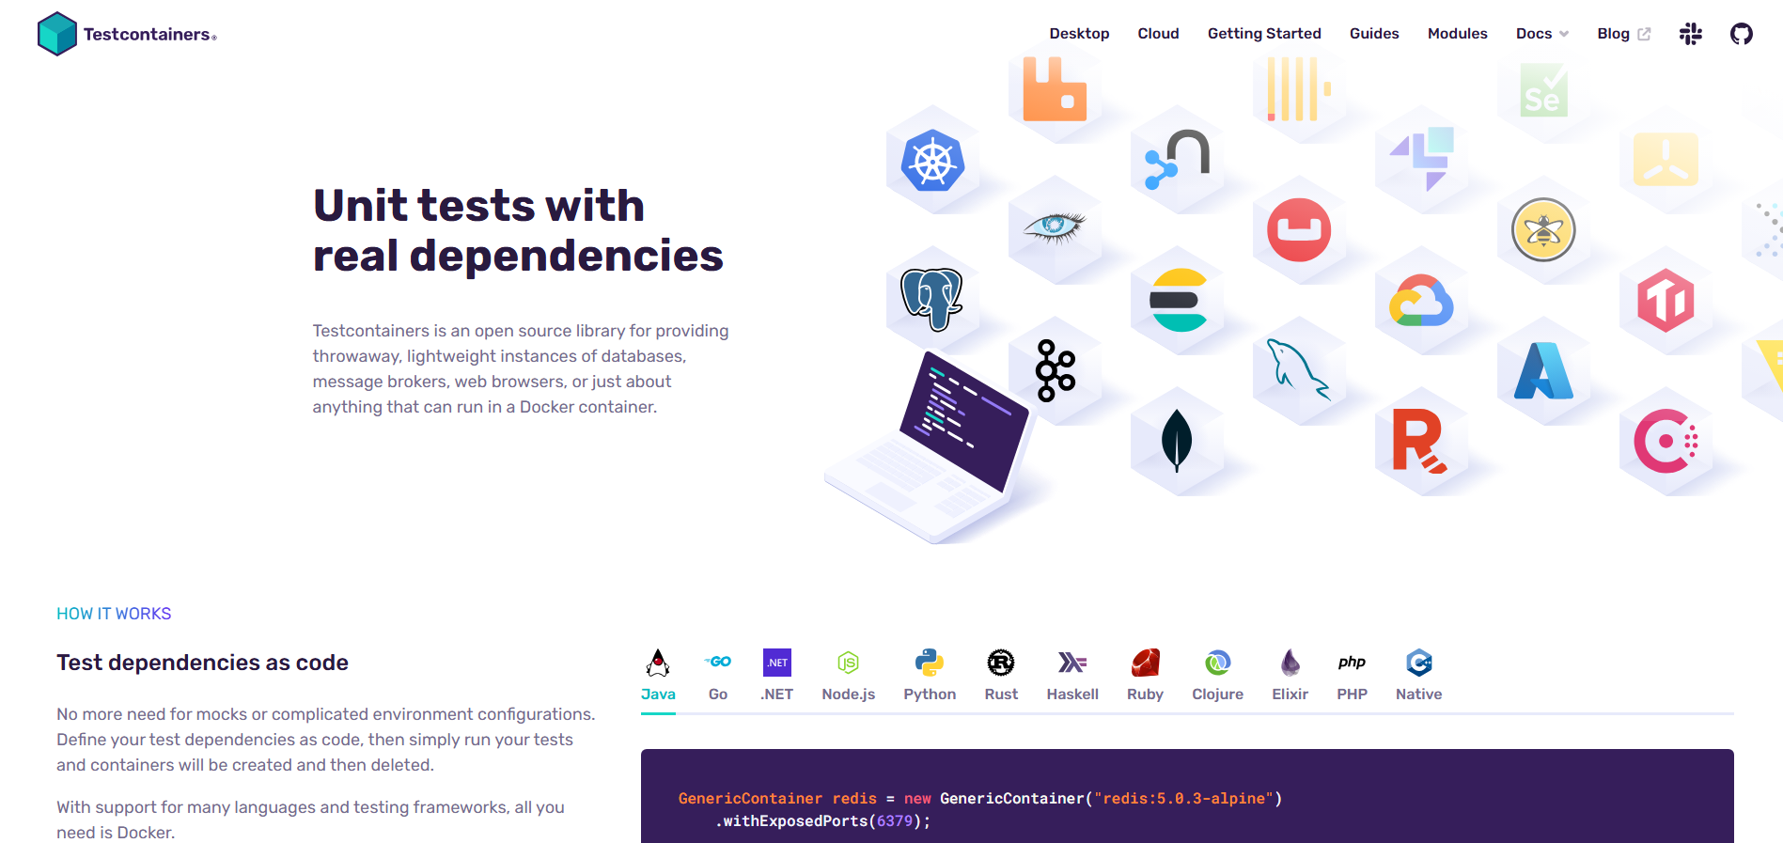  
  
Add dependencies to pom.xml to allow integration tests with test container.  
  
<dependency>

<groupId>org.springframework.boot</groupId>

<artifactId>spring-boot-testcontainers</artifactId>

<scope>test</scope>

</dependency>  
  
Add dependencies to allow rest communication during tests.  
  
<dependency>

<groupId>io.rest-assured</groupId>

<artifactId>rest-assured</artifactId>

</dependency>