1 - Integration tests
Integration testing verifies that different parts of an application work together correctly, often involving real external dependencies like databases or message brokers. Unlike unit tests, integration tests check the interaction between components in a realistic environment.
Testcontainers is a Java library that helps create lightweight, throwaway instances of external services (like databases) using Docker containers during tests. This ensures tests run against real, isolated environments without manual setup, improving reliability and consistency.
Using integration tests with Testcontainers allows developers to automate end-to-end testing with real infrastructure components, leading to more robust and maintainable applications.

https://testcontainers.com/
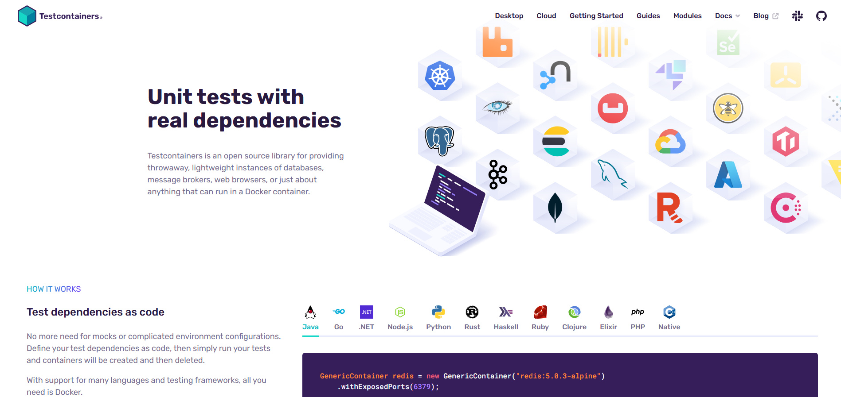
Add dependencies to pom.xml to allow integration tests with test container.
<dependency>
<groupId>org.springframework.boot</groupId>
<artifactId>spring-boot-testcontainers</artifactId>
<scope>test</scope>
</dependency>
Add dependencies to allow rest communication during tests.
<dependency>
<groupId>io.rest-assured</groupId>
<artifactId>rest-assured</artifactId>
</dependency>

2 - Flyway

https://www.red-gate.com/products/flyway/community/
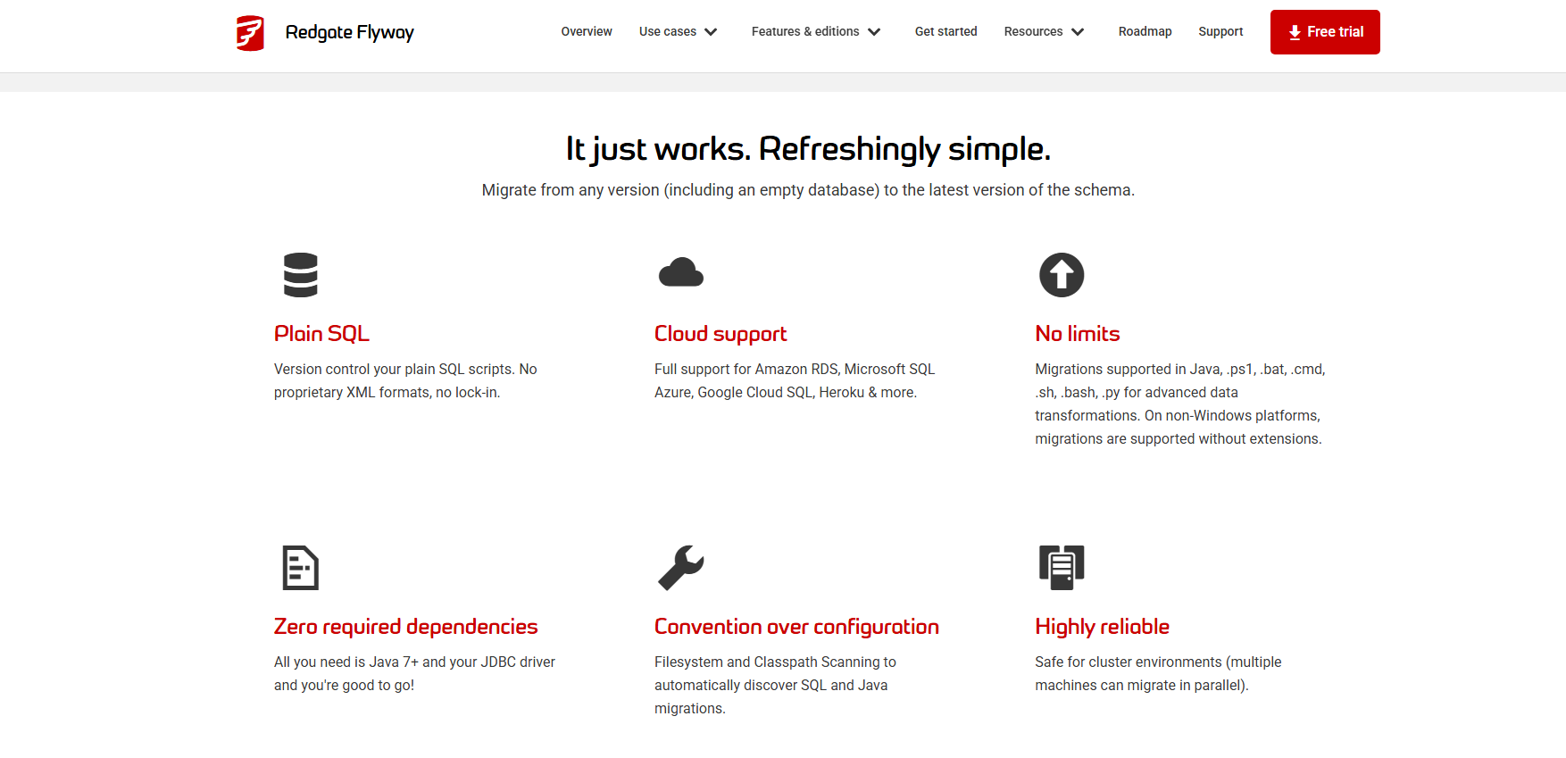
Flyway is a lightweight and powerful database migration tool. It helps manage and automate version control for your database schema. Flyway uses simple SQL or Java-based migration scripts to apply incremental changes to your database in a controlled and consistent way.
It integrates easily with Spring Boot and supports many relational databases like MySQL, PostgreSQL, Oracle, and more. With Flyway, you can ensure your database structure stays in sync across environments (development, testing, production) and team members.
Add the dependencies to enable flyway db migration
<dependency>
<groupId>org.flywaydb</groupId>
<artifactId>flyway-core</artifactId>
</dependency>
<dependency>
<groupId>org.flywaydb</groupId>
<artifactId>flyway-mysql</artifactId>
</dependency>
Whenever flyway is activated, it searches for the migration scripts in the next folder.


The scripts for migrations must follow the next name convention:
V<number>__<name>.sql Examples: V1__orders.sql, V1__init.sql

3 - Spring Cloud Open Feign
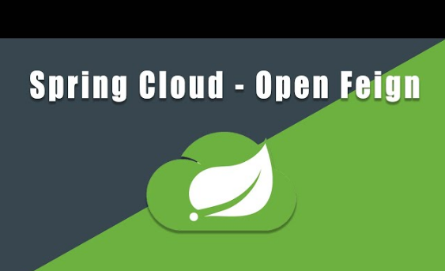
Spring Cloud OpenFeign is a declarative HTTP client that makes it easy to call other microservices in a Spring Boot application.
🔹 What it does:
It allows you to define Java interfaces to call REST APIs, avoiding boilerplate code with RestTemplate or WebClient.

🔹 How it works:
Add the dependency:
spring-cloud-starter-openfeign

Enable Feign clients in your main class with @EnableFeignClients.

Create an interface with @FeignClient, specify the service name or URL, and define the endpoints using Spring annotations like @GetMapping.
Inject and use the interface as a regular Spring bean.

✅ Benefits:
- Simple and readable code
- Built-in integration with Spring Boot
- Supports load balancing, fallback, logging, and more

4 - WireMock
WireMock is a tool used to mock HTTP services, allowing you to simulate external APIs and test your application without depending on real remote services.
- Add the WireMock dependency to your project (order-related module)
(spring-cloud-starter-contract-stub-runner)
- Use the @AutoConfigureWireMock(port = ...) annotation to configure WireMock on a specified port for integration testing
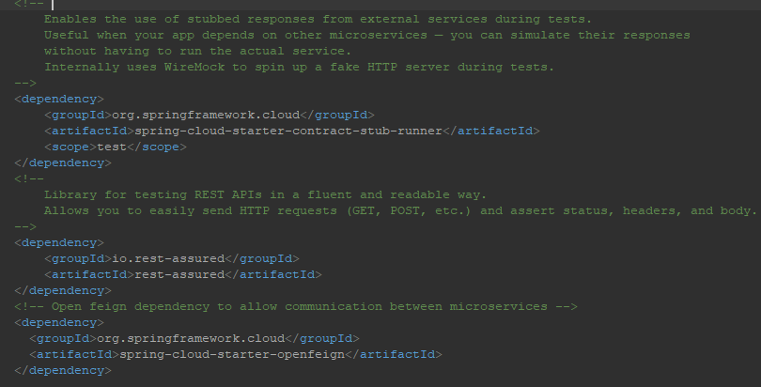

5 - API Gateway
An API Gateway is a server that acts as a single entry point for all client requests to a system made up of multiple services (usually microservices). It receives the requests, forwards them to the correct service, and returns the response back to the client.
Dependency:
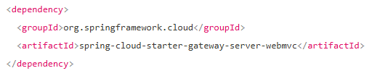
✅ Benefits:

Centralized entry point – Simplifies how clients access the system.
Security and monitoring – Easier to implement authentication, rate limiting, and logging.
Request routing – Routes traffic to the right service based on URL, method, etc.
Reduces client complexity – Clients don’t need to know about service locations.
Request aggregation – Combines multiple service calls into one response.

❌ Drawbacks:
Single point of failure – If the gateway goes down, the whole system may become unreachable.
Increased latency – Adds an extra network hop between the client and services.
Complex configuration – Routing rules and policies can grow complex over time.
Scalability needed – The gateway must handle all traffic, so it must be well-scaled.

6 - KeyCloak
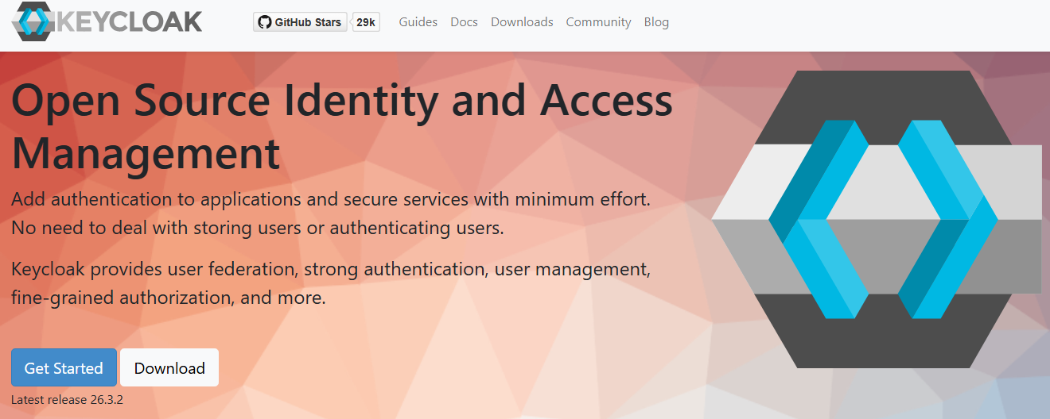
Keycloak is an open-source Identity and Access Management (IAM) solution developed by Red Hat. It provides features such as Single Sign-On (SSO), user federation, identity brokering, and centralized authentication and authorization for applications and services. With support for standard protocols like OAuth 2.0, OpenID Connect, and SAML 2.0, Keycloak enables secure and flexible user management out of the box. It also includes an easy-to-use admin console and integrates well with modern applications and microservice architectures.
OAuth 2.0: It is an authorization protocol that allows applications to access a user's resources on another service (such as Google or Facebook) without needing to share the user's password.
OpenID Connect (OIDC): It is an identity layer built on top of OAuth 2.0. It allows applications to verify the user's identity and securely obtain basic profile information.
SAML (Security Assertion Markup Language): It is an XML-based authentication protocol used for Single Sign-On (SSO), especially in enterprise environments. It allows users to authenticate once and access multiple applications.
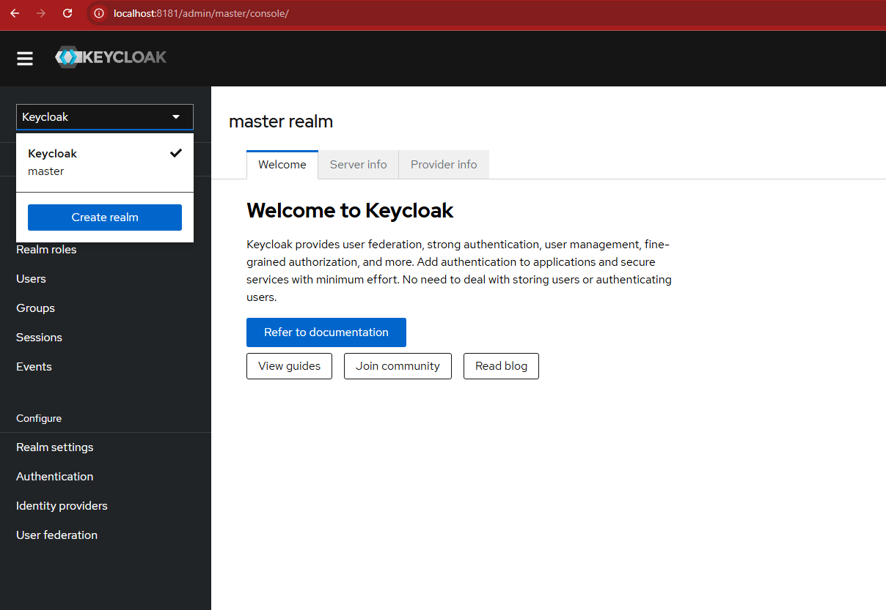
The first step is to create a new realm for the project configuration (users, roles, credentials etc).
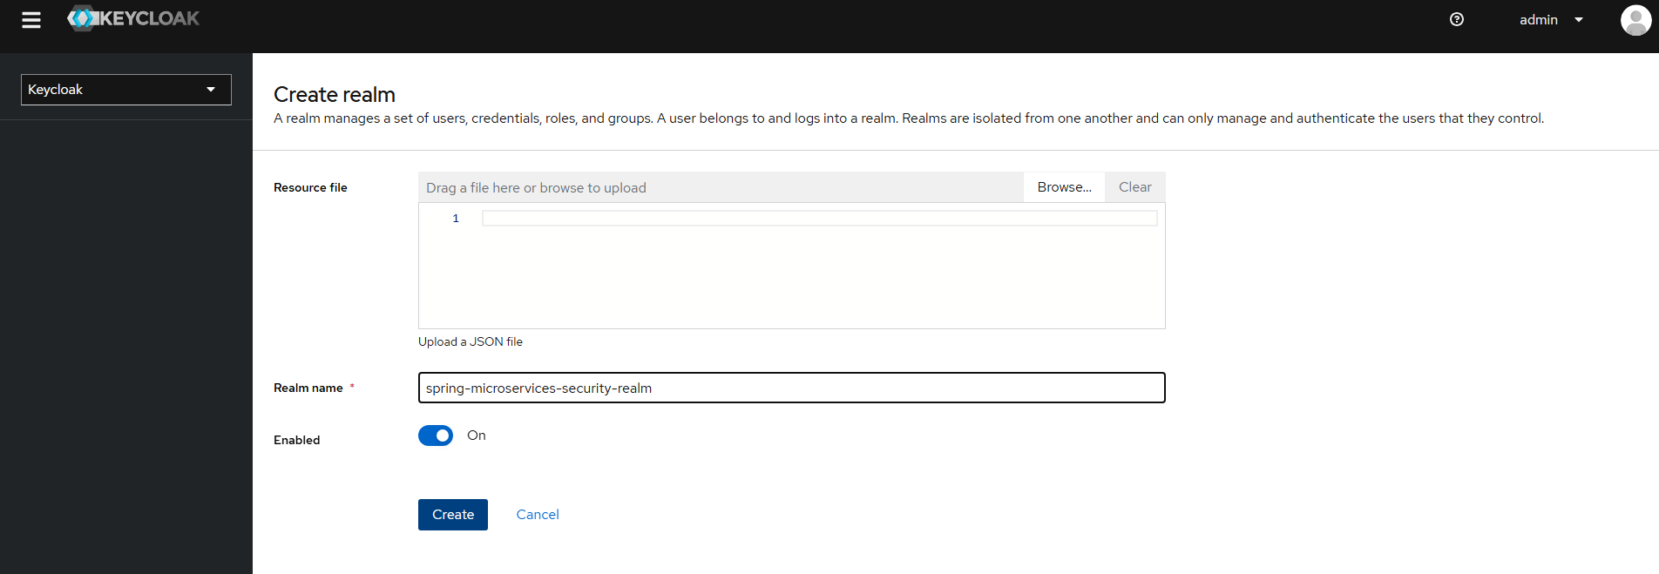
The next step is to create a new client
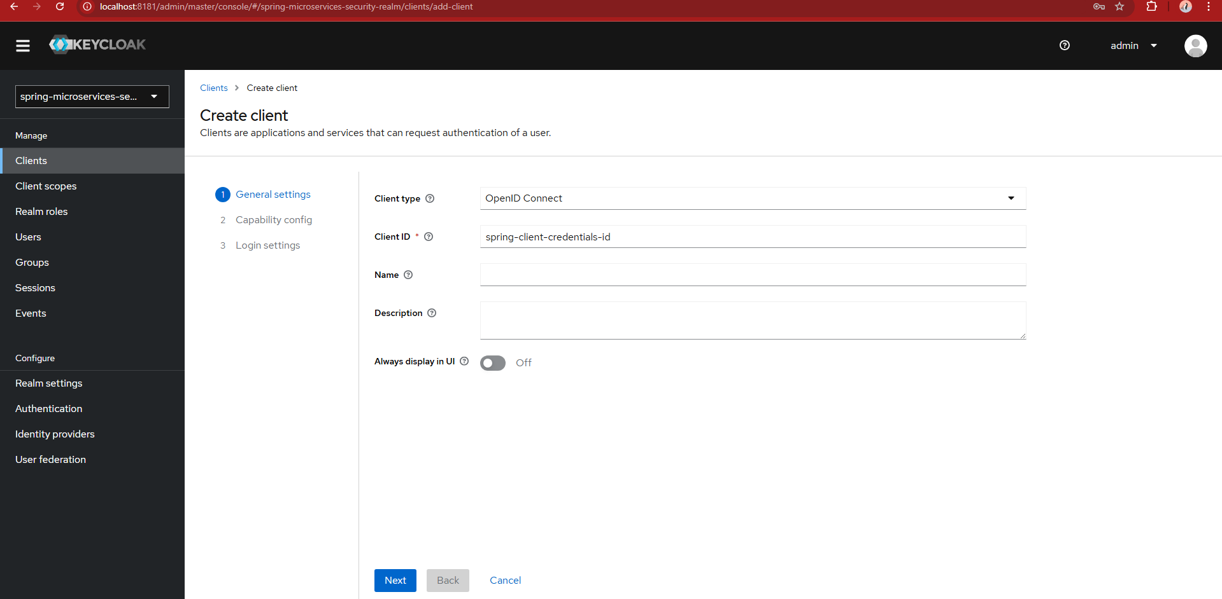
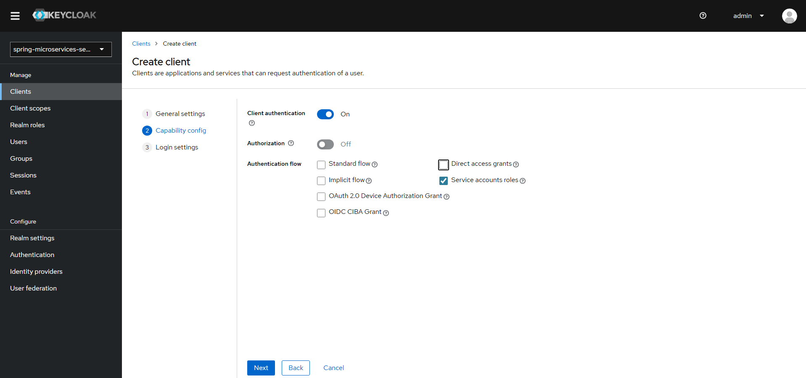
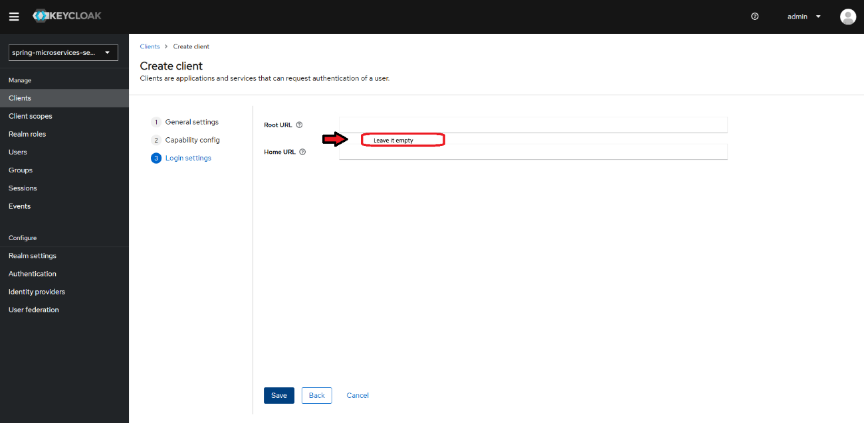

Next, check the client secret
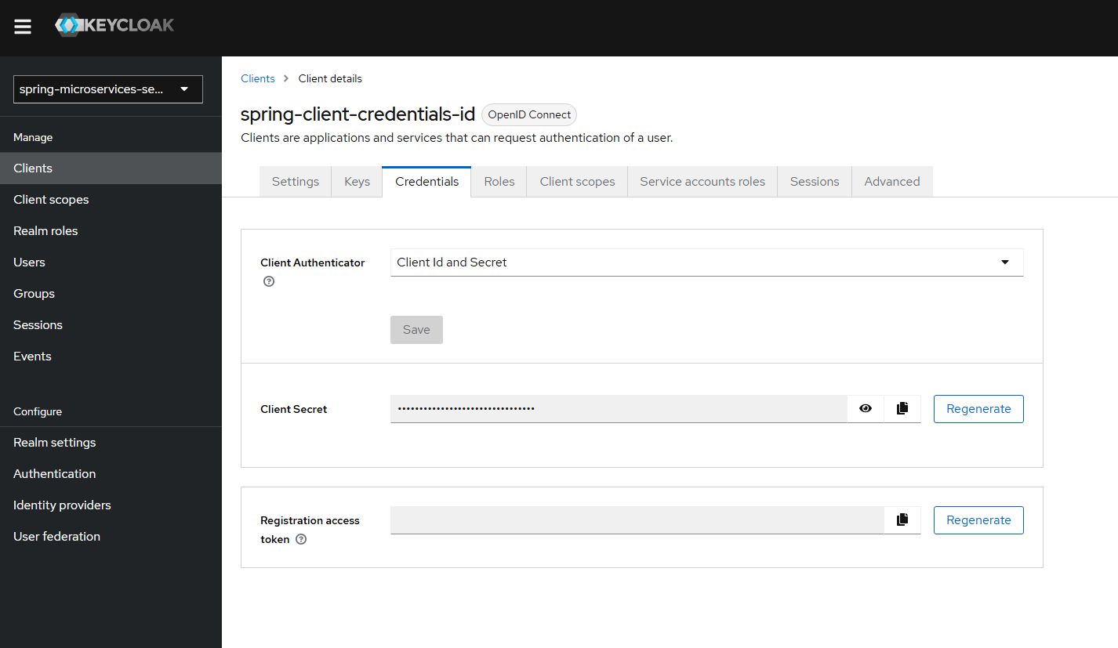
Through realm settings, we can access openId configuration endpoint
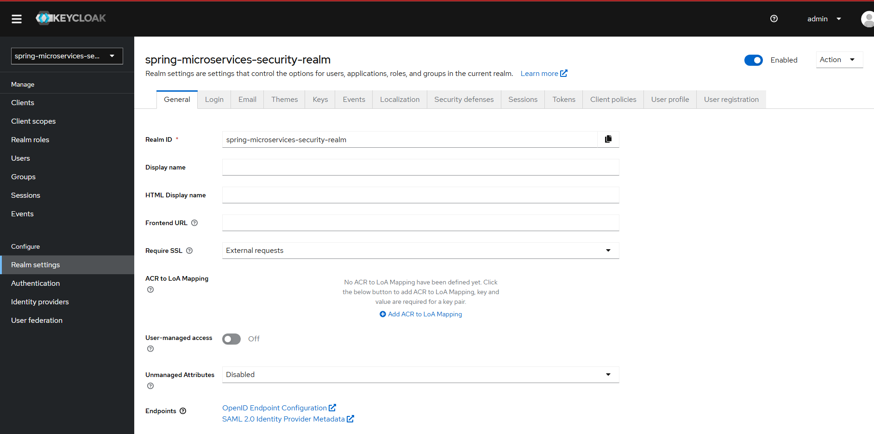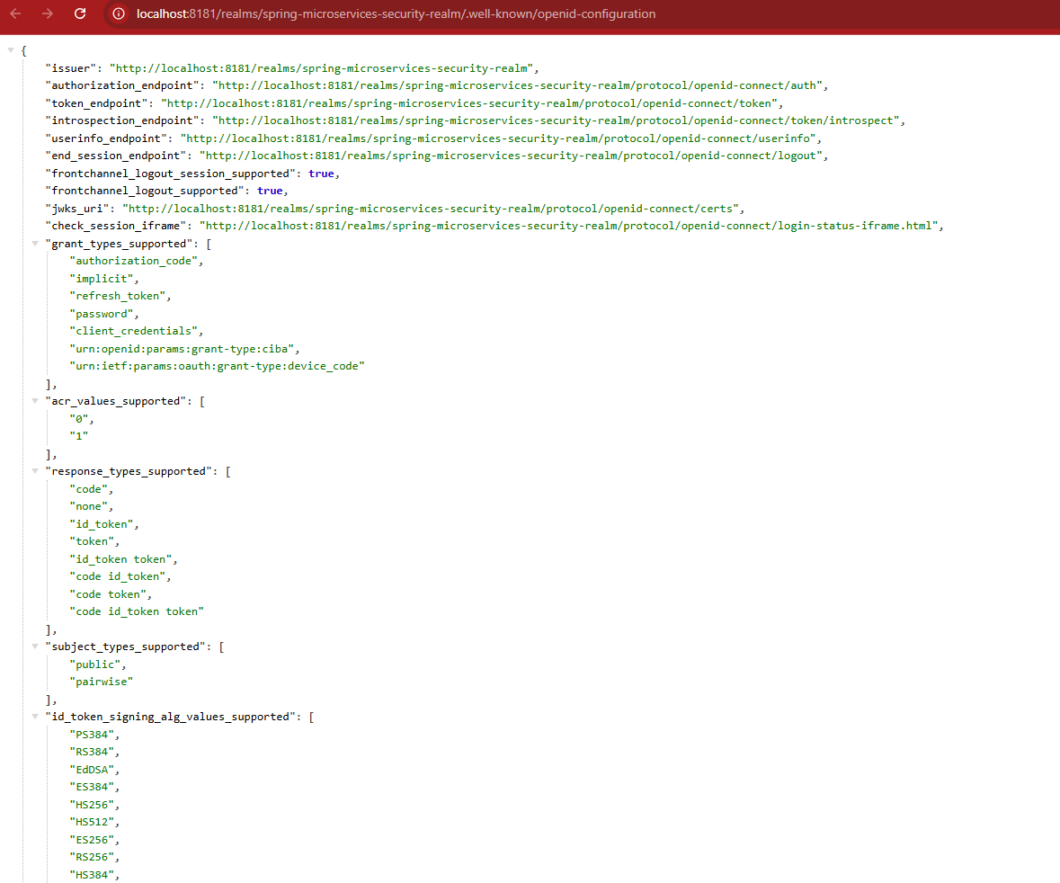
The API Gateway module will be configured as a resource server for oauth2.
Add the next dependency:
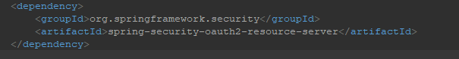
In the openId endpoint (keycloak / realm settings), we can check the token url
We can configure a new token for our requests in postman, so that we get authorized to access the endpoints of our application.
Besides the token url, we also need the client’s ID and secret.
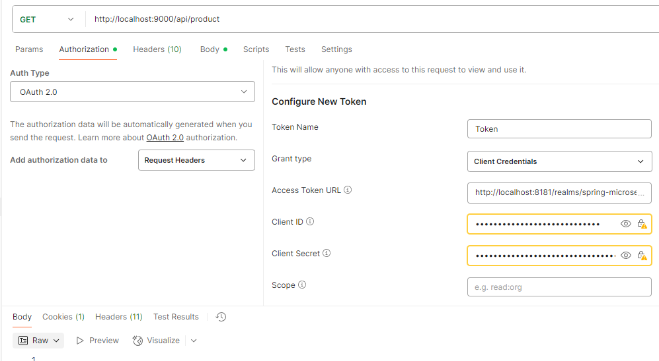
Finally scroll to the bottom and clic the button to generate the token, then clic on proceed.
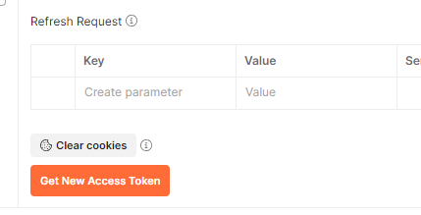
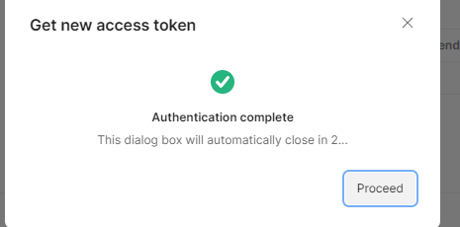
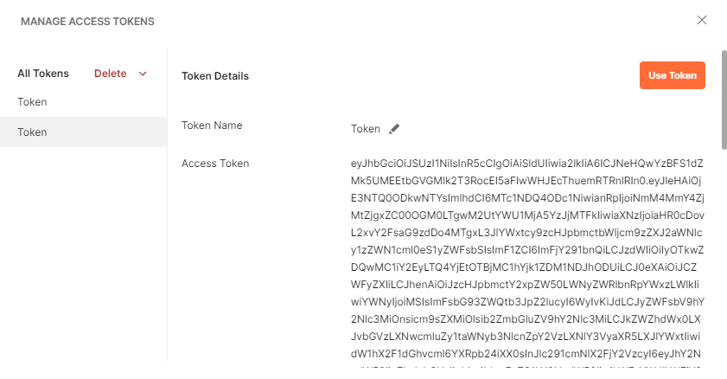
Press on use token and the token gets added to the header.
To authenticate the Angular frontend client application, we need to create a new client in our Keycloak realm.
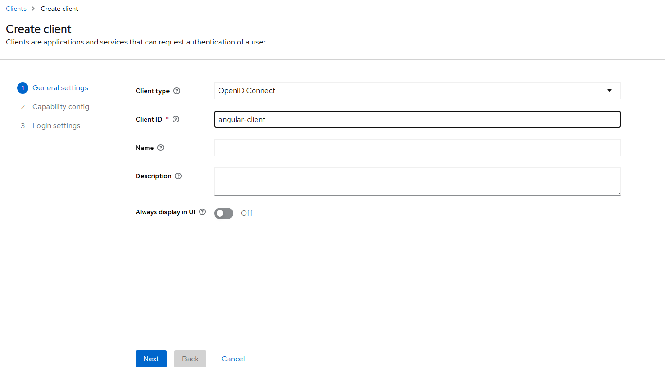
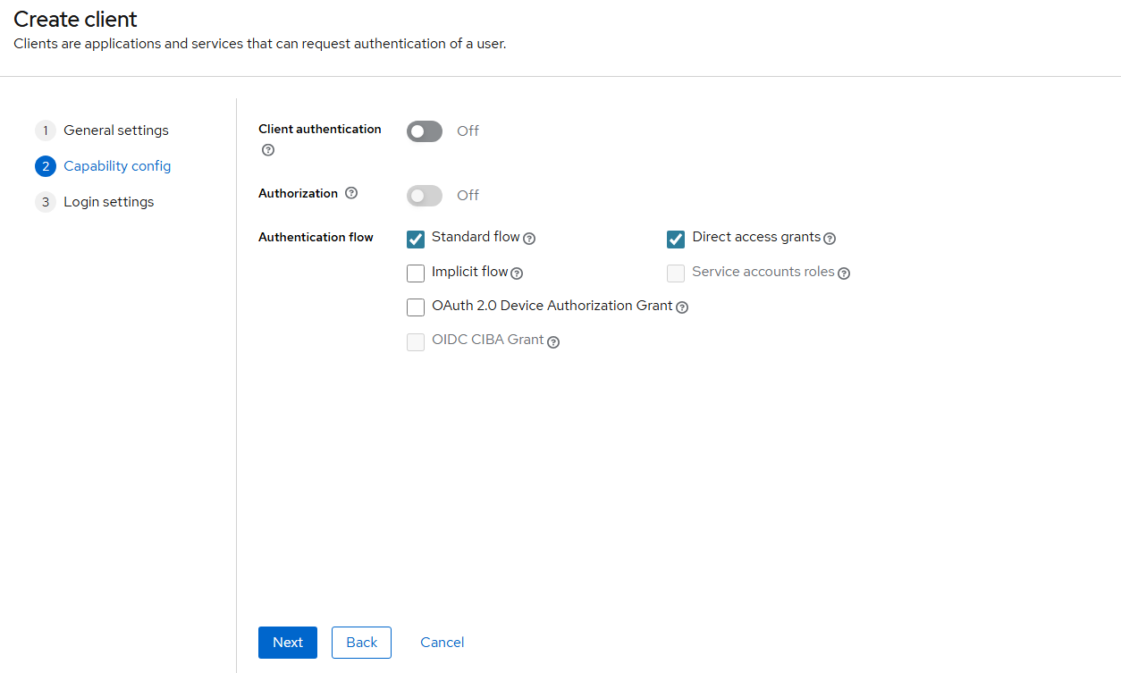
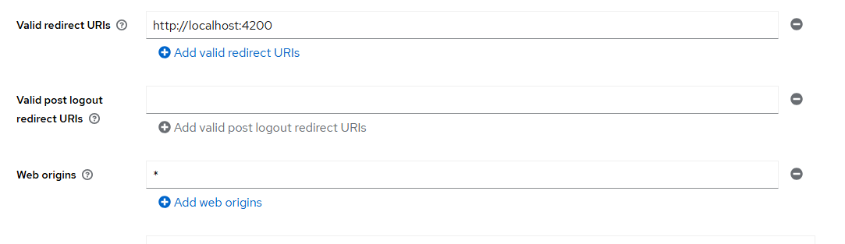
We can also activate the user registration option in our realm settings.
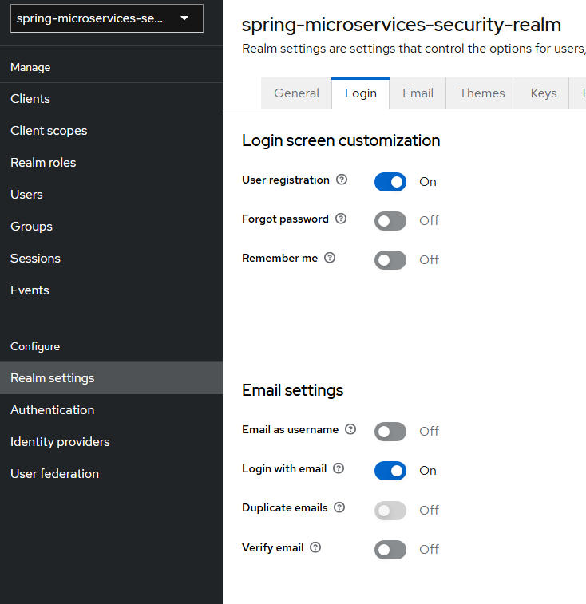

7 - Circuit breaker
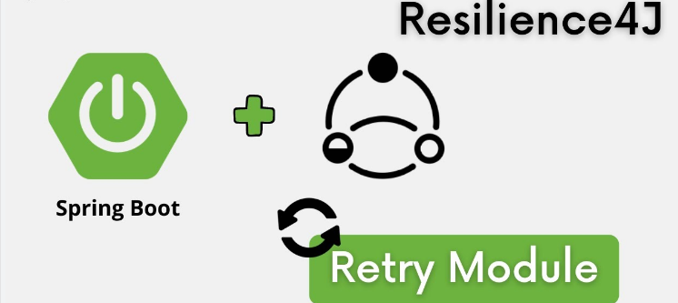
A circuit breaker is a design pattern used in microservices and distributed systems to improve reliability. It acts like a safety switch that stops requests to a failing service after a certain number of errors, preventing system overload and long wait times. After a cooldown period, it tests the service again to see if it has recovered, allowing requests to resume. This helps maintain overall system stability and resilience.
Resilience4j is a lightweight, easy-to-use fault tolerance library for Java applications. It helps developers build resilient systems by providing common patterns like circuit breakers, rate limiters, retry mechanisms, and bulkheads. Resilience4j is designed to work well with modern Java frameworks like Spring Boot, allowing you to protect your microservices from failures and improve overall system stability.
We will apply the circuit breaker pattern across all microservices.
These are the 3 posible states for the circuit breaker
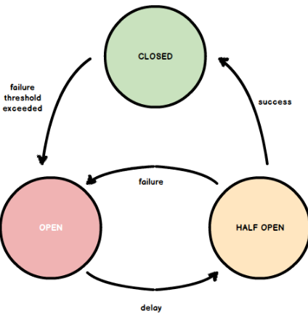
• Closed ✅
All requests are allowed. If the failure rate exceeds the threshold (e.g., 50%) based on the last N calls, the state transitions to Open.
• Open ❌
No requests are allowed. The Circuit Breaker waits for a configured cooldown period (waitDurationInOpenState). After that, it moves to Half-Open.
• Half-Open ⚠️
A limited number of test requests are allowed:
- If they succeed → the breaker closes (healthy again).
- If any fail → it goes back to Open.
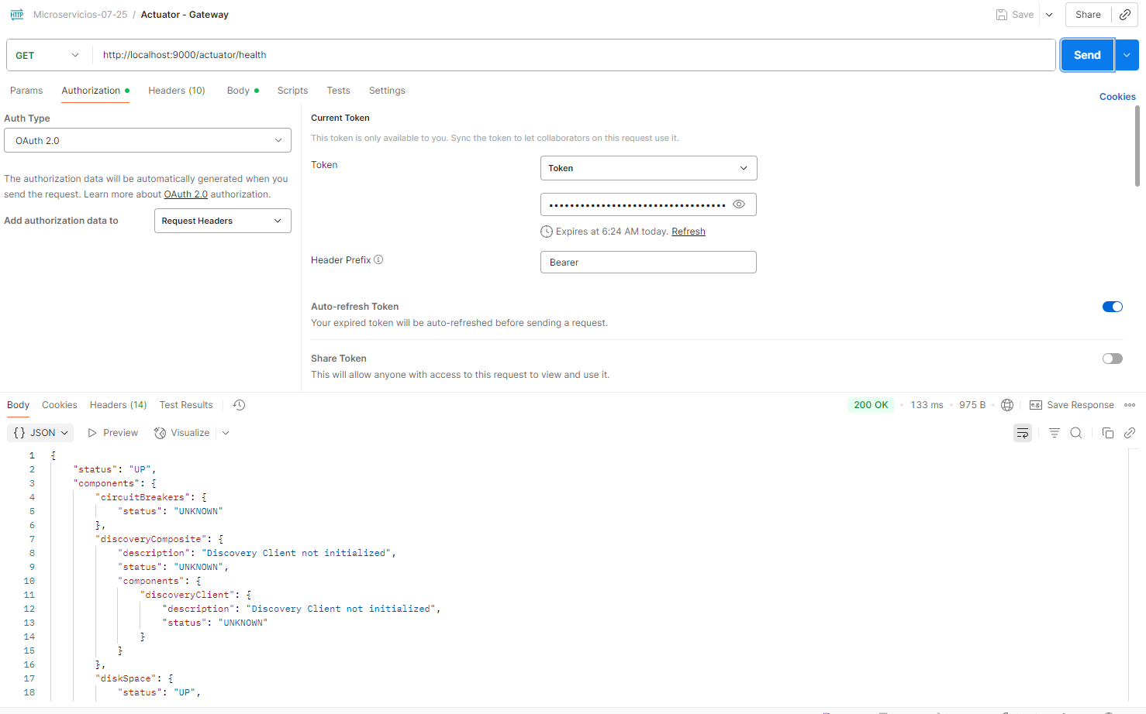
If we stop one of our services, and try to send a request, the circuit breaker will update its status to “UP”, and we will be able to see it through the actuator endpoint
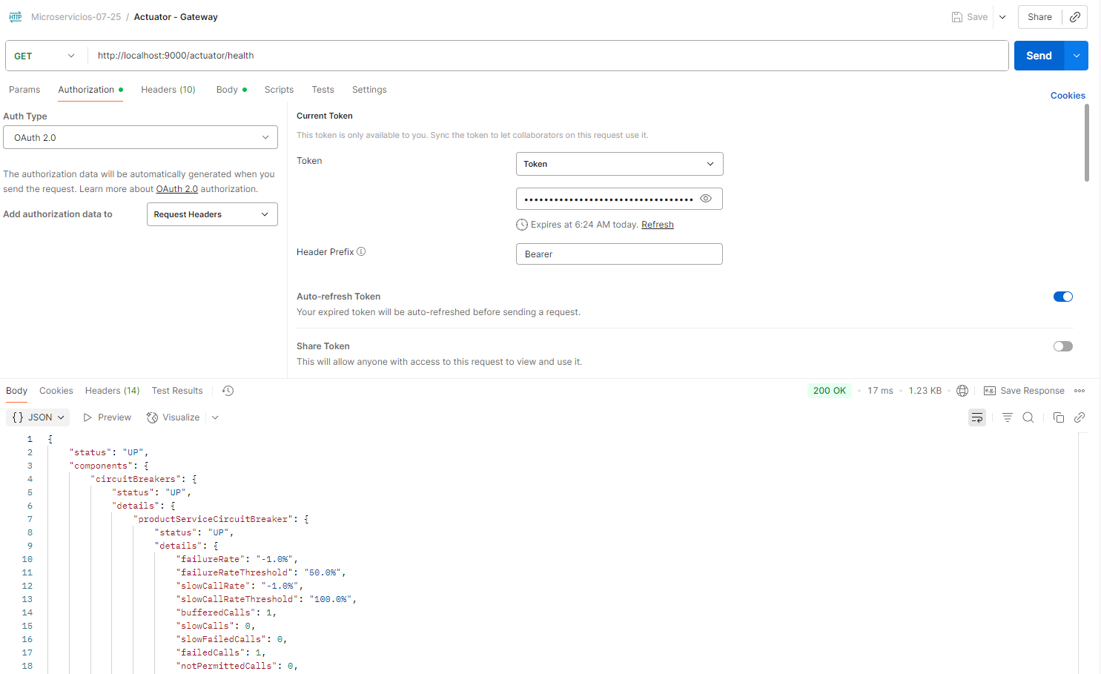
After enabling the actuator and the circuit breaker, we can monitor various metrics through the actuator endpoint, including the circuit breaker status.
Since we configured the circuit breaker to require a minimum of 5 failed requests before changing its status to OPEN, if we force 5 requests while the service is down and then access the actuator endpoint, we can verify that the status is now "OPEN".
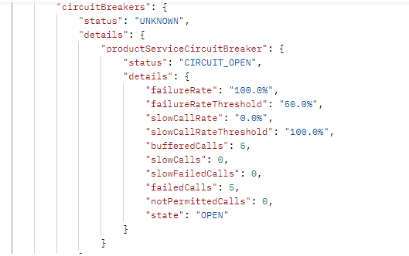
After the configured delay has passed, the status will be set to HALF_OPEN.
If 5 valid requests are sent during this period, the status will be updated to CLOSED (it will be updated on the fifth valid request).
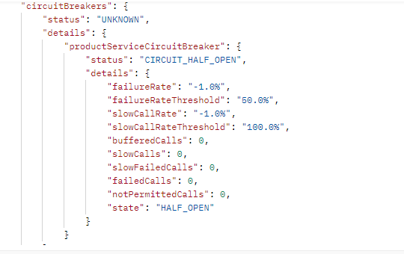

8 - KAFKA
Apache Kafka is an open-source, distributed event streaming platform used for building real-time data pipelines and applications.
It works like a high-performance messaging system where producers send messages (events) to topics, and consumers read those messages.
Kafka is designed for high throughput, scalability, and fault tolerance, making it ideal for microservices communication, log aggregation, and real-time analytics.
Go to localhost:8086 (dockerfile) to access to kafka ui dashboard and configure a new cluster.
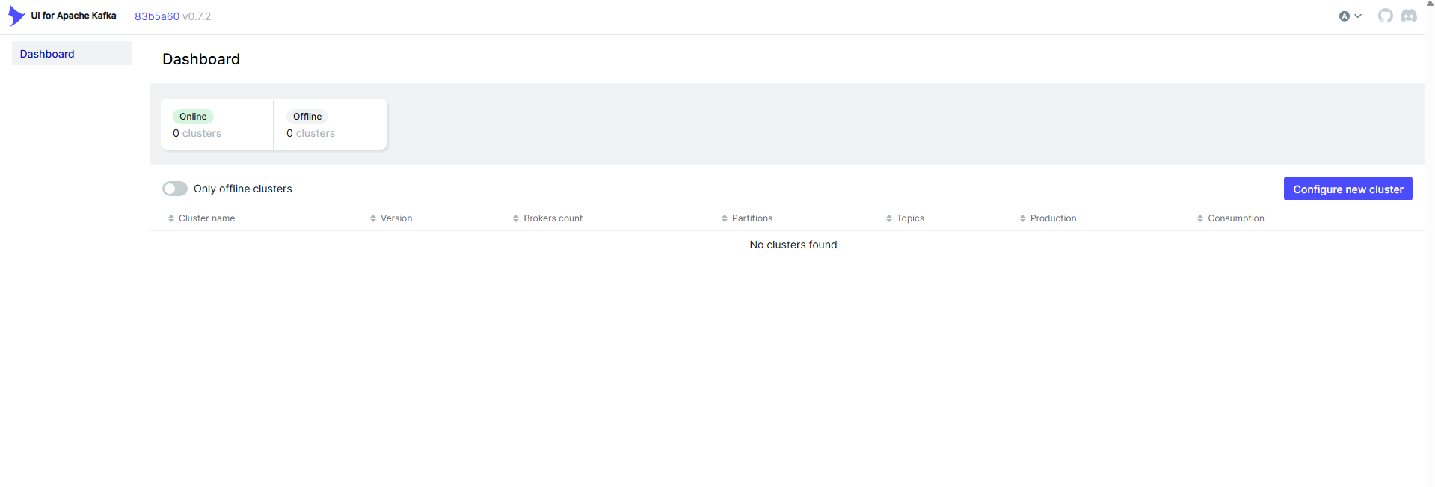
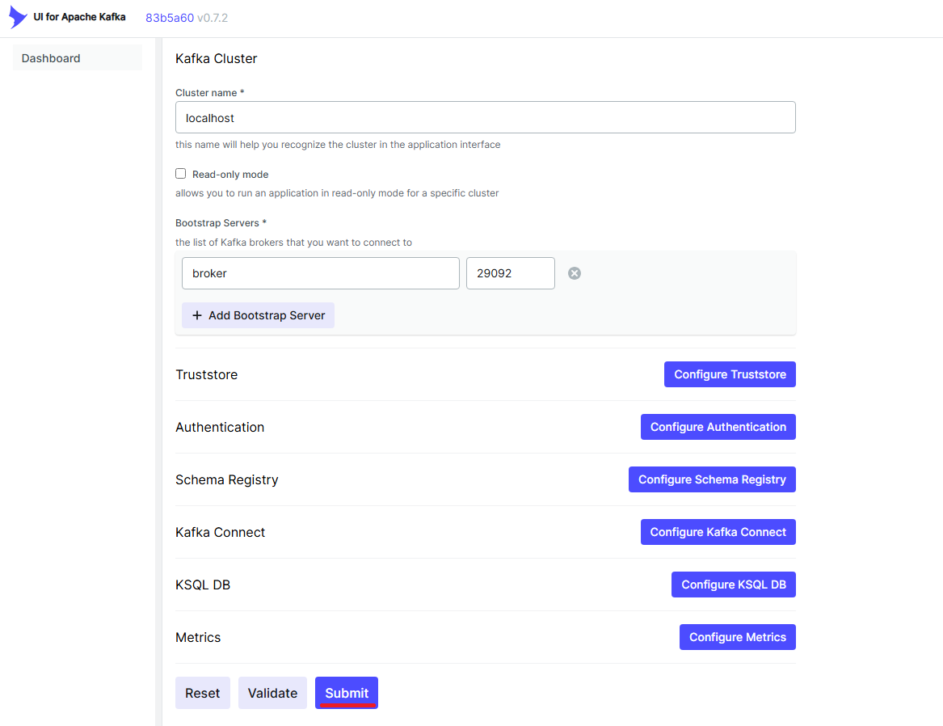
The cluster now appears in the dashboard, and we can access to “Topics”.
If we already made an order, we will see the order-placed topic created.
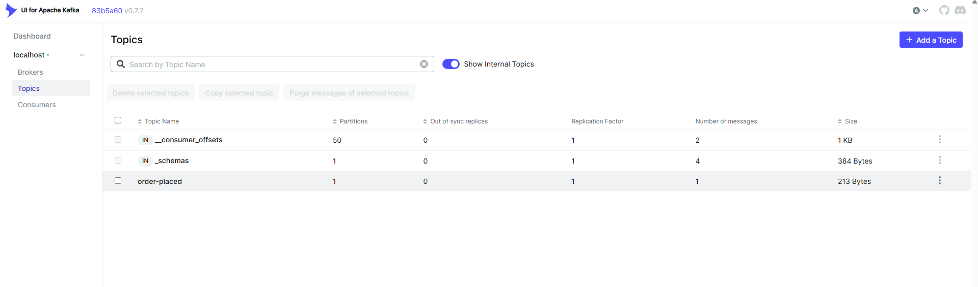
We can click on the Messages tab and check the message and its preview
