计算机体系结构第二次作业

PB17151767 焦培淇

1.a

从指令①到指令②存在对于寄存器R1的RAW相关。

从指令①到指令③存在对于寄存器R1的RAW相关。

从指令②到指令③存在对于寄存器R1的RAW相关。

从指令④到指令③存在对于寄存器R2的WAR相关。

从指令④到指令⑤存在对于寄存器R2的RAW相关。

从指令⑤到指令⑥存在对于寄存器R4的RAW相关。

1.b

指令时序如下：

|  |  |  |  |  |  |  |  |  |  |  |  |  |  |  |  |  |  |  |
| --- | --- | --- | --- | --- | --- | --- | --- | --- | --- | --- | --- | --- | --- | --- | --- | --- | --- | --- |
|  | 1 | 2 | 3 | 4 | 5 | 6 | 7 | 8 | 9 | 10 | 11 | 12 | 13 | 14 | 15 | 16 | 17 | 18 |
| 指令1 | IF | ID | EX | M | WB |  |  |  |  |  |  |  |  |  |  |  |  |  |
| 指令2 |  | IF | S | S | ID | EX | M | WB |  |  |  |  |  |  |  |  |  |  |
| 指令3 |  |  |  |  | IF | S | S | ID | EX | M | WB |  |  |  |  |  |  |  |
| 指令4 |  |  |  |  |  |  |  | IF | ID | EX | M | WB |  |  |  |  |  |  |
| 指令5 |  |  |  |  |  |  |  |  | IF | S | S | ID | EX | M | WB |  |  |  |
| 指令6 |  |  |  |  |  |  |  |  |  |  |  | IF | S | S | ID | EX | M | WB |
| 指令1 |  |  |  |  |  |  |  |  |  |  |  |  |  |  | IF | S | S | IF |

根据上表可知，总的时钟周期为17*99+1=1684个时钟周期。

1.c

指令时序如下：

|  |  |  |  |  |  |  |  |  |  |  |  |  |
| --- | --- | --- | --- | --- | --- | --- | --- | --- | --- | --- | --- | --- |
|  | 1 | 2 | 3 | 4 | 5 | 6 | 7 | 8 | 9 | 10 | 11 | 12 |
| 指令1 | IF | ID | EX | M | WB |  |  |  |  |  |  |  |
| 指令2 |  | IF | S | ID | EX | M | WB |  |  |  |  |  |
| 指令3 |  |  | S | IF | ID | EX | M | WB |  |  |  |  |
| 指令4 |  |  |  |  | IF | ID | EX | M | WB |  |  |  |
| 指令5 |  |  |  |  |  | IF | ID | EX | M | WB |  |  |
| 指令6 |  |  |  |  |  |  | IF | S | ID | EX | M | WB |
| 指令1 |  |  |  |  |  |  |  | S | IF | IF | ID | EX |

根据上表可知，总的执行时钟周期为9*99+3=894个时钟周期。

1.d

|  |  |  |  |  |  |  |  |  |  |  |  |  |
| --- | --- | --- | --- | --- | --- | --- | --- | --- | --- | --- | --- | --- |
|  | 1 | 2 | 3 | 4 | 5 | 6 | 7 | 8 | 9 | 10 | 11 | 12 |
| 指令1 | IF | ID | EX | M | WB |  |  |  |  |  |  |  |
| 指令2 |  | IF | S | ID | EX | M | WB |  |  |  |  |  |
| 指令3 |  |  | S | IF | ID | EX | M | WB |  |  |  |  |
| 指令4 |  |  |  |  | IF | ID | EX | M | WB |  |  |  |
| 指令5 |  |  |  |  |  | IF | ID | EX | M | WB |  |  |
| 指令6 |  |  |  |  |  |  | IF | S | ID | EX | M | WB |
| 指令1 |  |  |  |  |  |  |  |  | IF | ID | EX | M |

根据上表可知，总的执行时钟周期为8*99+4=796个时钟周期。

2.a

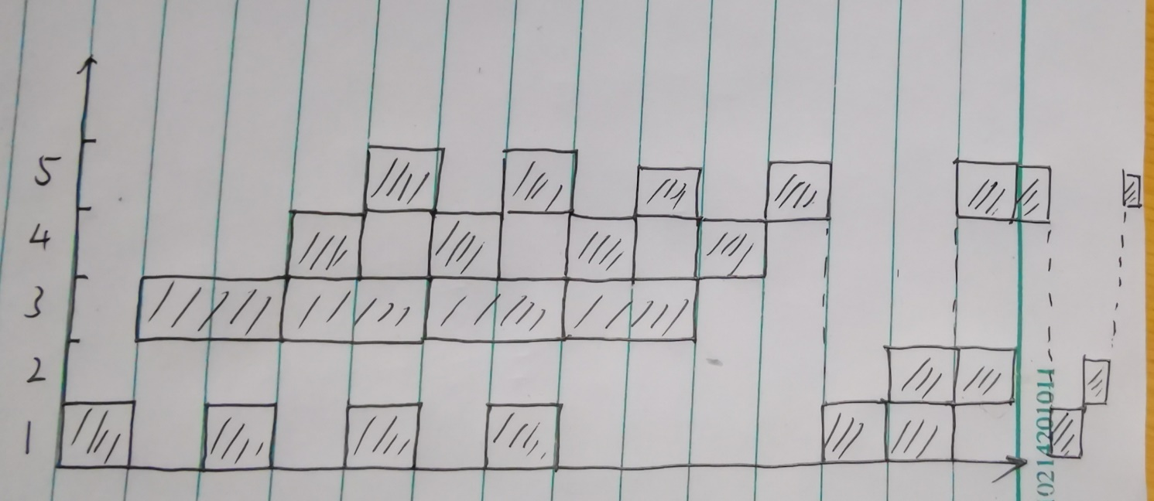

时空图如上所示。

根据时空图可以计算，

吞吐率为：(3+4)/(t*18)=7/(18t)；加速比为：(5*4+3*3)/18=1.61

效率为：29/(5*18)=32.22%

3.a

仅考虑数据相关，则5级流水线的机器CPI为6/5=1.2，而对于12级流水线，其CPI为11/8=1.375，考虑加速比：1.2/(1.375*0.6)=1.46。

3.b

对于5级流水线：CPI=1.2+2*0.2*0.05=1.22

对于12级流水线：CPI=1.375+5*0.2*0.05=1.425