[](http://www.tutorialspoint.com/index.htm)

Top of Form



Bottom of Form

* [Quizzes](http://www.tutorialspoint.com/questions_and_answers.htm)
* [Shared](http://www.tutorialspoint.com/shared-tutorials.php)
* [Articles](http://www.tutorialspoint.com/articles/index.php)

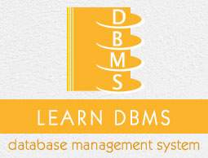

* DBMS Tutorial
* [DBMS - Home](http://www.tutorialspoint.com/dbms/index.htm)
* [DBMS - Overview](http://www.tutorialspoint.com/dbms/dbms_overview.htm)
* [DBMS - Architecture](http://www.tutorialspoint.com/dbms/dbms_architecture.htm)
* [DBMS - Data Models](http://www.tutorialspoint.com/dbms/dbms_data_models.htm)
* [DBMS - Data Schemas](http://www.tutorialspoint.com/dbms/dbms_data_schemas.htm)
* [DBMS - Data Independence](http://www.tutorialspoint.com/dbms/dbms_data_independence.htm)
* Entity Relationship Model
* [DBMS - ER Model Basic Concepts](http://www.tutorialspoint.com/dbms/er_model_basic_concepts.htm)
* [DBMS - ER Diagram Representation](http://www.tutorialspoint.com/dbms/er_diagram_representation.htm)
* [DBMS - Generalization, Aggregation](http://www.tutorialspoint.com/dbms/dbms_generalization_aggregation.htm)
* Relational Model
* [DBMS - Codd's Rules](http://www.tutorialspoint.com/dbms/dbms_codds_rules.htm)
* [DBMS - Relational Data Model](http://www.tutorialspoint.com/dbms/relational_data_model.htm)
* [DBMS - Relational Algebra](http://www.tutorialspoint.com/dbms/relational_algebra.htm)
* [DBMS - ER to Relational Model](http://www.tutorialspoint.com/dbms/er_model_to_relational_model.htm)
* [DBMS- SQL Overview](http://www.tutorialspoint.com/dbms/sql_overview.htm)
* Relational Database Design
* [DBMS - Database Normalization](http://www.tutorialspoint.com/dbms/database_normalization.htm)
* [DBMS - Database Joins](http://www.tutorialspoint.com/dbms/database_joins.htm)
* Storage and File Structure
* [DBMS - Storage System](http://www.tutorialspoint.com/dbms/dbms_storage_system.htm)
* [DBMS - File Structure](http://www.tutorialspoint.com/dbms/dbms_file_structure.htm)
* Indexing and Hashing
* [DBMS - Indexing](http://www.tutorialspoint.com/dbms/dbms_indexing.htm)
* [DBMS - Hashing](http://www.tutorialspoint.com/dbms/dbms_hashing.htm)
* Transaction And Concurrency
* [DBMS - Transaction](http://www.tutorialspoint.com/dbms/dbms_transaction.htm)
* [DBMS - Concurrency Control](http://www.tutorialspoint.com/dbms/dbms_concurrency_control.htm)
* [DBMS - Deadlock](http://www.tutorialspoint.com/dbms/dbms_deadlock.htm)
* Backup and Recovery
* [DBMS - Data Backup](http://www.tutorialspoint.com/dbms/dbms_data_backup.htm)
* [DBMS - Data Recovery](http://www.tutorialspoint.com/dbms/dbms_data_recovery.htm)
* DBMS Useful Resources
* [DBMS - Quick Guide](http://www.tutorialspoint.com/dbms/dbms_quick_guide.htm)
* [DBMS - Useful Resources](http://www.tutorialspoint.com/dbms/dbms_useful_resources.htm)
* [DBMS - Discussion](http://www.tutorialspoint.com/dbms/dbms_discussion.htm)
* Selected Reading
* [Developer's Best Practices](http://www.tutorialspoint.com/developers_best_practices/index.htm)
* [Questions and Answers](http://www.tutorialspoint.com/questions_and_answers.htm)
* [Effective Resume Writing](http://www.tutorialspoint.com/effective_resume_writing.htm)
* [HR Interview Questions](http://www.tutorialspoint.com/hr_interview_questions/index.htm)
* [Computer Glossary](http://www.tutorialspoint.com/computer_glossary.htm)
* [Who is Who](http://www.tutorialspoint.com/computer_whoiswho.htm)

ER Diagram Representation

Advertisements

[Previous Page](http://www.tutorialspoint.com/dbms/er_model_basic_concepts.htm)

[Next Page](http://www.tutorialspoint.com/dbms/dbms_generalization_aggregation.htm)

Let us now learn how the ER Model is represented by means of an ER diagram. Any object, for example, entities, attributes of an entity, relationship sets, and attributes of relationship sets, can be represented with the help of an ER diagram.

Entity

Entities are represented by means of rectangles. Rectangles are named with the entity set they represent.

Entities in a school database

Attributes

Attributes are the properties of entities. Attributes are represented by means of ellipses. Every ellipse represents one attribute and is directly connected to its entity (rectangle).

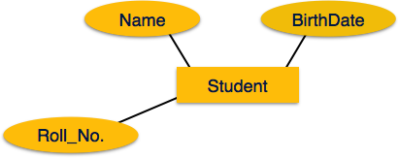

If the attributes are **composite**, they are further divided in a tree like structure. Every node is then connected to its attribute. That is, composite attributes are represented by ellipses that are connected with an ellipse.

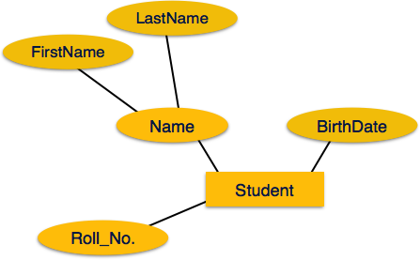

**Multivalued** attributes are depicted by double ellipse.

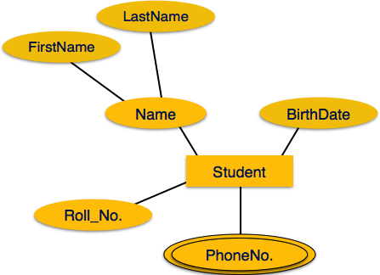

**Derived** attributes are depicted by dashed ellipse.

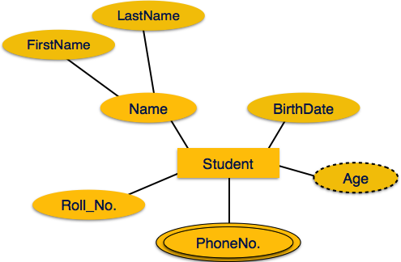

Relationship

Relationships are represented by diamond-shaped box. Name of the relationship is written inside the diamond-box. All the entities (rectangles) participating in a relationship, are connected to it by a line.

Binary Relationship and Cardinality

A relationship where two entities are participating is called a**binary relationship**. Cardinality is the number of instance of an entity from a relation that can be associated with the relation.

* **One-to-one** − When only one instance of an entity is associated with the relationship, it is marked as '1:1'. The following image reflects that only one instance of each entity should be associated with the relationship. It depicts one-to-one relationship.

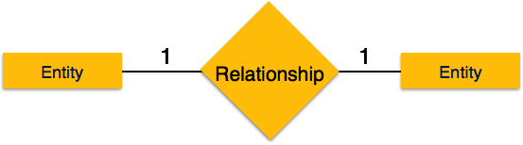

* **One-to-many** − When more than one instance of an entity is associated with a relationship, it is marked as '1:N'. The following image reflects that only one instance of entity on the left and more than one instance of an entity on the right can be associated with the relationship. It depicts one-to-many relationship.

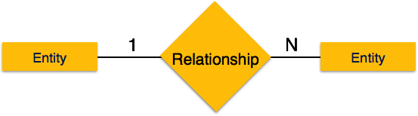

* **Many-to-one** − When more than one instance of entity is associated with the relationship, it is marked as 'N:1'. The following image reflects that more than one instance of an entity on the left and only one instance of an entity on the right can be associated with the relationship. It depicts many-to-one relationship.

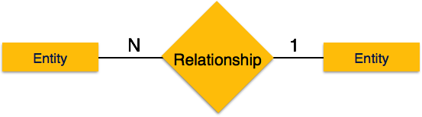

* **Many-to-many** − The following image reflects that more than one instance of an entity on the left and more than one instance of an entity on the right can be associated with the relationship. It depicts many-to-many relationship.

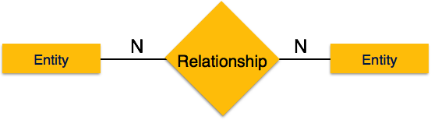

Participation Constraints

* **Total Participation** − Each entity is involved in the relationship. Total participation is represented by double lines.
* **Partial participation** − Not all entities are involved in the relationship. Partial participation is represented by single lines.

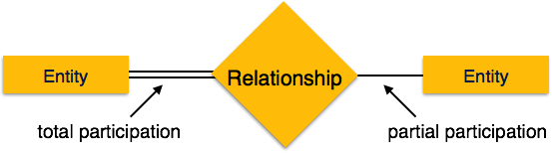

[Previous Page](http://www.tutorialspoint.com/dbms/er_model_basic_concepts.htm)

[Print](http://www.tutorialspoint.com/cgi-bin/printpage.cgi)

[PDF](http://www.tutorialspoint.com/dbms/pdf/er_diagram_representation.pdf)

[Next Page](http://www.tutorialspoint.com/dbms/dbms_generalization_aggregation.htm)

Advertisements

[[img](javascript:void(0)) [img](javascript:void(0)) [img](javascript:void(0)) [img](javascript:void(0)) [img](javascript:void(0)) img](javascript:void(0))

[](http://www.tutorialspoint.com/index.htm)

* [Write for us](http://www.tutorialspoint.com/about/tutorials_writing.htm)

* [FAQ's](http://www.tutorialspoint.com/about/faq.htm)

* [Helping](http://www.tutorialspoint.com/about/about_helping.htm)
* [Contact](http://www.tutorialspoint.com/about/contact_us.htm)

© Copyright 2015. All Rights Reserved.

 go