DUET: fast two-part hurdle testing for single-cell differential expression in Python
[AUTHOR ACTION: final author names, affiliations and corresponding author details required before submission.]

Abstract
Background. Two-part hurdle models jointly test detection and positive expression in single-cell RNA sequencing. A native Python implementation can simplify analysis within the scverse ecosystem, but computational speed must be distinguished from valid inference across donors.
Results. DUET (Detection–Expression Unified Test) implements a two-part hurdle analysis using NumPy and SciPy. On identical inputs, its detection statistics and coefficients agreed closely with MAST, while continuous-component statistics differed because of variance moderation. In five-run benchmarks without covariates, end-to-end CPU time was 39–257-fold lower than MAST's. Log-scale significance retained ranking information when conventional p-values underflowed. Across 100 muscat simulations at nominal BH 0.05, DUET had mean sensitivity 0.977 and mean observed false discovery rate 0.62. Thresholds calibrated on 50 replicates and evaluated on 50 separate replicates gave sensitivity 0.636 for DUET and 0.889 for DESeq2 pseudobulk, at mean observed false discovery rates of 0.061 and 0.049, respectively. DESeq2 also had higher sensitivity in each alternative simulation category at these calibrated thresholds. A pseudobulk-supported, direction-consistent DUET decision rule had sensitivity 0.677 with no false discoveries in these 100 simulations; empirical donor partitions nevertheless exposed residual errors. Pancreas comparisons were restricted to technical and descriptive evaluation because of data-source confounding and unresolved library-processing provenance.
Conclusions. DUET provides fast hurdle testing for two-group designs in Python and preserves numerical ranking information. Cell-level significance across donors was poorly calibrated. Sample-level testing is preferable for donor-level inference, subject to its design assumptions; DUET supplies complementary detection and expression summaries without establishing an advantage over pseudobulk at comparable error rates.
Keywords. single-cell RNA-seq; differential expression; hurdle model; MAST; pseudoreplication; false discovery rate; Python; scverse

Background
Differential expression (DE) testing in single-cell RNA-seq must contend with a distribution unlike that of bulk data: for most genes in most cells the observed count is zero, and the non-zero values form a roughly log-normal continuum. Whether those zeros represent a distinct biological or technical process has been debated: early methods modeled explicit dropout [1], whereas later analyses argued that droplet data are not zero-inflated beyond what a simple count model predicts [2]. The debate has not been fully resolved: a broad reassessment recasts the disagreement as one of definitions as much as biology [3], and analyses of unique-molecular-identifier data attribute most apparent dropout events to ordinary sampling variation within a homogeneous cell population rather than to excess zero inflation [4]. Regardless of this debate, the frequency of detection can carry biological information. For example, a gene detected in 5% of control cells and 98% of stimulated cells has changed in a way that a comparison based only on mean expression may capture poorly.
MAST [5] addresses this with a two-part hurdle model. A logistic component models whether the gene is detected in a cell; a Gaussian component models its level among cells in which it is detected. Each component is fitted with and without the condition term, and the two likelihood-ratio statistics are summed and evaluated against a χ² distribution with the summed degrees of freedom. The result is a single test that responds to shifts in both mean expression and detection rate. MAST remains widely used and is a default cell-level method in several pipelines. Comparative studies of single-cell DE tools have repeatedly ranked hurdle- and count-based cell-level methods among the stronger performers on per-cell criteria [6], [7], [8], even as attention has more recently shifted to how these methods behave across multiple samples and batches [9]. A systematic assessment of hurdle and zero-inflated formulations places the hurdle (MAST) model among the better-behaved members of this family [10].
Two practical issues arise when using MAST in a Python-based workflow. As an R package, MAST requires an R environment alongside the scverse stack [11], and the expression matrix has to be handed from Python to R. MAST accepts sparse input through a SingleCellExperiment, so any memory cost of such a workflow must be attributed to specific steps by measurement rather than assumed.
A third problem is numerical. At large cell counts, the summed hurdle statistic grows large enough that the corresponding p-value becomes smaller than the tested survival-function implementation can report as a non-zero double-precision value. The reported p is then stored as zero. That column cannot order genes once several values have underflowed. The same numerical floor was observed in the tested versions of MAST, diffxpy [12] and Scanpy's [13] Wilcoxon output. Its effect on a ranking depends on whether the package ranks genes by p-value or by a retained test statistic.
The numerical cause and the log-scale remedy are well established; genome-wide association studies have long reported significance on a −log10 scale. Single-cell software output has also reported zero p-values. However, to our knowledge, no previous study has quantified the practical effect on p-value-based gene rankings in single-cell DE software. We therefore measured the proportion of affected genes at realistic cell counts, the statistic each package retains, and the resulting changes in top-gene lists.
A separate statistical limitation concerns pseudoreplication. Squair et al. [14] and Zimmerman et al. [15] showed that cell-level DE tests treat cells as independent observations even though cells from the same donor are correlated through shared genotype, processing, and batch effects. In multi-donor studies, replication therefore occurs at the donor level. Squair et al. support pseudobulk aggregation, whereas Zimmerman et al. advocate mixed models that account for within-donor dependence. Subsequent benchmarks have largely endorsed this position: pseudobulk aggregation outperforms mixed-model and naive cell-level approaches on balanced measures that weigh both error types [16] and across multi-subject differential-state comparisons [17]. More recent work has proposed single-cell-specific approaches, including generalized linear mixed models with donor random effects (GLIMES), to address excess zeros, normalization, and donor effects [18]. Nevertheless, cell-level hurdle testing remains common, partly because sample-level aggregation does not model detection frequency as a separate component. A quantitative comparison is therefore needed to distinguish ranking performance from valid significance testing across donors.
We present DUET (Detection–Expression Unified Test), a pure-Python implementation that addresses computational integration and numerical reporting. We evaluate its agreement with MAST component by component, its computational cost in a matched benchmark, and its calibration under null experiments and replicated multi-donor simulations, including a comparison with donor-aware mixed models.

Implementation

Model
DUET implements the two-part model used by MAST. For a single gene within one cell type, let y be the expression vector across cells. A logistic regression models the detection indicator 1[y > 0], and a Gaussian linear model fits only the non-zero values. Without moderation, the component likelihood-ratio statistics compare a full design with a reduced design lacking the condition term. With empirical-Bayes moderation enabled, DUET instead converts the continuous-component two-sided moderated-t p-value to a χ²₁ statistic and adds it to the detection likelihood-ratio statistic. The sum is evaluated against χ² with the sum of the component degrees of freedom (two when both components are present). Thus the moderated continuous contribution is not a literal Gaussian likelihood-ratio statistic. The cellular detection rate—the number of genes detected per cell, termed cngeneson by MAST—is available as a nuisance covariate. The continuous component is moderated using limma-style empirical Bayes [19], which stabilizes the variance estimate for genes detected in few cells; MAST uses its own empirical-Bayes prior, so this component is not numerically identical between the two implementations (see Results). We control multiple testing using the Benjamini–Hochberg procedure [20]. The continuous component operates on log-normalized expression and therefore depends on the chosen normalization and variance-stabilizing transformation [21], [22].

Performance
Three design choices account for the performance reported below.
DUET operates on the in-memory AnnData object [23], so no expression matrix is exported for another runtime.
DUET streams one sparse gene column at a time and writes results in chunks, limiting memory growth as the number of genes increases.
For the two-group design without covariates, DUET takes a vectorized path in which both components have closed-form solutions: the logistic likelihood ratio reduces to a contingency-table statistic on detection counts, and the Gaussian component to a moderated t-test on the positive values. No iterative fitting is required, and all genes are processed using vectorized array operations. When covariates are present, DUET fits each gene iteratively with a compact iteratively reweighted least-squares (IRLS) routine; this path is substantially slower than the vectorized one (see Results).

Log-scale significance
The numerical problem described in Background is worth setting out precisely, because its remedy is the least obvious part of the implementation.
In SciPy 1.14.0, scipy.stats.chi2.sf(1440, 2) returns 0.0 although exp(−720), the exact two-degree-of-freedom survival probability, is approximately 2.03 × 10⁻³¹³ and remains representable in float64. This is algorithmic underflow in the tested survival-function implementation, before the smallest positive subnormal double is reached. The statistic can continue to increase after its reported p-value becomes zero.
DUET therefore reports neglog10p, computed without forming the final combined float64 p-value. It evaluates chi2.logsf where SciPy can still return a finite value and otherwise substitutes the asymptotic expansion of the χ² upper tail,
log sf(x; k) → −x/2 + (k/2 − 1)·log(x/2) − lgamma(k/2),
which is exact for k = 2, the standard hurdle case. Against chi2.logsf the maximum absolute error is 0.0 everywhere SciPy can still compute a value, so the column is continuous across the switch-over.
The empirical-Bayes step raises a second instance of the same problem. The moderated t statistic of the continuous component is converted to a χ²₁ statistic through its two-sided p-value, and scipy.stats.t.sf underflows for large |t|. DUET evaluates this tail in log space: the two-sided Student's t tail is written as a regularized incomplete beta function, whose logarithm is computed with a continued fraction, and scipy.special.ndtri_exp converts the log p-value to the χ²₁ statistic without forming the underflowing p-value. Where the p-value is at least 1 × 10⁻³⁰⁰, the result is bit-identical to the previous computation. Against a high-precision mpmath reference, over degrees of freedom from 3 to 10⁶ and down to log10 p = −323,380, the largest relative error was 4.7 × 10⁻¹³ for log p and 1.3 × 10⁻¹² for the χ² statistic.
DUET retains the original pvalue column, including underflowed zeros, for compatibility with MAST-based downstream code. Genes should instead be ranked using neglog10p. The statistical test is unchanged; only its reporting is extended.

Calling genes: the sample-level arm
The results below show that cell-level hurdle significance is poorly calibrated across donors. DUET therefore also provides a sample-level analysis through run_duet_pseudobulk. Raw integer counts are summed per cell type, donor and condition; in paired designs, aggregation by donor alone would merge the conditions and remove the contrast. The negative-binomial test on the aggregated counts is performed by PyDESeq2 [24], with ~donor + condition when the caller explicitly sets paired=True for a paired design, and ~condition with paired=False (the API default). The present Kang analysis used the paired design; pairing is not detected automatically. Samples are sorted before fitting, because we found that PyDESeq2's paired fit depends on sample order. The function returns one row per gene with the hurdle statistic, the pseudobulk result and a call. The decision rule was fixed before the evaluations reported here: a gene is significant when the pseudobulk BH-adjusted p-value is below 0.05 and the pseudobulk log2 fold change has the same sign as the DUET coefficient; direction_conflict when the pseudobulk test is significant but the signs differ; and ranked_only when it is not significant but the cell-level DUET adjusted p-value is below 0.05. ranked_only is a label for exploratory ranking and is never counted as a discovery. No rank threshold is used.

Results and discussion

Datasets
We analyzed three empirical datasets. The first was an integrated human pancreas dataset assembled from PDAC samples of GEO series GSE154778, GSE205013, GSE212966, GSE214295 and GSE242230 and from non-tumor HPAP donors HPAP-077, HPAP-092, HPAP-099, HPAP-101 and HPAP-104 [25–28]. It had previously been processed with the SCRAP pipeline; the HPAP input collection was the same as that used here. The 16 non-tumor files represented repeated sequencing runs of five donor libraries: 59.6% of 63,631 non-tumor rows repeated donor–barcode combinations corresponding to 25,731 cells. The stored counts layer duplicated the log-normalized matrix. Integer per-row counts were reconstructed by reversing the recorded normalization and rounding (maximum rounding residual 0.006), with recorded row totals and detected-gene counts reproduced. The subsequent preparation summed rows sharing a donor and barcode, yielding 191,362 cells. This check validates reconstruction of stored per-row counts, not unique-molecule counts across sequencing runs: overlapping UMIs from resequencing the same library require joint molecular deduplication, which cannot be verified from these matrices. Pancreas results are therefore technical agreement, runtime and descriptive sensitivity analyses of this fixed input, not independent biological validation. All tumor samples originate from GEO series and all non-tumor samples from HPAP, completely confounding condition with data source (Additional file 2: Table S12).
The pancreas object was generated in an earlier SCRAP analysis. Its exact historical pipeline revision and run configuration have not been independently recovered; current pipeline defaults cannot establish the settings of that run. The normalized expression, cell-type annotations and reconstructed count matrices used for the present technical comparisons are fixed archived inputs. The correction script and donor–library mapping document subsequent preparation. Differential-expression models use expression matrices and cell-type labels, not the scVI latent representation. A reproducible biological pancreas analysis would additionally require the historical preprocessing records and evidence that repeated sequencing runs were jointly deduplicated. No new alignment, integration or molecular deduplication was undertaken for this revision.
The second dataset comprised PBMCs from eight donors under control and IFN-β-stimulated conditions, with every donor measured in both conditions, as reported by Kang et al. [29]. The third comprised mouse cortex from four LPS-treated and four control animals, as reported by Crowell et al. [30]. Cell-level testing was performed within each cell type, so the analyzed populations contained 1,740–16,622 cells rather than the complete datasets.

Agreement with R MAST
We compared R MAST 1.33.0 and DUET using the same cells, genes, and design (~1 + condition). Across the 9 empirical cell-type comparisons and one simulation, the Pearson correlation for log2 fold change was 1.000, sign agreement was 99.97–100%, the Spearman correlation for −log10 p was 0.997–1.000, and the significant-gene Jaccard index was 0.85–1.00 (Table 1). On the nine benchmark inputs described below, which include up to 17,093 cells, the significant-gene Jaccard index was 0.999–1.000 (Fig. 1f).
High correlation does not show that the two implementations perform the same test, so we also compared them component by component on Kang CD14+ monocytes, Crowell astrocytes and pancreas ductal cells, with MAST run as bayesglm with empirical Bayes (its default), glm with empirical Bayes, and glm without it. A relative difference of at most 1 × 10⁻³ was fixed in advance as numerical agreement (Additional file 2: Table S1). Against MAST's glm fit, the detection likelihood-ratio statistic agreed to within 2 × 10⁻⁵ in absolute terms for every gene, the continuous coefficient to a relative difference of 2 × 10⁻⁴, and the log fold change to 1.5 × 10⁻⁴. With MAST's default bayesglm, 93.7–99.8% of detection statistics were within tolerance, and MAST's prior shrank its coefficients and log fold changes. The continuous test statistic differed in every setting: the median relative difference was 1.0–17.4% (maximum 35%) against MAST with empirical Bayes and 0.08–1.71% (maximum 21%) against MAST without it. This reflects the different variance-moderation procedures described in Implementation. The significant-gene Jaccard index across the three settings was 0.86–1.00. The two implementations therefore agree in the detection component and in the coefficients but not exactly in the moderated continuous statistic.
Because all comparisons above omitted covariates, they evaluated only the vectorized path. We validated the general per-gene path separately on Kang CD14+ monocytes by fitting ~1 + CDR + condition in DUET and ~1 + cngeneson + condition in MAST on the same cells and detection rates. The Pearson correlation for log2 fold change was 0.9994, sign agreement was 98.9%, the Spearman correlation for −log10 p was 0.9998, and the significant-gene Jaccard index was 0.9985. This validation was run before the log-space t tail was introduced, which changes results only for genes whose moderated p-value was below 1 × 10⁻³⁰⁰.
During that validation we replaced statsmodels GLM fitting with DUET's compact IRLS routine; across three datasets the two agreed on all 80,947 gene-by-cell-type tests (significant-call Jaccard index, 1.000000; largest statistic difference, 2.0 × 10⁻⁶), and IRLS is now the default. The comparison also revealed an error in how we identified separation. When a gene is detected in exactly 0% or 100% of one condition group, the condition coefficient has no finite maximum-likelihood estimate. Classifying separation from coefficient magnitude therefore depended on where each solver stopped iterating, and this classification determined whether a gene received a covariate-adjusted likelihood-ratio test or a contingency-table fallback that ignored covariates. Three genes in a 100-cell population fell on different sides of the threshold in the two solvers. DUET now identifies separation from the detection margins and retains the adjusted test; a detection_separated field marks affected genes so that unstable fold-change estimates can be identified.
MAST's logFC and DUET's corresponding coefficient use differences of group means on the log1p scale, expressed here in log2 units. These differ from coefficients of negative-binomial count models and from ratios based on back-transformed log means. Over 22,077 gene-by-cell-type combinations tested by all five methods in the pancreas input, median absolute effects were 0.14 for DUET and 0.14 for MAST, compared with 0.67 for DESeq2, 0.78 for diffxpy and 0.78 for the Wilcoxon output; DUET–Wilcoxon rank correlation was 0.95. These are empirical scale differences, not a general consequence of Jensen's inequality for between-group contrasts. For TRAPPC5, detected in 2.1% of non-tumor and 50.7% of tumor ductal cells, the default coefficient was +0.90 and the back-transformed-log-mean ratio was +6.34. DUET's linear_logfc option computes log2[(expm1(mean log1p expression in test) + ε)/(expm1(mean log1p expression in reference) + ε)], with ε = 10⁻⁹. This is not the log ratio of arithmetic mean CP10k values. Effect thresholds are not interchangeable among these estimands.

Computational performance
We benchmarked DUET and MAST on identical inputs. Each input was written once to a single file from which both engines read the same cells, genes, gene order and design. After one warm-up, each engine was run five times in a fresh process, alternating between the engines, single-threaded and pinned to the same processor cores. We recorded the CPU time and elapsed time of every stage (reading, export and R import for MAST, model fit, likelihood-ratio test and writing) and the resident memory of the whole process tree, sampled every 20 ms, together with the operating system's peak working set; the sampled and operating-system peaks differed by less than 9% in every run. MAST 1.33.0 was run with its default settings (bayesglm, ebayes = TRUE) on a dense matrix. The benchmark machine (Intel Core i9-14900K, Windows 11) was in use by other work during the measurements, with a median background CPU load of 9–31% per run. We therefore report CPU time as the primary timing; for these single-threaded runs the median elapsed time differed from the median CPU time by −2% to +4% for MAST and by at most 15% for DUET's runs of a few seconds. The interquartile range of MAST's five runs was below 5% of the median at 20 of 23 benchmark points (maximum 13%).
On the pancreas series (ductal cells subsampled to 1,000–8,020 cells, and three cell types pooled to 17,093 cells at approximately 8,500 genes), DUET's end-to-end CPU time was 1.6–2.5 s and MAST's 61–650 s, a ratio of 39–257-fold (Table 2; Fig. 1e and Fig. 2a). The ratio increases with population size mainly because DUET's time is dominated by a fixed start-up cost of about 1.5 s. Restricted to the model fit and test (DUET's fit-and-test stage against MAST's zlm plus lrTest), the elapsed-time ratio was 787–888-fold on every input, and the CPU-time ratio was 878–884-fold on the two inputs where DUET's compute time was long enough to measure reliably. The zlm and lrTest steps accounted for 84–98% of MAST's CPU time, and data export and R import for 3–4% (Fig. 2b; Additional file 2: Table S2), so the difference lies in the model fit and the test rather than in data transfer. Peak resident memory was 264–1,313 MiB for DUET and 1,356–8,084 MiB for MAST.
To attribute MAST's memory use, we ran MAST on the 8,020 ductal cells with dense or sparse input and with empirical Bayes on or off (three runs each; Fig. 2c; Additional file 2: Table S3). MAST 1.33.0's FromMatrix() does not accept a sparse matrix, so sparse input was passed through a SingleCellExperiment. The largest sampled memory values occurred during model fitting and testing; the peak stage differed by setting. For dense input without empirical Bayes, median sampled memory during lrTest was 3,202 MiB versus 3,156 MiB during zlm. Enabling empirical Bayes raised it from 3,156 to 4,609 MiB with dense input and from 2,355 to 6,192 MiB with sparse input. Sparse input lowered the peak only without empirical Bayes; with MAST's default settings it raised the peak and increased CPU time from 364 to 530 s. Densifying the matrix before building the SingleCellAssay increased R's heap by about 0.3 GiB at that step. MAST's memory use in this workflow is therefore driven mainly by the model fit and its empirical-Bayes step, not by the dense hand-off.
Because pooling cell types changes both size and composition, we also varied one data property at a time on simulated counts (Fig. 3 and Fig. 2d; Additional file 2: Table S4): the number of cells from 1,000 to 50,000 at 8,000 genes; the number of genes from 2,000 to 20,000 at 10,000 cells; and the zero fraction from 0.61 to 0.93 at 10,000 cells and 8,000 genes, changed by simulation rather than by deleting values. Compute time grew approximately linearly with cells (log–log slope 0.86 for DUET and 0.89 for MAST) and with genes (1.09 and 1.07), so the difference between the engines was a roughly constant factor rather than a difference in scaling; where DUET's compute time was long enough to measure, the CPU-time ratio was 530–1,082-fold. At 50,000 cells, MAST required 1,408 s and 20,170 MiB against 3.2 s and 2,470 MiB for DUET. A higher zero fraction reduced DUET's compute time and memory (1,146 to 362 MiB), whereas MAST's CPU time (335–386 s) and memory (4,451–4,670 MiB) changed little. Three nominally identical grid points measured independently gave 324–335 s for MAST.
The vectorized path does not apply when covariates are included. The archived CDR timing runs used different DUET settings from the main benchmark: the covariate branch omitted explicit empirical-Bayes moderation and used different positive-cell and partial-hurdle gates. These historical timings are preserved in Additional file 2: Table S5 for transparency, but cannot establish a matched-model DUET–MAST speed ratio. The independent covariate agreement analysis above used explicit matched settings. A corrected timing driver is supplied for a future matched rerun; no such rerun was performed for this revision.

Log-scale significance and gene rankings
We checked each package separately for underflow, for the statistic it retains, and for the order in which it reports genes (Additional file 2: Table S7). In Kang CD14+ monocytes (1,954 genes) and pancreas ductal cells (9,772 genes), the p-value was stored as zero for 4.6 and 6.4% of genes with DUET, 4.5 and 5.9% with MAST, 3.3 and 2.2% with Scanpy and 49 and 83% with diffxpy. DUET retains neglog10p and MAST retains the lrTest statistic, both finite wherever p = 0; Scanpy retains a z-score, and diffxpy's retained Wald statistic was infinite for some pancreas genes. DUET, MAST and diffxpy report genes in input order, whereas Scanpy orders them by the signed score, which is a directional rather than a two-sided significance ranking. When genes were ranked by p-value, with ties left in input order, the top-20 lists obtained from different input gene orders shared a Jaccard index of only 0.00–0.08 for DUET, MAST and diffxpy, and a p-value-ranked top-100 list shared 12–17 genes with the statistic-ranked list for DUET on pancreas ductal cells. Ranking by DUET's neglog10p or MAST's lrTest statistic gave identical top-20 and top-100 lists for every input order. Rerunning MAST with permuted gene order gave identical results for every gene. The loss of ranking information therefore depends on how a package ranks genes and on whether the user sorts by p-value, not on the implementation alone.
Before the log-space t tail was introduced, the continuous component could not exceed chi2.isf(1 × 10⁻³⁰⁰, 1) = 1373.87. In the corrected pancreas ductal population, 110 of 45,486 tested genes (0.24%) sat at this cap; all now receive distinct values (maximum 7,816), no significance call changed, and 84 of the previous top-100 genes remained in the top 100 (Additional file 2: Table S8).

Accuracy against ground truth
Using the Crowell dataset as the simulation reference [30], we generated data with muscat so that between-sample variance reflected an empirical experiment. We generated 100 independent replicates with recorded seeds, each containing 4,000 genes, 24,000 cells, four samples per group and approximately 400 truly differential genes. The truth was fixed from the muscat simulation categories before scoring. The de (mean shift), dp (differential proportion), dm (differential modality) and db (both) categories were treated as alternatives. The ee category and the ep category were treated as nulls: in muscat's simulation code, ep genes receive the same mixture of expression levels in both groups, so their distribution does not differ between groups. The label “same mean, diff. prop” used for ep in an earlier version of this analysis was therefore incorrect. Consistent with this, DUET called 45.7% of ep genes and 42.7% of ee genes significant. Nominal-threshold summaries use all 100 replicates; calibrated-threshold evaluation uses replicates 51–100, and genes absent from a method's output were recorded with the reason.
DUET, MAST, the Wilcoxon test, diffxpy, DESeq2 pseudobulk [24], [31] and DUET's two-stage rule were run on every replicate (Table 3, Fig. 4a–c). The methods differ in the unit of inference, the test statistic and the set of genes over which the BH correction is applied (Additional file 2: Table S6). In the simulation these BH denominators were matched (3,983–4,000 genes), whereas on pancreas ductal cells they ranged from 8,000 genes for diffxpy to 59,537 for the Wilcoxon test, so percentages of significant genes on real data are not comparable across methods without a common gene universe. DUET and MAST had nearly identical discrimination (ROC-AUC 0.960 ± 0.049 and 0.960 ± 0.049) and sensitivity (0.977 and 0.977) at a nominal BH level of 0.05. DESeq2 pseudobulk had a higher and more stable ROC-AUC (0.983 ± 0.013) and PR-AUC (0.956 ± 0.024 against 0.916 ± 0.101) but lower sensitivity at the nominal threshold (0.677).
Sensitivity at a nominal threshold is not comparable between methods that operate at different actual error rates. We therefore calibrated, for each method, the score threshold that gave a mean observed FDR of 5% on replicates 1–50 and evaluated it on replicates 51–100. At that threshold, the observed FDR was 0.049–0.061 on average, and sensitivity was 0.889 for DESeq2, 0.882 for diffxpy, 0.667 for the Wilcoxon test, 0.636 for DUET and 0.635 for MAST (Table 3). DUET's higher sensitivity at the nominal threshold therefore reflected its higher false discovery rate. Even at the calibrated threshold, DUET's observed FDR reached 0.82 in one evaluation replicate, so no fixed threshold made cell-level calls reliable.
At nominal BH 0.05, sensitivity differed by category (Table 4, Fig. 4c), including 94.8% for DUET versus 18.0% for DESeq2 in db. These values accompany substantially different error rates. Re-evaluating the saved outputs on replicates 51–100 using the separately calibrated thresholds gave db sensitivity 31.9% for DUET (95% bootstrap CI 27.6–36.4%) versus 65.0% for DESeq2 (60.8–69.2%). DESeq2 was also more sensitive for de, dp and dm. These analyses do not establish a detection- or shape-category advantage for DUET at comparable error rates. Additional file 2: Table S14 reports every category and Table S15 reports uncertainty for the aggregate calibrated comparisons. Confidence intervals resample complete evaluation replicates (2,000 bootstrap draws, seed 0); evaluation error rates are similar, not constrained to be identical.

The two-stage decision rule
The full decision rule described in Implementation was applied to every replicate. The significant set had a sensitivity of 0.677 and an observed FDR of 0.000 in all 100 replicates; on average 0.1 genes per replicate were labeled direction_conflict and 1,662 ranked_only. Because the rule requires pseudobulk significance, its sensitivity is bounded by that of the pseudobulk test (0.677); the hurdle statistic contributes the ranking and the ranked_only label, not additional discoveries.

Calibration and its limits
At a nominal BH level of 0.05, DUET's observed false discovery rate averaged 0.62 across the 100 replicates but ranged from 0.023 to 0.906; it was at or below 0.10 in 7 of 100 replicates. MAST tracked DUET closely, the Wilcoxon test averaged 0.12 (at or below 0.10 in 65 replicates), and DESeq2 pseudobulk had no false discoveries in any replicate (Fig. 4b). All replicates were generated with the same procedure and parameters, so a single simulation could have led to either a reassuring or an alarming conclusion about calibration.
Several analyses indicate that the excess false discoveries stem from the assumption of independent cells rather than from the test statistic or the multiple-testing correction.
First, under a label-permutation null in the Kang and Crowell datasets, condition labels were permuted across all cells of each cell type, rather than within donors. This removes the original alignment of labels with donor structure. DUET's type I error at α = 0.05 was 0.034–0.059 in all six cell types, and no gene reached an adjusted p-value below 0.05. One permutation was evaluated per cell type. This limited diagnostic does not establish calibration for donor-level contrasts.
Second, restricted to the genes muscat labels as nulls, the p-values themselves were not uniform (Table 5). DUET rejected 0.495 of null genes at raw p < 0.05 on average (range 0.046–0.990), with a median null p-value of 0.153; MAST gave 0.491, diffxpy 0.072, the Wilcoxon test 0.035 and DESeq2 pseudobulk 0.0002. The BH denominators were within 1% of one another (3,983–4,000 genes), so the difference between methods lies in the p-values and not in the correction. DESeq2 was conservative rather than exact, with a median null p-value of 0.829. Within replicates, DUET's false-positive rate among null genes rose from 0.32 in the lowest to 0.53 in the highest quartile of the per-gene design effect.
Third, the replicate-to-replicate variation followed the chance alignment of donors with the condition label. The realized cell-level offset between the two arms on null genes correlated with the observed type I error at Spearman ρ = 0.61 for DUET, 0.89 for the Wilcoxon test and −0.19 for DESeq2 (n = 100). The offsets were small: the mean absolute donor-level t statistic on null genes was 0.20–0.75 across replicates, below the value of 0.919 expected for the absolute value of a t-distributed variable with six degrees of freedom, but the same offset evaluated over 24,000 cells produced large cell-level statistics.
Fourth, we simulated donor and batch structure directly with a parametric negative-binomial simulator that used gene means and dispersions from the Crowell reference and a donor effect with standard deviation σ_d = 0.136 estimated from the same data (four versus four donors, 3,000 cells per donor, 20 replicates, global null; Additional file 2: Table S10). Without donor or batch effects, all methods rejected at most 0.025% of genes. With a donor effect independent of the condition, DUET rejected 36.2% of genes on average (raw type I error 0.45), the Wilcoxon test 15.3% and pseudobulk 0.016%. When the processing batch coincided with the condition, all methods, including pseudobulk (9.5%), reported differences, and the estimated log2 fold changes correlated with the simulated batch shift (r = 0.64–0.79); in this design the batch and condition effects cannot be separated, and no method can recover a condition effect.

Donor-swap global null
We also analyzed the real data under a donor-swap global null, in which donors from the reference condition were assigned to two artificial groups with no intended difference, keeping all cells of a donor together. Every unique balanced partition was evaluated once, counting mirror-image partitions once: 35 four-versus-four partitions per cell type for Kang, three two-versus-two partitions for Crowell, and 15 two-versus-two partitions for pancreas, leaving one of the five reference donors out (three for stellate cells, because one donor had fewer than ten such cells). Because no group difference was intended, every rejection is a false positive; we report the proportion of genes rejected, not an FDR, together with the number of discoveries per partition and the share of partitions with at least one BH-adjusted discovery (Table 6, Fig. 4d).
Cell-level DUET rejected on average 0.2–7.9% of genes in Kang, 54.9–90.9% in Crowell and 50.3–72.8% in pancreas cell types, and the Wilcoxon test 0.1–1.4%, 0.8–48.3% and 17.9–23.1%. Both produced at least one discovery in every partition. DESeq2 pseudobulk and the DUET two-stage rule rejected 0.00–0.33% of genes on average. The two-stage rule still produced at least one false discovery in 23–40% of Kang partitions and in nearly all Crowell neuron and pancreas partitions, but in none of the Crowell astrocyte partitions.
Under a true global null, FDR equals the probability of at least one rejection, not the mean fraction of genes rejected. The empirical donor partitions reuse donors and are dependent; their discovery frequency is a conditional diagnostic, not an independent estimate of population FDR. Low rejection proportions therefore do not establish FDR control. Pancreas partitions additionally inherit unresolved molecular-deduplication provenance.
The datasets differed in both sampling and processing design, so the between-dataset pattern cannot be attributed to donor count alone. Kang was the only multiplexed dataset: donors were pooled into shared sequencing runs and demultiplexed by genotype, reducing confounding between donor and batch. Samples in the pancreas and Crowell datasets were processed separately. This pattern is consistent with the sensitivity of cell-level tests to between-sample technical and batch variation, and with the simulation above, although these data do not establish that this is the only explanation.

Comparison with donor-aware cell-level models
We compared GLIMES [18] Poisson and binomial mixed models and MAST zlm with a donor random intercept fitted with lme4 [32] against DUET and pseudobulk on simulation replicates 51–70 (500 cells per sample) and on selected donor partitions (300 cells per donor). The saved GLIMES and MAST strata have different scored-gene universes: GLIMES 2,211–3,330 genes per replicate (median 2,343.5), MAST 3,927–3,994 (median 3,954.5). Most GLIMES exclusions were low-expression filters. Baselines are therefore reported separately within each stratum (Table 7); these are not two documented independent cell subsamples. Donor-aware models had mean observed FDR at most 0.004 and sensitivity 0.26–0.30, versus 0.56–0.62 for the two-stage rule within the respective strata. Different filtering, failed fits and limited convergence metadata constrain general comparisons. Under donor partitions, GLIMES-Poisson made no discoveries, GLIMES-binomial rejected 0.01–0.11% of genes and the two-stage rule 0.00–0.11%; pancreas values remain technical sensitivity analyses. Indicative runtimes on shared hardware were 102 (range 62–109) min per replicate for MAST with a donor random effect and 3.8–8.6 min per GLIMES model. These results do not establish universal superiority of the two-stage rule.

Pseudobulk implementation
The pseudobulk arm was checked against direct PyDESeq2 and R DESeq2 fits (Additional file 2: Table S9). Aggregated counts were identical in all nine cell types. In unpaired designs, DUET's wrapper reproduced a direct PyDESeq2 fit exactly; in the paired Kang design, the significant-gene Jaccard index was 0.986–1.000. PyDESeq2 and R DESeq2 agreed closely on log2 fold changes (Pearson r ≥ 0.999) but less closely on significant-gene sets (Jaccard index 0.53–0.98), consistent with differences in dispersion estimation and independent filtering.
The descriptive pancreas effect-size comparison is shown in Fig. 5; the input limitations apply to every panel.

Practical recommendation
Together, these results motivate a two-stage approach: assess significance across donors with a sample-level test, and use the hurdle statistic as an additional ranking.
In multi-donor designs, cell-level significance calls from DUET or MAST were poorly calibrated, and their observed false discovery rate could not be inferred from the output of a single analysis. We therefore discourage reporting numbers of significant genes based solely on a cell-level hurdle test applied across donors. DUET's run_duet_pseudobulk applies a negative-binomial sample-level test and reports its call alongside the hurdle statistic. The hurdle statistic did not rank genes better overall than pseudobulk in our simulations; it supplies separate descriptive information about detection and expression, which pseudobulk aggregation does not model separately. The calibrated category analysis does not demonstrate higher sensitivity for shape changes. Genes labeled ranked_only are candidates for follow-up, not discoveries.

Limitations
Calibration was evaluated in three datasets and in simulations derived from one reference dataset. The observed instability may generalize, but its magnitude is likely dataset-dependent and requires broader evaluation.
In the pancreas dataset, condition is confounded with data source and joint UMI deduplication across repeated library runs remains unverified. Reconstructing integer per-row counts does not resolve this limitation. Its agreement and timing results characterize a fixed input; its effect sizes and donor-partition results cannot support biological inference or a general calibration claim.
Computational performance was measured on one workstation that was also used for other work during the benchmark. CPU time was therefore the primary measure, and absolute times on other hardware will differ. The largest population measured had 50,000 cells; performance on larger populations has not been established.
The donor-aware comparison used subsampled cells and one simulation design. The two-stage rule only removes genes from the pseudobulk discovery set; a data-dependent direction filter does not automatically inherit a formal FDR guarantee. Its observed sensitivity is bounded by that of the pseudobulk test, which was lower than that of the cell-level methods at the nominal threshold. A donor-level random effect within DUET would allow the detection-rate component to be retained while accounting for sample structure; this has not been implemented.

Conclusions
DUET provides two-part hurdle testing natively in Python. It matches MAST in the detection component and in the coefficients on identical inputs, whereas its limma-style variance moderation makes the continuous test statistic differ modestly from MAST's. In a matched benchmark, the vectorized two-group path reduced the CPU time of the model fit and test by approximately three orders of magnitude and the end-to-end CPU time by 39–257-fold. A matched covariate speed ratio has not been established. MAST's memory use was driven mainly by its model fit and empirical-Bayes step rather than by the dense hand-off.
DUET reports log-scale significance values in both the hurdle and the empirical-Bayes steps. The effect of p-value underflow on a gene list depends on whether genes are ranked by p-value or by a retained statistic, and DUET's neglog10p enables this ranking when the user sorts explicitly in descending order; output rows retain input order.
DUET's speed made repeated analyses practical. One hundred independently generated simulation replicates and all unique donor partitions of the real datasets revealed marked variation in cell-level error rates, which followed the chance alignment of donors with the condition. A single run could therefore give a misleading impression of calibration.
The current analyses support sample-level testing for donor-level questions, with appropriate replication and control of batch effects. The two-stage rule produced no false discoveries in the 100 main simulation replicates, but this empirical result is not a universal FDR guarantee. The hurdle statistic and component summaries provide complementary exploratory descriptions, without a demonstrated advantage over pseudobulk at comparable error rates. DUET reports both arms through one function.

Availability and requirements
Project name: DUET (Detection–Expression Unified Test)
Project home page: https://github.com/Pahi95/duet
Archived version: [Zenodo DOI of the SOURCE CODE — to be done at submission.]
Operating system(s): Platform independent
Programming language: Python 3.11 or later (all reported results were produced on 3.12; the test suite runs on 3.11 and 3.12 in continuous integration)
Other requirements: NumPy, SciPy and pandas are required for the core engine, and AnnData is required for the input object. PyDESeq2 is needed for the sample-level arm. Optional functionality uses statsmodels, tqdm and psutil. DUET itself does not require an R installation.
License: MIT
Any restrictions to use by non-academics: None

List of abbreviations
AUC: area under the curve; BH: Benjamini–Hochberg; CDR: cellular detection rate; CPU: central processing unit; DE: differential expression; DUET: Detection–Expression Unified Test; FDR: false discovery rate; GEO: Gene Expression Omnibus; GLIMES: generalized linear mixed-effects models for single-cell expression studies; GLM: generalized linear model; HPAP: Human Pancreas Analysis Program; IFN-β: interferon beta; IRLS: iteratively reweighted least squares; LPS: lipopolysaccharide; MAST: Model-based Analysis of Single-cell Transcriptomics; PANC-DB: Pancreas Analysis Database (HPAP data repository); PBMC: peripheral blood mononuclear cell; PDAC: pancreatic ductal adenocarcinoma; PR: precision–recall; RNA-seq: RNA sequencing; ROC: receiver operating characteristic; scRNA-seq: single-cell RNA sequencing; SD: standard deviation.

Declarations
Ethics approval and consent to participate. Not applicable. This study analyzed only previously published, publicly available, and de-identified data: human single-cell RNA-seq datasets from the Gene Expression Omnibus and the Human Pancreas Analysis Program, and a published mouse dataset. The investigators of the original studies obtained ethical approval and informed consent, as described in the corresponding publications. No new human or animal data were collected.
Consent for publication. Not applicable.
Availability of data and materials. All primary data analyzed in this study are publicly available.
The pancreas dataset was assembled entirely from public sources. The PDAC samples were obtained from GEO series GSE154778, GSE205013, GSE212966, GSE214295 and GSE242230. Non-tumor pancreas samples were obtained from the Human Pancreas Analysis Program (PANC-DB, https://hpap.pmacs.upenn.edu; [25–28]) and include donors HPAP-077, HPAP-092, HPAP-099, HPAP-101 and HPAP-104; the mapping of the 16 HPAP count files to these five donor libraries is given in Additional file 1. Integration and cell-type annotation, were performed in an earlier SCRAP analysis; the historical run configuration and molecular deduplication remain to be verified as detailed in Results (Datasets). The integrated object is available from the authors on reasonable request, and all source datasets are available from the accessions listed above.
The Kang et al. [29] and Crowell et al. [30] datasets are publicly available and cited in the References. The muscat simulations, with their recorded seeds, the negative-binomial donor and batch simulations and the benchmark inputs are regenerated by scripts in the project repository. The publication/v4 directory contains the resolved manuscript source, machine-readable tables, figures, sample mapping, environment record and a results-only document builder. scripts/audit_v4_saved_results.py reproduces the new category and donor-partition summaries from the saved gene-level results; it does not regenerate simulations or fit models. The publication README distinguishes included summaries from large external inputs required for a full rerun. The analysis scripts will be archived with the versioned code release (Zenodo DOI above).
Competing interests. The authors declare that they have no competing interests.
Funding. [TBD]
CRediT authorship contribution statement. [TBD]
Acknowledgements. This study used data from the Human Pancreas Analysis Program database (https://hpap.pmacs.upenn.edu/; HPAP; RRID:SCR_016202; PMID: 31127054; PMID: 36206763). HPAP is part of the Human Islet Research Network consortium (RRID:SCR_014393; UC4-DK112217, U01-DK123594, UC4-DK112232 and U01-DK123716).

Figures
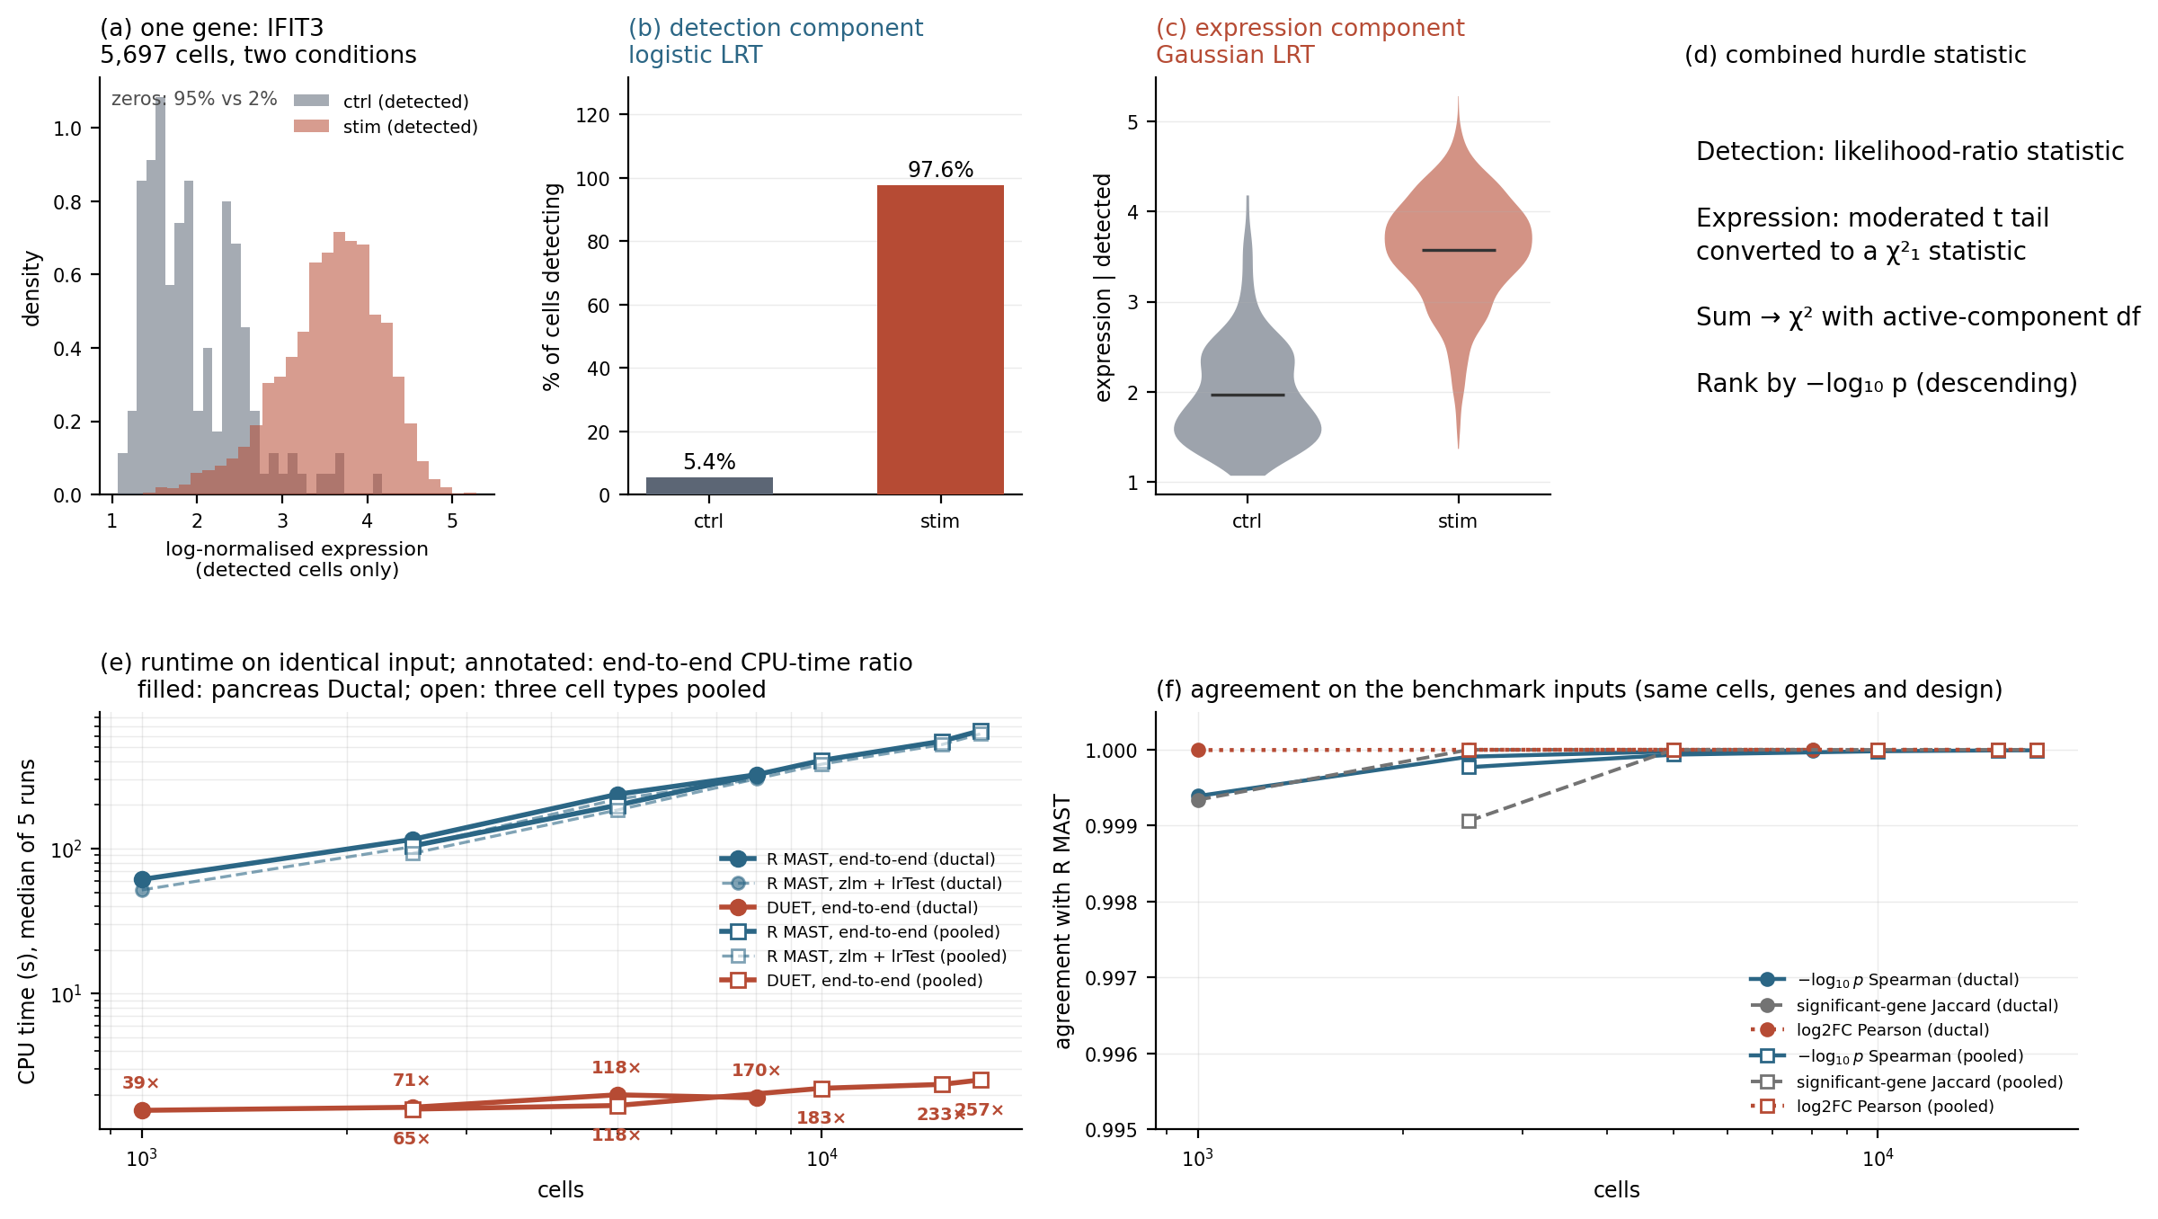
Figure 1. The two-part hurdle model and its computational cost. (a) For IFIT3 in Kang CD14+ monocytes (5,697 cells), the condition affects both the probability of detection and expression among detected cells. (b) Detection component: 5.4% of control cells versus 97.6% of stimulated cells. (c) Expression component among detected cells. (d) The detection likelihood-ratio and moderated continuous-component statistics are combined in one χ² test; the schematic distinguishes the two contributions and the log-scale ranking output. (e) CPU time on identical inputs against cell count (log–log; median of five runs). Filled markers, pancreas ductal cells to 8,020 cells; open markers, three cell types pooled to 17,093 cells. Solid lines, end-to-end; dashed lines, MAST's zlm plus lrTest only. Numbers give the end-to-end CPU-time ratio. (f) Agreement with R MAST on the same benchmark inputs.
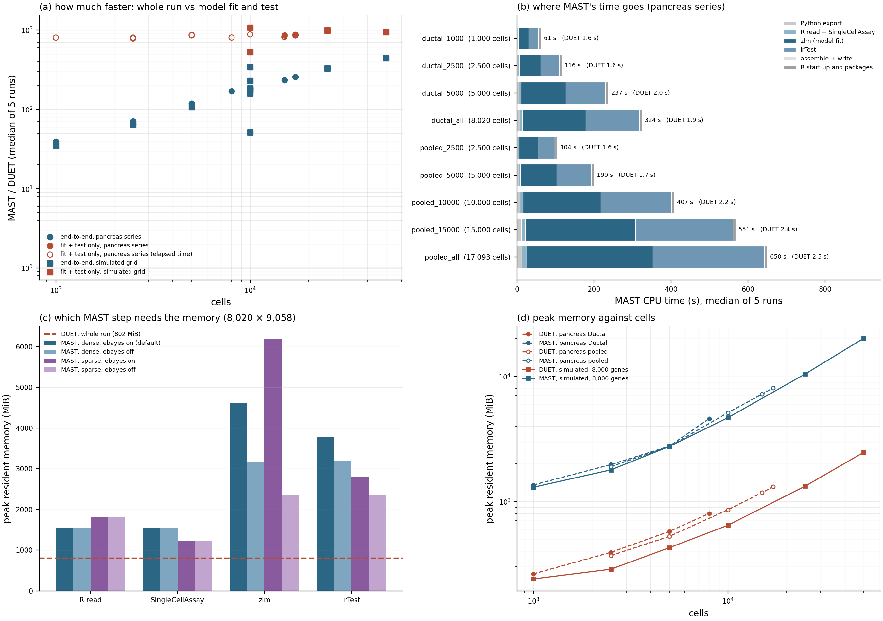
Figure 2. Summary of the matched benchmark (CPU time, median of five runs; memory, median of five runs, or three runs in c). (a) Ratio of MAST's to DUET's CPU time at every benchmark point, for the whole run and for the model fit and test only (DUET's fit-and-test stage against MAST's zlm plus lrTest); on the pancreas series DUET's fit is too short for a CPU-time ratio, so the elapsed-time ratio of the same stages is shown. The unmatched historical CDR measurements are excluded from the plotted speed ratios (Table S5). (b) MAST's CPU time on the pancreas series by stage, with DUET's end-to-end CPU time on the same input. (c) Peak resident memory of MAST per stage on 8,020 ductal cells with dense or sparse input and empirical Bayes on or off; dashed line, DUET's peak for the whole run on the same input. (d) Peak resident memory against cells for both engines on the pancreas series and the simulated grid (8,000 genes).
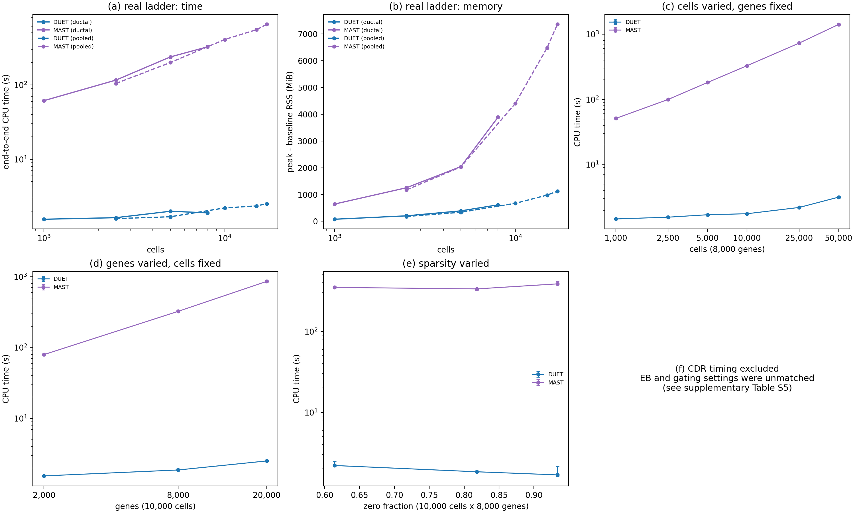
Figure 3. Computational cost as one data property is varied at a time (median CPU time and peak memory of five runs; bars, interquartile range). (a, b) Pancreas series: CPU time and peak minus baseline resident memory. (c) Cells varied at 8,000 genes. (d) Genes varied at 10,000 cells. (e) Zero fraction varied at 10,000 cells and 8,000 genes. (f) Historical CDR timings are omitted because empirical-Bayes and gating settings were not matched (Table S5).
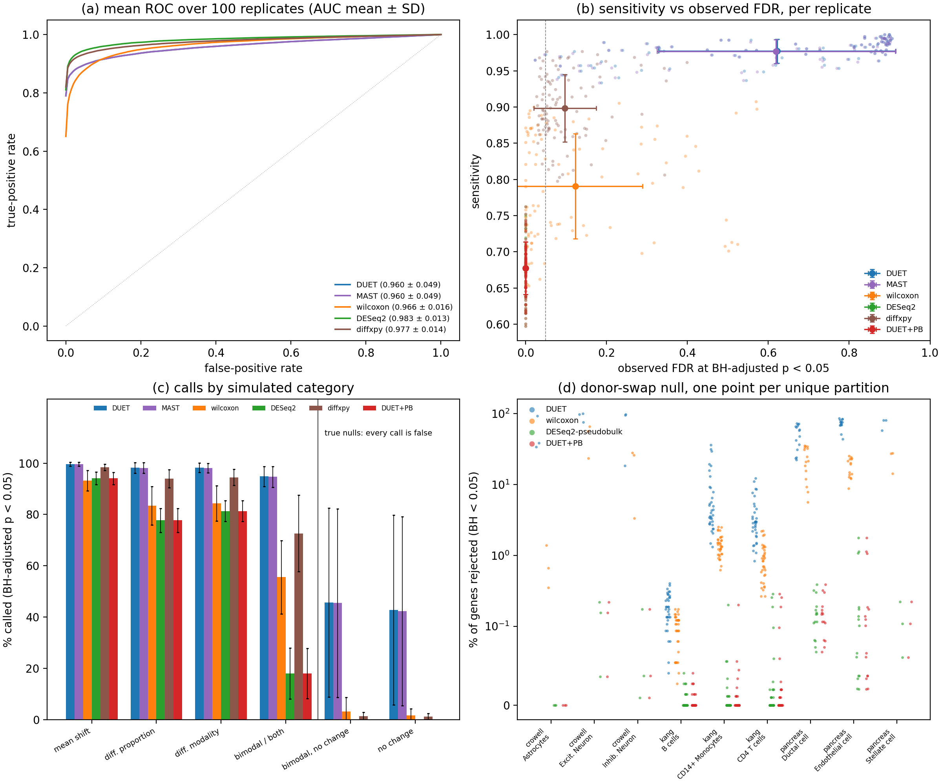
Figure 4. Accuracy against ground truth and calibration of cell-level testing. (a) Mean ROC curves over 100 muscat simulation replicates (AUC mean ± SD); DUET and MAST are superimposed. (b) Sensitivity versus observed FDR at a nominal BH level of 0.05; small points are individual replicates, large points and bars the mean ± SD. DUET+PB is the two-stage rule. (c) Percentage of genes called significant by simulated category (mean ± SD over 100 replicates); in the two null categories every call is false. (d) Donor-swap global null: percentage of genes rejected in each unique donor partition (symlog scale). This is a rejection proportion, not an FDR.

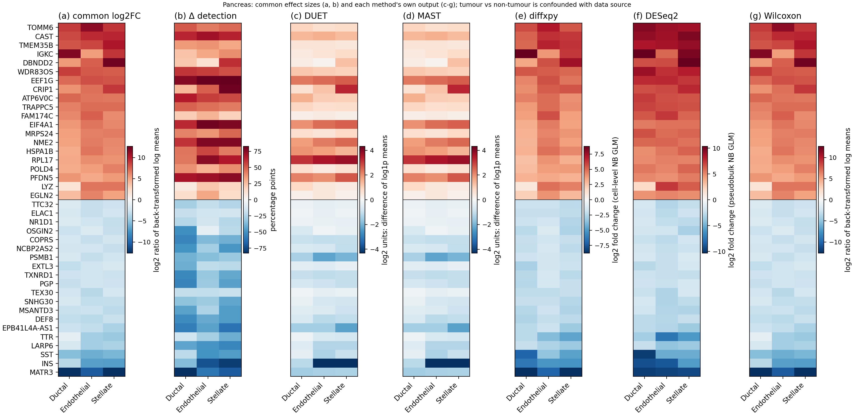
Figure 5. Effect sizes for 40 genes in three pancreas cell types. Genes were selected by a fixed, method-independent rule: the 20 largest positive and 20 largest negative values of the common log2 fold change averaged over the three cell types, among genes detected in at least 10% of cells in one group and tested by all methods, without a significance filter. (a) Common log2 fold change, log2[(expm1(x̄_test) + ε)/(expm1(x̄_ref) + ε)], computed from the group means of log1p(counts per 10,000). (b) Difference in detection rate, in percentage points, from the same input. (c–g) Each method's own effect-size output on its own color scale: DUET and MAST, difference of per-group log1p means in log2 units; diffxpy, cell-level negative-binomial log2 fold change; DESeq2, pseudobulk negative-binomial log2 fold change; Wilcoxon, Scanpy log2 ratio of back-transformed group log1p means. Tumor and non-tumor samples come from different data sources, so the values are descriptive only.

References
[1] P. V Kharchenko, L. Silberstein, and D. T. Scadden, “Bayesian approach to single-cell differential expression analysis,” Nat. Methods, vol. 11, pp. 740–742, 2014, doi: 10.1038/nmeth.2967.
[2] V. Svensson, “Droplet scRNA-seq is not zero-inflated,” Nat. Biotechnol., vol. 38, pp. 147–150, 2020, doi: 10.1038/s41587-019-0379-5.
[3] R. Jiang, T. Sun, D. Song, and J. J. Li, “Statistics or biology: the zero-inflation controversy about scRNA-seq data,” Genome Biol., vol. 23, p. 31, 2022, doi: 10.1186/s13059-022-02601-5.
[4] T. H. Kim, X. Zhou, and M. Chen, “Demystifying ‘drop-outs’ in single-cell UMI data,” Genome Biol., vol. 21, p. 196, 2020, doi: 10.1186/s13059-020-02096-y.
[5] G. Finak et al., “MAST: a flexible statistical framework for assessing transcriptional changes and characterizing heterogeneity in single-cell RNA sequencing data,” Genome Biol., vol. 16, p. 278, 2015, doi: 10.1186/s13059-015-0844-5.
[6] T. Wang, B. Li, C. E. Nelson, and S. Nabavi, “Comparative analysis of differential gene expression analysis tools for single-cell RNA sequencing data,” BMC Bioinformatics, vol. 20, p. 40, 2019, doi: 10.1186/s12859-019-2599-6.
[7] C. Soneson and M. D. Robinson, “Bias, robustness and scalability in single-cell differential expression analysis,” Nat. Methods, vol. 15, pp. 255–261, 2018, doi: 10.1038/nmeth.4612.
[8] S. Das, A. Rai, M. L. Merchant, M. C. Cave, and S. N. Rai, “A comprehensive survey of statistical approaches for differential expression analysis in single-cell RNA sequencing studies,” Genes (Basel)., vol. 12, p. 1947, 2021, doi: 10.3390/genes12121947.
[9] H. C. T. Nguyen, B. Baik, S. Yoon, T. Park, and D. Nam, “Benchmarking integration of single-cell differential expression,” Nat. Commun., vol. 14, p. 1570, 2023, doi: 10.1038/s41467-023-37126-3.
[10] T. Cui and T. Wang, “A comprehensive assessment of hurdle and zero-inflated models for single cell RNA-sequencing analysis,” Brief. Bioinform., vol. 24, p. bbad272, 2023, doi: 10.1093/bib/bbad272.
[11] I. Virshup et al., “The scverse project provides a computational ecosystem for single-cell omics data analysis,” Nat. Biotechnol., vol. 41, pp. 604–606, 2023, doi: 10.1038/s41587-023-01733-8.
[12] D. S. Fischer and F. R. Holzlwimmer, “diffxpy: fast and scalable differential expression analysis on single-cell RNA-seq data,” 2019, theislab: 0.7.4. [Online]. Available: https://github.com/theislab/diffxpy
[13] F. A. Wolf, P. Angerer, and F. J. Theis, “SCANPY: large-scale single-cell gene expression data analysis,” Genome Biol., vol. 19, p. 15, 2018, doi: 10.1186/s13059-017-1382-0.
[14] J. W. Squair et al., “Confronting false discoveries in single-cell differential expression,” Nat. Commun., vol. 12, p. 5692, 2021, doi: 10.1038/s41467-021-25960-2.
[15] K. D. Zimmerman, M. A. Espeland, and C. D. Langefeld, “A practical solution to pseudoreplication bias in single-cell studies,” Nat. Commun., vol. 12, p. 738, 2021, doi: 10.1038/s41467-021-21038-1.
[16] A. E. Murphy and N. G. Skene, “A balanced measure shows superior performance of pseudobulk methods in single-cell RNA-sequencing analysis,” Nat. Commun., vol. 13, p. 7851, 2022, doi: 10.1038/s41467-022-35519-4.
[17] S. Junttila, J. Smolander, and L. L. Elo, “Benchmarking methods for detecting differential states between conditions from multi-subject single-cell RNA-seq data,” Brief. Bioinform., vol. 23, p. bbac286, 2022, doi: 10.1093/bib/bbac286.
[18] C.-H. Wu, X. Zhou, and M. Chen, “Exploring and mitigating shortcomings in single-cell differential expression analysis with a new statistical paradigm,” Genome Biol., vol. 26, p. 58, 2025, doi: 10.1186/s13059-025-03525-6.
[19] G. K. Smyth, “Linear models and empirical Bayes methods for assessing differential expression in microarray experiments,” Stat. Appl. Genet. Mol. Biol., vol. 3, p. Article 3, 2004, doi: 10.2202/1544-6115.1027.
[20] Y. Benjamini and Y. Hochberg, “Controlling the false discovery rate: a practical and powerful approach to multiple testing,” Journal of the Royal Statistical Society: Series B, vol. 57, pp. 289–300, 1995, doi: 10.1111/j.2517-6161.1995.tb02031.x.
[21] C. Hafemeister and R. Satija, “Normalization and variance stabilization of single-cell RNA-seq data using regularized negative binomial regression,” Genome Biol., vol. 20, p. 296, 2019, doi: 10.1186/s13059-019-1874-1.
[22] C. Ahlmann-Eltze and W. Huber, “Comparison of transformations for single-cell RNA-seq data,” Nat. Methods, vol. 20, pp. 665–672, 2023, doi: 10.1038/s41592-023-01814-1.
[23] I. Virshup, S. Rybakov, F. J. Theis, P. Angerer, and F. A. Wolf, “anndata: access and store annotated data matrices,” J. Open Source Softw., vol. 9, p. 4371, 2024, doi: 10.21105/joss.04371.
[24] B. Muzellec, M. Telenczuk, V. Cabeli, and M. Andreux, “PyDESeq2: a python package for bulk RNA-seq differential expression analysis,” Bioinformatics, vol. 39, p. btad547, 2023, doi: 10.1093/bioinformatics/btad547.
[25] K. H. Kaestner, A. C. Powers, A. Naji, H. Consortium, and M. A. Atkinson, “NIH initiative to improve understanding of the pancreas, islet, and autoimmunity in type 1 diabetes: the Human Pancreas Analysis Program (HPAP),” Diabetes, vol. 68, pp. 1394–1402, 2019, doi: 10.2337/db19-0058.
[26] S. N. Shapira, A. Naji, M. A. Atkinson, A. C. Powers, and K. H. Kaestner, “Understanding islet dysfunction in type 2 diabetes through multidimensional pancreatic phenotyping: the Human Pancreas Analysis Program,” Cell Metab., vol. 34, pp. 1906–1913, 2022, doi: 10.1016/j.cmet.2022.09.013.
[27] M. Fasolino et al., “Single-cell multi-omics analysis of human pancreatic islets reveals novel cellular states in type 1 diabetes,” Nat. Metab., vol. 4, pp. 284–299, 2022, doi: 10.1038/s42255-022-00531-x.
[28] A. R. Patil et al., “Single-cell expression profiling of islets generated by the Human Pancreas Analysis Program,” Nat. Metab., vol. 5, pp. 713–715, 2023, doi: 10.1038/s42255-023-00806-x.
[29] H. M. Kang et al., “Multiplexed droplet single-cell RNA-sequencing using natural genetic variation,” Nat. Biotechnol., vol. 36, pp. 89–94, 2018, doi: 10.1038/nbt.4042.
[30] H. L. Crowell et al., “muscat detects subpopulation-specific state transitions from multi-sample multi-condition single-cell transcriptomics data,” Nat. Commun., vol. 11, p. 6077, 2020, doi: 10.1038/s41467-020-19894-4.
[31] M. I. Love, W. Huber, and S. Anders, “Moderated estimation of fold change and dispersion for RNA-seq data with DESeq2,” Genome Biol., vol. 15, p. 550, 2014, doi: 10.1186/s13059-014-0550-8.
[32] D. Bates, M. Mächler, B. Bolker, and S. Walker, “Fitting linear mixed-effects models using lme4,” J. Stat. Softw., vol. 67, no. 1, pp. 1–48, 2015, doi: 10.18637/jss.v067.i01.

Table 1. Agreement between DUET and R MAST 1.33.0 on identical cells, genes and model (~1 + condition). Genes: genes tested by both implementations. Jaccard: significant-gene sets at BH-adjusted p < 0.05. The simulation row gives the median over 100 muscat replicates. Pancreas values use the corrected object.
Dataset | Cell type | Cells | Genes | log2FC r | Sign % | −log10 p Spearman | Jaccard
Kang | B cells | 2,651 | 1,523 | 1 | 100 | 0.9998 | 0.8475
Kang | CD14+ Monocytes | 5,697 | 1,954 | 1 | 100 | 1 | 0.99
Kang | CD4 T cells | 11,238 | 1,293 | 1 | 100 | 1 | 0.9501
Crowell | Astrocytes | 1,740 | 2,987 | 1 | 100 | 0.997 | 0.9441
Crowell | Excit. Neuron | 16,622 | 5,842 | 1 | 99.98 | 1 | 0.9996
Crowell | Inhib. Neuron | 3,382 | 5,821 | 1 | 99.97 | 0.9994 | 0.9693
Pancreas | Ductal cell | 8,020 | 9,058 | 1 | 100 | 1 | 1
Pancreas | Endothelial cell | 5,332 | 7,436 | 1 | 100 | 0.9998 | 0.9997
Pancreas | Stellate cell | 3,741 | 7,129 | 1 | 100 | 1 | 0.9835
Simulation (median of 100) | cluster1 | 24,000 | 3,994 | 1 | 100 | 0.9999 | 0.9953

Table 2. Matched benchmark on pancreas data: median of five runs per engine after one warm-up, single-threaded, identical input file. CPU ratio: MAST/DUET end-to-end CPU time. Fit + test ratio: MAST zlm + lrTest against DUET's fit-and-test stage, elapsed time. Peak: resident memory of the process tree. The machine was in use during the benchmark (median background CPU load 9–31%).
Input | Cells × genes | DUET CPU (s) | MAST CPU (s) | CPU ratio | Fit + test ratio | DUET peak (MiB) | MAST peak (MiB)
ductal_1000 | 1,000 × 9,101 | 1.56 | 61.3 | 39× | 806× | 264 | 1,356
ductal_2500 | 2,500 × 9,082 | 1.64 | 115.7 | 71× | 803× | 392 | 1,970
ductal_5000 | 5,000 × 9,068 | 2 | 236.9 | 118× | 860× | 576 | 2,765
ductal_all | 8,020 × 9,058 | 1.91 | 323.6 | 170× | 808× | 802 | 4,600
pooled_10000 | 10,000 × 8,537 | 2.22 | 406.6 | 183× | 888× | 858 | 5,124
pooled_15000 | 15,000 × 8,523 | 2.36 | 550.6 | 233× | 856× | 1,176 | 7,210
pooled_2500 | 2,500 × 8,646 | 1.59 | 104.3 | 65× | 787× | 369 | 1,897
pooled_5000 | 5,000 × 8,474 | 1.69 | 199.1 | 118× | 872× | 526 | 2,755
pooled_all | 17,093 × 8,519 | 2.53 | 650.5 | 257× | 858× | 1,313 | 8,084

Table 3. Performance against muscat ground truth over 100 independent replicates (4,000 genes, 24,000 cells, four versus four samples). Sensitivity and observed FDR at a nominal BH level of 0.05, mean ± SD. Calibrated threshold: the score threshold giving a mean observed FDR of 5% on replicates 1–50, evaluated on replicates 51–100. The two-stage rule has the ROC-AUC of DUET's ranking and the calls of the pseudobulk arm.
Method | ROC-AUC | PR-AUC | Sensitivity | Observed FDR, mean (range) | Replicates with FDR ≤ 0.10 | Sensitivity at calibrated threshold | Observed FDR at calibrated threshold, mean (max)
DUET | 0.960 ± 0.049 | 0.916 ± 0.101 | 0.977 ± 0.016 | 0.622 (0.023–0.906) | 7 | 0.636 | 0.061 (0.819)
MAST | 0.960 ± 0.049 | 0.916 ± 0.101 | 0.977 ± 0.017 | 0.620 (0.023–0.906) | 7 | 0.635 | 0.061 (0.816)
Wilcoxon | 0.966 ± 0.016 | 0.901 ± 0.065 | 0.791 ± 0.072 | 0.124 (0.000–0.572) | 65 | 0.667 | 0.053 (0.397)
diffxpy | 0.977 ± 0.014 | 0.948 ± 0.028 | 0.898 ± 0.047 | 0.097 (0.027–0.398) | 68 | 0.882 | 0.061 (0.258)
DESeq2 pseudobulk | 0.983 ± 0.013 | 0.956 ± 0.024 | 0.677 ± 0.037 | 0.000 (0.000–0.000) | 100 | 0.889 | 0.049 (0.103)
DUET two-stage rule | 0.960 ± 0.049 | 0.916 ± 0.101 | 0.677 ± 0.036 | 0.000 (0.000–0.000) | 100 | — | —

Table 4. Percentage of genes called significant (BH-adjusted p < 0.05) by simulated category, mean ± SD over 100 replicates. High values are desirable for the four alternative categories and low values for the two null categories; in the null categories every call is a false discovery.
Simulated category | Truth | Genes per replicate | DUET | MAST | diffxpy | DESeq2 | Wilcoxon | Two-stage rule
mean shift (de) | alternative | 100 | 99.6 ± 0.7 | 99.6 ± 0.7 | 98.5 ± 1.2 | 94.1 ± 2.4 | 93.2 ± 3.9 | 94.1 ± 2.4
differential proportion (dp) | alternative | 100 | 98.2 ± 2.0 | 98.1 ± 2.1 | 94.0 ± 3.6 | 77.7 ± 4.7 | 83.4 ± 7.5 | 77.7 ± 4.7
differential modality (dm) | alternative | 99 | 98.2 ± 1.8 | 98.2 ± 1.8 | 94.5 ± 3.1 | 81.3 ± 4.1 | 84.4 ± 6.9 | 81.3 ± 4.1
both (db) | alternative | 100 | 94.8 ± 4.0 | 94.7 ± 4.1 | 72.6 ± 14.9 | 18.0 ± 9.9 | 55.5 ± 14.3 | 18.0 ± 9.8
bimodal, no change (ep) |  | 401 | 45.7 ± 36.8 | 45.4 ± 36.7 | 1.3 ± 1.5 | 0.0 ± 0.0 | 3.1 ± 5.6 | 0.0 ± 0.0
no change (ee) |  | 3,186 | 42.7 ± 37.0 | 42.3 ± 36.9 | 1.2 ± 1.2 | 0.0 ± 0.0 | 1.6 ± 2.7 | 0.0 ± 0.0

Table 5. Calibration on the genes muscat labels as nulls (ee and ep), averaged over 100 replicates (range across replicates in brackets). The BH denominators are within 1% of one another, so the differences between rows are in the p-values and not in the multiple-testing correction. Quartiles are of the per-gene design effect 1 + (m̄ − 1)·ICC with m̄ = 3,000 cells per sample. Valid conservative tests may have super-uniform rather than uniform p-values; null-gene rejection proportions are not FDR.
Method | BH denominator (mean) | Rejected at raw p < 0.05, mean (range) | Median p | KS distance from U(0,1) | False positives at FDR < 0.05 | By design-effect quartile Q1 / Q2 / Q3 / Q4
DUET | 3,992 | 0.4948 (0.0464–0.9897) | 0.153 | 0.489 | 0.430 | 0.322 / 0.408 / 0.460 / 0.528
MAST | 3,992 | 0.4912 (0.0461–0.9889) | 0.155 | 0.484 | 0.426 | 0.315 / 0.404 / 0.458 / 0.526
Wilcoxon | 4,000 | 0.0351 (0.0011–0.1731) | 0.738 | 0.284 | 0.018 | 0.003 / 0.008 / 0.015 / 0.044
diffxpy | 3,989 | 0.0715 (0.0440–0.1885) | 0.466 | 0.047 | 0.012 | 0.005 / 0.007 / 0.009 / 0.026
DESeq2 pseudobulk | 3,983 | 0.0002 (0.0000–0.0011) | 0.829 | 0.451 | 0.000 | 0.000 / 0.000 / 0.000 / 0.000
Exact continuous uniform null reference | — | 0.05 | 0.5 | 0 | ≤ 0.05 | flat

Table 6. Donor-swap global null over all unique balanced donor partitions: percentage of genes rejected (BH-adjusted p < 0.05), mean ± SD over partitions. Every rejection is a false positive; the values are rejection proportions, not false discovery rates. DESeq2 and the two-stage rule agree at displayed precision, but differ in two partitions; separate exact summaries and discovery frequencies are supplied in Table S16. The same partitions are shown in Fig. 4d. Pancreas rows are technical sensitivity analyses.
Dataset | Cell type | Partitions | DUET | Wilcoxon | Pseudobulk / two-stage rule | Partitions with ≥1 discovery, two-stage rule (%)
Crowell | Astrocytes | 3 | 54.90 ± 32.71 | 0.80 ± 0.53 | 0.00 ± 0.00 | 0
Crowell | Excit. Neuron | 3 | 90.92 ± 13.16 | 48.29 ± 22.05 | 0.14 ± 0.09 | 100
Crowell | Inhib. Neuron | 3 | 70.01 ± 44.69 | 19.08 ± 13.68 | 0.07 ± 0.09 | 100
Kang | B cells | 35 | 0.20 ± 0.09 | 0.10 ± 0.04 | 0.00 ± 0.01 | 23
Kang | CD14+ Monocytes | 35 | 7.89 ± 8.87 | 1.44 ± 0.49 | 0.01 ± 0.04 | 26
Kang | CD4 T cells | 35 | 3.75 ± 2.81 | 0.92 ± 0.54 | 0.03 ± 0.07 | 40
Pancreas | Ductal cell | 15 | 50.32 ± 19.01 | 22.33 ± 10.61 | 0.16 ± 0.10 | 100
Pancreas | Endothelial cell | 15 | 71.77 ± 11.59 | 17.85 ± 5.42 | 0.33 ± 0.54 | 100
Pancreas | Stellate cell | 3 | 72.79 ± 13.39 | 23.06 ± 7.70 | 0.13 ± 0.08 | 100

Table 7. Donor-aware cell-level models against DUET and its two-stage rule on simulation replicates 51–70, subsampled to 500 cells per sample (all methods on the same cells). Separate rows reflect different scored-gene universes (GLIMES: 2,211–3,330; MAST: 3,927–3,994), not verified different cell subsamples. Compare methods within each stratum. Donor-swap null results: Additional file 2, Table S13.
Run | Method | Replicates | Sensitivity | Observed FDR, mean (max) | ROC-AUC | PR-AUC
GLIMES | DESeq2 pseudobulk | 20 | 0.622 | 0.000 (0.000) | 0.965 | 0.923
GLIMES | DUET (cell level) | 20 | 0.906 | 0.331 (0.879) | 0.955 | 0.906
GLIMES | DUET two-stage rule | 20 | 0.622 | 0.000 (0.000) | 0.955 | 0.906
GLIMES | GLIMES binomial GLMM | 20 | 0.256 | 0.004 (0.015) | 0.944 | 0.869
GLIMES | GLIMES Poisson GLMM | 20 | 0.301 | 0.000 (0.000) | 0.955 | 0.889
MAST glmer | DESeq2 pseudobulk | 20 | 0.56 | 0.000 (0.000) | 0.949 | 0.881
MAST glmer | DUET (cell level) | 20 | 0.84 | 0.342 (0.889) | 0.931 | 0.85
MAST glmer | DUET two-stage rule | 20 | 0.56 | 0.000 (0.000) | 0.931 | 0.85
MAST glmer | MAST zlm, (1 | donor) | 20 | 0.262 | 0.001 (0.010) | 0.938 | 0.826

