**Task Mini Project**

**Sample JSON**

**{**

**"patientInfo": [**

**{**

"dateOfBirth": "05/01/2000",

"mrn": "12345678-9",

"firstName": "Andrew",

"lastName": "Johnson",

"gender": "Male",

"comment": "Prof Colin Garner, from Antibiotic Research UK, said finding new antibiotics to treat grampositive infections like MRSA was good news, but would not address the most pressing need."

}, {

"dateOfBirth": "01/05/1975",

"mrn": "12345555-9",

"firstName": "Donald",

"lastName": "Tramp",

"gender": "Male",

"comment": "Soil is teeming with millions of different micro-organisms that produce lots of potentially therapeutic compounds, including new antibiotics.Our concern are the so called gram-negative bacteria which are difficult to treat and where resistance is on the increase"

}, {

"dateOfBirth": "05/18/2017",

"mrn": "12346666-9",

"firstName": "Missy",

"lastName": "Jason",

"gender": "Female",

"comment": "Gram-negative bacteria cause pneumonia, blood and urinary tract infections as skin infections. We need new antibiotics to treat this class.They used a gene sequencing technique to analyse more than 1,000 soil samples taken from across the US."

}, {

"dateOfBirth": "05/05/2010",

"mrn": "12347777-9",

"firstName": "Ivonka.k.",

"lastName": "Bartlete",

"gender": "Female",

"comment": "When they discovered malacidins in many of the samples, they had a hunch it was an important find. They tested the compound on rats that they had given MRSA and it eliminated the infection in skin wounds."

}, {

"dateOfBirth": "05/05/1975",

"mrn": "12348888-9",

"firstName": "Jelyla",

"lastName": "Fitschgerald",

"gender": "Female",

"comment": "The researchers are now working to improve the drug's effectiveness in the hope that it can be developed into a real treatment for people.Dr Brady said: \"It is impossible to say when, or even if, an early stage antibiotic discovery like the malacidins will proceed to the clinic.\""

**}**

**] }**

Client side

* Create a new Angular2+ project using Visual Studio code • Create a UI component that displays the following information based on the patient’s detail fields retrieved from the service: Andrew Johnson (42 Years) M 12345678-9
* Gender should be displayed as blue M (for Male) and orange F (for Female).

• Create a page that will be display all the patients, using the RESTful service given above

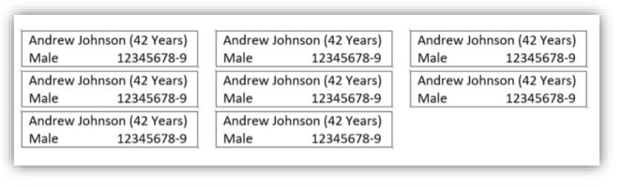

• Tooltip

* Display a tooltip upon hover over the Patient’s identifier number field. Use Ng-Bootstrap tooltip and display the “comment” field (from the JSON).
* Every time tooltip is opened, make a service call to “feedback” endpoint. Pass the patient’s ID to it
* Tooltip width should not exceed 250px, and shown in nice fashion over the relevant UI item

• Use PrimeNG (or any other 3rd party) spinner while page is loading with the data (assume delay with response from server)