Date: 2025-02-04

Time: 17:40:36.443060

Time Taken: 11 seconds

# Bradford Assay

**Normalised Equation**

To normalise for protein concentration after scaling up to 1000 μl:

$$C_{1}V_{1}=C_{2}V_{2}$$

$$For BSA in std. curve,$$

$$C_{1} = 2 μg/μl,$$

$$V_{1} = x_{axis} μl, [Total Volume]$$

$$C_{2} = UNK,$$

$$V_{2} = 1000 μl,$$

$$Therefore,$$

$C_{2}\left(normalised\right)=\frac{C_{1} × V_{1}}{V_{2}}=\frac{2 × x_{axis}^{i}}{1000}$

xi = value on the x-axis at index [i]

(in simple words, if i = 1, first value of ‘x’ is what we are looking at)

|  |  |  |
| --- | --- | --- |
| protein intial [init_x]  (initial conc. = 2μg/μl) | protein normalised conc  (x = (2μg/μl . [init_x] μl)/1000μl) | absorbance |
| 0.0 | 0.0 | 0.0 |
| 5.0 | 0.01 | 0.09 |
| 10.0 | 0.02 | 0.15 |
| 15.0 | 0.03 | 0.23 |
| 20.0 | 0.04 | 0.35 |
| 25.0 | 0.05 | 0.4 |

Bradford Assay Curve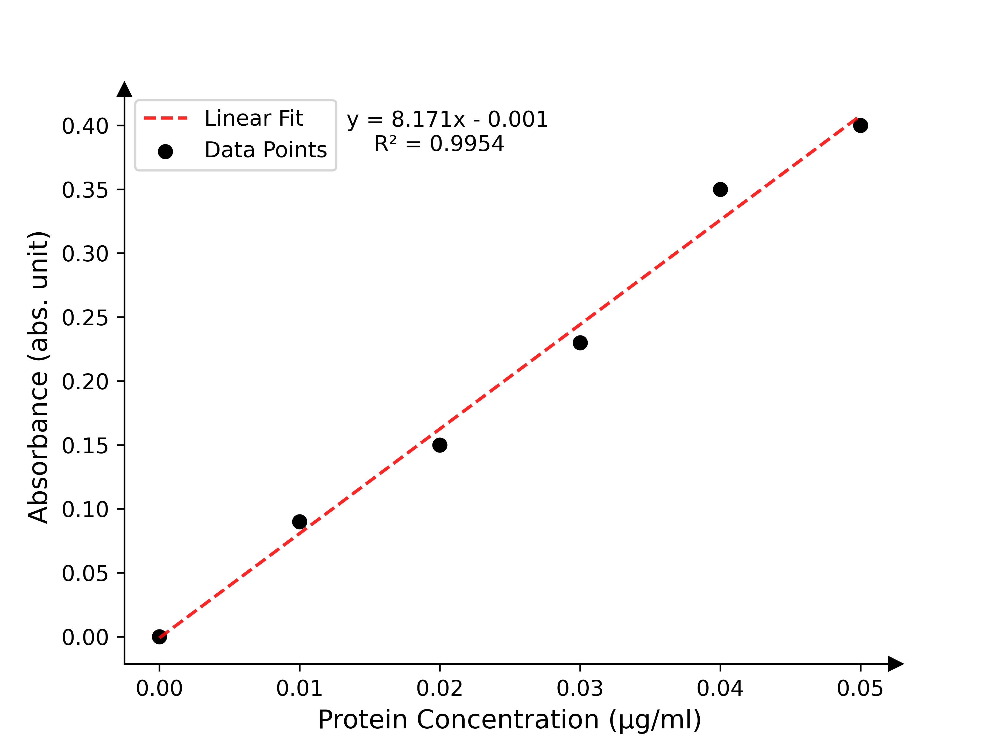

**Obtained Linear Fit Equation**

y = 8.1714x + -0.001   
 R2 = 0.9954

**Calculated concentrations**

|  |  |  |
| --- | --- | --- |
| Sample No. | Absorbance | Calculated conc. (μg/μl) |
| 1.0 | 0.1 | 0.309 |
| 2.0 | 0.1 | 0.309 |
| 3.0 | 0.1 | 0.309 |
| 4.0 | 0.01 | 0.034 |
| 5.0 | 0.01 | 0.034 |
| 6.0 | 0.1 | 0.309 |
| 7.0 | 0.01 | 0.034 |
| 8.0 | 0.1 | 0.309 |
| 9.0 | 0.3 | 0.921 |

Bradford Assay with Unknown(s)