Lab2 Deliverables

**Content**

1. Use Case Diagram ------------------------------------------------------------------------ 3
2. Use Case Description -------------------------------------------------------------------- 4
3. Updated UI mock-up --------------------------------------------------------------------- 24
4. Class Diagram ----------------------------------------------------------------------------- 26
5. Sequence Diagram ----------------------------------------------------------------------- 27
6. Initial Dialog Map ------------------------------------------------------------------------- 40

**Use Case Diagram  
**

**Use Case Description**

|  |  |  |  |
| --- | --- | --- | --- |
| Use Case ID: | 01A | | |
| Use Case Name: | Create a new user account | | |
| Created By: | Lai Xin Yee | Last Updated By: | Cho Zhi Wei |
| Date Created: | 30-8-2024 | Date Last Updated: | 7-9-2024 |

|  |  |
| --- | --- |
| Actor: | * User * Email API |
| Description: | Creating a new user account |
| Preconditions: | * System must have a stable connection to the database. * The email address used must not already exist in the database. |
| Postconditions: | * Show “Account created successfully” message. |
| Priority: | High |
| Frequency of Use: | 1-3 times per lifetime |
| Flow of Events: | 1. User clicks on the sign-up button. 2. User enters a valid email address, password and password confirmation fields. 3. User click the create account button. 4. System validates the format of the email address. 5. System validates the validity of the email address in database 6. System validates the fulfillment of the requirement of the password. 7. System validates the password and password confirmation field are identical. 8. System displays “account created successfully” message upon successful creation of a new user account. 9. System automatically sends confirmation email to the registered email address. |
| Alternative Flows: | AF-S4: System detects the invalid email address format.   1. System displays error message “Invalid email format”. 2. System returns to Step 2.     AF-S5: Email address exists in database:   1. System displays error message “Email exists, do you want to login?” 2. System returns to Step 2.     AF-S6: System detects password does not fulfill the password requirements.   1. System displays error message “Invalid password”. 2. System returns to Step 2.     AF-S7: System detects mismatch between password and password confirmation fields.   1. System displays error message “Password mismatch”. 2. System returns to Step 2. |
| Exceptions: | - |
| Includes: | * Validate the account availability. |
| Special Requirements: | - |
| Assumptions: | * Database refers to the system database. |
| Notes and Issues: | - |

|  |  |  |  |
| --- | --- | --- | --- |
| Use Case ID: | 01B | | |
| Use Case Name: | Create a new hawker account | | |
| Created By: | Lai Xin Yee | Last Updated By: | Cho Zhi Wei |
| Date Created: | 30-8-2024 | Date Last Updated: | 7-9-2024 |

|  |  |
| --- | --- |
| Actor: | * Hawker * Reviewer * Email API |
| Description: | Creating a new hawker account |
| Preconditions: | * The email address used must not already be in the database. * System must have a stable connection to the database. |
| Postconditions: | * Show “pending approval” status upon submission of request for creating account. * Send a notification once the account registration is approved. |
| Priority: | High |
| Frequency of Use: | 1-3 times per lifetime |
| Flow of Events: | 1. Hawker clicks on the sign-up button. 2. Hawker enters a valid email address, password and password confirmation fields. 3. Hawker uploads a valid operating license. 4. Hawker selects the create account button. 5. System validates the format of the email address. 6. System validates the validity of the email address in database 7. System validates the fulfillment of the requirement of the password. 8. System validates the password and password confirmation field are identical. 9. System display “pending approval” message. 10. Reviewer reviews the operating license and approves the account creation request. 11. System sends “account created successfully” notification upon successful creation of a new user account. 12. System automatically sends confirmation email to the registered email address. |
| Alternative Flows: | AF-S5: System detects invalid email address format.   1. System displays error message “Invalid email address format”. 2. System returns to Step 2.   AF-S6: Email address exists in database:   1. System displays error message “Email exists, do you want to login?” 2. System returns to Step 2.     AF-S7: System detects password does not fulfill the password requirements.   1. System displays error message “Invalid password”. 2. System returns to Step 2.     AF-S8: System detects mismatch between password and password confirmation fields.   1. System displays error message “Password mismatch”. 2. System returns to Step 2.     AF-S10: Reviewer disapproves the account creation request.   1. System sends “License disapproved, account creation failed” notification. 2. System returns to Step 2. |
| Exceptions: | - |
| Includes: | * Validate the account availability |
| Special Requirements: | - |
| Assumptions: | * Database refers to the system database |
| Notes and Issues: | - |

|  |  |  |  |
| --- | --- | --- | --- |
| Use Case ID: | 02A | | |
| Use Case Name: | Login to account | | |
| Created By: | Cho Zhi Wei | Last Updated By: | Tan Ming Hao |
| Date Created: | 30-8-2024 | Date Last Updated: | 31-8-2024 |

|  |  |
| --- | --- |
| Actor: | * User * Hawker |
| Description: | Login to account using the registered email address and password |
| Preconditions: | * User account must already exist in the database. * System must have a stable connection to the database. * User connects to the system. |
| Postconditions: | * Users can see the main menu of the system.   OR   * Users see an error message. * Users can re-login to their accounts. |
| Priority: | High |
| Frequency of Use: | 1 – 20 times per day |
| Flow of Events: | 1. System requires the input of email address and password. 2. User input the email address and password in the login interface. 3. User clicks on the login button. 4. System verifies that email address and password have been filled out. 5. System retrieves the information from the database. 6. System verifies the email address and password with the information retrieved from the database. 7. If the email address and password are verified, the system displays the main menu to the user. |
| Alternative Flows: | AF-S5: If email address or password is not filled out.   1. System displays the message “Please input all the required information”. 2. System returns to Step 2.     AF-S6: If the email address does not exist in the database.   1. System displays the message “Invalid email address or password. Do you want to create an account?”. 2. System returns to Step 2.     AF-S7: If the email address and password does not match the information in the database.   1. System displays the message “Invalid email address or password. Do you want to create an account?”. 2. System returns to Step 2. |
| Exceptions: | - |
| Includes: | * Verify Login Credentials. |
| Special Requirements: | - |
| Assumptions: | * Database can be referred to System’s database. |
| Notes and Issues: | - |

|  |  |  |  |
| --- | --- | --- | --- |
| Use Case ID: | 02B | | |
| Use Case Name: | Reset password when forgot | | |
| Created By: | Lai Xin Yee | Last Updated By: | Tan Ming Hao |
| Date Created: | 31-8-2024 | Date Last Updated: | 31-8-2024 |

|  |  |
| --- | --- |
| Actor: | * User * Hawker * Email API |
| Description: | To reset password when user or hawker forgot their password |
| Preconditions: | * User or hawker account must already exist in the database. * System must have a stable connection to the database. |
| Postconditions: | * Users or hawkers can re-login to their accounts. |
| Priority: | Low |
| Frequency of Use: | 1-5 times per lifetime |
| Flow of Events: | 1. User or hawker clicks on the “forgot password" button at the login page. 2. System requests user to enter the email address used to register for the account. 3. System verifies that the email address exists in the database. 4. System sends the user a link to the reset password website through email. 5. User clicks on the reset password website link. 6. User inputs a new valid password and password confirmation fields. 7. System automatically sends a confirmation email to the user upon successful reset of their password. |
| Alternative Flows: | AF-S3: Email address does not exist in the database.   1. System shows message “Invalid email address”. 2. System returns to Step 2.     AF-S6: System detects password does not fulfill the password requirements.   1. System displays error message “Invalid password”. 2. System returns to Step 6.     AF-S6: System detects mismatch between password and password confirmation fields.   1. System displays error message “Password mismatch”. 2. System returns to Step 6. |
| Exceptions: | - |
| Includes: | * Verify Login Credentials. |
| Special Requirements: | - |
| Assumptions: | * Database can be referred to System’s database. |
| Notes and Issues: | - |

|  |  |  |  |
| --- | --- | --- | --- |
| Use Case ID: | 03A | | |
| Use Case Name: | Hawkers update the information of the stall | | |
| Created By: | Tan Ming Hao | Last Updated By: | Chow Weng Shi |
| Date Created: | 30-8-2024 | Date Last Updated: | 3-9-2024 |

|  |  |
| --- | --- |
| Actor: | * Hawkers * Users |
| Description: | Hawkers update information of their respective stall |
| Preconditions: | * System must have a stable connection to the database. * Hawker account must exist in the database. * Hawkers want to update the information of their respective stall after seeing its information.   OR   * Hawkers must update the information of their respective stall after seeing a fault report from the users. |
| Postconditions: | The system will update the information about the stalls. |
| Priority: | Medium |
| Frequency of Use: | 0 – 20 times per week |
| Flow of Events: | 1. Hawker login to their respective account. 2. The system shows the number of fault reports on the right corner of an icon. 3. The system shows the number of the review added on the right corner of an icon. 4. The system shows the “Menu” icon. 5. The system shows the “Opening hours” icon. 6. The system shows “Open Shop” and “Close Shop” button. 7. The system shows a red “X” icon. 8. System updates the information of the stall. |
| Alternative Flows: | AF-S2: The hawker clicks on the fault report icon.   1. The system displays all the reporters’ names and their corresponding fault reports. 2. The system will display an exit button and a button to delete the notification. 3. The system will remove the report if the user clicks on the button to delete the notification. 4. The system returns to Step 3 upon exit.     AF-S3: The hawker clicks on the review icon.   1. The system displays all the newly added reviews. 2. The system displays an exit button and a button to delete the notification. 3. The system will remove the review notifications if the user clicks on the button to delete the notification. 4. The system returns to Step 4 upon exit.     AF-S4: The hawker clicks on the “Menu” button.   1. The system will show a page for the hawker to edit the menu. 2. The hawker edits the menu of the stalls. 3. The hawker clicks the edit button. 4. The system returns to Step 5 upon exit.     AF-S5: The hawker clicks on the “Opening hours” button.   1. The system will show a page for the hawker to edit the opening time. 2. Hawker edits the opening time and operating days. 3. Hawker clicks on the “Save” button. 4. The system returns to Step 6 upon exit.     AF-S6: The hawker clicks on the “Open Shop” button.   1. The system will show a message “Do you want to change the opening status?” with “Confirm” and “Cancel” buttons. 2. The hawker clicks on the “Confirm” button. 3. The system returns to Step 7 upon exit.     AF-S6: The hawker clicks on the “Close Shop” button.   1. The system will show a message “Do you want to change the opening status?” with “Confirm” and “Cancel” buttons. 2. The hawker clicks on the “Confirm” button. 3. The system returns to Step 7 upon exit. |
| Exceptions: | - |
| Includes: | - |
| Special Requirements: | - |
| Assumptions: | * Information of the hawker’s stalls can be referred to System’s database. |
| Notes and Issues: | - |

|  |  |  |  |
| --- | --- | --- | --- |
| Use Case ID: | 03B | | |
| Use Case Name: | Hawkers update the menu of the stalls | | |
| Created By: | Tan Ming Hao | Last Updated By: | Tan Ming Hao |
| Date Created: | 2-9-2024 | Date Last Updated: | 2-9-2024 |

|  |  |
| --- | --- |
| Actor: | * Hawkers |
| Description: | Hawkers update the menu of the stalls of their respective stalls |
| Preconditions: | * System must have a stable connection to the database. * Hawker account must exist in the database. * Hawker clicks on the “Menu” button. |
| Postconditions: | The system will update the menu about the stalls. |
| Priority: | Medium |
| Frequency of Use: | 0-12 per year |
| Flow of Events: | 1. The system shows a page which includes the menu of the shop. 2. The hawker clicks on the item at the right. 3. The system shows the detail of the item. 4. The system shows a “+” button, “Edit” button and “Exit” button. 5. The system returns to the home page of hawker. |
| Alternative Flows: | AF-S4: The hawker clicks on the “+” button.   1. The systems show another page for hawkers to add a new item into the menu. 2. The hawker fills in the details of the new item which include picture, name, description and price. 3. The hawker clicks on the “Add” button. 4. The system shows a message “Add Successfully”. 5. The system adds the item to the database of the store. 6. The system returns to Step 4 upon exit.     AF-S4: The hawker clicks on the “Edit” button.   1. The systems show another page for hawkers to add a new item into the menu. 2. The hawker edits the detail of the selected item. 3. The hawker clicks on the “Edit” button. 4. The system shows a message “Edit Successfully”. 5. The system updates the details of the item in the menu. 6. The system returns to Step 4 upon exit.     AF-S4: The hawker clicks on the “Exit” button.   1. The system returns to Step 5. |
| Exceptions: | - |
| Includes: | - |
| Special Requirements: | - |
| Assumptions: | The system will only show the “Edit” button if there is at least one item in the menu. |
| Notes and Issues: | - |

|  |  |  |  |
| --- | --- | --- | --- |
| Use Case ID: | 03C | | |
| Use Case Name: | Hawkers remove their account and their stall. | | |
| Created By: | Tan Ming Hao | Last Updated By: | Lai Xin Yee |
| Date Created: | 2-9-2024 | Date Last Updated: | 9-9-2024 |

|  |  |
| --- | --- |
| Actor: | * Hawkers |
| Description: | Hawkers close their account and their stall. |
| Preconditions: | * System must have a stable connection to the database. * Hawker account must exist in the database. * Hawkers click on the red “X” button. |
| Postconditions: | * The system will remove the hawker’s account and its information from the database. * The hawker account is removed successfully. * The hawker account no longer exists. |
| Priority: | Medium |
| Frequency of Use: | Once per lifetime |
| Flow of Events: | 1. The system displays the message “Are you sure you want to delete your account?” 2. Hawker clicks “Yes”. 3. The system displays two text boxes and requires the hawker to enter their password correctly twice. 4. The hawker enters their password correctly twice. 5. The system verifies the correctness of the password. 6. The hawker clicks on the “Delete Account” button. 7. The system processes the request (delete account). 8. The system shows message (“Account delete successfully”) 9. The system to Sign Up Page. |
| Alternative Flows: | AF-S5: If the email address and password does not match the information in the database.   1. The system displays the message “Password is incorrect”. 2. The system returns to Step 1. |
| Exceptions: | - |
| Includes: | - |
| Special Requirements: | - |
| Assumptions: | - |
| Notes and Issues: | - |

|  |  |  |  |
| --- | --- | --- | --- |
| Use Case ID: | 04A | | |
| Use Case Name: | User can see the information of the stalls | | |
| Created By: | Chow Weng Shi | Last Updated By: | Choo Zhen Ming |
| Date Created: | 30-8-2024 | Date Last Updated: | 3-9-2024 |

|  |  |
| --- | --- |
| Actor: | * User * Map system |
| Description: | User can view the information of a list of stalls after logging in to the account |
| Preconditions: | * User account must already exist in the database. * System must have a stable connection to the database. |
| Postconditions: | * The system displays a list of stalls with required information. |
| Priority: | High |
| Frequency of Use: | 1 – 20 times per day |
| Flow of Events: | 1. User logins to respective account successfully. 2. Map System detects the real-time location of the user. 3. The system displays the location of nearby hawker centers on the map. 4. The user clicks on a desired hawker center. 5. The system retrieves the information of all stalls in the chosen hawker center from the database. 6. The system shows a list of stalls in the hawker center with name, opening status, opening hours in 24-hour notation, ratings in number, crowd situation of the stalls, and a button to view the reviews. |
| Alternative Flows: | AF-S6: The user clicks on the name of the desired stall.   1. The system displays the menu of the stall, with names and pictures of dishes and their corresponding prices. 2. The system returns to Step 6 upon exit.     AF-S6: The user clicks on the review button.   1. The system displays the overall ratings of the stall and reviews by other users. 2. The system returns to Step 6 upon exit. |
| Exceptions: | - |
| Includes: | - |
| Special Requirements: | - |
| Assumptions: | * Information about the hawker center can be referred to in the System’s database. |
| Notes and Issues: | - |

|  |  |  |  |
| --- | --- | --- | --- |
| Use Case ID: | 05A | | |
| Use Case Name: | User submits fault report | | |
| Created By: | Cho Zhi Wei | Last Updated By: | Lai Xin Yee |
| Date Created: | 30-8-2024 | Date Last Updated: | 3-9-2024 |

|  |  |
| --- | --- |
| Actor: | * User |
| Description: | User can submit fault report to notify the hawker if either of the opening hours, operating days, content or price in the menu is wrong |
| Preconditions: | * User account must already exist in the database. * System must have a stable connection to the database. |
| Postconditions: | * The record of the fault report has been stored in the database. * Hawker can see the submitted fault report. |
| Priority: | Medium |
| Frequency of Use: | 0-5 times per day |
| Flow of Events: | 1. User goes to the desired stall after searching for the information through the system. 2. User logins to respective account successfully. 3. User searches up the current hawker center and the specific stall. 4. The system displays the stall information and a report button. 5. The user clicks on the report button. 6. The system displays “What issues have you found about the current stall?”, a text box below for the users to elaborate as well as an information button for the terms and condition of filing a report. 7. The user inputs the issues they found in the text box and submits the report. 8. The system displays “Fault report is submitted successfully.”. 9. The system returns to Step 4 upon exit. |
| Alternative Flows: | AF-S6: The user submits the report without inputting at least 1 character in the text box.   1. The system displays message “The report must contain at least one character”. 2. The system returns to Step 7.     AF-S6: The user clicks on the information button.   1. The system displays a page with information about when to file a report, as well as the terms and conditions of filing a report. 2. The system returns to Step 6 upon exit. |
| Exceptions: | - |
| Includes: | - |
| Special Requirements: | - |
| Assumptions: | User realizes false information about certain stalls in the system. |
| Notes and Issues: | - |

|  |  |  |  |
| --- | --- | --- | --- |
| Use Case ID: | 06A | | |
| Use Case Name: | User updates crowd situation about the store | | |
| Created By: | Tan Ming Hao | Last Updated By: | Lai Xin Yee |
| Date Created: | 31-8-2024 | Date Last Updated: | 2-9-2024 |

|  |  |
| --- | --- |
| Actor: | * User |
| Description: | User provides the information about the crowd situation about the stalls |
| Preconditions: | * System must have a stable connection to the database. * User account must exist in the database. * User logins to the respective account. |
| Postconditions: | * System updates the crowd situation of the store. |
| Priority: | Medium |
| Frequency of Use: | 0-2 times per day |
| Flow of Events: | 1. User searches and clicks on a certain stall. 2. User clicks on the “Update crowd situation” button. 3. User selects the number of icons that represent the crowd situation of the stalls. 4. User clicks on the “Update” button. 5. System displays message “Update Successfully”. |
| Alternative Flows: | - |
| Exceptions: | - |
| Includes: | - |
| Special Requirements: | - |
| Assumptions: | User realizes that the crowd situation is different from what is shown the system. |
| Notes and Issues: | - |

|  |  |  |  |
| --- | --- | --- | --- |
| Use Case ID: | 07A | | |
| Use Case Name: | User provides stall’s reviews and ratings | | |
| Created By: | Lai Xin Yee | Last Updated By: | Chow Weng Shi |
| Date Created: | 30-8-2024 | Date Last Updated: | 31-8-2024 |

|  |  |
| --- | --- |
| Actor: | * User |
| Description: | User provides reviews, and ratings of the stall they visited |
| Preconditions: | * System must have a stable connection to the database. * User account must exist in the database. |
| Postconditions: | * System shows “review/rating uploaded” message |
| Priority: | Medium |
| Frequency of Use: | 1-2 times per day |
| Flow of Events: | 1. User search and tap on the stall that they want to provide the review or rating. 2. User writes in their review and choose the number of stars for ratings in the review or rating section. 3. User taps the “Upload” button to upload the review or rating. 4. System shows “review/rating uploaded” message. |
| Alternative Flows: | AF–S2: User does not write in review and choose number of stars for ratings.   1. User only choose the number of stars for ratings and do not input any characters into the text box. 2. System returns to Step 3. |
| Exceptions: | - |
| Includes: | - |
| Special Requirements: | - |
| Assumptions: | - |
| Notes and Issues: | - |

|  |  |  |  |
| --- | --- | --- | --- |
| Use Case ID: | 08A | | |
| Use Case Name: | User searches for a location | | |
| Created By: | Lai Xin Yee | Last Updated By: | Lai Xin Yee |
| Date Created: | 30-8-2024 | Date Last Updated: | 30-8-2024 |

|  |  |
| --- | --- |
| Actor: | * User |
| Description: | To search for a desired location |
| Preconditions: | * System is connected to Wi-Fi or Mobile Data. |
| Postconditions: | * A list of relevant hawker centers will be displayed in the system. |
| Priority: | High |
| Frequency of Use: | 0-15 times per day |
| Flow of Events: | 1. User enters query in the search bar. 2. User taps the search button without adding filters. 3. System provides a list of relevant search results based on the user’s query. |
| Alternative Flows: | AF-S2: User taps the search button with filter based on the distance from their current location or ratings.   1. Users can choose to filter the distance or ratings in ascending or descending order. 2. System returns to Step 3. |
| Exceptions: | - |
| Includes: | - |
| Special Requirements: | - |
| Assumptions: | The map system can detect the user's current location (For showing the distance between the user and the desired location). |
| Notes and Issues: | - |

|  |  |  |  |
| --- | --- | --- | --- |
| Use Case ID: | 09A | | |
| Use Case Name: | Direct the user to a desired location | | |
| Created By: | Lai Xin Yee | Last Updated By: | Lai Xin Yee |
| Date Created: | 30-8-2024 | Date Last Updated: | 31-8-2024 |

|  |  |
| --- | --- |
| Actor: | * User * Map System |
| Description: | To direct the user from their current location to the desired location |
| Preconditions: | * System must have a stable connection to the database. * System must know the current exact location of the user. * User has searched for their desired location. |
| Postconditions: | * Close the Google Map directory interface. |
| Priority: | High |
| Frequency of Use: | 3-5 times per day |
| Flow of Events: | 1. User tabs on the “Show Direction” button beside their desired location. 2. System directs the user to Google Map. 3. System detected that the user has arrived at the location. 4. System closes Google Map and directs the user back to the last interface. |
| Alternative Flows: | AF-S3: User closes Google Map before arriving at the destination.  Return to Step 4. |
| Exceptions: | * Hawker does not include the Google Map link of their stall when updating the information of their stall in the system. |
| Includes: | - |
| Special Requirements: | - |
| Assumptions: | * The “Show Direction” button consists of a hyperlink to Google Map which can then direct the user to the location. |
| Notes and Issues: | - |

**Updated UI mock up**  
**

**Class Diagram**

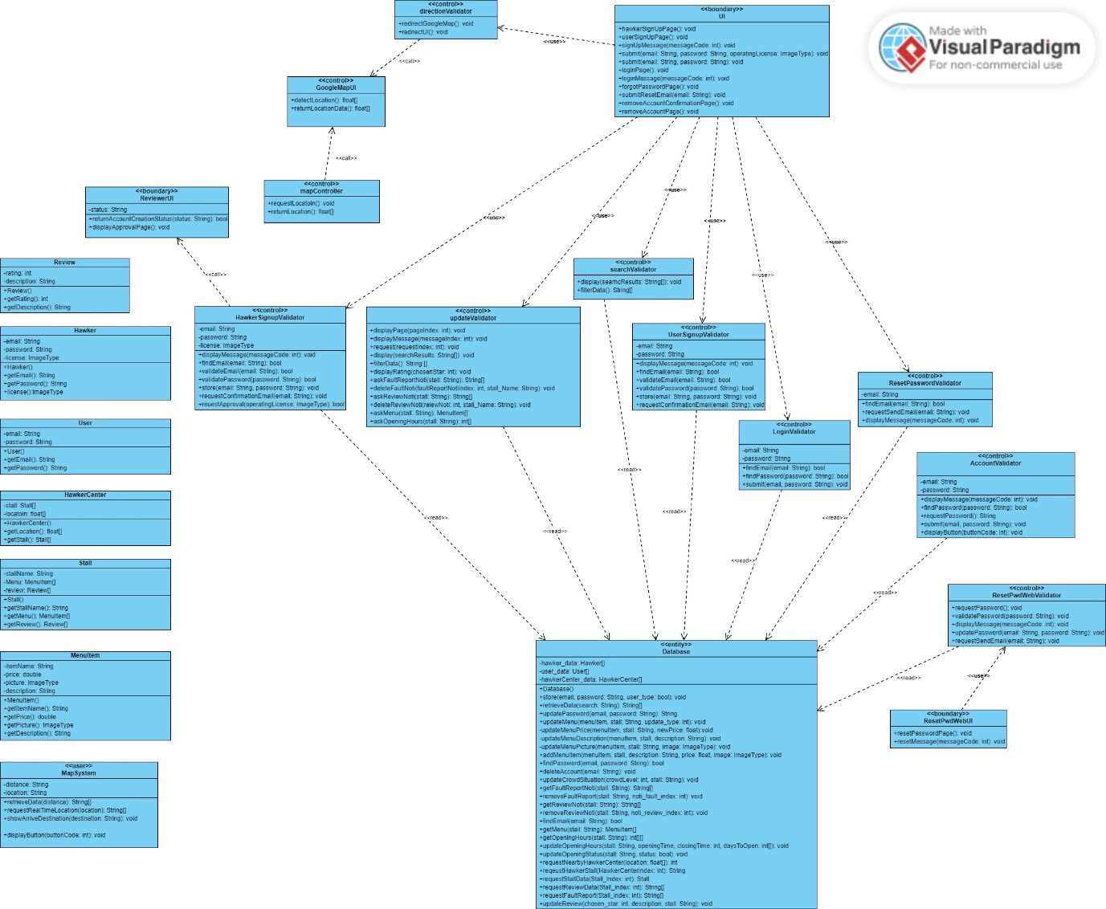

**Sequence Diagram**

Use Case ID: 01A

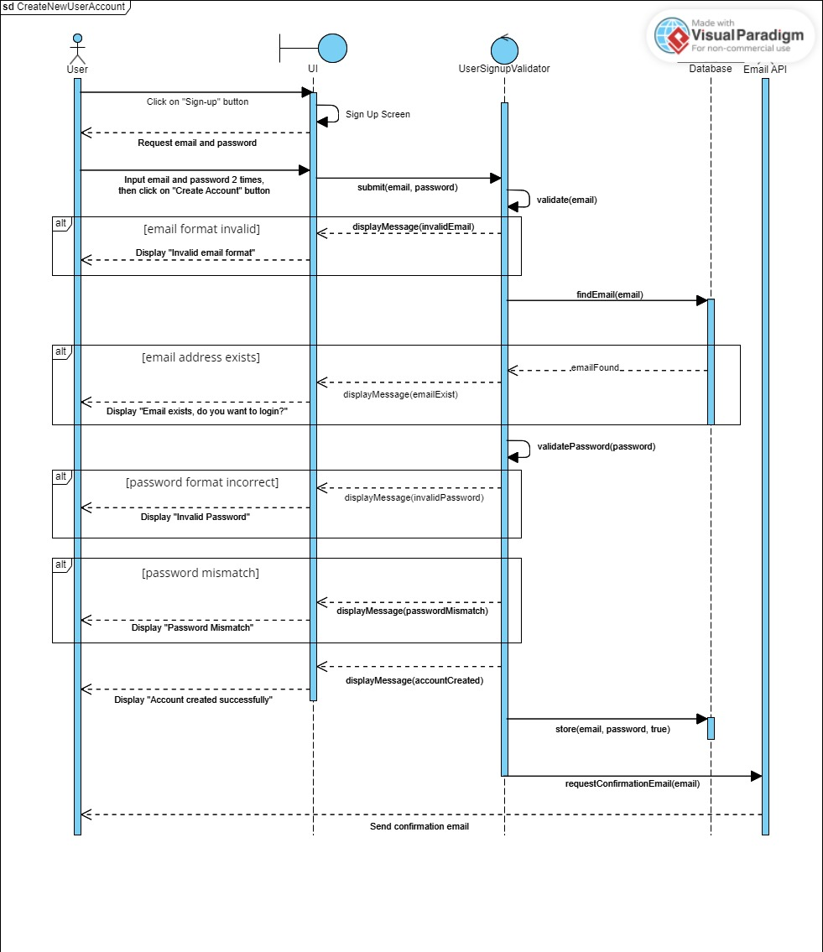

Use Case ID: 01B

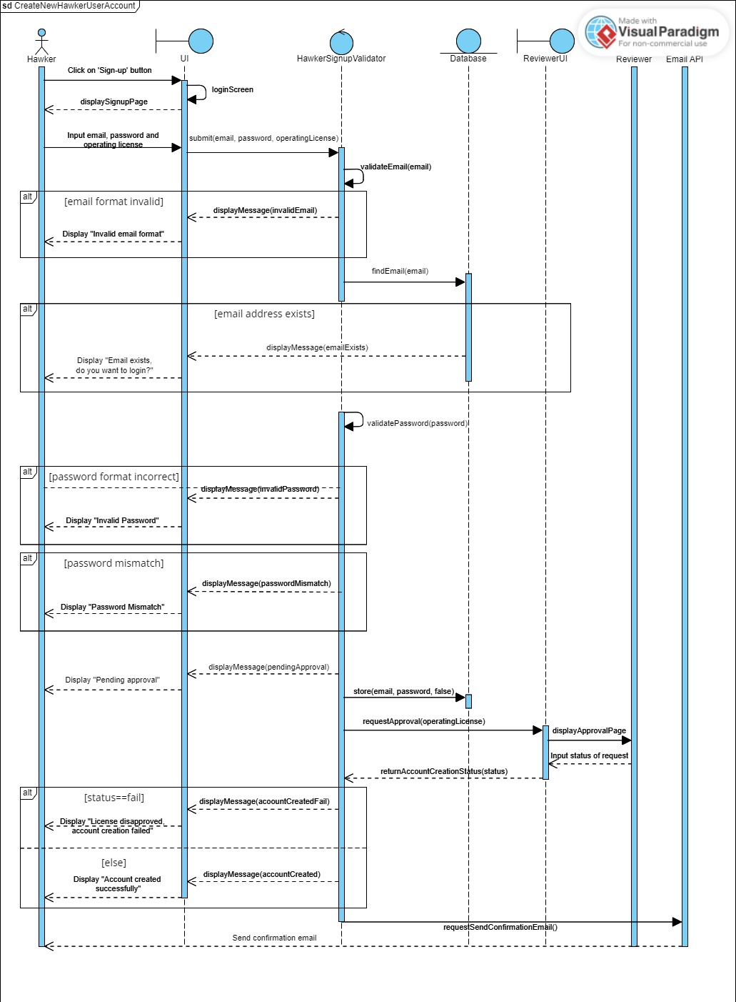

Use Case ID: 02A

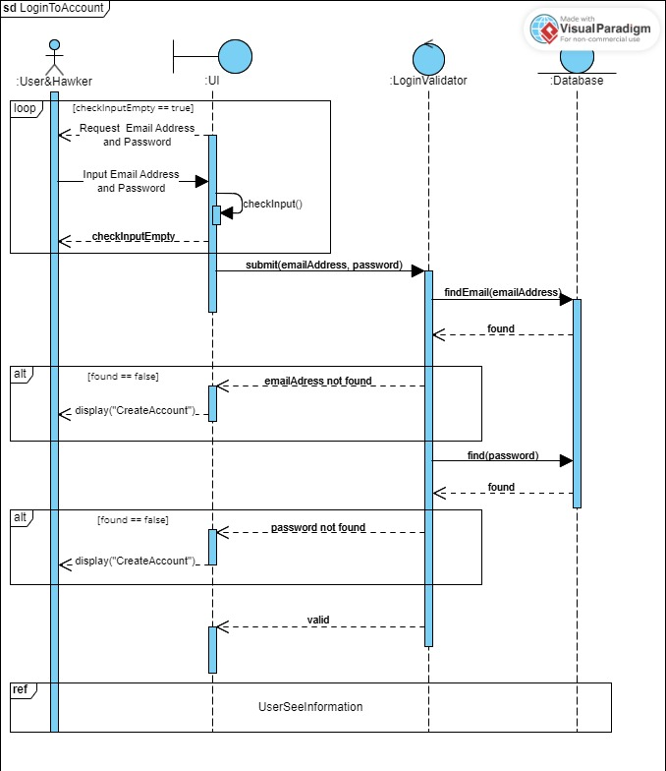

Use Case ID: 02B

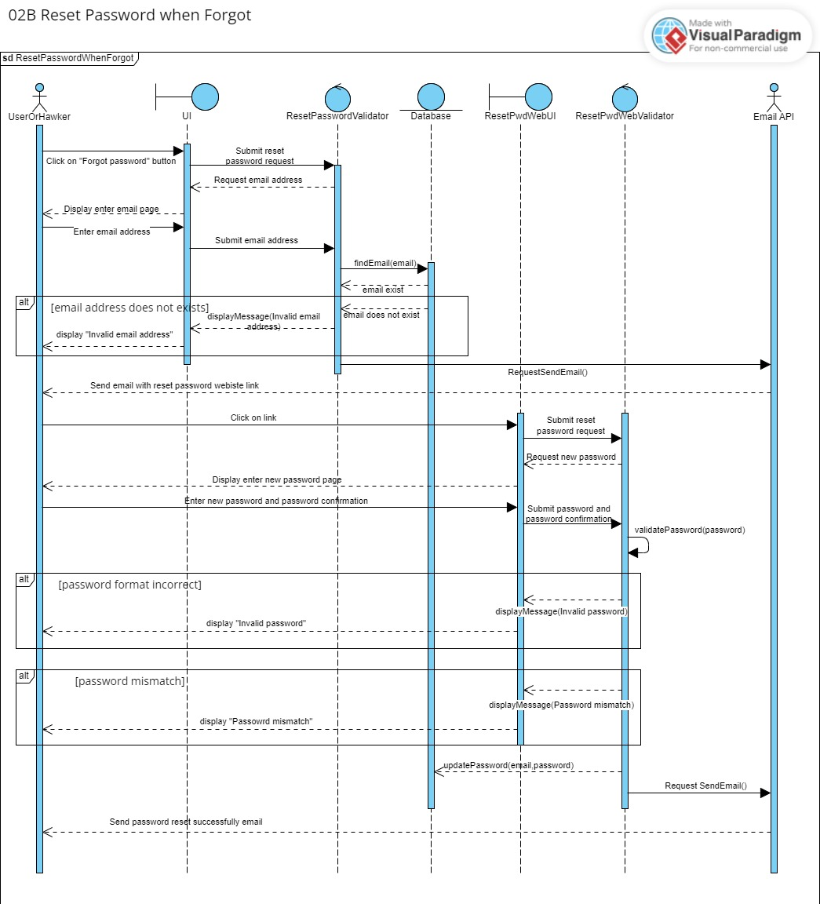

Use Case ID: 03A

Use Case ID: 03B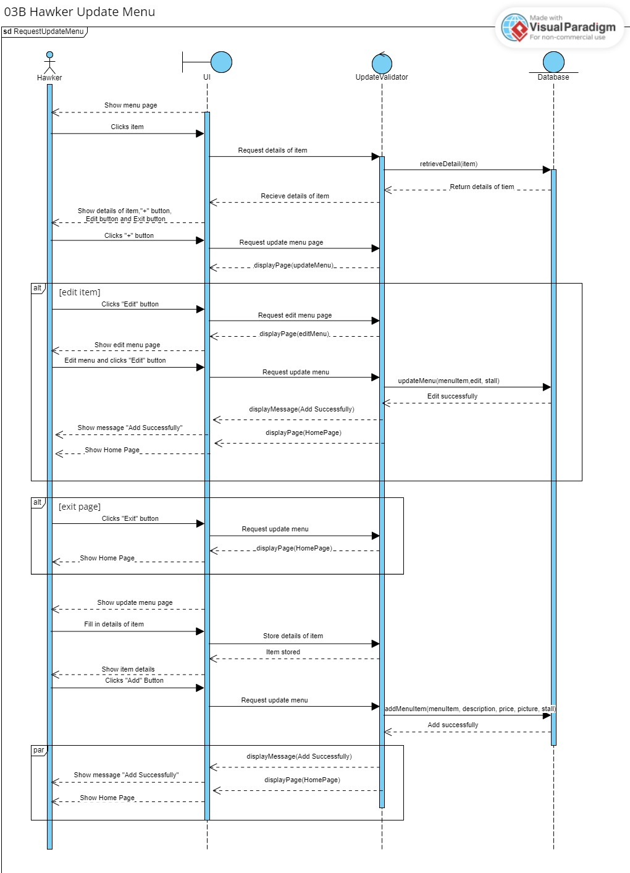

Use Case ID: 03C

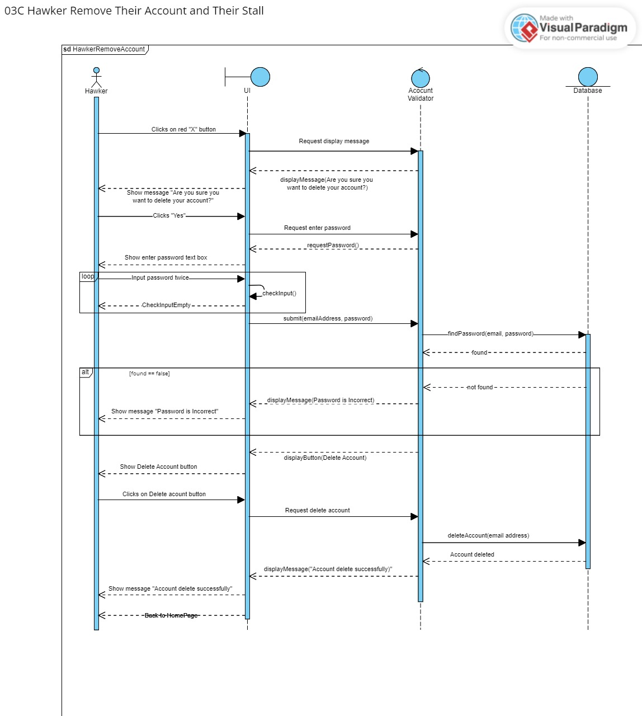

Use Case ID: 04A

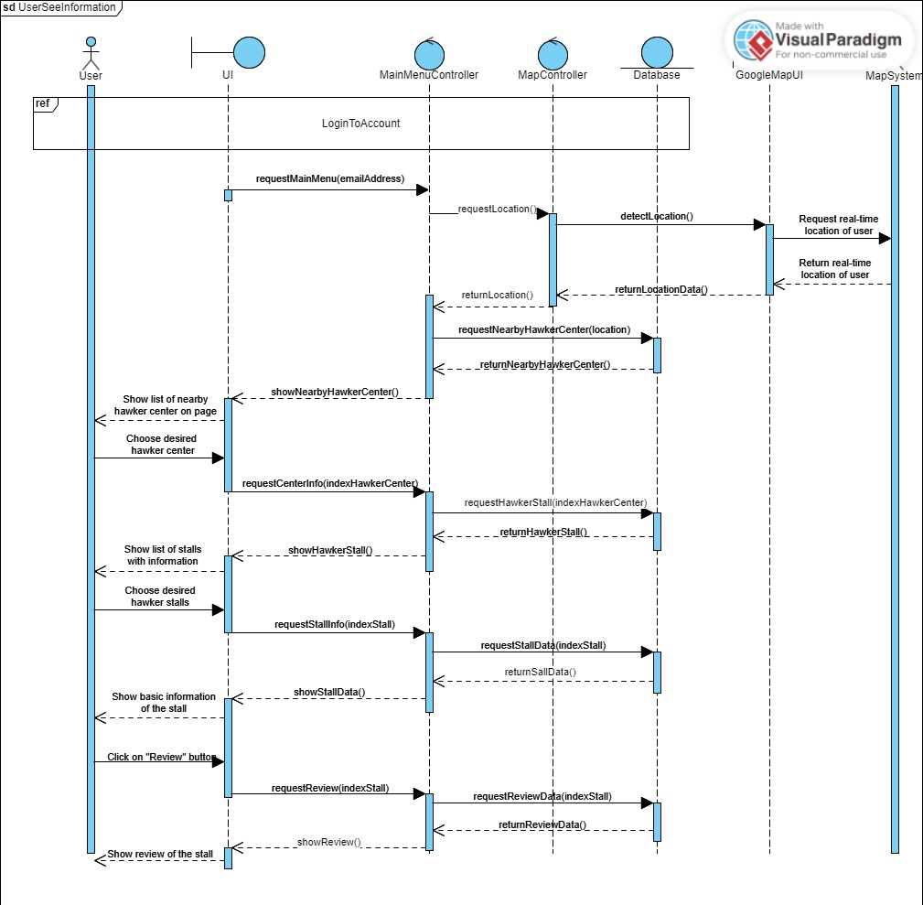

Use Case ID: 05A

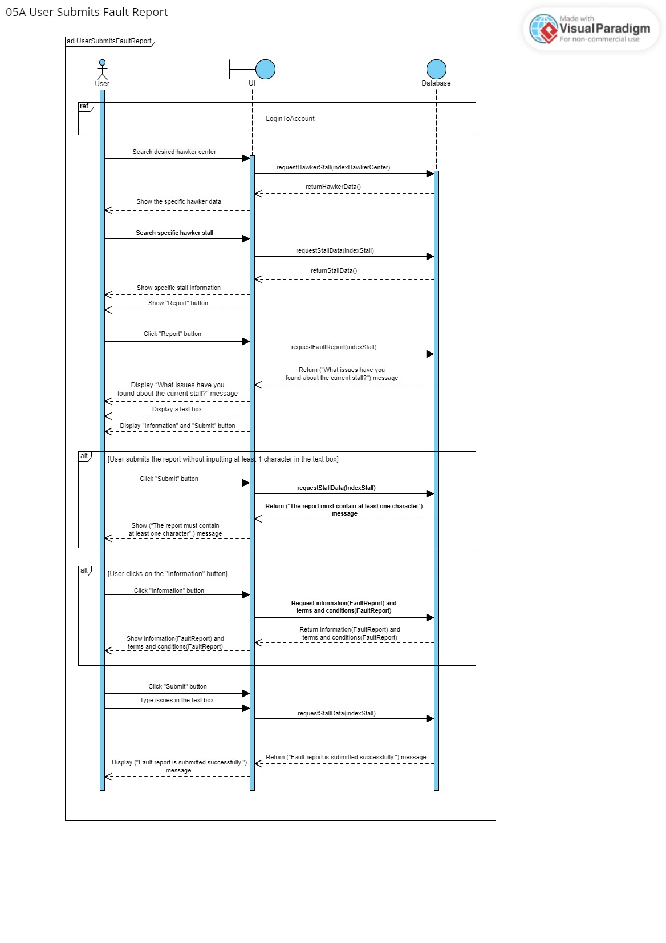

Use Case ID: 06A

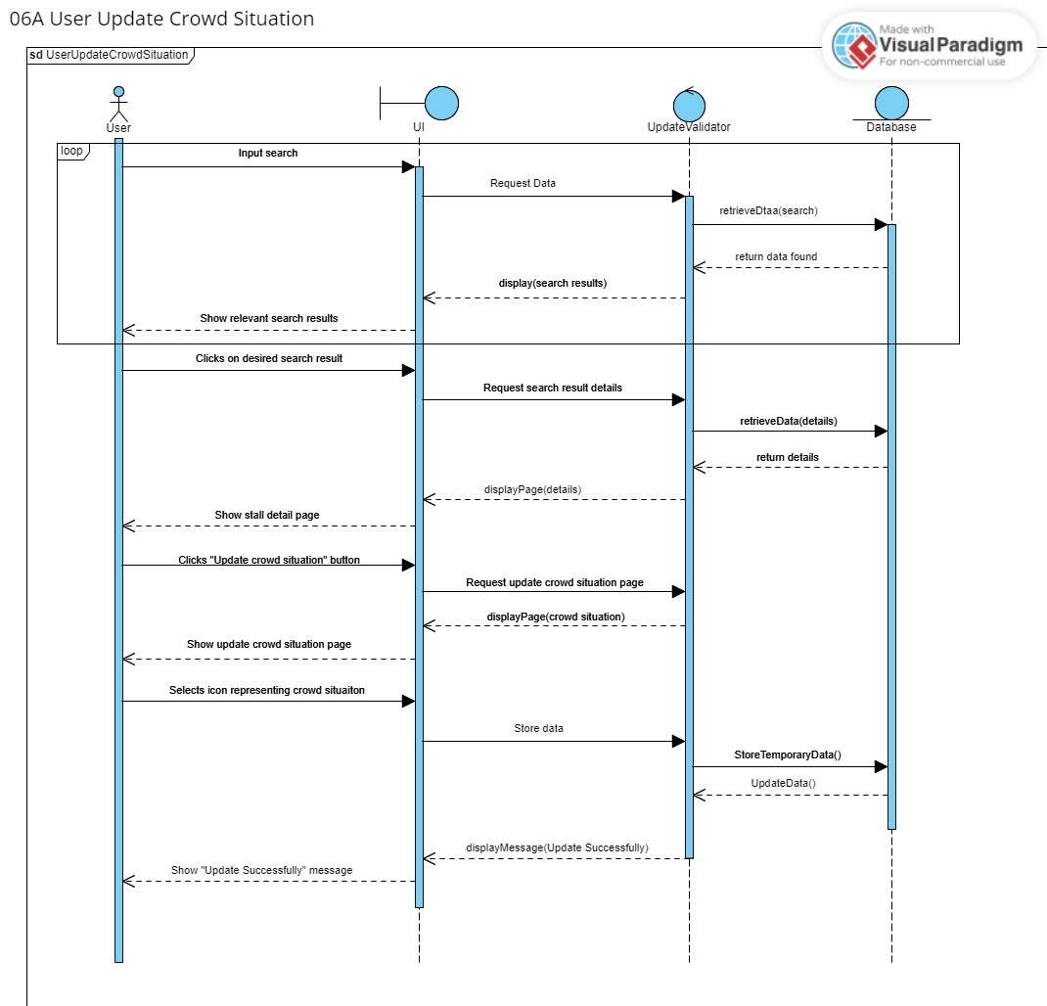

Use Case ID: 07A

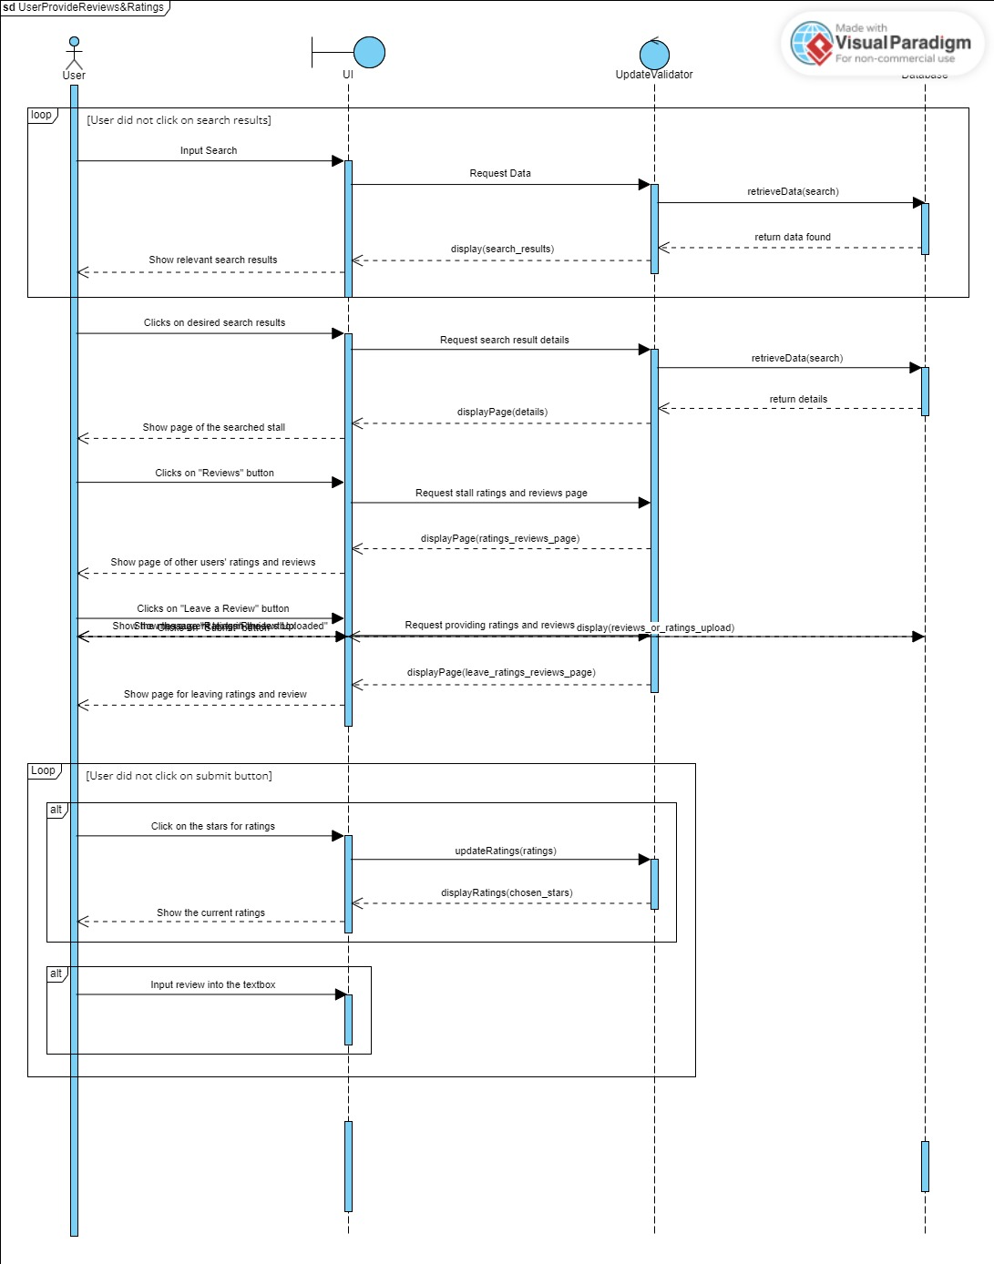

Use Case ID: 08A

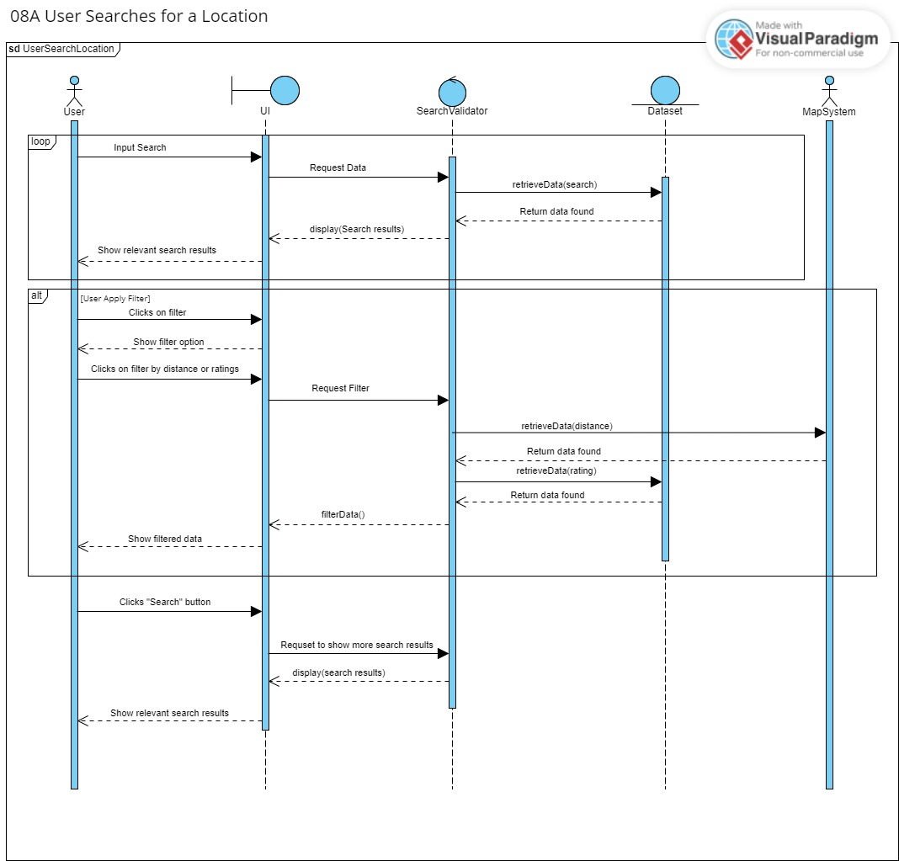

Use Case ID: 09A

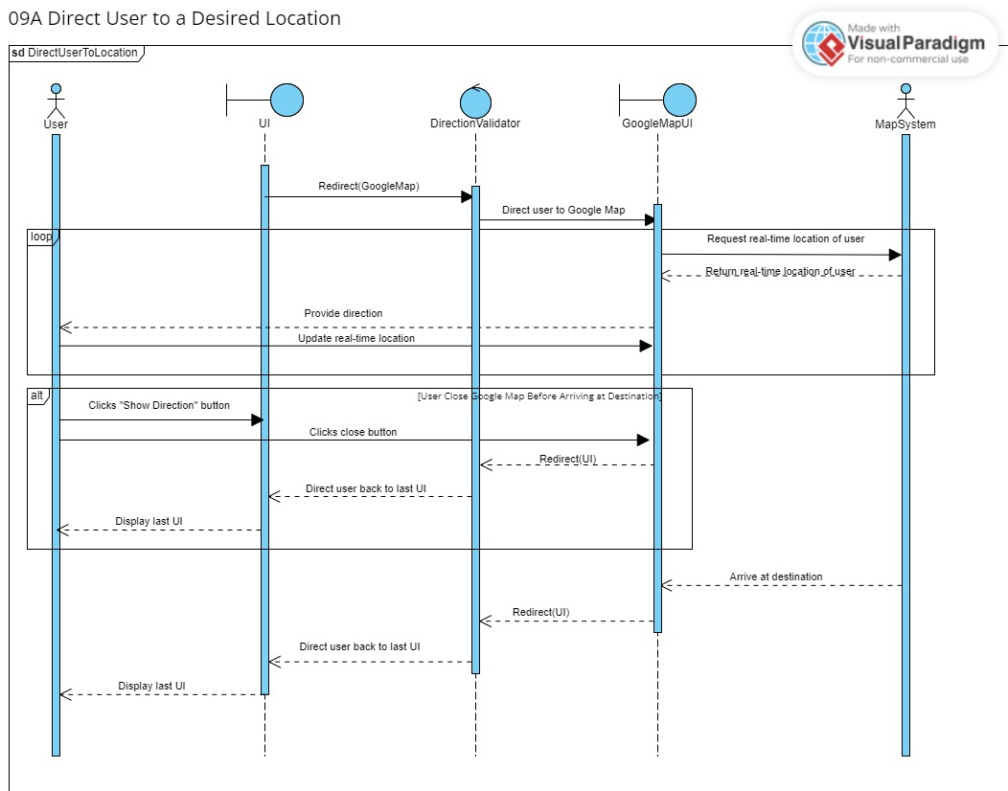

**Initial Dialog Map**

