

Worldly Travelers

Leila Nalivkina, Lisa Jowett, Paignton Wild | CMPS-253-SA1 | OCT 20, 2021

# IDENTIFY PROJECT IDEA

We are going to develop a travel (term) website. With the world changing due to COVID-19, travelers are searching for a reputable source of safety information when they are planning travel. COVID-19 has been particularly difficult for people looking to travel because there is so much uncertainty in government policies. Restrictions are being put into place and lifted on a daily basis. Our website will focus heavily on safety and transparency to give the customer the best vacation possible.

The primary problem that our project will address is the lack of safety information and flexibility that other travel websites provide. Health concerns are at an all-time high due to the global pandemic. For customers to feel safe when traveling, they need to have the most up to date information on health restrictions of the place they are departing from (country, Province, state, etc.) and the current health restrictions of the locations that they will be travelling to.

When we conducted our user research the theme of safety, cost, and relevant travel information came up frequently. With so much information available on Google it is easy to get lost in irrelevant information. By providing a “one stop” location for travel information we can help our users reduce the time it takes for them to conduct their research.

By clearly showing the customer the price that our website charges to book their trip, we can allow them to make an informed decision on whether it is worth it to book with our company. Another important theme that became apparent is access to user reviews. We will be creating an easy-to-understand star rating system that will also allow users to write their own personalized reviews. We will also create a “top 10” locations to safely travel during the pandemic.

We expect our system to be used by anyone who is planning to travel, either locally or internationally. Customers who travel locally may only use our website to find COVID-19 information and book accommodation. International customers will need information on what type of restrictions are in place at their intended destination, and what type of proof of vaccination is required. We also expect businesspeople to use our website to find the most up to date information on COVID-19 travel policies.

Lastly, our website will also provide a space for hotels and other types of accommodation to advertise their services. By steering them in the direction of focusing on their safety protocols, we can show customers why it is safe to stay with them.

# IDENTIFY TWO STAKEHOLDERS AND AT LEAST TWO USERS

**Stakeholders:**

1. Software Developers care about the new system that will be implemented as they will be working on it daily. To advance in their career, they will be fully immersed in the project and ensure that it gets completed. They would require advanced training (such as a Computer Science degree or Software Development diploma) to be able to implement and maintain the product. They should be at a senior level to be able to work on the project. They should be fluent in languages such as Java/Javascript, Python, CSS, HTML, and PHP. Developers can be of 18 years of age or older, and of any gender/ethnicity/sexual orientation.
2. Customer service representatives care about the new system that will be implemented as they will have to use it during their entire work shift. The system should be easy enough to navigate so that no advanced training is necessary. On the job training should be sufficient. Customer service representatives will need to be trained on the ins and outs of the system to provide a fast, smooth experience for customers. They can be of legal working age or older, and of any gender/ethnicity/sexual orientation.

**USERS:**

1. Eric Ramone, between the ages of 25-40, is a business salesman who enjoys traveling the world. Eric will appreciate the new system for its ease of use when he books his next travel ticket. Eric has a business degree from Harvard University and manages a real estate company.
2. Alice Dolly, between the ages of 40-50, is a content creator as well as a stay-at-home mother who enjoys traveling with her family. She has a degree in the fine arts. Alice will appreciate the new system when she books her next family trip for its flexibility in packaged deals and quick access to current COVID-19 restriction information.

# USER RESEARCH

We created a survey for travelers to determine what kind of hardships they have while planning and/or booking their trip, either for work, tourism, family matters or immigration. We decided to opt-out of personal questions as they are not related to our topics of interest.

The survey provided our responders freedom to choose several options per question. Answering some questions as problems or satisfactions often depend on various things, so we wanted to see as many difficulties and worries/concerns as people experience, to come up with better solutions than those that are currently available.

## Questions of the survey:

* + - 1. Do you use booking websites for planning your trip and buying tickets/booking accommodation?

Options:

* Yes
* No
  + - 1. What is your primary reason for travel?

Options:

* Work
* tourism
* family
* Relocation

1. How often do you travel (overall)?

Options:

* Less than once a year,
* once a year
* twice a year
* three times a year
* many times
* Never

1. How often do you travel inside of your country?

Options:

* once a year
* twice a year
* three times a year
* many times
* very rare
* never

1. How often do you travel outside of your country?

Options:

* once a year
* twice a year
* three times a year
* many times
* very rare
* never

1. What are your biggest challenges in booking a trip? (You can pick many)

Options:

* Price
* Availability
* personal constraints
* COVID restrictions
* To find a suitable ticket/vacation

1. What travel agency website do you use? (You can pick many)

Options:

* Expedia
* Booking.com
* WestJet, Priceline
* Disney Travel
* Costco Travel
* None
* Other

1. Do you book your trip as a separate piece (travel tickets separately from accommodation including buying on separate booking platforms) or as a packaged deal?

Options:

* Separate
* Package
* Mostly separate, once in a while packaged deals
* Mostly packaged deals, once in a while separate

1. Where do you go to find information about travel destinations? (you can pick many)

Options:

* Google
* Travel Agency
* Website of a resort of the destination
* YouTube (watch videos about a place of the destination)

1. What are the biggest challenges you find using an online booking system? (you can pick many)

Options:

* While booking hard to understand/see the final price for the trip
* Customer service
* Searching system is confusing
* There is no “Flex-date” option, Discrepancies in prices
* Can’t find information on safety measures
* Can’t customize packaged deal
* Hard to find answers on very specific questions
* Hard to navigate on the website
* Hard to have a hold of a living person to talk with through worries about the trip

1. What is most important to you when planning a trip (making a booking)? (you can pick many)

Options:

* Ticket prices
* Flexible Options
* Ability to plan the trip by yourself
* Chance to buy a packaged deal (do not worry about anything)
* Special needs options
* Personal experience dealing with certain companies
* Opinion of my friends/or loved one
* Travel Agency

1. What payment method do you prefer to use?

Options:

* Credit card
* BitCoin
* PayPal
* Other

## Major insight from user research

1. Question 1 pie chart

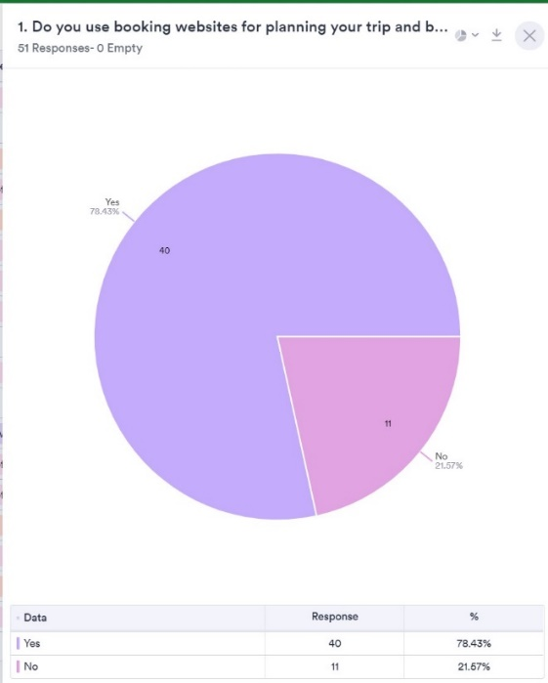

Fig 1

1. Question 2 pie chart

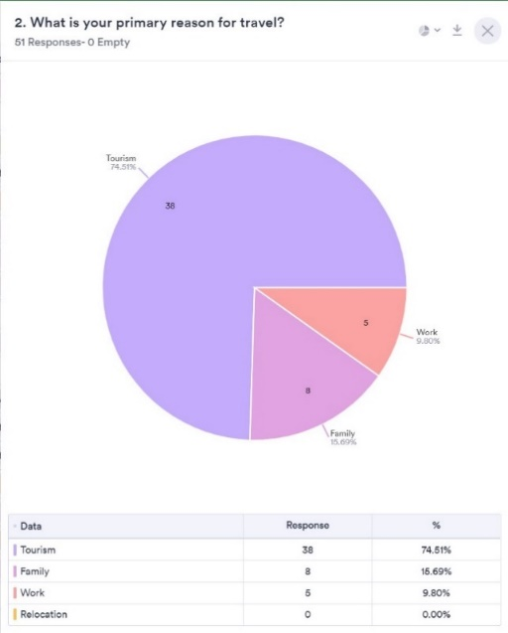

Fig 2

1. Question 3 pie chart

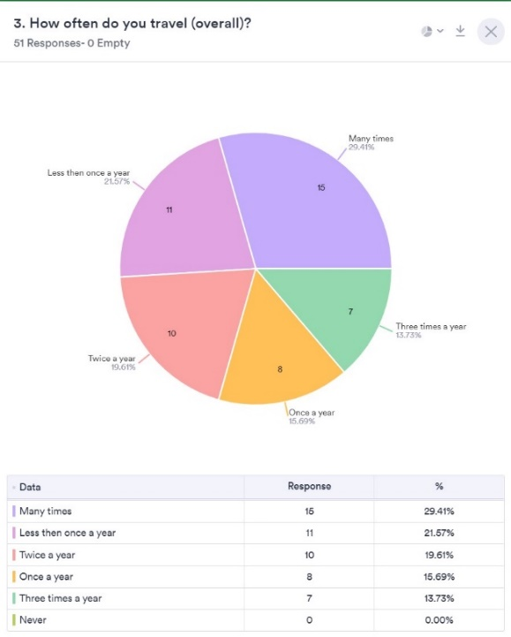

Fig 3

1. Question 4 pie chart

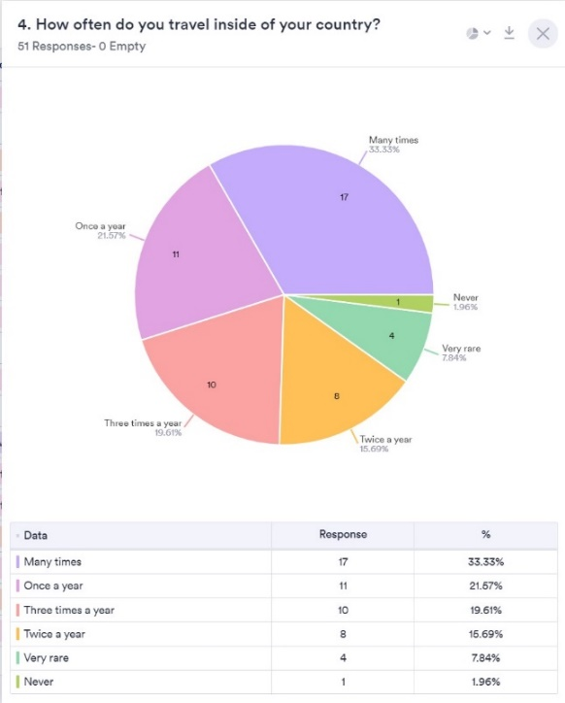

Fig 4

1. Question 5 pie chart

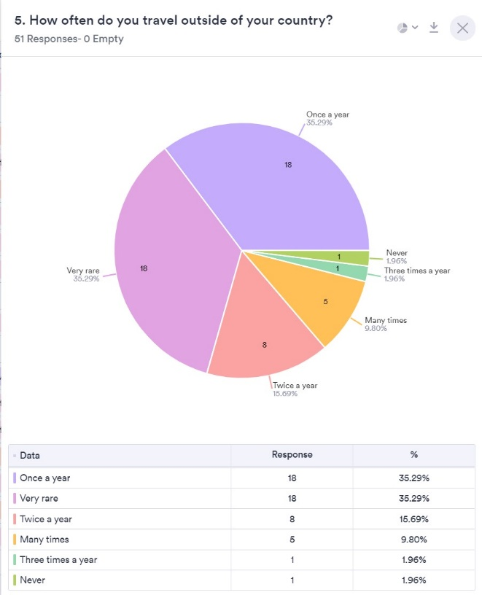

Fig 5

1. Question 6 bar chart

Fig 6

1. Question 7 bar chart

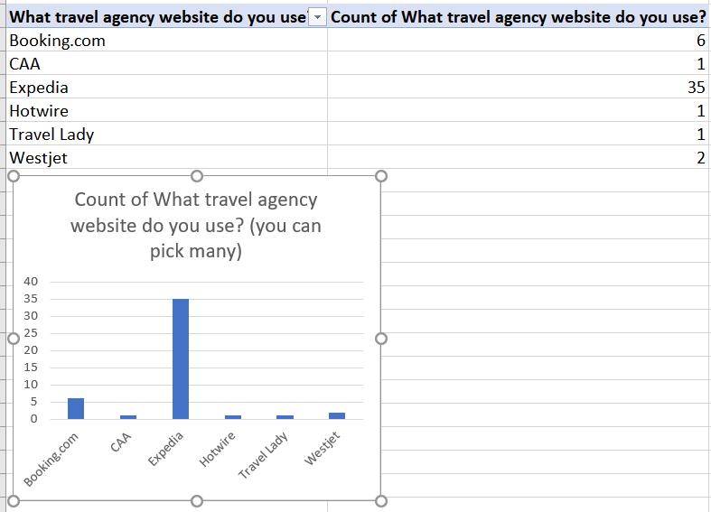

Fig 7

1. Question 8 pie chart

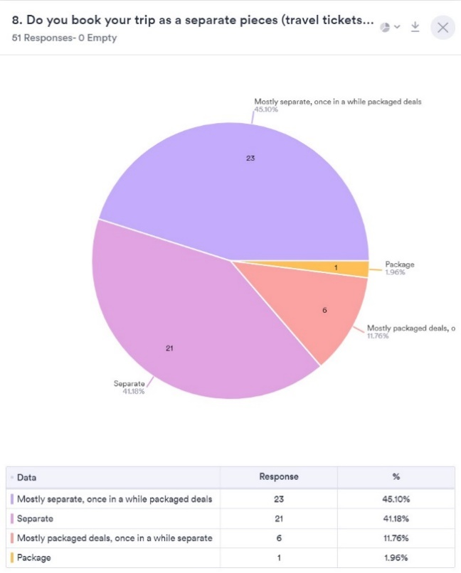

Fig 8

1. Question 9 bar chart

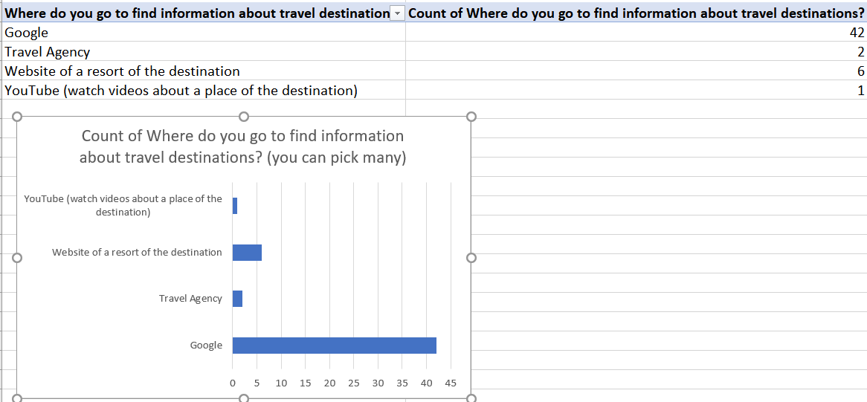

Fig 9

1. Question 10

Fig 10

1. Question 11 bar chart

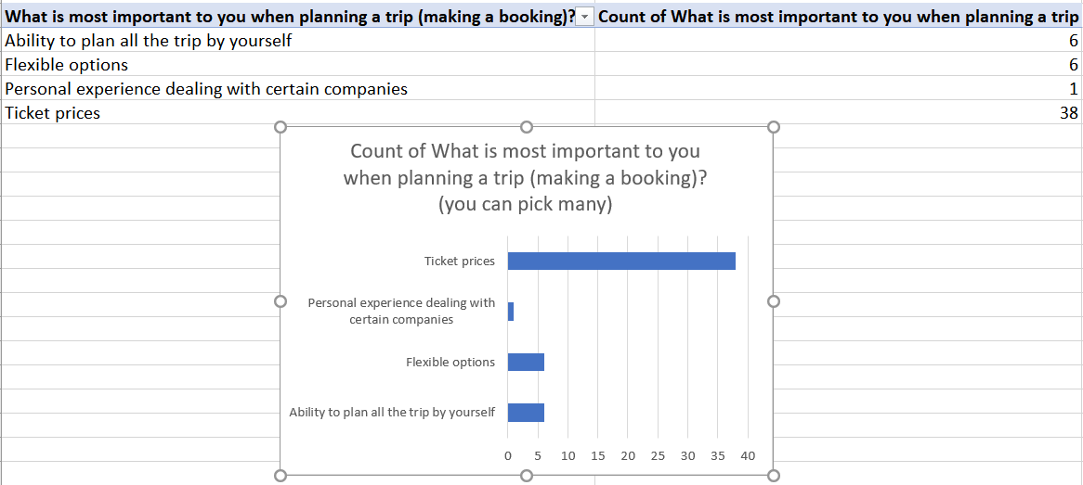

Fig 11

1. Question 12 pie chart

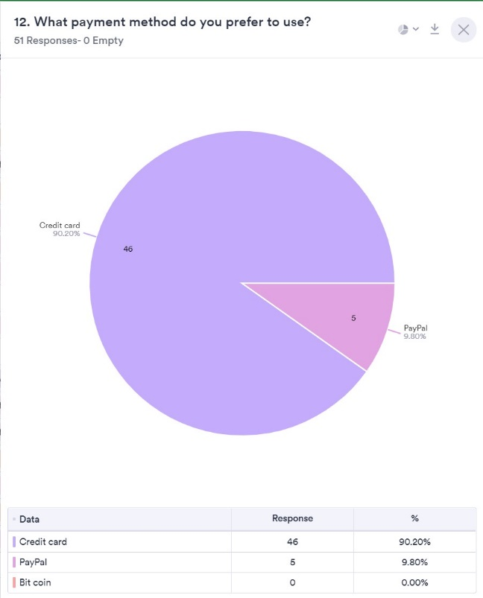

Fig 12

## Major insights from our survey

According to the data collected, 33% of responders travel outside of their country, with 35% traveling very rarely outside of their country. What was interesting to see is that another 35% are those who visit other countries do so at least once per year (prior to COVID-19).

Nearly 79% of responders are using booking websites to purchase travel tickets and accommodation, the primary reason being tourism. 41% of the survey participants stated that they will buy their trip in separate pieces. Prior to deciding where to go, about 84% of survey participants use the various resources on google to find information about their planned destination. Once the search is done, 70% would book their vacation on Expedia.com.

One of the major insights from our survey is that 48% of responders said that they have a hard time finding an answer to a particular question when using a booking system, and another 48% said that their biggest challenge is discrepancies in prices. When answering the question about the most important part in planning their trip, 76% of participants picked “ticket prices”.

Besides the above indicated insights, some of the answers that are worth mentioning are: concerns on COVID-restrictions and safety information, as well as flexibility options and customization of packaged deals.

## Empathy map

## User personas

1. Persona 1:

1. Persona 2:

## User need statements

**Eric:**

1. **Working as a salesperson, Eric, single, needs an easy and quick way to book travel tickets because time is money.**

* When we conducted our survey, we found that the majority of the people who completed the survey stated that pricing was the main concern.

1. **To safely schedule client meetings, Eric needs to see clear information about COVID restrictions, since he travels frequently for work.**

* Safety concerns are top priority for people traveling in a post pandemic world.

1. **With his fast-paced lifestyle, Eric needs to be able to quickly find answers about upcoming trips/travels, so that he can spend more time doing his job.**

* When we conducted our verbal/video interviews the interviewees expressed that conducting travel research was very time consuming.

**Alice:**

1. **Being a multitasking content creating mother of 3, needs quick access to COVID-19 restriction information, to make the best decision for her family when they travel.**

* According to results of our survey, some responders are worried about COVID-related restrictions and the lack of information on safety measures. On top of that, a lot of them indicated that it is very hard to find an answer for a specific question.

1. **For Alice to plan the greatest trip she needs more flexibility on packaged deals so she can pick the most fulfilling experience for her family vacation.**

* Flexible options and customized packaged deals are not the first choice of our responders, but, according to question 8, a whopping 45% of responders say that they book their vacation mostly separate, but sometimes as a package, and 12% who book mostly packaged deals, we can say that flexibility and customization are worth investigating.

1. **Being a budget conscious mother, needs to find the cheapest ticket prices so she can save money for more memorable experiences with her family.**

* Looking at figures 6 and 11, we can conclude that the question of ticket prices is the most important for our responders.

## Customer journey map

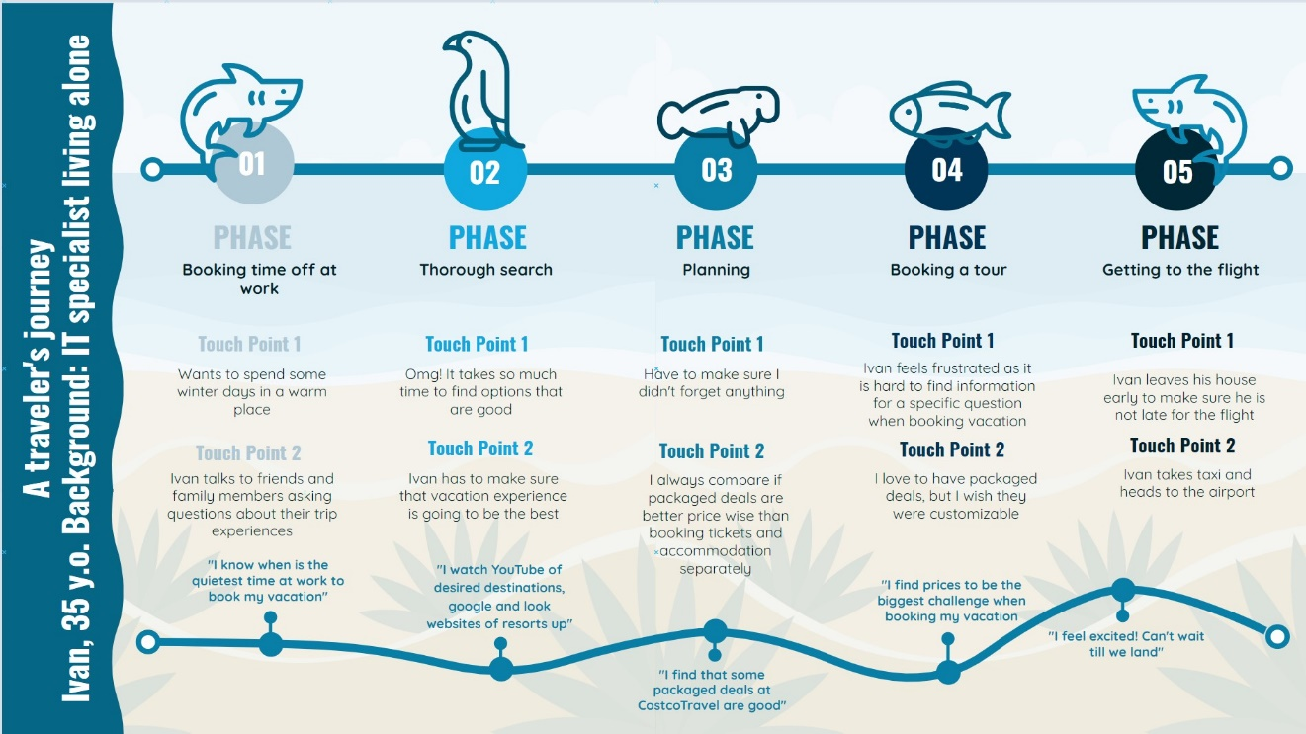

# PROPOSED LIST OF FEATURES

**Must Do:**

* + - 1. Provide a simple UI interface so customers can explore their travel options.
      2. Use the CRAP design philosophy effectively to create a visually pleasing and easily navigable website.
      3. Utilize the ideas of Contrast and Proximity to draw the user's attention to the safety information and primary search area.
      4. Include an easily navigable user review section.
      5. Create an unbiased price comparison feature.
      6. Provide clear information on the ways that the travel website makes money. Do not hide the cost incremental price increases in every aspect of booking the travel plan.
      7. Provide fast and reliable customer service to make sure the customer always feels like they are being cared for. Another important feature of our website will be the customer service team. It's extremely important that the customer feels that they are always being looked after.
      8. Allow for fast refunds if COVID-19 restrictions force the customer to change their plans. Allowing our travel packages to be flexible will also be a critical advantage that we will have over our competitors.

**Should Do:**

1. Provide a “top 10” destinations to travel during a global pandemic. Rate them based on the safety and stability of government policies.
2. Include a Tips section that provides answers to FAQ (frequently asked questions) and helps make the travel process easier.
3. Show of some beautiful photos of travel destinations to encourage people to go on their “dream vacations”
4. Create different sections depending on the needs of the customer (local travel, vacation travel, business travel etc.).
5. Connect the user to safe transportation options.

**Could Do:**

1. Create a mobile application so the customers can keep all their travel information in one place. Add features like apple wallet so the user can upload any important documents information (vaccination status, negative covid result test etc.)
2. Partner with major companies in other industries such as Uber, Air BnB and airline companies.
3. Add a featured cruise section to highlight deals or exclusive offers.
4. Add an option to book transportation directly through the website.
5. Move the website to a subscription-based service to ensure that there is a regular cash flow.

Feature: Real time updates directly from Twitter or any other reliable source of government information. There will also be a date/time that is updated regularly to ensure that the information being given to the customers is as up to date as possible.

# CITATION:

Link to the survey: <https://form.jotform.com/212755757513057>

Citation: <https://www.nngroup.com/articles/user-need-statements/>

Customer Journey Maps templates: <https://online.visual-paradigm.com/drive/#infoart:proj=0&new=CustomerJourneyMaps>

Visual Paradigm Online, *Understand Customer Journey Map.* Accessed on: Oct. 6, 2021. [Online]. Available:https://online.visual-paradigm.com/app/diagrams/#infoart:proj=0&type=CustomerJourneyMaps&gallery=/repository/66b47699-b306-44d0-8fc6-5160aedb4be2.xml&name=Understand%20Customer%20Journey%20Map

Empathy Map template:

https://www.invisionapp.com/freehand/templates/detail/empathy-map-template

User Persona Template: <https://xtensio.com/user-persona-template/>