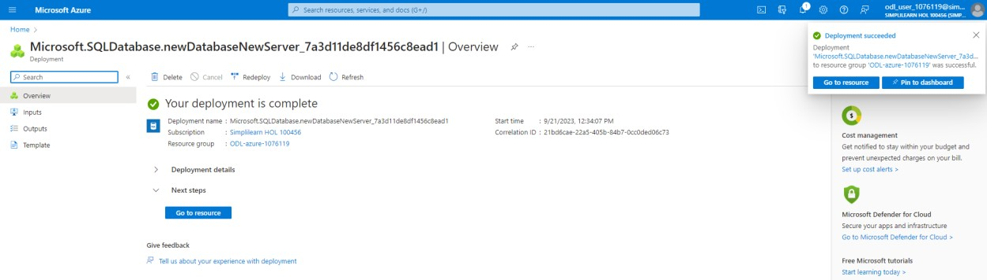

Create a docker image and container

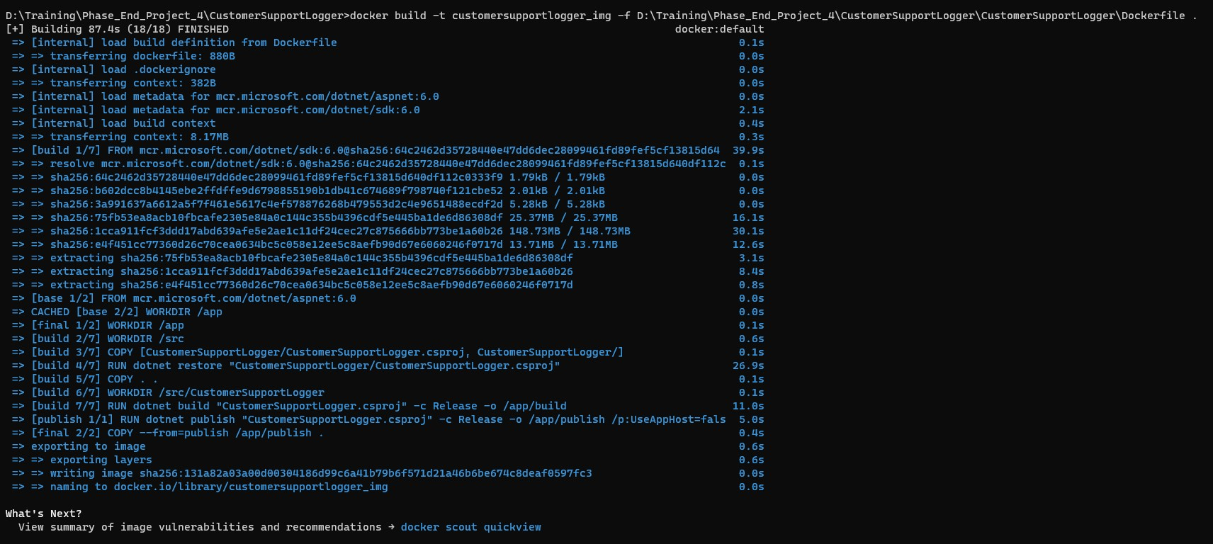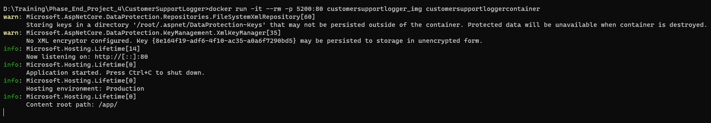

Container is running in the localhost:5200

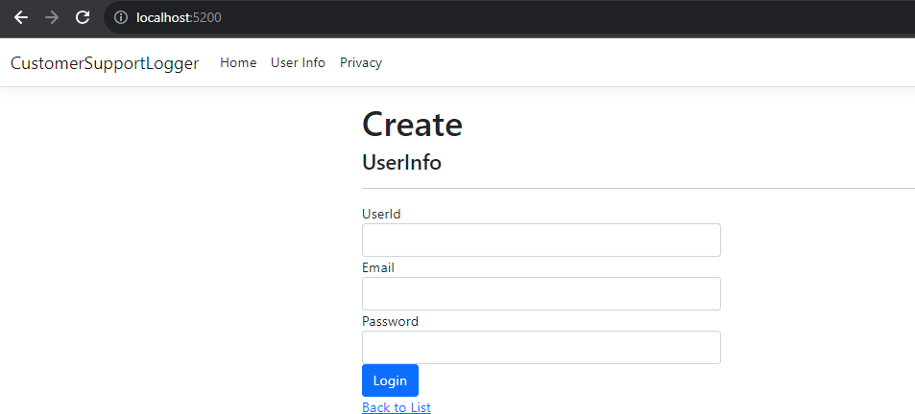

**Output of the Project**

Creating table in Azure SQL Database

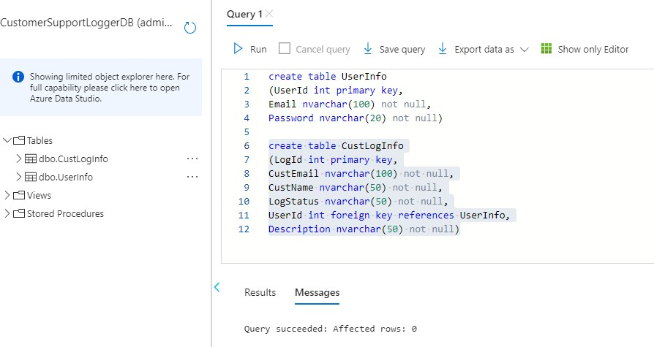

CustLogInfo

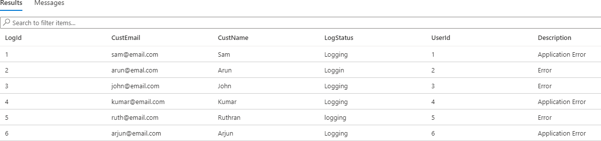

UserInfo

