Student Name- Aditya Singh
Section -A
Roll number -37
AeroVibe Travel

A professional, editorial-style travel platform for discovering and booking premium flight experiences. Designed with a focus on sophisticated typography, generous whitespace, and a minimalist aesthetic.

Features

- Editorial Home - A stunning landing page with high-quality visual storytelling and curated highlights.
- Global Exploration - Discover destinations through an intuitive search and filtering system.
- Flight Intelligence - Detailed flight views with pricing, route metadata, and service class badges.
- Premium UI - Clean, light-mode interface inspired by high-end studio design.
- Micro-Animations - Smooth fade-ups, shimmers, and float effects for a refined user experience.
- Responsive Layout - Fully optimized for seamless browsing across desktop and mobile devices.

Tech Stack

- Frontend: React 19 (Hooks, Router)
- Icons: Lucide React
- Build Tool: Vite
- Styling: Vanilla CSS3 with CSS Variables and Custom Design Tokens
- Typography: Inter (Sans-serif) & Playfair Display (Serif)

Project Structure
text
AeroVibe-Travel/
├── src/
│ ├── pages/
│ │ ├── Home.jsx Editorial landing page
│ │ ├── Explore.jsx Search and flight discovery
│ │ └── FlightDetails.jsx Individual flight information
│ ├── components/
│ │ └── Navbar.jsx (in App) Navigation and brand identity
│ ├── App.jsx Main routing and global layout
│ ├── App.css Component-specific styles
│ ├── index.css Design system and global tokens
│ └── main.jsx Entry point
├── public/
├── package.json
├── vite.config.js
└── index.html
Design & Styling

- Primary Background: Soft Stone (` f7f6f4`)
- Accent Color: Timeless Gold (` c5a46d`)
- Typography:
- Body: Inter (Modern & highly legible)
- Headers: Playfair Display (Sophisticated & editorial)
- UI Architecture: Glassmorphic navbar, custom-built grid systems, and subtle depth through shadows.

Key CSS Features
- Design Tokens: Extensive use of CSS variables for consistent spacing and color.
- Glassmorphism: Frosted glass navbar with `backdrop-filter`.
- Custom Animations: Hand-crafted `fadeUp` and `shimmer` keyframes.
Theming: Minimalist "Paper & Ink" theme with gold highlights.

Screenshots

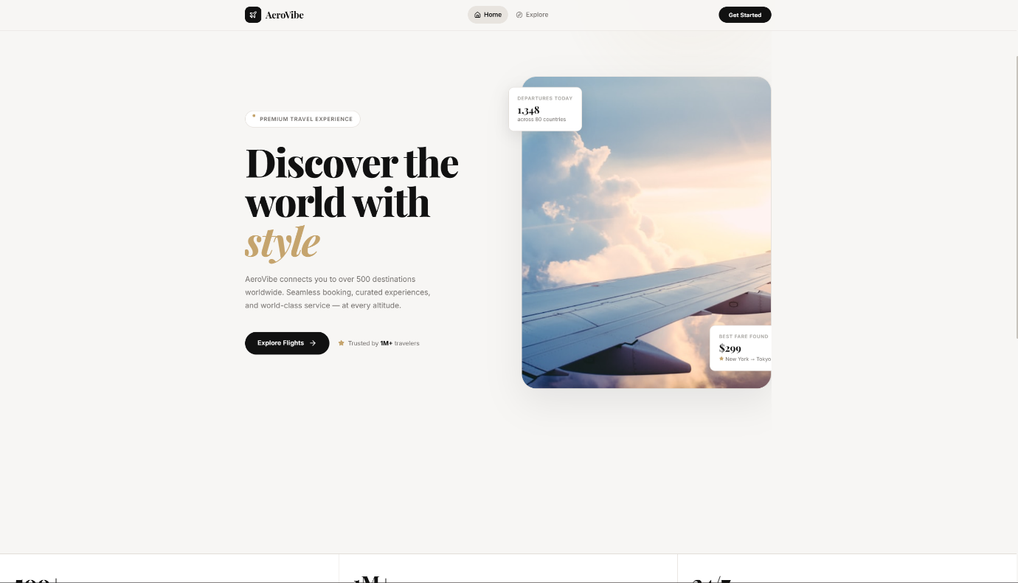
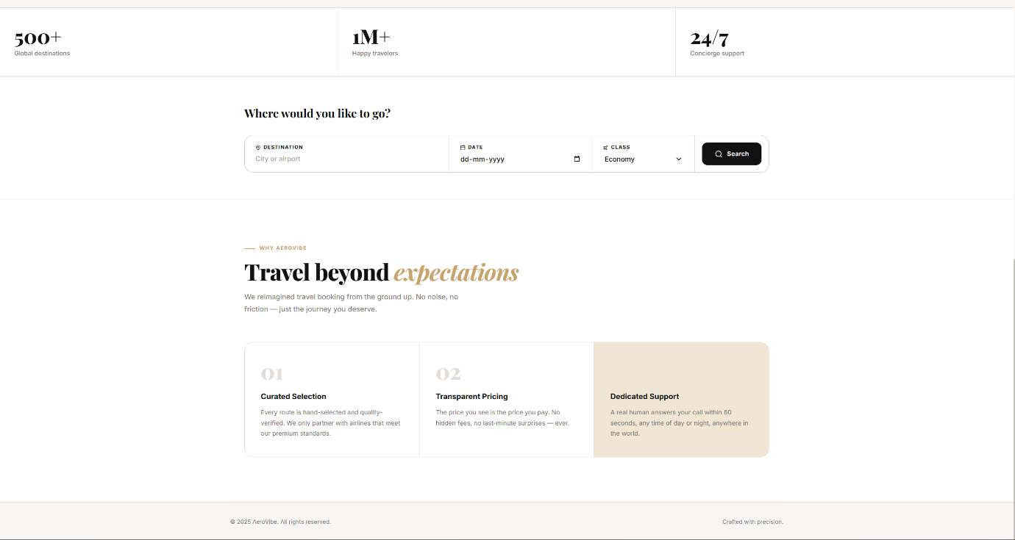
Home Page:-

Explore Page 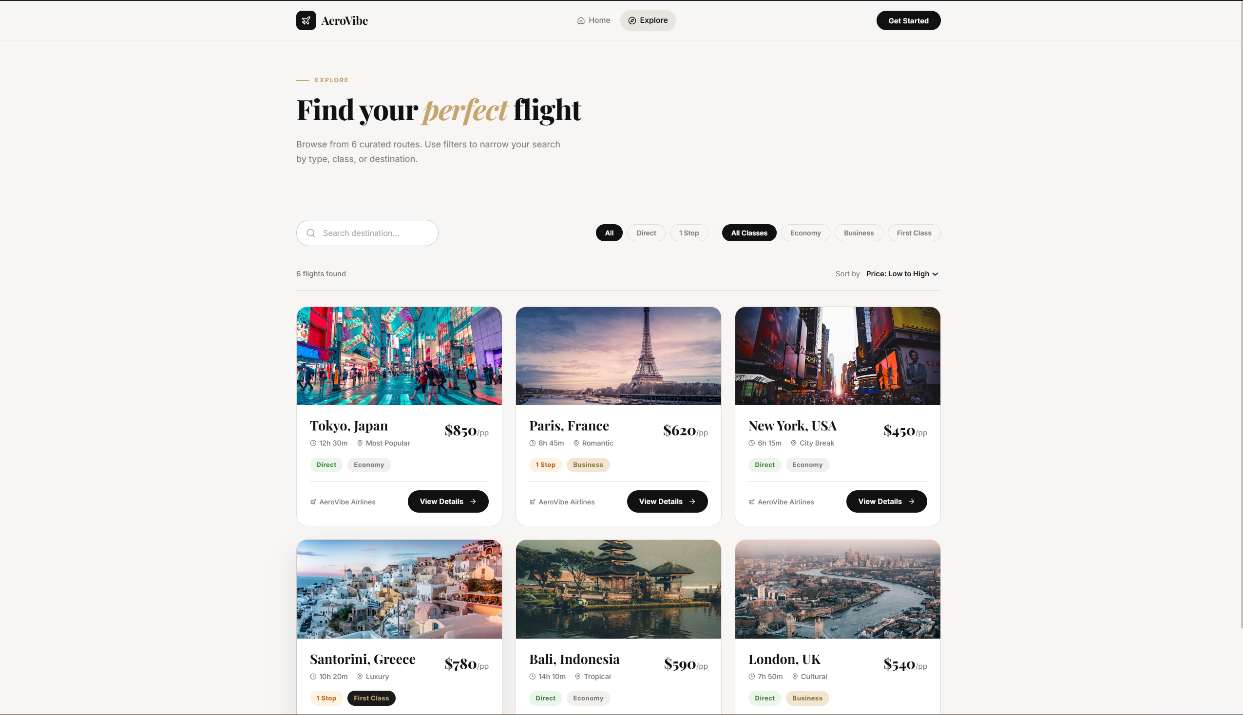

Booking Page:-
