**МГТУ им. Н.Э. Баумана**

Дисциплина: Архитектура ЭВМ

Лабораторный практикум №4 по теме:

«Исследование счетчиков»

Работу выполнила:

студентка группы ИУ7-45

Овчинникова А. П.

Вариант 18

Работу проверила:

Крыгина Т.Д.

2019

Цель работы – изучение принципов построения счетчиков, овладение методом синтеза синхронных счетчиков, экспериментальная оценка динамических параметров счетчиков, изучение способов наращивания разрядности синхронных счетчиков.

1. Четырёхразрядный синхронный суммирующий счётчик.

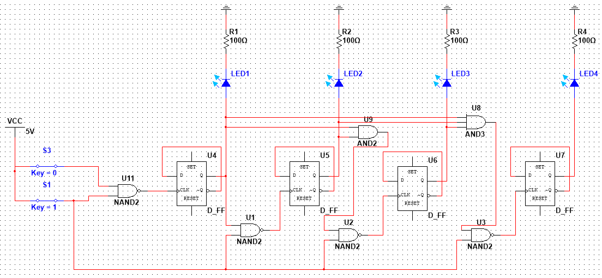

2. Счетчик по варианту (0,1,2,4,5,6,10,11,13,14)

| Q | Q* | J | K |
| --- | --- | --- | --- |
| 0 | 0 | 0 | A |
| 0 | 1 | 1 | A |
| 1 | 0 | A | 1 |
| 1 | 1 | A | 0 |

| N | Q3 | Q2 | Q1 | Q0 | Q3* | Q2* | Q1* | Q0* | J3 | K3 | J2 | K2 | J1 | K1 | J0 | K0 |
| --- | --- | --- | --- | --- | --- | --- | --- | --- | --- | --- | --- | --- | --- | --- | --- | --- |
| 0 | 0 | 0 | 0 | 0 | 0 | 0 | 0 | 1 | 0 | A | 0 | A | 0 | A | 1 | A |
| 1 | 0 | 0 | 0 | 1 | 0 | 0 | 1 | 0 | 0 | A | 0 | A | 1 | A | A | 1 |
| 2 | 0 | 0 | 1 | 0 | 0 | 1 | 0 | 0 | 0 | A | 1 | A | A | 1 | 0 | A |
| 4 | 0 | 1 | 0 | 0 | 0 | 1 | 0 | 1 | 0 | A | A | 0 | 0 | A | 1 | A |
| 5 | 0 | 1 | 0 | 1 | 0 | 1 | 1 | 0 | 0 | A | A | 0 | 1 | A | A | 1 |
| 6 | 0 | 1 | 1 | 0 | 1 | 0 | 1 | 0 | 1 | A | A | 1 | A | 0 | 0 | A |
| 10 | 1 | 0 | 1 | 0 | 1 | 0 | 1 | 1 | A | 0 | 0 | A | A | 0 | 1 | A |
| 11 | 1 | 0 | 1 | 1 | 1 | 1 | 0 | 1 | A | 0 | 1 | A | A | 1 | A | 0 |
| 13 | 1 | 1 | 0 | 1 | 1 | 1 | 1 | 0 | A | 0 | A | 0 | 1 | A | A | 1 |
| 14 | 1 | 1 | 1 | 0 | 0 | 0 | 0 | 0 | A | 1 | A | 1 | A | 1 | 0 | A |

J3 = Q1 ∧ Q2

| Q3Q2\  Q1Q0 | 0 0 | 0 1 | 1 1 | 1 0 |
| --- | --- | --- | --- | --- |
| 0 0 | 0 | 0 | - | - |
| 0 1 | 0 | 0 | A | - |
| 1 1 | - | - | -- | A |
| 1 0 | 0 | 1 | A | A |

K3 = Q1 ∧ Q2

| Q3Q2\  Q1Q0 | 0 0 | 0 1 | 1 1 | 1 0 |
| --- | --- | --- | --- | --- |
| 0 0 | A | A | - | - |
| 0 1 | A | A | 0 | - |
| 1 1 | - | - | -- | 0 |
| 1 0 | A | A | 1 | 0 |

J2 = (Q3 ∧ Q0) ∨ (!Q3 ∧ Q1)

| Q3Q2\  Q1Q0 | 0 0 | 0 1 | 1 1 | 1 0 |
| --- | --- | --- | --- | --- |
| 0 0 | 0 | A | - | - |
| 0 1 | 0 | A | A | - |
| 1 1 | - | - | -- | 1 |
| 1 0 | 1 | A | A | 0 |

K2 = Q1

| Q3Q2\  Q1Q0 | 0 0 | 0 1 | 1 1 | 1 0 |
| --- | --- | --- | --- | --- |
| 0 0 | A | 0 | - | - |
| 0 1 | A | 0 | 0 | - |
| 1 1 | - | - | -- | A |
| 1 0 | A | 1 | 1 | A |

J1 = Q0

| Q3Q2\  Q1Q0 | 0 0 | 0 1 | 1 1 | 1 0 |
| --- | --- | --- | --- | --- |
| 0 0 | 0 | 0 | - | - |
| 0 1 | 1 | 1 | 1 | - |
| 1 1 | - | - | -- | A |
| 1 0 | A | A | A | A |

K1 = (Q0) ∨ (Q3 ∧ Q2) ∨ (!Q3 ∧ !Q2)

| Q3Q2\  Q1Q0 | 0 0 | 0 1 | 1 1 | 1 0 |
| --- | --- | --- | --- | --- |
| 0 0 | A | A | - | - |
| 0 1 | A | A | A | - |
| 1 1 | - | - | -- | 1 |
| 1 0 | 1 | 0 | 1 | 0 |

J0 = (!Q1) ∨ (Q3 ∧ !Q2)

| Q3Q2\  Q1Q0 | 0 0 | 0 1 | 1 1 | 1 0 |
| --- | --- | --- | --- | --- |
| 0 0 | 1 | 1 | - | - |
| 0 1 | A | A | A | - |
| 1 1 | - | - | -- | A |
| 1 0 | 0 | 0 | 0 | 1 |

K0 = !Q1

| Q3Q2\  Q1Q0 | 0 0 | 0 1 | 1 1 | 1 0 |
| --- | --- | --- | --- | --- |
| 0 0 | A | A | - | - |
| 0 1 | 1 | 1 | 1 | - |
| 1 1 | - | - | -- | 0 |
| 1 0 | A | A | A | A |

Собранная схема

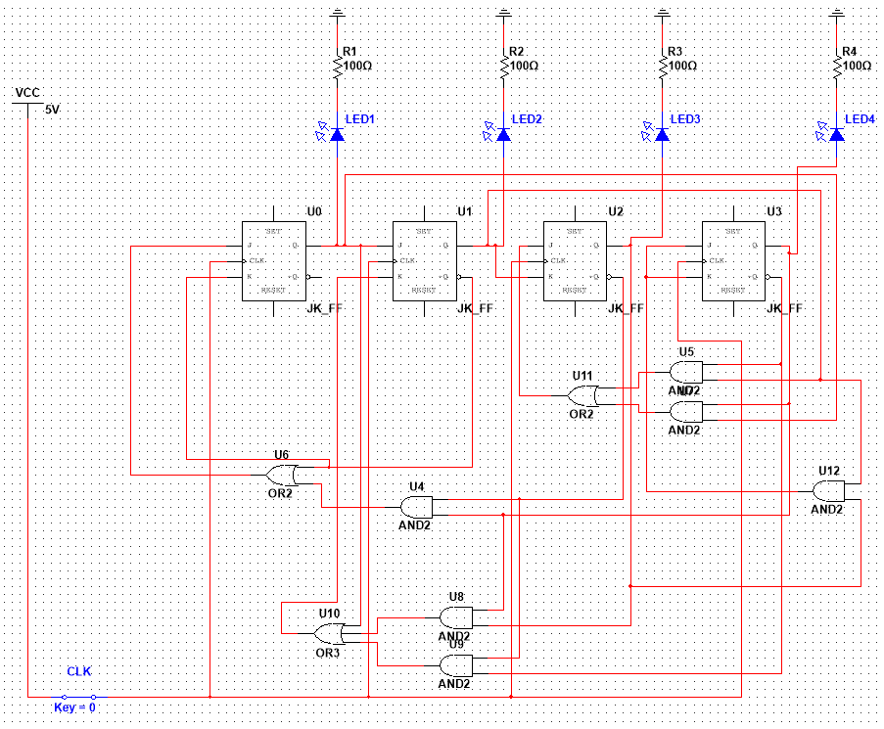

Работа собранной схемы

0



1

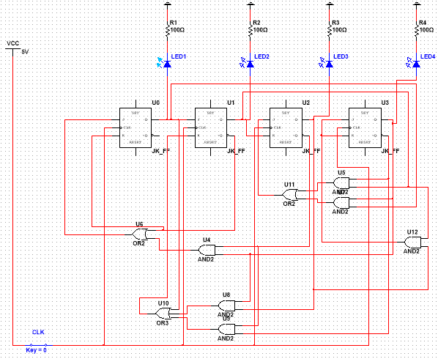

2

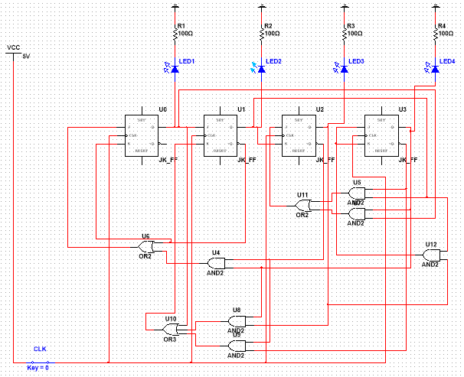

4

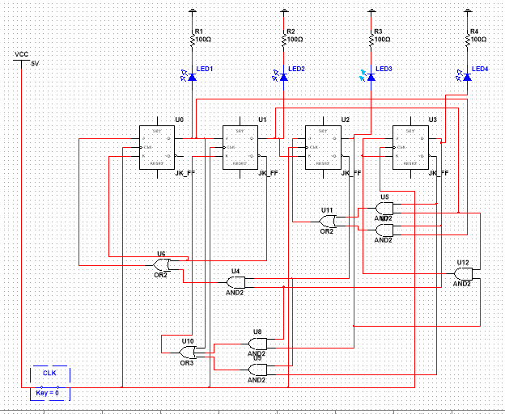

5

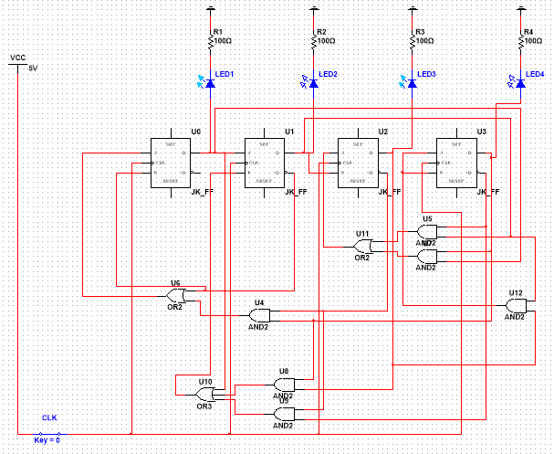

6

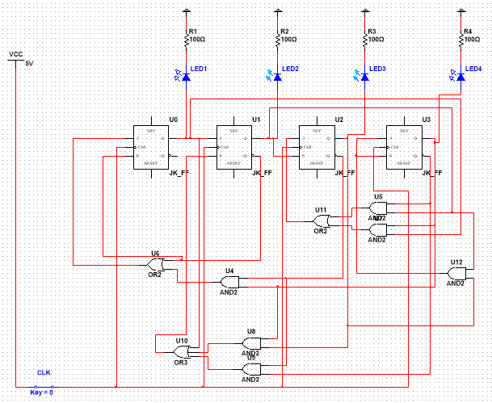

10

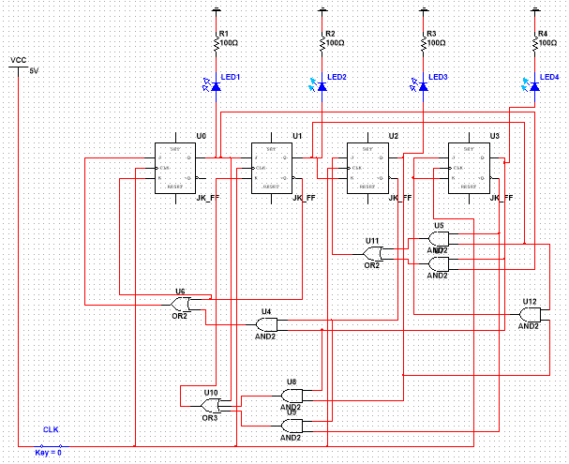

11

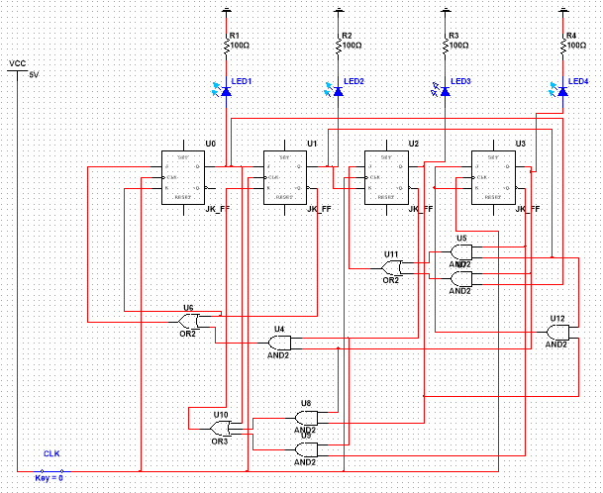

13

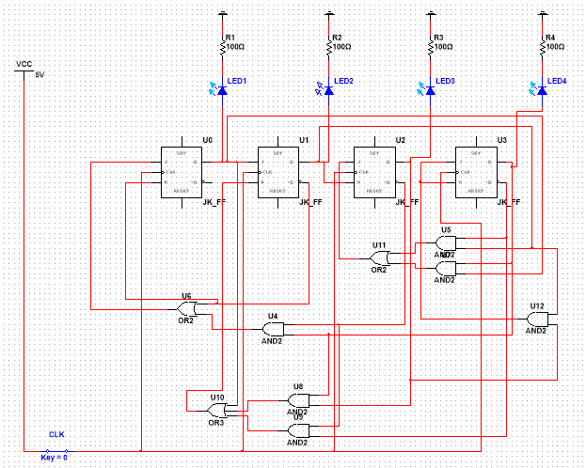

14

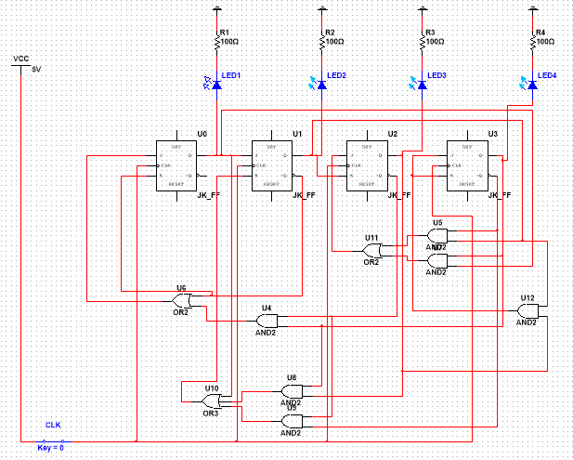

0



3. Счетчик от 0 до 10.

Проводя аналогичные расчеты, получаем:

J3 = Q0^Q1^Q2

K3 = Q1

J2 = Q1^Q0

K2 = Q1^Q0

J1 = Q0

K1 = Q0 v Q3

J0 = !Q1 v !Q3

K0 = 1

Собранная схема

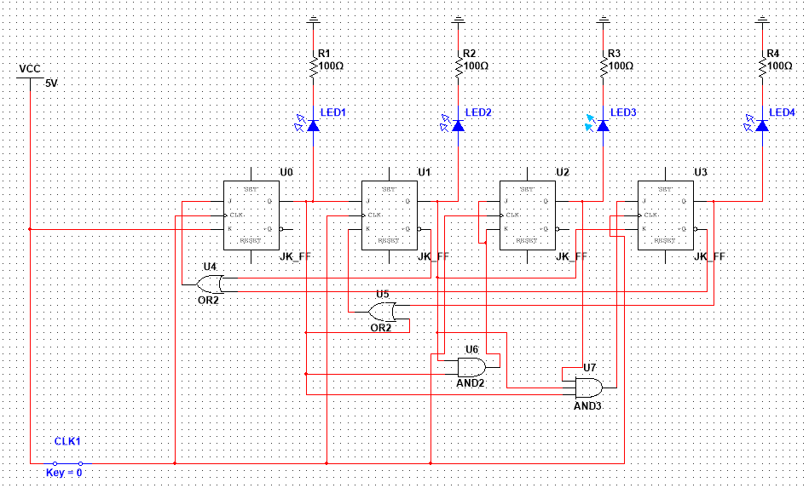

4. Счетчик 74LS160

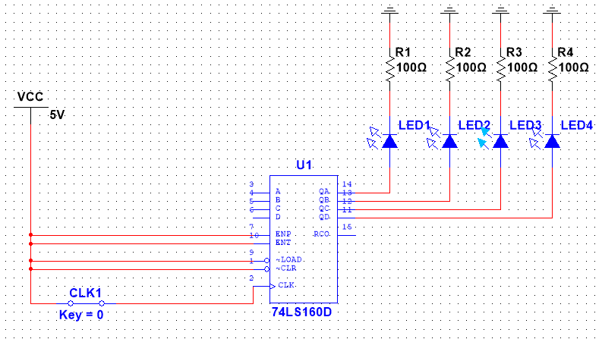

5. Схема наращивания разрядности счетчиков.

