**VP Branch Wise Mapping Details**

You will get this page in LOS on Master>>VP branch wise mapping  
In this page you will get basically two options

1. VP wise
2. Branch wise

After choosing Branch wise option and after choosing creator, branch and click on search button you will get data in table where you will get data like branch code , branch name, email, creator, VP name and also get some other option for performing some operations

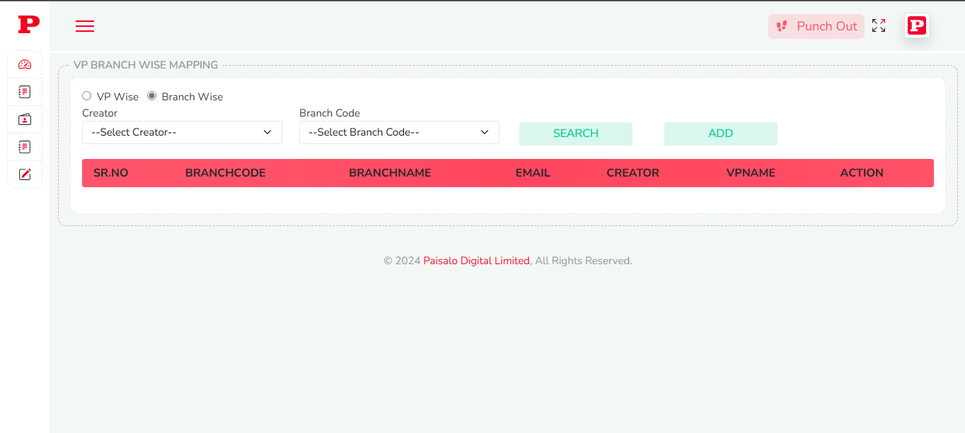And if you want data as per VP wise choose VP wise options and you will get VPs list in dropdown now choose any VP mail id and then you will get all the same data as per above mentioned

**Add new mapping**

On this page you will get Add button on Top corner after click on Add button you will an Popup box where you will get three fields where you will choose VP email, Creator and branch code and after click on submit button new branch will be mapped with VP

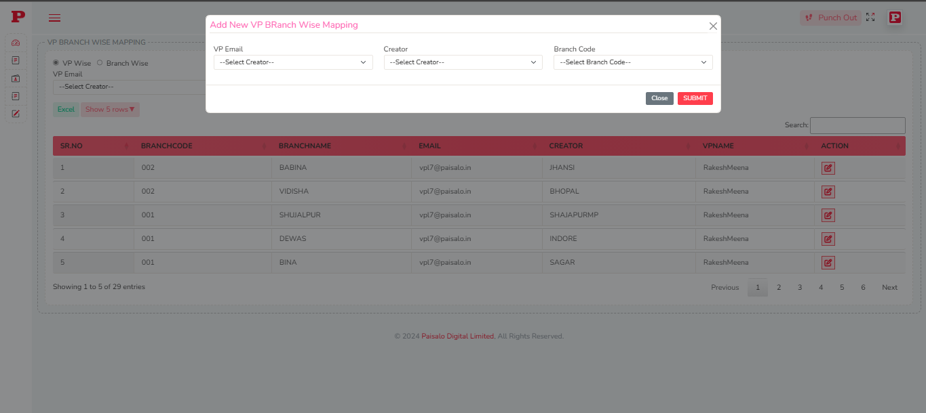

**Update any mapping**

After getting the list of data in the last on any row you will get an action button you will get an another popup in this popup you will again get three fields VP email dropdown, Creator, Branch code where creator and branch code is already disabled basically this option allows you to change VP for any branch so by this popup you can change the VP by selecting VP email and then click on submit VP will be updated for same branch

