HRMS – Complete Page Overview
Login to the New LOS Portal
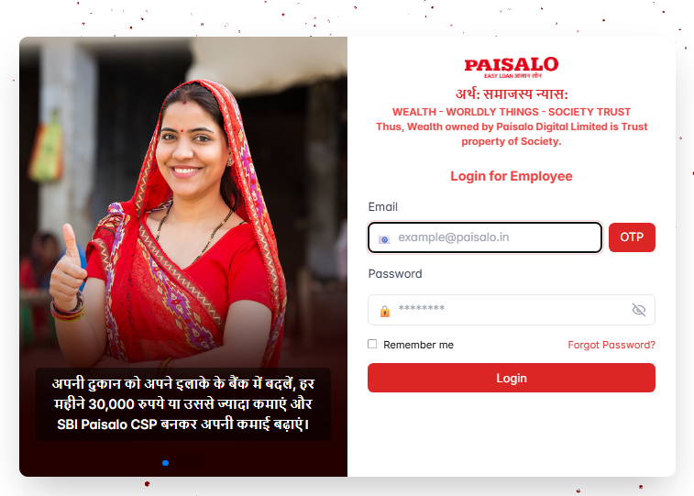
Add Email id.
Click here to add OTP
Enter password
To access the LOS portal:
- Open this URL in your browser:
https://uat.paisalo.in:4016/
- Enter your Username and Password.
- Click on the "OTP" button.
- Check your email for the OTP. (For now, you can use 123456 as the OTP.)
- Complete the login process.
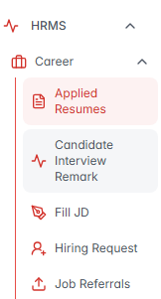
Click here to fill MRF Form
Access the Manpower Requisition Form (MRF) in HRMS
To raise a new job vacancy request:
- Go to the HRMS module from the main menu..
- Click on the “Career” section to expand it.
- Select the “Hiring Request” option.
- You will now see the Manpower Requisition Form (MRF).
Note: Only HODs and Managers are authorized to fill and submit the MRF directly from this section for HR processing.
Creating a Job Request in HRMS
After you click on “Hiring Request” under the Career section:
- You will see an “Add New Job” icon.
- Click on this icon to open the Job Requisition Form.
In this form, you need to fill in the following details:
- Job Title/Position
- How many people you want to hire
- Expected Salary Range
- Type of Hiring
(e.g., Contract-based, Internal Transfer, or New Joining)
- Once all the required details are filled in, click Submit.
- Once all the required details are filled in, click Submit.

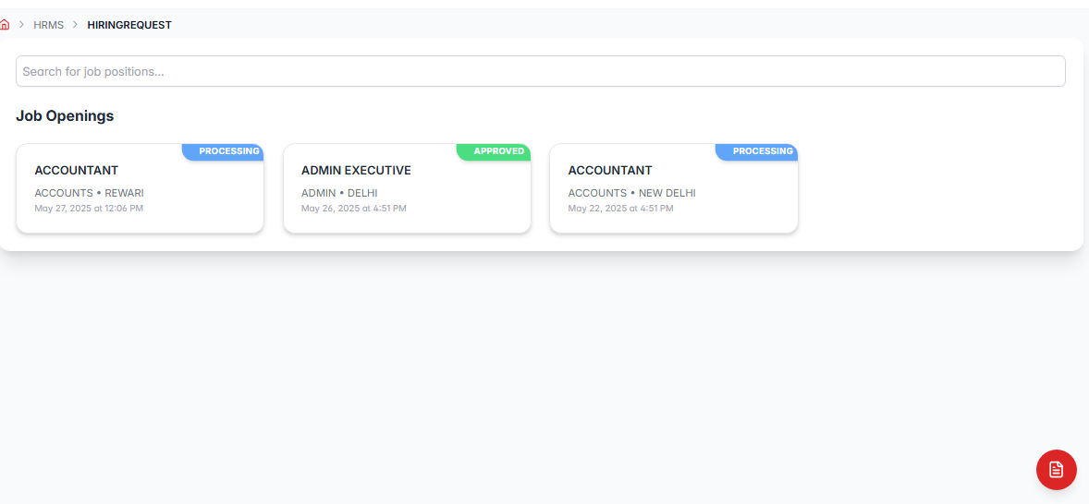
Add New Job
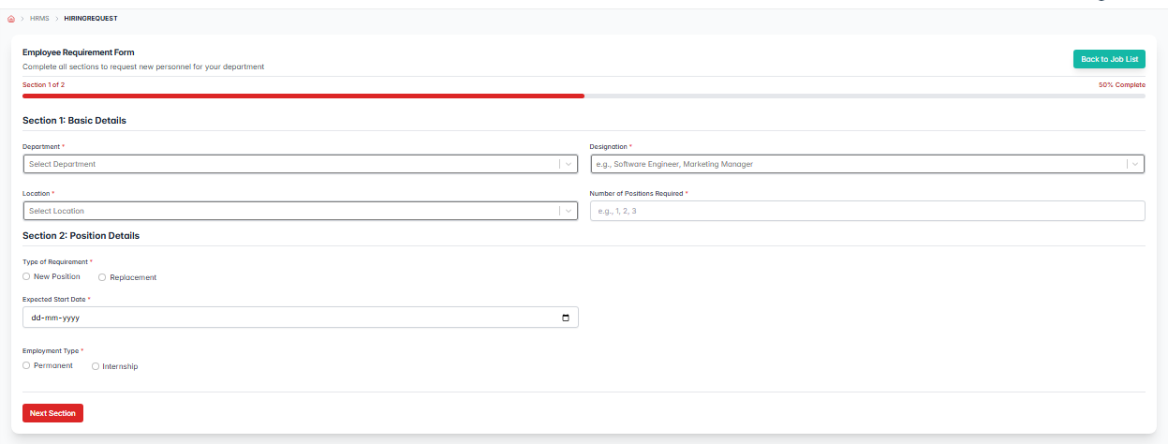
Types Of Requirement
Number of position
Date of joining
Click here for next section
Employment type
Location
Designation
Department

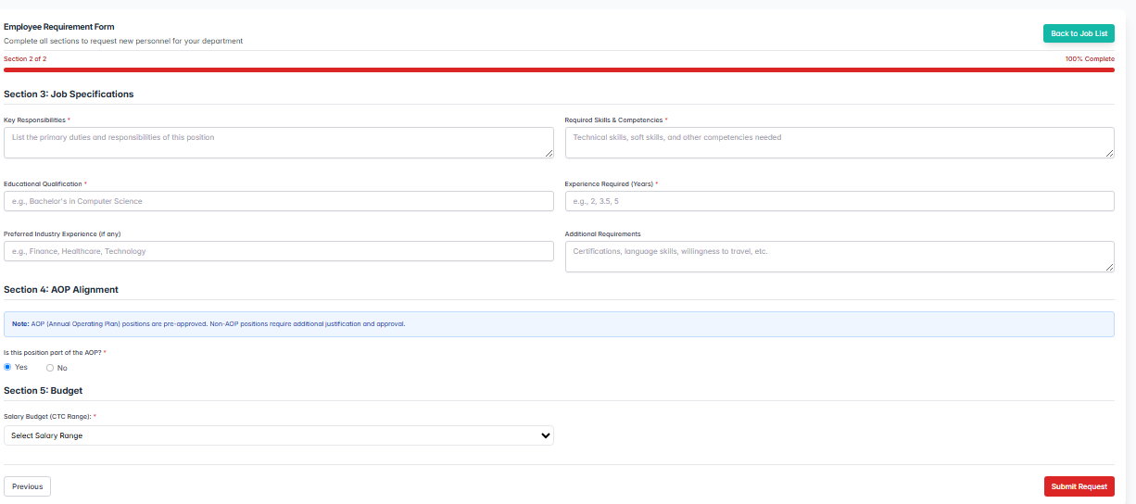
Key Responsibility
Aop Alignment
Required Skills
Salary budget
Prefered industry
Additional Requirement
Experience
Qualification
Previous page
Click on submit button to create the job

Job Request Approval Workflow
Once a job request is submitted:
- A notification or email is sent to the Head HR.
- The Head HR will review the request and take one of the following actions:
  - Approve: The request moves forward to the next step in the hiring process.
  - Reject: The request is closed and no further action is taken.
- Until the Head HR takes action, the job request will remain in Pending status.
Job is not approved
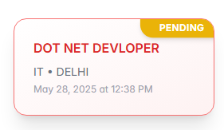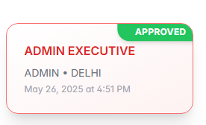
Job Approved
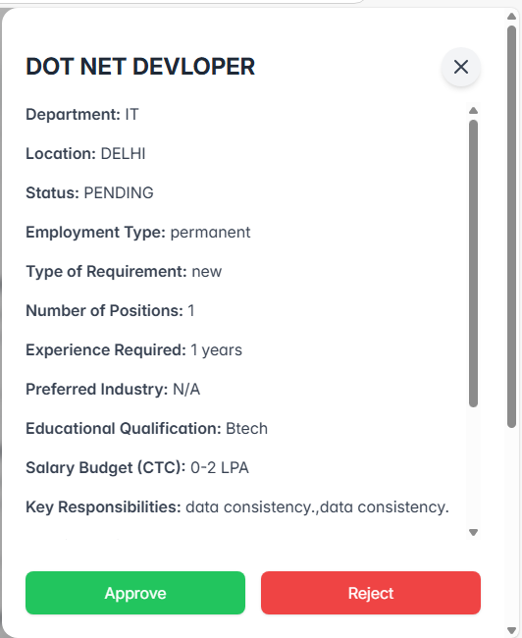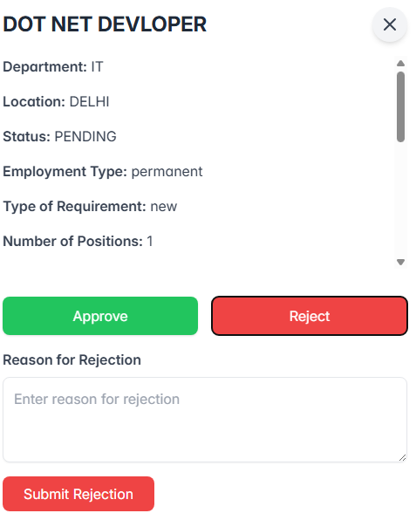
For Job Rejection remark should be added
Click on submit button to Reject the job
Click here to Approve job

HR Assignment Process
After the job request is approved by the HOD, it is sent to the Senior HR.
The Senior HR reviews the job requirements and assigns the request to a suitable HR representative.
Once assigned:
- The selected HR receives a notification or email.
- The job request appears on their dashboard for action.
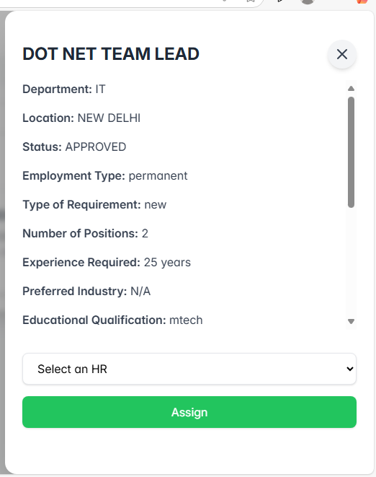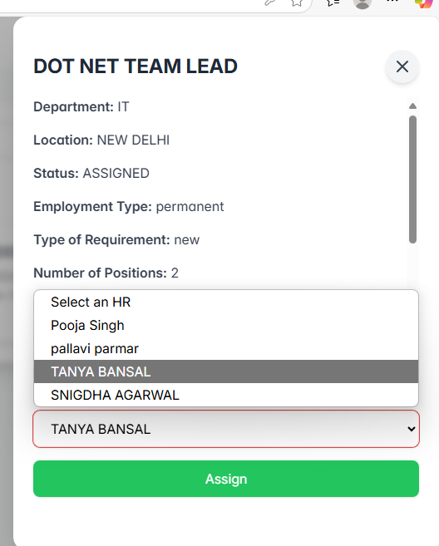
Click Assign to complete HR assignment.
Click to select HR.
JD Filling Process by HR
1.Visibility in JD Section-
All newly assigned job requests will appear under the "Fill JD" section of the assigned HR’s dashboard.
2.Job Assignment Notification
Once a new job request is assigned by the Senior HR, the assigned HR receives a notification (indicated by a notification icon).
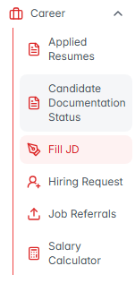
Add JD
3.JD Preparation
The assigned HR clicks on the Fill Description from the Fill JD section and fills out the required Job Description details, including:
- Detailed Role Overview
- Day-to-Day Responsibilities
- Preferred Skills and Experience

Click here to submit Job
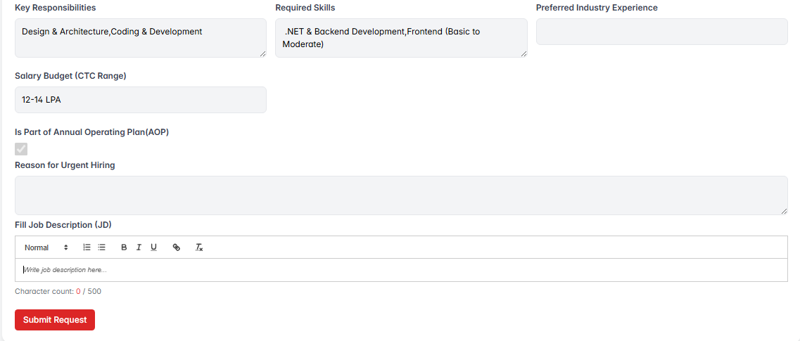
Notification
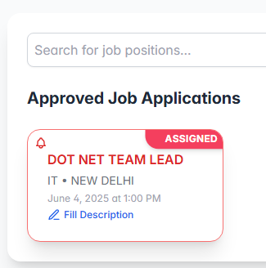
Check new job assigned.

Click here to fill JD

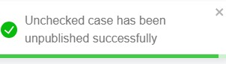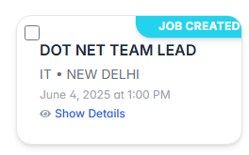
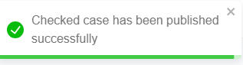
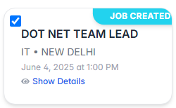

Notification for unpublished job
Private Sub Workbook_Open()
Worksheets("Sheet1").Columns("C").Hidden = True
End Sub
Click here to publish job

Job Publishing Process
Once the Job Description (JD) is prepared and submitted by the assigned HR, a "Publish Job" checkbox will appear.
- ✅ If the checkbox is checked, the job will be published and made visible on the portal or relevant platforms.
- ⛔ If the checkbox is left unchecked, the job will remain unpublished and stay as draft status.
This allows HR to control when the job should go live after JD submission.

CLSJ002978
Notification for published job

fdgfdggfddddddddd
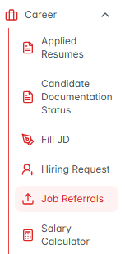

Use the form to apply or refer a candidate.
- This will open a new section where you can see complete job information.
Below the job details, a short form will appear where you can either refer someone or apply for the job yourself.
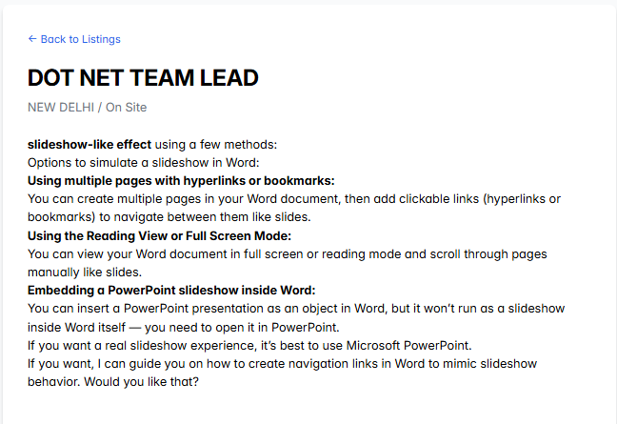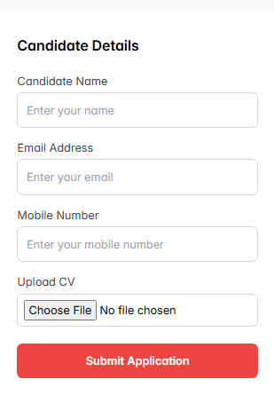

- When you click on the Job Referral page, all the published jobs will become visible.
- To know more about a specific job, click on the View Details button next to it.
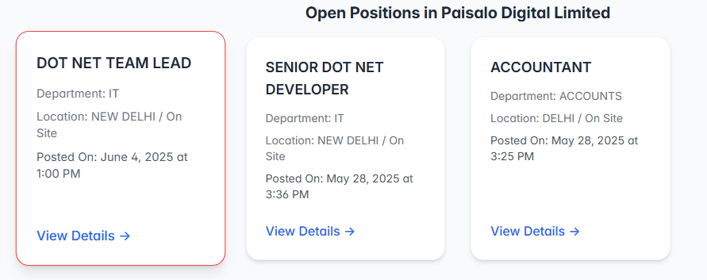
Click here to see all newly available jobs.
Job Visibility on Referral Page
Once the job is published, it will appear on the Job Referrals page.
- This page is open and accessible to all.
- Employees can view the published job and:
  - Submit referrals for suitable candidates.
  - Apply directly for the job themselves (if eligible).
This ensures that everyone in the organization has the opportunity to contribute to the hiring process or apply for internal openings.

Click "View Details" for job info.

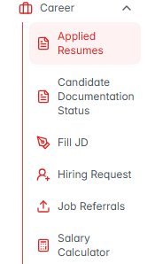jlklklk
Joining Form
Note: The Name and Email fields will be pre-filled in the joiningform form.
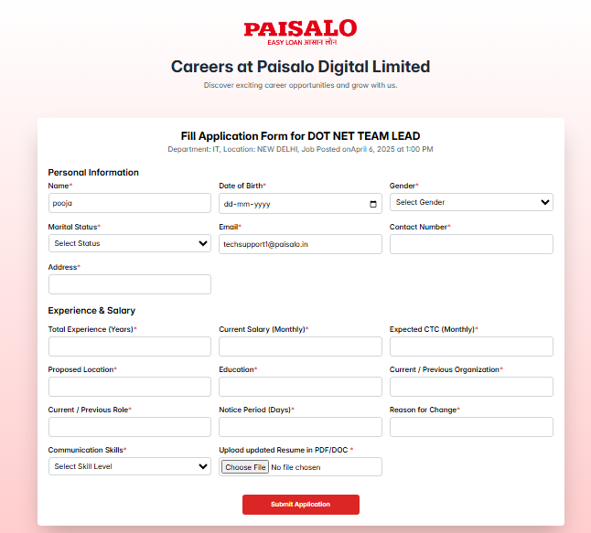

Click here to open joining form.
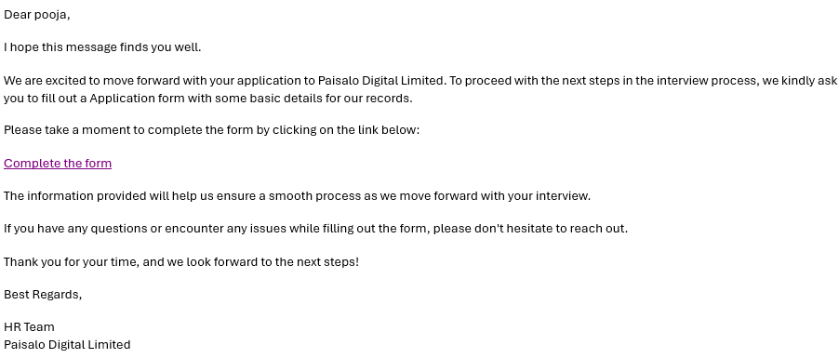

Click here to Reject Candidate
Send mail for Joining Form
Download Resume From Here.
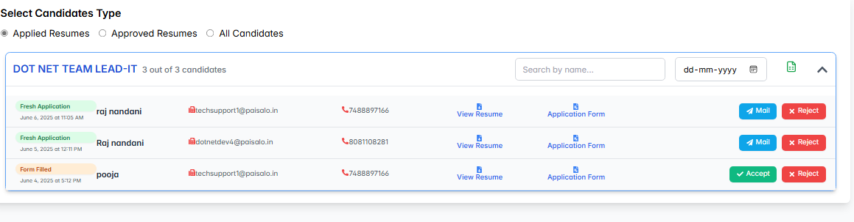
Click here to see all the applied candidates.
Applied/Referral Resume Section
- Whenever a candidate applies for a job or an employee submits a referral, the application is captured automatically.
- All received applications and referrals appear in the Applied Resumes section.
- This section helps HR or the concerned team to:
  - View all applications in one place.
  - Track the status of each resume.
  - Manage and process referrals efficiently.

Application Flow After Joining
Once a candidate successfully fills and submits the Joining Form, the application details become visible to the HR team. The HR team can then review each candidate’s application individually and take necessary action.
HR Actions:
HR can take one of the following actions using the buttons provided:
- ✅ Accept – Approves the application and forwards it to the next stage.
- ❌ Reject – Marks the application as rejected and stops further processing.

Candidate visible in interviewer Id
Candidate is visible in approved Resume Section
Interview Assignment & Notification Flow
Once HR assigns an interviewer for the first round, the selected employee will receive a notification under the "Interview Remark" section. At the same time, the HR will see the case listed under the "Approved Resumes" section for further tracking.

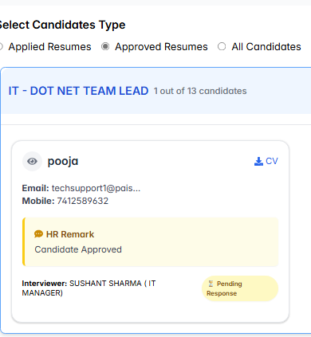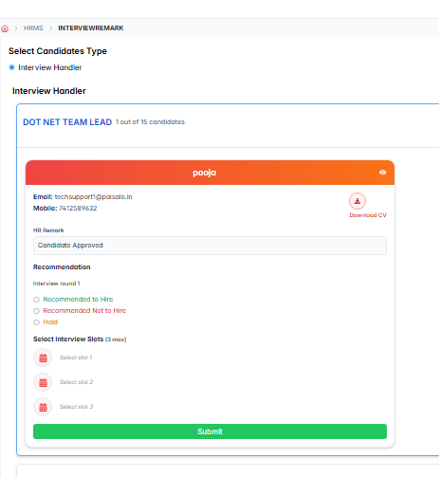
Drop down to assign interviewer
Interview Assignment After HR Approval
When HR clicks the "Accept" button on a candidate's application:
- A dropdown menu will appear.
- The dropdown will show a list of employees based on the candidate's department.
- HR can select any one employee from the list to assign for the first round of interview.
- Once selected, that employee gets marked as the interviewer for round 1.

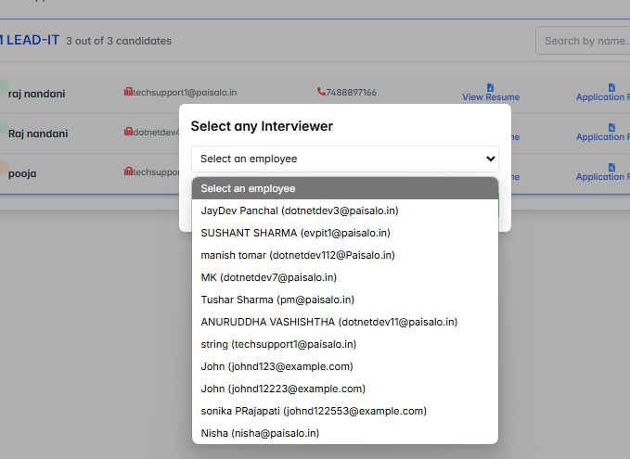
Click here to open application form

Interviewer Decision Options and Actions
The interviewer has three options after the interview:
- Recommended to Hire
  - If selected, the interviewer can add up to 3 interview slots to schedule further interviews with the candidate.
- Recommended Not to Hire
  - If selected, the candidate’s application will be rejected.
- Hold
  - If selected, the candidate’s resume will be moved to the "Hold" status for further review.

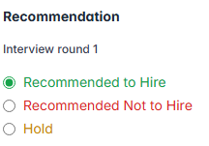

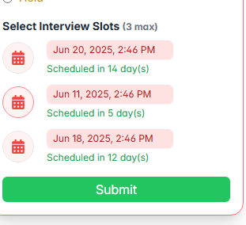

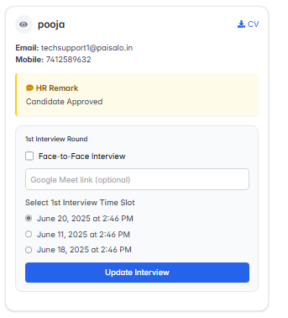
Click Here to submit all the three slot

HR Actions After Slot Submission:
After the interviewer fills all 3 interview slots, HR will have 2 options:
- Conduct the interview face-to-face
- Conduct the interview online
HR will select one slot out of the 3 provided by the interviewer and inform the candidate via email.

Interview Assessment and Feedback Process:
Once the interview is done, the interviewer will have an option to fill out an assessment form.
This form will contain sections to evaluate:
- Candidate’s communication skills
- Technical skills
- Overall skill level
- Suggestions for improvement
The interviewer will add all relevant feedback in this form.

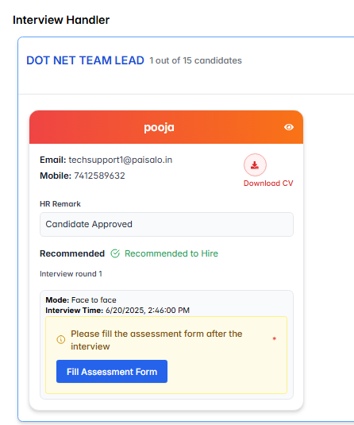l

Click to Update interview details
Click her to select interview mode

Click here to open assessment form

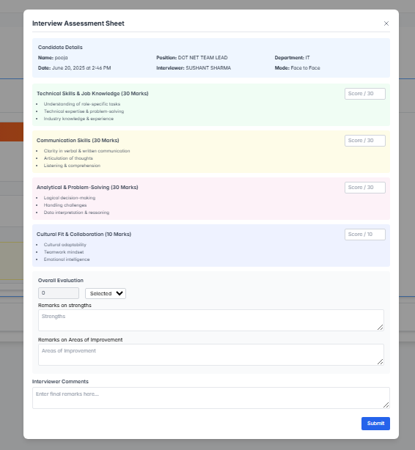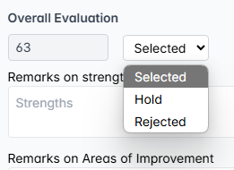
Once all remarks are filled in the assessment form, the Overall Evaluation section will appear, summarizing all the feedback. In this section, you can choose to keep the candidate on hold, reject the candidate, or select the candidate.

Click here to submit the form
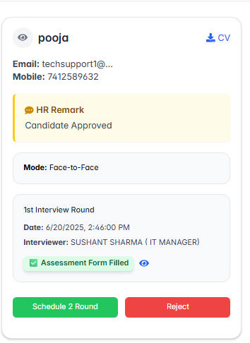
Second Round Interview:
After the first round of interview, the scheduling and assignment for the second round will begin.

Click to schedule round 2 interview
Note: The same process will be followed as in the first round.

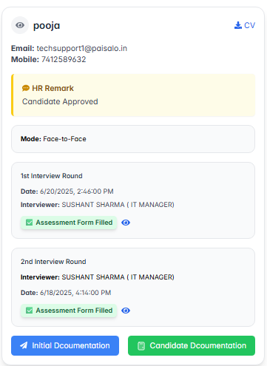

Documentation Process:
After this step, two buttons will appear:
- Initial Documentation
- Candidate Documentation
When Initial Documentation is clicked, a mail will be sent to the candidate to upload their documents.

Click here to upload documents
Mail sent to candidate
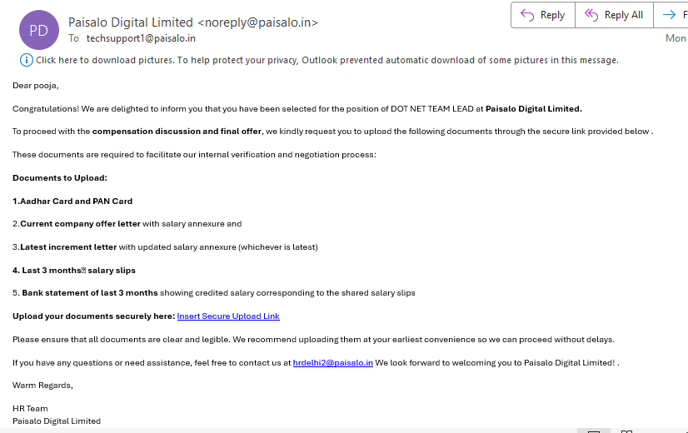
Click here to see uploaded documents
Click here to send mail

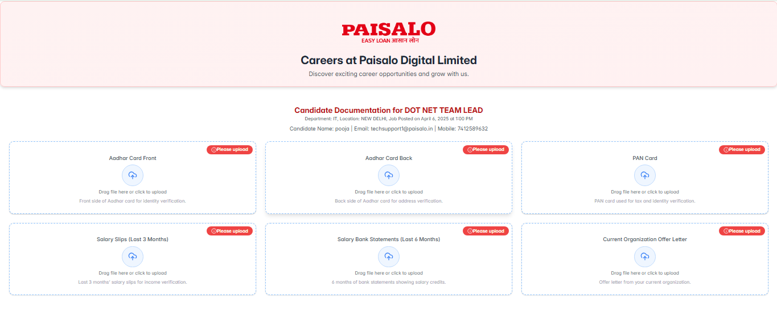
Click here to upload documents

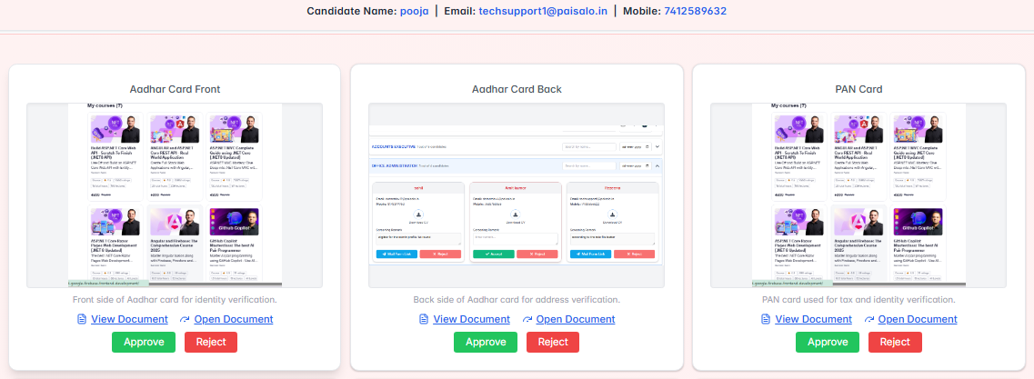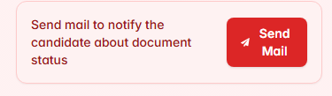
Candidate Document Review & Status Notification
Once the candidate uploads the documents, all documents will be visible in the Candidate Document section.
There will be two buttons:
- Approve
- Reject
If any document is rejected or all documents are approved, a Send Mail button will appear.
By clicking Send Mail, the candidate will be notified of the document status via email.

Approve

Reject

Click Here to send mail

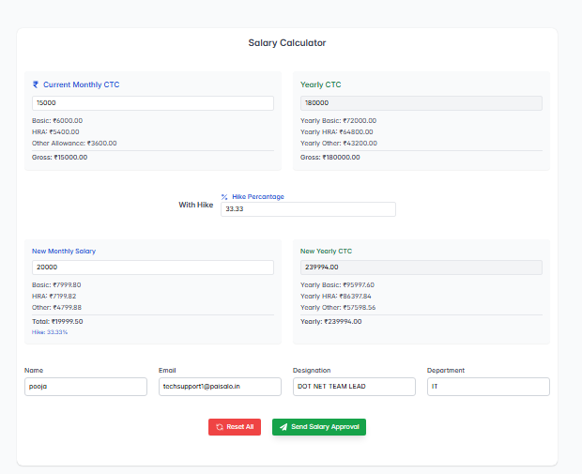

Salary Approval Request
After the documents are uploaded by the candidate, a "Salary Approve" button will appear.
On clicking this button, HR will send a salary approval request to the Department Head via email.

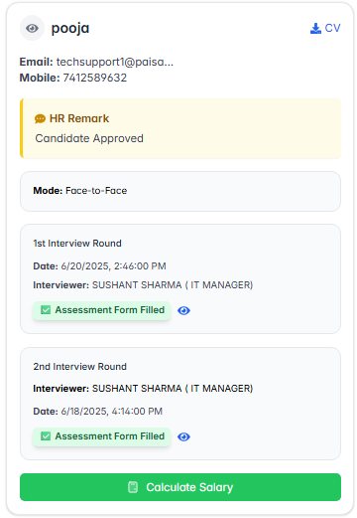

Click here to send salary approval request

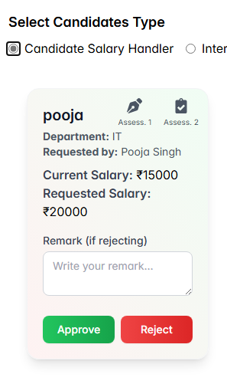

Click here to calculate salary

Salary Approval Action by Department Head
If the Department Head chooses to Reject the candidate’s salary proposal, then providing a reason is mandatory.
The system will not allow rejection without entering a valid justification.
Delete
Approve

Offer Letter Dispatch and Second Round Documentation:
After the salary is approved, an option will appear for HR: “Send Offer Letter.”
On clicking this, the HR will be prompted to select the candidate's joining date.
Once the joining date is selected, the offer letter will be sent to the candidate via email, and that email will also contain a link for the second round of documentation, where the candidate can upload the required documents.

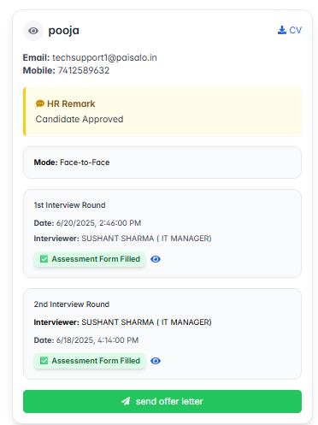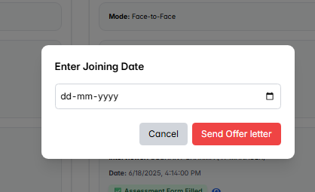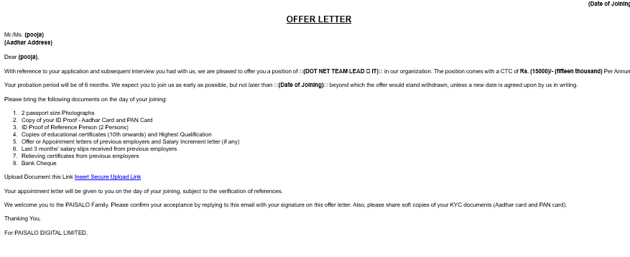

Click here to Reject Offer
Click here to accept Offer
Offer Letter Response by Candidate:
The offer letter email will contain a link.
When the candidate clicks on this link, they will see two options:
- Accept Offer
- Reject Offer
It is completely up to the candidate to accept or reject the offer.

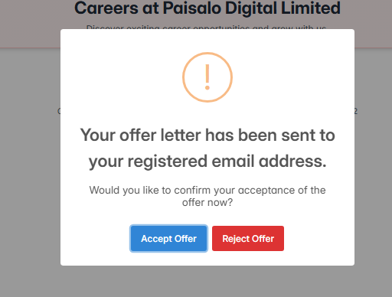
Click to upload documents
Add Joining Date
Click here to send offer letter

Second Round Documentation Form After Offer Acceptance:
Once the candidate accepts the offer letter,
a second round documentation form will be opened for them
to upload all required documents for the next process.

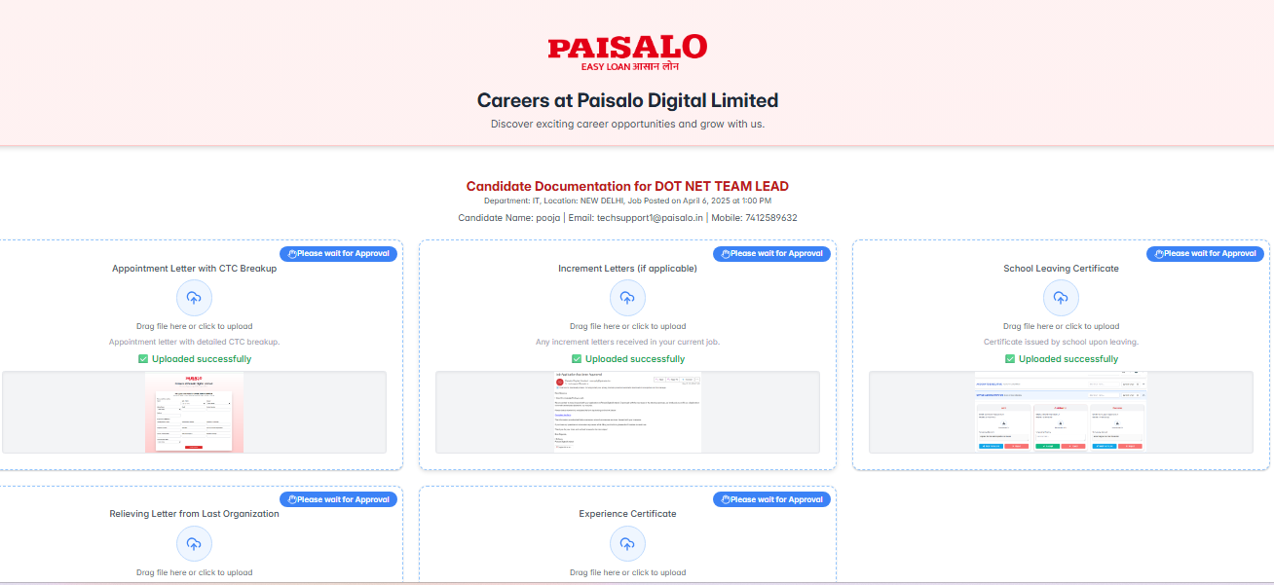

Click here to upload documents
HR Action on Candidate Documents (Second Round)
HR will have access to:
- View Candidate's Documents
- Approve or Reject each document
- A "Send Mail" button to notify the candidate about their document status (Approve/Reject) via email.

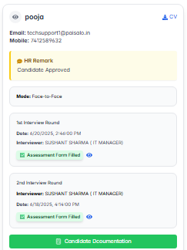
Fill Joining Form
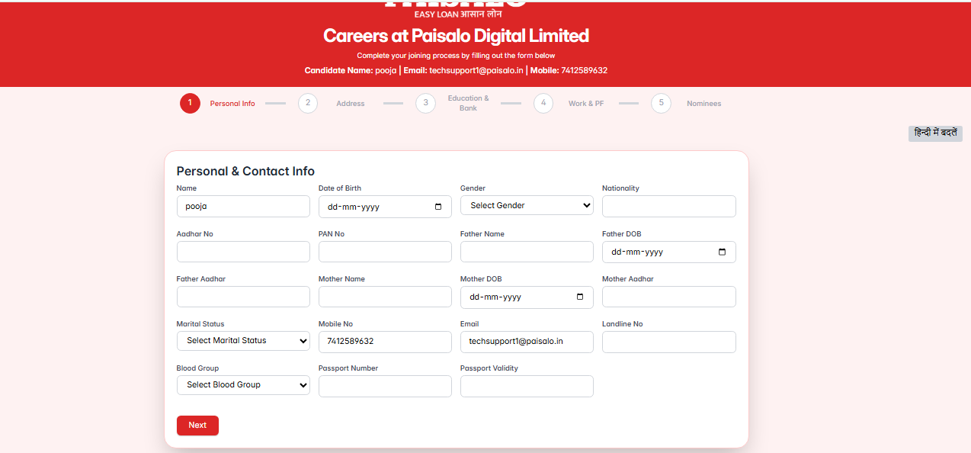
Candidate Submission of Joining Form:
- Once the candidate opens the joining form,
- They will fill in all the required details in the form,
- And then submit it to HR for further processing.
- The joining form consists of a total of 5 pages.
- It includes the candidate’s educational details and other necessary information.
- The candidate can choose to fill the form either in Hindi or English, based on their preference.

Click here to send joining form
Sending Joining Form to Candidate:
- After all documents are approved,
- HR will see an option to "Send Joining Form".
- On clicking this option, the joining form will be emailed to the candidate.
- .

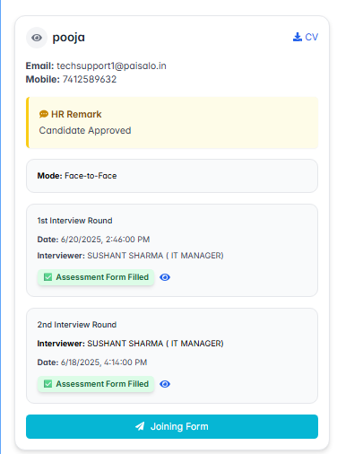
Document Re-upload and Final Approval Process:
- The candidate will receive a link via email to re-upload the rejected documents.
- After re-upload, HR will review and either approve or reject the documents again.
- If all documents are approved, HR will use the "Send Mail" button to notify the candidate about the final document status.

Click here to reupload rejected documents
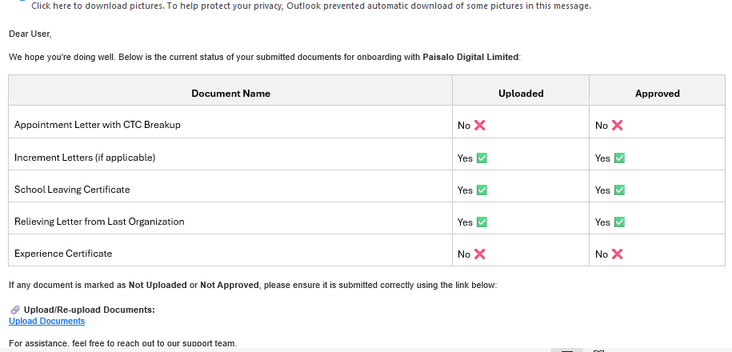
Click here to view candidate documents

Candidate Details
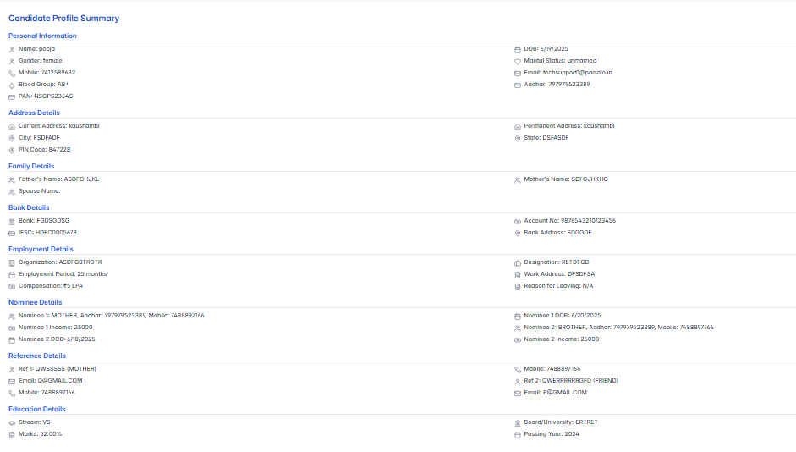
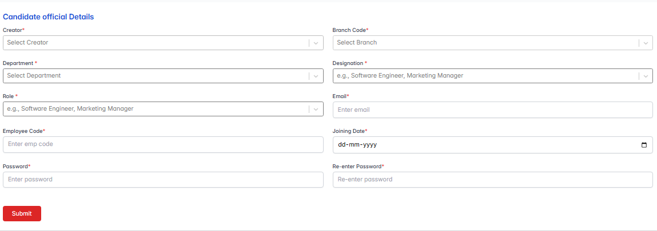
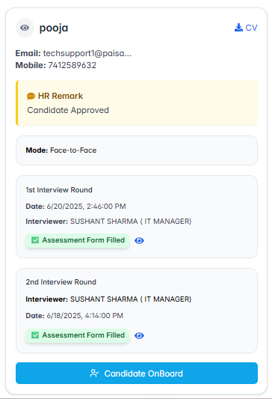

Fill candidate official details
Click here to submit
Click here to Onboard Candidate

Onboarding After Joining Form Submission
- After the candidate submits the joining form,
- HR will see a “Onboard Candidate” button.
- On clicking this button:
  - The data filled by the candidate in the joining form will be displayed.
  - A new form will open where HR will enter the candidate’s official details for onboarding.

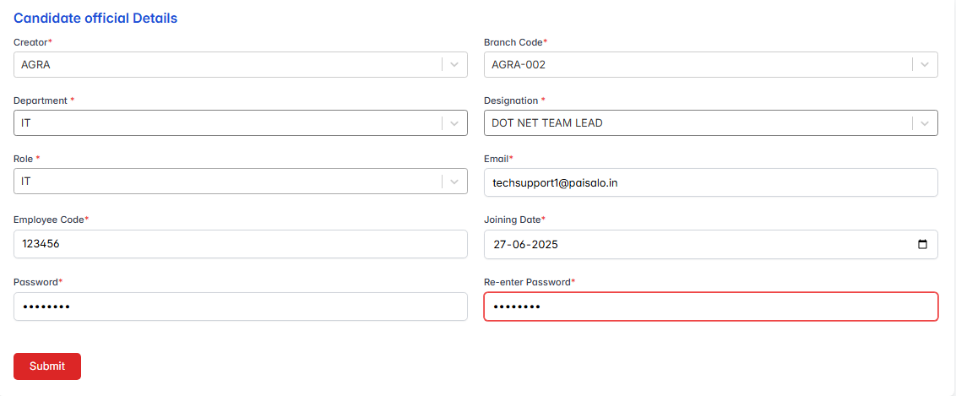

Candidate Official Details Entry by HR
In the Candidate Official Details section:
- HR will enter the candidate’s
  - Creator Email
  - Password
  - Role
  - Joining Date
  - and other official information needed for onboarding.

Candidate onboarded
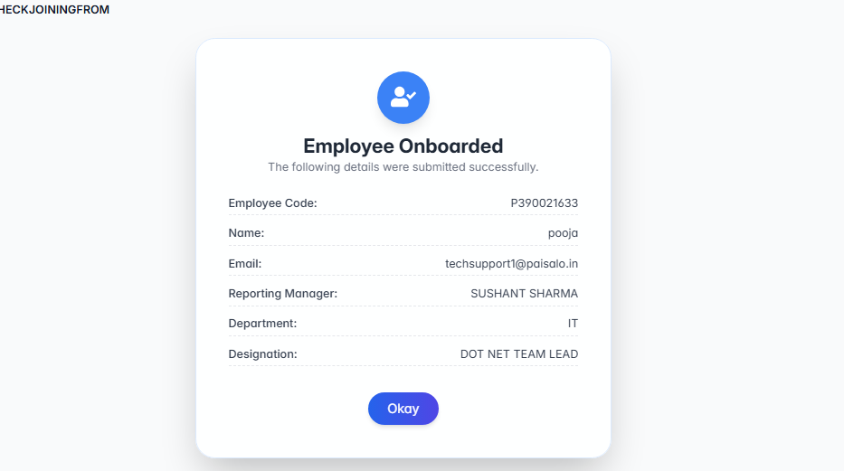
Candidate Details Confirmation and Finalization
Once the form is filled out, a popup will appear displaying all the details of the candidate. This serves as a final review step, allowing the candidate to verify and confirm their information before officially joining the organization.

