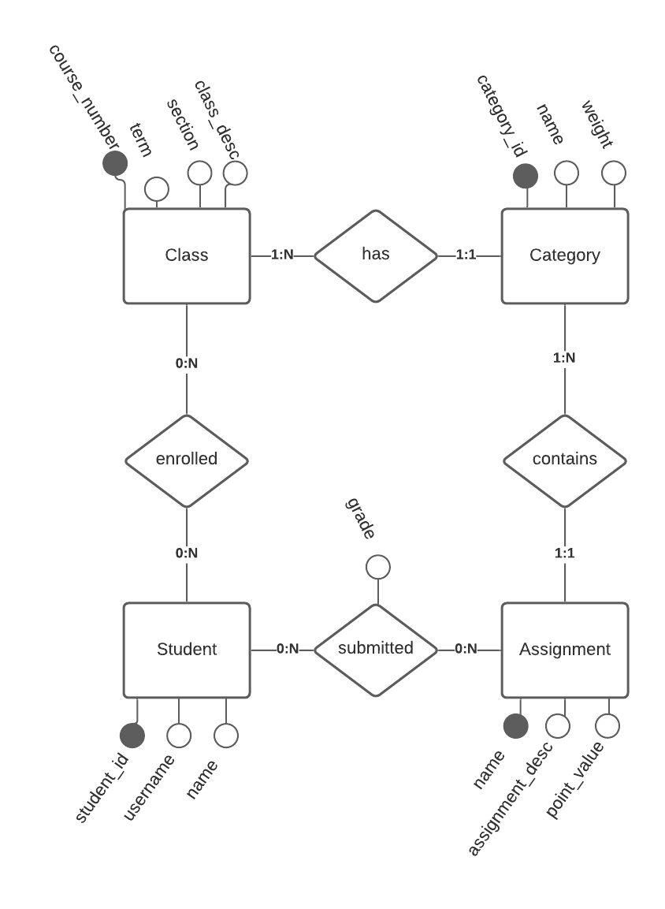

Class(varchar course_number, varchar term, int section, text class_desc);

Category(int category_id, varchar category_name, double weight, (foreign) int course_number);

Assignment(varchar assignment_name, int points, (foreign) int category_id);

Student(int student_id, varchar username, varchar student_name);

Enrolled((foreign) int student_id, (foreign) int course_number);

Submitted((foreign) int student_id, (foreign) varchar assignment_name, int grade_value);

