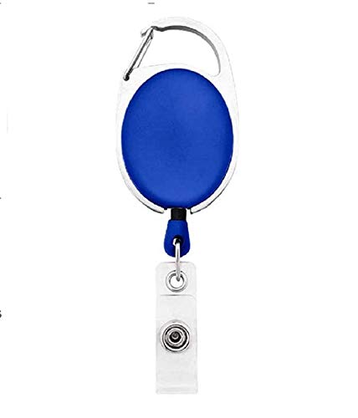

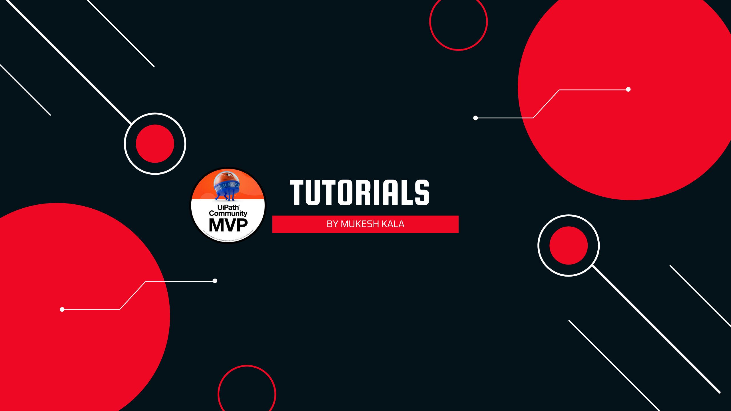

Sarah Neighbors | 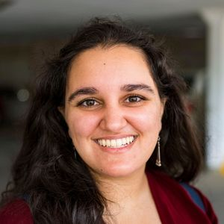
Purchase
03/14/2022
B +ve
9080706050

Questions / Queries – Drop an email to mailmukeshkala@gmail.com

