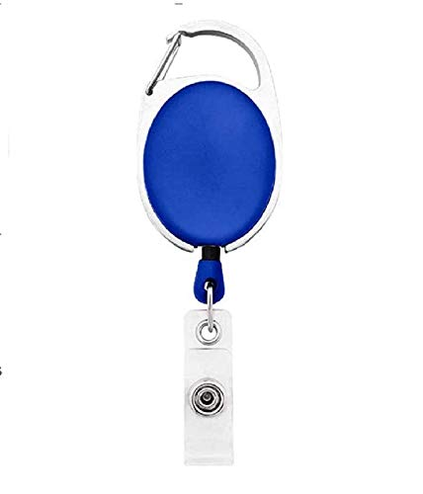

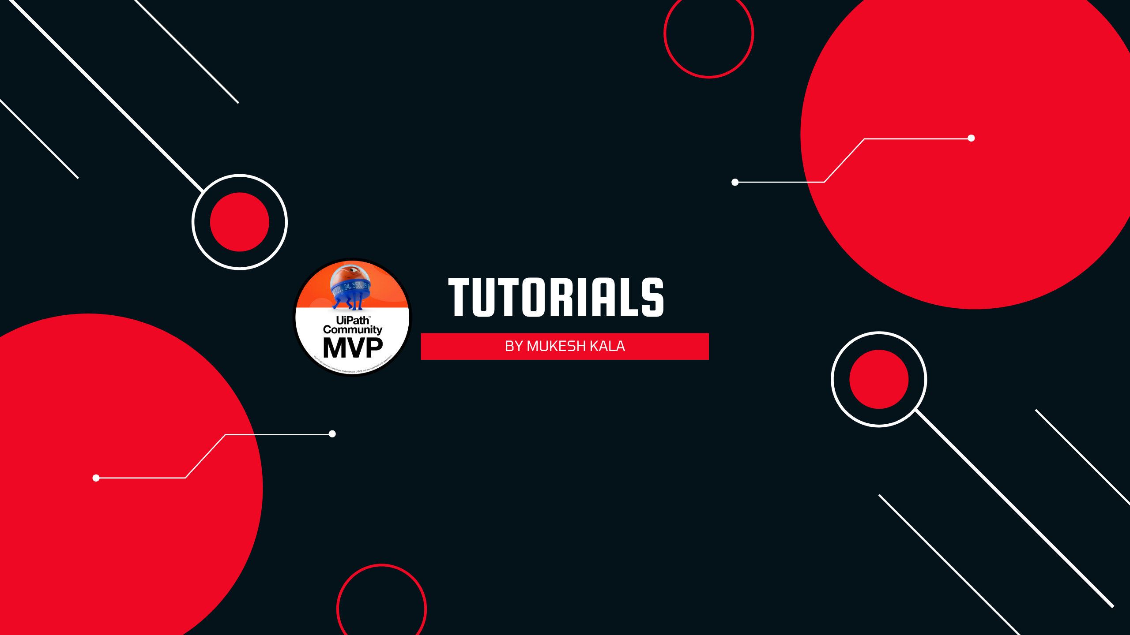

William Middlebrooks | 
Purchase
02/12/2022
A +ve
9080706050

Questions / Queries – Drop an email to mailmukeshkala@gmail.com

