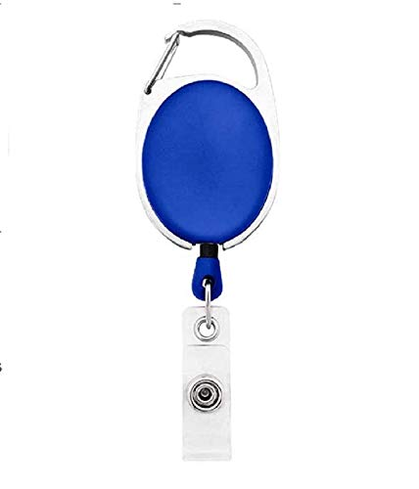



Brittney Carignan | 
Human Resource
02/12/2022
O +ve
9080706050

Questions / Queries – Drop an email to mailmukeshkala@gmail.com

