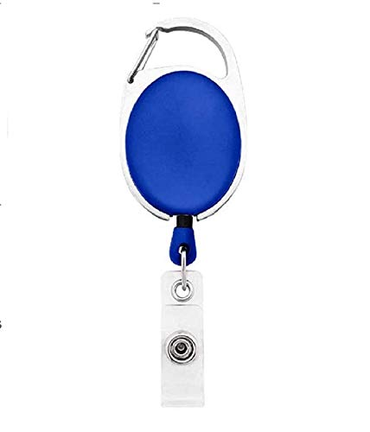



Sheila Dever | 
Human Resource
02/10/2022
O +ve
9080706050

Questions / Queries – Drop an email to mailmukeshkala@gmail.com

