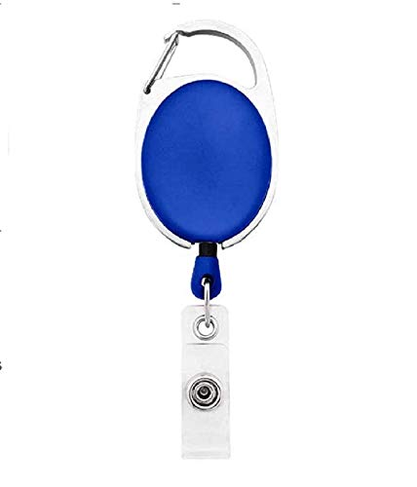



Sharon Becerra | 
Finance
02/17/2022
O +ve
9080706050

Questions / Queries – Drop an email to mailmukeshkala@gmail.com

