Dual Allegiance in Practice
Trust, Performance, and Corruption Perceptions of Traditional Authorities vs. Elected Local Government in Ghana
A quantitative test of the “two complementary systems” model using Afrobarometer Round 9 (2022) survey data
Paul
Political Scientist & Data Scientist — local governance, decentralisation, and traditional authority in Ghana
August 2026
Executive summary
Ghana runs two parallel local governance institutions — elected District Assemblies (Local Government Act, Act 936; 1992 Constitution Art. 270–277) and the chieftaincy institution (Chieftaincy Act, 2008). This analysis uses the Afrobarometer Round 9 (2022) nationally representative survey of Ghana (n = 2,369) to empirically test how citizens actually navigate this “dual allegiance,” comparing stated trust, perceived corruption, and performance approval for each institution against what citizens actually do when they need help. It closes with two models — a logistic regression and a Random Forest — predicting which demographic and geographic factors are associated with leaning toward traditional over elected local authority.
Headline finding: overall trust in the two institutions is statistically indistinguishable, but a real urban–rural split emerges underneath that average, and stated trust does not reliably predict who citizens actually turn to for help — a concrete empirical instance of dual allegiance in practice, not just in theory.

1. Research question & context
Political science and development-studies literature on Ghana has long framed citizens as navigating between two authority structures that are formally complementary but empirically in tension: the elected local government tier, and traditional (chieftaincy) authority. Prior qualitative and case-study work — including comparisons of District Assemblies and chieftaincy as “two complementary systems” — has documented that both structures compete for legitimacy and practical relevance at the local level, particularly in rural Ghana.
This analysis operationalises that debate with nationally representative survey data, asking:
- RQ1 — Trust: Do Ghanaians trust elected local government councils or traditional leaders more, and does that differ by area (urban/rural) and region?
- RQ2 — Performance & corruption: How do citizens rate councillor performance, and how does perceived corruption compare across the two institutions?
- RQ3 — Attitude vs. behaviour: Does citizens’ stated trust match who they actually contact for help?
- RQ4 — Predictors: Which individual-level factors (urban residence, age, gender, education, lived poverty) and regional context predict leaning traditional over elected local government?

2. Data & methods
Source: Afrobarometer Round 9 (2022), Ghana country file (part of the 39-country merged release), retrieved via the public Afrobarometer-Data-Explorer mirror of the official Afrobarometer microdata (afrobarometer.org). Full item wording and coding follow the official Round 9 Ghana Codebook (21 May 2024).
Sample: 2,369 respondents (1,417 urban / 952 rural), representative of the adult Ghanaian population across 16 regions.
Key variables (Afrobarometer item codes in parentheses):
- Trust in elected local government council (Q37d) and traditional leaders (Q37j) — 4-point scale, recoded 0 (Not at all) to 3 (A lot)
- Perceived corruption among local government councillors (Q38d) and traditional leaders (Q38h) — recoded 0/1 (none/some) to 3 (all)
- Approval of local government councillor performance (Q47c) — recoded 0 (Strongly disapprove) to 3 (Strongly approve)
- Contact behaviour: whether the respondent contacted a local government councillor (Q11b) or a traditional leader (Q11e) in the past year
- Demographics: urban/rural (URBRUR), region, age (Q1), gender (Q100), education (Q94, ordinal), and the Afrobarometer Lived Poverty Index
Analysis: descriptive comparison and paired-samples t-test for overall trust; group means for urban/rural and regional breakdowns; a “trust gap” index (trust in traditional − trust in local government); a logistic regression (statsmodels) for interpretable odds ratios; and a Random Forest classifier (scikit-learn, 5-fold cross-validated) as a non-parametric robustness check on the same predictors. Full reproducible code is provided in the companion Jupyter notebook.

3. Findings

3.1 Overall trust: statistically indistinguishable
Mean trust (0–3 scale) is 0.92 for elected local government councils and 0.95 for traditional leaders (paired t = 1.85, p = 0.064, n = 2,318). Most Ghanaians in 2022 trusted each institution only “a little” or “not at all” — there is no clear overall winner between the two.
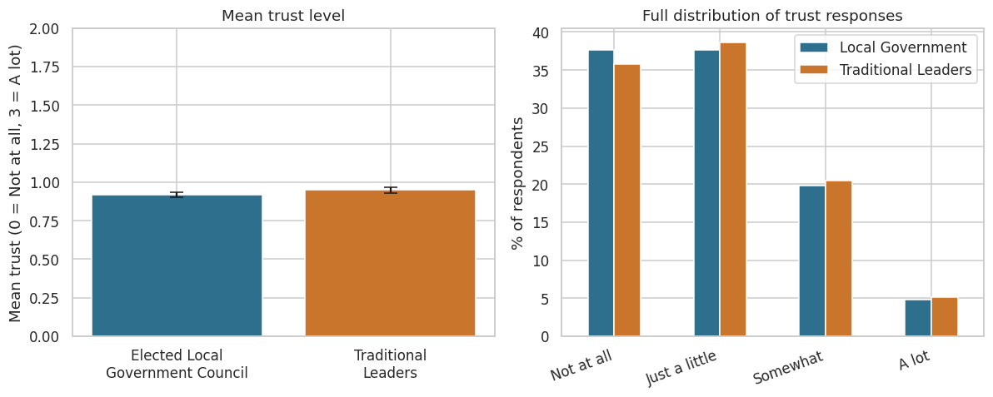
Figure 1. Mean trust and full response distribution, local government vs. traditional leaders.

3.2 The urban–rural divide
Averaged nationally the two institutions are statistically tied, but that average masks a real compositional split. In rural areas, traditional leaders are trusted more than local government (1.01 vs. 0.95); in urban areas the two are nearly tied (0.91 vs. 0.90). Traditional authority’s relative edge is concentrated in rural Ghana — consistent with the classic expectation in the dual-allegiance literature.
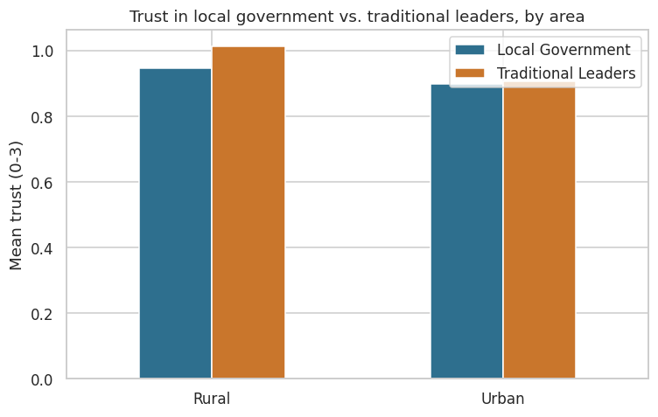
Figure 2. Trust by urban/rural residence.

3.3 Regional variation
The trust gap (traditional minus local government trust) varies substantially by region — some regions lean clearly toward traditional authority in relative trust, others toward elected local government — consistent with well-documented unevenness in chieftaincy strength and centralisation across Ghana’s regions.
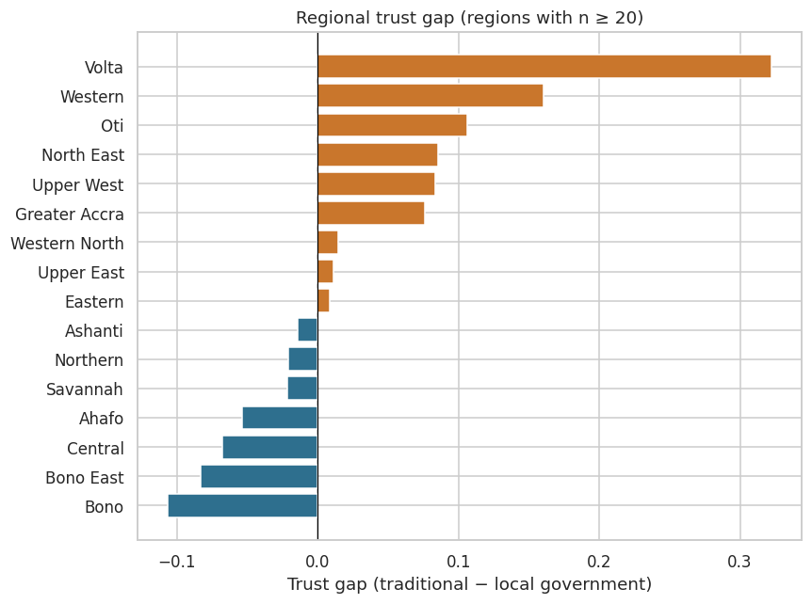
Figure 3. Regional trust gap (regions with n ≥ 20). Gold = leans traditional, blue = leans local government.

3.4 Performance and corruption
60.6% of respondents disapprove or strongly disapprove of their local government councillor’s performance. Perceived corruption is comparable across the two institutions (1.52 for local government councillors vs. 1.47 for traditional leaders, on a 0–3 scale) — corruption perception does not appear to be what drives the trust gap where one exists.
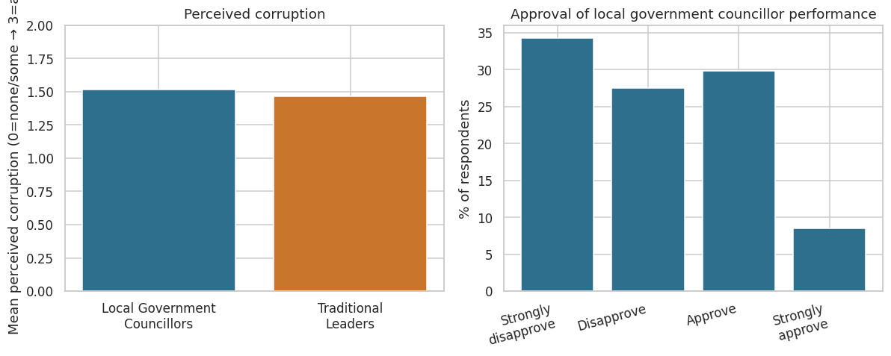
Figure 4. Perceived corruption (left) and councillor performance approval (right).

3.5 Stated trust vs. revealed behaviour
Trust is an attitude; contacting an authority for help is a behaviour, and the two diverge in a genuinely interesting way. Among the 119 respondents who say they trust traditional leaders “a lot,” more actually contacted a local government councillor in the past year (40.3%) than contacted a traditional leader (37.0%). Even citizens’ strongest traditional-authority loyalists route real problems through the formal local-government channel about as often as through the institution they say they trust more — a concrete empirical instance of dual allegiance in practice, not just an attitudinal split.
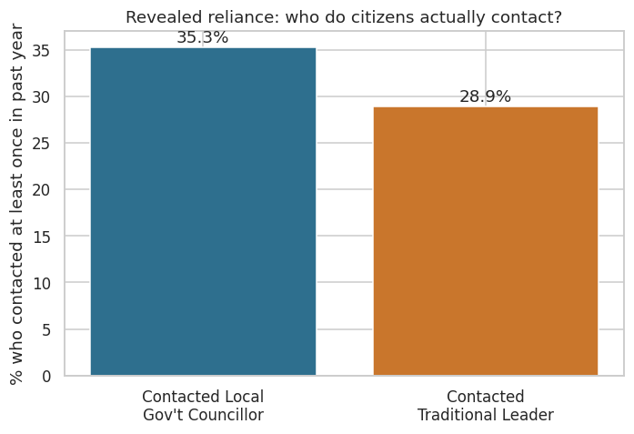
Figure 5. Share of respondents who contacted each institution in the past year.

3.6 Who leans traditional? Predictors
A logistic regression (outcome: trusts traditional leaders more than local government, region-adjusted; pseudo-R² = 0.027) finds two significant individual-level predictors: women are less likely than men to lean traditional (odds ratio = 0.76, p = 0.014), and each step up in education is associated with lower odds of leaning traditional (odds ratio = 0.93, p = 0.023). Urban residence, age, and the Lived Poverty Index are not significant once region is controlled for — the geography effect seen in Section 3.2 is apparently absorbed by region and by the gender/education effects, not by urban/rural status directly.
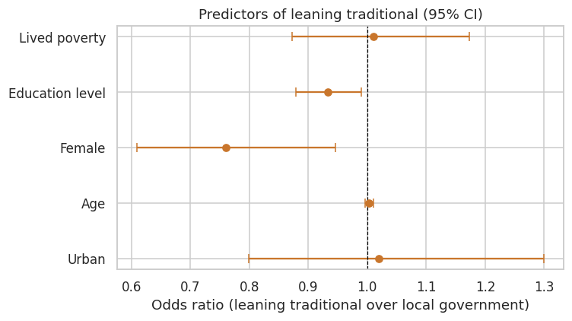
Figure 6. Logistic regression odds ratios with 95% confidence intervals.
Predictor | Odds ratio | 95% CI | p-value
Urban residence | 1.02 | 0.80 – 1.30 | 0.880
Age (years) | 1.00 | 1.00 – 1.01 | 0.407
Female | 0.76 | 0.61 – 0.95 | 0.014 *
Education level (ordinal) | 0.93 | 0.88 – 0.99 | 0.023 *
Lived Poverty Index | 1.01 | 0.87 – 1.17 | 0.882
* significant at p < 0.05. Region fixed effects included but omitted from the table for brevity (full output in the notebook).

3.7 Model comparison: logistic regression vs. Random Forest
Both models agree the demographics are, at best, weak predictors. The Random Forest achieves ROC-AUC = 0.58 (5-fold cross-validated: 0.579 ± 0.035) and the logistic regression ROC-AUC = 0.57 — both barely above chance (0.50). The logistic regression’s raw accuracy (80.6%) is inflated by class imbalance: only 19.1% of respondents lean traditional, so a model that always predicts “does not lean traditional” would already score about 78.7%. ROC-AUC is therefore the honest metric here, and it indicates demographics alone explain little of who leans traditional — age, education level, and lived poverty are the strongest features in the Random Forest, but predictive power overall stays modest.
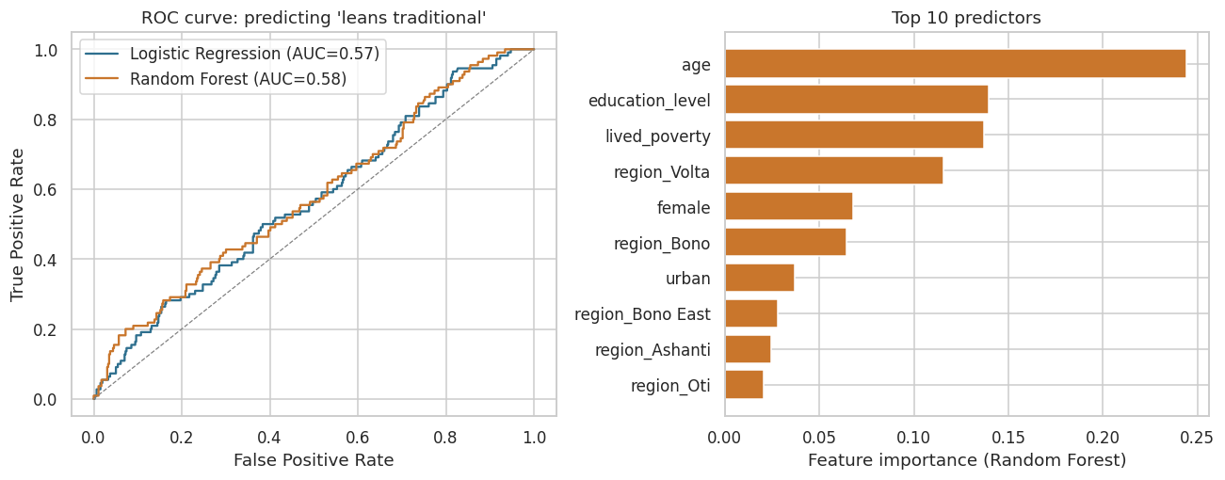
Figure 7. ROC curves (left) and Random Forest feature importances (right).

4. Conclusion
Institutional trust in Ghana’s dual local governance system looks driven far more by regional context and lived institutional performance than by individual demographic profile. The data support the classic urban–rural expectation from the qualitative dual-allegiance literature — traditional authority holds a real, if modest, trust edge specifically in rural Ghana — while also showing that trust and revealed reliance on an institution are not the same thing: strong traditional-authority loyalists still route practical problems through elected local government about as often as through the institution they say they trust more.
For practitioners and researchers working on decentralisation and local governance reform in Ghana, this suggests two things: (1) legitimacy-building interventions aimed at local government councils should not assume that rural distrust reflects an unbridgeable trust gap with chieftaincy — much of the gap is regional/contextual rather than a uniform rural rejection of the formal tier; and (2) programme design that routes services exclusively through the institution citizens say they trust more risks missing that many citizens already use both channels interchangeably.

Limitations
- Cross-sectional survey data support association, not causal claims.
- The Lived Poverty Index and self-reported contact behaviour are subject to recall and social-desirability bias typical of face-to-face survey instruments.
- The weak predictive power of the demographic models (ROC-AUC ≈ 0.58) means the logistic regression coefficients should be read as descriptive associations, not as a reliable classifier.
- Findings describe 2022 conditions specifically and would need the pipeline re-run on other Afrobarometer rounds to assess change over time.

Reproducibility
Full code, data preparation steps, and all model diagnostics are provided in the companion Jupyter notebook (ghana_dual_allegiance_analysis.ipynb), built with pandas, statsmodels, and scikit-learn. Data: Afrobarometer Round 9 (2022), redistributed for research/educational use.

