Lab -4

Ques1: Given an array S of unsorted elements. Design an algorithm and implement that to find a pair x, y such that x≠y from S that minimizes |x-y|.The worst case running time of the algorithm should be O (nlgn).
PROGRAM:
#include <bits/stdc++.h>
using namespace std;
int main() {
int n;
int arr[n];
cout<<"Enter number of Elements for an Array:";
cin>>n;
for(int i = 0;i<n;i++){
cin>>arr[i];
}
sort(arr, arr+n);
for (int j = 0; j < n; j++){
cout << arr[j] << " ";
}
cout << endl;
int diff = INT_MAX,n1,n2;
for (int i=0; i<n-1; i++) {

if (arr[i+1] - arr[i] < diff && arr[i+1]!=arr[i]){
diff = arr[i+1] - arr[i];
n1 = arr[i];
n2 = arr[i+1];} }
cout << "Pair : " << n1 << " " << n2 << endl;
return 0;
}
OUTPUT:
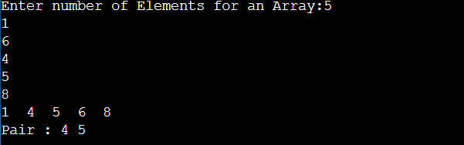

Ques2: Given two arrays A₁ , A₂ of size n and a number x, design an algorithm to find whether there exists a pair of elements one from A₁ and other from A₂ whose sum is equal to x. Also find the indices of those elements.

PROGRAM:
#include <bits/stdc++.h>
using namespace std;
void findPairs(int arr1[], int arr2[], int x)
{
for (int i = 0; i < 8; i++)
for (int j = 0; j < 7; j++)
if (arr1[i] + arr2[j] == x)
cout << i << " "<< j << endl;
}
int main()
{
int arr1[] = {2,5,9,7,1,6,0,20} ;
int arr2[] = {77,4,35,44,50,9,0} ;
int x = 50;
findPairs(arr1, arr2, x);
return 0;
}

OUTPUT:
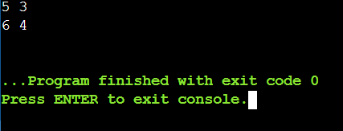

Que4: Develop an algorithm to solve the maximum segment sum problem.

PROGRAM:
#include<bits/stdc++.h>
using namespace std;
int maxSubArraySum(int a[], int n){
int max1 = INT_MIN, max2 = 0;
for (int i = 0; i < n; i++){
max2 = max2 + a[i];
if (max1 < max2)
max1 = max2;
if (max2 < 0)
max2 = 0;
}
return max1;
}
int main(){
int a[] = {6,-5, 7,-4, 5,-9,1, 0, 8};
int n = 8;
int maxSum = maxSubArraySum(a, n);
cout << "Max sum is: " << maxSum;
return 0;
}

OUTPUT:
