INDEX
Lab Exercise with topic | Page No.
Lab Exercise 1: Bubble sort analysis | 2-4
Lab Exercise 2: Merge sort analysis | 5-9
Lab Exercise 3: Insertion sort analysis | 9-12

LAB-1
Implement the given algorithm in C/C++/Java. Try to find the running time of the given algorithm. You have to perform a comparative analysis for the given n element.
Algorithm Bubble sort:
1)begin BubbleSort(list)
2)for all elements of list
3) if list[i] > list[i+1]
4) swap(list[i], list[i+1])
5) end if
6) end for
7) return list
8) end BubbleSort

PROGRAM: -
#include<stdio.h>
#include<time.h>
#include<stdlib.h>
int main()
{
int z;
printf("Enter size of array: ");
scanf("%d",&z);
int a[z],m,n,flag=0,temp;
printf("Enter range of numbers for array:: ");
scanf("%d %d",&n,&m);
srand(time(NULL));
for(int i=0;i<n;i++)
{
a[i]=rand()%(m-n+1)+n;
}
double time_spent = 0.0;
clock_t begin = clock();
for(int i=0;i<n;i++)
{
for(int j=0;j<n-i-1;j++)
{
if(a[j]>a[j+1])
{
temp=a[j];
a[j]=a[j+1];
a[j+1]=temp;
flag=1;
}
}
if(flag==0)
break;
}
clock_t end = clock();
time_spent += (double)(end - begin) / CLOCKS_PER_SEC;

for(int i=0;i<n;i++)
printf("%d ",a[i]);
printf("\n\nThe elapsed time is %f seconds", time_spent);
return 0;
}

OUTPUT:
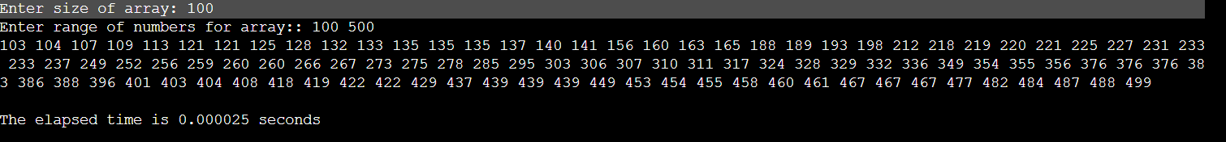

ANALYSIS:

Size of array | Execution time(sec)
50 | 0.000012
100 | 0.000036
1000 | 0.002350
2000 | 0.012669

GRAPH:

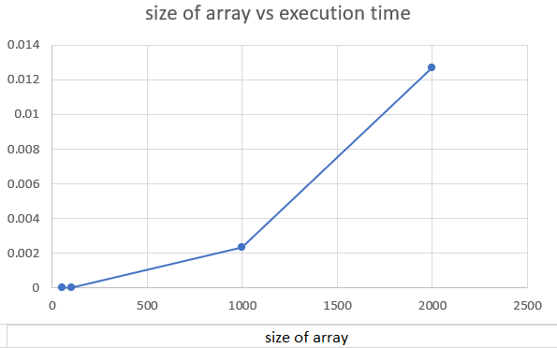
LAB 2
Implement the given algorithm in C/C++/Java. Try to find the running time of the given algorithm. You have to perform a comparative analysis for the given n element.
Algorithm Merge sort:
MergeSort(arr[], l, r)
If r > l
1. Find the middle point to divide the array into two halves:
middle m = l+ (r-l)/2
2. Call mergeSort for first half:
Call mergeSort(arr, l, m)
3. Call mergeSort for second half:
Call mergeSort(arr, m+1, r)
4. Merge the two halves sorted in step 2 and 3:
Call merge(arr, l, m, r)
PROGRAM:
#include<bits/stdc++.h>
#include<ctime>
#include<stdlib.h>
using namespace std;
void merge(int arr[], int p, int q, int r) {
int n1 = q - p + 1;
int n2 = r - q;
int L[n1], M[n2];
for (int i = 0; i < n1; i++)
L[i] = arr[p + i];
for (int j = 0; j < n2; j++)
M[j] = arr[q + 1 + j];
int i, j, k;
i = 0;
j = 0;
k = p;
while (i < n1 && j < n2) {
if (L[i] <= M[j]) {
arr[k] = L[i];
i++;
} else {
arr[k] = M[j];
j++;
}
k++;
}
while (i < n1) {
arr[k] = L[i];
i++;
k++;
}
while (j < n2) {
arr[k] = M[j];
j++;
k++;
}
}
void mergeSort(int arr[], int l, int r) {
if (l < r) {
int m = l + (r - l) / 2;
mergeSort(arr, l, m);
mergeSort(arr, m + 1, r);
merge(arr, l, m, r);
}
}
void printArray(int arr[], int size) {
for (int i = 0; i < size; i++)
cout << arr[i] << " ";
cout << endl;
}
int main()
{
int z,n,m;
cout<<"Enter size of array: ";
cin>>z;
cout<<"Enter range of numbers for array:";
cin>>n>>m;
int arr[z];

srand(time(NULL));
for(int i=0;i<z;i++)
{
arr[i]=rand()%(m-n+1)+n;
}
double time_spent = 0.0;
clock_t begin = clock();
mergeSort(arr, 0, z - 1);
clock_t end = clock();
time_spent += (double)(end - begin) / CLOCKS_PER_SEC;
cout << "Sorted array: \n";
printArray(arr,z);
cout<<"\nThe elapsed time is "<<fixed<<time_spent<<setprecision(4)<<"seconds"<<endl;
return 0;
}
OUTPUT:
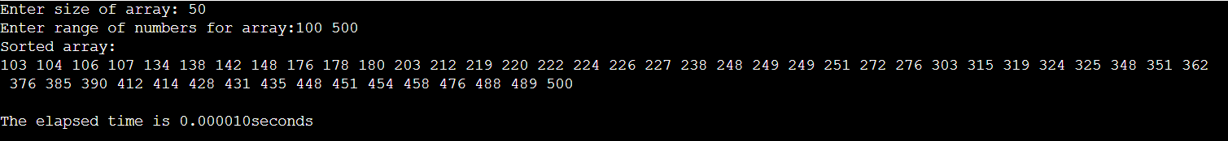
ANALYSIS:
Size of array | Execution time
50 | 0.000010
100 | 0.000016
500 | 0.000100
1000 | 0.000195
GRAPH:
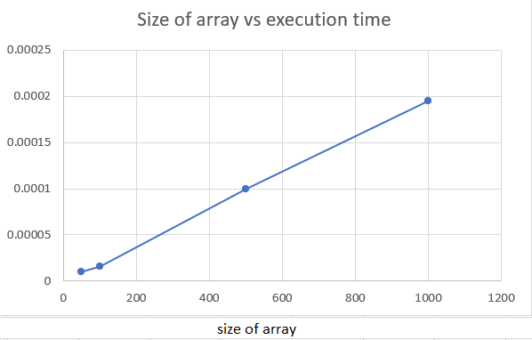

LAB 3
Implement the given algorithm in C/C++/Java. Try to find the running time of the given algorithm. You have to perform a comparative analysis for the given n element.
Algorithm Insertion Sort:
- For I = 1 to n-1
- Key = a[I]
- J = I - 1
- While J>=0 and a[J] > Key
- Set a[J+1] = a[J]
- J = J - 1
- a[J+1] = Key
PROGRAM:
#include <bits/stdc++.h>
#include<ctime>
#include<stdlib.h>
using namespace std;
void insertionSort(int arr[], int n)
{
int i, key, j;
for (i = 1; i < n; i++)
{
key = arr[i];
j = i - 1;
while (j >= 0 && arr[j] > key)
{
arr[j + 1] = arr[j];
j = j - 1;
}
arr[j + 1] = key;
}
}
void printArray(int arr[], int n)
{
int i;
for (i = 0; i < n; i++)
cout << arr[i] << " ";
cout << endl;
}
int main()
{
int z,n,m;
cout<<"Enter size of array: ";
cin>>z;
cout<<"Enter range of numbers for array: ";
cin>>n>>m;
int arr[z];
srand(time(NULL));
for(int i=0;i<z;i++)
{
arr[i]=rand()%(m-n+1)+n;
}
double time_spent = 0.0;
clock_t begin = clock();
insertionSort(arr, z);
clock_t end = clock();
time_spent += (double)(end - begin) /CLOCKS_PER_SEC;
cout << "Sorted array in Ascending Order:\n";
printArray(arr, z);
cout<<"\n The elapsed time is"<<fixed<<time_spent<<setprecision(4)<<"seconds"<<endl;
return 0;
}
OUTPUT:
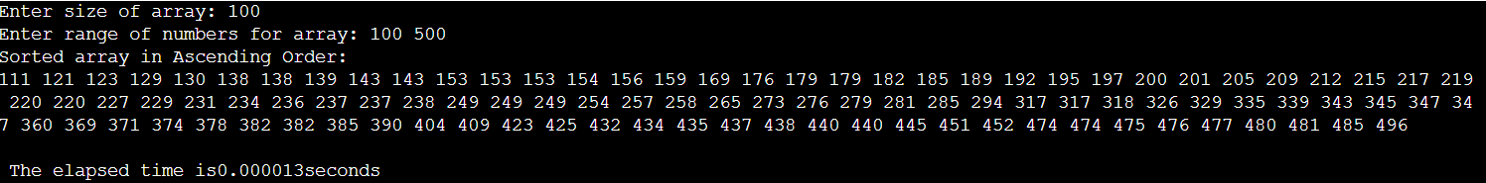
ANAYSIS:
Size of array | Execution time
100 | 0.000013
500 | 0.000208
1000 | 0.000722
5000 | 0.017163
GRAPH:
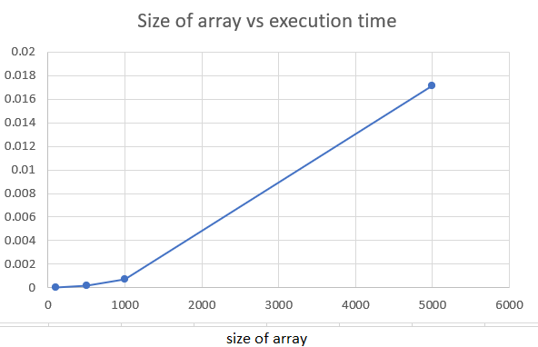
LAB 4
Implement the given algorithm in C/C++/Java. Try to find the running time of the given algorithm. You have to perform a comparative analysis for the given n element.
Algorithm Selection Sort:
list : array of items
n : size of list

for i = 1 to n - 1
/* set current element as minimum*/
min = i

/* check the element to be minimum */

for j = i+1 to n
if list[j] < list[min] then
min = j;
end if
end for

/* swap the minimum element with the current element*/
if indexMin != i then
swap list[min] and list[i]
end if
end for

end procedure
PROGRAM:
#include<bits/stdc++.h>
#include<stdlib.h>
#include<ctime>
using namespace std;

// function to swap the the position of two elements
void swap(int *a, int *b) {
int temp = *a;
*a = *b;
*b = temp;
}

// function to print an array
void printArray(int array[], int size) {
for (int i = 0; i < size; i++) {
cout << array[i] << " ";
}
cout << endl;
}

void selectionSort(int array[], int size) {
for (int step = 0; step < size - 1; step++) {
int min_idx = step;
for (int i = step + 1; i < size; i++) {

// To sort in descending order, change > to < in this line.
// Select the minimum element in each loop.
if (array[i] < array[min_idx])
min_idx = i;
}

// put min at the correct position
swap(&array[min_idx], &array[step]);
}
}

// main function
int main()
{
int ni,n,m;
cout<<"Enter size of the array: "<<endl;
cin>>ni;
cout<<"Enter range of numbers for array: "<<endl;
cin>>n>>m;

int arr[ni];

srand(time(NULL));
for(int i=0;i<ni;i++)
{
arr[i]=rand()%(m-n+1)+n;
}

double time_spent = 0.0;
clock_t begin = clock();

selectionSort(arr, ni);

clock_t end = clock();
time_spent += (double)(end - begin) /CLOCKS_PER_SEC;

cout << "Sorted array in Ascending Order:\n";
printArray(arr, ni);
cout<<"\nThe elapsed time is "<<fixed<<time_spent<<setprecision(5)<<"seconds"<<endl;
return 0;
}
OUTPUT:
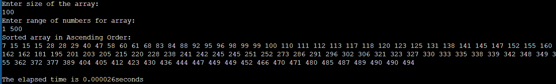

ANAYSIS:

Size of array | Execution time
100 | 0.000026
500 | 0.000417
1000 | 0.001235
5000 | 0.043333

GRAPH:

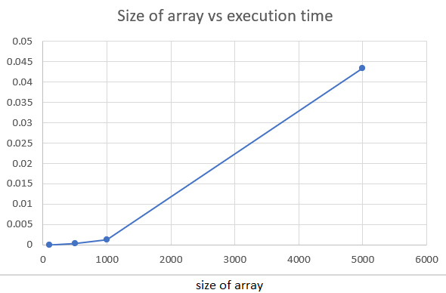

LAB 5
Implement the given algorithm in C/C++/Java. Try to find the running time of the given algorithm. You have to perform a comparative analysis for the given n element.
Algorithm Quick Sort:
1)quickSort(array, leftmostIndex, rightmostIndex)
2) if (leftmostIndex < rightmostIndex)
3) pivotIndex <- partition(array,leftmostIndex, rightmostIndex)
4) quickSort(array, leftmostIndex, pivotIndex - 1)
5) quickSort(array, pivotIndex, rightmostIndex)
6) partition(array, leftmostIndex, rightmostIndex)
7) set rightmostIndex as pivotIndex
8) storeIndex <- leftmostIndex - 1
9) for i <- leftmostIndex + 1 to rightmostIndex
10) if element[i] < pivotElement
11) swap element[i] and element[storeIndex]
12) storeIndex++
13) swap pivotElement and element[storeIndex+1]
14) return storeIndex + 1
PROGRAM:
#include<bits/stdc++.h>
#include<ctime>
#include<stdlib.h>
using namespace std;

int partition(int arr[], int start, int end)
{
int pivot = arr[start];
int count = 0;
for (int i = start + 1; i <= end; i++) {
if (arr[i] <= pivot)
count++; }
// Giving pivot element its correct position
int pivotIndex = start + count;
swap(arr[pivotIndex], arr[start]);
// Sorting left and right parts of the pivot element
int i = start, j = end;
while (i < pivotIndex && j > pivotIndex) {
while (arr[i] <= pivot) {
i++;
}
while (arr[j] > pivot) {
j--;
}
if (i < pivotIndex && j > pivotIndex) {
swap(arr[i++], arr[j--]);
}
}
return pivotIndex;
}

void quickSort(int arr[], int start, int end)
{
// base case
if (start >= end)
return;
// partitioning the array
int p = partition(arr, start, end);
// Sorting the left part
quickSort(arr, start, p - 1);
// Sorting the right part
quickSort(arr, p + 1, end);
}

void printArray(int arr[],int n)
{
for (int i = 0; i < n; i++)
cout << arr[i] << " ";
}

int main()
{
int ni,n,m;
cout<<"Enter size of the array: "<<endl;
cin>>ni;
cout<<"Enter range of numbers for array: "<<endl;
cin>>n>>m;
int arr[ni];
srand(time(NULL));
for(int i=0;i<ni;i++)
arr[i]=rand()%(m-n+1)+n;
double time_spent = 0.0;
clock_t begin = clock();
quickSort(arr, 0, ni - 1);
clock_t end = clock();
time_spent += (double)(end - begin) / CLOCKS_PER_SEC;
cout << "Sorted array: \n";
printArray(arr,ni);
cout<<"\nThe elapsed time is "<<fixed<<time_spent<<setprecision(5)<<"seconds"<<endl;
return 0;
}
OUTPUT:
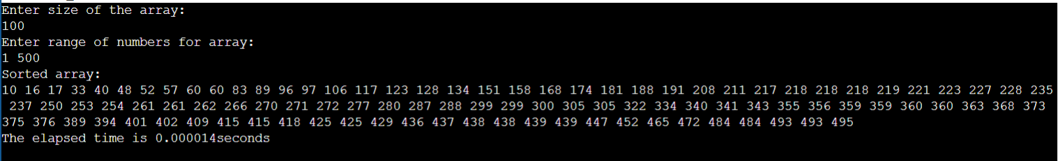

ANAYSIS:

Size of array | Execution time
100 | 0.000014
500 | 0.000091
1000 | 0.000182
5000 | 0.001425

GRAPH:
