
TRIBHUVAN UNIVERSITY
Faculty of Humanities and Social Sciences

Horaa Store

A PROJECT REPORT

Submitted to
Department of Computer Application
JANAMAITRI MULTIPLE CAMPUS
Kuleshawar, Kathmandu
In partial fulfillment of the requirement for the Bachelor’s degree in Computer Application [BCA].

Submitted by
Sujan Pakhrin [TU Redg No. 6-2-263-241-2023]
Symbol number: 26302155

Under the Supervision of
Kamal Tamrakar
March, 2026

Supervisor's Recommendation
I hereby recommend that this project entitled "Horaa Store ” prepared by under my supervision by Sujan Pakhrin (TU Reg. No. 6-2-263-241-2023) in a partial fulfillment of the requirement for the degree of Bachelor in Computer Application (BCA) under the guidelines of the curriculum prescribed by Dean’s Office of the Faculty of Humanities and Social Science, Tribhuvan University. I approved this and recommended it for the final evaluation.

----------------------------------
Kamal Tamrakar
Supervisor
HOD, Faculty of Computer
Janamaitri Multiple Campus
Kuleshwar, Kathmandu

LETTER OF APPROVAL

This is to certify that this project prepared by Sujan Pakhrin entitled "Horaa Store" in the partial fulfilment of the requirements for the degree of bachelor’s in computer application has been evaluated. In our opinion, it is satisfactory in the scope and quality for the required degree.
PROJECT EVALUATION COMMITTEE
Supervisor  Mr. Kamal Tarmrakar  HoD, Dept. of Computer Application | Project & Practicum Committee  Mr. Netra Lal Gyawali  Coordinator
Internal Examiner  Abita Kunwar  ------------------------------------ | External Examiner  Sanjaya K Shah  -------------------------------------

ABSTRACT

Horaa Store is an e-commerce website I built for my BCA project, covering the full purchase flow you'd expect from a real online store: browsing products, filtering by category, keeping a cart, checking out, and paying through eSewa. I built it with PHP, MySQL, and Bootstrap 5. The one thing I wanted to get right, more than anything else in this project, was payment handling — a lot of student e-commerce sites just mark an order as "paid" the moment the customer is bounced back from the payment page, which isn't how payment works. In HoraaStore, an order stays PENDING until the system has separately checked with eSewa's own servers that the payment really went through, so a browser redirect alone is never treated as proof of anything.
There are two sides to the system. On the customer side, you can register, log in, search and filter products, add things to a cart (with the price and stock always re-checked against the database, never trusted from what the browser sends), check out, pay through eSewa's sandbox, look back at your order history, and leave reviews. On the admin side, there's a dashboard for managing products and categories, going through orders, checking payment records, managing customer accounts, and moderating reviews.
I also spent a fair amount of time on security, since it's easy to skip in a project like this if you're only focused on getting features working. Every database query uses prepared statements, passwords are hashed with bcrypt, forms are protected with CSRF tokens, all output is escaped to stop XSS, and uploaded images are checked by their actual file content rather than just trusting the file extension. None of this is exotic — it's the same baseline discipline any small production site would need, and building it that way from the start was part of the point of the project.

List of Abbreviations or Acronyms
BCA Bachelor in Computer Application
CSS Cascading Style Sheets
DFD Data Flow Diagram
ER Entity-Relationship
HTML HyperText Markup Language
PHP HyperText Preprocessor
SQL Structured Query Language
JAVA Java Programming
JS JavaScript
MVC Model-View-Controller
UI User Interface

ACKNOWLEDGEMENT
We would like to express our sincere gratitude to all those who supported and guided us in the successful completion of this project.
First and foremost, we would like to extend our heartfelt appreciation to our Campus Chief, Mr. Bhola Nath Ojha and Assistant Campus Chief, Mr. Tikadatta Subedi, for providing a supportive academic environment and necessary facilities that enabled us to complete this work.
We are especially grateful to our Department Head and Project Supervisor, Mr. Kamal Tamrakar, for his invaluable guidance, continuous encouragement, and constructive feedback throughout the entire process. His support and insightful suggestions played a crucial role in shaping and improving this project.
We would also like to express our sincere thanks to all the faculty members of the JMC Computer Department - Dr. Neelam Subedi, Ms. Abita Kunwar, Mr. Kiran Sapkota, Mr. Kshitiz Khanal, Mr. Chet Raj Ojha, Mr. Rojesh Tamrakar and Mr. Bipin Shrestha - for their guidance, motivation, and academic support during the course of this project.
Our gratitude also goes to the administrative staff of JMC, who provided the resources, facilities, and institutional support necessary for carrying out this academic work.
We would like to acknowledge our colleagues, friends, and peers for their cooperation, encouragement, and valuable suggestions that enriched the quality of this project.
Finally, we are deeply thankful to our families and loved ones for their constant support, patience, and encouragement throughout this journey.
This work would not have been possible without the collective support and cooperation of these individuals. Their contributions have played a significant role in the successful completion of this project.

Table of Contents
List of Abbreviations or Acronyms iv
Chapter 1: Introduction 1
1.1. Introduction 1
1.2. Problem Statement 1
1.3. Objectives 1
1.4. Scope and Limitation 2
Chapter 2: Background Study and Literature Review 3
2.1. Background Study 3
2.2. Literature Review 3
Chapter 3: System Analysis and Design 4
3.1. System Analysis 4
3.1.1. Requirement Specification 4
3.1.2. Feasibility Study 5
3.2. System Design 5
3.2.1. Process Modeling — Context Diagram 5
3.2.2. System Architecture 6
3.2.3. Payment Verification Design 6
3.2.4. Database Design 7
Chapter 4: Implementation and Testing 8
4.1. Implementation 8
4.1.1. Tools and Technologies Used 8
4.1.2. Key Modules 8
4.2. Testing 9
4.2.1. Test Cases — Authentication 9
4.2.2. Test Cases — Cart 10
4.2.3. Test Cases — Checkout and Payment 10
Chapter 5: Conclusion and Future Recommendation 12
5.1. Lesson Learnt 12
5.2. Conclusion 12
5.3. Future Recommendation 13
APPENDICES 14
Homepage 14
Product Listing 14
Shopping Cart 15
Checkout 15
eSewa Sandbox Login 16
eSewa Verification 16
Payment Confirmation 17
Source Codes: 17
References: 17

Chapter 1: Introduction

1.1. Introduction
Horaa Store is a modern, responsive, and fully functional e-commerce web application designed to facilitate seamless online shopping. Built to provide a rich user experience, the system allows users to browse products, manage their shopping carts, and securely complete purchases. A key highlight of Horaa Store is its realistic mock integration of the eSewa payment gateway, a popular digital wallet in Nepal. This project serves as a comprehensive Management Information System (MIS) that bridges the gap between buyers and digital merchandise, efficiently handling inventory, user profiles, and order processing.

1.2. Problem Statement
Traditional retail businesses face significant limitations in reach, operating hours, and customer convenience. Furthermore, many existing small-scale e-commerce platforms struggle with clunky user interfaces and lack localized payment options. There is a pressing need for a streamlined, intuitive online store that not only presents products attractively but also offers familiar and secure payment pathways (like eSewa) tailored to local consumers. Horaa Store was developed to address these inefficiencies by providing a fast, secure, and user-centric online shopping environment.

1.3. Objectives
- To develop a fully functional e-commerce platform that allows users to seamlessly browse, select, and purchase products.
- To implement a secure user authentication and authorization system for customer profiles and admin management.
- To design an intuitive, interactive UI with modern aesthetics (glassmorphism, smooth animations).
- To integrate a simulated local payment gateway (eSewa) to demonstrate realistic transaction flows.
- To provide an efficient backend system for managing products, inventory, and order statuses.

1.4. Scope and Limitation
Scope:
- The system supports customer registration, login, and profile management.
- A dynamic shopping cart and checkout system.
- E-commerce administrative capabilities (managing products and viewing orders).
- A simulated eSewa ePay portal for transaction processing.
Limitations:
- The payment gateway (eSewa) is currently a mock simulation for demonstration purposes and does not process real financial transactions.
- The system does not currently feature third-party logistics (delivery) tracking APIs.
- Advanced features like AI-based product recommendations are outside the scope of this version.

Chapter 2: Background Study and Literature Review

2.1. Background Study
The rapid growth of internet access and digital technology has changed the way people shop. Nowadays, people prefer online shopping because it is fast, convenient, and time-saving. Instead of visiting multiple physical stores, customers can browse different products, compare prices, and choose suitable options from one platform.
E-commerce platforms provide customers with easy access to products anytime and from anywhere. They reduce the time and effort required for traditional shopping and offer a wide range of product choices. In Nepal, the increasing use of smartphones, internet services, and digital payment systems such as eSewa has further increased the popularity of online shopping.
Management Information Systems (MIS) play an important role in managing e-commerce activities. They help manage important information such as products, customers, orders, payments, and inventory efficiently.
Therefore, Horaa Store has been developed as an e-commerce website to provide a simple, convenient, and time-saving shopping experience. The system allows users to explore different products, view available options, and purchase products easily through an online platform. It aims to make the shopping process more efficient while helping the business manage its information and operations effectively.

2.2. Literature Review
Extensive research was conducted on modern web development frameworks and e-commerce architectures. Literature emphasizes that User Interface (UI) and User Experience (UX) are primary drivers of e-commerce success. Studies show that a complicated checkout process is the leading cause of cart abandonment. Consequently, modern applications utilize streamlined, single-page-like checkout forms and clear, trustworthy payment portals. Furthermore, literature on relational database design in MIS highlights the importance of normalized database structures to ensure data integrity for orders, users, and inventory—principles that were strictly adhered to during the development of Horaa Store.

Chapter 3: System Analysis and Design

3.1. System Analysis

3.1.1. Requirement Specification
I worked out these requirements by thinking through what a typical e-commerce site needs to do, from both the customer's side and the admin's side, then split them into functional (what the system should do) and non-functional (how well it should do it) requirements.
i. Functional Requirements
- User Management: Users must be able to register, log in, update profiles, and view order history.
- Product Catalog: The system must display available products with details, pricing, and dynamic stock status.
- Shopping Cart: Users can add items, update quantities, and remove items from their cart.
- Checkout & Payment: The system must capture shipping details and process payments through an eSewa mock portal, generating unique transaction reference codes.
- Admin Dashboard: Administrators must be able to add/delete products and manage orders.
ii. Non-Functional Requirements
- Performance: Pages should load quickly, and database queries must be optimized for speed.
- Usability: The interface must be fully responsive, working seamlessly across desktops, tablets, and smartphones.
- Security: User passwords must be securely hashed. The application must protect against SQL injection and cross-site scripting (XSS).
- Aesthetics: The design must utilize modern CSS techniques to provide a premium look and feel.

3.1.2. Feasibility Study
Before actually starting to build anything, I checked whether this project made sense to attempt at all — technically, operationally, and cost-wise.
Name | Description | Remarks
Technical Feasibility | High. The chosen tech stack (PHP, MySQL, HTML, CSS, JS) is widely supported robust and well- suited for building and e-commerce MIS. | All required tools are free, well-documented, and widely supported, so the system is technically feasible.
Operational Feasibility | The admin panel is designed with a simple sidebar layout and consistent CRUD forms across all modules. | The intuitive design ensures that both customers and administrators can use the system without extensive training.
Economic Feasibility | Built entirely on free and open-source technologies; eSewa's sandbox credentials are publicly available at no cost. | Utilizing open-source technologies (PHP, MySQL, Bootstrap) eliminates licensing costs, making the project highly cost-effective.

3.2. System Design

3.2.1. Process Modeling — Context Diagram
The diagram below shows Horaa Store as a single process, with three outside entities it exchanges information with: the Customer, the Admin, and eSewa.
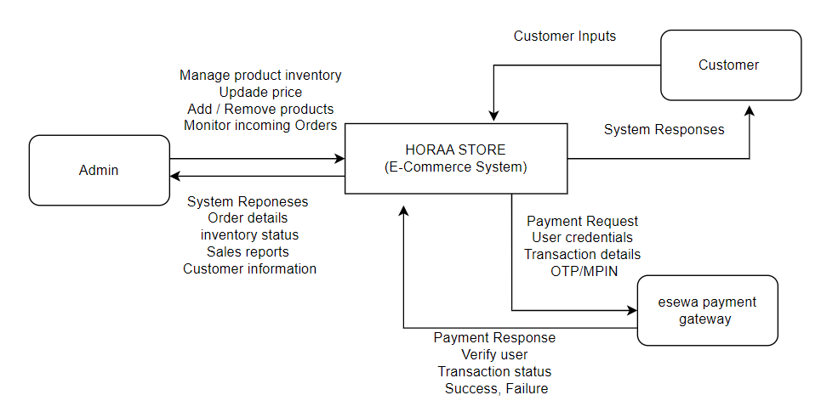
Figure 1: Context Diagram

3.2.2. System Architecture
This is a rough Input–Process–Output view of how the system works: whatever the user does gets validated and checked against the database, and that produces the outputs the customer or admin ends up seeing.
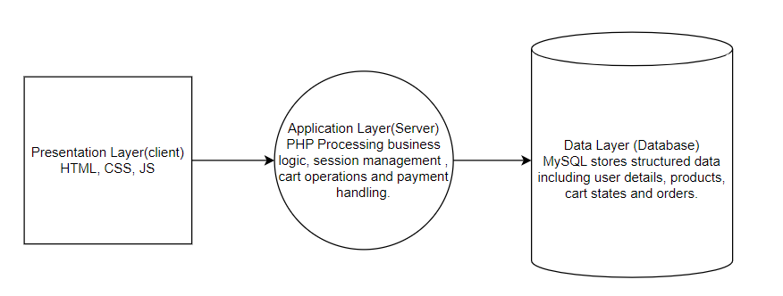
Figure 2: System Architecture

3.2.3. Payment Verification Design
The payment system simulates the eSewa gateway using a multi-step verification process:
- Initiation: The system generates a cryptographic signature based on order totals and redirects the user to the eSewa mock portal.
- Authentication: The user provides an eSewa ID (Mobile) and MPIN, alongside a reCAPTCHA verification.
- OTP Verification: A simulated SMS OTP is triggered. The user inputs the 6-digit code.
- Completion: Upon verification, a unique transaction reference code is generated, the order status is updated in the database to 'paid', and the user is redirected to the order success page.

3.2.4. Database Design
The relational database is designed with robust data integrity principles in mind. It consists of several main tables including users, categories, products, cart, orders, and order_items.
I used DECIMAL(10,2) for anything involving money instead of FLOAT, since floating-point rounding errors are exactly the kind of bug you don't want in a table full of prices. Status fields use ENUM so a column like order_status can only ever be one of a fixed set of values (e.g., PENDING, PROCESSING, DELIVERED, CANCELLED) rather than whatever string happens to get typed in somewhere. Foreign keys tie everything together properly across tables, and unique constraints stop things like duplicate emails from sneaking in.
One thing I want to point out specifically: the order_items table stores its own copy of the price and subtotal, even though that same price already exists on the products table. That's intentional, not an oversight — it's a historical snapshot. If I go into the admin panel next month and change a product's price, every order placed before that change needs to still show what the customer actually paid at the time, not today's updated price.

Chapter 4: Implementation and Testing

4.1. Implementation

4.1.1. Tools and Technologies Used
- Frontend: HTML5, vanilla CSS3, Bootstrap 5, JavaScript
- Backend: PHP 8+ (procedural style, using PDO for all database access)
- Database: MySQL,
- Payment Gateway: eSewa ePay v2 (sandbox/test environment)
- Development Environment: XAMPP (Apache + MySQL + PHP), Visual Studio Code

4.1.2. Key Modules
Authentication Module
Handles registration and login. Passwords go through PHP's password_hash() and get checked with password_verify() — nothing is ever stored in plaintext. Duplicate emails are caught server-side, and the session ID gets regenerated right after a successful login so an old session ID can't be reused (session fixation).
Product Catalog Module
On the customer side this covers browsing, keyword search, category filters, and price sorting. On the admin side, full create/update/deactivate for products, with the image upload going through actual validation rather than just checking the file extension.
Cart and Checkout Module
The cart is stored in the database per user, not in a session variable, so it survives across logins. Every time something is added to the cart, the quantity is updated, or checkout happens, the price and stock get pulled fresh from the products table — whatever number the browser sends is never used for anything financial.
Payment Module (eSewa Integration)
This is the part I spent the most time on. It builds an HMAC-SHA256 signed request in the exact field order eSewa's docs specify (total_amount, transaction_uuid, product_code), sends the customer to eSewa's sandbox, and then on the way back: checks the response's own signature, calls eSewa's Status Check API as the real confirmation, compares the confirmed amount against what's stored for that order, and only after all of that marks the payment SUCCESS, the order CONFIRMED, and reduces stock. If the same callback somehow fires twice — a page reload, for instance — it just recognizes the payment is already SUCCESS and doesn't reprocess it.
Order Management Module
Customers can see their own order history and order details — every query checks that the order actually belongs to the logged-in user, so nobody can view someone else's order just by changing an ID in the URL. Admins can see everything, filter by status, and update order status separately from payment status.
Admin Dashboard Module
Shows live numbers — total customers, products, orders, pending orders, successful payments, total sales — plus a table of the most recent orders.

4.2. Testing
I tested this manually rather than writing an automated test suite, given the time available for the project. That meant going through individual actions on their own (does add-to-cart behave correctly by itself?) and then testing the checkout → payment → order flow end-to-end, including running real transactions through eSewa's sandbox.

4.2.1. Test Cases — Authentication
Test ID | Scenario | Expected Result | Remarks
01 | User logs in with correct credentials. | System authenticates user, establishes session and redirects to profile/shop. | Pass
02 | Register with an already-registered email | Error: "This email is already registered" | Pass
03 | Log in with an incorrect password | System displays an error flash message and denies acess. | Pass

4.2.2. Test Cases — Cart
Test ID | Scenario | Expected Result | Remarks
01 | Add an item to cart update quantity. | Subtotal, shipping and grand total recalculate dynamically. Item persists in session. | Pass
02 | Add a valid quantity of an in-stock product | Item added to cart with correct subtotal | Pass
03 | Change a product's price in admin after it is already in a customer's cart | Cart total reflects the updated price on next view (never a stale browser value) | Pass

4.2.3. Test Cases — Checkout and Payment
Test ID | Scenario | Expected Result | Remarks
01 | Submit checkout with a complete shipping form | Order and payment created as PENDING; redirected to eSewa sandbox | Pass
02 | Process order using eSewa. | User is redirected to eSewa portal, MPIN entry works, OTP generates, order status updated to ‘paid ’ stock is deducted. | Pass
03 | Cancel the transaction on eSewa's page | Redirected to failure page; payment marked FAILED; order remains PENDING | Pass
04 | Reload the success page after a completed payment | "Payment Already Confirmed" shown; no duplicate stock decrement | Pass

Chapter 5: Conclusion and Future Recommendation

5.1. Lesson Learnt
Developing Horaa Store provided invaluable hands-on experience in building a full-stack e-commerce application. Key takeaways include:
- Don't trust anything the browser sends when money is involved — prices, totals, stock counts, all of it needs to come fresh from the database at the moment it actually matters, not from whatever was true a page load ago.
- The importance of robust session management for maintaining cart states and user security.
- Advanced UI/CSS techniques for creating pixel-perfect, premium interfaces that replicate real-world systems (like the eSewa portal).
- Practical application of database normalization and handling transactional integrity when processing order
- A redirect back from a payment gateway means "go check," not "it worked." That one distinction — browser says success vs. the gateway's own server confirms success — turned out to be the single most important idea in the whole payment integration.
- Idempotency isn't just a textbook word — browsers really do reload pages, hit back, and double-submit forms, and a payment handler that breaks the second time it runs will eventually cause a real problem for a real customer.

5.2. Conclusion
The Horaa Store MIS project was successfully completed, meeting all defined functional and non-functional requirements. It demonstrates a practical application of web technologies to solve real-world retail problems. The system is secure, visually appealing, and highly functional, featuring a complex but user-friendly checkout process intertwined with a simulated local payment gateway. This project stands as a solid foundation for a scalable, production-ready e-commerce business.

5.3. Future Recommendation
To enhance the system for a real-world production environment, the following improvements are recommended:
- Real Payment API: Replace the mock eSewa portal with the actual eSewa Merchant API for processing real monetary transactions.
- Admin Analytics: Implement graphical dashboards in the admin panel to track sales trends, popular products, and revenue over time.
- Logistics Integration: Connect with courier APIs to provide real-time package tracking for customers.
- AI Recommendations: Integrate a recommendation engine based on user browsing history and purchase patterns.

APPENDICES
These are screenshots I took of the actual running site on my own machine (XAMPP, localhost), going through a real purchase from the homepage all the way to a confirmed eSewa sandbox payment.

Homepage
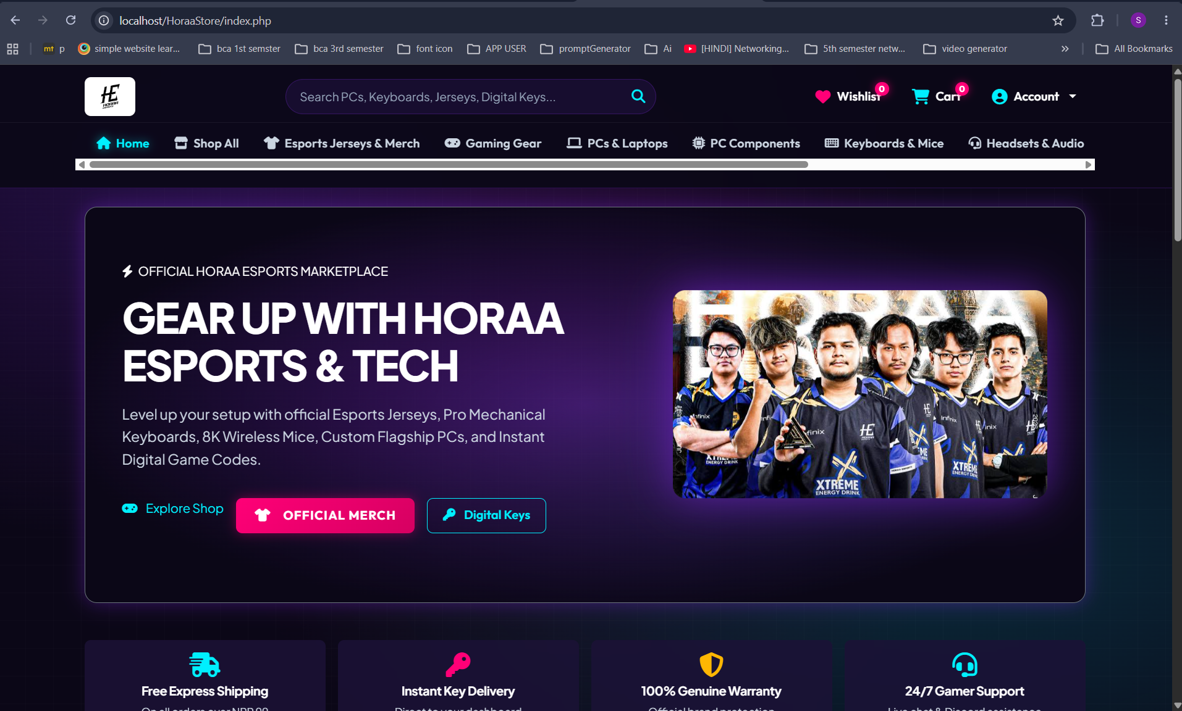
Homepage — featured products and category navigation

Product Listing
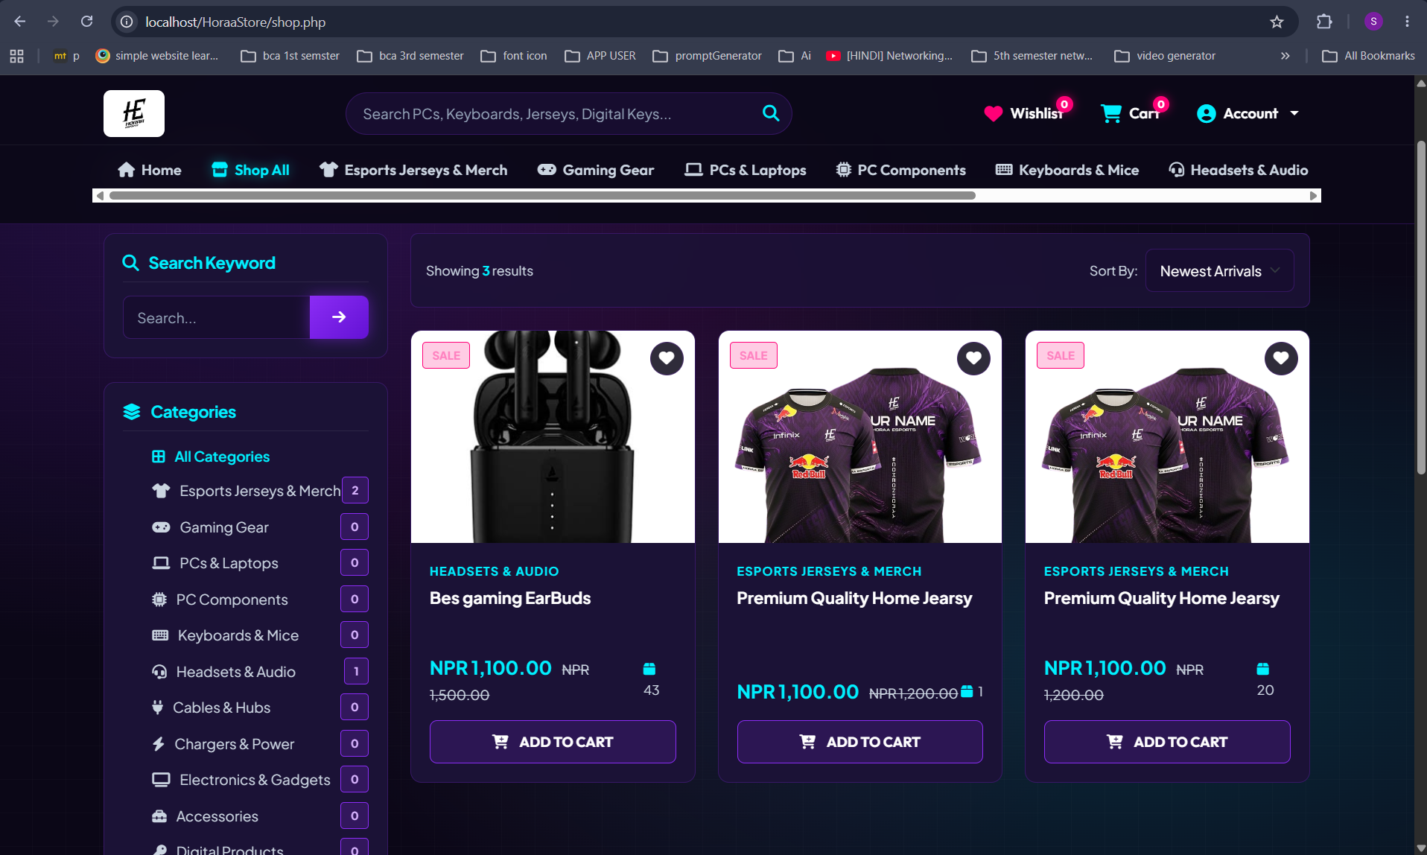
All Products page with category filter and sort options

Shopping Cart
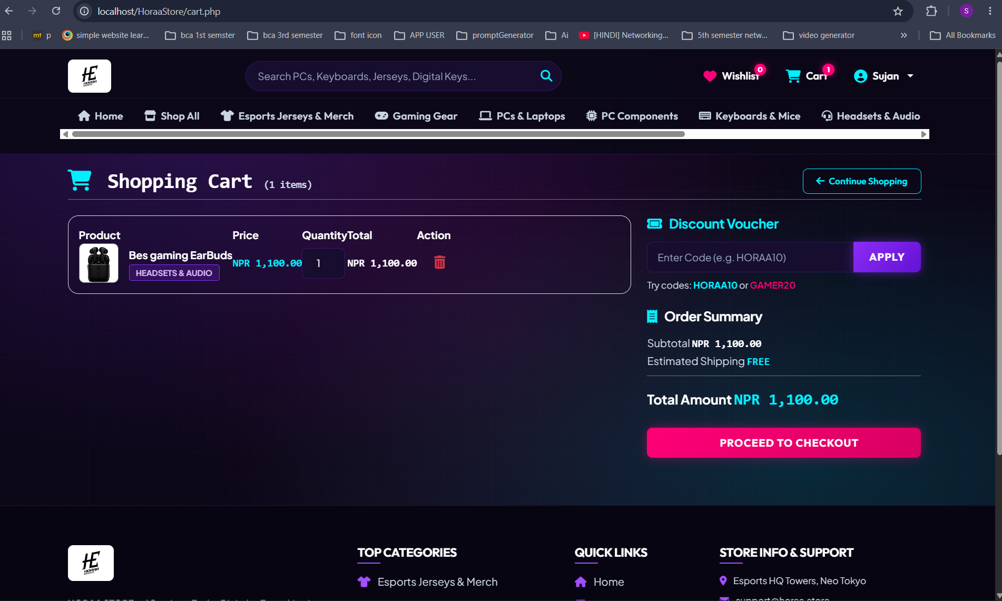
Cart page showing an added item, quantity control, and total

Checkout
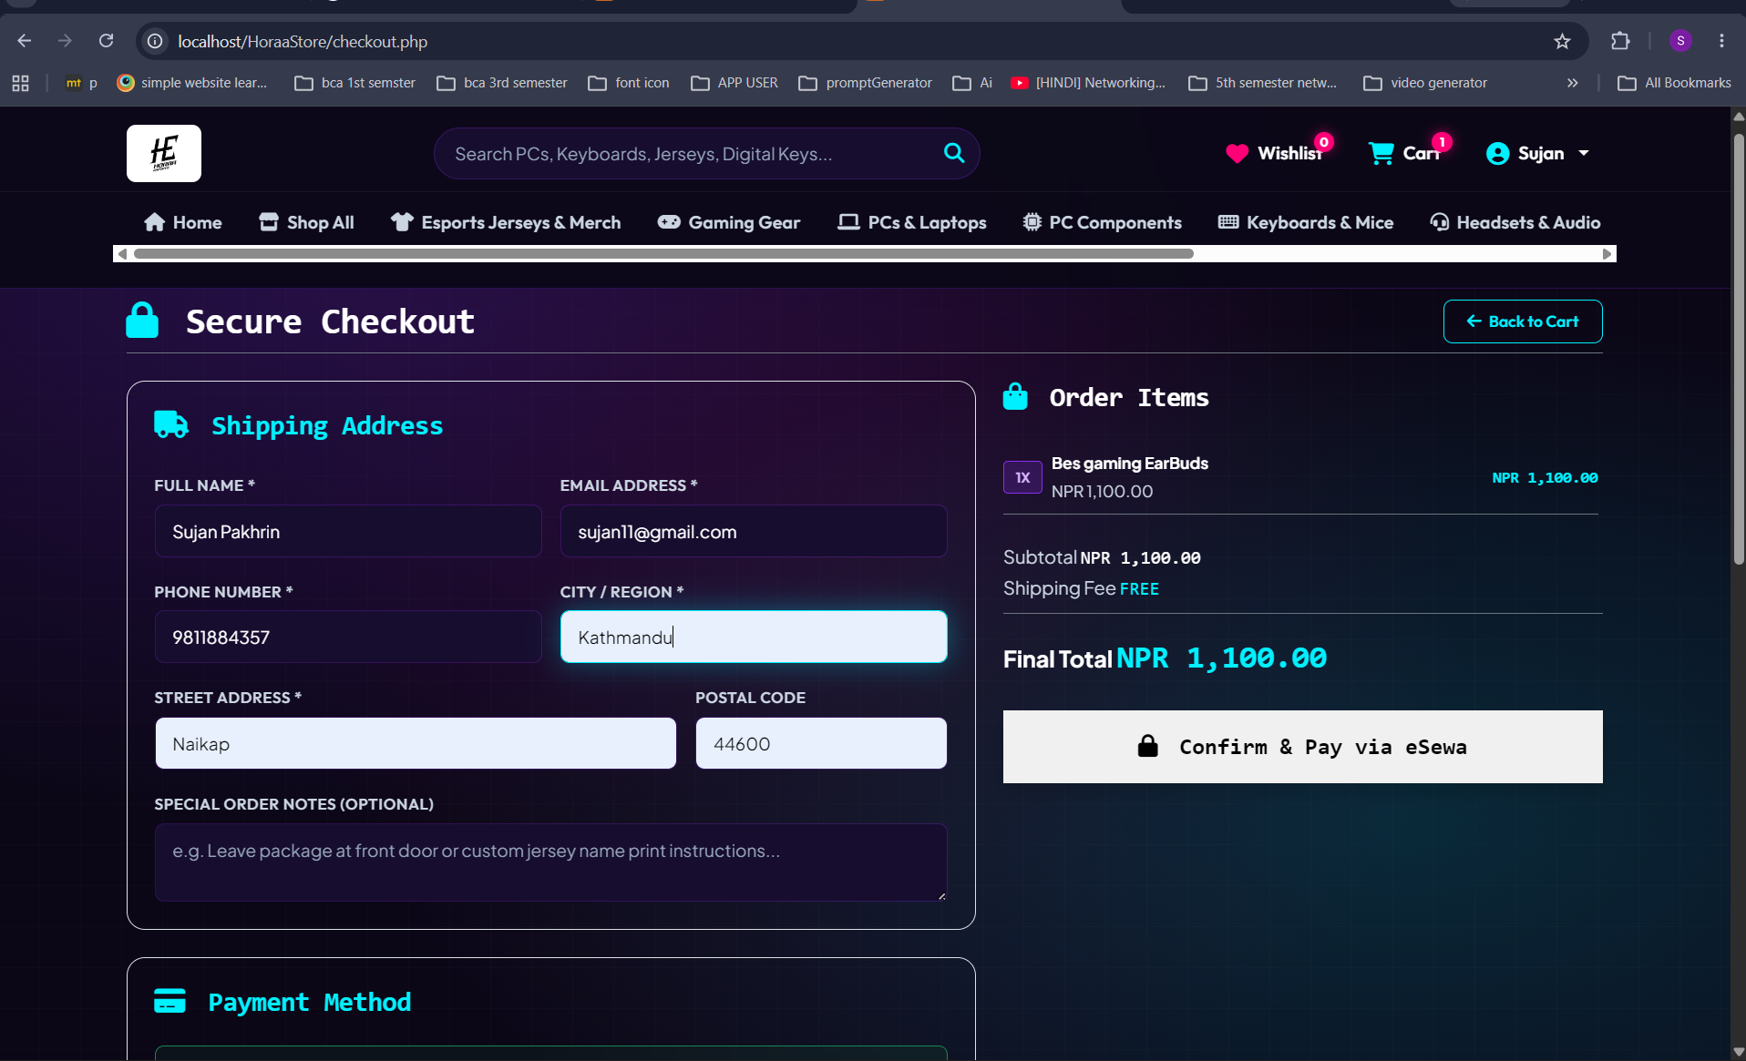
Checkout page with shipping details and order summary

eSewa Sandbox Login
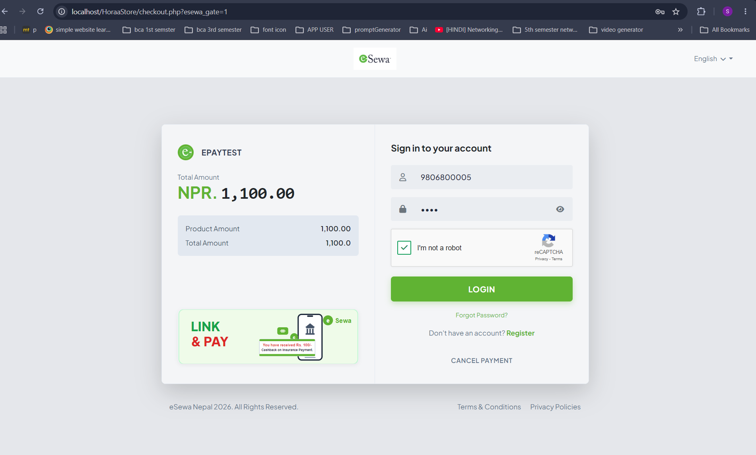

eSewa Verification
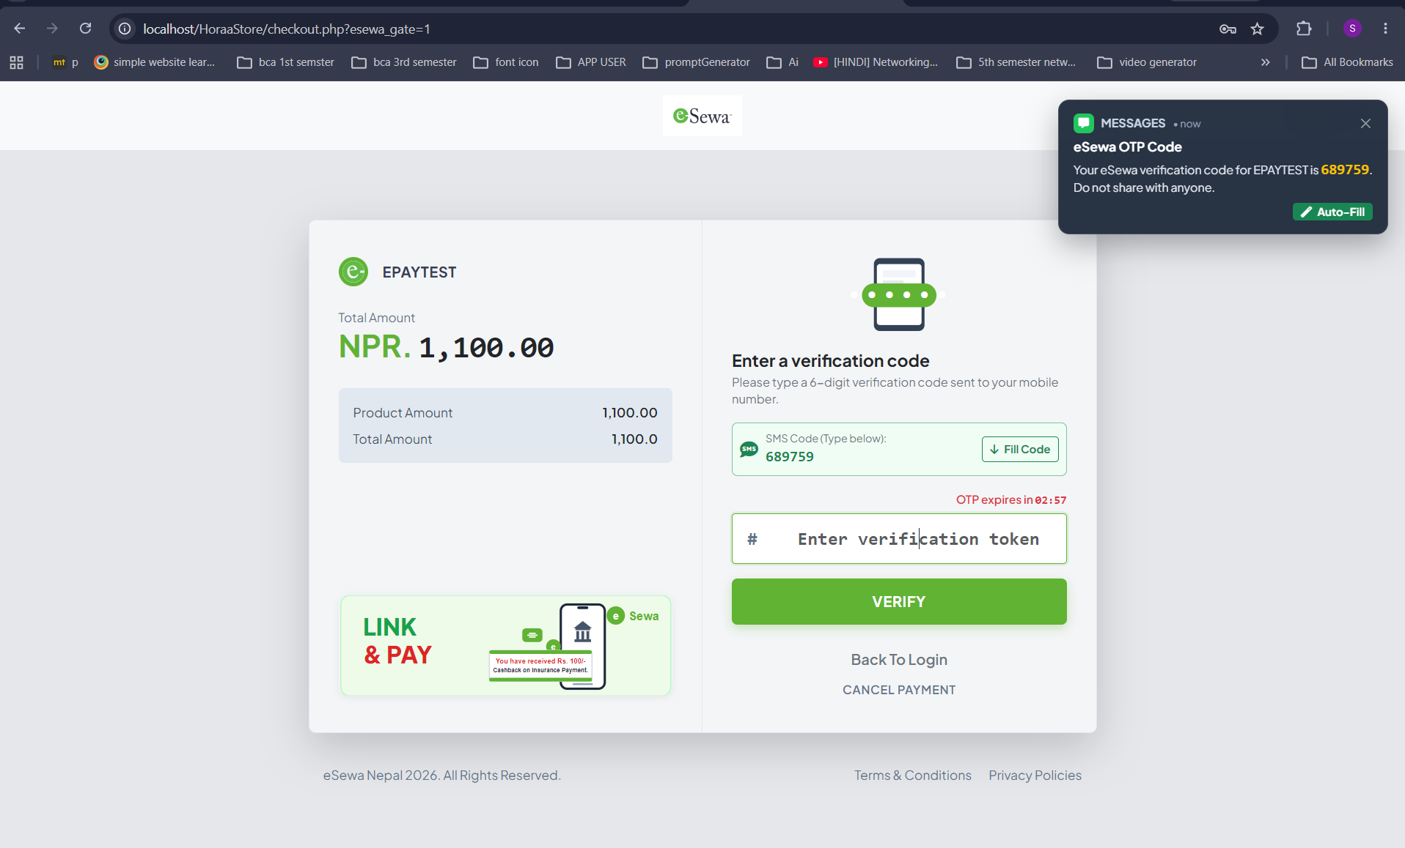
eSewa (EPAYTEST) sandbox login screen showing the signed transaction amount

Payment Confirmation
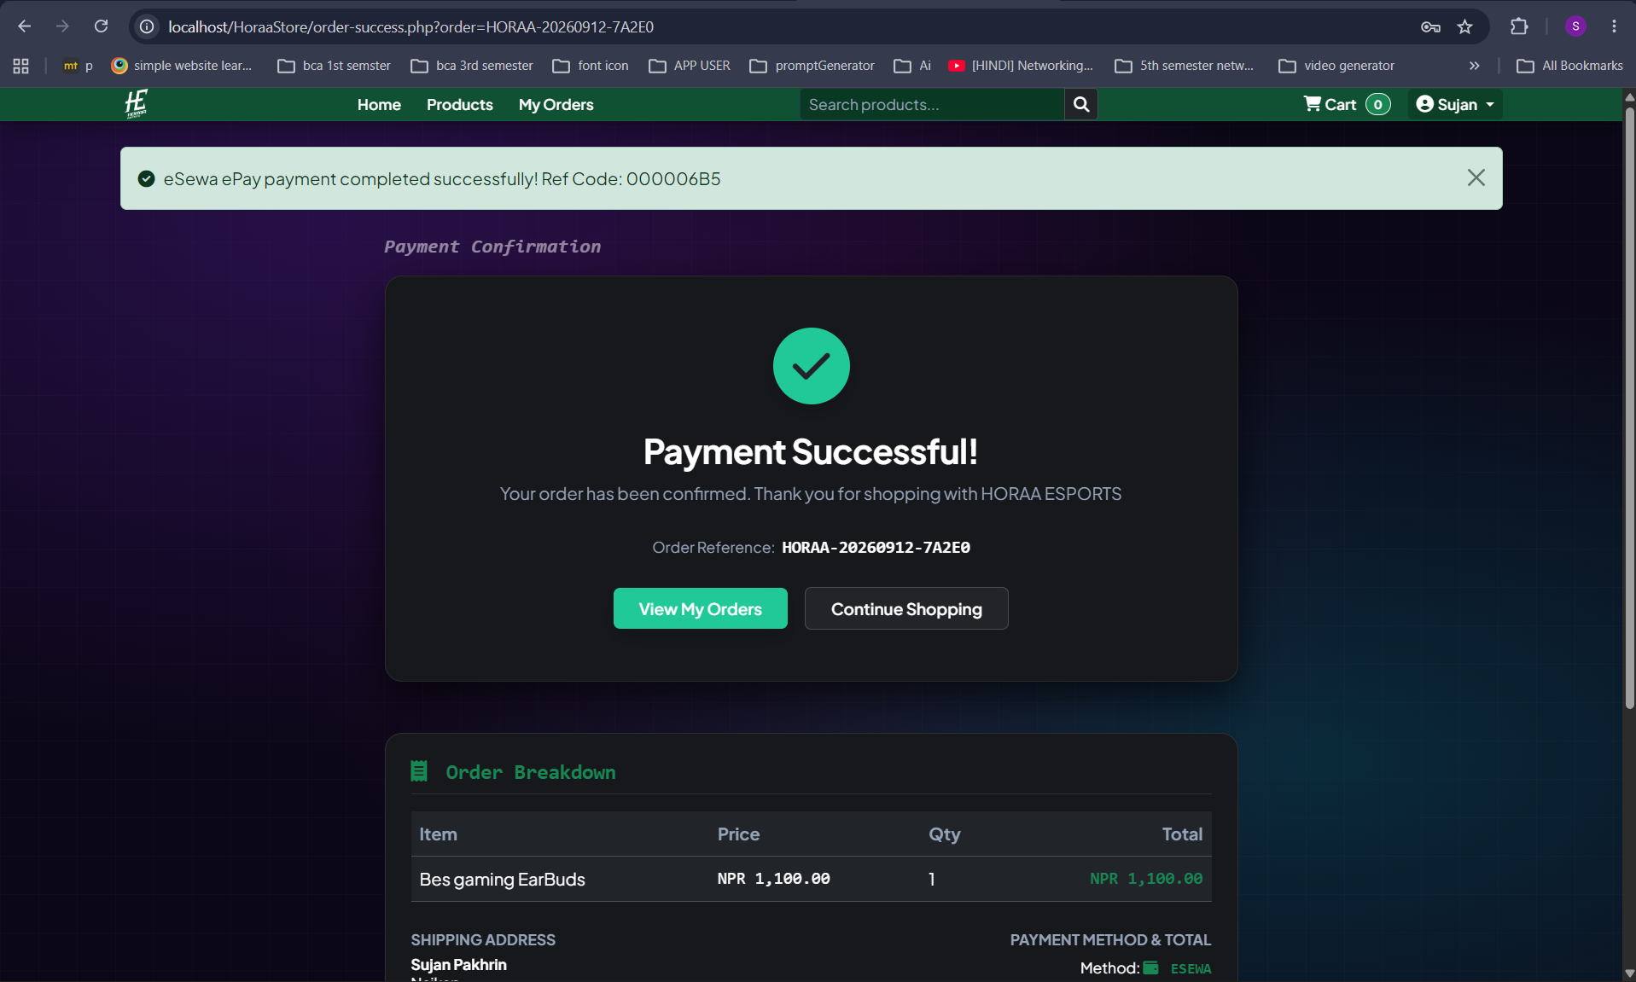
Payment Successful page shown after signature verification and eSewa status confirmation

Source Codes:
Links:
https://github.com/Pakhrin00000/Horaa_Store.git

References:
- Horaa Esports official page https://horaaesports.com.np/
- Wikipedia. [Online]. Available: https://en.wikipedia.org/wiki/E-commerce

